Assessment
Your teacher will assess your work from this unit and check you are making progress. You will receive a band for :
- Knowledge and understanding
- Evaluation and Justification
- And Discussion
‘Going to mass is the best thing you can do for a persecuted Christian’ Discuss

……………………………………………………………………………………………………………………………………………………………………………………………………………………………………………………………………………………………………………………………………………………………………………………..…………………………………………………………………………………………………………………………………………………………………………………………………………………………………………………………………………………………………………………………………………………………………………………………………………………………………………………………………………………………………………………………………………………………………………………………………………………………………………………………………………………………………………………………………………………………………………..…………………………………………………………………………………………………………………………………………………………………………………………………………………………………………………………………………………………………………………………………………………………………………………………………………………………………………………………………………………………………………………………………………………………………………………………………………………………………………………………………………………………………………………………………………………………………………..…………………………………………………………………………………………………………………………………………………………………………………………………………………………………………………………………………………………………………………………………………………………………………………………………………………………………………………………………………………………………………………………………………………………………………………………………………………………………………………………………………………………………………………………………………………………………………..…………………………………………………………………………………………………………………………………………………………………………………………………………………………………………………………………………………………………………………………………………………………………………………………………………………………………………………………………………………………………………………………………………………………………………………………………………………………………………………………………………………………………………………………………………………………………………..…………………………………………………………………………………………………………………………………………………………………………………………………………………………………………………………………………………………………………………………………………………………………………………………………………………………………………………………………………………………………………………………………………………………………………………………………………………………………………………………………………………………………………………………………………………………………………..………………………………………………………………………………………………………………………………………………………………………………………………………………………………………………………………………………………………………………………………………………………………………………………………………………………………………………………………………………………………………………………………………………………………………………………………………………………………………………………………
……………………………………………………………………………………………………………………………………………………………………………………………………………………………………………..…………………………………………………………………………………………………………………………………………………………………………………………………………………………………………………………………………………………………………………………………………………………………………………………………………………………………………………………………………………………………………………………………………………………………………………………………………………………………………………………………………………………………………………………………………………………………………..………………………………………………………………………………………………………………………………………………………………………………………………………………………………………………………………………………………………………………………………………………………………………………………………………………………………………………………………………………………………………………………………………………………………………………………………………………………………………………………………
……………………………………………………………………………………………………………………………………………………………………………………………………………………………………………..…………………………………………………………………………………………………………………………………………………………………………………………………………………………………………………………………………………………………………………………………………………………………………………………………………………………………………………………………………………………………………………………………………………………………………………………………………………………………………………………………………………………………………………………………………………………………………..……………

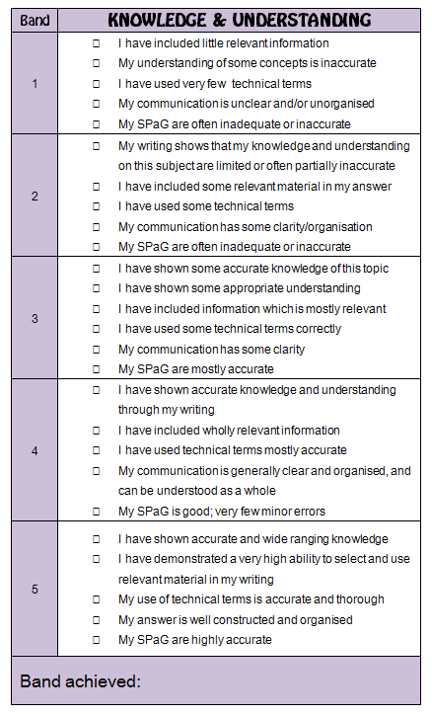
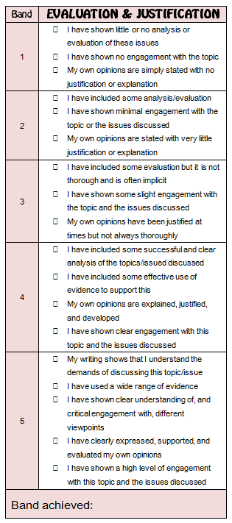
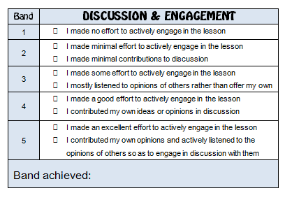

Making progress in CORE RE
Measuring progress after GCSE:
- Level 1 / Level 2: sub-AS level
- Level 3: if you achieved a C grade at GCSE, you should be working on and above a level 3
- Level 4: if you achieved a B grade at GCSE, you should be working on and above a level 4
- Level 5: if you achieved an A/A*grade at GCSE, you should be working on a level 5

‘Going to mass is the best thing you can do for a persecuted Christian’ Discuss

