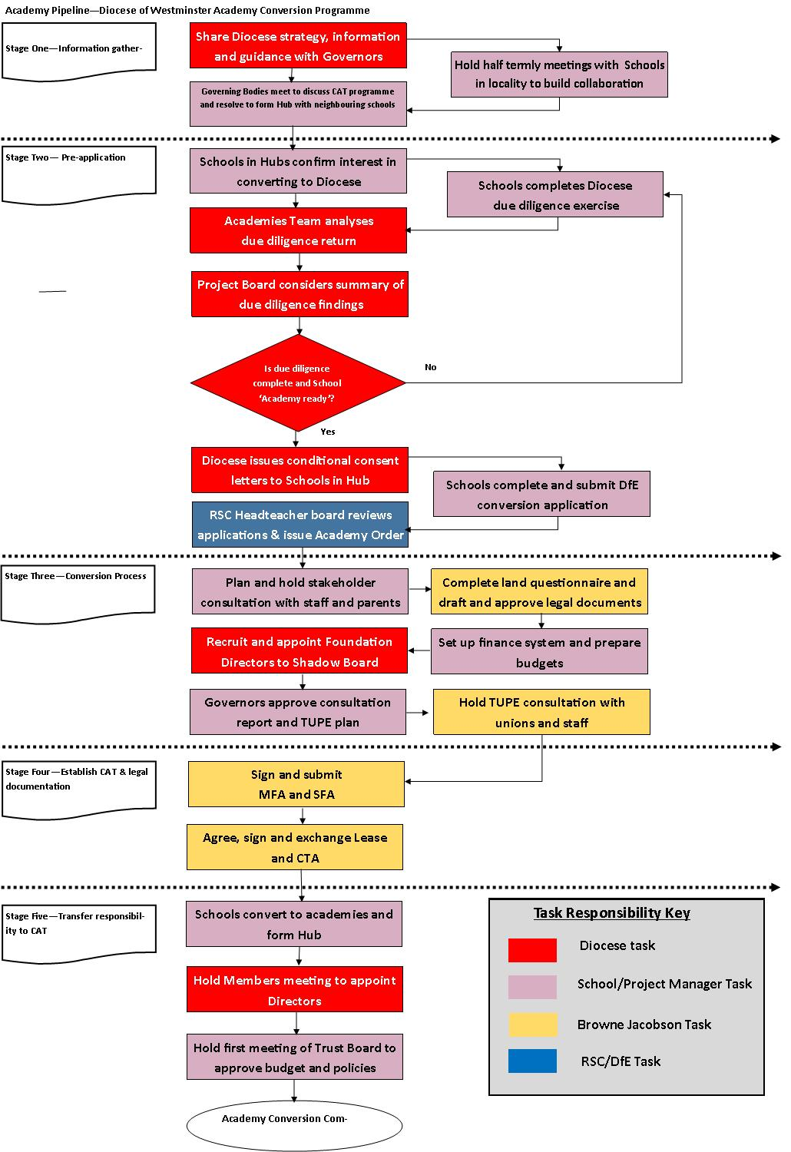

Diocese of Westminster: Academy Conversion Programme
Summary Overview for Governing Boards (April 2018)
1.Informal exploration by Governing Board and school leaders
Governing Board informally agree to explore option of becoming an academy within a Catholic Academy Trust
Action: Review Academy Strategy Documentation on diocese website.
Date Action taken:
Governing Board Due Diligence on what Academy Status means
Action: create a working group to explore becoming an academy trust looking at areas including curriculum & school performance, finance and property, staffing and governance.
Date Action taken:
Working group provides initial report to governing board
Action: Agree whether to register an interest in becoming an academy
Date Action taken:
2.Expressing an interest through to academy order
Register interest with DfE and obtain DfE advice on next stages of process & let the Diocese know as soon as you have expressed interest.
Action: https://form.education.gov.uk/fillform.php?self=1&form_id=FitANqky23M&noLoginPrompt=1​
Date Action taken:
Governing Board to pass resolution to investigate academy status
Action: Propose minute should be carefully minuted and expressed to be conditional upon further Governing Board, Diocesan and other approvals and upon agreement of the specific documentation
See example minute in Academy Conversion Pack
Date Action taken:
Obtain conditional consents from Diocese and RO and any further advice required at this stage
Action: Submit Due Diligence Forms to the Academy Project Board Word document and Excel spreadsheet available on diocesan website Academy section. If Order school, obtain consent from Religious Superior.
Date Action taken:
Prepare to Inform staff, parents, pupils and your local authority that you are considering becoming an academy and that, if the Governing Body decide to continue investigating academy status, a consultation will be undertaken.
Action: send letter, create Academy conversion area on website
See example letter in Academy Conversion pack

Date Action taken:
Academy Project Board and Education Commission Approval to move forward
Action: Chair of Governors to submit application to convert to DfE on line will need to create account with DfE
https://form.education.gov.uk/build/fillform.php?self=1&&form_id=qxvrr4gQioH&ShowMsg=1&skipExtraPage=1&form_name=Academy%20conversion%20application%20form&noRegister=false&ret=/MyServices&blackListId=qxvrr4gQioH&isBlacklisted=1&1
Example of forms available at
https://www.gov.uk/government/publications/academy-conversion-application-forms

Date Action taken:
Governing Board to draw up and agree consultation proposals
Action: Agree consultation timeframe
See example letter and questionnaire on Academy Conversion pack
Date Action taken:
Initial discussions with solicitors as required
Action: Formal appointment to take place after academy order granted
Date Action taken:
Local Government Pension Scheme notify L.A and seek guidance
Action: Actuarial assessment of pension contributions academy trust would be responsible for

Date Action taken:
Academy order granted by DfE
Action: support grant released £25,000 and indicative funding allocation letter provided to review
Date Action taken:
3. Consultations
Governing Board to formally consult on plans to become academy trust with anyone who has interest in school (including staff, parents, pupils and wider local community).
Actions :Documents published /Consultation meetings /Consultation feedback considered by Governing Board to determine response. (Consultation must be completed before signature of funding agreement.)
Date Action taken:
TUPE informative process to be conducted (after academy order grant)
Action: TUPE letter / TUPE meeting with legal advice on letter and documentation
See example letter and questionnaire on Academy Conversion pack
Date Action taken:

4.Establishing the Catholic academy trust and agreeing the legal documents
Documentation for approval Academy Project Board templates must be followed
Action: Memorandum and Articles of Association
Master Funding Agreement applying to all academies in the trust
Supplemental Funding Agreements for each academy within the trust.
Church Supplemental Agreement for all Catholic schools
Lease/other property documents as required for the different academies
Commercial Transfer Agreement for each academy
Scheme of Delegation for each academy
Service level agreements with providers

Date Action taken:
Appointment of Members and Directors and provisional appointment of Local Governing Committee members
Action: Notifications to Companies House
Date Action taken:
5.Transferring responsibility to the academy trust
Final consents given
Action: Read Academy Financial Handbook , finalise banking, insurance and appoint auditors. Apply for Diocese’s conditional consent to become unconditional.
Date Action taken:
Completion of relevant documentation and TUPE process.
Action: Issue relevant letters and notifications, see examples in Academy Conversion pack
Date Action taken:
Completing necessary registrations/filings
Action: making necessary notifications DfE, Information Commissioner, Edubase, exam boards etc

Date Action taken:
Confirming policies and procedures
Action: CAT policy review for Academy status

Date Action taken:

Websites to go live/ Email headers updated/Stationary updated
Action: Update for new status and legal compliance for CAT

Date Action taken:

Diocese Conversion Deadlines
Conversion date | 1st September to 1st December | 1st January to 1st March | 1st April to 1st August
GB resolution | October | March | July
Submit 3 year budget plan and standards information | Early-November | End March | Early-September
Audit report | End of term -December | Mid-May | Mid-October
Submit remaining Due Diligence | End of term -December | May Half Term | October Half Term
Project Board approval and recommendation to Diocese Trustees | Early-February | Early-June | Early-November
Diocese Trustees approval and consent letter | February Half Term | Mid-June | Mid-November
Submit Application, Minutes and Consent letter | February Half Term | Mid-June | Mid-November
Academy Order | Mid-March | Mid July | End of term -December
Start conversion work | After Easter | 1st week September | 1st week January

