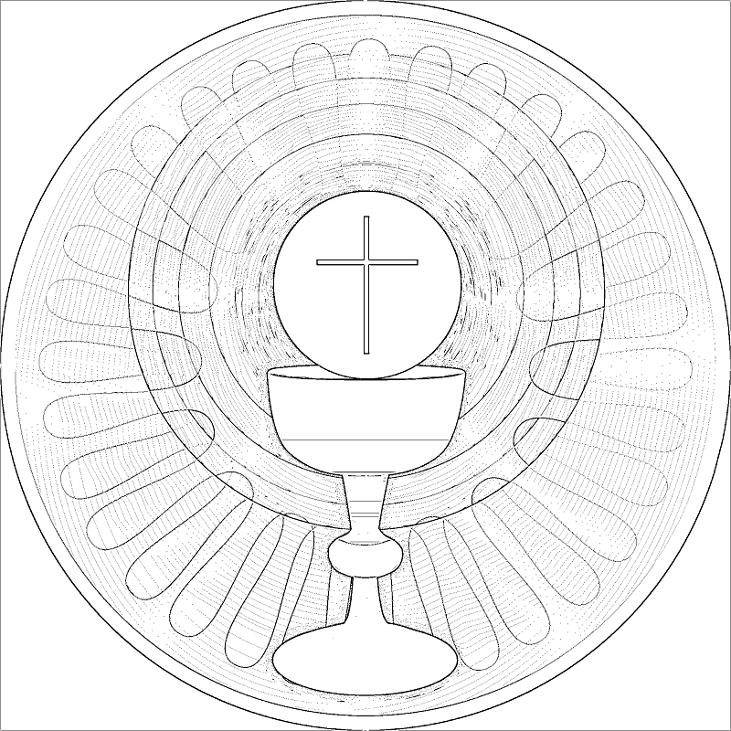
My Blessed Sacrament Booklet

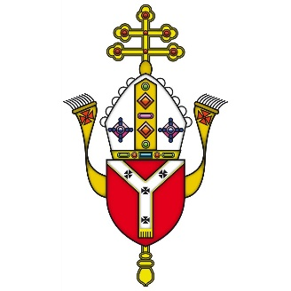

NAME:_____________________

Dear Friend,
How are you? I watch you every day with your family and friends as you share food and conversations. I see you as you listen to music and spend time with your gadgets. You're always so busy... at home and in school. I long to spend time with you, to listen to you and share my peace with you.
I want you to know, dear Friend, that I am always here for you, waiting... You can speak to me anytime but I am present in a very special way in the Blessed Sacrament.
I know that this may seem like a big mystery to you but my love for you is real and uncomplicated: I will love you always, no matter what...
This booklet may help you to know and understand my presence in the Blessed Sacrament a little more. Do not worry about anything.
All I ask, dear Friend, is that you come to me with an open heart. There is so much I want to give you - a peace and joy that the world cannot offer. I have such plans for you and my heart is burning with love for you.
And so, I will wait for you, dear Friend, and look forward to being with you, just as you are.
With all my love,
Your friend,
Jesus
The Divine Praises
Blessed be God.
Blessed be His Holy Name.
Blessed be Jesus Christ, true God and true man.
Blessed be the name of Jesus.
Blessed be His most Sacred Heart.
Blessed be His most precious blood.
Blessed be Jesus in the most Holy Sacrament of the Altar.
(Blessed be Jesus in the poorest of the poor)
Blessed be the Holy Spirit, the Paraclete.
Blessed be the great Mother of God, Mary most holy.
Blessed be her holy and Immaculate Conception.
Blessed be her glorious Assumption.
Blessed be the name of Mary, Virgin and Mother.
Blessed be Saint Joseph, Her most chaste spouse.
Blessed be God, in His angels and in His saints.

O Sacrament most holy, O Sacrament Divine,
All praise and all thanksgiving
be every moment thine.

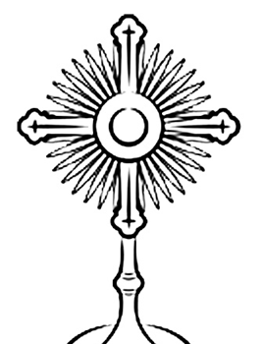
Blessed be God
What would you like to praise God for? Write or draw all the wonderful gifts.
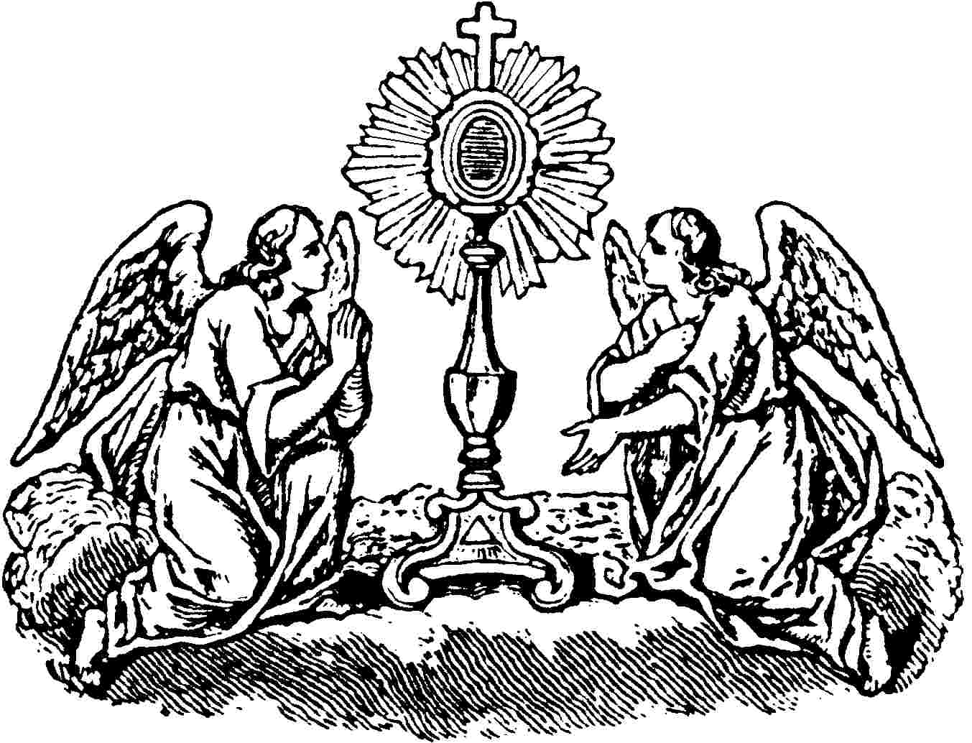
What names do you have for God? Write all the names above and decorate your favourite.

Blessed be His Holy Name
Blessed be Jesus Christ, true God and true man
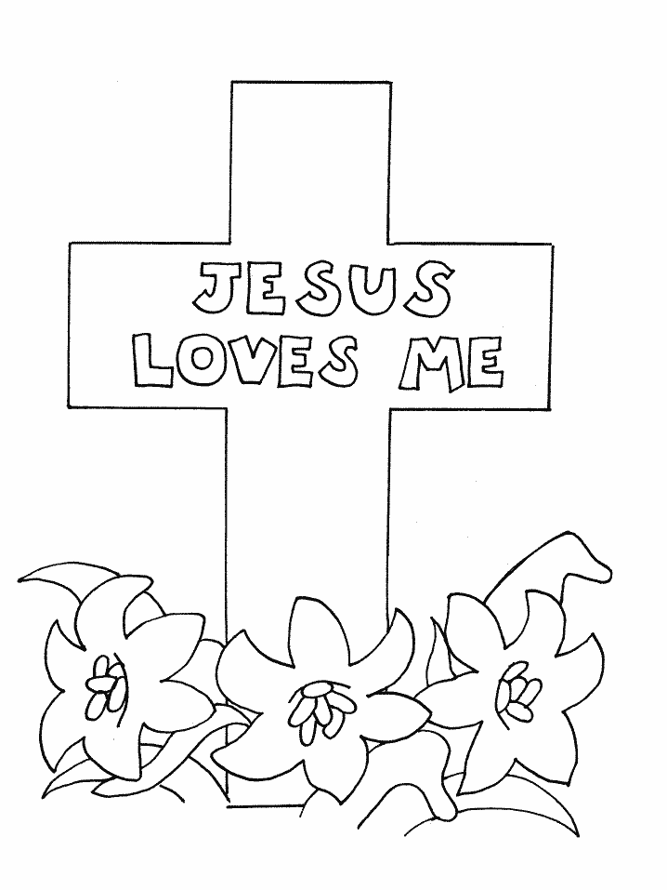
Blessed be the name of Jesus
Who do you say Jesus is? Write about or draw your image of Jesus.

Write the other names or titles for Jesus above and illustrate using symbols.

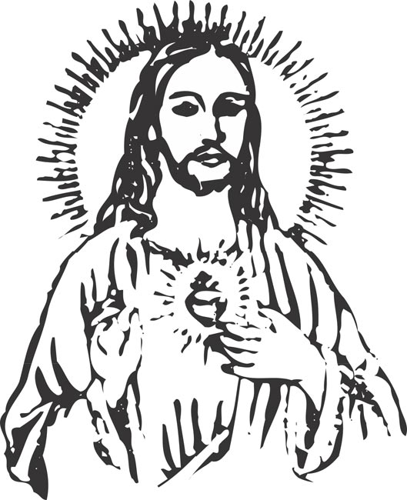
Blessed be His most
Sacred Heart
How does Jesus love? How can you have a heart like Jesus? Write or illustrate above.

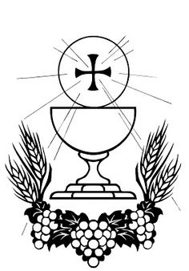
Blessed be His most
Precious Blood

Jesus shed his blood for you and others. He was a ‘Servant King’. What can you do to serve others?
Blessed be Jesus in the Most Holy Sacrament of the Altar
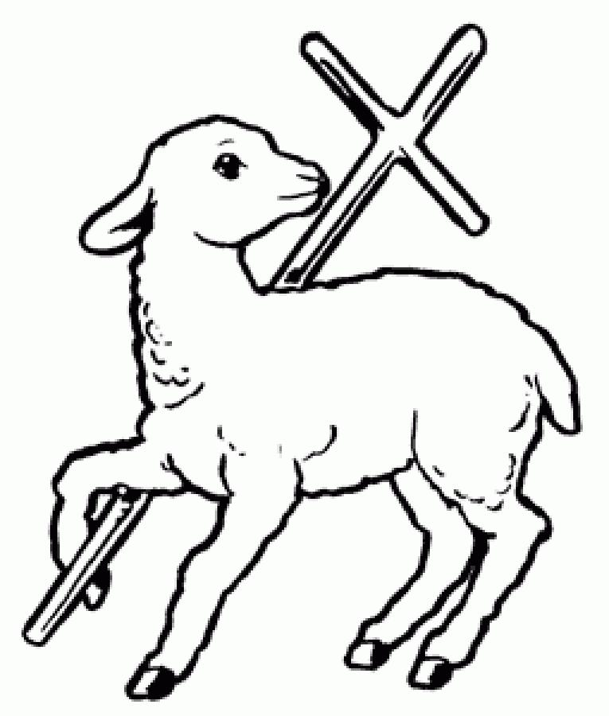

Jesus sacrificed Himself to save us from sin and reconcile us to the Father. What can you do to be reconciled with God?
Blessed be Jesus in the poorest of the poor
NOTE: This is an additional Divine Praise said by St Teresa of Calcutta and her missionaries.
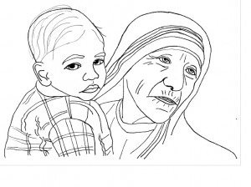
Who are the poorest of the poor in my neighbourhood? How can we help and serve them?
Blessed be the Holy Spirit, the Paraclete.
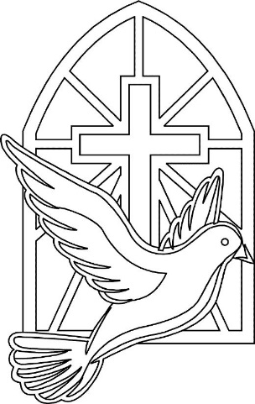
Blessed be the great Mother of God, Mary most holy.
The Holy Spirit brings love, joy and peace and helps us in our relationships with others. How can you improve your relationships with others?
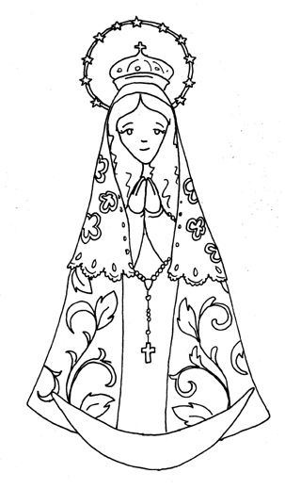
Mary said ‘yes’ to God to be the mother of His son. How can you say ‘yes’ to God? What could He be asking of you?
Blessed be her holy and Immaculate Conception.
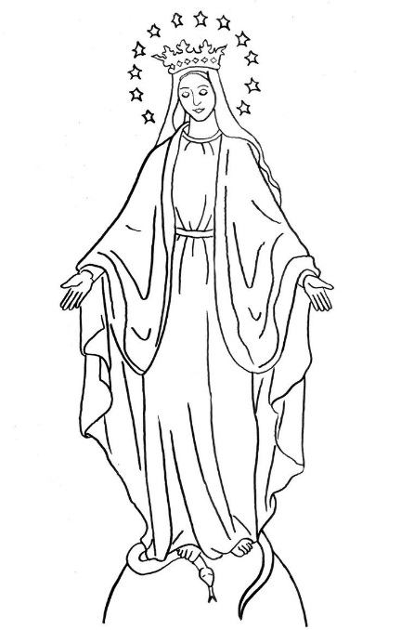
Mary was conceived without sin and lived a holy life. How can you follow her example?
Blessed be her glorious Assumption.
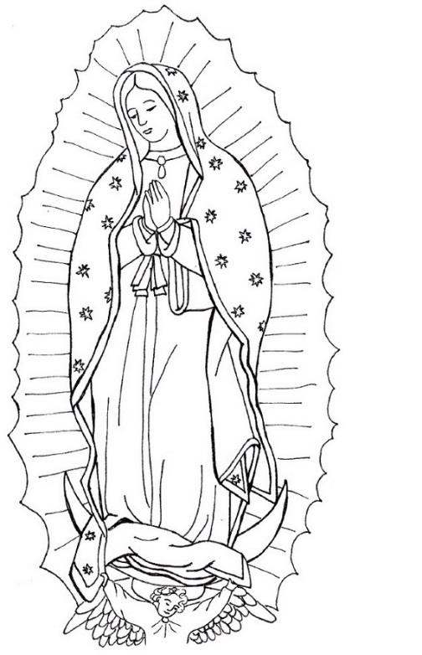
Blessed be the name of Mary, Virgin and Mother.
Mary is Queen of Heaven. What is your image of Heaven? How can you bring about Heaven on Earth?
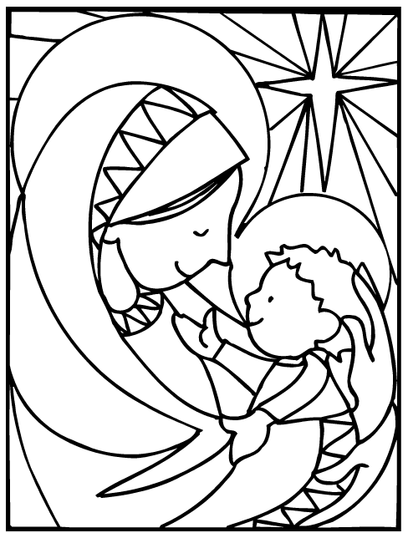
What names or descriptions do you have for Mary? Write the names or descriptions above and illustrate.
Blessed be St Joseph, her most chaste spouse.

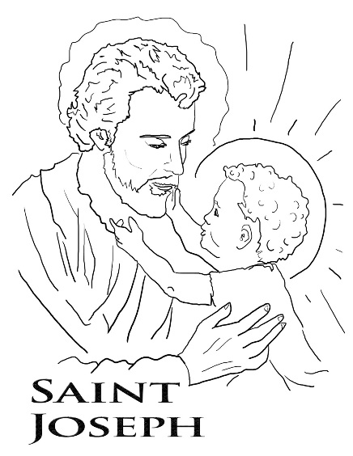

Joseph took great care of his family as God asked. How can you take care of your/God’s family?
Blessed be God in His angels
and in His saints.
We are called to be saints. Which saint do you admire most and why? How can you follow their example?

