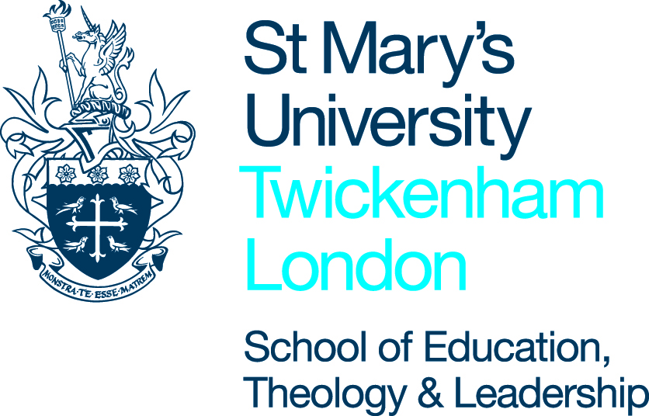
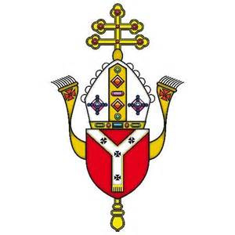
Science and the Catholic Faith –
Origins of the universe and Human Life

Lesson topic: Introduction to the unit.
Teacher |  | Date
Year |  | No. of students
Set/MA |  | Support staff

Learning objectives | - What are the Roles of Science and Faith?  - Is there a conflict between faith and science?
RECD: | Revelation: the Church’s teaching about faith (e.g. gift, virtue) and the place of reason in the search for God.
Meeting the individual needs of the students (details of students with SEN/G&T etc…)
Pre-supposed knowledge/ possible concepts/ misconceptions | Some knowledge of creationism and scientism though perhaps not by using those terms.  Some knowledge of the differing roles of faith and science.  There is a lot of discussion in this lesson – teacher should be facilitator rather than discussion being too teacher led.
Resources: | PowerPoint Lesson 1 introduction: the conflict between faith and science, workbook.

Sequence of learning activities | T& L activities | Differentiation: (planned stretching / simplifying activities  Reference to: SEN; G&T; underachievers; relevant dept target groups  (name students here) | Sign post for progress  (when is progress going to be assessed and how? What alternative activities are planned if students do not understand?)
Starter  5mins | Pupils read the statements in their booklets and tick them if they agree with them. Swap with a neighbour and discuss where they agree/ disagree? |  | Ticklist
Development  5mins  10 mins  10 mins  10 mins  5 mins  10 mins  10 mins  5 mins | Pupils read extract and consider what it implies about Christian attitudes about vaccinations.  Then ask the pupils to consider the other extracts and the problem with forming opinions based on evidence presented to you.  Introduce the 'golden thread'.  ‘Beware the golden thread’ this means that it is possible to find (a golden thread of) evidence to support a point of view (even when there is evidence to the contrary) and ignore other evidence in order to ‘prove’ your point. Pupils should be aware of this when considering evidence that is presented to support a point e.g. Christians are opposed to science.  Class complete written task on the problem with the golden thread.  Introduce the issue of conflict. Do they perceive there to be a conflict?  Class read the terms creationism and scientism – do they know examples of people who fit into these camps i.e. Richard Dawkins/ Sarah Palin.  Acknowledge the fact there is a conflict between scientism and creationism but there doesn’t have to be between science and faith.  Discuss the questions on the slide. Pupils can discuss in pairs and feedback or teacher can facilitate a class discussion - depending on class size.  Present the class with the thought experiment - Why is the kettle boiling?  Hear some answers to  - Which answer is more right?  - Why ?  - Can they both be correct?  and then share the answers with the class.  Ensure they understand the analogy –  Answer in groups/ pairs question about the McGrath quote  - what does this suggest about the roles of science and faith?  Class read the aquarium analogy.  Think-pair-share class what they think Mary Midgleley meant in the aquarium analogy. Do they agree?  Read and discuss the McGrath explanation. Do they agree?  Class complete written task on the conflict between faith and science in their booklets  reflection – class reflect on the pale blue dot | Throughout the lesson some pupils might require more assistance in understanding the issues/ examples.  Some pupils might require more guidance in answering the written task – e.g. a writing frame  Perhaps reduce the number of questions depending on the ability of the class/ pairs.  Differentiate by giving lower ability students easier questions to consider.  Winterson Q is most difficult. | Written task  Examples of people who fit in each camp.  Discussion and feedback  Discussion and feedback  Discussion and feedback  Think pair share feedback  Written task which can form part of the assessment

Assessment opportunities and homework
Discussion tasks
Written task on golden thread.
Written task on conflict/ relationship between science and faith.

Opportunities for SMSC
Opportunities to discuss the relationship between faith and science and the role of faith in understanding the world.
Opportunities to discuss/ complete work on human beings are spiritual beings and there is a dimension to humans that is not easily explained by science.
Refection on the pale blue dot.

