
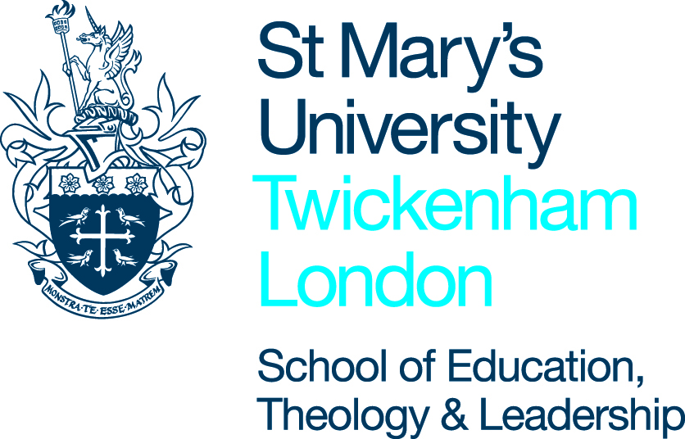
Science and theCatholic Faith –
Origins of the universe and Human Life

Lesson topic: Existence: Contingent and Necessary Existence
Teacher |  | Date
Year |  | No. of students
Set/MA |  | Support staff

Learning objectives
RECD: | Science and Religion: Existence of the universe and the argument from contingency.
Meeting the individual needs of the students (details of students with SEN/G&T etc…)
Pre-supposed knowledge/ possible concepts/ misconceptions | Students will already have basic knowledge of some scientific theories for the origins of the universe including the Big Bang theory. They will also have looked at the argument from causation at GCSE so will have some understanding of the Cosmological argument.
Resources: | Power point presentation, links to TED Talk & Scientific answers to the question of the universes contingency.

Sequence of learning activities | T& L activities | Differentiation: (planned stretching / simplifying activities  Reference to: SEN; G&T; underachievers; relevant dept target groups  (name students here) | Sign post for progress  (when is progress going to be assessed and how? What alternative activities are planned if students do not understand?)
Starter | Put up first slide…on a post it note get students to write down their initial response to the question without discussion. (They could answer the question again at the end of the lesson, as an exit ticket). |  | Potential change in answer from the start of the lesson to the end.
Development  (Break down the lesson into a variety of teaching activities that are both engaging and appropriate to the KS/level of the course.) | Consider the question ‘Why does the universe need an explanation?’ with students, get them to respond to the bullet points.  Look at the four key questions that come out of philosophical reasoning in search of an answer. (At this point you could show the TED talk, the link is a few slides on or explain contingent/necessary first).  Explain to students the difference between contingent and necessary things. Ask them to write down examples of both…Can they come up with something other than God for a necessary thing/being?  Get them to discuss the possibility of the universe being a necessary thing.  Watch the TED Talk (18mins long):  https://www.ted.com/talks/jim_holt_why_does_the_universe_exist?language=en  In light of this get students to look at the 3rd Way from Aquinas’ cosmological argument and consider the questions raised by Leibniz (why is there something rather than nothing).  Talk to students about the link between science and religion, that they are both searching for the same answer…‘what is the ultimate cause of our existence?’  Read the internet article on some of the answers to the question put forward by Science.  http://www.infoplease.com/cig/theories-universe/scientific-origins-universe.html  As an exit ticket ask students for their conclusions, have they changed their mind from the beginning of the lesson? |  | Written responses and or verbal responses to the questions posed.

Assessment opportunities and homework
Research the philosophical challenges to Aquinas’ 3rd why, including Hume and Russell. Can these also be challenges posed to science?

Opportunities for SMSC

