Q & A GUIDELINES
FOR CELEBRATING
SCHOOL MASSES

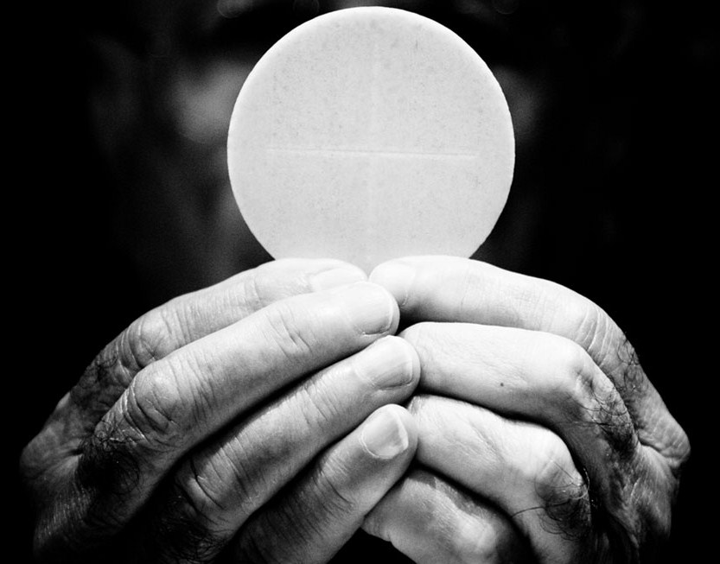

Diocese
Of
Westminster
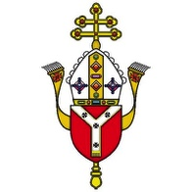

Introduction

- The celebration of the Mass is at the heart of Catholic life and worship. It is therefore important that assistance is given to those in our schools who are responsible for planning and preparing Eucharistic celebrations.

- These Question and Answer Guidelines have been written in response to requests for practical advice. They apply both to Masses celebrated in school and Masses for schools celebrated in diocesan churches and chapels.

- The Q & A Guidelines do not offer a complete treatise on celebrating the Eucharist, nor do they supersede any of the authoritative documents of the Church.

- These Q & A Guidelines address some important aspects of our Eucharistic celebrations. They seek to help those involved in planning and celebrating school Masses to be attentive to what the Church teaches and requires.

- The Guidelines are for use in primary and secondary phases.

- This document is a revised version of guidelines originally produced by the Diocese of Leeds. Credit must go to the then Bishop, Rt Rev Arthur Roche, and all those from the Diocese of Leeds who contributed to creating that resource.

Questions
Introduction 1
1. Why is it important to celebrate school Masses? 5
2. Should school Masses be any different from other Masses? 5
3. When should school Masses take place? 5
4. Where can a school Mass take place? 6
5. What are the responsibilities of the priest? 6
6. In what sense do children and students participate in school Masses? 7
7. What is needed for a school Mass? 7
8. What colours should be used for vestments, altar frontals and lectern covers? 8
9. What is the structure of the Mass? 8
A. THE INTRODUCTORY RITES 9
B. THE LITURGY OF THE WORD 9
C. THE LITURGY OF THE EUCHARIST 9
D. THE CONCLUDING RITES 9
10. What are the Introductory Rites? 9
11. What is the Entrance Procession? 10
12. What is the form of the Penitential Act? 10
13. What is the Gloria? 10
14. What is the Liturgy of the Word? 11
15. What readings should be used? 12
16. Which translation of the Scriptures should be used during school Masses? 12
17. What is the homily? 12
18. What is the Profession of Faith (the Creed)? 12
19. What is the Prayer of the Faithful (General Intercessions)? 13
20. What is the Liturgy of the Eucharist? 13
21. What is the Preparation of the altar and Procession and Presentation of the Gifts? 14
22. What is the Eucharistic Prayer? 14
23. What is the Communion Rite? 15
24. What is the Rite of Peace? 15
25. What is the Fraction (Breaking of the Bread) 16
26. What happens during Holy Communion? 16
27. What are the Concluding Rites? 17
28. What postures should be used during school Masses? 17
29. What place does singing have in school Masses? 18
30. How should drama, dance and presentation be used in school Masses? 18
31. How can non-Catholics be involved in Mass? 19
32. Do all students have to come forwards for a blessing at Communion? 19
33. Can non-Catholics read at Mass? 19
34. Can non-Catholics be altar servers? How old does someone need to be to serve? 19
35. Should all students be expected to bow or genuflect to altar/tabernacle? 19
36. What age do students need to be to attend a school Mass? 20
37. What age do students have to be to be an Extraordinary Minister of Holy Communion? 20
38. What needs to be included in a blessing if it is being written for a specific event? 20
39. What do you do if the priest will not allow female altar servers? 21
40. What should happen on feast days and Holy Days of Obligation? 21
41. What differences are there when it is a Bishop celebrating the Mass? 21
a) Holy Days of Obligation: 22
b) Feast Days: 22
c) Other useful documents: 23
d) Useful websites: 24

Why is it important to celebrate school Masses?

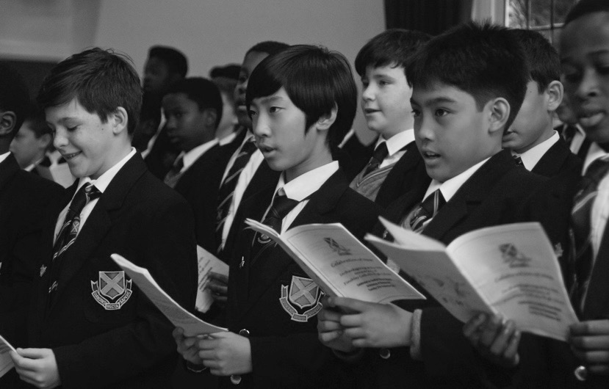
- “At the heart of the life of the Catholic Church has always been the celebration of the Eucharist, or the Mass, as Catholics often call it. Taking part in the Mass is the hallmark of the Catholic, central and crucial to our Catholic identity.” (Celebrating the Mass 1) This is true for Catholic schools.
- By this sacramental act we fulfil the command of the Lord Jesus to celebrate the Eucharist in memory of Him. The mystery of His saving death and resurrection is made present for us as the living Lord speaks through the Scriptures and gives Himself in the bread that becomes His Body and the wine that becomes His Blood. The purpose of every school Mass is to unite all present more closely to Christ, to deepen their love for him and for others.

Should school Masses be any different from other Masses?

- Each celebration of Mass with pupils should be “carefully prepared beforehand, especially with regard to the prayers, songs, readings, and intentions of the general intercessions.” Ideally, this preparation should include the pupils themselves. (DMC 29)
- Masses celebrated for schools, whether in school or in church, should have the normal structure and content as laid out in the Roman Missal. Apart from adaptations that are necessary because of the children's age, the result should not be markedly different from the Order of Mass celebrated with an adult congregation. (DMC 21)

When should school Masses take place?

- This will depend on local circumstances and the availability of priests. Some schools have weekly class Masses, others at set times during the term and year.
- The celebration of school Masses follows the Church’s liturgical calendar. Masses that are celebrated according to a particular theme can be integrated within specific seasons and feasts. For example, a Mass which takes ‘light’ as its theme would rightly be celebrated in Advent, the theme of ‘forgiveness’ in Lent, and the theme of’ joy’ in Eastertide.
- Feast days are celebrated more solemnly than weekday Masses and, where appropriate, schools may anticipate the celebration of feasts and solemnities which fall on Sunday.
- It is important to celebrate Masses in school according to the liturgical calendar and, whenever appropriate, to mark the feasts of saints.

Where can a school Mass take place?

- Any suitable space in the school can be used or a local church or chapel.
- There should be a recognisable altar/table, lectern (or ambo) and a presidential chair. Ideally these should only be used for the celebration of Mass.

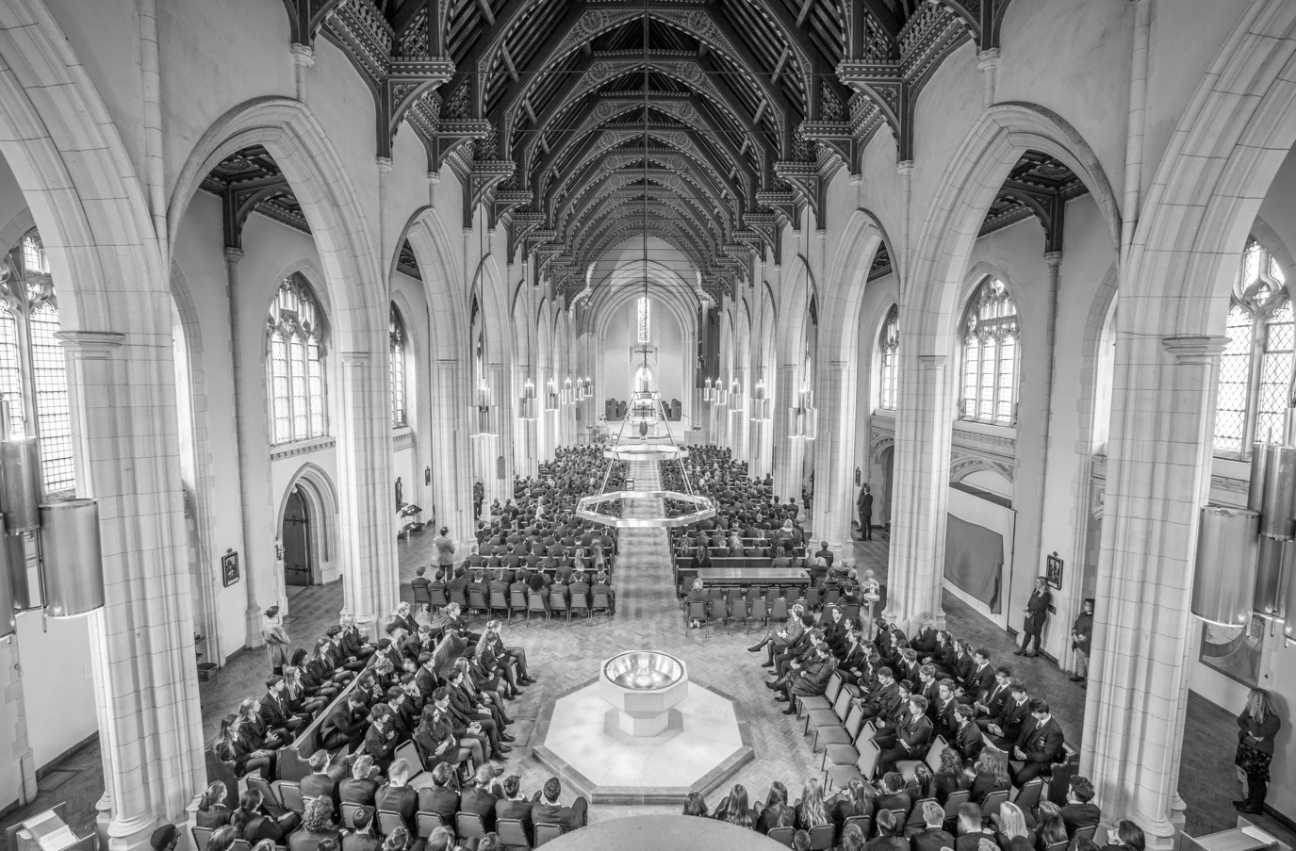

What are the responsibilities of the priest?

- The priest is to celebrate Mass in accord with the norms of the Church.
- The Mass should be prepared to enable this to happen, under the guidance of the priest.
- The celebration of school Masses requires a good working relationship between clergy and school staff.
- Preparing the liturgy with the celebrating priest in advance will help ensure there are no misunderstandings.
- The General Instruction on the Roman Missal presumes the choices are made by the priest, but with sensitivity to the circumstances of the congregation, and collaboratively with other ministers.
- In his celebration of the Mass, the priest should “be concerned above all about the dignity, clarity and simplicity of his actions and gestures,” making sure he is easily understood. (DMC 23).

In what sense do children and students participate in school Masses?

- The principles of active and conscious participation in the liturgy are important for Masses celebrated with children and students.
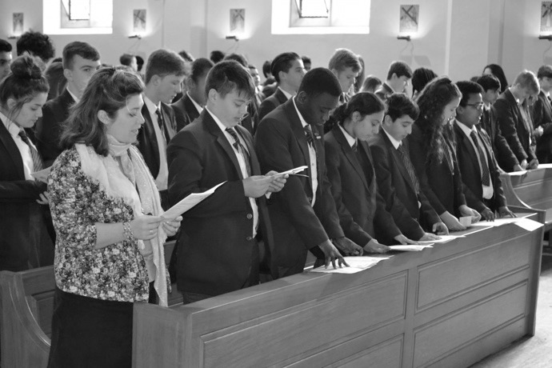
- Everyone is invited to participate spiritually and prayerfully.
- Children and students should also take up different specific roles, as appropriate, during the celebration – for example, serving, singing and music, reading, praying, and bringing up the gifts of bread and wine.
- Silence also has an important place and a value in enabling participation.

What is needed for a school Mass?

- The celebration of the Mass involves the use of all the senses: we hear the Word of God; we see the cross, the candles, the vestments; we smell the flowers and the incense; we may even touch the Sacred Host.
- There are various practical items needed for Mass: a corporal, a ciborium and altar breads, a chalice and wine, purificators, a Roman Missal, a Lectionary, jug of water, bowl, lavabo cloth, a small side table, altar cloth, candles, crucifix, vestments. At the beginning of Mass there should be a white altar cloth, candles and a crucifix on the altar. Further information can be found about this in handbooks for altar servers.
- The vessels, cloths, vestments, liturgical books, and other liturgical items, should be clean and of a good standard. Glass or earthenware vessels should not be used for the Sacrament itself. If a school does not possess these, arrangements should be made, perhaps with a local, parish for them to be borrowed when needed.

What colours should be used for vestments, altar frontals and lectern covers?

There are four liturgical colours:
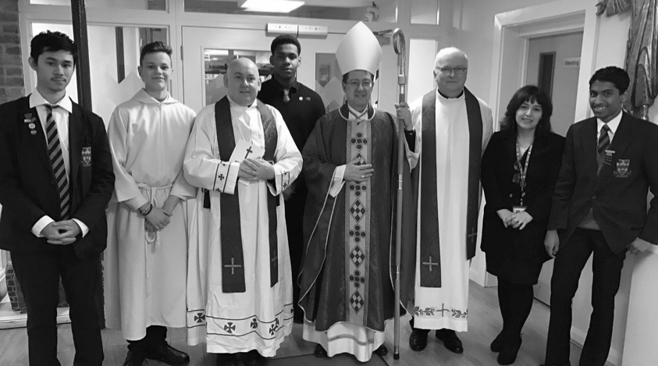
- White - used in the seasons of Easter and of Christmas; also on celebrations of the Lord (other than of his Passion), of the Blessed Virgin Mary, of the Holy Angels, and of Saints who were not Martyrs; on the solemnities of Trinity Sunday, All Saints (1 November) and of the Nativity of Saint John the Baptist (24 June); and on the feasts of Saint John the Evangelist (27 December), of the Chair of Saint Peter (22 February), and of the Conversion of Saint Paul (25 January). It may, in England & Wales, be used for Funerals.
- Red - used on Palm Sunday of the Lord’s Passion and Good Friday, on Pentecost Sunday, on celebrations of the Lord’s Passion, on feasts of the Apostles and Evangelists, and on celebrations of martyred Saints.
- Green - used in Ordinary Time.
- Purple - used in the seasons of Advent and of Lent and for reconciliation. It may also be worn for Funerals.
- On solemn festive days more precious, sacred vestments may be used, even if not of the colour of the day.

What is the structure of the Mass?

- The Mass is a unified celebration which has four parts: a beginning and an end and two central pillars, the Liturgy of the Word and the Liturgy of the Eucharist. This forms one act of worship and the structure of the Mass should always be maintained.

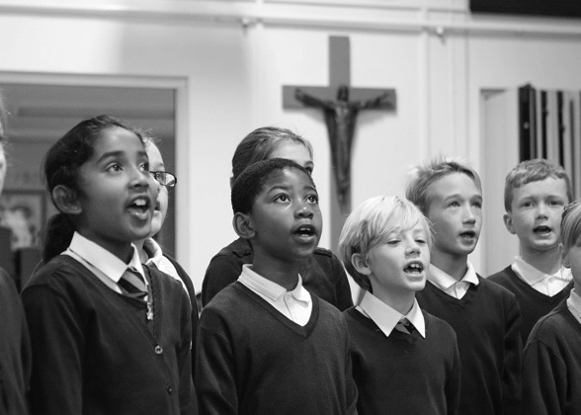
A. THE INTRODUCTORY RITES

Sign of the cross
Penitential Act – when we pray for God’s mercy
(Gloria - a song of praise, used on Holy Days of Obligation and feast days, see Appendix for a list)

B. THE LITURGY OF THE WORD

First Reading - from the Old or New Testament
Responsorial Psalm - a Psalm from the Old Testament
(Second Reading from the New Testament is included during Sunday Mass)
Gospel Acclamation - to prepare for the Gospel
Gospel Reading from St Matthew, St Mark, St Luke or St John
Homily - a short address on the Scriptures
(Creed - a statement of what we believe, used on Holy Days of Obligation, see Appendix for a list)
Prayer of the Faithful - a communal prayer for different needs

C. THE LITURGY OF THE EUCHARIST

Preparation of the altar & the gifts - the bread & wine
Eucharistic Prayer - including the words of Jesus
Lord’s Prayer - the Our Father
Sign of Peace - offering a gesture of peace to others
The Fraction - Breaking of the Bread
Communion - distribution of Christ’s body and blood

D. THE CONCLUDING RITES

Blessing
Dismissal - sending out

What are the Introductory Rites?

- Ordinarily the congregation stands from the beginning of the Mass until after the Collect (Opening Prayer). These are the Introductory Rites.

What is the Entrance Procession?

- The Mass begins with the opening song and the entrance procession.
- The procession may include altar servers, carrying cross and candles, and readers.
- This procession is the fitting place to bring forward any objects or symbols representing the particular celebration or assembly of people gathered. Their significance may be explained before Mass begins. These objects can be placed near the altar.
- Where appropriate, incense may be used in school Masses and can be part of the procession.

What is the form of the Penitential Act?

- This should follow one of those set out in the Roman Missal: the “I confess…”, or the format “Have mercy on us, O Lord…” or the three-fold format “Lord, have mercy – Christ, have mercy – Lord, have mercy.”
- The Rite for the Blessing and Sprinkling of Water can also take the place of the Penitential Act (see Appendix II of the Roman Missal).
- Where the threefold format is used, this is essentially a prayer of praise for God’s mercy and should not have the form of an examination of conscience. For example, this should not begin: ‘Lord, for the times we have…..’ or ‘Lord, when we are…...’ Rather, it should be focused on Christ and should follow the pattern of the Roman Missal: For example: You were sent to heal the contrite of heart: Lord, have mercy; You came to call sinners: Christ have mercy; You are seated at the right hand of the Father to intercede for us: Lord, have mercy. (See Appendix VI of the Roman Missal for further examples).

What is the Gloria?

- The Gloria is a song, a hymn of praise to God.
- It is used on feast days, solemnities, Holy Days of Obligations and Sundays (except in Lent). The Roman Missal will indicate when the Gloria should be used.
- It is preferable for it to be sung.
- It is not used in ordinary weekday Masses.

What is the Liturgy of the Word?

- The Scripture readings of the Liturgy of the Word should follow this pattern:

Where there are two readings before the Gospel –

  - First Reading (Old Testament or Acts of the Apostles in Eastertide)
  - Psalm
  - Second Reading (New Testament other than a Gospel, or Acts of the Apostles in Eastertide)
  - Gospel Acclamation
  - Gospel

Where there is one reading before the Gospel –

- Reading (Old Testament or New Testament other than a Gospel)
- Psalm
- Gospel Acclamation
- Gospel

- Ordinarily the congregation is seated for the Scripture reading or readings, then stands for the Gospel Acclamation and the Gospel reading, and sits for the homily. Where possible the Psalm and the Gospel Acclamation should be sung.
- The Scripture readings may not be substituted with any other readings, whatever their source.
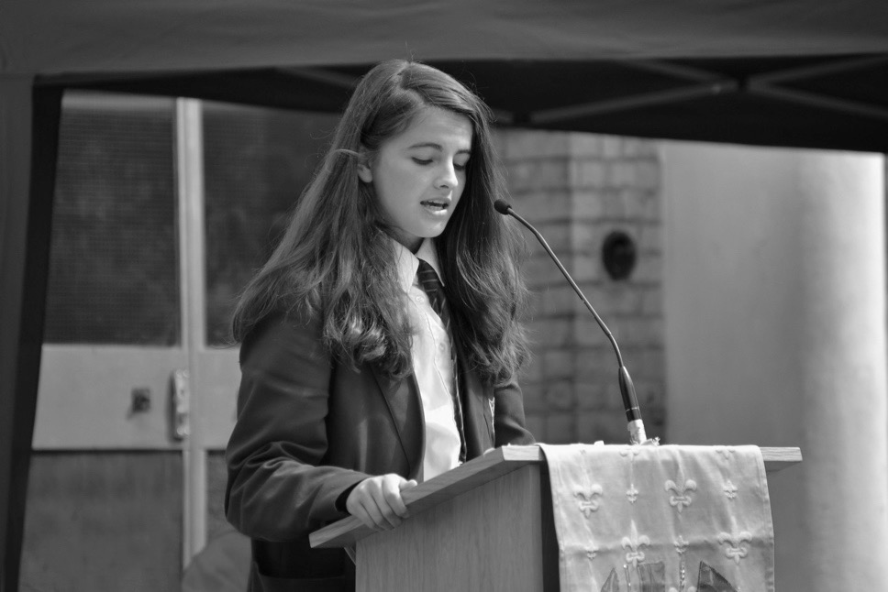
- Introductory comments may precede the readings and help the children to listen better and more fruitfully, either by explaining the context or by introducing the text itself.
- When the text of the readings lends itself, it may be helpful to have the children read it with parts distributed among them.
- The proclamation of the Gospel is reserved to a deacon, if present, or to the priest.

What readings should be used?

- School Masses should, wherever possible, follow the cycle of readings in the Lectionary.
- If it is a special celebration, such as a feast day or anniversary, or the start or end of year, any suitable readings can be taken from the lectionary.
- Any texts (whether spoken or sung) using the Hebrew Tetragrammaton YHWH (Yahew or Jehovah) are highly offensive to people of the Jewish Faith. This name is not to be read, sung or prayed in the liturgy.

Which translation of the Scriptures should be used during school Masses?

- The current Lectionary for all Masses in England and Wales uses the Jerusalem Bible translation of the Scriptures and the Grail Psalter.
- It is also permissible to use properly approved lectionaries for Masses with children which have more appropriate language for younger aged pupils.
- For more information see:
www.liturgyoffice.org.uk/Resources/Scripture/Versions.shtml/

What is the homily?

- The homily, sometimes called a sermon, explains the word of God and should be given prominence. This may take the form of a dialogue with the children.
- The homily during Mass should only be delivered by an ordained minister, a bishop, priest or deacon.

What is the Profession of Faith (the Creed)?

- The Profession of Faith, also called the Creed, is the summary of Christian faith. It has a longer form (the Nicene Creed) and a shorter form (the Apostles’ Creed). These can be found in the Roman Missal.
- The Profession of Faith is used on Sundays, Holy Days of Obligation and solemnities. It is not used during ordinary weekday Masses or on feasts. The Roman Missal will indicate when the Profession of Faith should be used.
- When the Profession of Faith does occurs in the liturgy, the shorter Apostles’ Creed may be used in school.
- Ordinarily the congregation stands for the Creed which is a solemn act of proclaiming our faith.

What is the Prayer of the Faithful (General Intercessions)?

- The form of this prayer is a petition rather than thanksgiving or praise to God. The number of prayers should not be excessive and the response should be appropriate and memorable. Ordinarily the congregation stands for this.
- The petitions express the intentions of the community gathered in prayer. They should not begin, “Dear God, we pray for…” or “Lord Jesus, thank you for…” but rather “Let us pray for…” or simply “For...”
- After the intention is announced we give prayerful assent through the response. There are a variety of possible responses, for example: Lord in your mercy – hear our prayer; We pray to the Lord – Lord hear our prayer; Lord hear us – Lord graciously hear us. Other examples can be found in the Appendix of the Roman Missal I & IV.
- The General Instruction of the Roman Missal identifies four intentions as general guidance for the Prayer of the Faithful: 1. for the needs of the Church; 2. for public authorities and the salvation of the whole world; 3. for those burdened by any kind of difficulty; 4. for the local community.
- These intentions may be shaped to reflect more closely the particular needs of the community or occasion.
- The Prayer of the Faithful is introduced simply and concluded in prayer by the celebrant.
- At the end of the intentions, before the celebrant concludes, it is customary in England and Wales to say the ‘Hail Mary.’
- The Prayer of the Faithful concludes the Liturgy of the Word and the Liturgy of the Eucharist begins with the Preparation of the Gifts.

What is the Liturgy of the Eucharist?

- The Catechism of the Catholic Church teaches: “The liturgy of the Word and liturgy of the Eucharist together form ‘one single act of worship.’ The Eucharistic table set for us is the table both of the Word of God and of the Body of the Lord.” (CCC 1346)
- “The Church’s Eucharist, in all its rich variety of forms and traditions, has always retained this basic shape: the taking of the elements of bread and wine in the preparation of the gifts, the act of thanksgiving in the Eucharistic Prayer, the Breaking of the Bread, the giving and sharing of the Body and Blood of Christ in Communion.” (CTM 174)

What is the Preparation of the Altar and Procession and Presentation of the Gifts?

- The congregation is seated during the preparation of the gifts. “The purpose of this rite, then, is to prepare the altar, the gifts which are placed on it, and the assembly ready for the Eucharistic offering which is to follow.” (CTM 177)
- During the Preparation of the Gifts instrumental music may be played, the choir may sing or silence may be kept.
- Where possible, altar servers assist the priest in bringing the items needed for the celebration of Mass to the altar. This includes the Roman Missal and the sacred vessels.
- Sufficient altar breads and wine for the celebration are prepared before the beginning of Mass. These should be placed on a table by themselves at the place from where they are to be brought in procession
- The gifts of bread and wine are brought to the priest by members of the congregation.
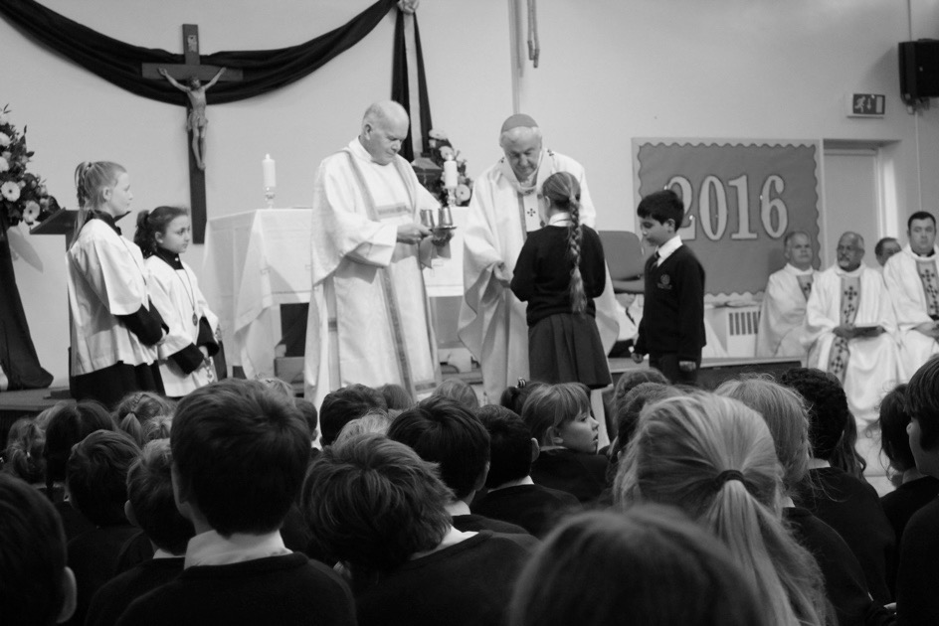
- Any items that symbolise the particular work or identity of the congregation or the occasion for the celebration are best brought to the sanctuary as part of the entrance procession and displayed near the altar or other suitable place. They should not be brought in the procession with the gifts of bread and wine.
- The point of the Procession of Gifts is to bring forward what is to be offered to God in the celebration of the Eucharist or gifts to be given to help the poor or the Church.
- The priest, having received the gifts of bread and wine, offers them to God the Father and then places them on the altar.

What is the Eucharistic Prayer?

- The celebrant may choose one of the Eucharistic Prayers found in the Roman Missal or one of those for Masses with Children: “The three prayers use different levels of language. Prayer I may be more suitable for those only recently introduced to the Eucharist. Prayers II and III may be more appropriate as children grow in sacramental awareness and in familiarity with the Eucharistic liturgy.” (CTM 188)
- In Masses with older children one of those for Masses of Reconciliation or those of Masses for Various Needs and Occasions may also be chosen.
- The Eucharistic Prayer begins with the Preface which is introduced by the Dialogue and ends with the Holy, Holy, Holy (the Sanctus) which should be sung if possible
- After the words of Institution in the Eucharistic Prayer - where the priest, taking separately the elements of bread and wine, repeats the words of Jesus from the Last Supper – and the elevation, there follows the Memorial Acclamation.
- As seen in the Roman Missal, all of these Acclamations are either proclamations of the death and resurrection of Christ or affirmations of this great mystery. The Paschal Mystery, His dying and rising, is the primary focus of the prayer.
- The text for the Memorial Acclamation should be one of the three available in the Roman Missal. Wherever possible, it should be sung.
- At the end of the Eucharistic Prayer the priest again elevates the Body and Blood of Christ and says or sings the Doxology which concludes with the Great Amen

What is the Communion Rite?

- When the Eucharistic Prayer has ended, the Lord’s Prayer, the breaking of bread, and the invitation to communion, follow on as the Communion Rite.

What is the Rite of Peace?

- It is the peace of Christ which is exchanged with those immediately around them (CTM 204). Care should be taken that the exchange of the sign of peace does not become disruptive.
- “The sign of peace - in England & Wales customarily a handshake – is sufficiently strong and expressive not to need explanatory song and commentary.” (CTM 204)

What is the Fraction (Breaking of the Bread)

- During the Fraction, the Breaking of the Sacred Host, the Lamb of God (Agnus Dei) is sung or said.
- This is a litany-song intended to accompany the action of breaking and therefore may be prolonged by repetition, but not unduly extended.
- If in addition to the Sacred Host (the bread that has been consecrated and has become the Body of Christ) Holy Communion is also to be distributed to the congregation from the chalice (containing the Precious Blood, the wine that has become the Blood of Christ) then sufficient chalices should have been prepared in advance at the Preparation of the Gifts.
- Christ is present, whole and entire, in both the Sacred Host and the Precious Blood and we receive Holy Communion fully whether by means of the Sacred Host alone, or by means of the Sacred Host and the Precious Blood.
- It is not permitted to decant consecrated wine into other chalices.
- The judgement as to whether Holy Communion should be administered under both kinds (the Sacred Host and Precious Blood) at school Masses should be made in consultation with the celebrant and will depend on numbers and appropriate catechesis.

What happens during Holy Communion?

- The congregation completes the Eucharistic action by receiving Holy Communion.
- The decision as to whether to receive the Sacred Host, the Body of Christ, on the tongue or in the hand belongs to the individual child or young person and will have been discussed when they made their preparation for First Holy Communion.
- A bow of the head or other act of reverence should be made before receiving Holy Communion.
- Those receiving the Sacred Host should consume it immediately. The response before receiving the Eucharist is ‘Amen.’
- Proper preparation and catechesis is needed so that children and young people might receive the Eucharist respectfully and that those who are not receiving the Eucharist understand how to indicate they desire a blessing.
- Those not receiving Communion may come forward for a blessing by joining the procession and crossing their hands in front of their chest. This may not always be feasible where there are whole classes of children who have not yet made their First Holy Communion.
- Trained and Commissioned extraordinary ministers of Holy Communion may assist with the distribution of the Eucharist where there are not sufficient clergy at any particular celebration.
- Extraordinary ministers of Holy Communion should not respond to those coming forward for a blessing by holding up the Sacred Host and tracing the sign of the cross while speaking a blessing using the formula of the Trinity. Neither should they give any blessing by making the sign of the cross with their hand invoking the Trinity. If someone approaches a lay minister who is distributing the Sacred Host, but indicates they wish to receive a blessing, the lay minister may extend a hand towards the person with these or similar appropriate words ‘May the Lord Jesus bless you.’ Sensitivity and understanding should be shown towards children of other religions who may come forward for a blessing.
- Music during the distribution of Holy Communion music “should be suited to the mystery being celebrated, the part of the Mass, the liturgical season or the day.” (CTM 213) There may also be a moment of silence.
- Any Hosts that are not consumed must be returned to the tabernacle. If the Mass is celebrated in a school where there is no tabernacle, provision must have been made in advance, in consultation with the priest, for the dignified and reverent transfer of the Hosts to a nearby church. Any school which does have a tabernacle should ensure that the Blessed Sacrament is regularly renewed.
- After Holy Communion is finished the vessels are purified immediately or may be purified afterwards.
- The priest then brings the Communion Rite to a close with the Prayer after Communion.

What are the Concluding Rites?

- These are the blessing and dismissal. The purpose is to send people forth to put into effect in their daily lives what they have celebrated in the liturgy.
- The form of the blessing should be taken from the Roman Missal.
- After the blessing and dismissal, the priest and any other servers leave the sanctuary or altar in procession.
- There may be a concluding hymn or instrumental music

What postures should be used during school Masses?

- The different postures adopted during Mass (standing, sitting, kneeling and bowing) reflect the different significances of what is taking place.
- Where possible, school Masses should follow the pattern of posture used in parish churches, although there may need to be some adaptation according to the circumstances of the celebration and the nature of the school environment.

What place does singing have in school Masses?
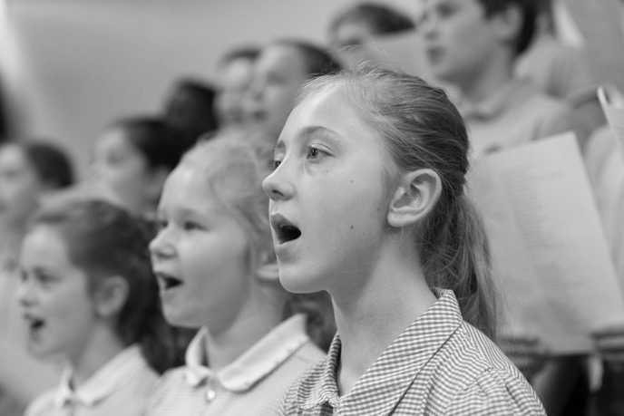
- Singing has great importance in Masses celebrated with children, with a choir to support the congregation if appropriate.
- The music for the Mass should be sympathetic to the liturgy and balance should be sought with the richness of our Catholic musical heritage.
- It is especially fitting that the acclamations of the Mass be sung, particularly those that form part of the Eucharistic Prayer (DMC 30).
- For guidance about which parts of the Mass should be sung according the nature of the celebration please see the Music Committee of the Bishops’ Conference of England and Wales leaflet ‘Singing the Mass.’
- Some musical settings of the Mass are commonly used in parishes across the Diocese and these could usefully also be learned and sung in school Masses.

How should drama, dance and presentation be used in school Masses?

- Drama and dance do not have an automatic place within the celebration of the Eucharist. A dramatic presentation of a scripture reading, however, could take place before the Mass begins as a means of preparation. Similarly, dance might also precede the beginning of Mass or follow the end of the Mass by way of thanksgiving.
- Any presentations after Holy Communion should enhance the spirit of prayerful reflection. PowerPoint celebrations of class or year groups, or events in the life of the school, are better placed at the end of the celebration of Mass.
- Without overshadowing the liturgy, PowerPoint displays, used respectfully and with discretion, may assist the congregation in making liturgical responses and in singing.

How can non-Catholics be involved in Mass?

- They can learn to listen to and engage with the prayers and the Scriptures
- They can assist with music and song
- They can help with the preparation of the liturgical space
- They might be part of a group considering Mass intention/themes for Prayer of the Faithful
- They can come forward for a blessing

Do all students have to come forwards for a blessing at Communion?

- No. The encouragement is for the ‘blessing’ to be more a simple prayer for the person concerned rather than a blessing. Good practice is to ensure all ministers including clergy observe the same form.

Can non-Catholics read at Mass?

- The Ecumenical Directory (133) states that only a Catholic should read the scriptures during a Eucharistic celebration. The Bishop may give permission in exceptional circumstances.
- Ministers of the Word are expected to be of the Catholic faith.

Can non-Catholics be altar servers? How old does someone need to be to serve?
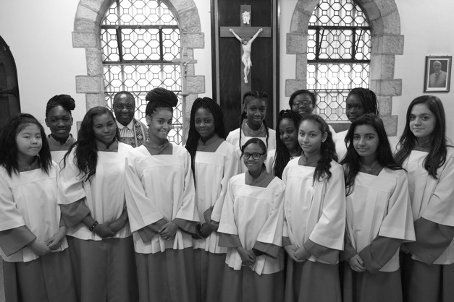
- Anyone assisting in so central a place should be a Catholic.
- It is common practice to invite people to prepare to be altar servers after they have made the first Holy Communion.

Should all students be expected to bow or genuflect to altar/tabernacle?

- Many non-Catholics would do this as a sign of respect for Catholic faith and for Catholics.
- However some would object as a matter of religious principle, and this objection should be respected.

What age do students need to be to attend a school Mass?

- There is no minimum age. What is likely to be helpful is a matter of judgment and will often depend on local circumstances.
- This consideration applies especially to nursery and early years children.

What age do students have to be to be an Extraordinary Minister of Holy Communion?

- This will depend on the circumstances in consultation with local clergy.
- Any Extraordinary Minster should have celebrated Confirmation and Eucharist and received the appropriate training and commissioning.

What needs to be included in a blessing if it is being written for a specific event?
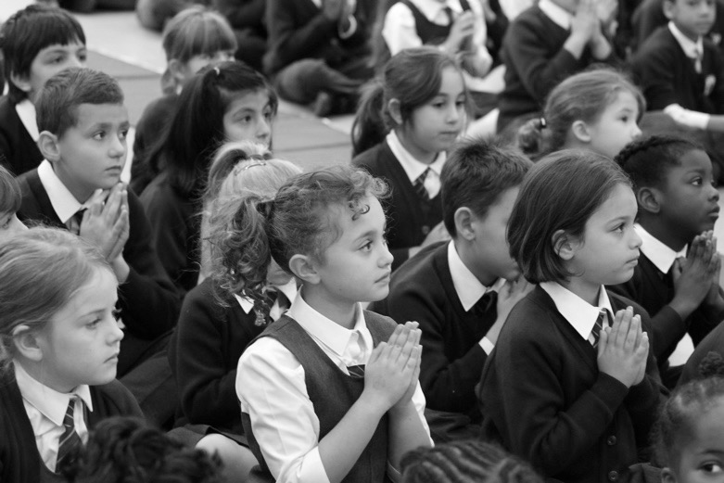
- Blessings during the Mass should come from the Roman Missal
- Outside of Mass the Book of Blessings provides texts for many different settings.
- If something does need to be composed, it could follow the structure of the Collect: Begin by addressing God or naming God (e.g. God and Father of new beginnings); then name who God is for us (e.g. You are our strength and hope); then we ask God to bless us or to do something (e.g. Be with us as we journey together this year); we end praying to God in and through Christ (e.g. Through Christ our Lord Amen).
- Prayers are addressed to the Father, through the Son, in the Holy Spirit.

What do you do if the priest will not allow female altar servers?

- No one has a right to serve – male or female. However, there is no liturgical reason for excluding girls from the ministry in school Masses.

What should happen on feast days and Holy Days of Obligation?

- Feast days and Holy Days of Obligation should be marked as best as possible in school, but it may not always be feasible to have a celebration of Mass or Masses depending on the availability of priests.
- The obligation on Holy Days is for Catholics to attend Mass, not for schools to provide Mass. There is the opportunity of attending evening parish Masses.
- If necessary, feasts may be anticipated or celebrated after the day itself.

What differences are there when it is a Bishop celebrating the Mass?

- The Bishop will usually bring his mitre and crozier and it is helpful to have two additional servers to assist with these.
- These servers walk behind the Bishop in the procession and may wear vimpae, special scarfs which the Bishop will bring with him.
- As the Bishop arrives at the altar he will pass the crozier and mitre to these servers who can take them to the side
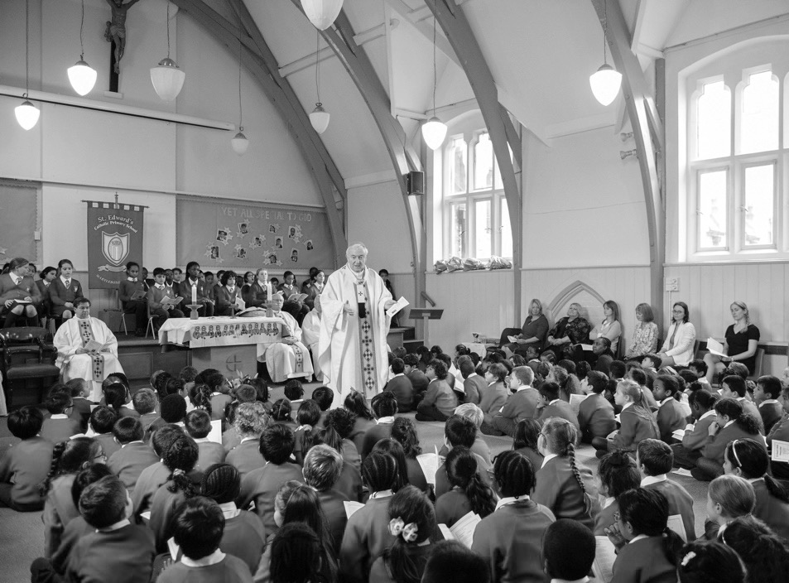
- The text of the Mass is as normal apart from the Bishop’s greeting at the beginning of Mass, after the Sign of the Cross, is ‘Peace be with you – and with your spirit.’
- The Bishop will usually wear his mitre for the first reading and psalm (and if there is one, the second reading). This can be brought to him by the server.

- During the Gospel Acclamation, the Bishop may bless the deacon or priest who is to read the Gospel. Then he will remove his mitre – which the server can take away – and receive the crozier which the other server will bring.
- After the Gospel the server will need to take the crozier to the side.
- The Bishop may preach the homily using the mitre and the crozier and this can be clarified before Mass.
- The Bishop may wear the mitre to receive the gifts during the offertory procession.
- After communion, the servers should bring the bowl, water and cloth so that the Bishop may purify his fingers.
- The Bishop needs the mitre and crozier for the final blessing.
- This Blessing may be a special one from the Roman Missal.

Appendix

Holy Days of Obligation:

The following is a list of Holy Days of obligation which may fall within the school week. Christmas Day, Easter Sunday, the Assumption (15th August) and every Sunday are also days of obligation when we are asked to be present at the celebration of Mass.

- Epiphany - 6th January
- Feast of the Ascension - 40 days after Easter
- Corpus Christi - the Thursday after Trinity Sunday
- St Peter and Paul - 29th June
- The Assumption - 15th August
- All Saints' Day - 1st November
- Christmas - 25th December

Feast Days:
Use - http://www.liturgyoffice.org.uk/Calendar/2017/index.shtml

Other useful documents:

These documents should be consulted in conjunction with these guidelines as they provide further information and clarification: (Please note in these documents, reference numbers relate to paragraph, not page numbers)

- The Catechism of the Catholic Church (CCC) provides an authoritative summary of the Church’s faith concerning the Eucharist.
- EDE - Ecclesia de Eucharistia (On the Eucharist and the Church) Encyclical Letter of Pope John Paul II (London: Catholic Truth Society, 2003). This explores the relationship between the Church and the Eucharist.
- CTM - Celebrating the Mass: A Pastoral Introduction, Catholic Bishops’ Conference of England and Wales (London: Catholic Truth Society, 2005)
- DMC - Directory for Masses with Children, Congregation for Divine Worship (1973)
- GIRM - General Instruction of the Roman Missal Catholic Bishops’ Conference of England and Wales (London: Catholic Truth Society, 2005)
- MS - Musicam Sacram (Instruction on Music in the Liturgy), Sacred Congregation of Rites (1967)
- RS - Redemptionis Sacramentum (On certain matters to be observed or to be avoided regarding the Most Holy Eucharist), Congregation for Divine Worship and Discipline of the Sacraments (London: Catholic Truth Society, 2004). This outlines various matters to be observed or avoided with respect to the Eucharist.
- The Directory for Masses with Children was written in 1973 by the Congregation for Divine Worship in Rome. It is concerned more explicitly with children of primary school age, although the general principles may also be carried forward to younger children at secondary school. This may especially be the case where the level of practice and faith understanding is low. The interpretation and application of the Directory’s principles will require the sensitive pastoral judgement and co-operation of clergy and school staff. The Directory acknowledges the Church’s concern for the spiritual wellbeing and development of children and young people (DMC 1), while at the same time recognising that parents may not always fulfil the religious obligations they undertook at their child’s baptism. (DMC 2) In this context, the liturgy has an important formative role in assisting the spiritual and catechetical progress of children, not least for those who do not regularly attend Sunday Mass. It is through the liturgy that the Church’s faith is expressed and embodied. By means of the Eucharistic celebration, the Church reaches out to young people to instruct and to bless them. (DMC 3)

Useful websites:
- https://liturgybrisbane.net.au/assets/How-to-prepare-a-school-mass-LabOra-Liturgy-Brisbane.pdf

