School Buildings – Capital Investment
Accessing and Completing the Online HPCF Proposal Submission Form
Applicable Diocesan Protocols (Capital Asset Management):
Capital Asset Management Includes: Planned and/or Reactive Maintenance (Condition), Adaptation of Existing Buildings (Suitability) and Increasing/Decreasing the Net Capacity by extending existing buildings, adding new buildings or demolishing buildings (Sufficiency).
De Minimis: £2,000.00. All Works to School Premises, with a forecast (or actual) value in excess of the de Minimis, are classified as Capital and subject to the protocols in this section.
Exceptions to the De Minimis Rule:
Statutory Compliance (Testing, Servicing and Maintenance) Contracts: Contracts of this type are deemed revenue expenditure. Payments in excess of the de Minimis are permitted, by the Trustees, for Works directly relating to the maintenance of existing Plant, Machinery and Systems. The flexibility afforded by this exception does not extend to the installation of new/updated plant, machinery and systems and all related works.
Protocol 4 | When considering Capital Works, the Occupier must comply with any Policies, Standing Orders and Financial Regulations issued by the Trustees relating to the Management, Financing and Procurement of Capital Works Projects. In addition, the Occupier is responsible for compliance with all legislation, regulation and Statutory Guidance relating to Health and Safety and Construction Design and Management (CDM).
Protocol 5 | The Occupier must adhere to all Diocesan Trust Policy relating to Capital Works that may be published from time to time. Policy Documents will be available directly from the appropriate Diocesan Service and published on the Diocesan Website. For advice on permissions needed for Capital Works please contact the Diocesan Education Service.
Protocol 8 | The Occupier must appoint a Trustee approved Specialist Building Consultant to advise and assist the Governors/Directors with all aspects of School maintenance, Statutory Compliance and Capital Works. Neither the Occupier, nor an employee of the Occupier may act as Principal Designer (CDM Regulations 2015) or undertake any of the roles and responsibilities properly assigned to a Specialist Buildings Consultant. The Occupier and their Employees are designated as “Clients” and must limit themselves to that specified role. The Diocesan Trustees commit to maintaining a list of competent professionals from which the Occupier will select their preferred Consultant.

Introduction:
In anticipation of the announcement of the 2019-2020 Health Schools Capital Fund (HPCF) the Education Commission is inviting all Catholic VA Schools in Westminster Diocese to submit a proposal for Matched Funding.
The deadline for this round of proposal submission is Friday 23rd November 2018.
Assessing the Online Form:
Please click here to access the form.
Completing the Form:
Page 1:
On this page, you are asked for provide school identification and associated information.
Important: You will need the 6 digit Unique Reference Number (URN) for your school in order to complete this form. Please do not attempt to use the 7 digit Local Authority/Establishment Number (i.e. 123/4567). The LAESTAB number has been superseded by the URN and the Education Service (DOWES) is using the URN for school identification purposes.
The first screen will look like this:
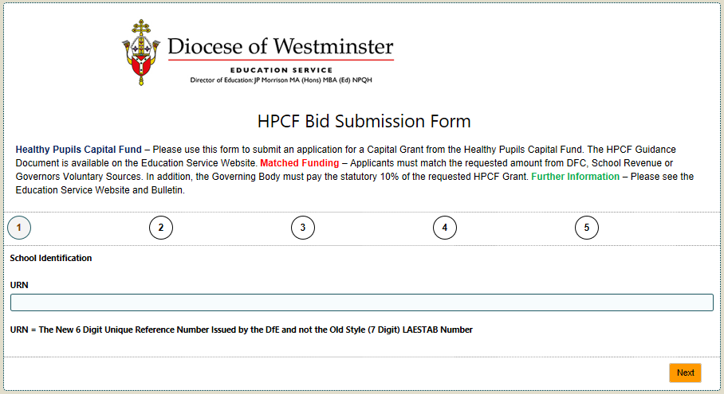
When you have entered the URN, the page opens completely and appears like this:
This Icon indicates a Lookup Field
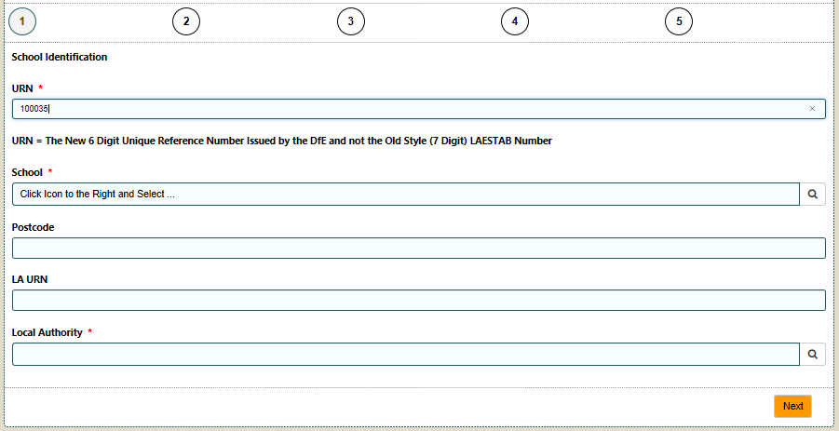
Close-Up of Lookup Icon

Click on the Lookup Icon to the right of the “School” Field. Details of the Target School should appear in a lookup table like this:
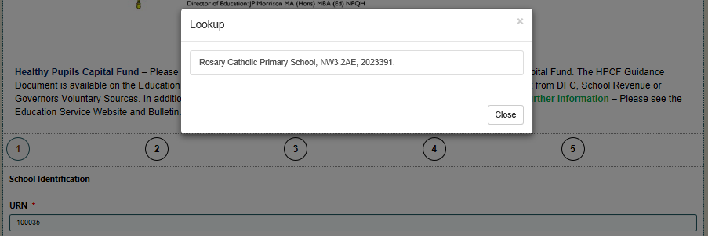
Click Here
Click (where indicated above) to select the school.
Important: If the name of the wrong school appears, or the Lookup Table is empty, please abandon the form and contact Nigel Spears on 07738183828 (leaving a voicemail message as necessary). Nigel will investigate the problem and confirm when the problem has been resolved.
The remainder of the required information (except for the name of your local authority) should automatically populate.
Example of populated Page 1:
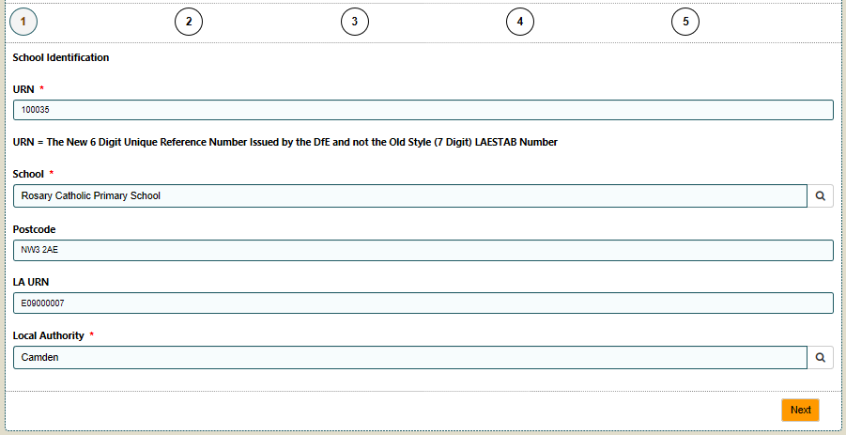
Click on the lookup icon to the right of “Local Authority” and select to confirm.
Click “Next” to move to the next page

Page 2:
On this page you are asked to identify the individual completing the form and supply (direct/personal) email addresses for the three designated principal contacts. The page looks like this:
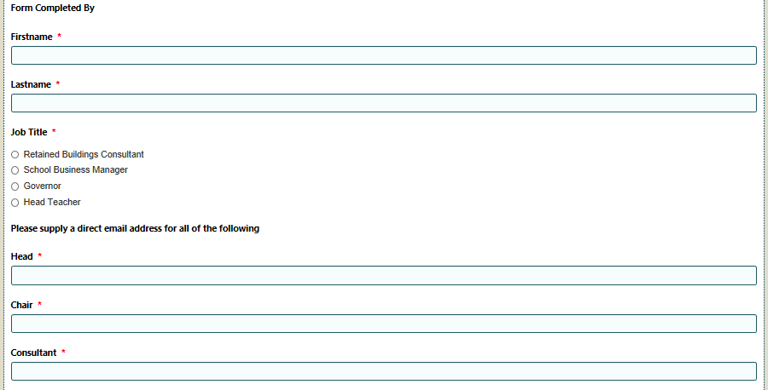
Page 3:
On Page 3, the Focus is the Proposed Works. The page appears like this:
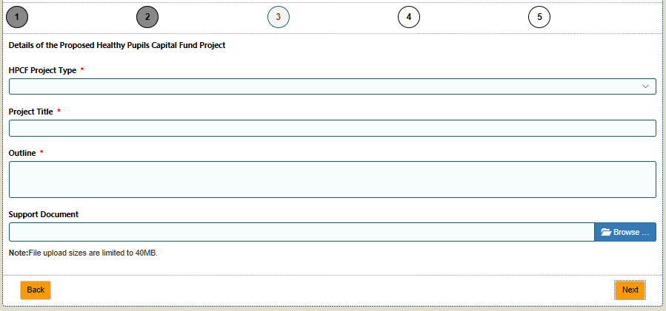
New Facility to Upload Document
Dropdown Field

The “HPCF Project Type” Field on this page is Dropdown. Clicking on the field will reveal the following list:
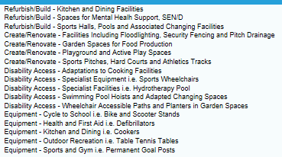
Please select the best match for the Proposed Works.
A Support Document (Max 2 Sides of A4) can be uploaded to this page. Click on Browse, find the appropriate file and select. Click on Upload to complete the process.
Page 4:
Please confirm the Diocesan Trust Approved Buildings Consultant retained by the Governing Body by selecting from the Dropdown list.
NB: The Retains Buildings Consultant will provide a basic plan and specification, tender the work, confirm contractor appointment and certify the completed works.

Page 5:
On the final page, the focus is cost. The page appears as follows:
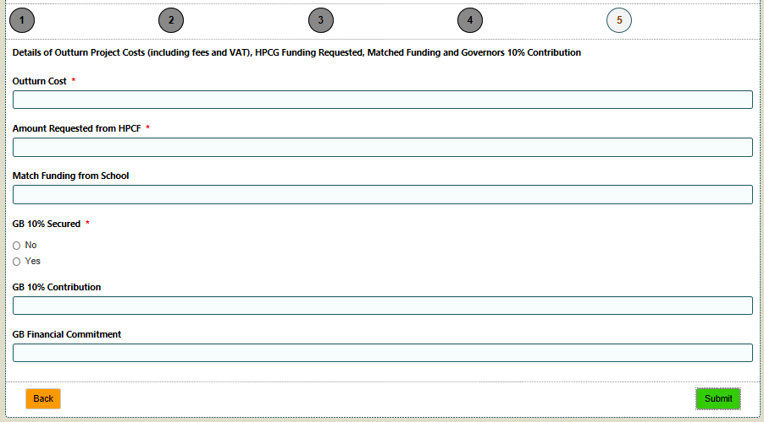
“Outturn Cost”, “Amount Requested from HPCF and “Matched Funding from School” Fields are formatted as “Decimal”. Please do not enter a currency symbol (£) or commas (,).
A monitory value of £123,456.78 must be entered as 123456.78

Further Support:
Please contact Nigel Spears (Assistant Director – Capital Strategy and Pupil Placement Planning)
Email: nigelspears@rcdow.org.uk
Mobile: 07738 183828

