Pupil Placement Planning (PPP)
Accessing and Completing the Online PPP – Registered Pupils Form
A Guide for School/Academy Based Colleagues
Applicable Diocesan Protocol:
School Place Planning (Protocol 2 - Data): To ensure that the Diocesan Bishop is able to fulfil his canonical responsibility, the Occupier must comply with the Diocesan Bishop’s directions to supply data relating to a) applications for admission (statutory admission rounds) and b) registered pupils.
Introduction:
This data collection process relates to part B of the protocol named above. On the designated enumeration day, schools and academies (State and Independent) are asked to submit “Postcode Area” data relating to every registered pupil (including Nursery and Sixth Form where applicable)
The designated Enumeration Day for 2018 is Thursday 4th October 2018. Changes in data that occur after this date are not reported.
The deadline for data submission is Friday 12th October 2018.
The collated data will be presented on the Education Service Website in this (or similar) format:
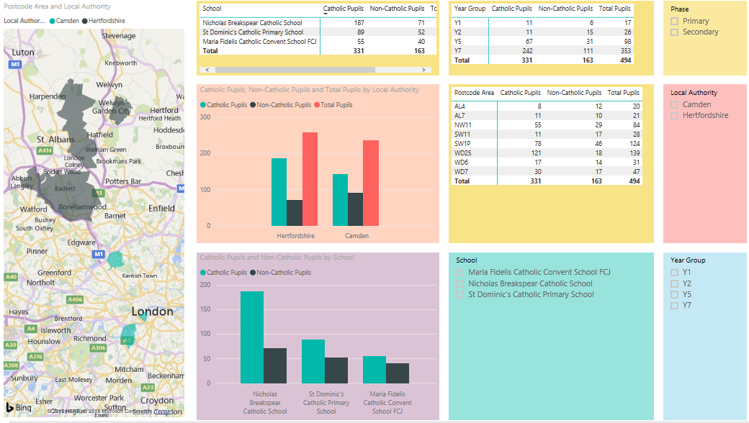

Assessing the Online Form:
Please click here to access the form.
Completing the Form:
Page 1:
On this page, you are asked for provide school identification and associated information.
Important: You will need the 6 digit Unique Reference Number (URN) for your school in order to complete this form. Please do not attempt to use the 7 digit Local Authority/Establishment Number (i.e. 123/4567). The LAESTAB number has been superseded by the URN and the Education Service (DOWES) is using the URN for school identification purposes.
The first screen will look like this:
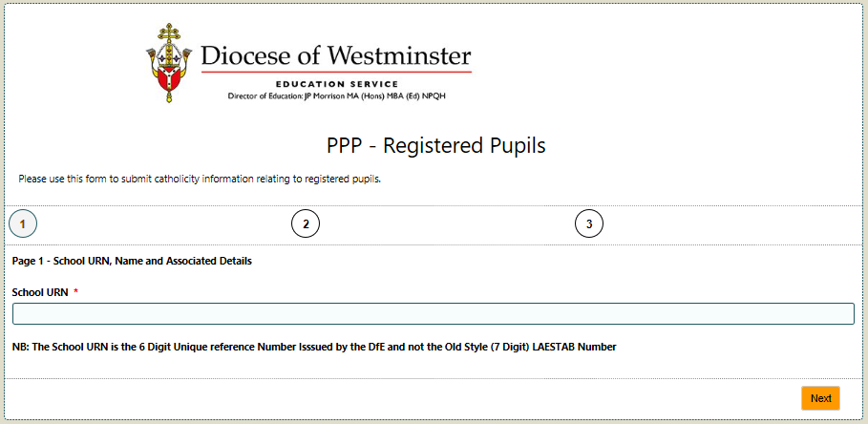
When you have entered the URN, the page opens completely and appears like this:
This Icon indicates a Lookup Field
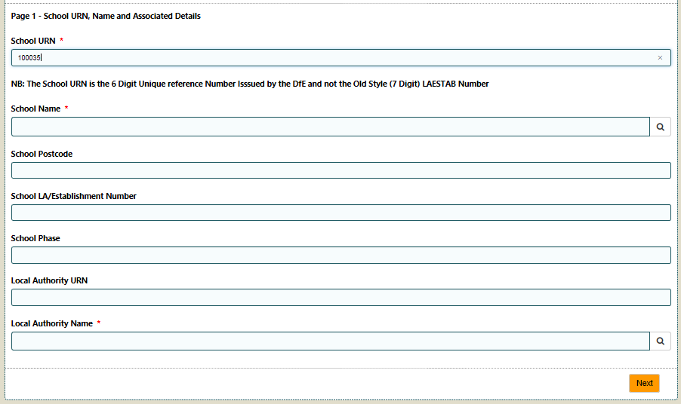
Close-Up of Lookup Icon | 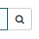

Click on the Lookup Icon to the right of the “School Name” Field and you should see the Name and Postcode of your School/Academy in a Lookup Table that appears like this:
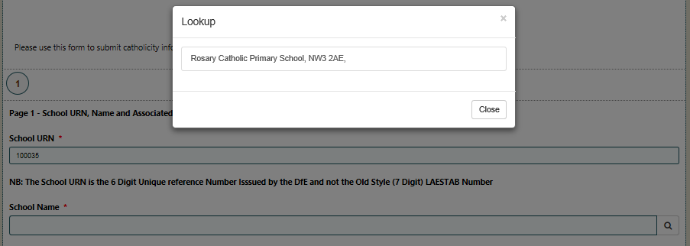
Click Here
Click on the name/postcode of your school to select.
Important: If the name of the wrong school appears, or the Lookup Table is empty, please abandon the form and contact Nigel Spears on 07738183828 (leaving a voicemail message as necessary). Nigel will investigate the problem and confirm when the problem has been resolved.
The remainder of the required information (except for the name of your local authority) should automatically populate.
Example of populated Page 1:
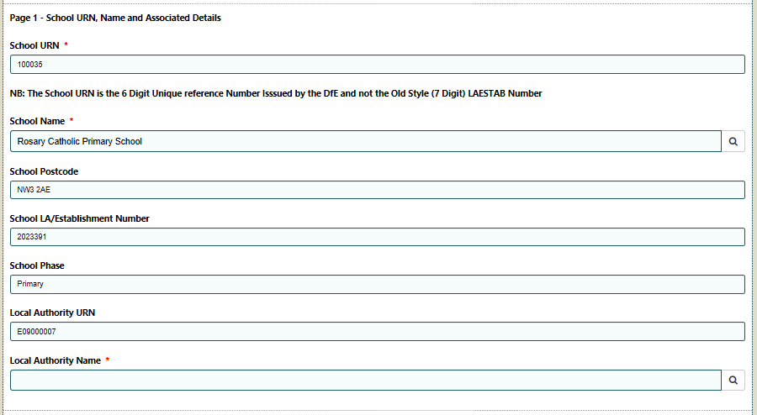
Click on the lookup icon to the right of “Local Authority Name” and select to confirm.
Click “Next” to move to page 2 | 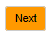

Page 2:
On this page you are asked to supply your contact details.
Important: Please ensure that you provide your designated school email address in order that we can contact you directly if there are any issues with your submission.

Page 3:
Upon opening, page 3 will appear like this:
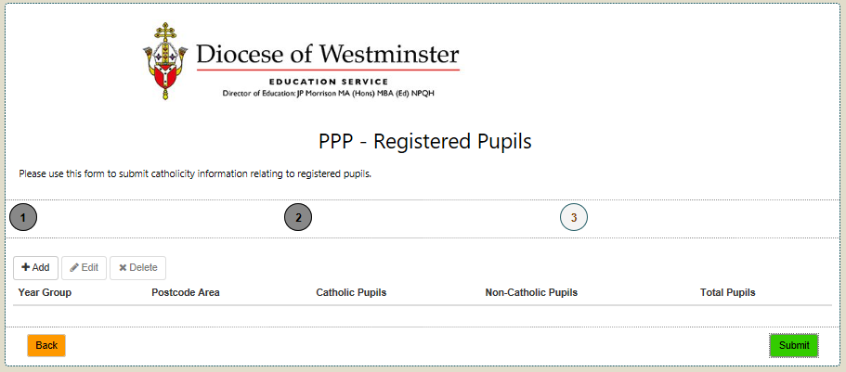
Click “+Add” Button to create a new record.
This is a repeating page and you will return to this page after you have entered the required data for each Year Group + Postcode Area.
Clicking the +ADD Button will open the following page:
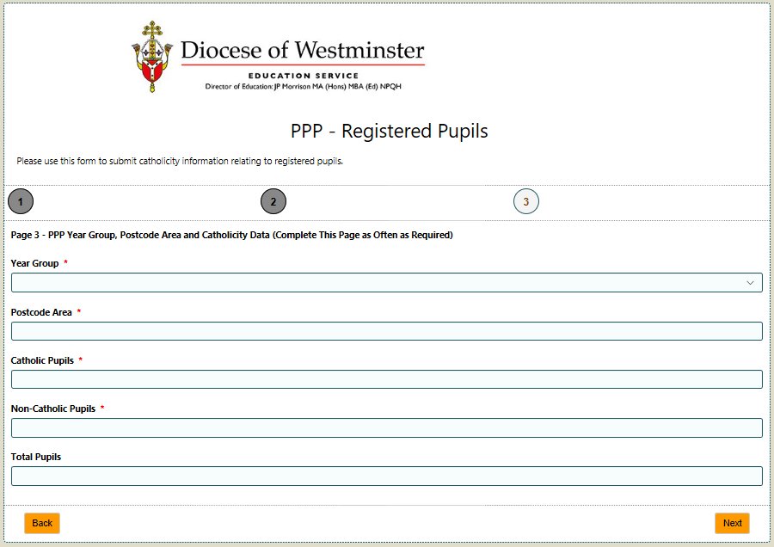
Postcode Areas (Of the Pupils and not the School):
In order to safeguard individual pupils, the Education Commission has decided to focus on a count of the pupils living in a Postcode Areas. This decision will necessitate some advanced preparation. A worked example is provided on the next page.

Postcode areas identified from the first 2 to 4 characters in a UK Postcode. In standard presentation, these are the characters that appear before the space: In the following example, postcode and postcode area are listed for comparison:
Postcode Area | Postcode | Catholic | Non-Catholic
E1 | E1 7AN | 0 | 1
E14 | E14 6NU | 0 | 1
E14 | E14 6RT | 1 | 0
E14 | E14 0AD | 0 | 1
E14 | E14 8DD | 1 | 0
E14 | E14 8DD | 0 | 1
E14 | E14 5SQ | 1 | 0
E14 | E14 7FP | 1 | 0
E14 | E14 6HS | 1 | 0
E14 | E14 6QP | 1 | 0
E14 | E14 0ND | 0 | 1
E14 | E14 6LQ | 0 | 1
E14 | E14 6JA | 0 | 1
E14 | E14 6QP | 0 | 1
E1W | E1W 3SE | 1 | 0
E3 | E3 4EX | 1 | 0
E3 | E3 5NA | 1 | 0
E3 | E3 5GJ | 1 | 0
E3 | E3 3NP | 1 | 0
E3 | E3 3FW | 1 | 0
E3 | E3 2LQ | 1 | 0
E3 | E3 3GS | 0 | 1
E3 | E3 3FX | 0 | 1
IG5 | IG5 0HA | 0 | 1
Total |  | 13 | 11

Having identified Postcode Areas, the next task is to count the number of Catholic and Non-Catholic Pupils live in each Postcode Area. Using the above data, the adjusted table would look like this:
Year Group | Postcode Area | Catholic | Non-Catholic | Total
Y2 | E1 | 0 | 1 | 1
Y2 | E14 | 6 | 7 | 13
Y2 | E1W | 1 | 0 | 1
Y2 | E3 | 6 | 2 | 8
Y2 | IG5 | 0 | 1 | 1

Once the data is prepared, the completion of page 3 is reasonably straightforward.
Discretionary Note: If a pupil is “technically” on roll, but you know that he/she has moved out of the area and is simply waiting to enroll at a new school, you may omit this pupil from your submission.
The “Year Group” field is a dropdown list. Click where indicated and the full dropdown list will appear:
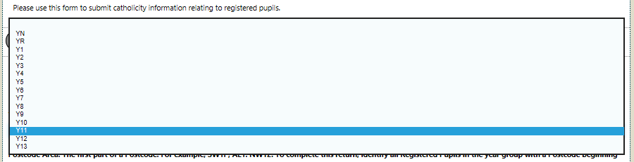
Select the required option and the field will populate.
For schools with nursery aged pupils:
Please report on all nursey pupils, even if you have more than 1 age group, under the single YN code.
Enter the count of the Catholic and Non-Catholic pupils.
The “Total” Field will alto-populate.
Click next to return to the Add, Edit and Delete page.
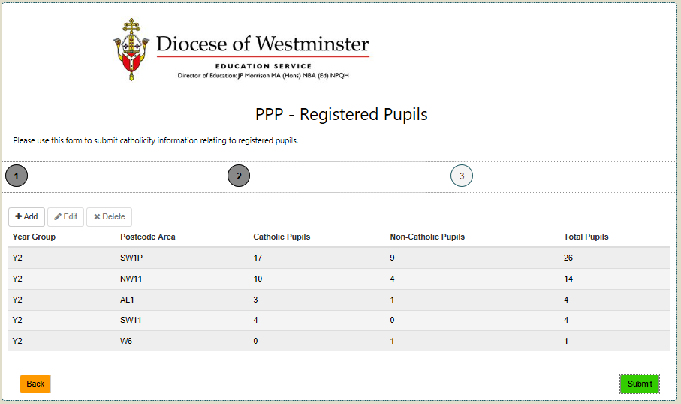
List of School Entered Data
Pupil Postcode Areas
The data from the previous screen is referenced on this page as an expandable list. Highlighting one of the lines in this list activates the Edit and Delete Buttons.
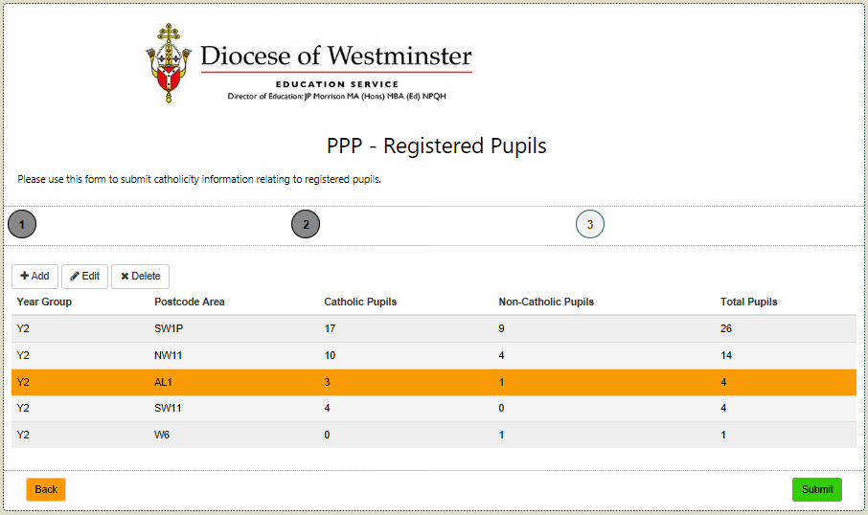
Edit and Delete Buttons are Active
Form Submission:
When all Year Group + Pupil Postcode Area entries are recorded, click on the “Submit” Button and your submission is complete.
Click “Submit” when complete.

Acknowledgement from the Education Service:
An email acknowledging the submission will be dispatched to the nominated email address. Attached to the email is a report that reflects the submitted data. Please retain in the School’s Records.
Example of Word Attachment:
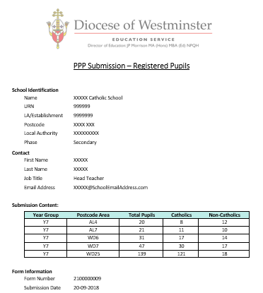
Multiple Submissions:
Saving and returning to this form before submission is not possible. However, it is possible to submit data in batches. The detailed reflection of submitted data will help to reduce the likelihood of accidental duplication.
Submissions from different individuals is allowed. For example, this task might be assigned to each Head of Year to complete. The complete record from the school is linked by the URN.
Further Support:
Please contact Nigel Spears (Assistant Director – Capital Strategy and Pupil Placement Planning)
Email: nigelspears@rcdow.org.uk
Mobile: 07738 183828

