The Diocese of Westminster Education Service
Enhancing the School Year
Support materials for a chaplaincy team

Contents
Ideas for Getting Started: Church Calendar 2
SEASON of Ordinary Time: Autumn - September to Christ the King 3
September: Special dates 4
October: Special dates 5
November: Special dates 6
SEASON of Advent 7
December: Special dates 8
SEASON of Christmas 9
January: Special dates 10
SEASON of Ordinary Time: Spring – Epiphany to Shrove Tuesday 11
February: Special dates 12
SEASON of Lent: Ash Wednesday – Holy Saturday 13
March: Special dates 14
SEASON of Easter: Easter Sunday to Pentecost 15
April: Special dates 16
SEASON of Ordinary Time: Summer – Day after Pentecost until First Sunday of Advent 17
May: Special dates 17
June: Special dates 19
July: Special dates 20
Planning and Preparing for Worship: Getting Started 21
Pupil Participation in Acts of Worship 23
Prayer Experiences 27
Useful Links 30

Ideas for Getting Started: Church Calendar

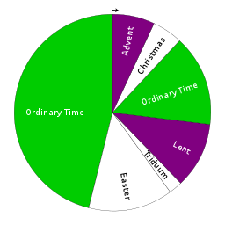

This document has been created to support your school and Chaplaincy Team with prayer throughout the school year. It is centred on the Lturgical Year, although it begins in September when the school year begins. Each of the Christian seasons are explained briefly and liturgically appropriate prayer intentions are included.
Special dates and feast days have also been included, although this is not an exhaustive list. They have been included to support your Chaplaincy Team in planning which topics/themes/celebrations they can focus on each month as it is not recommended that all dates are celebrated. It is better to do less and do them well. Those highlighted in red are feasts of martyrs and those in bold are holy days of obligation.
Some national and international days have been included so that your team can incorporate these into prayer and liturgy where appropriate. We hope that you can bring them to life with your energy and interesting ways of sharing them with others. Celebrations from other faiths have been included in this document so that you can be sensitive to the celebrations of other believers.
We hope that this can support your Chaplaincy Team and school community in growing in faith through prayer and liturgy as you journey through the year together.

SEASON of Ordinary Time: Autumn - September to Christ the King
PRAYER INTENTIONS FROM SEPTEMBER  TO CHRIST THE KING  (Based on the Liturgical Year) | Liturgical Colour
Students and Teachers  Education Sunday – 2nd Sunday in September | GREEN  WHITE
The Spread of the Gospel
Especially on Home Mission Day (3rd Sunday) and World Mission Day (penultimate Sunday in October)
The Harvest, Fruits of Human Work and Care of Creation
Especially on World Day of Prayer for the Care of Creation and on last Sunday in September or whenever Harvest Festivals are held
Justice and Peace in the World
Especially on Racial Justice Day (2nd Sunday in September) and on Harvest Fast Day (1st Friday in October)
Interfaith prayer for World Peace (links to One World Week)
All Victims of War (Purple, white or black)
Especially on Remembrance Sunday (2nd Sunday in November)
Young People
Especially on Youth Day (Christ the King)
Prisoners and their Families
Especially on the Day of Prayer for Prisoners and their Dependents (2nd Sunday in October) and during Prisons Week (2nd week in October)

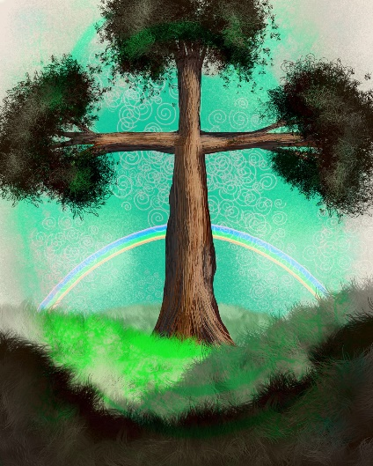
During this season we listen to readings about the teachings and parables of Jesus and reflect on what it means to be a follower of Christ.

In this ordinary time, we concentrate on the saints and try to imitate their holiness as Christ’s followers.

We also pray for the above intentions, especially on the special days.

September: Special dates
LITURGICAL YEAR | NATIONAL AND INTERNATIONAL DAYS | OTHER FAITHS/CULTURES
- St Gregory (3rd)  - St Teresa of Calcutta (5th)  - Nativity of the Virgin Mary (8th)  - Holy Name of Mary (12th)  - St John Chrysostom (13th)  - Exaltation of the Cross (14th)  - Our Lady of Sorrows (15th)  - Korean Martyrs (20th)  - St Matthew, Apostle and Evangelist (21st)  - Our Lady of Walsingham (24th)  - St Vincent de Paul (27th)  - St Jerome (30th) | - International Day of Charity (5th)  - National Literacy Day (8th)  - World Suicide Prevention Day (10th)  - First Aid Day (14th)  - International Day of Democracy (15th)  - World Ozone Day (16th)  - International Day of Peace (UN) (21st)  - Maritime Day (26th)  - World Tourism Day (27th)  - International Translation Day (30th)  4th Sunday – World Rivers Day  Last week – Day of Deaf | - Rosh Hashanah (Jewish New Year – Sept/Oct)  - Yom Kippur (Jewish Day of Atonement – Sept/Oct)  - Eid al-Adha (Islamic sacrifice of Ibrahim – date varies)  - Ashura (Islamic)  - Krishna Janmashtami (Hindu Birth of Krishna)  - Raksha Bandhan (Hindu relationships)  - Pahila Prakash Sri Guru Granth Sahib (Sikh Title of Guru Granth Sahib 1st)

Liturgical Colour | SUNDAYS IN SEPTEMBER | Note
GREEN | World Day of Prayer for the Care of Creation  Education Sunday  Home Mission Day  World Mission Day | The dates of these will change each year. Please check

October: Special dates
LITURGICAL YEAR | NATIONAL AND INTERNATIONAL DAYS | OTHER FAITHS/CULTURES
- St Thérèse of Lisieux (1st)  - Guardian Angels (2nd)  - St Francis of Assisi (4th)  - Our Lady of the Rosary (7th)  - St John Henry Newman (9th)  - St John XXIII (11th)  - St Edward the Confessor (13th)  - St Theresa of Avila (15th)  - St Luke, Evangelist (18th)  - St John Paul II (22nd)  - Ss Simon and Jude (28th)  - Blessed Martyrs of Douai College (29th) | - International Day of Older Persons (1st)  - International Day of Non-Violence (2nd)  - Animal Welfare Day (4th)  - World Teachers Day (5th)  - World Mental Health Day (10th)  - International Day of the Girl-Child (11th)  - UN National Disaster Reduction Day (13th)  - International Day of Rural Women (15th)  - World Food Day (16th)  - International Poverty Eradication Day (17th)  - UN day (24th)  Black History Month  One World Week (varies)  1st Monday – World Habitat Day  2nd Monday – World Sight Day | - Sukkot (Jewish Feast of Tabernacles – Sept/Oct)  - Simchat Torah (Jewish celebration of Torah – Sept/Oct)  - Navratri (Hindu good over evil)  - Arba’een (Islamic)  - Bandhi Chhor Divas (Sikh Celebration of Freedom – 27th)  - Shemini Atzeret (Jewish memorial)

Liturgical colour | SUNDAYS IN OCTOBER | Note
GREEN  WHITE | Ordinary Time  Feasts of Our Lady | Month of the Rosary

November: Special dates
LITURGICAL YEAR | NATIONAL AND INTERNATIONAL DAYS | OTHER FAITHS/CULTURES
- All Saints (1st)  - All Souls (2nd)  - St Martin de Pores (3rd)  - St Charles Borromeo (4th)  - Lateran Basilica (9th)  - St Martin of Tours (11th)  - St Frances Xavier Cabrini (13th)  - St Albert the Great (15th)  - St Margaret of Scotland (16th)  - Presentation of Mary (21st)  - St Cecilia (22nd)  - St Andrew (30th) | - World Tsunami Day (5th)  - National Stress Awareness Day (6th)  - World Science Day for Peace and Development (10th)  - Remembrance Sunday (11th)  - World Kindness Day (13th)  - International Day for Tolerance (16th)  - World Day of the Poor (17th)  - World Toilet Day (19th)  - Universal Children’s Day (20th)  - Carers’ Rights Day (21st)  - International Day for the Elimination of Violence Against Women (25th)  Month of Remembrance  Remembrance Sunday is the beginning of Interfaith Week. | - Diwali (Hindu festival of Light)  - Eid-e-Shuja (Islamic – date varies)  - Mawlid an-Nabī (Islamic Birthday of the Prophet Muhammed Oct/Nov)  - Guru Nanak Gurpurab (Sikh Birth of Guru Nanak Nov)  - Martyrdom of Guru Tegh Bahadur (Sikh 22nd)  - Mitzvah Day (Jewish – links to Day of the Poor)

Liturgical colour | SUNDAYS IN NOVEMBER | Note
Green,white, purple or black  GREEN  WHITE  PURPLE | Remembrance Sunday  Ordinary Time  Christ the King  Advent | These dates vary each year. World Day of the Poor is the week before Christ the King.

SEASON of Advent
PRAYER INTENTIONS during Advent and Christmastide  (Based on the Liturgical Year) | Liturgical Colour
Migrants and Refugees  (Migrants’ day - 3rd December) | PURPLE
Openness to the Word of God
(Bible Sunday – 2nd Sunday in Advent)
Expectant Mothers
(especially on 4th Sunday)

December: Special dates
Advent is a time to:

- Prepare for the Solemnities of Christmas in which the First Coming of the Son of God to humanity is remembered
- As we remember this, we prepare our hearts and minds for the Second Coming of Christ at the end of time

During this time, we hear in the readings about the promise of the Messiah in the prophecies of the Old Testament and the preparation of Mary and John the Baptist. It is a time of joyful expectation.

The crib is used as a symbol are for reflection during this season and believers often attend the sacrament of Reconciliation and say the Joyful Mysteries of the Rosary.

This season lasts until Christmas Eve.

LITURGICAL YEAR | NATIONAL AND INTERNATIONAL DAYS | OTHER FAITHS/CULTURES
- St Francis Xavier (3rd)  - St Nicholas (6th)  - St Ambrose (7th)  - Immaculate Conception (8th)  - Our Lady of Guadalupe (12th)  - St Lucy (13th)  - St John of the Cross (14th)  - Christmas day (25th)  - St Stephen (26th)  - St John the Apostle (27th)  - Holy Innocents (28th) | - National Pollution Control Day & Abolition of Slavery (2nd)  - International Day of Persons with Disabilities (3rd)  - International Volunteer Day for Economic and Social Development & World Soil Day (5th)  - Human Rights Day (10th)  - World Energy Conservation Day (14th)  - International Migrants Day (18th)  - International Human Solidarity Day (20th) | - Hanukkah/Chanukah (Jewish Festival of Light – Nov/Dec)  - Martyrdom of the Sahibzade (Sikh sons of Guru Gobind Singh 21th , 26th)

Liturgical colour | SUNDAYS IN DECEMBER | Note
VIOLET  ROSE | 1,2 and 4th Sundays in Advent  3rd Sunday (Gaudete) | The dates of these will change each year. Please check
SEASON of Christmas

Liturgical colour | SUNDAYS IN DECEMBER | Note
WHITE/GOLD | Feast of the Holy Family | This is the Sunday after Christmas day.

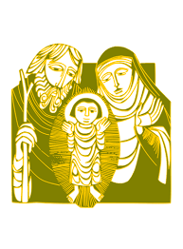

Christmas begins at the Christmas Vigil on Christmas Eve until the Baptism of Jesus. The 12 days of Christmas are from the Christmas Vigil until 6th January which was when the feast of the Epiphany (Coming of the Magi/Wise Men) was celebrated in the past. There are 40 days from Christmas to the Presentation of Jesus (Candlemas).

This is the season in which we reflect on the importance of Jesus’ birth as well as his early manifestations.

January: Special dates
LITURGICAL YEAR | NATIONAL AND INTERNATIONAL DAYS | OTHER FAITHS/CULTURES
- Mary, Mother of God (1st)  - Epiphany (6^{th )}  - Baptism of Our Lord  - St Anthony (17th)  - St Agnes (21st)  - St Francis de Sales; Our Lady of Peace (24th)  - Conversion of St Paul, Apostle (25th)  - Ss Timothy and Titus (26th)  - St Thomas Aquinas (28th)  - St John Bosco (31st) | - World Braille Day (4th)  - International Day of Education (24th)  - World Leprosy Day/Housen’s Disease (26th)  - International Day of Commemoration in Memory of the Victims of the Holocaust and Genocide (27th)  - Week of Prayer for Christian Unity (18-25th Jan) | - Tu B’Shvat (Jewish New Year for trees Jan-Feb)  - Birth of Guru Gobind Singh, Founder of Sikhism (Sikh – 5th)  - Maghi (Sikh -14th)

Liturgical colour | SUNDAYS IN JANUARY | Note
WHITE  WHITE  GREEN  GREEN | Epiphany  Baptism of the Lord  World Peace Day (2nd Sunday in Ordinary Time)  Sunday of the Word (3rd Sunday in Ordinary Time) | The Baptism of Our Lord is celebrated on the Sunday after Epiphany. There are 12 days between Christmas and the Epiphany.

SEASON of Ordinary Time: Spring – Epiphany to Shrove Tuesday
PRAYER INTENTIONS FROM EPIPHANY TO SHROVE TUESDAY  (Based on the Liturgical Year) | Liturgical Colour
Christian Unity  (Octave or prayer for Christian unity in January) | GREEN
Peace on Earth
(Peace Day – 2nd Sunday in Ordinary Time)
Victims of Human Trafficking
(Feast of St Josephine Bakhita)
Sick and Those Who Care For Them
(World day of the Sick – Feast of Our Lady of Lourdes)
Europe
(Feast of Ss Cyril and Methodius)
Racial Justice
(Racial Justice day - 3 Sundays before Lent)
Unemployed
(Day for the unemployed – Sunday before Lent)

During this season we listen to readings about the teachings and parables of Jesus and reflect on what it means to be a follower of Christ.

In this ordinary time, we concentrate on the saints and try to imitate their holiness as Christ’s followers.

We also pray for the intentions above in green at any time but especially on their special days.

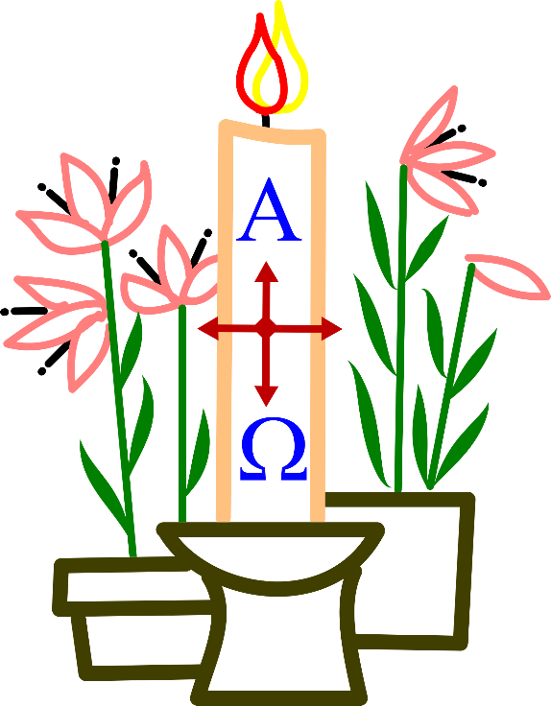

February: Special dates
LITURGICAL YEAR | NATIONAL AND INTERNATIONAL DAYS | OTHER FAITHS/CULTURES
- St Brigid (1st)  - Presentation of Our Lord (2nd)  - St Blaise (3rd)  - St Agatha (5th)  - Paul Miki and Companions (6th)  - St Jerome Emiliani; St Josephine Bakhita (8th)  - Our Lady of Lourdes (11th)  - Ss Cyril and Methodius (21st)  - Chair of St Peter (22nd) | - World Wetlands Day (2nd)  - World Cancer Day (4th)  - World Pulses Day (10th)  - International Day of Women and Girls in Science; Safer Internet Day (11th)  - World Day of the Sick (11th)  - World Radio Day (13th)  - World Day of Social Justice (20th)  - International Mother Language Day (21st)  - International Polar Bear Day (27th)  Interfaith Harmony Week - 1st week in Feb | - Chinese New Year (Buddhist)  - Magha Puka Day (Buddhist Important Event in Life of Buddha)  - Fast of Esther (Jewish Feb/Mar)  - Purim (Jewish Feb/Mar)

Liturgical colour | SUNDAYS IN FEBRUARY | Note
WHITE  GREEN | Presentation of the Lord  Ordinary Time | There are 40 days from Christmas to the Presentation of Our Lord, otherwise known as Candlemas. Some people leave their Christmas crib up until this day.

SEASON of Lent: Ash Wednesday – Holy Saturday
PRAYER INTENTIONS during Lent - Ash Wednesday – Holy Saturday  (Based on the Liturgical Year) | Liturgical Colour
Penitents and Wanderers | PURPLE
The Needy and Hungry of the World
Especially on Lent Fast day (Friday after 1st Sunday of Lent)
Candidates for the Sacraments
Especially on the Sundays in Lent
Women
Especially on Women’s World day of Prayer (1st Friday in March)
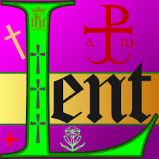

Lent is the time of preparation for the celebration of Easter and the Paschal Mystery. The final week of Lent is Holy Week begins on Palm Sunday and ends on Holy Saturday at the Easter Vigil Mass.

The Easter Triduum begins with the Mass of the Lord’s Supper on Maundy Thursday (following the Jewish counting of time with the day beginning at sunset). It lasts for three days: Thursday night, Friday night and Saturday night.

The Stations of the Cross are often reflected upon during this season as are the Sorrowful Mysteries of the Rosary and believers often attend the Sacrament of Reconciliation.

March: Special dates
LITURGICAL YEAR | NATIONAL AND INTERNATIONAL DAYS | OTHER FAITHS/CULTURES
- St David (1st)  - St Casimir (4th)  - Ss Perpetua and Felicity (7th)  - St John of God (8th)  - St Frances of Rome (9th)  - St Patrick (17th)  - St Cyril of Jerusalem (18th)  - St Joseph (19th)  - Annunciation (25th) | - Zero Discrimination Day (1st)  - World Wildlife Day (2nd)  - Int Women’s Day (8th)  - International Day of Happiness; French Language Day (20th)  - International Day for the Elimination of Racial Discrimination (21st)  - World Poetry Day (21st)  - International Day of Forests (21st)  - World Water Day (22nd)  - World Meteorological Day (23rd)  - Remembrance of Victims of Slavery Day (23rd)  - Mother’s Day | - Pesach (Jewish Passover Mar/Apr)  - Holla Mohalla (Sikh Olympics – 17th)  - Holi (Hindu Festival of Colours)  - Laylat al-Mi’raj (Islamic Mar/Apr)

Liturgical colour | SUNDAYS IN MARCH | Note
PURPLE  ROSE  RED | Sundays in Lent  4th Sunday (Laetare)  Palm Sunday (Sunday Before Easter) | Lent begins on a different date each year. There are 40 days between Ash Wednesday and Easter.

SEASON of Easter: Easter Sunday to Pentecost
PRAYER INTENTIONS during Easter  (Based on the Liturgical Year) | Liturgical Colour
New Members of the Church | WHITE/GOLD
Vocations
Especially on the World Day of Prayer for Vocations
(4th Sunday of Easter)
Human Work
Especially on St Joseph the Worker (1 May)
The Right Use of Media
Especially on World Communications Day (Ascension)
The Church  Especially on Pentecost Sunday | RED

Easter

Easter Sunday is the greatest of all Christian celebrations. The fifty days from Easter Sunday to Pentecost are celebrated joyfully, as one “great Sunday”. These above all others are the days for the singing of the Alleluia.

During this time, we hear about the appearances of the risen Christ. The readings about the Good Shepherd are read on the Fourth Sunday. Other readings include the words of Jesus at the Last Supper. We also pray for the above intentions.

The Ascension of Our Lord is takes place 40 days after Easter and Pentecost is celebrated 50 days after Easter when we remember that Jesus sent his Holy Spirit.

April: Special dates
LITURGICAL YEAR | NATIONAL AND INTERNATIONAL DAYS | OTHER FAITHS/CULTURES
- St Francis of Paolo (2nd)  - St Isidore (4th)  - St Vincent Ferrer (5th)  - St Stanislaus (11th)  - St George (23rd)  - St Mark, Evangelist (25th)  - St Catherine of Siena (29th) | - International Day for Mine Awareness and Assistance in Mine Action (4th)  - International Day of Sport for Development and Peace (6th)  - World Health Day (7th)  - International Day of Human Space Flight (12th)  - Chinese Language Day (20th)  - World Creativity and Innovation Day (21st)  - World Mother Earth Day (22nd)  - Spanish Language Day (23rd)  - World Malaria Day (25th)  - International Chernobyl Disaster Remembrance Day (26th) | - Vaisakhi (Sikh Birth of Kahlsa – 14th)  - Veisakha Puja (Buddhist -Buddha’s birthday April/May)  - Laylat al-Bara’at (Islamic – Sunni/Shia -Mar/Apr)  - Muhammad al-Mahdī (Islamic – Shia - Mar/Apr)  The Islamic festivals above occur on the same night

Liturgical colour | SUNDAYS IN APRIL | Note
WHITE | Easter Sunday  4th Sunday of Easter – Good Shepherd Sunday

SEASON of Ordinary Time: Summer – Day after Pentecost
until First Sunday of Advent
PRAYER INTENTIONS FROM DAY AFTER Pentecost Until First Day of Advent  (Based on the Liturgical Year) | Liturgical Colour
Deeper Understanding Between Christians and Jews | GREEN
Those Who Suffer Persecution
Especially on St John Fisher and St Thomas More (22nd June)
Those Who Suffer Oppression
Especially on St John Fisher and St Thomas More (22nd June)
Those Who Suffer Denial of Human Rights
Especially on St John Fisher and St Thomas More (22nd June)
Europe
Especially on the feasts of St Benedict (11 July), St Bridget of Sweden (23 July), St Catherine of Siena (29 April)
Human Life
Especially on the day for Life (3rd Sunday in June)
Seafarers
Especially on Sea Sunday (2nd Sunday in July)
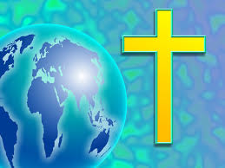

During this season we listen to readings about the teachings and parables of Jesus and reflect on what it means to be a follower of Christ.

In this ordinary time, we concentrate on the saints and try to imitate their holiness as Christ’s followers.

We also prayer for the above intentions especially on these special days.

May: Special dates
LITURGICAL YEAR | NATIONAL AND INTERNATIONAL DAYS | OTHER FAITHS/CULTURES
- St Joseph the Worker (1st)  - Ss Philip and James (3rd)  - Feast of English Martyrs (4th)  - St Damien de Veuster (10th)  - Our Lady of Fatima (13th)  - St Matthias (14th)  - St Bede (25th)  - St Augustine (27th)  - Visitation (31st)  Ascension Thursday  The date of Easter changes every year and the Ascension is celebrated 40 days after Easter Sunday.  Mary, Mother of the Church Monday after Pentecost | - World Tuna Day (2nd)  - World Migratory Birds Day (11th)  - International Day of Families (15th)  - International Day of Living Together in Peace (16th)  - World Telecommunication and Information Day (17th)  - World Bee Day (20th)  - World day for Cultural Diversity (21st)  - International Day of UN Peacekeepers (29th)  - World No-Tobacco Day (31st)  - Laudato Si week | - Yom HaSho’ah (Jewish Holocaust Remembrance Day)  - Shavuot (Jewish Pentecost May/June)  - First day of Ramadān (Islamic Fasting – date varies)  - Laylat al-Qadr (Islamic – date varies according to Ramadān)

Liturgical colour | SUNDAYS IN MAY | Note
WHITE  RED | Sundays in Easter  Pentecost | Pentecost is 10 days after the Ascension (50 days after Easter Sunday)

June: Special dates
LITURGICAL YEAR | NATIONAL AND INTERNATIONAL DAYS | OTHER FAITHS/CULTURES
- St Justin (1st)  - Charles Lwanga and Companions (3rd)  - St Boniface (5th)  - St Norbert (6th)  - St Barnabas (11th)  - St Anthony of Padua (13th)  - St Aloysius (21st)  - Ss John Fisher and Thomas More (22nd)  - St John the Baptist (24th)  - St John Southworth (27th)  - Ss Peter and Paul (29th)  - Sacred Heart of Jesus (19 days after Pentecost) | - Global Day for Parents (1st)  - World Bicycle Day (3rd)  - World Environment Day (5th)  - Russian Language Day (6th)  - World Oceans day (8th)  - World Day Against Child Labour (12th)  - World day to Combat Desertification and Drought (17th)  - World Refugee Day (20th)  - Seafarer Day (25th)  - International Asteroid Day (30th)  - Father’s Day | - Chaand Raat (Islamic –date varies – linked to Eid al-Fitr)  - Eid al-Fitr (Islamic Break the Fast of Ramadān – date varies – new moon for start of Eid)  - Martyrdom of Guru Arjan (Sikh 16th)

Liturgical colour | SUNDAYS IN JUNE | Note
WHITE  WHITE  GREEN | Most Holy Trinity  Corpus Christi  Ordinary Time | Trinity Sunday is the Week after Pentecost and the week before Corpus Christi.

July: Special dates
LITURGICAL YEAR | NATIONAL AND INTERNATIONAL DAYS | OTHER FAITHS/CULTURES
- St Oliver Plunket (1st)  - St Thomas, the Apostle (3rd)  - St Elizabeth (5th)  - St Maria Goretti (6th)  - St Benedict (11th)  - St Henry (13th)  - St Bonaventure (15th)  - Our Lady of Mount Carmel (16th)  - St Mary Magdalene (22nd)  - St James (25th)  - Ss Joachim and Anne (26th)  - St Martha (29th) | - International Day of Cooperatives (11th)  - World Youth Skills Day (15th)  - Nelson Mandela Day (18th)  - International Day of Friendship (30th) | - Tisha B’Av (Jewish tragedies)

Liturgical colour | SUNDAYS IN JULY | Note
GREEN | Ordinary Time

Useful Links
Details | Website link
Liturgy Office: For materials to support prayer and worship throughout the liturgical year see the website | https://www.liturgyoffice.org.uk/  https://rcdow.org.uk/diocese/liturgy/diocesan-supplement/
Universalis: For materials to support daily Liturgy and Mass throughout the year visit the website. Alternatively, subscribe to it and this resource can be available on your electronic device(s) | https://universalis.com/
Catholic Culture: For information about the liturgical year, prayers, resources, activities, recipes and more see the website | https://catholicculture.org
CAFOD: For free pupil-led Collective Worship materials as well as resources to support assemblies to support the liturgical year and various themes visit their website | https://cafod.org.uk/Education/Primary-teaching-resources/Collective-worship-resources
Mission Together: For resources to support prayer, worship and mission during the liturgical year visit the website | https://missiontogether.org.uk/
Pope’s Prayer Intentions: For the Pope’s monthly prayer intentions every year | 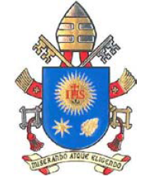  https://www.popesprayer.va/the-challenges-facing-humanity-and-assists-the-mission-of-the-church/#INTENTIONS

