Prayer, Liturgy
and Worship
support materials for a chaplaincy team
The Diocese of Westminster Education Service

Contents
Section 1: 2
Prayer and spirituality 2
Prayer Tables 3
Prayer Boxes 4
Prayer Focal Area: Planning and Monitoring 6
Prayer Experiences 7
Chaplaincy Team Prayer and Promise 10
Section 2: 11
Child-led Acts of Worship 11
Planning and Preparing for Worship: Getting Started 12
Pupil Participation in Acts of Worship 14
Act of Worship Toolkit 18
Act of Worship Toolkit Template (example) 21
Section 3: Involving Pupils in the Mass and Liturgies 22
Guidelines for involving pupils in the Mass 23
Bidding prayers (template for pupils) 25
School Masses and Liturgies Plan 26
Mass Planning Sheet 28
Pupil-led Liturgy plan (template) 29
Liturgical Objects at Mass: Glossary 31
Liturgical Vestments: Glossary - Vesture the ministers wear 33
Adoration Plan 34
Useful links 35

Section 1:

Prayer and spirituality

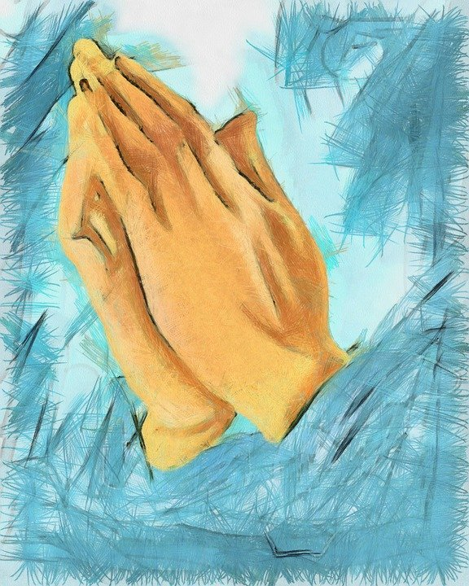

Prayer Tables
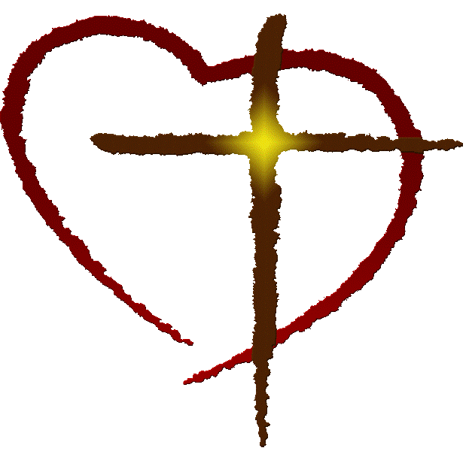
Pupils can take responsibility for setting these up in their own/other classrooms as well as around the school. They can assist leaders with maintaining and monitoring them regularly. Members of the Chaplaincy Team could be involved in setting these up and overseeing them around the school. They may get other pupils to help with this in individual classes.

CAN INCLUDE: | - Cloth – liturgically correct  - Religious artefacts eg Cross/crucifix, candle, Bible (perhaps opened at a relevant piece)  - Link to scripture/message/ liturgical season (eg ‘Heal us, Lord’) or class topic  - Plant/fresh flowers  - Prayer (eg prayer book, prayers written by pupils etc)
DO: | - Ensure that it is liturgically correct  - Make sure that it is respectful and holy (Catholic)  - Make sure it is tidy  - Involve the pupils where possible eg prayer table monitors

Prayer Boxes
It may be helpful for the Chaplaincy Team to have a box for each prayer area. This could include, among other objects:

OBJECT | NOTES
Cloths | Liturgical colour include:  - green for ordinary time;  - white for Christmastide and the Easter season; purple for Lent and Advent;  - red for martyrs’ feast days/Pentecost/Holy Spirit;  - gold can be used in place of white;  - pink for Gaudete Sunday during Advent and Laetare Sunday during Lent;  - blue for Marian feasts.  Other colours can be used for general use although they are not linked to the liturgical year eg red/black for Remembrance/November.
Cross/crucifix | This should be age appropriate. There are lots to choose from and the pupils could be actively involved in this. If setting it on the table, it might be useful to consider how it can be raised so it can be seen.
Bible/prayer book/stories of Jesus | This should be age appropriate. There are lots to choose from. Ideally, pure scripture will be used and the text will be changed regularly to reflect the liturgical season/RE topic/theme.
Plant/flowers | These can be real/artificial/made by pupils. If they are real, pupils could take responsibility for looking after them.
Candle | This may be artificial depending on the age of pupils. Consideration must be given to the storage of matches/lighters for health/safety reasons. These can reflect the liturgical season/theme.  Candles may be designed (safely!) with images/Scripture. Various colours and shapes might be used to link to the season/theme.
Rocks/stones/pebbles | These can symbolise a variety of things including the Earth. Pupils can make different shapes for them (eg cross/heart).
Images/icons | These can link to various themes etc and can be of various styles (eg Jesus, the Holy Spirit). They may even be created by pupils.
Words/letters/Scripture | These can be versatile or specific. For example, packs of wooden letters can be changed to suit the theme. Scripture can be written on card/wood/ stone etc or framed.
Statues/objects | These can be linked to school/class saint or the liturgical year eg Mary. It is also useful to have abstract ones which can suit various themes eg praying hands, family, friends etc
Holy water/oil | These could be used for blessing each other during prayer/worship. They could also be used simply as visual symbols.  (Fragranced) oil could be used be burned and linked to the Liturgy providing it is done safely.

Prayer Focal Area: Planning and Monitoring

The pupils could plan and monitor focal areas using the prompts below.
Alternatively, they could compose their own planning sheet.

Key questions to think about when planning my prayer focus:
- Is the prayer table/area in a prominent in the classroom, readily accessible to the children?

- Are there appropriate items on display (Bible, cross, candle)

- Is the prayer corner / area attractive and well cared for? (Focus changed regularly to reflect the liturgical time of the year?)

- Are the statues and pictures good quality religious art? Do they create a sense of a sacred space?

- Do the children help with the planning and/or maintenance of the prayer corner / area?

- Is there a selection of books connected to the topic available for children (these can be kept in a box near the prayer focus)?

- Is there evidence of children’s work and/or prayers? Are they used?

- Has each classroom an RE display? Is it up-to-date and based on the current topic?

- Are there traditional/school prayers on display to support learning?

Prayer Experiences
Pupils can be involved in reading, composing or sharing in a variety of types of prayer, many of which are listed below. These can be based on the special times and themes listed in this document, although they may also be based on the pupils’ own life and needs. It is important that they will be exposed to a positive, rich and varied experience of prayer and that these will be modelled and taught in a meaningful and engaging way. There is a plethora of resources available to support with this. The importance of personal and genuine prayer that develops a relationship with God should always be at the heart of prayer; it should not become a task or performance but a true joy and source of peace.

TYPE | EXAMPLE
Examen | Beginning prayer, review of the day, reflection of God’s presence and personal response, prayer of thanks/penance/praise
Praying the psalms | Give thanks to the Lord…. his faithful love endures forever [Psalm 136]
Traditional prayers | Glory be to the Father, Our Father, Hail Mary (and lots more)
Repetitive prayer [mantra] | ‘Come Lord Jesus’, repeated several times, slowly
Meditation | Scripture reflection with use of imagination eg Guided Meditation
Bodily prayer | Raising hands in praise, bowing, dancing, kneeling, being still
Prayer of the heart | Stillness to listen to God: ‘Come to me and I will give you peace’
Spontaneous prayer | Speaking to God from the heart
Prayer of petition | Asking God for his help in our lives and the lives of others
Prayer of penance | Asking God for forgiveness and for help to forgive others
Prayer of praise/thanksgiving | Praising/thanking God through words/song
Contemplation | Looking at a scene from nature, a piece of art etc
Gestures | The sign of the cross, the sign of peace, prayer actions
Hymns | Traditional and modern hymns
Music | Listening to God through quiet, reflective music, hymns, Christian rock, appropriate pop music etc Praying through song
Litanies | For all you have given us: Thank you Lord
Processions | Gospel procession with sung ‘alleluia’
Prayer services and liturgies | Formal and spontaneous prayer using holy water, candles, incense and other symbols
Stations of the Cross | Reflecting on the suffering and death of Jesus
Novena | Eg to the Sacred Heart, Our Lady of Knots
Rosary | Meditating on a time in the life of Mary/Christ (eg could be one decade or the joyful mysteries etc)

Chaplaincy Team Prayer and Promise
The team members could write their own unique prayer that they could recite each time they meet or worship together. Here is one example below. A business card with details of their roles/mission could also be created and distributed to visitors by members of the team.
Chaplaincy Team Prayer
God our Father,
Thank you for our school community and for our teachers and clergy who help us to learn more about you.
Thank you for our friends and family who show us your love and care.
Bless us as we grow together in peace to build up your kingdom and make the world a better place.
Help all the members of our school and parish, especially those who are in most need of your help.
Fill us with your Spirit so that we can be your hands on earth. Amen

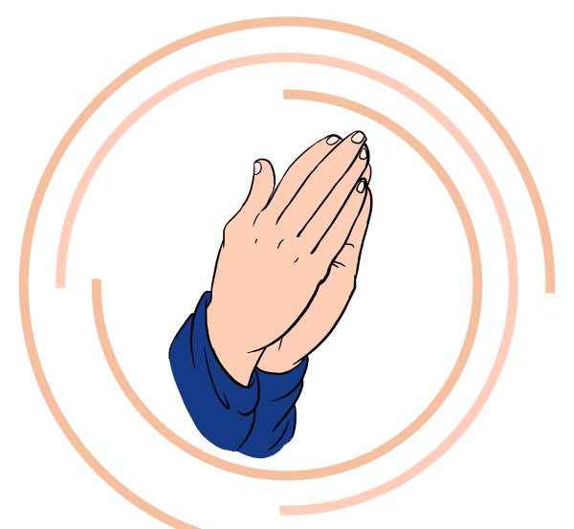
Chaplaincy Team Promise
As a ___________ (name of team) of
___________________ (name of school)
I promise to set a good example to others
and help to bring peace and faith to the school.
I promise to pray to God and follow His rules.
I promise to help those in need.

Section 2:

Child-led Acts of Worship
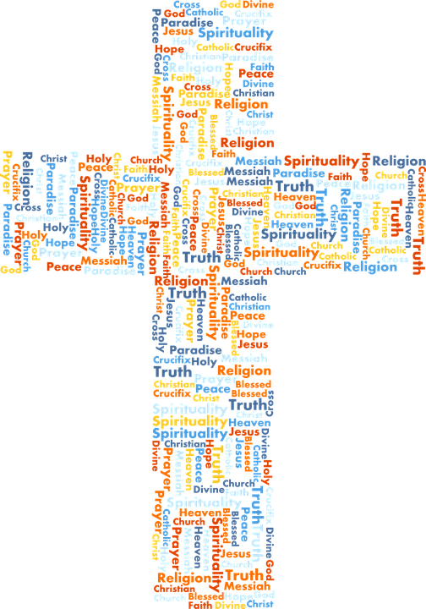

Planning and Preparing for Worship: Getting Started
Prayer, worship and liturgy can be based on or refer to all of the special times listed previously in the document. Leaders of prayer will need to research these so that they are familiar with their meaning and context and get guidance from an adult as/when appropriate.

 | EXAMPLES/IDEAS
Starting point | - Link to topic/theme or specific lesson (eg Memories)  - Link to liturgical year (eg Lent/Pentecost)  - Link to special feast days (eg St David’s Day)  - Link to wider world (eg Festival of Light, Fast Day)
Variety of content and presentation | - Use of Scripture  - Artefacts/stimuli  - Different presenters (teachers, pupils etc)  - Stories/drama/poetry/reflection/dance (linked to theme/word)  - Music (background, singing of group or all)  - Whiteboard (for word, reflective questions, mission etc)  - Video clips  - Focal points eg a picture, candle, cloth, symbol of theme
Involvement of pupils | - Being encouraged to share  - Acting/miming a story (with props)  - Reading  - Pupils’ artwork can be shown on screen for reflection  - Poems or prayers written by pupils can be read out  - Songs of prayer/praise written by pupils can be sung  - Recording their prayers or completing an activity for the response
Different ways to pray/worship | - Music  - Song  - Dance  - Drama  - Words of praise  - Prayers  - Readings and teachings  - Listening  - Thoughtful silence/mindfulness  - Meditation  - Contemplation  - Service  - Symbolic action
Think of all pupils | - Encourage active pupil participation (not just those leading)  - Make it part of the routine BUT also try to make it varied so that they enjoy it and it is memorable and meaningful  - Think of different intelligences and learning styles – offer these to God  - Try to include: visual, auditory, kinaesthetic  Make the children feel:  - Special in God’s eyes  - Part of the community  - Valuable to all

Pupil Participation in Acts of Worship

Important note to remember | All pupils are valuable in their participation simply be being present – there is not just an emphasis on ‘doing’ but also in ‘receiving’ – both roles are equally important
Opportunities for pupils to lead | - Set up a focal area with different symbols/images linked to theme  - Get the music ready. Choose an alternative song or scripture if appropriate  - Complete the activity beforehand to model what pupils can do  - Prepare a PowerPoint based on the ideas given  - Choose alternative activities eg write a short song or poem based on this scripture and offer these as prayers  - Choose an alternative mission  - Link this to learning in class, Wednesday Word, the liturgical year or quotes from special people
Pupil involvement BEFORE worship | SETTING UP  - Sorting song words  - Selecting and setting up CD/ICT  - Putting out/moving chairs  - Preparing prayer table  WELCOMING  - Greeting (eg at door)  - Meeting visitors at entrance  PLANNING  - Choosing music/songs  - Finding or writing prayers; choosing others’ prayers  - Preparing video and visual materials  - Training for new helpers
Pupil involvement DURING worship  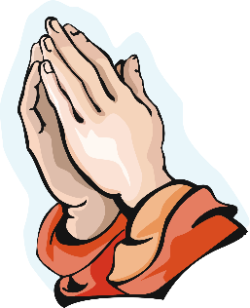 | GATHERING  - Singing as others arrive  - Lighting candle  - Saying a welcoming sentence/greeting  ENGAGING  - Introduce a visitor/pupil etc  - Share the word (eg on screen)  - Drama  - Holding props  - Telling or reading the story  - Showing a clip  RESPONDING  - Asking and answering questions  - Reading or saying prayers  - Leading prayer  - Singing or playing instruments  - Leading actions or signing to songs or prayer  SENDING  - Explaining the Mission  - Giving examples  - Distributing resources eg bookmark, challenge/mission  - Saying closing prayer  - Choosing music/songs  - Blowing out candle
Pupil involvement AFTER worship | CLEARING UP  - Supervising pupils leaving respectfully  - Holding doors  - Putting away equipment  RECORDING  - Leading evaluation (asking others what they thought)  - Complete a CW record form for evidence file  EVALUATION  - Record evaluation (own and others’)  - Share evaluations with REC/ HT/ CT/clergy/governors/School Council as required
EVALUATIONS  (Examples of questions the Chaplaincy Team can discuss with each other and other pupils. Pupils could choose which ones to discuss and rotate these as necessary. They may come up with their own questions also) | - How did it make you feel?  - Has it helped you to understand more about God? How?  - What did it make you think about?  - What have you learnt?  - Did you find out anything new about yourself or others?  - Do you think you will behave differently as a result of it?  - Did it give you a chance to pray if you wanted?  - Do you want to ask anything about what you heard about/ experienced?  - What did you enjoy about it? Why?  - What will you remember about it?  - What might you have done differently?  - How do you think it might be improved?  GATHERING  - Is there a sense of calm, excitement, intrigue, respect, community?  ENGAGING  - Is it engaging and appropriate for all present? For example, does it have story, song, visitors, questions, images, meaningful resources?  RESPONDING  - Is there space for pupils’ response? For example, is there singing, praying, discussion, sharing, action, silence?  MISSION  - Is there a sense of mission? For example, do pupils leave with a sense of purpose, challenge, resolve, blessing?

Act of Worship Toolkit

Chaplaincy Teams can support with the implementation, development and evaluation of Acts of Worship throughout the school. This can be done in a variety of ways depending on the needs and vision of the school. It is essential that the pupils liaise with the appropriate adults in order to make this process most effective and valuable.

Toolkit aims

- To provide pupils with the tools to plan a daily Act of Worship
- To provide a range of meaningful themes drawn from a range of resources and the seasons of the Liturgical Year
- To provide resources to ensure that pupils know the traditional prayers of the Church
- To provide examples of children planning and leading the daily Act of Worship in the classroom

Toolkit notes

- The Toolkit for staff and pupils should be used as best fits the needs of the school; changed and adapted as necessary
- This is most suitable for use in a classroom/group prayer setting
- The Act of Worship should last for about 10 minutes

The Toolkit provides pupils with:
- Ideas to choose from
- Confidence in using the correct structure
- Inspiration on ways to gather or respond to the Word and a model for making additional cards
- THE RESPONSIBILITY REMAINS WITH THE TEACHER!

Toolkit: Before you begin

- Gather, Response to the Word & Mission are generic
- Use a suitable edition of the Bible to read the suggested Scripture
- Worship based on a season or theme, e.g. Mary, are located in the same folder

Toolkit: How it can be used

- Select a group of children
- Children need to be given time to plan
- TA or class teacher to act as a scribe to complete plan & evaluation
- Children can create their own ideas
- At a convenient time in the school day, the teacher sets the sacred space and invites the children to lead the act of worship
- Children should have a sense of ownership
- Evidence of a planned act of worship will be found in ‘Pupil Planning & Evaluation’
- Materials on Slack contains printable traditional prayers appropriate for the different key stages

GATHER
Some ideas to choose from:
- Make the sign of the cross
- Play reflective music as you gather
- Ring the bell until everyone is gathered
- Make the sign of the cross on your forehead and heart
- Sit in a circle, light a candle and remember that Jesus is the light of the world
- Pass round a bowl of water, dip your fingers and make the sign of the cross
- Pass round a symbol or object to remember Jesus and that we all belong to God’s family

WORD

Choose from a topic in your RE programme or a liturgical year season for the appropriate key stage.

RESPONSE TO THE WORD
Some ideas to choose from

- Drop a pebble in a bowl of water remembering the important message of God’s word that you have just heard and saying a silent prayer in your heart
- Together, pray a litany of thanks to God in response to the Word you have listened to
- Pray silently to God about what you feel and what ideas you have about hearing the word
- Reflect on what God is saying to you in the ‘Word’ today. What is God saying to you today? Talk to God in your heart. When you have finished make a sign of the cross in the water bowl
- Reflect on the word you have heard and write a prayer on a cut out leaf in response to it. Share your prayer with the class and make a prayer tree
- Listen to some of the reflective music and place the word you have just listened to in the centre of the circle. Use collage materials (flowers, glass beads…) to surround the word. Say a prayer to thank God for his word.
- Think about the times you have forgotten to talk to God, ask God for forgiveness
- Place a stone at the foot of the cross whilst the class prays for you in their heart

MISSION
- Find a few moments in the day to say ‘thank you’ to God
- Greet someone with a smile
- Tell someone in another class what you have prayed about today
- Be an example of Jesus today: help someone in need, share with someone, be kind, look after our world
- Care for God’s world by picking up a piece of litter
- Do something helpful at home
- Invite someone who is lonely to play with you
- Care for God’s world by picking up piece of litter
- Do something helpful at home
- Invite someone who is lonely to play with you at break time
- Take a few moments during the day to say a quiet prayer in your classroom prayer corner

Act of Worship Toolkit Template (example)

Date: | Names of pupils:
GATHER

LISTEN
RESPOND

MISSION

EVALUATION

Section 3:
Involving Pupils in the Mass and Liturgies

Guidelines for involving pupils in the Mass
Please see Westminster Education Service’s document ‘Mass Guidelines’ for questions and answers on celebrating school Masses. Below you will find some ways in which pupils can take a leading role in various parts of the Mass, although it must be emphasised that all pupils are active participants through their presence and prayers as well as through joining in Communion. Consult your priest when preparing for these celebrations.
Before the Mass | - Children can help to set up the altar in preparation for Mass. This could be done with the priest and could include explanation. The priest may choose to put on Mass vestments in front of the children also.
Introductions | - Children can read/write their own introduction to the Mass as well as the Penitential Rite etc
Penitential Rite | - Pupils can write parts of the Penitential Rite (ie NOT including things we are sorry for but positive statements about Our Lord eg ‘You are the way leading to the Father’ Lord have mercy). The priest will then read the statements.
Readings | - Only one (as well as a psalm) is needed during the week  - Children can read or dramatise the reading  - The psalm can be sung as long as it is based on scripture  - Readings of the day can be changed if it is a special Mass (eg Beginning of school year) or if the readings are not at all relevant to children  - The Good News Translations and New Jerusalem Bibles are appropriate translations  - Lectionaries for Children may be used but this should be checked with the priest
Bidding Prayers | - These can be written and read by pupils  - They should start with the wider Church and then become more personal (Church, Leaders, Diocese, Community, Personal)  - They should begin ‘We pray for…’ or ‘For…’ or ‘Let us pray for…’ NOT names/titles of the Lord (then no Trinitarian errors)  - Spontaneous prayers can also be said
Offertory gifts | - Gifts/objects (such as books, sports equipment, mission statements, objects related to theme etc ) can be brought up at the beginning of Mass during eg opening procession and these can be explained by the children  - For the Offertory procession, should be ‘holy things for the holy people of God’ (ie the community). These would be items/gifts that are to be ‘transformed’ by the Lord for the service of others (their prayers/art etc could be used, depending on the rationale)
Dance/Drama | - This could be done after the post-Communion prayer (as long as it is suitable)

Bidding prayers (template for pupils)

Invitation to prayer
(followed by silence)

Read by (eg priest) _________________
Response (Eg Lord have mercy/Lord hear our prayer/other)
- 1. Prayer for the needs of the Church

Read by _________________________
- 2. Prayer for the world

Read by __________________________
3. Prayer for those in need

Read by __________________________
4. Prayer for the local community

Read by _________________________
Invitation to pray in silence for
personal intentions
Read by _________________________
Prayer (eg Hail Mary)
Concluding prayer (Collect)
Read by (eg priest) _______________
NOTE: Prayers should begin: ‘Let us pray for…’, ‘We pray for….’ or ‘For…’

School Masses and Liturgies Plan
The list below is an example of all the school Liturgies/Masses that could take place throughout the year. It may be that these are attended on a rotational basis, or that the whole school attends each one. Where is is difficult to attend Mass, a Liturgy could be celebrated instead. Pupils can be involved in the planning, preparation and leading of various elements of the Mass, although it is important that schools liaise with their Parish Priest to plan for the year and discuss expectations and practicalities.

CELEBRATION | DATE | RESOURCES | PUPILS
Beginning of Year Mass
Harvest Liturgy

All Saints Day Mass
Remembrance Liturgy
Advent Liturgy KS1/EYFS
Advent Liturgy KS2/EYFS
Advent Adoration/Benediction
Reconciliation Y4-6
Epiphany Mass
Ash Wednesday Service
Ash Wednesday Liturgy EYFS/Y1

Lent Liturgy KS1/EYFS

Lent Liturgy KS2
Lent Adoration/Benediction
Reconciliation Y4-6
Easter Liturgy KS1/EYFS
Easter Liturgy KS1/EYFS
Ascension Mass
Crowning of Our Lady Liturgy

First Holy Communion Celebration Mass
Pentecost Liturgy KS1/EYFS
Pentecost Liturgy KS2/EYFS
St Peter and St Paul Mass
End of Year Mass

Mass Planning Sheet
Mass intention
Title/theme
Gathering hymn:
Gloria (said/sung):
Liturgy of the Word:

Alleluia (said/sung):
Offertory:

Prayers of the Faithful read by:

Acclamation (said/sung):

Our Father (said/sung):

Communion hymn(s):

Recessional hymn(s):

Pupil-led Liturgy plan (template)
This is similar to an Act of Worship but it is different in that it includes symbolic action. As you can see it follows the structure of the Liturgy of the Word which takes place at Mass (the supreme form of Christian Liturgy). Pupils can be trained in preparing, contributing to and leading Liturgies. This plan will support them in ensuring they have the necessary elements and structure. This should be planned to suit the needs, ages and abilities of those present to ensure that it is meaningful for them.
Names of pupils
Theme
(eg St Joseph, bullying, Advent)
Focal point
(eg cloth, candle, symbols)
Gathering song
Opening prayer (Collect)
Scripture
Reflection on Scripture

(eg drama, brief homily/presentation written by pupils)
Prayer

(eg Our Father, pupil’s own prayer)
Action (Where appropriate)

(eg receive ashes, place flowers around Mary’s statue)
Closing prayer/going forth
Closing song
Resources needed

Liturgical Objects at Mass: Glossary

OBJECT | DEFINITION
Altar | A table on which the sacrifice of the Mass is offered. It is the centre of importance in the place where the Mass is celebrated. Also called: The Table of the Lord.
Ambo | The place where the Scriptures are proclaimed. Also called Lectern. Avoid: Pulpit.
Altar bread/wine and Host/Precious Blood | The altar bread is the unconsecrated host before Mass; it is just bread. The Host is the consecrated bread – it is the Body of Christ.  The altar wine is the unconsecrated wine before Mass; it is just wine. The Precious Blood is the consecrated wine, the Body of Christ.
Cathedra | The Archbishop’s throne. Celebrant's Chair: The place where the celebrant sits. It expresses his office of presiding over the assembly and of leading the prayer of those present. AVOID: The use of the word THRONE.
Processional Cross | The cross carried in the processions. Bread and Wine: The elements used in the celebration of Eucharist (unleavened bread and natural pure wine). NOTE: After the Eucharistic Prayer the bread and wine is referred to as: the consecrated bread and wine or the body and blood of Christ.
Cruets | The containers/vessels holding the water and wine. Tabernacle: Place in the church where the Eucharist or sacred species is reserved.
Chalice | The cup used to hold the wine.
Paten | The plate used to hold the bread that will be consecrated during the Eucharistic prayer.
Ciborium | A vessel used to hold the consecrated bread for the distribution of communion.
Cathedral | The major church in an archdiocese or diocese. It is the seat of the local Ordinary.
Lectionary | The book that contains all the readings from the Scriptures for use in the celebration of the liturgy.
Sacramentary | The book used by the celebrant, containing all the prayers for the liturgy of the Mass.
Book of Gospels | The book which contains the Gospel texts, from which the priests or deacon proclaims the Gospel of the day.
Purificator | The linen cloth used to wipe the chalice after the celebration of Mass.
Corporal | The square white cloth, now usually somewhat smaller than the breadth of the alter, upon which the chalice and paten, and also the ciborium containing smaller hosts for Holy Communion are placed during the celebration of Mass.
Tabernacle | The fixed lock box in which the Body of Christ is reserved after Mass. We genuflect to the tabernacle, not the altar.
Water and Holy Water | Holy water has been blessed and is a reminder of our Baptism. We make the sign of the cross with it. Ordinary water has not been blessed. It can be brought up to Mass with the wine.

Liturgical Vestments: Glossary - Vesture the ministers wear

VESTMENT | DESCRIPTION
Alb | The white garment covering one's street dress for participation in the liturgy.
Chasuble | The vestment worn over the alb by priests, bishops and Pope when celebrating the Mass.
Cassock | A non-liturgical, full-length, close-fitting robe for use by priests and other clerics under liturgical vestments; usually black for priests, purple for bishops and other prelates, red for cardinals, white for the Pope.
Stole | The vestment worn around the neck by all ordained ministers. For priests, bishops and Pope, it hangs down in front (under the chasuble); the deacons wear it over their left shoulder crossed and fastened at the right side.
Mitre | A headdress worn at some liturgical functions by bishops, abbots and, in certain cases, other ecclesiastics. Crosier (pastoral staff): The staff which a bishop carries when he presides at the liturgy.
Cincture | A rope-like or ribbon-like article sometimes worn with priests’ vestments, encircling he body around or above the waist. A bishop’s cincture is made of intertwining gold and green threads, a cardinal’s has red and gold and the pope’s has white and gold.
Crosier | This is a crook/staff symbolizing his role as a shepherd.

Adoration Plan

Exposition
(The Blessed Sacrament is removed from the Tabernacle and brought to the altar). All kneel
Gather:
Prayer:
Adoration
Respond in silent reflection: | As you sit here in the presence of Jesus who gives himself to us in this special sacrament:  Thank him for your blessings and his presence in your life  Tell him about your thoughts and feelings – he is your best friend!  Ask him for his help and guidance in your life  Listen to his response in the silence of your heart
Litany: (optional)

Prayer: (optional)
Benediction (if priest/deacon is present)
All bow their heads in prayer when the priest/deacon raises the monstrance.
Reposition
(The Blessed Sacrament is placed back in the Tabernacle)
Sing:

For more examples, see those on the Westminster Education Service – Catholic Life - Adoremus

Useful links
Details | Website link
CAFOD:  Resources for prayer, liturgy and reflections.  Prayers and assemblies for young people.  Resources for Children’s Liturgy  And more! | https://cafod.org.uk/Pray/Prayer-resources  https://cafod.org.uk/Pray/Prayers-for-young-people  https://cafod.org.uk/Education/Children-s-liturgy
Mission Together: For resources to support prayer, worship and mission during the liturgical year visit the website | https://missiontogether.org.uk/
Sacred Space: For prayers linked to social justice which can be used with adults of pupils visit this website. | https://www.sacredspace.ie/
Loyola Press: For innovative and enjoyable child-friendly resources.  For 3 minute retreats see: | https://www.loyolapress.com/our-catholic-faith/family/catholic-kids  https://www.loyolapress.com/3-minute-retreats-daily-online-prayer
Examen: For resources the Examen for children to offer inspiration so they can begin to lead the Examen themselves | https://soundcloud.com/pray-as-you-go/examen-for-children  https://pray-as-you-go.org/article/examen-prayer  http://jesuitinstitute.org/Pages/Examen.htm
Lectio Divina: For guidance and tips on how to pray using Lectio Divina | https://teachingcatholickids.com/lectio-divina-for-kids/  https://www.christiethomaswriter.com/kids-ideas-blog/lectio-divina-for-kids/  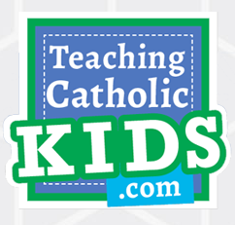
Catholic Culture: For information on the liturgical year, prayers, resources, activities, recipes and more see: | https://www.catholicculture.org/#
Catholic Teacher: For creative ideas and resources including prayer services | https://www.catholicteacher.com/
Catholic Icing: For support with creative crafts to enhance Liturgy and Worship | https://www.catholicicing.com/
Pathways to God: This is a Jesuit site with inspiration for daily prayer as well as the Pope’s prayer themes which are linked to CST and Gospel Values. | www.pathwaystogod.org/org/mount-street-jesuit-centre

