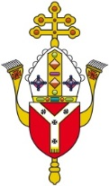
DIOCESE OF WESTMINSTER
EDUCATION SERVICE
FOUNDATION GOVERNOR CERTIFICATE OF CLEARANCE
Name of appointee
DBS certificate number
DBS certificate date

I have seen the above DBS certificate and I am satisfied that there is no cause for concern
Signed
Print name
Position | Chair of Governors | Headteacher | Safeguarding Officer
please tick)

Local Authority
Date
School stamp

Please return this form to the Foundation Governors Co-ordinator by email to carolc@rcdow.org.uk or by post to Vaughan House, 46 Francis Street, London SW1P 1QN
The applicant is not a governor until this certificate has been received, the Bishop has made the appointment and the applicant has been sent the deed of appointment.

