DIOCESE OF WESTMINSTER EDUCATION SERVICE

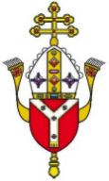 Support Materials in Times of COVID and Beyond

Prayer, Worship and Liturgy

The first task in life is this: prayer. But not the prayer of words, like a parrot; the prayer of the heart: gazing on the Lord, hearing the Lord, asking the Lord.’

Pope Francis

Resources

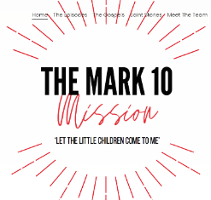Mark 10 Mission

For worship based on the weekly Gospel click [here](https://www.themark10mission.co.uk/theepisodes)

For resources on saints which link with the liturgical year click [here](https://www.themark10mission.co.uk/saint-stories)

CAFOD resources

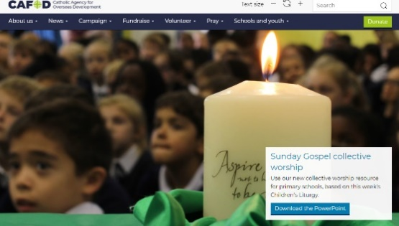Resources Collective Worship based on the Sunday Gospels can be found [here](https://cafod.org.uk/Education/Primary-teaching-resources/Collective-worship-primary)

For prayers, liturgies and reflections click [here](https://cafod.org.uk/Pray/Prayer-resources)

For short video prayers for children see [here](https://cafod.org.uk/Education/Primary-teaching-resources/Children-s-prayers)

Info for the online assembly on Harvest on 8th of Oct is [here](https://cafod.org.uk/News/Events/Harvest-assembly)

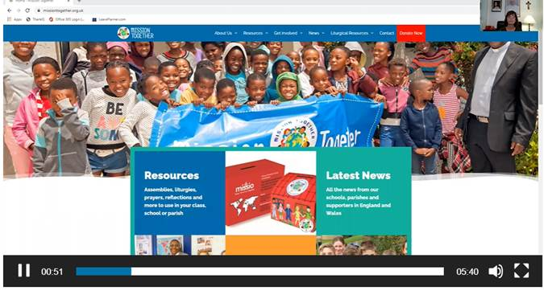Mission Together

have created a short video to explain their FREE resources to support schools during the year for collective worship. It also includes details about their home/school learning materials with cross curricular links as well as their Children’s Liturgy materials linked to the Sunday Gospel. See [here](https://missiontogether.org.uk/about-mission-together/)

Adoration

For links to virtual Adoration click [here](https://www.google.com/search?q=virtual+adoration&rlz=1C1GCEU_enGB893GB894&oq=virtual+adoration&aqs=chrome..69i57j0l4.4126j0j4&sourceid=chrome&ie=UTF-8)

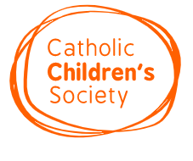Christian Meditation

For weekly videos for primary and secondary settings see [here](https://www.cathchild.org.uk/meditation-with-children-young-people/)

Information on Meditation with children can be found [here](http://www.meditatio.co.uk/christian-meditation-with-children/)

3 Minute Retreats by Loyola Press

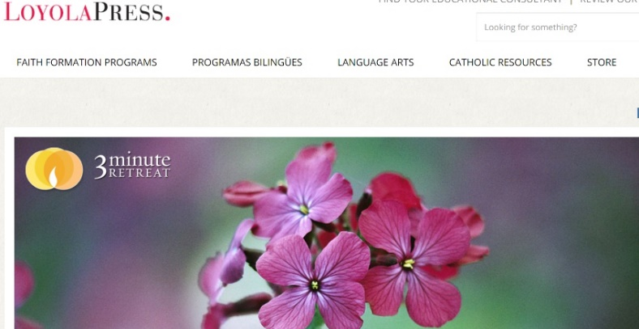Find a daily retreat here or subscribe so that you are sent one every day. Look at the archives or search for one on a particular theme to suit your needs see

<https://www.loyolapress.com/3-minute-retreats-daily-online-prayer/>

Guided Meditations/Visualisations

For examples, see those created by The Good Shepherd Primary in Hammersmith [here](https://www.goodshepherdrc.lbhf.sch.uk/meditation-at-the-good-shepherd/)

For more information and guidance on leading imaginative prayer see [here](https://teachingcatholickids.com/teach-your-kids-imaginative-prayer/)

Lectio Divina

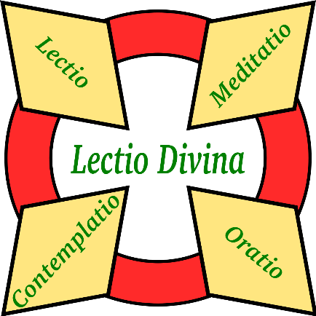A simple explanatory video by St Mary’s Press for staff/pupils/parents see [here](https://www.youtube.com/watch?v=R3_KmsG7Lgc)

For more information to build up own understanding from Busted Halo see [here](https://bustedhalo.com/?s=lectio+divina)

There are some Lectio/ Visio Divina resources from CARFLEO, a Catholic Canadian website [here](https://carfleo.com/?s=lectio+divina)

Rosary

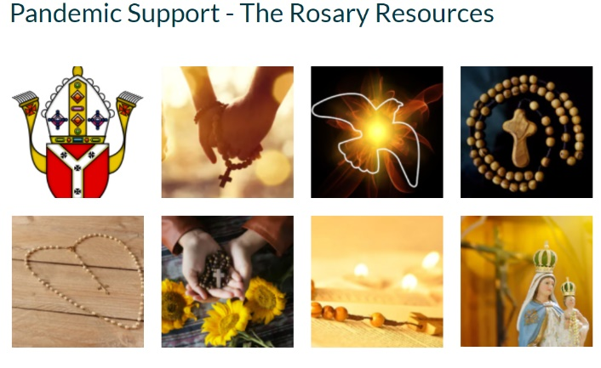For PowerPoints on each decade created by Westminster Education Service which you can amend to suit your setting see [here](https://education.rcdow.org.uk/the-rosary-resources/)

For creating ways of engaging with the Rosary from Loyola Press click [here](https://www.loyolapress.com/catholic-resources/prayer/traditional-catholic-prayers/prayers-honoring-mary/mysteries-of-the-rosary/)

Pope Francis Five Finger Prayer

A prayer for all those in our community using our fingers. It can be used at home or school or for independent use for those of all ages. For various examples of visuals and videos for use with children see [here](https://www.google.com/search?q=five+finger+prayer&rlz=1C1GCEU_enGB893GB894&oq=five+finger+prayer&aqs=chrome.0.69i59j0l4j69i60l3.3992j0j4&sourceid=chrome&ie=UTF-8)

Examen

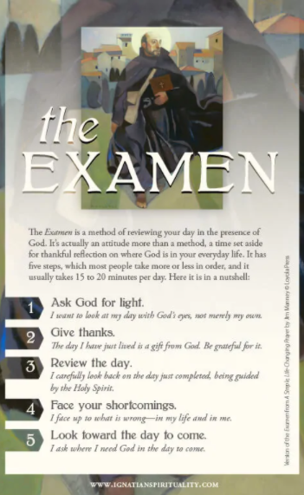For a free, ready-to-use short video for use at home/in school see [here](https://soundcloud.com/pray-as-you-go/examen-for-children)

For use with pupils/teachers, see this short video click [here](https://www.youtube.com/watch?v=JVItxNMrNnw)

A daily Examen for families click [here](https://www.dsj.org/wp-content/uploads/2016/10/STF-Daily-Examen-for-Families.pdf)

For a prayer card to share with pupils:  
https://www.ignatianspirituality.com/wp-content/uploads/2019/06/Examen-Prayer-Card.pdf

Sung Prayers

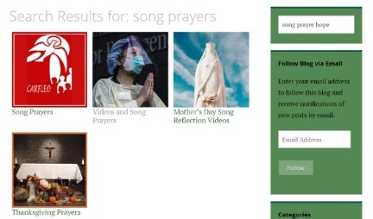For a variety of free sung prayers (with lyrics and appropriate artwork) that can be used for Christian prayer and worship see [here](https://carfleo.com/?s=song+prayers)

Christian Art

For free artwork and a reflection linked to the Gospel of the day which can be used for daily prayer with pupils, staff or parents, subscribe for free by clicking [here](https://www.christian.art/)

Bible Society

For free resources on the Bible for The Year of the Word and a virtual prayer tree see [here](https://www.biblesociety.org.uk/)

Whilst Collective Worship may ‘look’ different initially in your classroom and school, the essential premise remains the same…to provide pupils with meaningful opportunities to share in prayer together.

The resources above (which are mainly free, user-friendly and easily accessible) can support staff with ensuring that prayer and liturgy are meaningful and valuable to the whole community, in time of social distancing and beyond.

Some practical examples for Collective Worship shared by schools:

Below are some examples of what schools are doing about prayer, liturgy and worship during times of Covid. It is not an exhaustive list and is only just the beginning.

General

* Collective Worship can take place as normal but in a socially distanced way
* Pupils can attend Mass or liturgies in their bubbles either in school or in the church (include a risk assessment and check with priest/governors)
* Leaders can check that new routines include prayer and worship and that there is some form of progression throughout the school

Using Technology

* Collective Worship can take place on Zoom/Teams and may be recorded to be shared at an appropriate time
* Whole school prayer/liturgy can have each class represented on screen with a member of each class being a spokesperson
* Weekly assemblies/worship can be recorded and shared in all classes at the same time or at a time suitable for individual bubbles
* The Headteacher could lead a liturgy assembly with a different class each time so they have an opportunity to join in with responses (and recording)

Staff

* A school leader could share expectations with staff so they don’t feel anxious and have clear direction, resources or guidelines where appropriate
* Prayer/liturgy could be organised for staff as a source of hope and strength for them (as well as to provide opportunities for connection)
* Staff could take it in turns to organise and lead prayer virtually for other staff members of their key stage/the whole school

Pupils

* Child-led worship could continue to take place in classrooms/bubbles (eg Using the Acts of Worship Toolkit: Gather, Listen, Respond, Mission) with pupils supporting with the planning and leading of this
* Pupils can support in evaluating current prayer and liturgy provision and offer ideas on how to develop this further for their home and school community
* Pupils could plan/lead worship in style of others eg: Mark 10 Mission
* They can work with teachers to plan an assembly/worship modelled on one from an agency such as CAFOD’s (eg: Harvest)
* They can be creative and forward-thinking eg pupils creating a podcast on the Gospel, creating a worship dance on Tik Tok, using Tablets to organise ideas and resources…
* They can join in with socially distanced singing, humming, actions of songs/readings etc If the weather is clement, singing outside is a popular option

Parents

* Prayer/liturgies/assemblies could be shared with parents or those isolating at home in a safe way (eg Google Classroom/VLE/Dojos)
* Those preparing liturgy can use karaoke music or MP3 Juice with music in the background for hymns or songs used for prayer and worship (if sharing with community, for copyright reasons where appropriate)

Priests

* Priests can choose to visit the school in a socially distanced way following all guidelines, although do discuss this beforehand as some priests may be shielding or may not be able to come in for other reasons
* They could support the community in various ways (eg record a Zoom prayer/blessing, Q and A online for pupils on their topics in class, talking through the Mass virtually). Again, do discuss this with your priest as some may not feel comfortable with using technology and may prefer to support in a different way
* They could support schools if visiting the church to enhance their learning but do ensure that you complete the necessary risk assessment in line with government guidelines and check this with a governor
* They could record a Mass or livestream it for the school/particular classes on a regular basis or for special celebrations or feast days
* They could hold a Eucharistic liturgy or a Liturgy of the Word for a bubble, or record it to share at a special time

Spirituality Days/Retreats

Staff or pupil could have a virtual retreat (eg One Life Music)

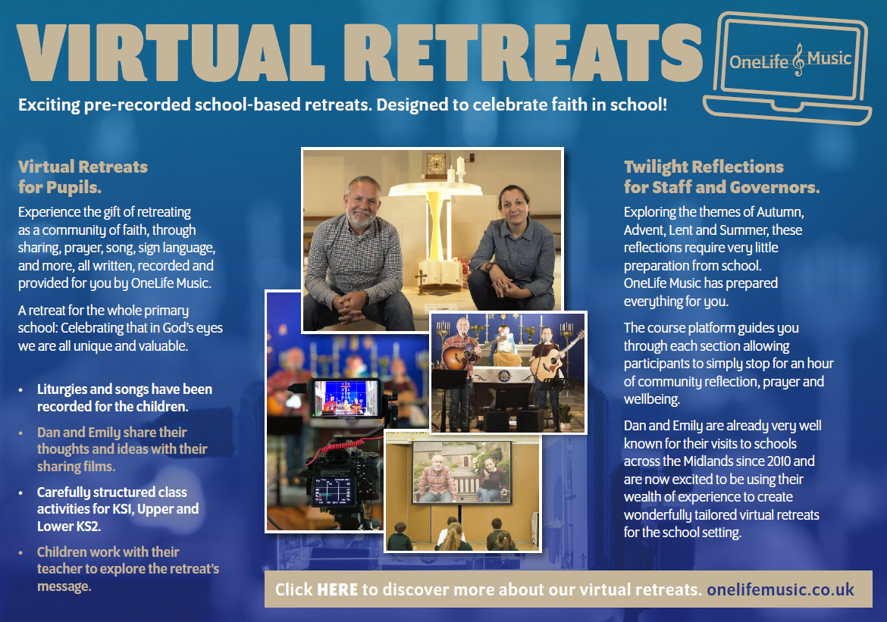

Some other ideas include:

* Picture books (all year groups could do this with an age-appropriate book eg The Three Trees – hopes and dreams) – link this to prayer
* Box – feelings/prayers (eg worry/hopes and dreams)
* Resources to engage/support with individual prayer and reflection (eg leaves, hearts)
* Artefacts (eg prayer stones/wooden crosses)
* Prayer letters/postcards to Jesus (using own words/drawings)
* Visit <https://www.ndcys.com/> for new and inspirational resources to use with young people in the time of Covid.