**Witness to the Word Week 7: School Bulletin 14.10.20**

Dear Colleague in Catholic Education,

The Education Service *every* Wednesday provides schools with a wide variety of materials, resources, advice and updates

on all matters relating to our schools and colleges. The content of these Bulletins are for Headteachers, Senior Leaders,

Teaching Staff, Governors, Clergy and anyone who you feel would benefit from them. Please feel free to share widely.

**Objectives of the Education Service during Coronavirus (Covid-19) pandemic from September 2020**

* To support and training for Headteachers, Heads of RE, RE Coordinators, Governors and the wider school community to cope at this time of unprecedented challenge;
* To provide the updates from the UK Government, DfE, CES and the Diocese of Westminster on all aspects of the Coronavirus Covid-19 relating to schools and colleges;
* To provide resources and advice relating to the Teaching and Learning of RE;
* To provide resources and advice relating to Mental Health issues;
* To provide resources and advice relating to Spiritual support and renewal.

**Subject Content Today**

1. **RE, Catholic Life and Worship Resources ..………………..…………………………………………………………………………… Page 2**
2. **Black History Month ……………………………………………………………………………………………………………………………….. Page 2**
3. **Fratelli Tutti ………………………..…………………………………………………………………………………………………………………. Page 4**
4. **Year of the Word: God who speaks …………………………………………………………………………………………………………. Page 6**
5. **Mental Health Checklist ……………………………..……………………………………………………………………………….…..…….. Page 6**
6. **Capital and Pupil Placement Planning updates ………………………………………………………………………………………... Page 7**
7. **UK Government & DfE Updates ………………………………………………………………………………………………………………. Page 9**

**Thank you for all you are doing for your school community and for Catholic education**

**RE, Catholic Life and Worship Resources**

**October: The Rosary and the Angelus**

As October is the month of the Rosary, it is quite fitting that we have finished the entire set of the Rosary with all the PowerPoints and recordings of the mysteries now available on our website to be used and amended at any time in the future. See [here](https://education.rcdow.org.uk/the-rosary-resources/). If you would like to find out more about Our Lady and the Rosary, please see our Catholicism Unpacked resources [here](https://education.rcdow.org.uk/catholicism-unpacked-new/) as well as other Mary and Rosary resources [here](https://education.rcdow.org.uk/dowry-of-mary-new/). For a child-friendly PowerPoint on Mary’s ‘yes’ with both the original and child-friendly version of the Angelus (which can be used at home and at school at any time of the year) click [here](https://education.rcdow.org.uk/support-resources-catholic-life/)

**Collective Worship**

A number of schools have asked for support with Collective Worship during these unprecedented times. You will find [here](https://education.rcdow.org.uk/support-resources-catholic-life/) a support document with links to free materials for use with primary and secondary pupils as well as staff.

**Upcoming CPD – Online Courses (19th October to 23rd October Inclusive)**

|  |  |  |
| --- | --- | --- |
| Date/Time | Course | Booking Links |
| **19th October**  **9.00am to 3.00pm** | RSE Day 3 | [Single Ticket](https://courses.rcdow.org.uk/event/rse-day-3-online-course-2/) |
| **20th October**  **5.00pm to 6.00pm** | Presenting Officers | [Book Ticket](https://courses.rcdow.org.uk/event/presenting-officers-online-course/) |
| **21st October**  **3.30pm to 5.00pm** | RE in the EYFS | [Single Ticket](https://courses.rcdow.org.uk/event/religious-education-in-the-eyfs-online-course-single-ticket/)  [School Ticket](https://courses.rcdow.org.uk/event/religious-education-in-the-eyfs-online-course-school-ticket/) |
| **22nd October**  **3.30pm to 5.00pm** | Art in RE | [Single Ticket](https://courses.rcdow.org.uk/event/art-in-religious-education-online-course-single-ticket/)  [School Ticket](https://courses.rcdow.org.uk/event/art-in-religious-education-online-course-school-ticket-2/) |

***(Please click on the ticket link to book)***

**Black History Month**

Black history month was first launched in London in the 1980s, where the aim was for the local community to challenge racism and educate themselves and others about the British history that was not taught in schools. At the Education Service we are keen that Black History should not be a feature of one standalone month but should be very much part of British culture and education and we hope it will be a springboard for greater diversity and inclusivity in our schools.

We are grateful to **St Mary's Catholic Secondary School in Bishop Stortford** have produced a powerpoint and worksheet to be used in their Core RE lessons with KS5. They are happy to share these if you contact [L.Barnes@stmarys.net](mailto:L.Barnes@stmarys.net)

Our thanks also go to **St Elizabeth’s Primary in Tower Hamlets** for sharing their newsletter information – see below.

Black History Month is once again our focus for October at St Elizabeth Catholic Primary School. This is a special time where we promote knowledge of black history, culture and heritage.

**Why is Black History Month important?**There has been a lack of representation of black people in history books and school curriculums. Black History Month is a time to remember and celebrate the forgotten people who helped to shape the UK.

**Why should schools teach about Black History Month?**Black History Month is a great way to celebrate and recognise the contribution of black people to British society. Schools play a significant role in teaching children about the importance of having respect and tolerance for all cultures.

**Celebrating Black History Month at our School**We will begin to celebrate BHM the week beginning 5th October 2020. Each year group will be given an influential person to explore and celebrate. **They will learn about this person and showcase this through a display in the hall and record a short video clip of themselves presenting the information or take photos.**

Throughout this month, please feel free to **refer to other black males and females throughout the world who have had an impact on our society, not just limiting yourself to your assigned key person**. For homework during the month of October, please can you **include some History based work related to your assigned individual or it could be about Black History Month in general.**

|  |  |
| --- | --- |
| **Year Group** | **Focus** |
| Nursery | African Patterns & Jewellery |
| Reception | African Patterns & Motown Music |
| Year 1 | John Boyega – Actor |
| Year 2 | Beverly Knight – Singer |
| Year 3 | Anthony Joshua – Boxer |
| Year 4 | Ozwald Boateng – Fashion Designer |
| Year 5 | Malorie Blackman – Writer |
| Year 6 | Maggie Aderin-Pocock – Scientist |

Black History Month might be celebrated differently in school this year, but we will still continue to learn about these individuals and their contributions in class. Please also take the time to speak to your class about their own backgrounds and encourage them to speak about their family’s culture and identity. Instead of bringing in dishes from their country, children can come in dressed in their African or Caribbean Country national dress or bring in photos to show under the visualiser so that they can be shared safely.

**Catholic Association for Racial Justice (CARJ)**

A series of free workshops for School Chaplains, Teachers and others interested in Catholic Education, has been organised by the Catholic Association for Racial Justice with support from CAFOD’s Development Education Fund. The Workshops will attempt to relate key issues to the life of the school. Click [here](https://www.carj.org.uk/2020/09/14/workshops-on-diversity-inequality-and-racism-in-the-uk/) for further details

**Fratelli Tutti**

We are providing a summary of a section of Pope Francis’ Social Encyclical each week taken from [www.vaticannews.va](http://www.vaticannews.va). Click [here](http://www.vatican.va/content/francesco/en/encyclicals/documents/papa-francesco_20201003_enciclica-fratelli-tutti.html) to download the full document.

**Week 2 - Love builds bridges: the Good Samaritan**

The second chapter, “A stranger on the road”, is dedicated to the figure of the Good Samaritan. In it, the Pope emphasises that, in an unhealthy society that turns its back on suffering and that is “illiterate” in caring for the frail and vulnerable (64-65), we are all called – just like the Good Samaritan – to become neighbours to others (81), overcoming prejudices, personal interests, historic and cultural barriers. We all, in fact, are co-responsible in creating a society that is able to include, integrate and lift up those who have fallen or are suffering (77). Love builds bridges and “we were made for love” (88), the Pope adds, particularly exhorting Christians to recognize Christ in the face of every excluded person (85). The principle of the capacity to love according to “a universal dimension” (83) is also resumed in the third chapter, “Envisaging and engendering an open world”. In this chapter Francis exhorts us to go “‘outside’ the self” in order to find “a fuller existence in another” (88), opening ourselves up to the other according to the dynamism of charity which makes us tend toward “universal fulfilment” (95). In the background – the Encyclical recalls – the spiritual stature of a person’s life is measured by love, which always “takes first place” and leads us to seek better for the life of the other, far from all selfishness (92-93).

**Hate Crime Awareness Week**

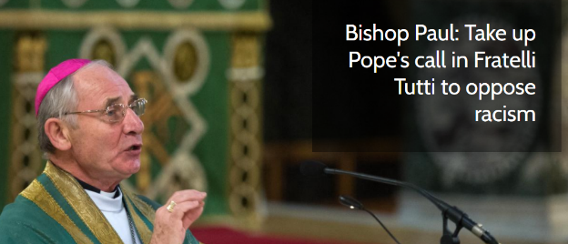Bishop Paul McAleenan, the lead Catholic Bishop for Migrants and Refugees, has called on people in the UK to take up Pope Francis’ call in Fratelli Tutti to oppose racism in all its manifestations.

Speaking on behalf of the Bishops’ Conference at the start of Hate Crime Awareness week Bishop Paul McAleenan said:

'In his latest encyclical *Fratelli Tutti* Pope Francis puts before us a radical vision of human togetherness, addressing fundamental issues such as migration, peace building and the economy.

'One of the challenges he mentions is the need to tackle racism, warning that: “a readiness to discard others finds expression in vicious attitudes that we thought long past, such as racism, which retreats underground only to keep re-emerging. Instances of racism continue to shame us, for they show that our supposed social progress is not as real or definitive as we think."

'Our own society is not immune from this pattern of behaviour. In recent years we have witnessed a disturbing resurgence of hate speech and hate crimes. These take many different forms including Islamophobia, Antisemitism, hatred towards migrants and refugees, and hostility against Gypsy, Roma and Traveller communities.

'During this Hate Crime Awareness Week we should recommit ourselves to actively opposing racism in all its manifestations. In the words of Pope Francis: "Let us dream, then, as a single human family, as fellow travellers sharing the same flesh, as children of the same earth which is our common home, each of us bringing the richness of his or her beliefs and convictions, each of us with his or her own voice, brothers and sisters all."'

**Carlo Acutis**

Carlo Acutis was beatified on Saturday 10th October 2020 at the basilica in Assisi. Carlo lived most of his life in Italy, but what is less well-known is Carlo’s connection with the Church of Our Lady of Dolours on Fulham Road, in London.

Carlo was born in London on 3rd May 1991 to Italian parents and was baptised at Our Lady of Dolours on 18th May of the same year by Fr Nicholas Martin OSM, Parish Priest at the time. The family moved to Italy shortly afterwards where Carlo was raised in the same active faith as his parents. Having made his First Holy Communion at the age of seven, he made the decision to attend Mass and pray the Rosary daily. He said, ‘By standing before the Eucharistic Christ, we become holy.’ He also had a routine of weekly confession. By the age of 11, he became a catechist.

‘He was a remarkable young man, who had a great understanding of the sacraments and scripture’, explains Fr Patrick Ryall OSM, current Parish Priest of Our Lady of Dolours.

Fr Patrick added: ‘We’re grateful that Carlo and his family had that time with our parish. We are sure he will be a source of blessing for us.'

Carlo learned about the known sites of Eucharistic miracles around the world and expressed a keen desire to go on pilgrimage to see these sites. Unfortunately, he developed leukaemia, which made this impossible. He offered his suffering for the Pope and the Universal Church. To help others learn to grow in devotion to the Eucharist, he used his digital media skills to develop a website to catalogue each of these miracles. One of the Eucharistic Miracles that Carlo highlights is that connected with St Juliana, Foundress of the Servite Sisters on her death bed.

Carlo died in 2006 at the age of 15. His cause was opened in 2013 and he was declared a Servant of God. On 5th July 2018, Pope Francis declared him to be venerable. Beatification is the final step before sainthood and was helped when a young Brazilian sought Carlo Acutis' intercession in healing from a serious pancreatic disease. In February this year, the Pope approved a miracle attributed to him.

**The Year of the Word – The God Who Speaks**

As mentioned previously, the official ‘The God Who Speaks’ website continues to go from strength to strength, particularly in terms of the material available to support our schools.

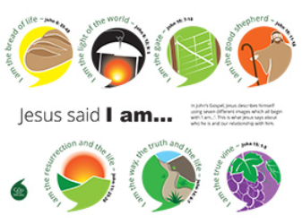As part of the education section, a wide variety of posters are now have been added which can be downloaded directly [here](https://www.godwhospeaks.uk/the-god-who-speaks/education/posters-for-schools/).

These include the following:

* Jesus Said, ‘I Am.’
* 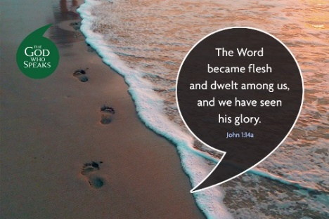12 Apostles
* 10 Catholic Symbols

Previous posters related to the Gospels of both Matthew and Mark are also available, along with a ‘Catholic Bookshelf’ poster. This week’s poster is based on John 1:14a.

Please remember that you can also download a ‘Weekly Scripture’ poster by clicking on the following link [here](https://www.godwhospeaks.uk/the-god-who-speaks/weekly-bible-verse/).

## **Mental Health and wellbeing Checklist :** A Whole School Approach

**Mentally Healthy Schools -** this charity provides a wide range of information, resources and support linked to mental health and well-being within school. The following links provide information to support the development of a whole school approach to mental health and wellbeing within your school:

[Click here](https://www.mentallyhealthyschools.org.uk/whole-school-approach/learnmore/) for information on how to adopt a whole school approach to mental health and wellbeing within your school.

[Click here](https://www.mentallyhealthyschools.org.uk/whole-school-approach/england/understanding-the-mental-health-landscape-in-england/) for information on the mental health landscape of England

[Click here](https://www.mentallyhealthyschools.org.uk/whole-school-approach/england/mental-health-on-the-curriculum-in-england/) a brief guide to mental health on the school curriculum

[Click here](https://www.mentallyhealthyschools.org.uk/whole-school-approach/england/mental-health-services-for-schools-in-england/) a brief guide to mental health services for schools in England

[Click here](https://www.mentallyhealthyschools.org.uk/whole-school-approach/england/showcasing-activity-for-ofsted/) showcasing activity for OFSTED

[Click here](https://www.mentallyhealthyschools.org.uk/whole-school-approach/parentcarer-engagement/) Parent/carer Engagement

[Click here](https://www.mentallyhealthyschools.org.uk/whole-school-approach/childrens-voice/) Children’s Voice

[Click here](https://www.mentallyhealthyschools.org.uk/whole-school-approach/supporting-staff-wellbeing/) Supporting Staff Well-being

[Click here](https://www.mentallyhealthyschools.org.uk/mental-health-needs/rebuild-and-recover-resources/) Rebuild and recover resources to support children and staff after lockdown

[Click here](https://www.mentallyhealthyschools.org.uk/resources/) for resources to support World Mental Health Day

[Click here](https://www.mentallyhealthyschools.org.uk/media/2267/world-mental-health-day-2020-toolkit.pdf) for the Toolkit –for World Mental Health Day “Celebrating difference”

[Click here](https://www.mentallyhealthyschools.org.uk/media/1831/toolkit-wmhd.pdf) for the 2019 Toolkit for previous World Mental Health Day

Young Minds – Hello Yellow Campaign

[Click here](https://youngminds.org.uk/get-involved/how-to-fundraise/helloyellow-resources/) for primary and secondary school resources for the Hello Yellow campaign

[Click here](https://youngminds.org.uk/get-involved/how-to-fundraise/helloyellow/#for-schools) for more information about the Hello Yellow campaign

## **The DfE has announced extra funding for mental health and well-being for schools, including funding for their** Wellbeing for Education Return programme. [Click Here](https://www.gov.uk/government/news/8m-programme-to-boost-pupil-and-teacher-wellbeing)  **for the DfE news link**.

The Wellbeing for Education Return programme is a joint initiative from the Department for Education, Department of Health and Social Care, Health Education England, NHS England and Public Health England. The programme supports staff working in schools and colleges to respond to the additional pressures some young people may be feeling as a direct result of the Covid-19 pandemic, as well as to any emotional response they or their teachers may be experiencing.  Content for this programme has been developed by MindEd with input from mental health and education experts. [Click Here](https://www.minded.org.uk/) to register at MindEd and gain access to the programme’s webinar training.

**DfE Mental Health and Wellbeing training material for teachers**

The DfE have also produced training materials for schools linked to mental wellbeing as part of the new Health Education curriculum launched in the Autumn Term. [Click Here](https://www.gov.uk/guidance/teaching-about-mental-wellbeing)

**DfE guidance for parents on Mental Health and Wellbeing**

The DfE has also created guidance for parents and carers on supporting children’s mental health and wellbeing during the COVID pandemic [Click Here](https://www.gov.uk/government/publications/covid-19-guidance-on-supporting-children-and-young-peoples-mental-health-and-wellbeing/guidance-for-parents-and-carers-on-supporting-children-and-young-peoples-mental-health-and-wellbeing-during-the-coronavirus-covid-19-outbreak)

**Capital & Pupil Placement Planning**

**VASCA 2020/2021**

More of the wave 2 projects have joined the programme this week.

**Statlog**

A significant number of site surveys are planned for the end of this month (half-term). These will ensure that the needs of your school are reflected in the overall Diocesan Asset Management Plan.

If you have not arranged for the Statlog Baseline Survey etc, please contact your retained buildings consultant urgently. All data must be uploaded by the 31 January 2021 to ensure that your needs are considered.

**CAUTION**: Schools that choose to delay their engagement with Statlog will not have any access to strategic level capital funding in the 2021/22 financial year. This includes Emergency Funding should your school experience an unexpected loss/breakdown. It is advisable to document this point for your Governing Body as the responsibility for the maintenance of the asset rests with them.

**Insurance**: Please ensure that all statutory tests are completed on time. Failure to demonstrate robust compliance management could invalidate your capital insurance cover and jeopardise the future of your school. Statlog is designed to help you manage Statutory Compliance efficiently and the information it contains will be available to loss adjusters.

**Priority School Building Programme**

Project managers continue to monitor the progress of schools in this scheme.

**Pupil Placement Planning**

**1st Planner Project**

The Project’s Oversight and Scrutiny Committee is expected to meet before the end of November. Their deliberations will determine the direction of Stage 3. Diocesan colleagues are currently considering potential partnerships and delivery models that will protect the integrity of the Diocesan Charitable Status and deliver its mission.

**Lighthouse**

This year, Lighthouse has been commissioned to facilitate the collation of Catholic School data. Click [**HERE**](https://forms.office.com/Pages/ResponsePage.aspx?id=06LxYAK5WEqE951qVoGKkc0u_6UKUSZHiPP2IDYC389URE5YU0hDWjQ1QzNKVzhWRlY1VENJT0lWSy4u) to fill out the Diocesan October Census. Thank you for supporting this initiative.

**Drug Incidents in Schools**

A number of school aged children from Camden have recently been taken to hospital having taken Nerds sweets containing **Tetrahydrocannabinol**, as recently reported in the news.  (THC is the principal [psychoactive](https://en.wikipedia.org/wiki/Psychoactive_drug) constituent of cannabis)

Below is a photograph of the sweets, which has been shared by the police in Camden:

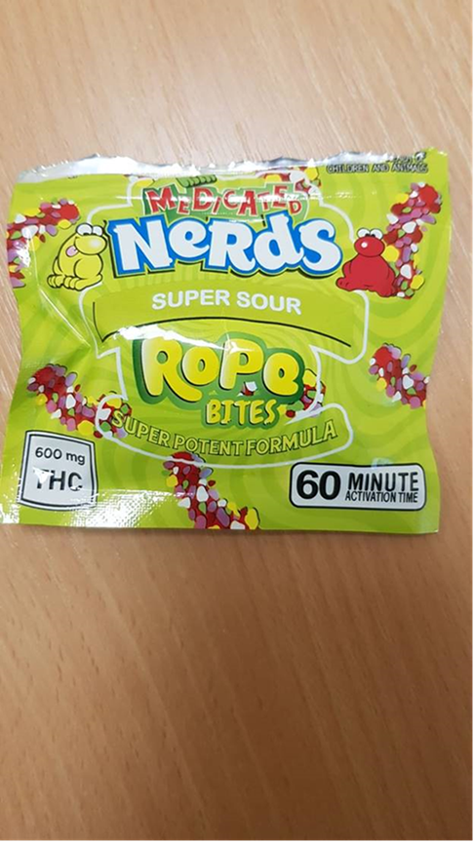

Schools may wish to share this with their school community.

In addition, [https://www.talktofrank.com](https://eur01.safelinks.protection.outlook.com/?url=https%3A%2F%2Fwww.talktofrank.com%2F&data=02%7C01%7CEmma.Smethurst%40phe.gov.uk%7Cd5743f34ce6746afa35508d86a0a84c3%7Cee4e14994a354b2ead475f3cf9de8666%7C0%7C0%7C637375940688992588&sdata=WUMESgnERVs04nprd0ydGyztO7%2Fr8TXHKdwxzVSBVcM%3D&reserved=0) is an online resource which children and parents can go to for easily accessible information on drug awareness.

**UK Government & DfE Updates and links;**

**Maintaining Educational Provision for Vulnerable and Key Worker Children:**

**Guidance Updates as of 07.10.20**

**DfE Guidance**

Please see below links to the most recent DfE guidance that has been issued to schools and colleges.

* **Changes to the school exclusion process during the coronavirus (COVID-19) outbreak** – updated 5 October 2020

<https://www.gov.uk/government/publications/school-exclusion/changes-to-the-school-exclusion-process-during-the-coronavirus-outbreak>

* **Coronavirus (COVID-19): travel advice for educational settings** – updated 5 October 2020

<https://www.gov.uk/government/publications/coronavirus-covid-19-travel-advice-for-educational-settings>

* **Safeguarding and remote education during coronavirus (COVID-19)** – updated 6 October 2020

<https://www.gov.uk/guidance/safeguarding-and-remote-education-during-coronavirus-covid-19>

* **School census 2020 to 2021: technical information** – updated 6 October 2020

<https://www.gov.uk/government/publications/school-census-2020-to-2021-technical-information>

* **Early years foundation stage statutory framework (EYFS)** – updated 7 October 2020

<https://www.gov.uk/government/publications/early-years-foundation-stage-framework--2>

* **Coronavirus (COVID-19): test kits for schools and FE providers** – updated 7 October 2020

<https://www.gov.uk/government/publications/coronavirus-covid-19-home-test-kits-for-schools-and-fe-providers>

* **School governance update** – updated 8 October 2020

<https://www.gov.uk/government/publications/school-governance-update>

* **School resource management self-assessment tool** – updated 9 October 2020

<https://www.gov.uk/government/publications/school-resource-management-self-assessment-tool#history>

**Catch up funding for schools**

The first instalment of the catch-up premium is expected to be provided to Local Authorities on 1 October 2020 and will be passed onto schools soon after on the basis of the allocations published. This will be 25% of the provisional total for the year based on the October 2019 census.

<https://www.gov.uk/government/publications/coronavirus-covid-19-catch-up-premium-provisional-allocations>

The second instalment is expected in the spring term and the final one in the summer. These will be adjusted for the updated pupil number data from the October 2020 census. Catch up funding can be spent to support pupils who may have fallen behind during lockdown and the wider re-opening of schools in the summer term.

Schools may choose to spend it on interventions, the purchases of devices or other resources in line for DfE guidance

<https://www.gov.uk/guidance/coronavirus-covid-19-catch-up-premium>

The National Tuition Programme is also available to support catch up. More information about what it can offer can be found here: <https://nationaltutoring.org.uk/faqs>

**NHS COVID-19 app**

The NHS COVID-19 app is part of the NHS Test and Trace service and will be used, alongside traditional contact tracing, to help notify you if you have come into contact with someone who tests positive for coronavirus.

The app will:

* allow you to report symptoms
* order a coronavirus test
* check in to venues by scanning a QR code

Any data shared with the app is held on your phone. Nobody, including the government, will know who or where you are, or where you have been. You can delete the app and all data at any time. Please see the [video explainer](https://www.youtube.com/watch?v=fp0kHcr_Pi4&feature=youtu.be) introducing the app for more detail. More information can be found at: [www.covid19.nhs.uk](http://www.covid19.nhs.uk/). Please download it and encourage your staff, family and friends to do the same. The app is for anyone aged 16 and over.

**How to tell the difference between a common cold and Covid-19**

Most people who feel ill with coronavirus [**will have at least one of the key symptoms:**](https://www.bbc.co.uk/news/health-51048366)

* a high temperature
* a new, continuous cough
* a loss or change to their sense of smell or taste

The BBC have produced a video explaining the differences which schools may find helpful

<https://www.bbc.co.uk/news/health-54145299>

**Remote education provision in primary and secondary schools**

You will have received information from DfE on Friday about providing immediate remote education for pupils who are self-isolating, you can read the guidance in full at:

<https://www.gov.uk/government/publications/remote-education-good-practice?utm_source=2%20October%202020%20C19&utm_medium=Daily%20Email%20C19&utm_campaign=DfE%20C19>

There are two free national school webinars run by DfE you can attend:

[https://www.gov.uk/guidance/remote-education webinars?utm_source=2%20October%202020%20C19&utm_medium=Daily%20Email%20C19&utm_campaign=DfE%20C19](https://www.gov.uk/guidance/remote-education%20webinars?utm_source=2%20October%202020%20C19&utm_medium=Daily%20Email%20C19&utm_campaign=DfE%20C19)

**Ofsted COVID-19 Series**

Via the link below, please find briefing notes and a commentary from Amanda Spielman, Ofsted Chief Inspector, about providers that have been visited or spoken to by Ofsted during the interim phase of their return to routine inspection.

<https://www.gov.uk/government/collections/ofsted-covid-19-series>