Witness to the Word - School Bulletin 11.11.20

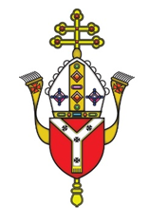
Dear Colleague in Catholic Education,
The Education Service every Wednesday provides schools with a wide variety of materials, resources, advice and updates on all matters relating to our schools and colleges. The content of these Bulletins are for Headteachers, Senior Leaders, Teaching Staff, Governors, Clergy and anyone who you feel would benefit from them. Please feel free to share widely

Objectives of the Education Service during Coronavirus (Covid-19) pandemic from September 2020
- To provide support and training for Headteachers, Heads of RE, RE Coordinators, Chaplains, Teachers, Governors and the wider school community to cope at this time of unprecedented challenge;
- To provide resources and advice relating to the Teaching and Learning of Religious Education;
- To provide resources and advice relating to Spiritual support and renewal.
- To provide resources and advice relating to Mental Health issues;
- To provide the updates from the UK Government, DfE, CES and the Diocese of Westminster on all aspects of the Coronavirus Covid-19 relating to schools and colleges;

Subject Content Today
- Religious Education and Catholic Life resources are here
- Information about upcoming CPD and Training is here
- Caritas Update is here
- SPEC and Youth Ministry Update is here
- Mental Health and Wellbeing Resources are here
- Capital and Pupil Placement Planning updates are here

Thank you for all you are doing for your school community and for Catholic education

Religious Education and Catholic Life Resources

Guidance re Liturgy in school
The Education Service has received a number of requests to provide guidance about the celebration of liturgies in schools, including Mass, under The Health Protection (Coronavirus, Restrictions) (England) (No. 4) Regulations 2020 which came into force last week. The Regulations permit schools to remain open for the purposes of education. This means that schools are permitted to continue to undertake any of their normal activities subject to appropriate risk-assessments and sign-off at the appropriate level, having had regard to the latest government guidance. Collective worship, including the celebration of Mass, would fall within these potentially permitted activities within the parameters described above. The latest DfE Guidance for schools can be found here:

Questions have also been raised about the position of school chapels, following the general closure of places of worship. The Regulations contain an exemption which allows places of worship to be used for the purposes of education. Therefore, provided the activity is one which would be permitted elsewhere in the school, it will be equally permitted by the Regulations if it takes place in the school chapel. The exemptions set out above do not, however, permit any of the activities mentioned to be open to visitors from outside those who are attending school to receive education or are necessary for the school to deliver education.

Please note however that the fact that an activity is still permitted by the Coronavirus Legislation is not an indication that it is necessarily safe to carry it out, and ultimately it is for the school to make the decisions about whether, how and by whom such activities are undertaken based on a robust risk assessment.

Christmas Card Design 2020
We would like to invite all schools to submit entries to our Christmas card competition this year. The winner will be the official design for the Education Service Christmas card.
Please encourage your students to design a card based on the following theme:

‘They will call him Immanuel’ (God with us)
Please submit a high quality electronic copy to Elaine Arundell elainearundell@rcdow.org.uk by 22nd November 2020. Please submit no more than one entry per phase group and ensure that the child’s name, year group, school and deanery is included within the email.

Anti-bullying week 16th-20th November
The Bullying and Belief toolkit is a resource to support schools to deal with the topic of religious bullying. It contains five 60-minute lessons for Primary and Secondary schools, with resources and films on which to base your teaching within lessons. The toolkit also contains resources for organising assemblies around this theme.
Bullying and Belief Toolkit Booklet Aug 2020. With thanks to NATRE there is also a super range of anti-bullying lessons and assemblies for both primary and secondary available for free. Click here

Fratelli Tutti
We are providing a summary of a section of Pope Francis’ Social Encyclical each week taken from www.vaticannews.va. Click here to download the full document.

Week 5: Politics: valuable form of charity
The theme of the fifth chapter is “A better kind of politics”, which represents one of the most valuable forms of charity because it is placed at the service of the common good (180) and recognizes the importance of people, understood as an open category, available for discussion and dialogue (160). In a certain sense, this is the populism indicated by Francis, which counters that “populism” which ignores the legitimacy of the notion of “people”, by attracting consensuses in order to exploit them for its own service and fomenting selfishness in order to increase its own popularity (159). But a better politics is also one that protects work, an “essential dimension of social life”, and seeks to ensure everyone the opportunity to develop their own abilities (162). The best help to a poor person, the Pontiff explains, is not just money, which is a provisional remedy, but rather allowing him or her to have a dignified life through work. The true anti-poverty strategy does not simply aim to contain or render indigents inoffensive, but to promote them in the perspective of solidarity and subsidiarity (187). The task of politics, moreover, is to find a solution to all that attacks fundamental human rights, such as social exclusion; the marketing of organs, tissues, weapons and drugs; sexual exploitation; slave labour; terrorism and organized crime. The Pope makes an emphatic appeal to definitively eliminate human trafficking, a “source of shame for humanity”, and hunger, which is “criminal” because food is “an inalienable right” (188-189).
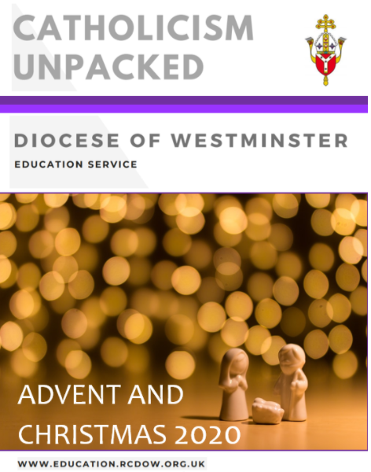
Catholicism Unpacked: Advent and Christmas
We are delighted to share with you our new Advent Support Document which has been created to improve the subject-knowledge of all staff and so support you with planning and teaching. It is also hoped that it will save you lots of much-needed time and energy looking for resources for prayer and liturgy as well as charitable acts for this season. This is an interactive document so there are various hyperlinks throughout to various other pieces of information such as articles, reflection and resources for teaching. We hope you find it useful. Click here
Please note that it has information for the lead up to Advent including the World Day of the Poor (15th November) and the feast of Christ the King (Sunday before the beginning of Advent). The document also includes readings for each week as we will be in Year B: St Mark as well as other new materials relevant for social distancing and blended learning. Should you have any feedback or questions about it, please contact elainearundell@rcdow.org.uk
Mark 10 Mission
Every week, Mark 10 Mission creates a short video for pupils based on the Sunday Gospel. The free liturgy includes a reading, homily, prayer and song which are relevant for pupils of various ages.
For Series Two which includes liturgies for this term, click here.

The Year of the Word – The God Who Speaks
This Week's Bible Verse
The Bible is the most important book we have. Our faith is rooted in Sacred Scripture. Scripture inspires learning, culture, art, music and literature. With a renewed love of Scripture comes the opportunity and desire to share it with others. With its 73 books, it offers an incredibly detailed picture of the story of the Creator and His creation. We can literally hear the word of the living God spring from its pages. Each week, you can download a weekly Bible verse from the God Who Speaks website: This week's verse is from Matthew 24:44: Click here to access the Weekly Bible Verse archive.
Scripture based Novena
Please find here an excellent Scripture-based Novena from the national Spirituality Committee which they’ve prepared to assist people praying for the dead during this month. On each day a different group is prayed for, including those who have lost their lives during this Pandemic.
Scripture Soundbites
Please click here for super Scripture Soundbites for Tutors to use with their Forms in the daily act of collective worship, from a High School in Liverpool Archdiocese. The Scripture Soundbites are 2 minute invitations to reflection on the Sunday gospels and starters for discussion.

Justice, Equality and Diversity
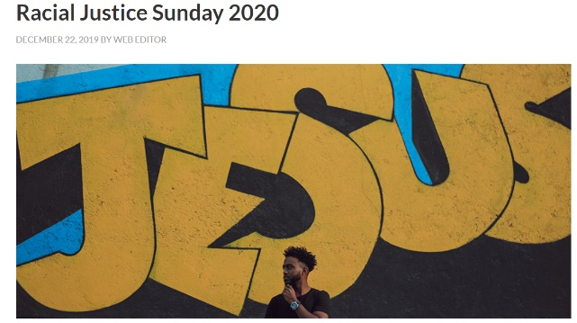
Racial Justice Sunday
At the beginning of September every year, the Church in England and Wales celebrates Racial Justice Sunday. This was not promoted this year due to the challenges with Covid at the beginning of this academic year. However, the website has lots of useful resources including prayers, powerful poetry and quotes from recent popes. For resources click here.

Recommended Reading for Racial Justice.
Click on the books for further details
- The Inner Work of Racial Justice: Healing Ourselves and Transforming Our Communities Through Mindfulness
- Racial Justice and the Catholic Church
- White Fragility: Why It's So Hard for White People to Talk About Racism
- Becoming Brave: Finding the Courage to Pursue Racial Justice Now
- Uprooting Racism - 4th Edition: How White People Can Work for Racial Justice
BAME stories for pupils
To guide parents with suitable literature for primary school age pupils that might serve as Christmas presents, see attached our BAME book catalogue.
If you haven’t seen The danger of a single story – Chimamanda Ngozi Adichie, it’s a really excellent starting point for diversity discussion with older pupils.
Sky News of Ms Aninakwa on Black History and the Curriculum
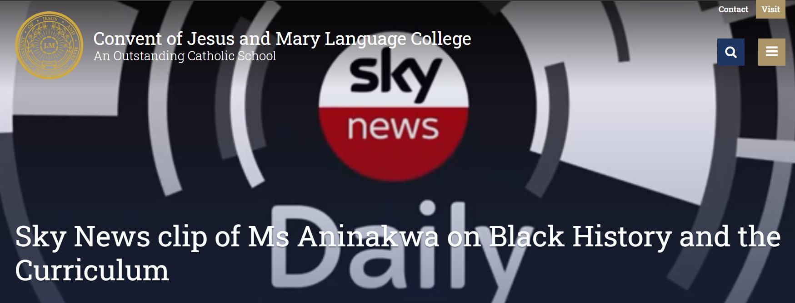
See here for a video clip from the Convent of Jesus and Mary Language College.
BAME saints
There are a number of inspirational BAME saints and holy men and women with which our communities are not familiar. Why not encourage your pupils to find out more about the following:
1. Venerable Pierre Touissant a Haitian Slave
2. Mary Elizabeth Lange founder of the Oblate Sisters of Providence
3. Venerable Henriette De Lille Sisters of the Holy Family
4. Venerable Augustus Tolton
5. Sr Thea Bowman Franciscan
Some other examples include: St Anthony the Great of Thebes, St Anthony Veira SJ, St Augustine, St Benedict the Moor, St Bakhita, St Bessarion, St Felicitas, St Katherine Drexel, St Martin de Porres, St Monica of Tegaste, St Moses the black and St Perpetua.
BAME Ed Network
This website is very useful for resources including videos on various issues. To find out more, click here.
Free CAFOD CPD supported by the British Council – Available online
‘Everything is Connected: enrich school life through global learning.’
Inspired by Catholic Social Teaching, this course looks at our fundamental interconnectedness, providing practical tools, resources and teaching activities to enrich your curriculum and inspire students to put their faith into action, as part of a global family. Exploring human relationships that are rooted in human dignity, the course also opens up the challenges of differing perspectives, and how we can develop a culture of encounter. With opportunities for reflection, the well being of staff is supported through the positive, uplifting and active message of Laudato Si’.
Training, resources and course content folder provided free of charge.
The existing public course dates can be found here and anyone is welcome to sign up:
Schools are welcome to contact CAFOD for bespoke, flexible INSET:
bfriery@cafod.org.uk or schools@cafod.org.uk

Upcoming CPD – Online Courses November 2020

Date/Time | Course | Booking Links
16th- 18th November  5.00pm to 7.00pm | Introduction to Governorship Three Part Course | Single Ticket  School Ticket
19th November  9.00am to 10.30am | Continuing Development for the NQT | Single Ticket  School Ticket
19th November  5.00pm to 6.00pm | Chair of Governors Briefing | Book Ticket
23rd November 3.00pm to 5.00pm | Primary Moderation | Book Ticket
24th November  5.00pm to 6.00pm | Diocesan Inspection for Governors | Book Ticket
25th November  3.30pm to 5.00pm | Music in Religious Education | Single Ticket  School Ticket
26th November  9.00am to 10.00am | REC Surgery | Book Ticket
27th November  9.30am to 3.30pm | Heads of RE Day | Single Ticket
30th November  3.00pm to 5.00pm | Primary Moderation | Book Ticket
(Please click on the ticket link to book)

Caritas Westminster

Mitzvah Day – World Day of the Poor

Sunday 15th of November sees the celebration of both Mitzvah Day and World Day of the Poor.

In order to support both of these marvellous initiatives, Rosa Lewis (Caritas Westminster) and Georgina Bye (CEO of Mitzvahday.org) have been working together to promote these worthy causes in schools and parishes throughout the diocese.

Rosa Lewis – Caritas Westminster
‘World Day of the Poor was established by Pope Francis in 2016 at the end of the Extraordinary Jubilee of Mercy. He said WDOTP is: 'a day to help communities ... to reflect on how poverty is at the very heart of the Gospel and that, as long as Lazarus lies at the door of our homes (cf. Lk 16:19-21), there can be no justice or social peace.' For Caritas Westminster the day is emblematic of our mission.
The theme for this years' WDOTP is 'Stretch forth your hand to the poor', which is a line taken from the book of Sirach in the Old Testament.
For the past two years Mitzvah Day, the SVP and Caritas Westminster have worked together with Jewish and Catholic schools so that children can get involved with putting together ‘Vinnie Packs’ for the homeless.
Vinnie Packs are an initiative of the St Vincent de Paul Society. Each year, over 10,000 Vinnie Packs are distributed across the UK.
Each pack contains cold weather essentials including a hat, gloves and socks which are all thermal, toothpaste, toothbrush, pen and information card.
How might you mark Mitzvah Day/World Day of the Poor?’

Georgina Bye – Mitzvah Day
Mitzvah Day brings people of all faiths, backgrounds and ages together to do good deeds to improve your neighbourhood and support local causes!
You can join us this month, as we fill lockdown with kindness with A Month of Mitzvahs. Register here to get involved and you can see ideas for Covid-safe Mitzvah Day projects here.
Any questions feel free to get in touch with the Mitzvah Day team on info@mitzvahday.org.uk or call 0203 747 9960.

As part of this, they have created a promotional video to accompany their efforts; click on the following link to view this highly informative video: https://youtu.be/nbJptRFPpVM
Sincere thanks to Nigel Spears for ‘weaving his magic’ in the creation of this video.

Advent Giving Calendar
After a great response last year Caritas Westminster are pleased to share with you this year’s ‘Advent Giving Calendar’ to mark World Day of the Poor. It follows the concept of a ‘reverse’ Advent Calendar and gives suggestions for items to collect each day to donate to a local foodbank or food poverty project in time for Christmas. The calendar has information to help you find local projects to support, and is also a way for families to find support without stigma. This year we know running a big collection in school might not be possible but please do share the calendar with families so everyone can take part at home. We have also created an accompanying powerpoint and session plan which suggest lots of ways to mark World Day of the Poor this year, when help is needed more than ever. Please email cfc@rcdow.org.uk with any questions and please share pictures and stories with us if you do take part.

Operation Christmas Elf - Gifts for prisoners’ children
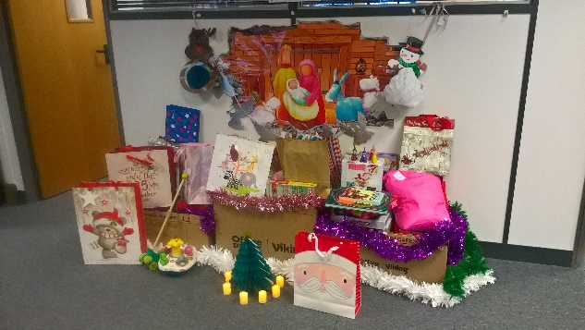
For the last few years Caritas Westminster has partnered with PACT to help collect presents for the children of prisoners, who often face stigma and loneliness whilst their parent is in prison. The project allows the imprisoned parent to give the donated gift to their child for Christmas. Usually they ask people to donate presents directly, but unfortunately because of the pandemic this is not possible. This year they are asking that people buy book tokens and send them to the PACT office so these can be sent to the children instead. You can find all the information about how to get involved in this important project here. Please note the deadline to take part this year is 23rd November to allow time for the book tokens to reach PACT and for them to distribute them before Christmas, so this activity would need to be done before Advent. Please let Caritas Westminster know if you are taking part and if we can help in anyway.

SPEC and Youth Ministry

Senior Retreat Leader Recruitment
We are looking to appoint for the role of ‘Programmes Senior Retreat Leader’ for SPEC Retreat Centre for the Diocese of Westminster.

Job Title: Programmes Senior Retreat Leader
Location: SPEC (Pinner, Middlesex)
Salary- £33,000 per annum

As a Programmes Senior Retreat Leader you will be expected to design, co-ordinate, lead and
deliver one-day and residential retreat programmes for young people from schools and parish
groups and will be responsible for the recruitment and management of retreat leaders and
volunteers. This is a non-residential post that will require high level of organisation, creativity
and commitment to the mission of SPEC Retreat Centre that is part of the Diocese of
Westminster Youth Ministry.

Applicants should be practising Catholics, ideally with a professional qualification or its
equivalent and possess relevant experience of working with young people; and the right to
work in the UK.

The role is subject to satisfactory references and a DBS Enhanced Level Disclosure and Barred
List check.

Hours of work: Full-time contract of 35 hours per week.

Holiday: 23 days a year + public holidays + discretionary days

Closing date: 12 noon on Monday, 7 December 2020

Interview date: Thursday, 10 December 2020

For a full job description of the role and application form, please click here

Mental Health and Wellbeing Resources

Anti-Bullying Week and Friendship Friday - Monday 16th to Friday 20th November
Anti-Bullying Alliance Click Here - A range of resources to support schools for this year’s theme entitled ‘United Against Bullying’
Bullying UK Click Here – As part of anti-bullying Week – the organisation has a campaign called ‘Wear Blue for Well-being’
BBC - Click Here – The BBC have produced a range of resources to support schools during Anti-bullying week
Mentally Health Schools Click Here – A useful resource signposting organisation and resources to assist in support Anti-bullying Week
Kidscape UK Click Here – Download useful resources to support Anti-bullying week and a pack to celebrate Friendship Friday
Young Minds - Click Here for copy of the guide - More information on combatting bullying can be found here Click Here

Mental Health Champions Foundations Programme
An online children’s mental health training course developed to enhance professionals’ understanding of children’s mental health and introduces approaches that foster positive wellbeing in schools. The course is free to qualified teachers and school-based staff in the UK, and is carried out at a time and pace that is convenient to you. To book onto the course which starts on 20th November, click here

Capital and Pupil Placement Planning Updates

Capital
Condition Data Collection – Round 2
The Government is about to commence of the second round of Condition data Collection (CDC). The CDC1 programme ran from 2017 to 2019. CDC1 visited every government funded school in England and collected information about the condition and management of school buildings. The data collected provided a robust evidence base to enable the Department for Education to target capital investment in the school estate to where it is most needed, and to make the case for further capital funding for school buildings.
To provide a credible picture of changing investment needs over time, the Government needs to refresh that data. They plan to run a successor programme - CDC2 - from 2021 to 2026. CDC2 will collect similar information to CDC1 and will follow a similar process, with improvements based on feedback from CDC1, including how and when collected data is shared with schools and responsible bodies.
The Government is mindful of the challenges associated with visiting schools over the coming months and beyond during the coronavirus (COVID-19) pandemic and want to work closely with local authorities, multi-academy trusts and dioceses to ensure that they collect a complete condition dataset on all schools. The DfE is monitoring the situation closely
Within the Diocese of Westminster, the following Catholic Schools and Academies are listed as provisional for tranches 1 and 2:
URN | Establishment Name | LA (name) | Academy Trust | Proposed CDC2 Tranche
100347 | St Augustine's RC Primary School | Hammersmith and Fulham |  | 1
101146 | Westminster Cathedral RC Primary School | Westminster |  | 1
101364 | St James' Catholic High School | Barnet |  | 1
138354 | St Thomas More Roman Catholic Primary School | Hertfordshire | THE DIOCESE OF WESTMINSTER ACADEMY TRUST | 1
100496 | St Joseph's Catholic Primary School | Kensington and Chelsea |  | 2
101128 | St Edward's Catholic Primary School | Westminster |  | 2
101335 | St Theresa's Catholic Primary School | Barnet |  | 2
102058 | St Ignatius College | Enfield |  | 2
102421 | St Swithun Wells Catholic Primary School | Hillingdon |  | 2
102426 | Sacred Heart Catholic Primary School | Hillingdon |  | 2
117470 | St Adrian Roman Catholic Primary School | Hertfordshire |  | 2
117483 | St Cross Catholic Primary School | Hertfordshire |  | 2
117491 | Saint Alban and St Stephen Catholic Primary School | Hertfordshire |  | 2
117496 | Pope Paul Catholic Primary School | Hertfordshire |  | 2
125214 | St Ignatius Catholic Primary School | Surrey |  | 2
125233 | St Michael Catholic Primary School | Surrey |  | 2
131418 | St Mary's RC Primary School | Brent |  | 2
135261 | The Rosary Catholic Primary School | Hounslow |  | 2
137895 | The Saint John Henry Newman Catholic School | Hertfordshire | THE DIOCESE OF WESTMINSTER ACADEMY TRUST | 2
138106 | Loreto College | Hertfordshire | LORETO COLLEGE (ST ALBANS) | 2
141931 | The Cardinal Vaughan Memorial RC School | Kensington and Chelsea | THE CARDINAL VAUGHAN MEMORIAL SCHOOL | 2

Further details about the programme and a full list of schools can be found at: https://www.gov.uk/government/publications/condition-data-collection-2-cdc2-provisional-school-visits
The tranche school site visit dates are:
- tranche 1 runs from February 2021 to July 2021
- tranche 2 runs from August 2021 to January 2022
- tranche 3 runs from February 2022 to July 2022
- tranche 4 runs from August 2022 to January 2023
- tranche 5 runs from February 2023 to July 2023
- tranche 6 runs from August 2023 to January 2024
- tranche 7 runs from February 2024 to July 2024
- tranche 8 runs from August 2024 to January 2025
- tranche 9 runs from February 2025 to July 2025

VASCA 2020/2021
In addition to the live projects listed below, the Diocese is maintaining an emergency reserve to resolve unexpected/emergency works that occur during the winter.
Statlog
Schools occupying lands owned by or otherwise controlled by the Diocese of Westminster Trustees – Please remind your Governing Body that the use of Statlog for Capital Expenditure and Statutory Compliance Management is mandatory. It is a requirement imposed by the landlord and affects all occupiers (VA Governing Bodies and Academy Trusts). Governing Bodies that occupy lands owned by a Religious Order only need to engage with Statlog if they believe that they will require access to VASCA for Planned or Reactive work.
Statutory Compliance in School is a high priority for the Diocesan Trustees. The effective management of statutory compliance helps to protect the Occupier (Governing Body/Academy trust), and the Owner (Diocesan Trustees or Religious Order Trustees). The current compliance overview is:
This Week’s Data:
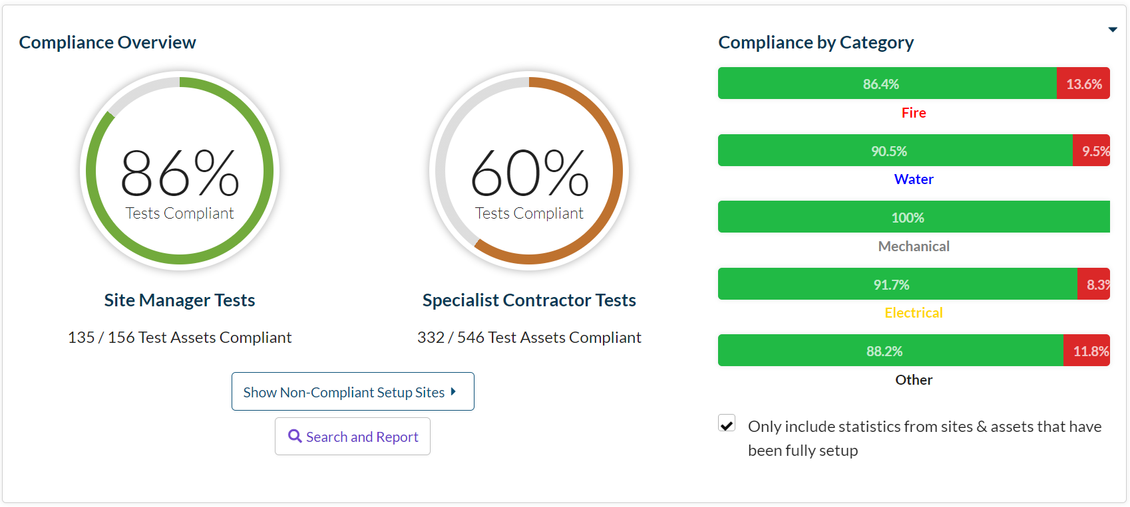

Last Week’s Data:
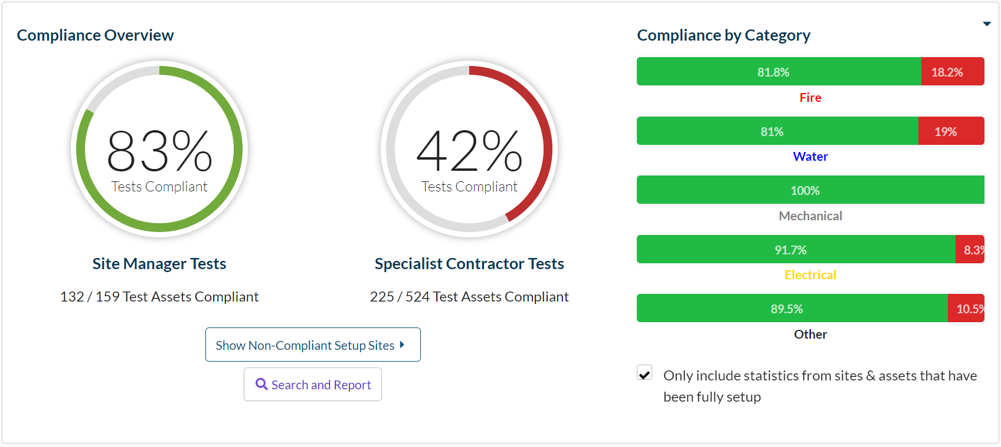
Significant progress in Fire management and Water Management has resulted in an 18% improvement in Contractor Tests.

Priority School Building Programme
Project managers continue to monitor the progress of schools in this scheme.

Pupil Placement Planning
1st Planner Project
The Project’s Oversight and Scrutiny Committee is expected to meet on November 24th. At this meeting, the committee hopes to identify the longlist of potential projects that will progress to Stage 3.

Lighthouse
This year, Lighthouse has been commissioned to facilitate the collation of Catholic School data.
Click HERE to fill out the Diocesan October Census.

