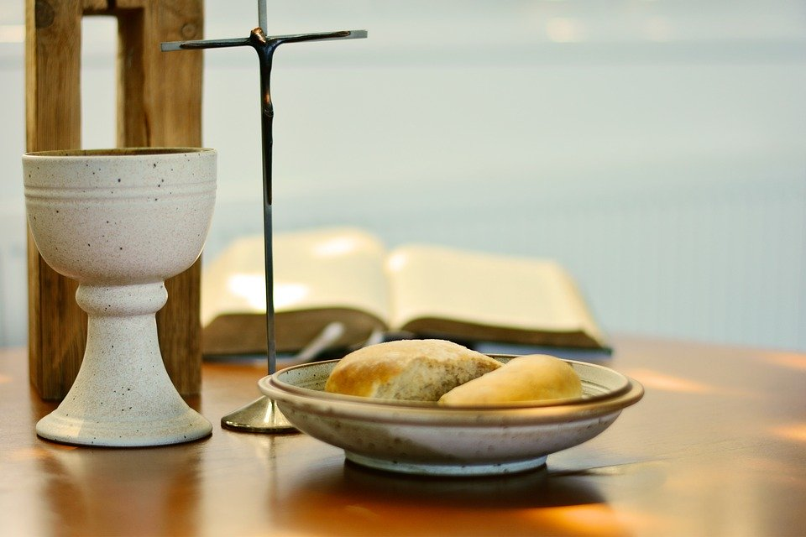
The Basics of our Faith using the Divine Praises
ADVENT AND CHRISTMAS 2020
Diocese of Westminster Education Service
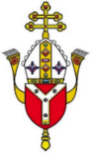
Support Materials for the
Basics of our Faith using The Divine Praises
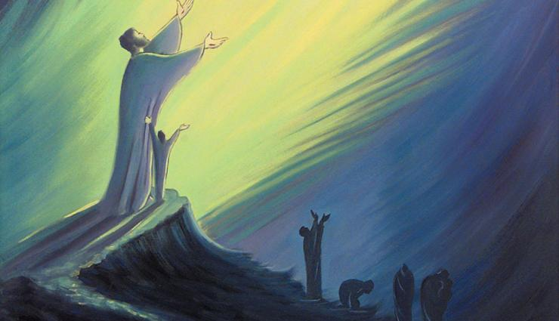
“So great is the Most Holy Name of Jesus that God highly exalted him and gave him the Name that is above every name, so that at the Name of Jesus every knee should bend; in heaven and on earth and under the earth, and every tongue confess that Jesus Christ is Lord, to the glory of God the Father.”
St Paul the Apostle (died c. 64-67 AD) (Phil 2:9-11)

About this Resource

Aims
The main aims of this resource include:
- Developing the basic theology of staff, parents and pupils, especially those who are new to the faith or growing in their confidence of the beliefs and traditions of the Catholic faith including those who are involved in sacramental preparation
- Supporting all members of the school community in understanding more about the Divine Praises, especially during the month of January which is devoted to the name of Jesus
- Enhancing the home-school-parish links
How can I use this resource?
Each one of the Divine Praises is looked at in some detail with some links to Scripture and the sacraments, especially the Eucharist. There are some ‘I wonder…’ ideas for personal prayer and/or reflection as well as some suggestions for extra independent research using YouCat or YouCat for Kids. The information, artwork and questions can be used for personal use as well as for blended learning as they can be differentiated and used by pupils of different ages and abilities at home and at school.

What is YouCat?
YOUCAT is the Catechism of the Catholic Church for adolescents and young people. The Catechism is the book with official Catholic teachings and doctrines. In YOUCAT, the most important elements of the faith are summarised briefly and comprehensibly in a question-and-answer format. YOUCAT was approved by the Congregation for the Doctrine of the Faith in Rome and officially published by the Austrian Bishops' Conference with the foreword written by Pope Benedict XVI. YOUCAT for Kids is for families with very useful illustrations. Both resources are invaluable for anyone involved with teaching the faith to young people. For more information see https://www.youcat.org/
Divine Praises

What are the Divine Praises?

The Divine Praises is a special prayer said or sung during Eucharistic Adoration, specifically after the Benediction. The celebration of the Eucharist (Mass) is the ‘source and summit of Catholic life’ and Catholics believe that Jesus is truly present in the Eucharist, which is also known as the Blessed Sacrament, so it is a holy time of prayer and devotion. This special prayer is led by the priest or deacon and the worshippers echo his words and praises, although this prayer can be said personally by the believer as a way of giving thanks to the Trinity, Holy Family, God’s angels and his saints.

The Divine Praises are said to make up (reparation) for bad language, using the Lord’s name in vain and speaking badly about God (blasphemy) although there is nothing in the prayer about sin directly. It can be said at any time as a prayer, especially during the month of January, the month dedicated to the holy name of Jesus.

The Divine Praises were written by an Italian Jesuit priest in the 18th Century (Luigi Felici, 1797). Originally there were only eight praises and then six more were added (by a number of popes). In this version, there are 15 praises in total as an extra praise from Saint Teresa of Calcutta has been added.

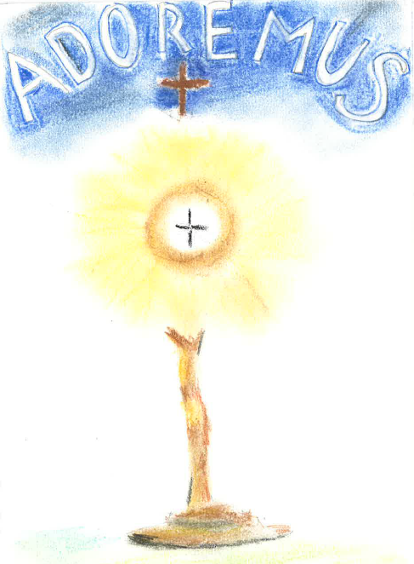
The Divine Praises
Blessed be God.
Blessed be his holy Name.
Blessed be Jesus Christ, true God and true Man.
Blessed be the Name of Jesus.
Blessed be his most Sacred Heart.
Blessed be his most Precious Blood.
Blessed be Jesus in the most Holy Sacrament of the Altar.
Blessed be Jesus in the Poorest of the Poor.
Blessed be the Holy Spirit, the Paraclete.
Blessed be the great Mother of God, Mary most Holy.
Blessed be her holy and Immaculate Conception.
Blessed be her Glorious Assumption.
Blessed be the Name of Mary, Virgin and Mother.
Blessed be St. Joseph, her spouse most chaste.
Blessed be God in his Angels and in his Saints

All praises begin with ‘Blessed be…’ as blessed means holy or consecrated. A song is often sung during Benediction, which is at the end of Eucharistic Adoration:

O Sacrament most holy, O Sacrament Divine,
All praise and all thanksgiving be every moment thine
Blessed be God
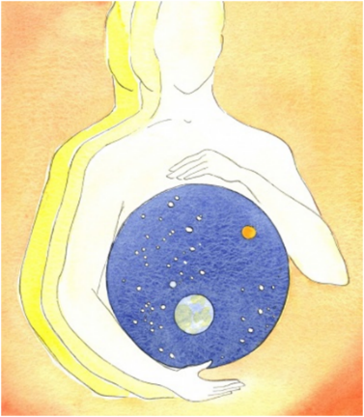
Who is God?
Christians believe in one God who created the world and everything in it. In the Creed (a statement of belief said by Catholics at Mass on Sunday), we say:

I believe in God, the Father almighty
Maker of heaven and earth,
Of all things visible and invisible.

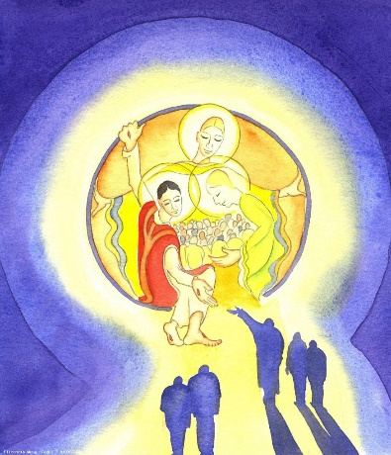
We believe in a Triune God, meaning that there are THREE persons but only ONE God and this is known as the Trinity. The three persons in the Trinity are: God the Father, God the Son and God the Holy Spirit.
God is omnipotent (all-powerful), omniscient (all-knowing) and omnipresent (ever- present). He has no beginning and no end and is a God of love, justice and mercy who calls all people to himself. Trinity comes from the word ‘tri’ meaning three and ‘unity’ meaning ‘one’.

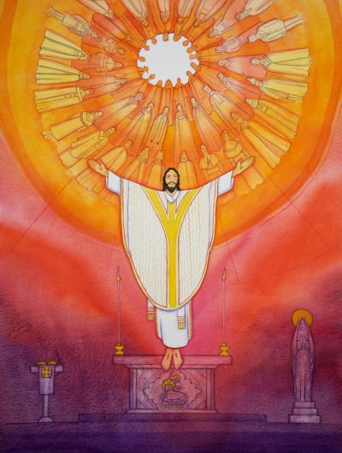
Can you think of where you might have heard the words ‘Blessed be God’ or words like them before? They are used in Mass which is also known as the Eucharist or Holy Communion, which is a great act of thanksgiving and a very special celebration for believers. The Eucharist is ‘the source and summit’ of the Catholic faith and the supreme act of worship. Jesus first instituted the Eucharist at the Last Supper which Jesus celebrated with his friends the night before he died. This meal was the Passover meal which the Jews celebrated to give thanks to God for delivering them out of slavery in Egypt to new life in Israel, the Promised Land.

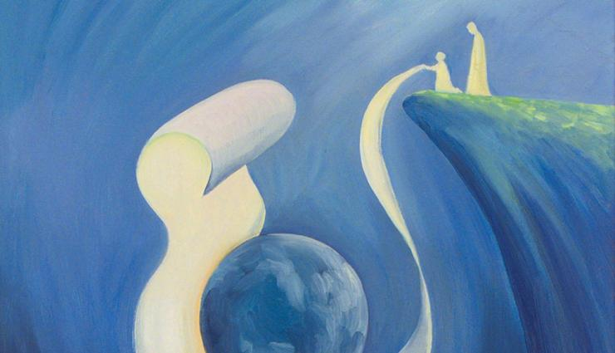
We give thanks to God in a special way during Mass. Catholics attend on a Sunday as this is the Lord’s day and the day of the Resurrection, although Mass takes place every day all over the world. However, we can give thanks to God at any time or place and in many different ways. A good time might be in the morning or before we go to sleep at night. During Mass we say “It is right to give Him thanks and praise” and “Thanks be to God.”

The psalms are special poems/songs found in the Old Testament of the Bible and many of them give thanks and praise to God. At Mass a psalm is always said, or sung, in response to the First Reading
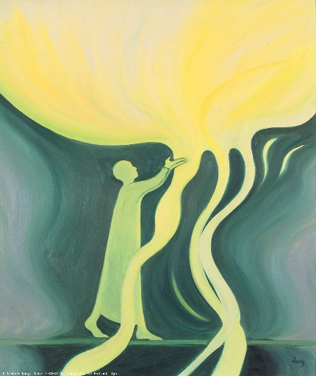
“I will exalt you, my God the King; I will praise your name for ever and ever… Great is the Lord and most worthy of praise; his greatness no-one can fathom.” (Psalm 145)

‘Exalt’ means ‘to hold up in high regard’ and ‘fathom’ means understand. As King David (an ancestor of Jesus) wrote, no-one can ‘fathom’ or understand God and all his greatness. We never will, certainly not in this life. God doesn’t need us to understand everything. He just wants us to love him and others as best we can. Of course, we should try to understand him more and more through prayer, liturgy and his Word.

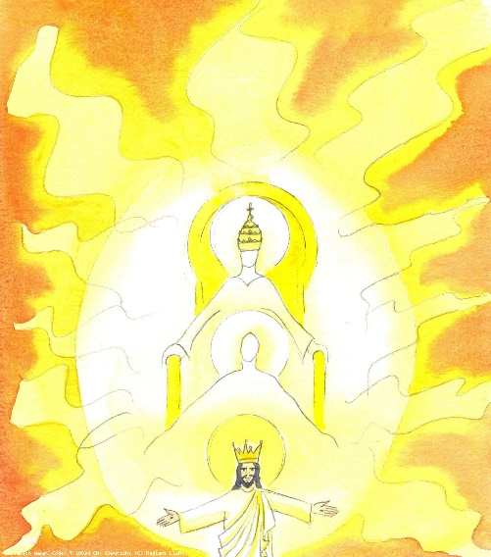
At Mass, Catholics thank God for all of creation and ultimately for giving us his only son, Jesus, to save his people from sin and death. We believe that God is present in a very special way in the Eucharist (the holy bread and wine) and through his word (the special readings). God continuously communicates with his people and makes himself known to them. The word we use to describe how God communicates with us and makes himself known to the world is ‘Revelation’. Our knowledge about God has not been invented by the Church but it is shown to us by God himself. At the heart of this revelation is the Son of God, Jesus Christ. We believe that God tells us about himself through Sacred Scripture and Sacred Tradition. The word ‘sacred’ means ‘holy’ or ‘belonging to God’.

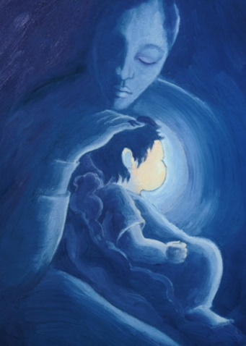
St John tells us: ‘God is love. Whoever lives in love lives in God, and God in him’ (1 Jn 4). Jesus himself calls God ‘abba’ (Mk 14:36) which means ‘beloved father’ or ‘loving father’.
Jesus tells us lots of parables (stories with a heavenly meaning) about God such as the Prodigal Son and the Lost Sheep, describing him as being all-compassionate, merciful and loyal. He teaches us to pray to God, as he taught his disciples, by saying the prayer:

‘Our Father who art in heaven
Hallowed be thy name.
Thy kingdom come, thy will be done
On earth as it is in heaven.
Give us this day our daily bread
And forgive us our trespasses
As we forgive those who trespass against us.
And lead us not into temptation
But deliver us from evil. Amen.

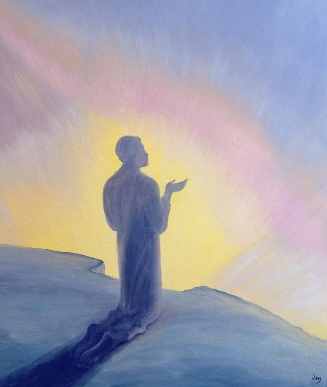
Find out more
Read about the teachings of the Catholic Church on this topic:
YOUCAT For Kids - Questions 14-22
YOUCAT - Questions 30-37

To develop home-school-parish links
Click here for the study guide: What do we know about God?
Click here for the study guide: What is worship?
Click here for the video: Who is God?
Click here for a simple video: Is there a contradiction between the Creation and Evolution?
Click here for the worksheet: God Made Me
Click here for the worksheet: Images of God
Click here for the word search: Facts about God (The Creed)

I wonder…
- What you would like to give thanks or praise for?
- What would you ask God if you could meet him face to face?
- What part of God’s creation do you appreciate most?

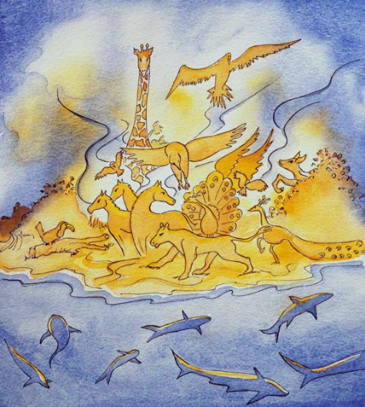
A time to pray:

God our Father,
We thank you for all that you have created:
For the world, the animals,
Our families and friends
And for creating us in your image.
Thank you for loving us always.
We praise you and we bless you, O God,
For now and ever more.
Amen

Blessed be the name of God
What is special about God’s name?
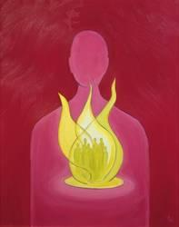
There is great power in a name. Names are very important to us – they are part of our identity and sense of self. It is what we are known by and called by all those around us. The name of God, then, is most powerful. The Bible says the name of God is like a ‘strong tower. The righteous can turn to it and be saved’ (Proverbs 18:10). When we feel scared and alone, even saying God’s name can give us comfort and strength.

God gives himself a name to make it possible for us to address him. He doesn’t want to be incognito but wants to be known and called upon and have a real relationship with us.

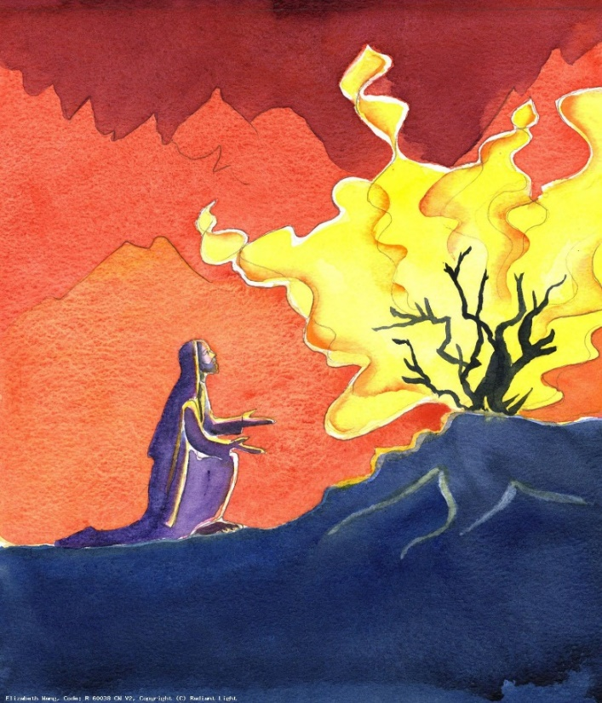
Do you know any names for God? When God appeared to Moses in the burning bush, Moses asked God what his name was and he was told, “I AM WHO I AM” (Ex 3:14). The Hebrew for this translation name is so holy that many Jews did not and do not say or write it and neither do Catholics. The title Adonai (Lord) is substituted. In fact, there are several Hebrew names for God which have different meanings.

For example, one name for God is ‘Elohim’ which means ‘God Most High’. It means he is the ‘Mighty One’ over all nature, this world and the heavens above. Even the angels adore him and keep his name holy. ‘Adonai’ is a common name for God in the Old Testament. It is the word meaning ‘My Lord’.

Hebrew | Translation
El | The oldest name of God (strength, might or power)
Elohim | God (supreme)
El Elyon | Most High God
El Shaddai | Almighty God (all-sufficient)
El Hai | Living God
El Olam | Everlasting God
Adonai | My Master/My Lord

Jesus called God ‘Abba’ which means ‘Loving Father’. It is an intimate, friendly name and shows that he can be trusted because he knows us (his children) so well and loves us so deeply. In Genesis, the first book of the Bible, it tells us that God made mankind in his own ‘image’. God calls us into relationship with him and we can do this through prayer.
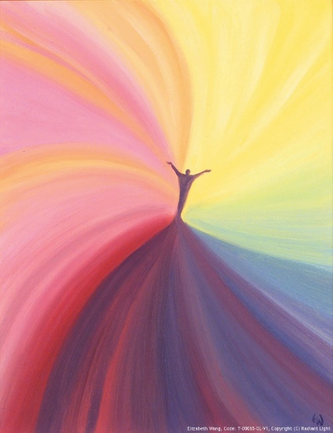
Find out more
Read about the teachings of the Catholic Church on this topic:
YOUCAT For Kids - Questions 138-159
YOUCAT - Questions 8, 31, 359

To develop home-school-parish links
Click here for the study guide: How does God reveal himself to me?
Click here for the worksheet: God is like…
Click here for the video: How does God reveal himself?
Click here for prayer cubes to make with family and friends.
Click here for the video: What is prayer?
Click here for the worksheet: Prayer - God always has the time
Click here for the worksheet: Five Finger Prayer

I wonder…
- What is your favourite name of God?
- What is your favourite image of God’s name (e.g. a strong tower)?
- What type of prayer do you think is best for you?

A time to pray:

God our Father and Creator,
We praise and glorify your holy name.
You alone are worthy and mighty,
Full of love and compassion.
You are always there for us,
Protecting us from all harm.
Blessed be your holy name forever.
Amen

Blessed be Jesus Christ, true God and true Man

Who is Jesus?
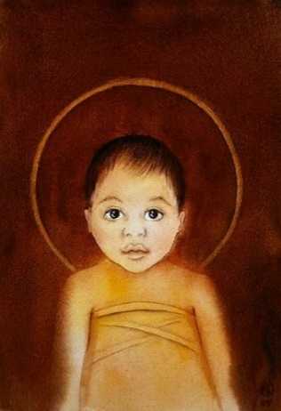
We have been looking at God the Father. Now we are going to learn about the second person in the Trinity: God the Son – Jesus. He is the Word of God, through whom all things were created (Jn 1:1). The name Jesus means ‘God saves’. Jesus is truly God (his divine nature) – spiritual, powerful, holy; he is also truly man (his human nature) – he can feel, struggle and fall like each of us. God sent his Son so that we could see what a perfect human being looks like. He came to show us the way to heaven, to save us and to show that each and every human being is truly loved by God. He is our ‘Emmanuel’ which means ‘God-with-us’.

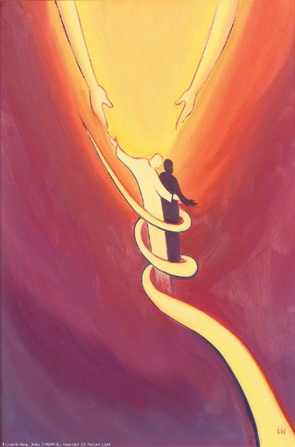
Can you think of when you might have heard the words: “God from God, Light from Light, true God from true God… For us men and for our salvation he…became man”? (These words are from the Nicene Creed which is said at Mass).

The Incarnation is the term given for when God became man in Jesus Christ. He came to lead the way to the Father and show us how to live. It is through Christ’s death and resurrection that we are saved. Jesus Christ is our Saviour because he gives us the perfect revelation of God’s love for us. He does this through his life of teaching, and in his death on the cross which cancels out human sins.
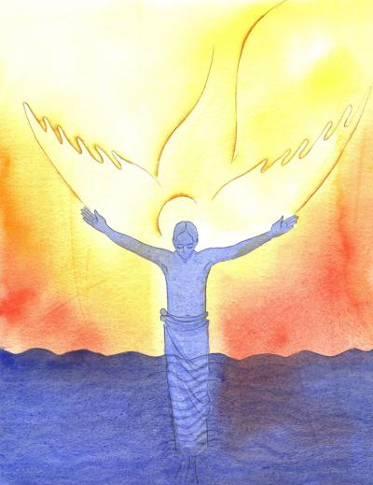
When Jesus was baptised, there was “a voice from heaven, saying: ‘This is my beloved Son, in whom I am well pleased” (Mt 3:16-7). Jesus himself said, “I and the Father are one” (Jn 10:30).

Jesus showed his divine nature through his miracles: “The works that the Father has given me to finish - the very works I am doing – testify that the Father has sent me.” (John 5:36). Also by his holiness, the perfection of his teaching and by fulfilling the prophecies in the Old Testament.

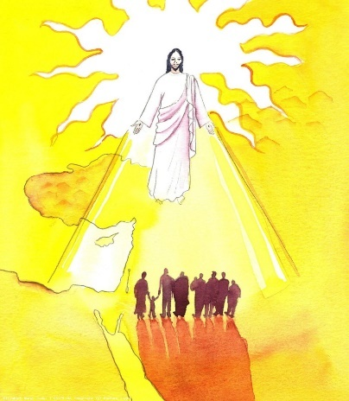
Jesus asked Peter who/what others thought he was. Some said he was a great prophet back from the dead (Elijah or John the Baptist) and some thought he was a holy man or prophet.

Peter believed Jesus was the ‘Messiah’, the Son of the living God. Messiah and Christ both mean ‘anointed one’ in different languages. For his faith, Jesus changed his name from Simon to Peter (which means rock) and later he became the first pope. Peter was one of the 12 Apostles, Jesus’ chosen friends.

Jews believe Jesus was a holy man. Muslims believe he was a prophet. Christians believe he is the Son of God. Jesus came to lead the way to the Father. He came to fulfil the law given by the prophets in the Old Testament. We hear about Jesus’ life in the New Testament, especially in the Gospels.

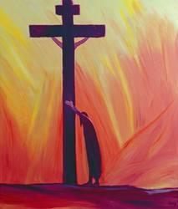
Find out more
Read about the teachings of the Catholic Church on this topic:
YOUCAT For Kids - Questions 23-45
YOUCAT Questions 70-112

To develop home-school-parish links
Click here for the study guide: What does it mean that God became man?
Click here for the video: What is Man?
Click here for the worksheet: 12 Apostles
Click here for the secret code that Jesus gave to Peter
Click here for the worksheet: Liturgical Colours
Click here for the worksheet: The Four Gospels

I wonder…
- Who is Jesus to you?
- How can Jesus help and heal you?
- What would you say to Jesus if you could meet him face to face?

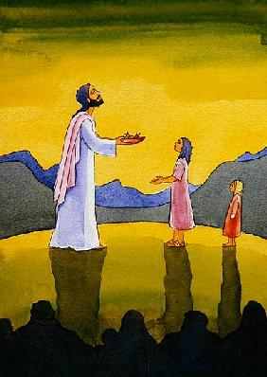
A time to pray

Lord Jesus,
You are truly God and truly man,
Sent by our Father to show us the way to Heaven.
Help us to live like you,
To obey God’s commands
And to love one another as you have loved us.
Help us to complete your mission on earth
And to be one with you and the Father,
Now and for ever
Amen

Blessed be the Name of Jesus
What are the names or titles of Jesus?

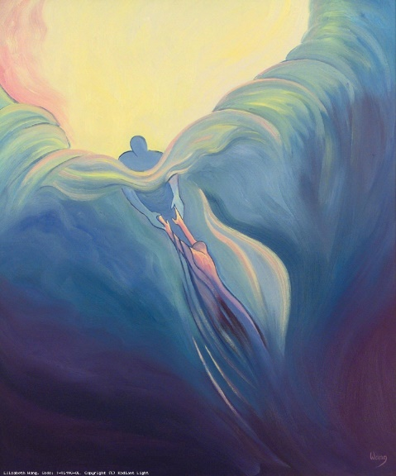
We talked about how special a name is and Jesus’ name is the most special alongside the name of God. In Greek the name of Jesus is Iesous and means ‘God saves’ (like Joshua). Jesus is our Saviour. In the Old Testament, we hear the story of God telling Moses ‘I am who I am’. In the New Testament Jesus also used the phrase ‘I am…’ seven times (seven is a special number in the Bible and symbolises perfection and completeness. Jesus is perfect and complete). He says:
“I am the bread of life.” (John 6:35, 48, 51)
“I am the light of the world.” (John 8:12; 9:5)
“I am the door of the sheep.” (John 10:7, 9)
“I am the good shepherd.” (John 10:11, 14)
“I am the resurrection and the life.” (John 11:25)
“I am the way, the truth and the life.” (John 14:6)
“I am the true vine.” (John 15:1)

Why is the name of Jesus special? The name of Jesus is so powerful it can cause healing and cast out demons. It can protect and comfort us and we can call on him at any time. The word ‘Maranatha’ is a simple prayer which can be repeated in silence and is Aramaic for ‘Come, Lord’. Jesus was so unique that he has been given many names and descriptions, many of which can be found in the Bible. These help us to get to know him more fully.

The shortened form of Iesous is IHS. This is a very popular symbol for Jesus and you will see it in churches, on priest’s vestments and on some religious art and artefacts. On the host that Catholics receive at Communion there may be the letters IHS to show Jesus is truly present. The fish and the Chi Rho are also special monograms for the name of Jesus.

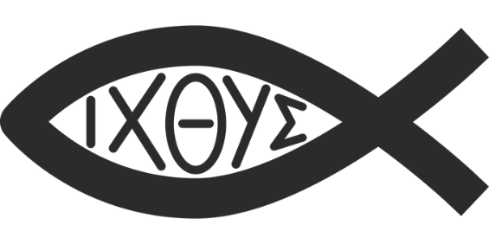
The fish is a Christian symbol because of this, not because Jesus’ friends were fishermen or because he told them that he would make them ‘fishers of men’ (Mt 4:19). The word fish in Greek is ichthys and the ichthys symbol in Greek (IH∑OY∑) spells out Jesus (I) Christ (H) Son (∑) of (O) God (Y) Saviour (∑).

In the early Church, when Christians were being persecuted, they would use the fish symbol as a secret sign symbolising to others that they were Christians, followers of Christ.

Like others at that time, Jesus did not have a surname, as we do. He would have been known as ‘Jesus, son of Joseph’ or ‘Jesus, the carpenter’s son (as was thought by some at the time because Joseph was his guardian).’ ‘Christ’ means ‘anointed one’ in Greek. ‘Messiah’ means ‘anointed one’ in Hebrew. Jesus is our Messiah, our Saviour, the one whose coming was foretold in the Old Testament and whose role was fulfilled in the New Testament.
The Chi Rho (☧) is another symbol or monogram for Jesus and is made up of the first two sounds in Christ (x = ch, p= r) . The α (first letter of Greek alphabet – alpha) and Ω (last letter of Greek alphabet –omega). This means Jesus is eternal – he is at the beginning and end of our lives and all things.

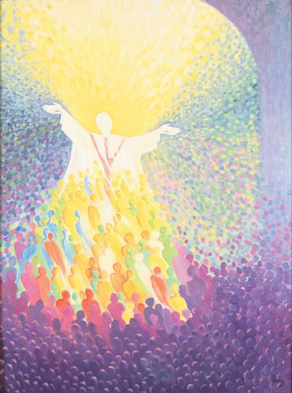
Find out more
Read about the teachings of the Catholic Church on this topic:
YOUCAT For Kids - Questions 23-26
YOUCAT Questions – 72

To develop home-school-parish links
Click here for the study guide: What does faith mean?
Click here for the study guide: What is the Bible good for?
Click here for the study guide: Why the suffering?
Click here for the study guide: Why the Cross?

I wonder…
- What is your favourite name of Jesus? Why?
- Can you use the symbols of Jesus to design something special (such as a Paschal candle, your school mission, your website page)
- What is your favourite ‘I am’?

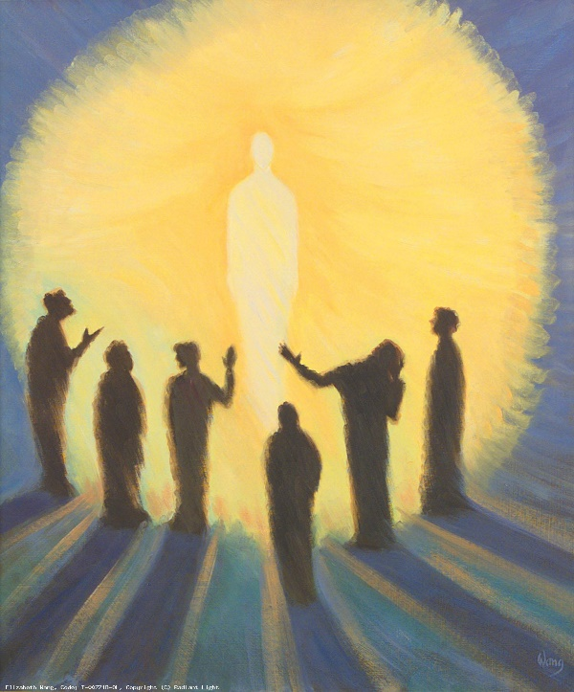
A time to pray:

Blessed be your name, O Jesus!
You are the chosen one,
God’s only Son,
Our saviour and guide.
You are our Good Shepherd,
The Way, the Truth and the Life.
Help us, O Lord,
To follow your path
Finding comfort and strength
in your name
which is above all other names.
Amen

Blessed be his most Sacred Heart
Who or what is the Sacred Heart?
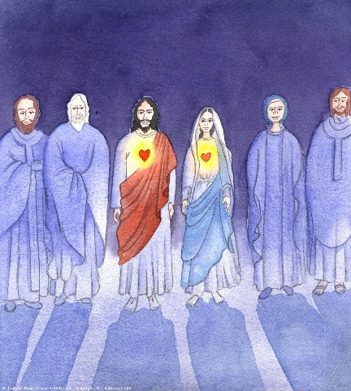
Some images of Jesus show his heart on the outside of his body with symbols of flames, divine light, a cross, a crown of thorns, a lance wound and bleeding…). This symbolises that Jesus’ heart was pierced on the Cross. It means that his love was not just words but real action. The month of June is dedicated to the Sacred Heart. There is a simple prayer: ‘Most Sacred Heart of Jesus, I place all my trust in you.’ It can be said by anyone at any time. Mary, his mother, is known as the Immaculate Heart and May is the month which is dedicated to Mary.

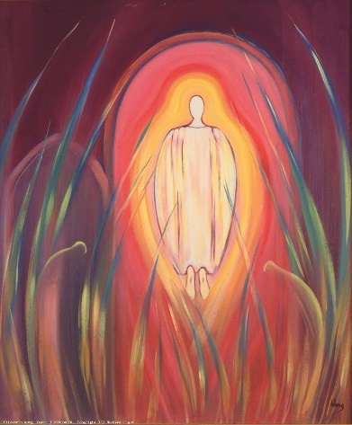
When Jesus was asked what the greatest commandment was, he replied:

“’Love the Lord your God with all your heart
and with all your soul and with all your mind.’
This is the first and greatest commandment.
And the second is like it: ‘Love your neighbour as yourself.’
All the Law and the Prophets hang on these two commandments.”
(Mt 22:36-40)

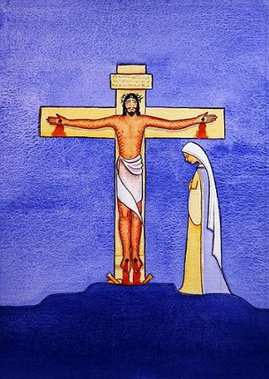
Jesus’ whole teaching was about love. He was love in human form. Through his words and actions, he taught us to love, even when it is difficult:

“But to you who are listening I say: Love your enemies, do good to those who hate you... Do to others as you would have them do to you.” (Lk 6:27-31)

“Greater love has no one than this: to lay down one’s life for one’s friends.”
(Jn 15:13)

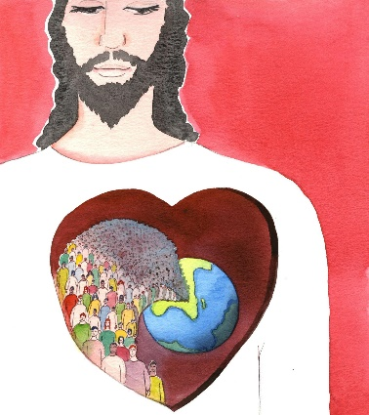
Why did Jesus come to earth, what was his mis sion? Jesus came for the salvation of all people, especially sinners. He spent a lot of time with those in society who were outcasts and had made poor choices. Jesus wanted to help them to change and feel God’s unconditional love and limitless mercy. He came to reconcile all people to his Father.

We believe that Jesus knows and loves us with tremendous love and that he gave himself up on the Cross for each one of us without exception.

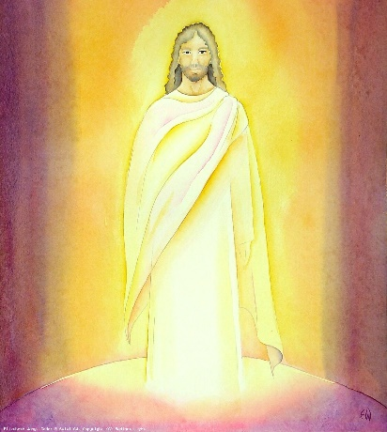
He has loved us all with a human heart which was pierced by our sins and for our salvation. Jesus is our divine Redeemer. For this reason, the Sacred Heart is considered to be a powerful sign and symbol of Jesus’ love of the eternal Father and all human beings.

Find out more
Read about the teachings of the Catholic Church on this topic:
YOUCAT For Kids Questions – 25, 164
YOUCAT Questions - 70-112

To develop home-school-parish links
Click here for the video: What are the Commandments?
Click here for the Ten Commandments Board Game
Click here for the worksheet: Ten Commandments maze
Click here for the worksheet: The Ten Commandments
Click here for the word search: 10 rules of the game, by God

I wonder…
- How can you love and forgive those who are difficult?
- How you could ask Jesus for his help to love as he does? (for example, write a prayer, letter or song)
- How could you thank Jesus for his sacrifice and love?

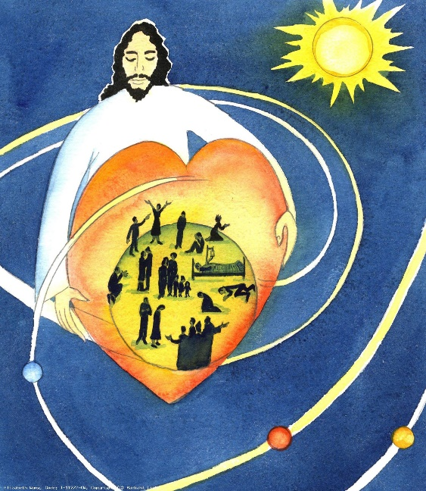
A time to pray:

Sacred Heart of Jesus
We thank you for your great love
For each and every one of us.
May our hearts burn with love
For you and for all others
Especially those who are difficult to love.
Help us to bring your love to
Everyone we meet
Through our words, our actions
And our whole being.
Amen

Blessed be his most Precious Blood

Why is Jesus’ blood precious?
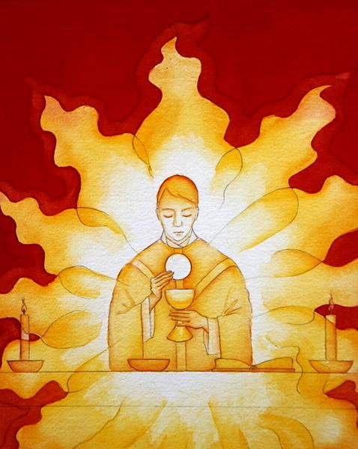
Every time we go to Mass, we remember the Last Supper when Jesus shared the chalice/cup. He said, “Each of you drink from it for this is my blood, which seals the covenant between God and his people. It is poured out to forgive the sins of many” (Mt 26:28).
The covenant Jesus mentions is an agreement between God and his people. He will be our God, we will be his people. We can do this by following Christ and doing as he commanded: by loving one another.

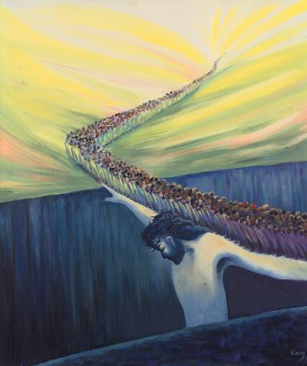
As we know, Jesus taught us to love God and all others. He gave his whole life, body and blood, to serve others. Before Jesus died, after the Last Supper, he showed us that he wants us to serve others by washing his disciples’ feet. He is our Servant King:
“For even the Son of Man did not come to be served, but to serve, and to give his life as a ransom for many.” (Mark 10:45)

Through Jesus’ blood, we are saved and are led to eternal life with God.

We have looked at the different names of Jesus. One of these is ‘Lamb of God’. Have you heard that phrase before? It is said at Mass: ‘Lamb of God, you take away the sins of the world have mercy on us… Lamb of God you take away the sins of the world, grant us peace.’ This refers to the words of John the Baptist, which we find in John 1:29.
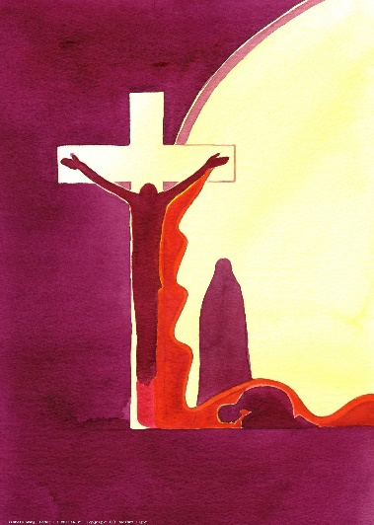
In Jesus’ time, people sacrificed animals as a way of showing penance. They believed that their sins were transferred into the spotless animal which was then sacrificed and the person was then forgiven. In the Bible it says, “Without the shedding of blood there is no forgiveness” (Hebrews 9:22) The person had to identify with this animal (which could be a sheep, goat, bull etc).

At the Passover, Jews celebrated the Exodus and sacrificed a lamb. Jesus is the Passover lamb. He is the ‘Lamb of God’ and his blood is of the ‘new covenant’. This means that the sacrificial animal is no longer needed. Christ is the eternal sacrifice. This means that he only needed to die once. We make present his death (and his life and resurrection) every time we go to Mass.

We are united with God through Christ but we must be willing to change to find peace. Jesus forgave many people like Zacchaeus, Peter, the tax collector… He told them their sins were forgiven and to go in peace and sin no more. They changed their ways and became better people, and so they were filled with great peace and strength of faith.

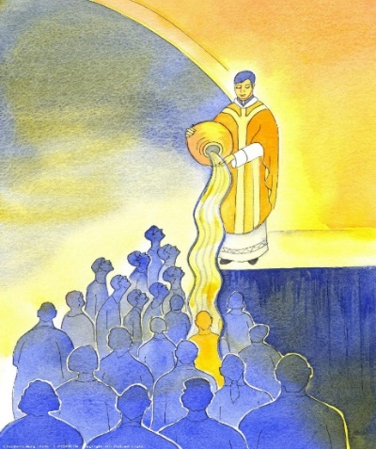
Find out more
Read about the teachings of the Catholic Church on this topic:
YOUCAT For Kids - Questions 74-80
YOUCAT - Questions 168, 208-223, 365

To develop home-school-parish links
Click here for the study guide: Why is the Holy Mass the ‘main event’ of the Church?
Click here for the study guide: How does Jesus teach us to pray?

I wonder…
- How can you be reconciled to God by making amends?
- Is there anyone in your life you could make amends with? How?
- In which ways could Jesus help you to change and make better choices?

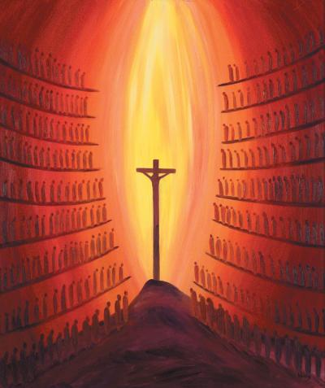
A time to pray:

O Sweet Jesus,
You suffered so much for us
And shed your precious blood
So that we could be forgiven
And reconciled with God the Father.
We thank you and we praise you
Our God, our Servant King.
Help us to follow your example
By serving others with love.
Amen

Blessed be Jesus in the Most Holy Sacrament of the Altar

What is the Most Holy Sacrament? (Mass, Jesus) What is an altar? (table of sacrifice).
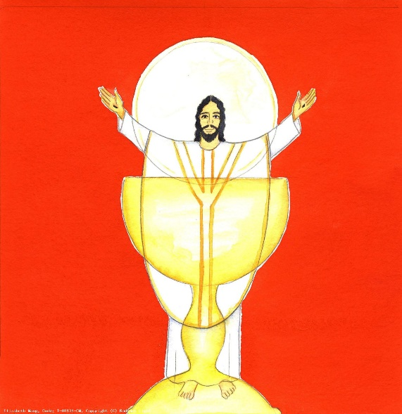
There are seven sacraments in the Catholic Church and one of these is the Eucharist. The’ most holy Sacrament’ or the ‘Blessed Sacrament’ refers to the precious Body and Blood of Jesus. Catholics believe that Jesus is truly present in this sacrament and that the bread and wine are not just symbols. Jesus said ‘This is my body’ and ‘This is my blood’ (1 Cor 11:24). The term for the change of substances from bread and wine into the Body and Blood is called transubstantiation and it takes place at the most sacred part of the Mass. The Blessed Sacrament is Jesus under the appearance of bread and wine once it has been consecrated at Mass. It is not only a Sacrament but also a sacrifice.

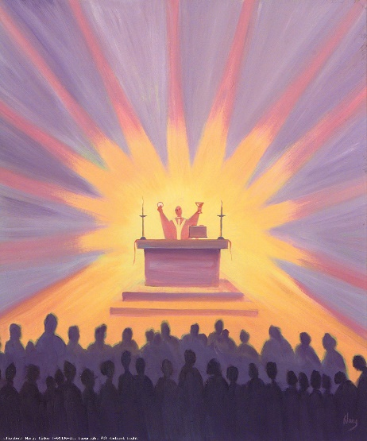
The word Eucharist comes from the Greek word ‘eukharistia’ meaning thanksgiving. The Eucharist makes present Christ's saving sacrifice at Calvary and unites us to him and to each other in Holy Communion.

At the Eucharist, the Mass, Christians remember Jesus’ death and are united with him through his Body and Blood in the form of bread and wine. Eucharist is another word for the Mass and Sacrament as well as the Sacred Host (Jesus’ Body and Blood in the form of bread).

An altar is the table of sacrifice where we re-enact Jesus’ sacrifice on the Cross at Calvary on Good Friday. A priest is the one who presides at Mass and Jesus is the eternal High Priest.

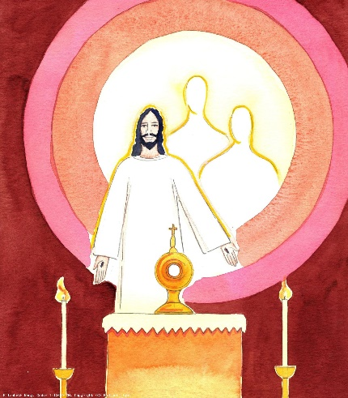
Adoration is the worship of Jesus Christ, outside of Mass, who is present, Body, Blood, Soul and Divinity, under the appearance of the consecrated host.

At the beginning of Exposition of the Blessed Sacrament, a priest or deacon removes the sacred host from the tabernacle and places it in the monstrance (a special vessel for holding the Blessed Sacrament) on the altar for Adoration by the faithful.
We may sing ‘O Sacrament most holy’ or ‘O Salutaris Hostia’ at this point. ‘All praise and all thanksgiving be every moment thine.’
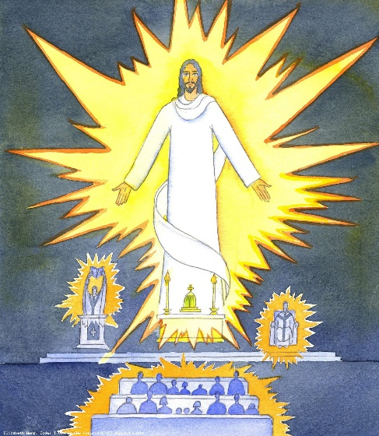
Benediction means the blessing given by the priest or deacon with the Blessed Sacrament at the end of Exposition. It includes hymns, prayers and readings related to the Real Presence of the Lord Jesus in the Eucharist such as the Divine Praises. A Holy Hour is time in Eucharistic Adoration where a priest has exposed the Blessed Sacrament and we pray together with other people. A Holy Hour will often begin with Exposition and end with Benediction. The tabernacle is the ornate, secure container in which the Blessed Sacrament is reserved outside of Mass. It is often at the centre of the sanctuary or some other place of honour in the church. The sanctuary lamp burns near the tabernacle as a sign in honour of the Real Presence of Christ.
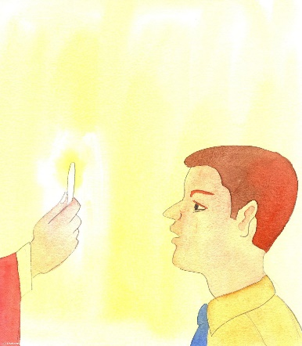
Whenever we celebrate the sacraments, we come into contact with Christ – we encounter Christ the Redeemer. It is the same at Mass; we encounter Christ in the Word of God and in the Real Presence of the Eucharist.

This encounter with Christ has the power to form and reform us. Just as we hear in the Parable of the Sower (Mark 4:1-20), the Word of God can take root in the rich soil of our hearts and produce a wonderful harvest, fruit that will last.

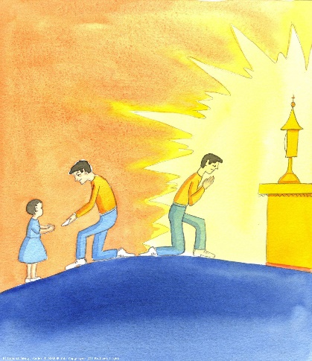
That’s why it’s important when we come to celebrate Mass that we are attentive and actively engaged with the prayer that is taking place. It has been said that when we receive the Eucharist, ‘we become what we receive’. That is to say, we become the Body of Christ.

In Eucharistic adoration, we can also be formed by the Real Presence of Jesus. When we adore the Eucharist, even outside of Mass, we adore that which we have received, and become more and more part of the Body of the Risen Lord.

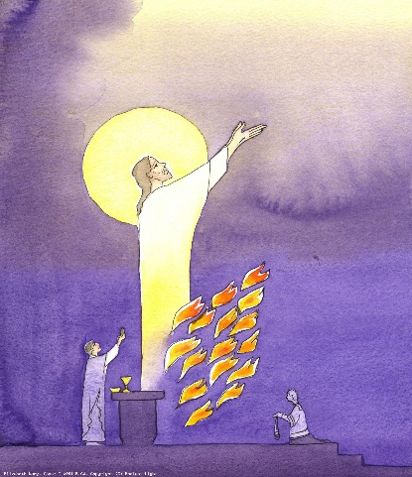
The word ‘Mass’ is derived from the final words of the Mass in Latin Ite, missa est. This means, ‘Go, it is the sending’ or ‘Go, it is the dismissal’. In Christian use, the word dismissal is connected with the word missio or ‘mission’.

It is good to reflect on how we are ‘sent out’ at the end of Mass. To ask ourselves when we have celebrated the Eucharist, ‘how I am being sent?’ and, ‘what does God ask of me, where is he sending me?’

‘Go in peace to love and serve the Lord’.

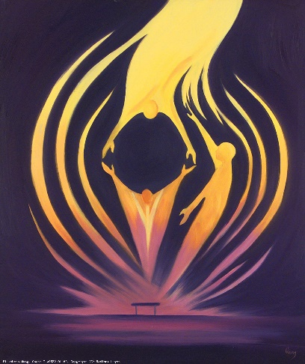
Find out more
Read about the teachings of the Catholic Church on this topic.
YOUCAT For Kids - Questions
YOUCAT Questions – 191, 213-223

To develop home-school-parish links
Click here for a game on the seven sacraments
Click here for a video on the Sacrament of Baptism
Click here for a video on the Sacrament of Confirmation
Click here for the study guide: Why do Christians get baptised?
Click here for the study guide: Why are Christians confirmed?

I wonder…
- In which ways can you serve God and others through your life, words or actions?
- Could you be more self-giving or self-sacrificing?
- What could Jesus forgive you for? How could you make amends?

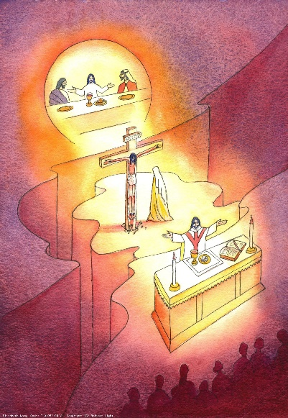
A time to pray:

Lord Jesus,
Thank you for the special gift of the Mass
A great time of thanksgiving
For all that you have done for us.
It is a time when we remember
And relive your great sacrifice for us,
A time to share in the hope
and joy of your resurrection.
O, Lamb of God,
May we bless you always.
Amen

Blessed be Jesus in the Poorest of the Poor
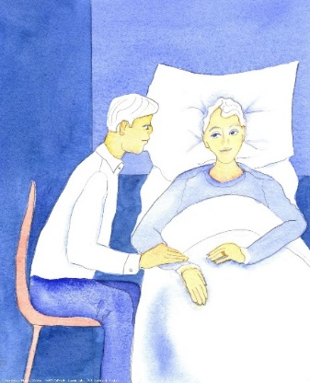
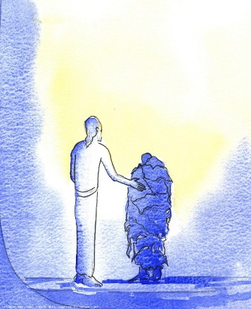
What do we mean by poor?
As we know, Jesus came to show us God’s love to all people. He spent a lot of time with sinners and those who were outcasts in society – those who were ill, unloved, rejected and downcast. Jesus said,
“Whatever you do to the least of my brethren, you do to me.” (Mtt 25:40).
In other words, when we feed the hungry, we are feeding Jesus. When we include others in our activities and celebrations, we are including Jesus. When we are helping someone who is hurt, we are helping Jesus.
We know that Jesus doesn’t just want us to love our friends, but our enemies too. As Christians, we try to see the face of Jesus in our friends, enemies and in the poor. This may include people in developing or war-torn countries. It may also be in our own communities or families.
There are many in our society who are ‘poor’, whether this is financially, spiritually, physically or emotionally.
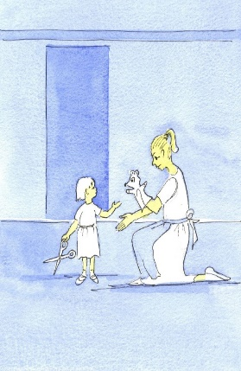
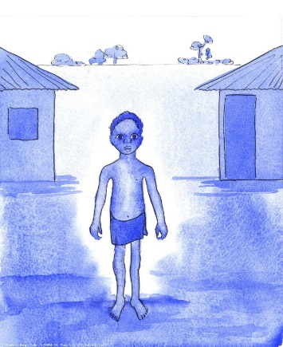
Numerous saints throughout the ages have been kind to the poor; one of these is St Teresa of Calcutta who was known as Mother Teresa. This Divine Praise was added in her memory as she lived these words of Jesus so profoundly. St Teresa taught us “Don’t look for big things, just do small things with great love.”
St Teresa spent time with those who were so poor and ill, that no-one else wanted them including one man who was so close to death that he was being eaten alive by rats.
She also helped to cure the sick including one man who could not walk. This man, was extremely emaciated and could not walk upright. Through prayer and loving care, the man was not only able to walk but he could also run. It was a miracle! She took in babies who were left in the streets to die and she nursed them to health. Not only did she help the poor, she lived as one of them. She lived on the street, she begged for food and she taught the poor by writing in the dirt. She saw beauty in every human being and she helped to make the lives and deaths of those around her more peaceful and full of love.
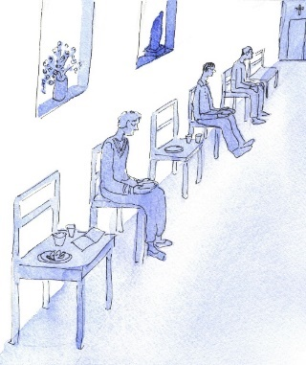
St Teresa of Avila (a different Saint Teresa!) said, ‘Christ has no body on earth but yours, no hands, no feet on earth but yours, yours are the eyes with which he looks compassion on the world….’ When you spend time with Jesus in Holy Communion or Adoration, he lives in you and gives you the strength and joy to do his work. If you keep spending time with him, people may see him when they look at you.
Find out more
Read about the teachings of the Catholic Church on this topic:
YOUCAT For Kids - Questions 149, 193
YOUCAT Questions – 181, 321-342, 438, 446-449

To develop home-school-parish links

I wonder…
- How can you help the (poorest of the) poor around you?
- Could you say a prayer for the poor in your world asking St Mother Teresa to help you to see the world with her eyes?
- Is there someone in your life who would appreciate some compassion at this time?

A time to pray:
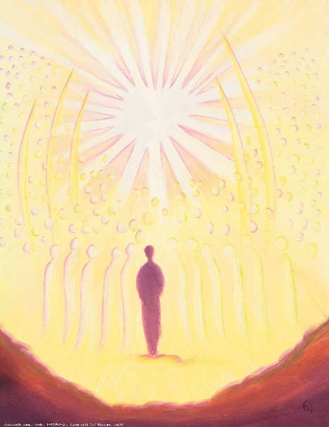
Lord Jesus,
I give you my hands that they may work hard
and share with others.
I give you my tongue that it will speak kindly
to those who are sad and lonely.
I give you my eyes that I will recognise you in others
and respond to their needs.
I give you my whole self
so that you can use me to bring your love
to all those around me,
especially the poor and weak.
Amen

Blessed be the Holy Spirit, the Paraclete
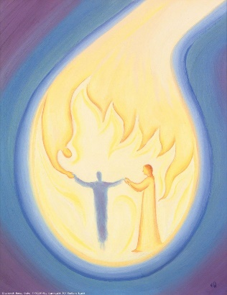
Who or what is the Holy Spirit?
We have looked at God the Father and the Son. Now we will learn about God the Holy Spirit, the third person of the Trinity. The Spirit was present at the very beginning of time when God created the world as the Spirit ‘hovered over the water’. (Gen 1).
He was present throughout the Old Testament as he has ‘spoken through the prophets’ (mentioned in the Creed). In fact, the Bible is inspired, literally ‘God-breathed’ by him.
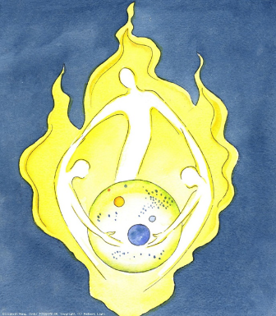
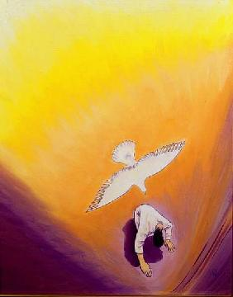
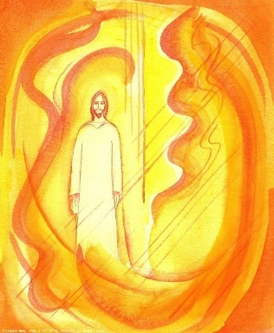
We hear about the Holy Spirit throughout the New Testament. He was there when Mary said yes and she conceived by the power of the Holy Spirit. We heard the Father’s voice at Jesus’ Baptism when the Spirit descended ‘like a dove’ (Mt 3:16) and we hear about the Spirit’s power on the day of Pentecost, when the Church was born. On the day of Pentecost, the Spirit appeared as tongues of fire on the disciples’ heads and gave them great courage and ability to speak in different languages so they could go out and tell the whole world about Jesus. We often see the Holy Spirit in artwork as a dove, cloud, light, wind or fire as he is depicted in different ways throughout Scripture.
The Holy Spirit, like God and Jesus, has other names too. He is known as the ‘paraclete’ (which means ‘counsellor’, an adviser/a guide), ‘advocate’ (which means someone who speaks up for us, speaks on our behalf) and ‘comforter’. Jesus himself calls the Holy Spirit a ‘Helper’ (Jn1 14:26) and ‘the Spirit of Truth’ (Jn 16:13). He assures us that the Holy Spirit will help us and teach us all things (Jn 14:26). He will guide us in our time of weakness (Rom 8:26) for he is truth and life. When we say the Creed at Mass we affirm that he is ‘the Lord, the giver of life’.
The term ‘Spirit’ translates the Hebrew word ‘ruah’ which means breath, air, wind. We cannot see the Holy Spirit but, like breath, air or wind, we can see the effects of them. For example, we know it is a windy day because we can see the leaves and branches on the trees move and we can feel it on our skin.
In the same way, we can see the Holy Spirit at work because we can see the fruits of the Holy Spirit and good relationships and we can feel joy and peace.
“But the fruits of the Spirit are love, joy, peace, patience, kindness, goodness, trustfulness, gentleness and self-control.” (Galatians 5:22-23) This is how we know the Spirit is alive in us and others.
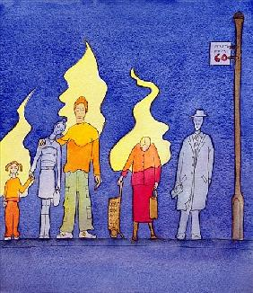
Find out more
Read about the teachings of the Catholic Church on this topic:
YOUCAT For Kids Questions – 27, 46, 222
YOUCAT Questions – 76, 113-120, 195-207

To develop home-school-parish links
Click here for the word search: Prayer: God always has the time
Click here for the study guide: How are Christians acting socially responsible?

I wonder…
- How can you improve your relationship with others?
- Where can you see the Holy Spirit at work?
- Which gift of the Holy Spirit might benefit you most?

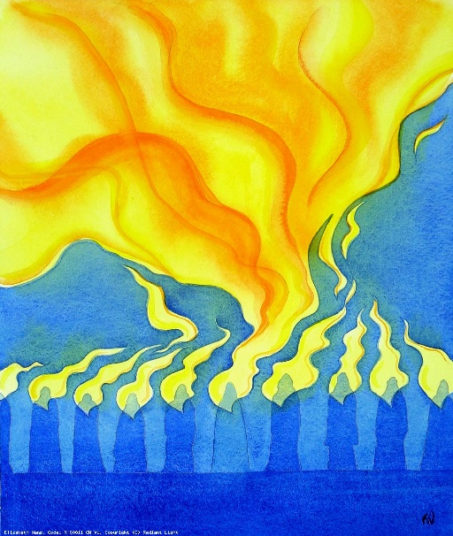
A time to pray:
Come Holy Spirit,
Fill us with your gifts of wisdom and
wonder and awe in God’s presence.
Strengthen us so that we too can be a guide
and a comfort to others.
Give us the courage to make the right choices,
especially when it is difficult.
Come Holy Spirit,
Fill us with your peace.
Amen

Blessed be the great Mother of God, Mary most holy

How is Mary a ‘great mother’?

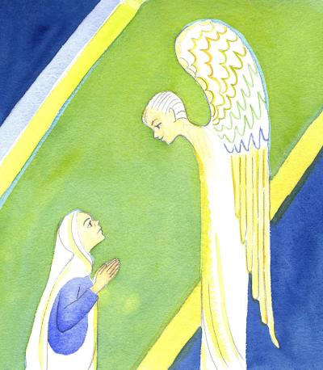
We first hear about Mary when the angel Gabriel visits her to announce that she is to be the mother of God’s son, even though she is quite young and has no husband. The angel greets her with, “Rejoice, you who enjoy God's favour! The Lord is with you.” (Luke 1:28) He tells her not to be afraid.

Naturally, she is quite shocked and confused, but Mary is full of faith and is obedient to God’s will. Her response is, “You see before you the Lord's servant, let it happen to me as you have said.” (Luke 1:38) In short, Mary says ‘yes’ to God and her ‘yes’ changes the world.
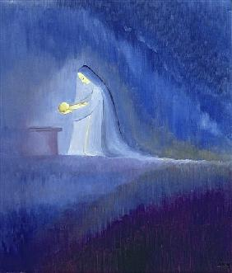
Mary was like other mothers: she gave birth to Jesus, nursed and clothed him; she taught him how to walk, talk and pray, leading him by example. However, she was unlike other mothers because throughout her life, right from the start, Mary was free from sin. Mary was filled with God’s grace and was always faithful to God. Mary knew many hardships as a mother.

When Herod threatened to kill Jesus (the new king) as an infant, she and Joseph fled to Egypt to protect him; when he was lost in the Temple for three days when he was twelve, she worried about him; when she watched the Roman soldiers torture him and saw Jesus fall as he carried his Cross to his Crucifixion, her heart was broken. Throughout all of this, Mary’s faith remained strong.

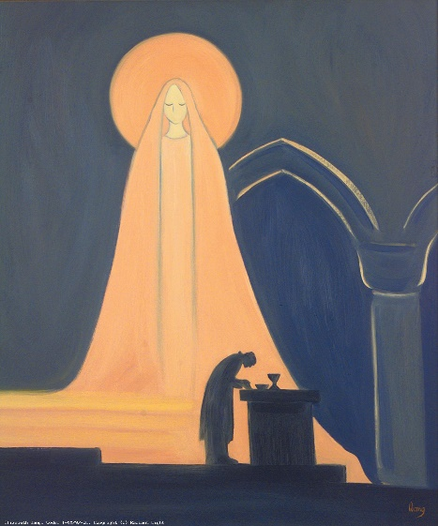
Mary “treasured up all these things and pondered them in her heart.” (Luke 2:19) In other words, she always trusted God and prayed to him, even though she didn’t understand everything that was happening. Mary teaches us to do the same, and always points us towards her Son.

Jesus loved his mother and was always respectful to her. When she told him to help out at the wedding at Cana, Jesus did as his mother asked. Catholics pray to Mary, not to worship Mary as worship is for God alone, but to ask her to intercede for us and place our needs and intentions in before her Son, Jesus. Mary is the Mediatrix, the intercessor between us and Christ. She is our mother and mother of the Church.

There are a number of special prayers to Mary, including: Hail Holy Queen (Salve Regina), the Memorare and Regina Coeli. The most famous prayer is the Hail Mary which includes words from the Angel Gabriel and Marys’ cousin Elizabeth. Mary’s special prayer/song of praise is called the Magnificat.
Mary is also known as Theotokos which means ‘God-bearer’. Mary is a great mother because she was specially chosen to carry God’s only Son. She is indeed ‘blessed’ among all women and a perfect example of faith and motherhood. Her feast day as Mother of God is on 1st January.

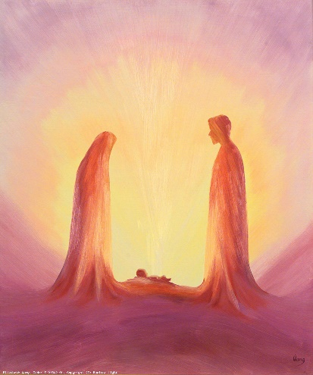
Find out more
Read about the teachings of the Catholic Church on this topic:
YOUCAT For Kids Questions – 48, 214
YOUCAT Questions – 82-85, 147-148

To develop home-school-parish links
Click here for the study guide: God Calling

I wonder…
- How can you say ‘yes’ to God?
- Can you ponder and reflect on God’s work?
- How might you be ‘full of grace’ like Mary? Is there anything you could do differently?

A time to pray:
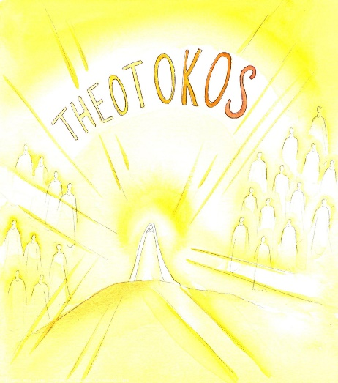
Mother Mary, you are most holy,
blessed among all people.
May we follow your example
by saying ‘yes’ to God and
by being faithful to his laws.
Help us, great mother,
to trust in God even when
we don’t understand his holy will.
Amen

Blessed be her holy and Immaculate Conception
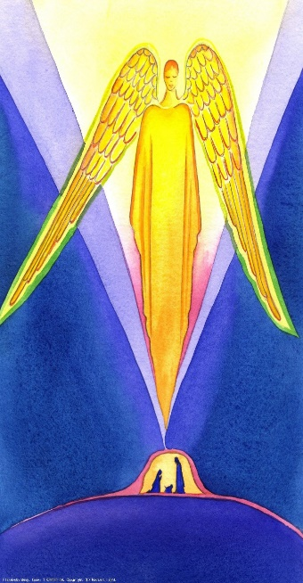
What does it mean to be holy?
When we think about holiness we think of being ‘sacred’, ‘pure in heart’, having a relationship with a ‘divine power’, being ‘perfect’ in a moral sense. This was Mary. She was perfect and pure and set aside for a special purpose for God. She was holy and faithful in all that she did. We know this because when she appeared to St Bernadette at Lourdes, she said ‘I am the Immaculate Conception’ which means that from the very first moment of her existence, her conception, she was free from sin.

No human beings are perfect, we inherit a flawed human nature from our parents. Yet, as God and as our Saviour, this cannot be true for Jesus. Therefore, God intervened in a particular way at Mary's conception to give her a sinless nature to prepare for Jesus’ coming.

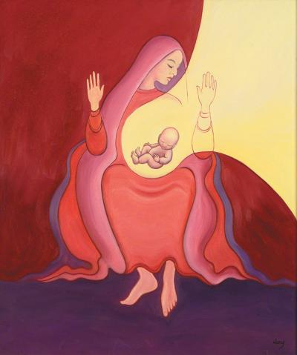
When the angel Gabriel visits Mary, he talks about another conception, this time it is Jesus’. He tells her: “You are to conceive in your womb and bear a son, and you must name him Jesus” (Luke 1:31). He also says, “The Holy Spirit will come upon you, and the power of the Most High will cover you with its shadow. And so the child will be holy and will be called Son of God.” (Lk: 1:35). This means that God is undoubtedly the real father of Jesus.

We hear these words at Mass when we say the Creed: “For us men and for our salvation, he came down from heaven and by the Holy Spirit was incarnate from the Virgin Mary and was made man”.

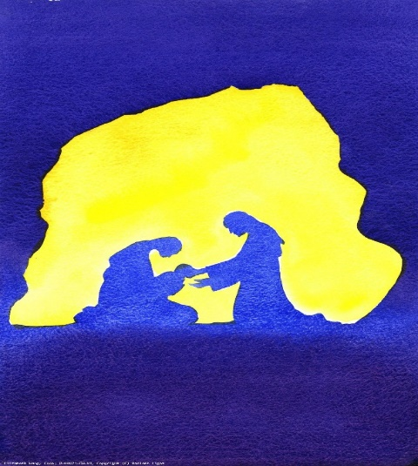
What is meant by incarnate? The Incarnation is a central Christian doctrine that God became flesh, that God assumed a human nature and became a man in the form of Jesus Christ, the Son of God and the second person of the Trinity. ... Christ was truly God and truly man. Christians celebrate this at Christmas time which takes place on 25th December each year. This is a significant time of the year as it is the middle of winter when the earth is at its coldest and harshest. Jesus is a light in the darkness, a hope that darkness cannot overcome.

Just as Eve brought sin into the world when she disobeyed God, Mary brought Jesus into the world to conquer sin and death when she obeyed God. Mary is the new Eve.
Mary is a perfect example of a life of purity and chastity. She was spotless and immaculate in body and soul. As our mother, Mary is ready to help us to follow her example to lead us to Christ.

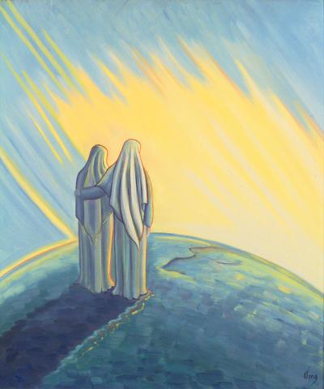
Find out more
Read about the teachings of the Catholic Church on this topic:
YOUCAT For Kids Questions - 48, 214
YOUCAT Questions – 83, 117, 147-148

To develop home-school-parish links

I wonder…
- How can you follow Mary’s example?
- How could Mary help with something in your life that could be better and more holy?
- Is there someone you know who would like Mary’s help too? Perhaps you could pray for them.

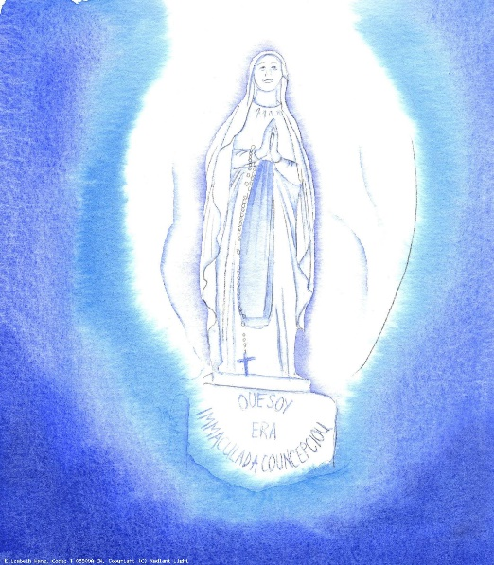
A time to pray:

Blessed Mary,
You are the perfect example of holiness,
pure in body and soul.
Help us to grow to be pure in heart like you
and to grow in holiness.
Pray for us, holy mother,
that we may grow to be more like you,
so that we too can carry Christ wherever we go.
Amen

Blessed be her Glorious Assumption

What do you think Heaven is like?

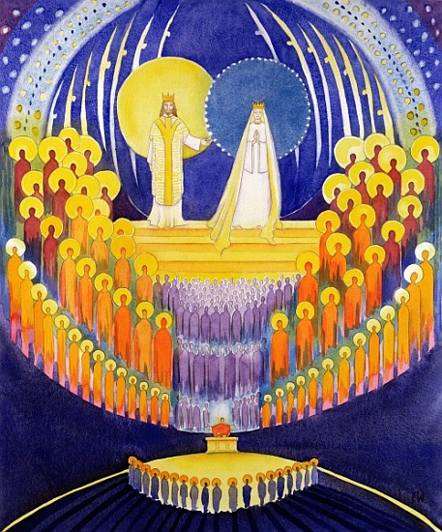
Mary is known as ‘Queen of Heaven’. Having served God on earth and been pure in body and soul, we believe that she was assumed (taken), body and soul, into Heaven to be with God and Jesus.
Jesus also went back to heaven, body and soul, when he ascended. This is called the Ascension and took place 40 days after Jesus rose from the dead at Easter.

In the book of Revelation 12:1 we read: “A great sign appeared in the sky, a woman clothed with the sun, with the moon under her feet, and on her head a crown of twelve stars.”

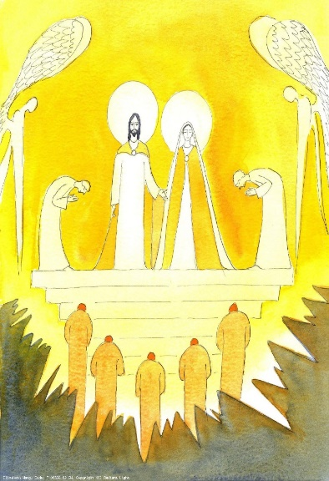
Where have you heard about Heaven? Jesus taught us to pray using the Our Father, encouraging us to build up God’s kingdom on earth:

“Our Father who art in Heaven, hallowed (holy) be thy name.
Thy kingdom come, thy will be done on earth as it is in Heaven”.

Mary is a perfect model of how we should live to prepare us for heaven and to bring about God’s kingdom on earth. Saying the Rosary is one way of helping us to understand God’s story and Mary’s place in it as it allows us to reflect on the moments and events in the life of Jesus.

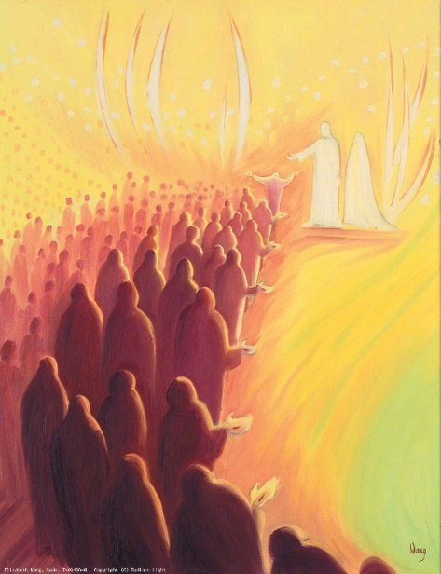
The Catechism tells us that this perfect life with the Most Holy Trinity - this communion of life and love with the Trinity, with the Virgin Mary, the angels and all the blessed - is called "heaven." Heaven is the ultimate end and fulfilment of the deepest human longings, the state of supreme, definitive happiness. (CCC 1024)

Jesus told us several parables about the Kingdom of Heaven and how valuable it is. He said we must always be ready for it because we don’t know when the time will come. Spending time with Jesus in prayer and the Eucharist helps us to prepare for Heaven, as it is a time when we are with Jesus face to face and can be at peace. It also gives us the strength to go out to love and serve God in others.

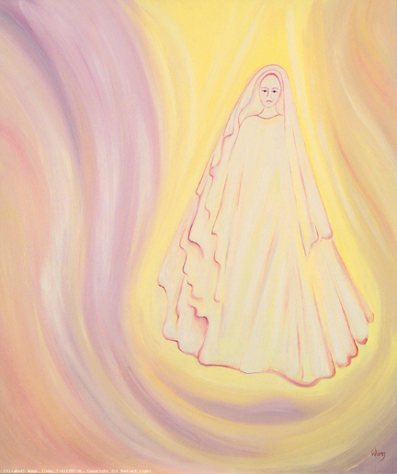
Find out more
Read about the teachings of the Catholic Church on this topic:
YOUCAT For Kids Questions – 98, 103
YOUCAT Questions – 52, 123, 158, 242, 147, 479

To develop home-school-parish links

I wonder…
- What is your image of Heaven?
- In which way could you help to bring about God’s Kingdom?
- How could you be pure in heart and ready for Heaven?

A time to pray:
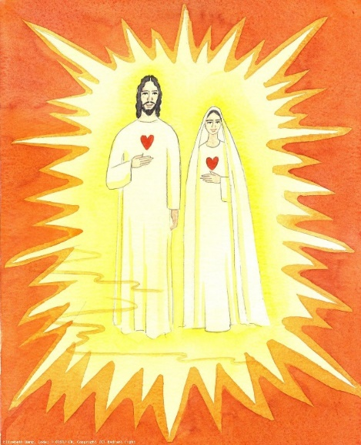
Mary, you are Queen of Earth and Queen of Heaven.
Guide us so we may grow closer to God
by listening to him in prayer and
opening our hearts to him in the Eucharist.
May we help to bring about God’s kingdom on Earth
by being peaceful and loving like you.
Pray for us, Mary, now and at the
hour of our death
and lead us to Heaven.
Amen

Blessed be the name of Mary, Virgin and Mother

What other names and titles are given to Mary?
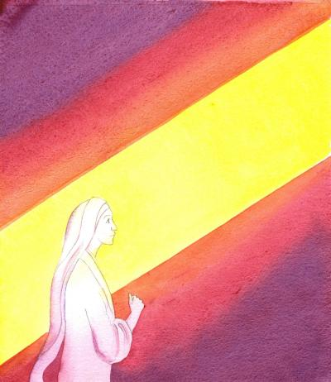
Mary’s name was chosen for her by her parents: Anna and Joachim. In Hebrew this means ‘beloved’ or ‘wished-for child’. Some of the other names of Mary include: ‘Queen of Peace’, ‘Star of the Sea’, ‘Mother of Mercy’, ‘Seat of Wisdom’ and ‘Our Lady of Perpetual Succour’. There is no doubt that Mary is indeed special and that her name is special too.

The feast of the Name of Mary is celebrated on 12th September. On this feast day, we praise Mary’s greatness as she is blessed among all women; we also seek her help at the invocation of her holy name. It calls us to consider our own Christian name which was given to us at Baptism, when we become a member of God’s family. Through the intercession of Mary and the saints, we pray that we can draw closer to Jesus and deepen our relationship with him. We also pray that we can follow their example in loving God and others.

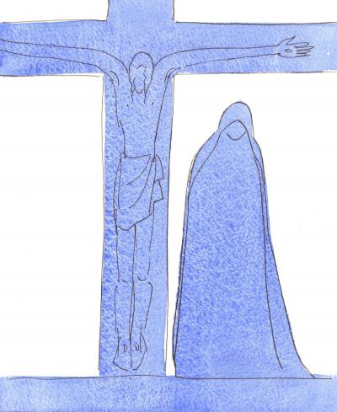
Mary is the mother of God’s only Son, Jesus Christ, through whom the Church came into being. She is therefore mother of the Church and our mother too. We know this because when Jesus was on the cross with Mary, his mother, and John, his beloved friend, at the foot of the cross he said,
“Woman, behold your son (and to John) …behold your mother”
(Jn 19:25-27).
Through these words Jesus is giving his mother to us, to love and guide us as she did him.

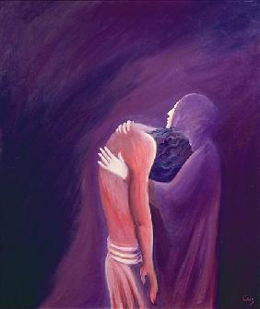
From the moment of her conception, Mary was free from original sin, she is the Immaculate Conception. At the Annunciation, when the angel Gabriel appeared to her to announce God’s news for her, Mary asked ‘How will this be since I am a virgin?’ Catholics believe that Mary is ‘ever-virgin’ and that she did not have any other children. The birth of Jesus at Christmas is known as the Virgin Birth.

As Jesus’ mother, Mary faced many challenges. When she and Joseph presented Jesus in the Temple when he was only eight days old, Simeon ‘blessed them and said to Mary, his mother: “This child is destined to cause the falling and rising of many in Israel, and to be a sign that will be spoken against, so that the thoughts of many hearts will be revealed. And a sword will pierce your own soul too.” (Lk 2:34-35)
Mary is the mother of God’s only Son, Jesus Christ. She is mother of the Church and our mother too.
She is the Virgin Mary, chosen above all women to bear God’s Son. ‘Ave Maria’ is Latin for ‘Hail Mary’ and this is sung throughout the world in praise of this very special lady.

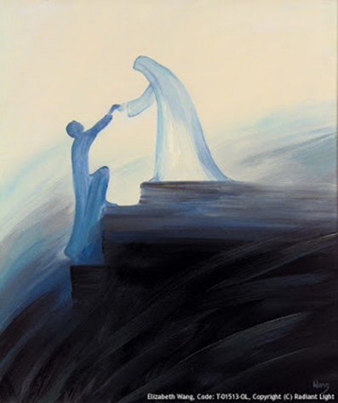
Find out more
Read about the teachings of the Catholic Church on this topic:
YOUCAT For Kids - Questions 49, 216
YOUCAT Questions – 80-85, 117, 147-148

To develop home-school-parish links
Click here for the study guide: How to say ‘yes’ to God

I wonder…
- What is your favourite title or name for Mary?
- Which image of Mary do you prefer?
- How can Mary our mother look after and protect you today?

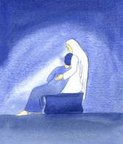
A time to pray:

Mary, Virgin and Mother,
Thank you for saying yes
to being Jesus’ mother
and our spiritual mother.
You understand what is in our hearts.
Be with us, Mother, as we grow in faith
and help us in times of difficulty.
Star of the Sea, pray for us.
Amen

Blessed be St Joseph, her spouse most chaste

What qualities would Joseph have had to be a good foster father to Jesus?

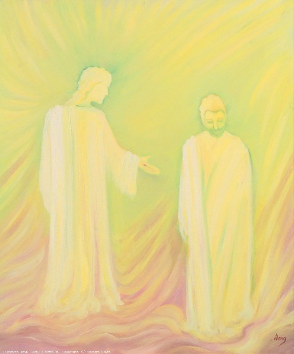
Joseph was Mary’s ‘spouse’, her husband. He was ‘chaste’ because he was pure in heart and body. Like Mary, he was faithful and obedient to God, even when it was difficult.
God chose him to do a very special job – to be the foster father of his only Son. To act as the father of someone else’s child meant that Joseph would have taken on a great responsibility. It would not be an easy thing to do.

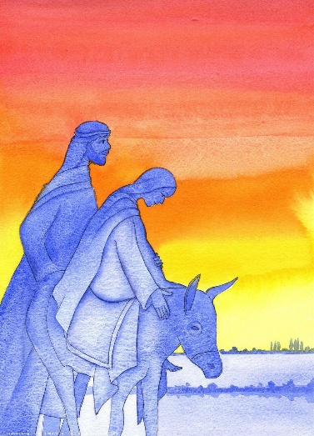
But Joseph listened to God in his dreams. When he was going to break off his betrothal with Mary, he was told "Joseph son of David, do not be afraid to take Mary home as your wife, because what is conceived in her is from the Holy Spirit” (Mt 1:20). Like Mary he trusted God.
He then protected the young Jesus by following the angel’s advice when he said, “Arise, take the young Child and his mother, flee to Egypt, and stay there until I bring you word; for Herod will seek the young child to destroy him.” (Mt 2:14) Like Mary, he ‘pondered’ over God’s word and said ‘yes’.

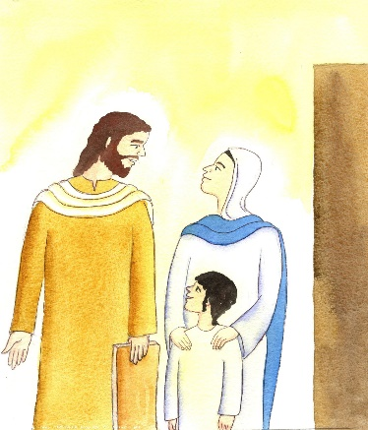
Joseph is a perfect example of kindness, goodness, strength and humility; he shows us how to follow God’s will in a real and ordinary way.
He dedicated his whole life to caring for his wife Mary and lovingly bringing up God’s greatest treasure, God’s only son, Jesus.

Joseph is so special that, like Mary he is often mentioned in the prayers during the Mass and there are many churches and schools name after him.

Jesus, Mary and Joseph are the Holy Family. Here is a prayer to the Holy Family asking for their help to be at peace with them in Heaven:

Jesus, Mary and Joseph, I give you my heart and my soul,
Jesus, Mary and Joseph, assist me now and in my last agony,
Jesus, Mary and Joseph, may I breathe forth my soul in peace with you.

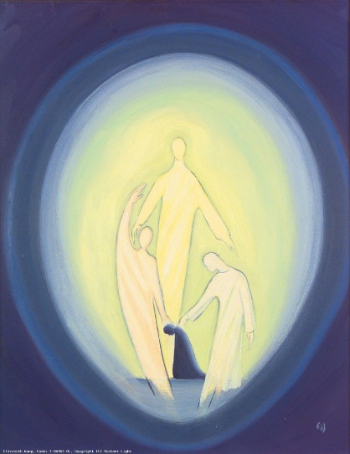
Find out more
Read about the teachings of the Catholic Church on this topic.
YOUCAT For Kids Questions - 30
YOUCAT Questions – 146, 497

To develop home-school-parish links

I wonder…
- How can you care for and protect your family as Joseph did?
- In which ways can you look after Jesus who is present in others?
- How can St Joseph guide you in making good choices for your family or community?

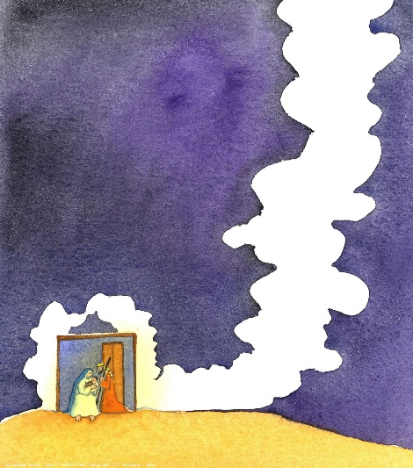
A time to pray:

Blessed Joseph,
You listened to the voice of God through the angel
and looked after Mary and Jesus.
Help us too, to listen to God’s voice
and to protect others in our family and society
with a loving and faithful heart.
May we make good choices like you did
and willingly do the job God has chosen for us
to the best of our ability.
Amen

Blessed be God in his Angels and in his Saints

What is an angel? What is a saint?

There are a number of references to angels in the Bible. In the Book of Psalms it is written: ‘Praise the LORD, you his angels, you mighty ones who do his bidding, who obey his word’ (Ps 103:20) and ‘For he will command his angels concerning you to guard you in all your way’s (Ps 91:11). Angels are servants, messengers of God; they help to protect and guide us along the way. We have already heard about the archangel Gabriel who is God’s messenger. Michael is another archangel and we pray to him for protection. The Church celebrates the feast of the Guardian Angels on 2nd October.

We have also heard about two saints – Mary and Joseph. There are hundreds of other famous saints. St Peter was the first pope and St Paul converted many people to Christianity through his preaching and his writings. St Matthew, St Mark, St Luke and St John wrote the four Gospels and St John the Baptist was Jesus’ cousin and baptised him.

All of Jesus’ apostles were saints and many of them were also martyrs. A martyr is someone who is put to death for their faith. Not all saints are martyrs and not all martyrs are saints.
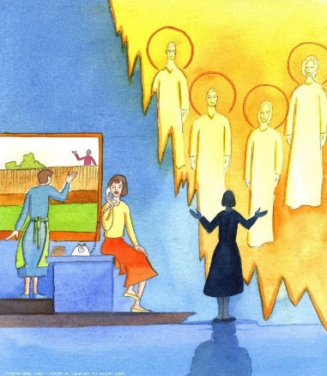
The word ‘saints’ literally means ‘holy ones’ (Acts 9:13) or ‘faithful ones’ (1 Sm 2:9). For this reason, all faithful Christians are ‘saints’ in this sense. God is speaking to all Christians when he says in Scripture, “Be holy because I [am] holy” (see 1 Pt 1:14-16). St Therese of Lisieux, known as the Little Flower, teaches us that we do not have to do extraordinary things to become a saint; rather we should “Do ordinary things with extraordinary love,” even the mundane everyday tasks. St Teresa of Calcutta was so inspired by this saint that she chose to be named after her.

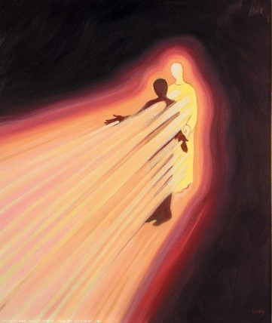
In our churches, there are many stained-glass windows of saints. These are colourful and beautiful, each telling a different story, and they let the light shine through.
In the same way we are called to be saints, to let the light of Christ shine through us in our words and actions and in how we love others.

St Pope John Paul II said: “My Dear Young People, do not be afraid to be saints of the new millennium! Be contemplative, love prayer; be…generous in the service of your brothers and sisters, be active members of the Church and builders of peace. To succeed in this demanding project of life, continue to listen to his word…” (World Youth Day 2000 Rome).
Through the Holy Spirit we are united at Mass with the saints and angels in one Sacrifice of Praise.
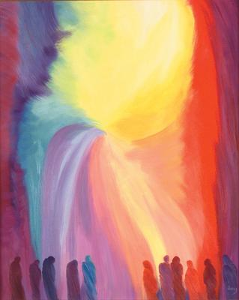
Find out more
Read about the teachings of the Catholic Church on this topic:
YOUCAT For Kids Questions – 31, 49-50, 93
YOUCAT Questions – 52-55, 132, 146, 202, 242-243, 275, 497

To develop home-school-parish links
Click here for the worksheet: Holy Women (saints)

I wonder…
- How can you be generous in the service of others?
- In which way could you be a more active member of your parish community?
- How can you do ordinary things with extraordinary love?

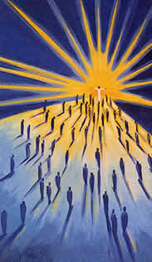
Let us pray:
God our Father,
You have given us guardian angels to protect us
and saints to inspire us to pass on the faith.
Send your Holy Spirit upon us so that we may
become saints of this millennium.
May we serve our brothers
and sisters with compassion,
build a world of peace
and be active members of our church.
May your light shine through us.
Father we ask this through Jesus Christ your son.
Amen

Further information and support

Artwork
All artwork by Elizabeth Wang. To view and download images by Elizabeth Wang (and about Christian faith in general) please visit the Radiant Light website and use the search button to search by topic:
https://radiantlight.org.uk/

The Catechism of the Catholic Church
For a free online version of the Catechism see here
To order a copy of the full version or the Compendium from St Paul’s bookshop click here

YOUCAT
For the foreword on this resource by Pope Francis see here
For information about YOUCAT as well as detailed study guides reflecting on big questions see here

YOUCAT for Kids
For information about YOUCAT for Kids and bonus materials including videos, worksheets and games for use with pupils see here

Catholicism Unpacked Series
For more resources in the series, see the Westminster Education Service website or contact your adviser.

