Witness to the Word - School Bulletin 13.01.21

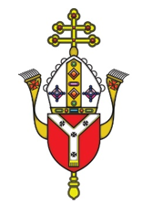
Dear Colleague in Catholic Education,
The Education Service every Wednesday provides schools with a wide variety of materials, resources, advice and updates on all matters relating to our schools and colleges. The content of these Bulletins are for Headteachers, Senior Leaders, Teaching Staff, Governors, Clergy and anyone who you feel would benefit from them. Please feel free to share widely

Objectives of the Education Service during Coronavirus (Covid-19) pandemic from September 2020
- To provide support and training for Headteachers, Heads of RE, RE Coordinators, Chaplains, Teachers, Governors and the wider school community to cope at this time of unprecedented challenge;
- To provide resources and advice relating to the Teaching and Learning of Religious Education;
- To provide resources and advice relating to Spiritual support and renewal.
- To provide resources and advice relating to Mental Health issues;
- To provide the updates from the UK Government, DfE, CES and the Diocese of Westminster on all aspects of the Coronavirus Covid-19 relating to schools and colleges;

Subject Content Today
- Religious Education and Catholic Life resources are here
- Racial Justice, Equality and Diversity updates are here
- Information about upcoming CPD and Training is here
- Mental Health and Wellbeing Resources are here
- Capital and Pupil Placement Planning updates are here

Thank you for all you are doing for your school community and for Catholic education

Religious Education and Catholic Life Resources

The Coronavirus Novena
We are grateful to the Good Shepherd Primary School for prompting us to join together and pray the Novena. We are encouraging schools to say the daily Novena at 9am beginning Thursday 14th January. You are welcome to join at the same time each day, or simply to say it at a time that suits you.
While we face the coronavirus pandemic, let us turn to the face of God in prayer and ask for his healing, his help and his protection. We will pray for all who are affected, for all who are sick and suffering, for all those who work in the medical profession, and for those who have died as well as for their grieving family members.
What is a Novena?
The word novena is taken from “novem,” the Latin word for nine. A novena is made up of nine days of prayer and meditation usually to ask God for special prayer requests or petitions.
Read more about what a novena is here. To join this particular novena please click here to sign up or use the attached PDF.

Pope Francis Prayer Intentions: January
Intention for evangelisation - Human fraternity
May the Lord give us the grace to live in full fellowship with our brothers and sisters of other religions, praying for one another, open to all.

The Christmas Season and Ordinary Time
The Epiphany (the 12th day of Christmas) is celebrated on 6th January. The Sunday afterwards, the Baptism of Our Lord is celebrated on 10th January. This marks the end of the Christmas season when green is used instead of white. The Presentation of the Lord (also known as Candlemas) is then celebrated on 2nd February and marks the end of 40 days of Christmas. These special days are feasts of the manifestation of Our Lord.

PowerPoints have been created on the Baptism of Our Lord for key stages one and two and can be found on our website. Click here.

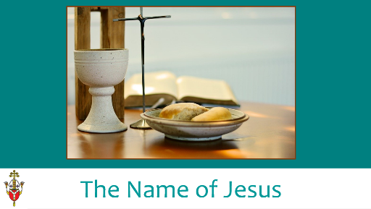
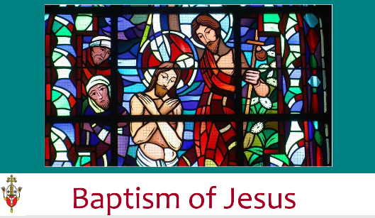

January – the month of the Most Holy Name of Jesus
This month is dedicated to the Most Holy Name of Jesus. For a PowerPoint on this to support prayer and liturgy see here.
Peace Sunday (Pax Christi)– 17th January
Loving God of peace,
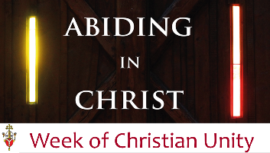
Strengthen my determination to work for a world of peace and justice; My conviction that, whatever our nationality or race, we are all global citizens, one in Christ; My courage to challenge the powerful with the values of the gospel; My commitment to find nonviolent ways of resolving conflict—personal, local, national and international; My efforts to forgive injuries and to love those I find it hard to love. Amen ‘Peace alone is holy. Peace alone is holy. Not war.’
(Pope Francis)
Click here for: Pax Christi Prayer Card

Week of Christian Unity – 18th-25th January
We have created a PowerPoint based on this resource. It includes an Act of Worship for five days and is suitable for pupils aged 9+. Each day includes a different prayer, a piece of Scripture and reflection as well as a mission. It ends with a focus on the Word of God as this is the theme for the following Sunday. More resources will be sent to support with this. For the PowerPoint, see here.
Click here for the document with Week of Christian Unity prayers

Prayer Intentions during the season of Ordinary Time:
PRAYER INTENTIONS from the Baptism of Our Lord until Shrove Tuesday
(Based on the Liturgical Year)
During this season we listen to readings about the teachings and parables of Jesus and reflect on what it means to be a follower of Christ. In this ordinary time, we concentrate on the saints and try to imitate their holiness as Christ’s followers. We also pray for the intentions below in green at any time but especially on their special days.

Christian Unity
(Octave or prayer for Christian unity 18-25 January 2021)
Peace on Earth
(Peace Day – 2nd Sunday in Ordinary Time – 17 January 2021)
Victims of Human Trafficking
(Feast of St Josephine Bakhita – 8 February 2021)
Sick and Those Who Care For Them
(World day of the Sick – Feast of Our Lady of Lourdes – 11th February 2021)
Europe
(Feast of Ss Cyril and Methodius -14th February 2021)
Racial Justice
(Racial Justice day - 3 Sundays before Lent - 31st January 2021)
Unemployed
(Day for the unemployed – Sunday before Lent – 14th February 2021
LITURGICAL YEAR | NATIONAL AND INTERNATIONAL DAYS
- Baptism of Our Lord (10th)  - St Anthony (17th)  - St Agnes (21st)  - The Word of God (24th)  - St Francis de Sales; Our Lady of Peace (24th)  - Conversion of St Paul, Apostle (25th)  - Ss Timothy and Titus (26th)  - St Thomas Aquinas (28th)  - Racial Justice Day (31st)  - St John Bosco (31st) | - International Day of Education (24th)  - World Leprosy Day/Housen’s Disease (26th)  - International Day of Commemoration in Memory of the Victims of the Holocaust and Genocide (27th)  - Week of Prayer for Christian Unity (18-25th Jan)
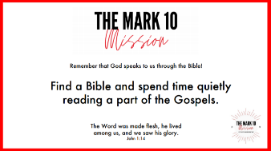
Sunday Gospel
Mark 10 Mission have created videos for each of the Sundays this term. They also have a new addition – a mission linked to each Sunday’s Gospel.
See Sunday Gospels Term 3 and Weekly Missions Term 3

Fratelli Tutti
We are providing a summary of a section of Pope Francis’ Social Encyclical each week taken from www.vaticannews.va. Click here to download the full document.
Week 8: The art of peace and the importance of forgiveness
The value and promotion of peace is reflected on in the seventh chapter, “Paths of renewed encounter”, in which the Pope underlines that peace is connected to truth, justice and mercy. Far from the desire for vengeance, it is “proactive” and aims at forming a society based on service to others and on the pursuit of reconciliation and mutual development (227-229). In a society, everyone must feel “at home”, the Pope writes. Thus, peace is an “art” that involves and regards everyone and in which each one must do his or her part. Peace-building is “an open-ended endeavour, a never-ending task”, the Pope continues, and thus it is important to place the human person, his or her dignity and the common good at the centre of all activity (230-232). Forgiveness is linked to peace: we must love everyone, without exception – the Encyclical reads – but loving an oppressor means helping him to change and not allowing him to continue oppressing his neighbour. On the contrary: one who suffers an injustice must vigorously defend his rights in order to safeguard his dignity, a gift of God (241-242). Forgiveness does not mean impunity, but rather, justice and remembrance, because to forgive does not mean to forget, but to renounce the destructive power of evil and the desire for revenge. Never forget “horrors” like the Shoah, the atomic bombing of Hiroshima and Nagasaki, persecutions and ethnic massacres – exhorts the Pope. They must be remembered always, anew, so as not be become anaesthetised and to keep the flame of collective conscience alive. It is just as important to remember the good, and those who have chosen forgiveness and fraternity (246-252).

Sunday of the Word of God - 24th January 2021
The Sunday of the Word of God takes place on the third Sunday in Ordinary Time. Pope Francis’ Apostolic Letter, Aperuit illis, published on 30 September 2019, established that 'the Third Sunday in Ordinary Time is to be devoted to the celebration, study and dissemination of the Word of God'. Through celebrating this special day, Pope Francis is inviting Catholics across the world to deepen their appreciation, love and faithful witness to God and his Word.
In keeping with The God Who Speaks - The Year of the Word, the Education Service will be sharing with you a powerpoint on the 18th January which can be used as an assembly or reflection to celebrate the Sunday of the Word of God. Please use this resource the week before or after and share it with your parents too.

Racial Justice, Equality and Diversity

The BAME Working Party has met each half term and it has been renamed to the Racial Justice Equality and Diversity (RJED) Working Party as it was considered more inclusive.
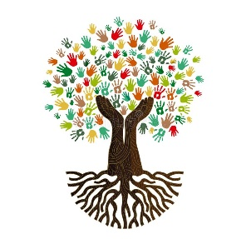
Black History Month in November was a springboard to promote diversity and equality to ensure that the changes and additions become part of our culture and mindset. RJED is being promoted regularly throughout each term. For example, in newsletters and bulletins, resources, links, recommended texts and suggested activities have been shared. Images of people and artwork from various backgrounds and cultures have been incorporated into resources for courses and support, where appropriate, and ideas for working together as a family to promote justice and equality have been shared.

In December, Terms of Reference for the group were agreed and a detailed action plan was devised with long, medium and short-term aims. These include organising effective training on issues such as Unconscious Bias, developing an aspirant leaders mentoring programme and reviewing the curriculum that is offered to pupils.

As Racial Justice Day takes place at the end of January, the advisory team has begun to work alongside The Justice and Peace Commission to prepare for this. They have also been liaising with external agencies including the Catholic Association for Racial Justice (CARJ) and CAFOD to explore opportunities for Continuous Professional Development (CPD).

Racial Justice Day
This will be celebrated on 31st January. It is one of our diocesan priorities this year to work for racial justice and equality.
We invite schools to design Racial Justice Prayer Cards. For this, pupils can write a prayer and design an image linked to this theme and we can share their work on our website. Please only send one entry per key stage (typed on word with an image on the same page) to elainearundell@rcdow.org.uk.
Pieces may be created by individuals or groups. More details about this day will follow in the next bulletin.
Here is a prayer by CARJ that can be shared with your community.

100 Great Black Britons
For information about literature, 100 great Black Britons and a home school competition to explore Black British History see here.

Columban Missionary Society Image and Writing Competition
‘Let’s Create a World Without Racism’ is the theme for a schools’ competition launched by the Columban Missionary Society. It is open to young people aged 14-18. You can learn more about the competition and the Columbans. Click here for further details

Upcoming CPD – Online Courses January 2021
Date/Time | Course | Booking Links
18th January 8th Feb, 1, 8, 22 Mar  3.45pm to 5.00pm | Introduction to the Five Pillars of Islam | Book Ticket
20th January  3.45pm to 5pm | Foundation Stones - Introducing Catholic Faith | Book Ticket
21st January  3.30pm to 4.30pm | Mental Well-Being A Whole School Approach | Book Ticket
26th January  3.30pm to 5.00pm | Spirituality in the Catholic Primary School | Book Ticket
28th January  3.30pm to 5.00pm | Mental Well-Being for Children | Book Ticket
29th January  3.30pm to 5.00pm | Guidance on Employment Procedures | Book Ticket

CCRS

There will be a new CCRS group starting on 1st February 2021. The course will be online and will take place from 4-6pm on Mondays, in sequences of 5 weeks per module, with breaks for working on assignments. For more information or to register your interest please contact Margaret Hanley at ccrs@rcdow.org.uk.

Foundation Stones
This is a 12-hour online course which is appropriate for staff and governors. It explores the foundations of the Catholic faith using Scripture, Prayer and the Teaching of the Church (Magisterium). All delegates will receive a certificate on completion of the course. Detailed support materials and PowerPoints will be provided for each of the 12 sessions and these can be used for future teaching and research as they will include ideas and resources for practical application in the classroom.

We are aware that this is a big time-commitment for staff but we are dedicated to supporting schools as efficiently as possible. There are various ways in which to complete this course:

A – complete each of the 12 sessions which will run from January to July 2021. All sessions will take place from 3:45-5pm.
B – complete some of the sessions which are being run in January to July and then complete the rest in the next academic year.
C – complete a personalised course (with delegates from other schools) at times at times which are convenient to you and the course leader. Contact Claire O Neill if you are interested.

However, each of the individual sessions can also stand alone and are appropriate for staff training.

To find out more about the Foundation Stones course, see our video In Conversation With...

The course begins in January and the dates are as follows. Should you have any questions about this course, please contact Elaine Arundell elainearundell@rcdow.org.uk

January | February | March | April | May | June | July
20th | 3rd | 10th | 21st | 5th | 9th | 7th
 | 24th | 24th |  | 19th | 23rd

Mental Health and Wellbeing Resources

Children’s Mental Health Week begins on 1st February. Click here for useful resources to help you prepare.

Supporting parents and carers during the current lockdown

Mentally Healthy Schools - Click here – Guidance for parents on how to use the Mentally Healthy Schools resources.

Anna Freud Centre - Click here - Top tips to help families work together and support one another during the coronavirus outbreak

Anna Freud Centre - Click here – Advice for parents and carers talking about mental health with young people at primary school.

Anna Freud Centre - Click here – Advice for parents and carers talking about mental health with young people at secondary school.

Anna Freud Centre - Click here – A series of expert podcasts to help parents understand and manage child and family mental health problems.
More information to support parents and carers can be found here

Young Minds - Click here - for a wide range of resources to support parents/carers in the well-being of their children.

UK Government/Public Health England Click here –Guidance for parents and carers on supporting children and young people’s mental health and wellbeing during the coronavirus (COVID-19) pandemic
Place2Be - Click here - Coronavirus: wellbeing activity ideas for families

Childline - Click here Advice and support on coping with Lockdown 3

NSPCC Learning - Click here Advice and guidance on supporting children and young people’s mental health

Mentally Healthy Schools - Click here - Guidance and practical tools to support children’s mental health during the coronavirus crisis.
NHS - Click here - Looking after a child or young person's mental health. Support and advice for parents and carers.
Justtalkherts.org Click here Hertfordshire County Council’s Toolkit for the Five Ways to Wellbeing for children and young people.

CYPMHC - Click here - Useful resources for parents and carers on Covid-19 and children and young people’s mental health.

Capital

Academies – Land and Buildings Collation Tool
The land and buildings collection tool (LBCT) is live. The submission deadline is 28th January 2021.
Returns for two trusts (ASCAT and TASCAT) have been completed and a third (DOWAT) is underway. We are waiting for CHAT, BHFAC Salvatorian CAT and CVMS to begin the process.
The link is: (https://www.gov.uk/government/publications/academies-land-and-buildings-collection-tool).
Nigel Spears is the Designated Diocesan User for the 2020 LBCT. Please ensure that you use the correct contact email address (nigelspears@rcdow.org.uk) when submitting your return.
Nil response to date: Catholic Schools in this Diocese, that are part of a Multi Academy Trust that has schools in more than one Diocese, were asked to confirm which Diocese (and Designated Diocesan User) the MAT Trustees have elected to name for the purposes of their Financial Return (assuming that it is not the Diocese of Westminster). This information helps Diocesan Bishops to cross reference responses and ensure all Church Land is correctly recorded and protected.

VASCA 2020/2021
There are now 83 live projects on Statlog.

VASCA 2021/22
The survey data available within Statlog will be used to identify priority works. The deadline for uploading surveys is Friday 12th February 2021. A programme of work will be generated and schools will be invited to engage at the appropriate time. As previously communicated, the aim is to fully resolve each identified need before moving on to the next project/school. We expect to launch 2 or 3 waves of projects during the course of the year.

Statlog
130 schools are fully registered and setup on Statlog. The data on the charts below confirms the increase in the number of scheduled tests.
Schools occupying lands owned by or otherwise controlled by the Diocese of Westminster Trustees – Please remind your Governing Body that the use of Statlog for Capital Expenditure and Statutory Compliance Management is mandatory. It is a requirement imposed by the landlord and affects all occupiers (VA Governing Bodies and Academy Trusts). Governing Bodies that occupy lands owned by a Religious Order only need to engage with Statlog if they believe that they will require access to VASCA for Planned or Reactive work.
Statutory Compliance in School is a high priority for the Diocesan Trustees. The effective management of statutory compliance helps to protect the Occupier (Governing Body/Academy trust), and the Owner (Diocesan Trustees or Religious Order Trustees). The current compliance overview is:
Current Data:
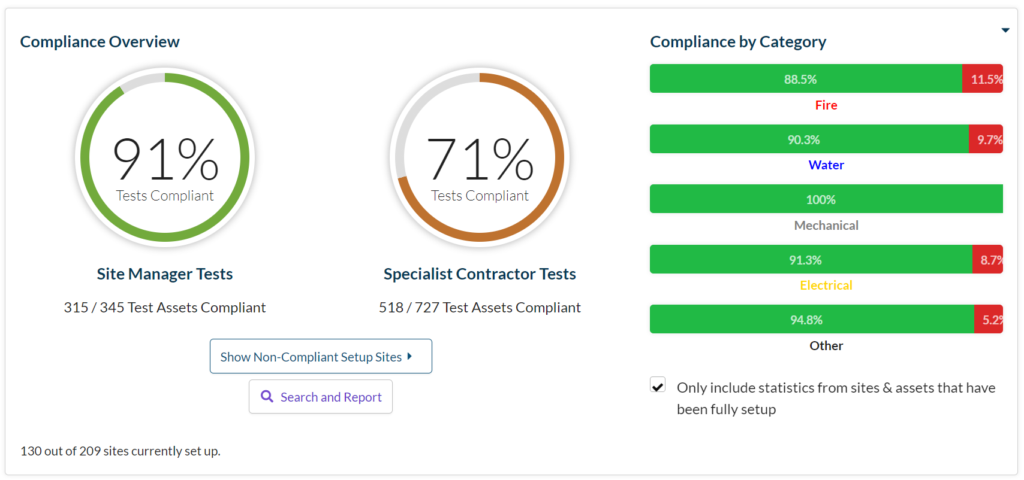
Data from the last report:

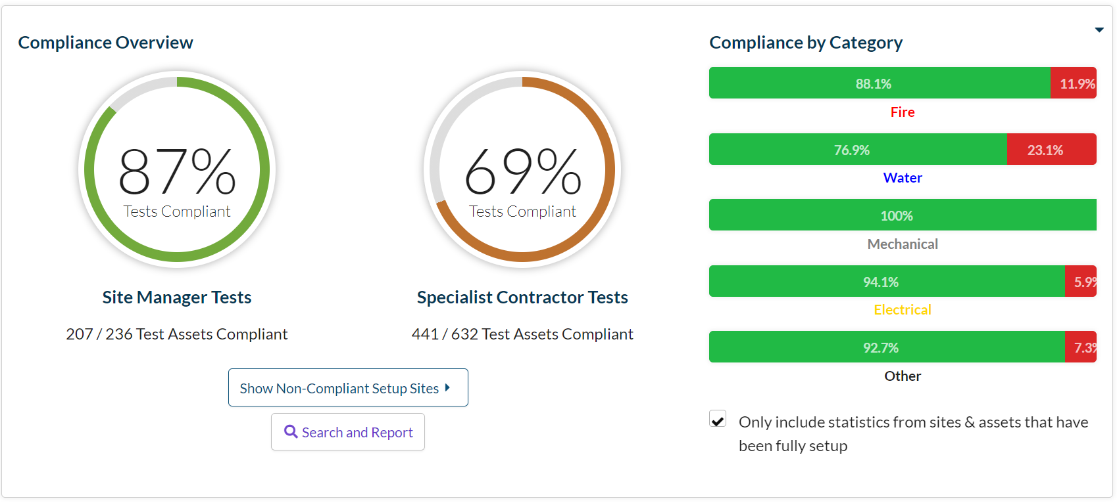

Priority School Building Programme
Project managers continue to monitor the progress of schools in this scheme.
St Mary’s, Bishop’s Stortford. Work is complete on site. However, concerns have been raised about the safety stairway banisters. The contractor and the ESFA are attempting to resolve matters.

Pupil Placement Planning

1st Planner Project
The Project’s Oversight and Scrutiny Committee met on November 24th.
The committee resolved:
- The Pilot Project should progress to stage 3. The priority is to identify and prioritise deliverable schemes that will create momentum and a positive cashflow in the programme.
- 1st Planner will now be commissioned to complete stages 1 and 2 throughout the rest of the Diocese
  - Stage 1 involves the collation data and the identification of potential funding opportunities. Reports will focus on geographical areas containing between 4 and 8 schools and will be shared with school leaders in that group. All reports will be available to all interested parties in due course
  - Stage 2 begins a process of engagement and dialogue with school leaders in each cluster area.
The engagement programme for the next phases of this project has been circulated to schools this week.
Aedificabo will:
- Manage the programme of work (Minor Works). The company will be the de facto project manager for all projects, commissioning services from other professional teams as appropriate.
- Engage as the Registered Social Housing Provider. The application to register for this function will begin this month.

