Witness to the Word - School Bulletin 27.01.21

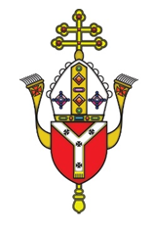
Dear Colleague in Catholic Education,
The Education Service provides schools with a wide variety of materials, resources, advice and updates on all matters relating to our schools and colleges every second Wednesday. The content of these Bulletins are for Headteachers, Senior Leaders, Teaching Staff, Governors, Clergy and anyone who you feel would benefit from them. Please feel free to share widely

Objectives of the Education Service during Coronavirus (Covid-19) pandemic
- To provide support and training for Headteachers, Heads of RE, RE Coordinators, Chaplains, Teachers, Governors and the wider school community to cope at this time of unprecedented challenge;
- To provide resources and advice relating to the Teaching and Learning of Religious Education;
- To provide resources and advice relating to Spiritual support and renewal.
- To provide resources and advice relating to Mental Health issues;
- To provide the updates from the UK Government, DfE, CES and the Diocese of Westminster on all aspects of the Coronavirus Covid-19 relating to schools and colleges;

Subject Content Today
- Religious Education and Catholic Life resources are here
- Racial Justice, Equality and Diversity updates are here
- Caritas Updates are here
- Information about upcoming CPD and Training is here
- Mental Health and Wellbeing Resources are here
- Governance and Admissions Updates are here
- Capital and Pupil Placement Planning updates are here

Thank you for all you are doing for your school community and for Catholic education

Religious Education and Catholic Life Resources

Pope Francis Prayer Intentions: January
Intention for evangelisation - Human fraternity
May the Lord give us the grace to live in full fellowship with our brothers and
sisters of other religions, praying for one another, open to all.
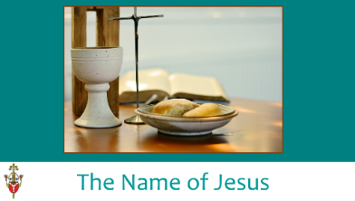
January – the month of the Most Holy Name of Jesus
This month is dedicated to the Most Holy Name of Jesus. For a PowerPoint on this to support prayer and liturgy see HERE.

Year of St Joseph
Our Holy Father has proclaimed this year as a year of St Joseph. To read more about this year and Pope Francis’ words, see HERE.

For assembly slides and notes on St Joseph created by Mission Together see HERE.

Prayer Intentions during the season of Ordinary Time:
PRAYER INTENTIONS from the Baptism of Our Lord until Shrove Tuesday
(Based on the Liturgical Year)
During this season we listen to readings about the teachings and parables of Jesus and reflect on what it means to be a follower of Christ. In this ordinary time, we concentrate on the saints and try to imitate their holiness as Christ’s followers. We also pray for the intentions below in green at any time but especially on their special days.

Christian Unity
(Octave or prayer for Christian unity 18-25 January 2021)
Peace on Earth
(Peace Day – 2nd Sunday in Ordinary Time – 17 January 2021)
Victims of Human Trafficking
(Feast of St Josephine Bakhita – 8 February 2021)
Sick and Those Who Care For Them
(World day of the Sick – Feast of Our Lady of Lourdes – 11th February 2021)
Europe
(Feast of Ss Cyril and Methodius -14th February 2021)
Racial Justice
(Racial Justice day - 3 Sundays before Lent - 31st January 2021)
Unemployed
(Day for the unemployed – Sunday before Lent – 14th February 2021
LITURGICAL YEAR | NATIONAL AND INTERNATIONAL DAYS
January  - The Word of God (24th)  - St Francis de Sales; Our Lady of Peace (24th)  - Conversion of St Paul, Apostle (25th)  - Ss Timothy and Titus (26th)  - St Thomas Aquinas (28th)  - Racial Justice Day (31st)  - St John Bosco (31st)  February  - St Brigid (1st)  - Presentation of Our Lord (2nd)  - St Blaise (3rd)  - St Agatha (5th)  - Paul Miki and Companions (6th)  - St Jerome Emiliani; St Josephine Bakhita (8th)  - Our Lady of Lourdes (11th)  - Ss Cyril and Methodius (14th)  - Chair of St Peter (22nd) | January  - International Day of Education (24th)  - World Leprosy Day/Housen’s Disease (26th)  - International Day of Commemoration in Memory of the Victims of the Holocaust and Genocide (27th)  - Week of Prayer for Christian Unity (18-25th Jan)  February  - World Wetlands Day (2nd)  - World Cancer Day (4th)  - World Pulses Day (10th)  - International Day of Women and Girls in Science; Safer Internet Day (11th)  - World Day of the Sick (11th)  - World Radio Day (13th)  - World Day of Social Justice (20th)  - International Mother Language Day (21st)  - International Polar Bear Day (27th)  Interfaith Harmony Week - 1st week in Feb

Conversion of St Paul (25th Jan)
For Mission Together’s assembly notes and slides as well as a liturgy and activity see HERE.
Racial Justice Sunday (31st Jan)
For further details, see further on in this document. PowerPoints for KS1, KS2 and secondary are available on our website HERE.
St Josephine Bakhita (8th February)
On 8 February we celebrate Bakhita Day, the Feast Day of St Josephine Bakhita, the patron saint of victims of modern slavery. It is an opportunity for schools to raise awareness of modern slavery and human trafficking, and to gain support for Caritas Bakhita House, a safe house for women escaping human trafficking and modern slavery, opened in the Diocese of Westminster in 2015 at an undisclosed location (for protection and safety) and providing accommodation for 12 women at a time. If you would like more information about how your school might help Caritas Bakhita House, more information can be found here HERE.
For Caritas Westminster’s PowerPoint on Bakhita Day see HERE.
Our Lady of Lourdes (11th Feb) - For Mission Together’s liturgy for the World Day of the Sick see HERE.
Catholicism Unpacked
This series of resources was written to develop subject knowledge and theology in RE and all documents are free to access on our website HERE.

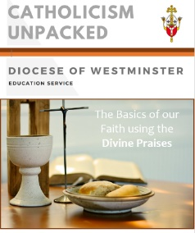
The Basics of our Faith using the Divine Praises
This document was written to support staff and parents with the basics of our faith. It uses the Divine Praises as a structure and explains the fundamental theological beliefs about the Trinity, the Holy Family, the Eucharist and the saints using words and images to support teaching. There are also various links to videos and worksheets that can be used for learning at home and in school.

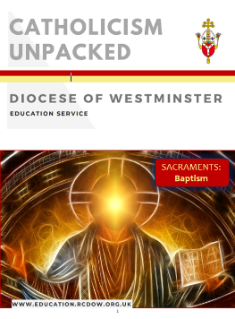
The Sacrament of Baptism
This document includes frequently answered questions about Baptism and all of the basics (and more!) about this first Sacrament of initiation. It is based on the Catechism of the Catholic Church and includes references to Scripture as well as a comprehensive glossary. Links to a variety of videos are included and these can be used to develop religious knowledge and understanding of both staff and pupils. Various artwork linked to the general theme of Baptism as well as Jesus’ Baptism are also included as are some ideas and resources for teaching.

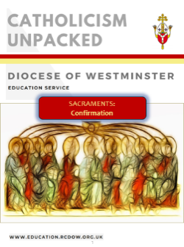
The Sacrament of Confirmation
This document is written in the same style as the one on Baptism and has similar contents, this time concentrating on the Sacrament of Confirmation as well as including information and resources linked to Pentecost and the Holy Spirit. Both of these documents complement each other as the two sacraments are Sacraments of Initiation and therefore inextricably linked. A similar document on the Eucharist (the third Sacrament of Initiation) should be released later in the year.

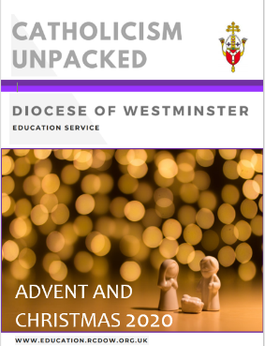
Advent and Christmas
Packed full of information with an A-Z for this season, a multitude of links for teaching, ideas for developing home-school-parish links, resources for prayer/liturgy for the season and suggestions for enhancing the common good, this resource is useful for all members of staff. A similar document on Lent/Easter should be released later this term. There will also be a similar resource on the Sacraments of Healing (Reconciliation and the Sacrament of the Sick) which should be coming out and should support these documents and those listed above.

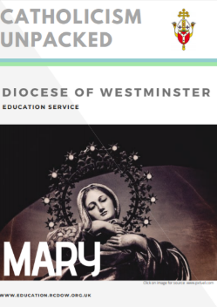
Mary
This document explains who Mary is and what the Church teaches about her and her role in salvation. It answers challenging questions about the Immaculate Conception, her Assumption, her role in Salvation and her place in the Church. This document is supported by a PowerPoint that is ready to be used for staff training. A document on the Dowry of Mary contains more information about Mary as the Mother of Jesus and the Church and has practical ideas and resources for teaching. Resources can be found HERE.

Fratelli Tutti
We are providing a summary of a section of Pope Francis’ Social Encyclical each week taken from www.vaticannews.va. Click here to download the full document.
Week 9: Never Again War, A failure of Humanity
Part of the seventh chapter, then, focuses on war: it is not “a ghost from the past” – Francis emphasizes – “but a constant threat”, and it represents “the negation of all rights”, “a failure of politics and of humanity”, and “a stinging defeat before the forces of evil” which lies in their “abyss”. Moreover, due to nuclear chemical and biological weapons that strike many innocent civilians, today we can no longer think, as in the past, of the possibility of a “just war”, but we must vehemently reaffirm: “Never again war!” And considering that we are experiencing a “world war fought piecemeal”, because all conflicts are interconnected, the total elimination of nuclear arms is “a moral and humanitarian imperative”. With the money invested in weapons, the Pope suggests instead the establishment of a global fund for the elimination of hunger (255-262).

The Year of the Word
As you may recall, during the first lockdown, the Education Team produced a weekly Rosary resource to support our schools; we hope that you found this useful. As part of the remote on-going support that we are offering during the current lockdown, we have decided to produce a weekly resource to support 'The Year of the Word: The God Who Speaks'.
As such, you will receive weekly PowerPoints that can be used however you see fit, as either a class/home reflection or as part of an 'assembly' focusing on the Old Testament reading or Psalm from the coming Sunday.
The decision to focus on the Old Testament readings/Psalm was made based on two factors. Firstly, we recognise that our pupils are often less familiar with these readings; in addition to this, we recognise that the resources currently being produced by The Mark 10 Mission organisation are wonderful in bringing to life the Gospel reading from each Sunday...we simply could not compete! (https://www.themark10mission.co.uk/)
Initially, the opening slides will remain consistent each week as a way to reinforce/embed your pupils understanding of the Old Testament, with the 'focus' for each week being adapted as appropriate based on the OT passage for the following Sunday.
As part of the on-going support provided, the PowerPoints will also be placed on the Education Service webpage each week from where they can be readily downloaded.
Please feel free to adapt these PowerPoints as you see fit and use them in a way which will best suit your school and meet the needs of your pupils.
Finally, if you have any feedback concerning these resources, or any of the other resources that we produce, we would love to hear from you.

Racial Justice, Equality and Diversity

The information below is from the Bishops’ Conference of England and Wales
Sunday, 31 January 2021
This year’s Racial Justice Sunday is more important than ever. The effects of the Coronavirus pandemic, the killing of George Floyd, and the powerful message on fraternity and equality by Pope Francis in Fratelli Tutti speak of the need to actively oppose racism and pursue racial justice with renewed vigour. Click HERE for the Pope’s encyclical letter.

Theme
The theme is ‘A Time to Act‘. Racial issues and inequalities were identified nationally and internationally in 2020 generating awareness, emotion and outrage. In light of this Racial Justice Sunday 2021 is particularly significant. Action is needed to further the cause of racial justice but what can we do? Read a reflection on the theme HERE.
Racial Justice Sunday 2021
At the beginning of his public ministry Jesus outlines his Mission in the synagogue in Nazareth:
‘He has sent me to bring the good news to the poor,
to proclaim liberty to captives and to the blind new sight,
to set the downtrodden free,
to proclaim the Lord’s year of favour’
His ministry was one of compassionate involvement, concern for the disadvantaged. Aware of obstacles, including those of the Law, which limited joy and fulfilment Jesus acted. He confronted, sometimes angrily, what undermined a person’s dignity.
The theme of Racial Justice Sunday 2021 is A Time to Act.
Racial issues and inequalities were identified nationally and internationally in 2020 generating awareness, emotion and outrage. In light of this Racial Justice Sunday 2021 is particularly significant.

Action is needed
Action is needed to further the cause of racial justice. What can we do?
In recent years Pope Francis has repeatedly used four verbs encouraging positive and direct action in relation to migrants and refugees, ‘Welcome, Protect, Promote and Integrate’. These same words are essential to advancing the cause of racial justice. None can be omitted, it is as necessary to have plans to Promote and Integrate as it is to Welcome.

Mark 1:21-28
Gospel reading on Racial Justice Sunday
Jesus’ sermon in the synagogue in Capernaum triggered a reaction from a member of the congregation. (It is always unnerving to have your sermon interrupted by someone who disagrees with your words). ‘What do you want with us?’ ‘Have you come to destroy us?’
The duty of the Prophet in speaking God’s words and so bringing God’s light into lives and situations is to enlighten, to encourage, sometimes to warn. To identify what action is needed to ensure that all God’s people know they are equally valued by society and the Church.
The plea of the psalmist today is ‘ …listen to his voice, harden not your hearts’.
Racial Justice Sunday is a time to absorb fully this scriptural request.
Listening to the voice of God and the voice of the Church we learn of equal love for all:
- Voices that discriminate unjustly, attitudes that undermine on the grounds of race must be opposed.
- Voices of those who feel rejected or perpetually in second place must be listened to.
- The dignity of all must be respected and promoted.
In the Church we proclaim that everyone of whatever racial origin should be Welcomed, Protected, Promoted and Integrated.
We need to challenge ourselves to act now so that this may be achieved.
This is reinforced in the message from Bishop Paul McAleenan – Lead Bishop for Racial Justice.

Resources
As well as a thought-provoking reflection on the theme, there is a message from Bishop Paul McAleenan, the Lead Bishop for Racial Justice, and there will also be a series of videos available on the website HERE. The Bishops’ Conference has also given us a prayer to bring this important work to the Lord.

‘A Time to Act’ - Reflection
For a reflection on the theme of Racial Justice Sunday 2021 - 'A Time for Action' see HERE.

Bishop’s Message for RJS 2021
Bishop Paul McAleenan, Lead Bishop for Racial Justice says in his message: "It's not enough to simply denounce racism. This is a time to act. In the words of Pope Francis: 'God asks us to dare to create something new.'” For his message see HERE.

Other Updates

Diocesan Prayer Cards
We invite schools to design Racial Justice Prayer Cards. For this, pupils can write a prayer and design an image (using art or ICT skills) linked to this theme and we can share their work on our website. Please only send one entry per key stage (see Racial Justice Sunday PowerPoint for further information) to elainearundell@rcdow.org.uk by Thursday 20th February (World Day of Social Justice). Pieces may be created by individuals or groups.

Columban Missionary Society Image and Writing Competition
‘Let’s Create a World Without Racism’ is the theme for a schools’ competition launched by the Columban Missionary Society. It is open to young people aged 14-18. You can learn more about the competition and the Columbans HERE.

100 Great Black Britons
For information about literature, 100 great Black Britons and a home school competition to explore Black British History see HERE.

Sharing of resources – pupil work
Primary pupils of St Monica’s in Hackney created their own podcast on Black History. Click HERE for the podcast.

Prayer
Lord Jesus Christ,
in your ministry
you were approached by people
of many different nations and cultures.
You listened to their cry for help,
treated them with love and compassion,
and brought them healing and wholeness.
In our own time may we provide
to all those who are suffering
the help that they need
and the care that they require.
May we respond to the invitation of the Holy Spirit
to dream of a world made new
where the poor are not forgotten
but are given the opportunity
to live and flourish
with good health and equal prospects.
We ask this in the name of Jesus the Lord.
Amen.
This prayer was taken from the Bishops’ Conference website and can be found here

Support materials
We have created support materials for you that can be used for prayer/liturgy in KS1, KS2 and Secondary. Click on the link HERE.

Caritas Update

Caritas Westminster Tech Appeal
The Caritas Westminster Tech Appeal is a new project aimed at combatting the Digital Divide felt in schools across the Diocese of Westminster. We will be appealing for people to donate their old and unused laptops and tablets which can be put to better use by schools. Schools will work with Caritas Westminster to receive and process devices before giving them to their students. Together we can help students continue learning throughout the pandemic!
If you would like to register your school's interest in the Caritas Westminster Tech Appeal, please go to: https://tinyurl.com/CaritasTechAppeal

Upcoming CPD – Online Courses - January – February 2021

Date/Time | Course | Booking Links
28th January  3.30pm to 5.00pm | Mental Well-Being for Children | Book Ticket
29th January  3.30pm to 5.00pm | Guidance on Employment Procedures | Book Ticket
1st February  3.30pm to 5.00pm | Religious Vocabulary in the Primary School | Book Ticket
2nd February  3.30pm to 5.00pm | The Liturgical Year | Book Ticket
3rd February  3.45pm to 5.00pm | Foundation Stones Session – God’s Revelation and God the Father and Creator | Book Ticket
4th February  3.30pm to 5.00pm | Mental Well-Being for Staff | Book Ticket
9th February  4.00pm to 6.00pm | Aspiring to Catholic Leadership Secondary | Book Ticket
10th February  3.30pm to 5.00pm | EYFS Praying with Small Children | Book Ticket
12th February  9.00am to 10.30am | NQT Day 2 (The Taught RE) | Book Ticket

CCRS

There will be a new CCRS group starting on 1st February 2021. The course will be online and will take place from 4-6pm on Mondays, in sequences of 5 weeks per module, with breaks for working on assignments. For more information or to register your interest please contact Margaret Hanley at ccrs@rcdow.org.uk.

Foundation Stones
This is a 12-hour online course which is appropriate for staff and governors. It explores the foundations of the Catholic faith using Scripture, Prayer and the Teaching of the Church (Magisterium). All delegates will receive a certificate on completion of the course. Detailed support materials and PowerPoints will be provided for each of the 12 sessions and these can be used for future teaching and research as they will include ideas and resources for practical application in the classroom.

We are aware that this is a big time-commitment for staff but we are dedicated to supporting schools as efficiently as possible. There are various ways in which to complete this course:

A – complete each of the 12 sessions which will run from January to July 2021. All sessions will take place from 3:45-5pm.
B – complete some of the sessions which are being run in January to July and then complete the rest in the next academic year.
C – complete a personalised course (with delegates from other schools) at times at times which are convenient to you and the course leader. Contact Claire O Neill if you are interested.

However, each of the individual sessions can also stand alone and are appropriate for staff training.

To find out more about the Foundation Stones course, see our video In Conversation With...

The course begins in January and the dates are as follows. Should you have any questions about this course, please contact Elaine Arundell elainearundell@rcdow.org.uk

January | February | March | April | May | June | July
20th | 3rd | 10th | 21st | 5th | 9th | 7th
 | 24th | 24th |  | 19th | 23rd

Mental Health and Wellbeing Resources

Staff Wellbeing
Anne Freud Centre/Mentally Healthy Schools:
- Advice on supporting staff well-being Click here
- Advice for SLT in supporting staff with mental health difficulties Click here
- Ten steps to school staff well-being Click here

Young Minds
What keeps us going – resource for teachers about their own mental health Click here

Mental Health Foundation:
- How to guide to looking after your mental health Click here
- Address your stress Click here
- Looking after your mental health as a teacher Click here

Health and Safety Executive:
- Working together to reduce stress at work Click here
- Tackling work related stress using the Management Standards approach Click here

Education Support
- Telephone support and counselling Click here
- Resources and support for school staff on issues relating to mental health Click here
- Seven tips for Headteachers coping with the coronavirus pandemic Click here

BUPA – Running a staff session on mental health and well-being Click here

Mental Health at Work – Advice and signpost for resources to support staff mental health Click here

Partnership for Children - Resources to support staff mental health and well-being Click here

SecEd – Staff Well-being – 36 ideas for your school Click here

Governance and Admissions Updates

Governor Hub

Please ensure all members of your governing body are registered on governor hub or they will not be receiving diocesan communication including notifications of training or events. Clerks are responsible for ensuring the platform stays up to date with current contact details.

Governor Hub is an incredibly useful platform enabling diocesan officers to identify if your governing body has any vacancies and direct willing volunteers accordingly. There are many benefits to ensuring your governing board information is up to date on this platform. If there are any queries relating to Governor Hub please contact Amanda Crowley amandacrowley@rcdow.org.uk

New process for appointing foundation governors / directors
For a long time now, we have known of the considerable frustration experienced in getting foundation governors appointed by the diocese. We have studied why these delays occur and looked at ways in which the system can be improved.
Time after time we have found that delayed applications are caused by difficulties in getting references and DBS clearances to support the applications, despite reminders being sent. In brief, instead of the diocese seeking to collect the supporting documentation from referees we are asking that the school does this instead. We believe that there is more likelihood that this will be effective when it is done locally than when done centrally. In addition, we have redesigned the process so that it occurs completely electronically. This new system will operate for all applications after the 1st January 2021.
What does your school need to do?
- We ask that your school appoints a Nominated Person (either the Clerk to Governors or perhaps, someone in the School Office) who will administer this process.
- The Nominated Person should download the suite of forms [available at Link to website ] and personalise them to the school, including the email address of the nominated person.
- The Nominated Person will send the application to and receive the application from the applicant.
- The Nominated Person will seek the references and the DBS certification. (Note: the parish priest may wish to return the reference directly to the diocese; if they wish to do this, they have been asked to let the nominated person know).
- When all references and Clearances are available, the Nominated Person will upload all documents to the Diocese using this secure link at : Link to website A receipt will be sent to the Nominated Person and the Applicant on submission.
- The Diocese will determine the complete application within 21 days, either with a letter and deed of appointment, or other communication.
If you have any questions about how the system will work or difficulty in downloading the materials, please contact Mike Pittendreigh (mikep@rcdow.org.uk) Other, more general, governors queries should continue to be addressed to Carol Campbell (governors@rcdow.org.uk)
Admissions Appeal Arrangements during COVID-19 – Update
On the 31 January 2021 the School Admissions (England) (Coronavirus) (Appeals Arrangements) (Amendment) Regulations 2021 will come into force.
These regulations amend the School Admissions (England) (Coronavirus) (Appeals Arrangements) (Amendment) Regulations 2020. The main effect of these Regulations is that the amendments to admissions appeals arrangements due to coronavirus will continue to have effect until 30 September 2021 (rather than ceasing on the 31 January 2021).
In summary, they give admission authorities, local authorities and admission appeal panels more flexibility when dealing with appeals during the COVID-19 outbreak. The 2020 regulations permit appeal hearings to be heard by telephone or video conference. They also allow appeals to be decided on the basis of written submissions only. In addition, the statutory timescales have been amended.
The 2021 Regulations can be found at: https://www.legislation.gov.uk/uksi/2021/14/made

Capital

Academies – Land and Buildings Collation Tool
The land and buildings collection tool (LBCT) is live. The submission deadline is 28th January 2021.
The current status of the return as of 1200 today is:
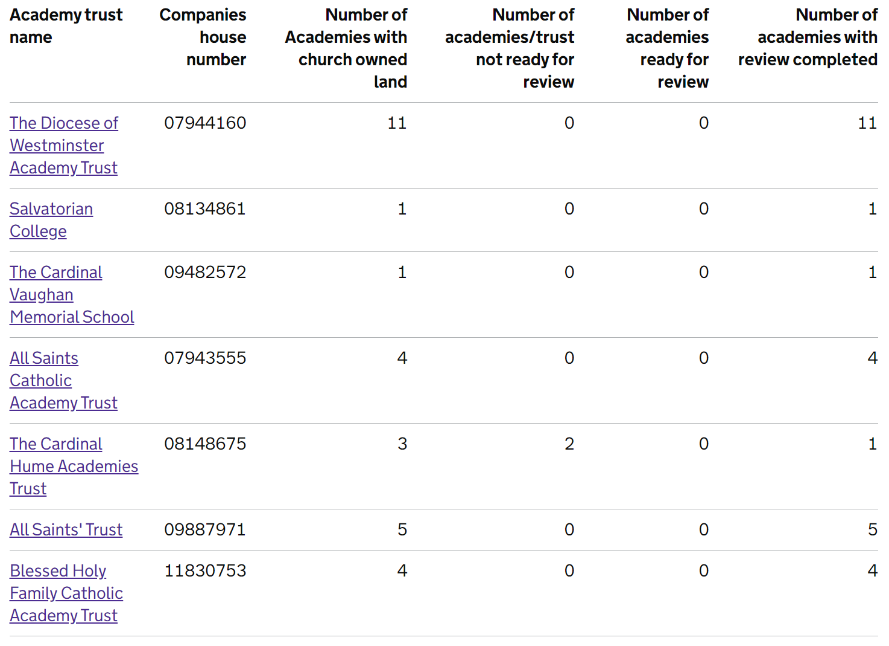
The final 2 schools in CHAT will be processed as soon as they are presented.
VASCA 2020/2021
There are currently 84 live projects on Statlog.

VASCA 2021/22
The survey data available within Statlog will be used to identify priority works. The deadline for uploading surveys is Friday 12th February 2021. A programme of work will be generated, and schools will be invited to engage at the appropriate time. As previously communicated, the aim is to fully resolve each identified need before moving on to the next project/school. We expect to launch 2 or 3 waves of projects during the course of the year.
The following is a summary of the required works identified to date:
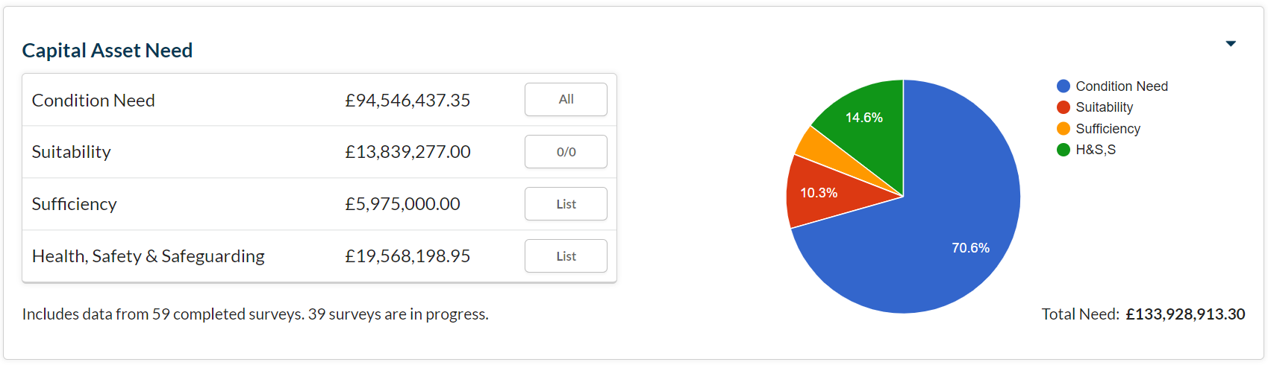
Consultants are working diligently to ensure that all surveys commissioned by schools are uploaded before the February deadline.

Statlog
134 schools have purchased full licences for Statlog. Consultants are working to activate the Statutory Compliance Modules for licenced schools. The following includes a setup tracker:
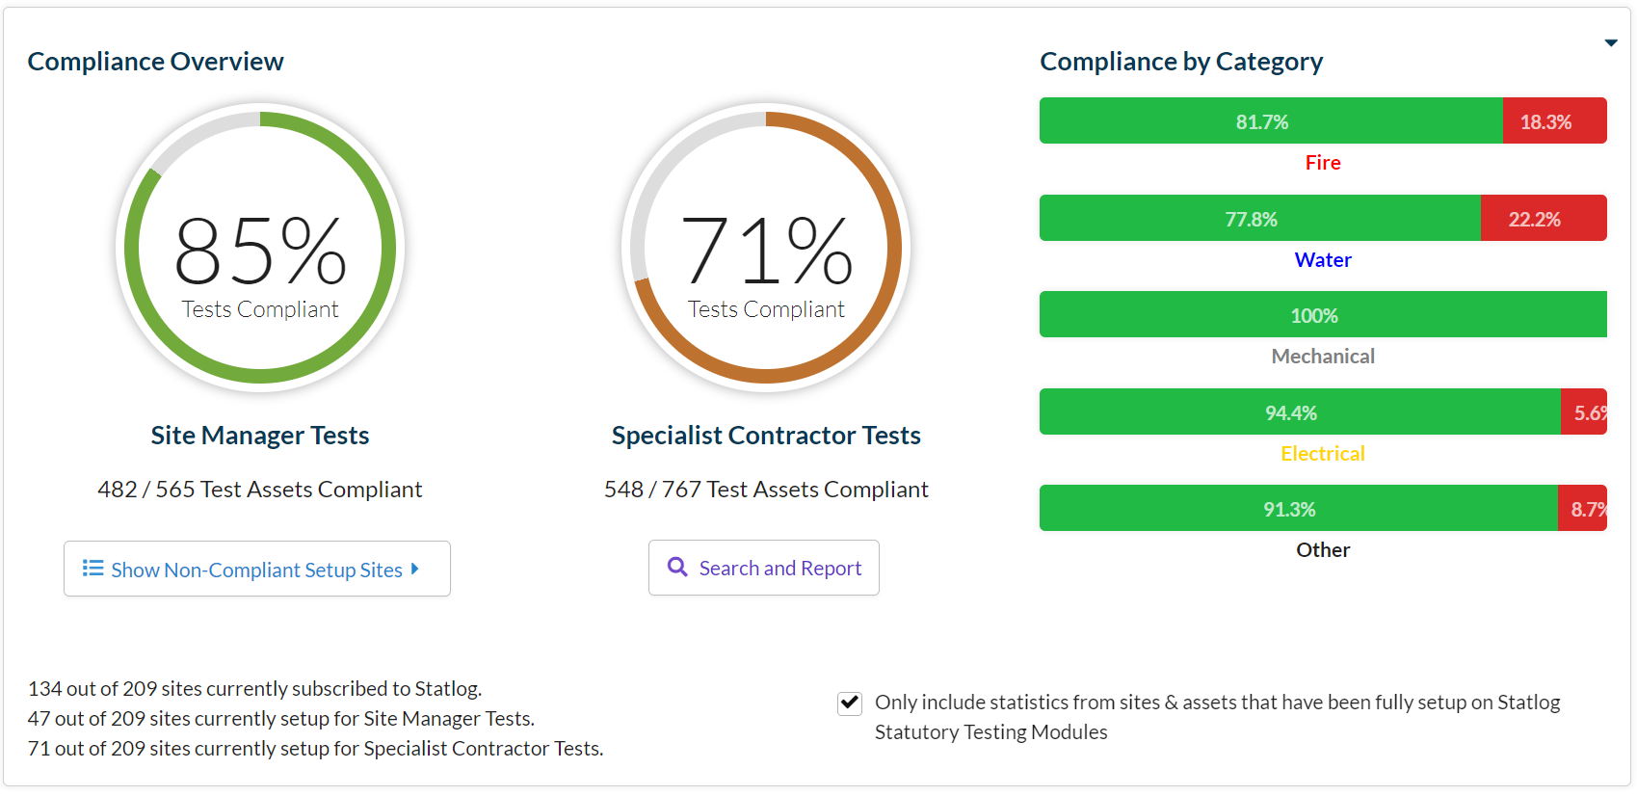
The slight reduction in the percentage score for Site Manager Tests is due to the addition of new schools to the programme. In the 47 school that are fully setup for Site Manager Test, the combined test count now stands at 565. This is in increase of 220 since the last report.

Priority School Building Programme
Project managers continue to monitor the progress of schools in this scheme.

Pupil Placement Planning

1st Planner Project
The Project’s Oversight and Scrutiny Committee met on November 24th.
The Project Team is now focused on delivering the three strands of the programme.
- Major Project – The team is working on school capacity/need models that will inform the role out of this segment. As agreed, these will be moderated by Head Teachers to ensure that all required elements are included.
- Minor Projects – The team is reviewing local need in preparation for detailed discussion with schools and Local Authorities
- New Starts – The Team has begun the process of trawling for and cleansing data that will ensure that we can present WinWin options to Schools and Local Authorities as appropriate.
During the School Leaders, Business Managers and Chairs briefings conducted over the last 2 weeks, a programme confirming anticipate dates for engagement were circulated.
Aedificabo will:
- Manage the programme of work (Minor Works). The company will be the de facto project manager for all projects, commissioning services from other professional teams as appropriate.
- Engage as the Registered Social Housing Provider. The application to register for this function will begin this month.

