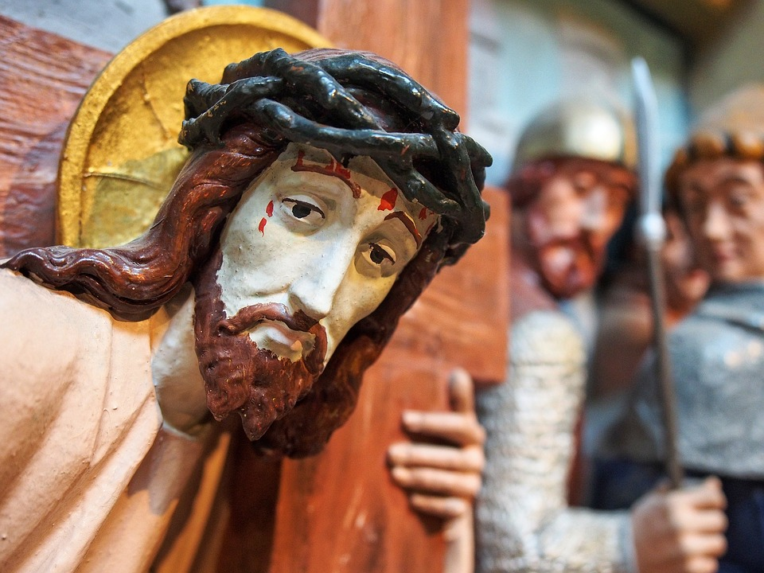
LENT 2021
Contents

Lent Document: An overview 3

Section 1: Information and theology
- Lent: An A-Z 4
- Lent: The Liturgical Year Q & A 12
- Lent: Ash Wednesday 16
- Lent: Observance and Practice 17
- Lent: Holy Week and the Triduum 18
Section 2: Charitable Acts

- Mission Together 20
- CAFOD 22
- Caritas Westminster 24
- Catholic Children Society 25
Section 3: Resources for further research and teaching

- Lent: Videos 27
- Lent: General resources and artwork 31
- Lent: Prayer resources 32
- Lent: Song Prayers 33
- Lent: Virtual Retreats 34
- Sources and thanks 35

Lent document: An Overview
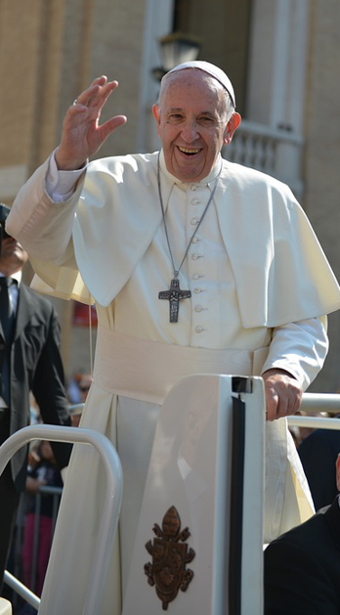
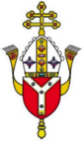
A Lenten Challenge

Fasting

Fast from hurtful words and speak kind words.
Fast from sadness and be filled with gratitude.
Fast from anger and be filled with patience.
Fast from pessimism and be filled with hope.
Fast from worries and have trust in God.
Fast from complaints and contemplate simplicity.
Fast from pressures and be prayerful.
Fast from bitterness and fill your heart with joy.
Fast from selfishness and be compassionate.
Fast from grudges and be reconciled.
Fast from words and be silent so you can listen.t
Pope Francis (Ash Wednesday 2017)

This document

Aims
The main purpose of this resource is to help you as teachers and leaders to appreciate more fully the Lenten season and save you time and energy so that you, in turn, can develop the theology, religious literacy and spirituality of pupils as well as their understanding of Catholic Social Teaching.

Structure
There are three main sections in the document, although they may overlap:
- Information to develop one’s own theology and religious literacy. This takes the form of Q&A as well as an A-Z of Lent
- Support materials to develop this theology and share it with pupils. This will take the form of video and website links
- Links to various diocesan, national and universal charities in order to enhance the Lenten experience for all members of the community

How to use this resource
This resource is intended to support various members of staff in a Catholic school, it is not intended as a resource for pupils. Due to its importance, there is a plethora of materials on Lent and Holy Week so this document is not intended as a complete or exhaustive list of information.

However, it is hoped that it will be useful for all members of staff especially teachers and RE Coordinators. The materials here are relevant for teaching about Lent as well as the Passion and death of Christ. We hope that you find it helpful and have a happy and holy Lent.

Lent: An A-Z

A
Abstinence: The giving up of something during Lent such as meat, alcohol or chocolate. You could also give up a habit or an activity such as spending time on technology. The purpose of this is to make a sacrifice and grow closer to God. Abstinence is not exclusively confined to Lent. For example, many Catholics choose not to eat meat and instead eat fish on Friday throughout the year.

Almsgiving: Giving to charity and helping those in need. This is to make our hearts kinder and more like the heart of Jesus.
B
Betray: Judas betrayed Jesus in the Garden of Gethsemane on Holy Thursday night and revealed him to the Roman soldiers by kissing him on the cheek. He did this for forty pieces of silver.
C
Carnival: The merrymaking and festivity that takes place in many Roman Catholic countries in the last days and hours before the Lenten season. The derivation of the word is uncertain, though it possibly can be traced to the medieval Latin carnem levare or carnelevarium, which means to take away or remove meat.

Chrism Mass: On a morning in Holy Week - the actual day depends on the diocese – the bishop, joined by the priests of the diocese, gather at the Cathedral to celebrate the Chrism Mass. It is a solemn Mass during which they bless the oils for the sacraments during the year. These are presented at the beginning of each Evening Mass of the Lord’s Supper on Holy Thursday. For more information click HERE

Crucifixion: Jesus gave up his life for us on the cross and died by crucifixion. He had large nails inserted into his hands and feet although none of his bones were broken (to fulfil the words of the prophet) and he hung on the cross for six hours. Before he was crucified, Jesus was tortured. He was whipped, had a crown of thorns placed on his head and was made to carry his heavy cross to the place of his crucifixion.
D
Desert: Jesus spent 40 days in the desert where he was tempted by the devil three times. Before this time, Jesus went to be baptised by John the Baptist and began his ministry. He was approximately 30 years old at this time.

Dice: When the soldiers crucified Jesus, they took his clothes, dividing them into four shares, one for each of them, with the undergarment remaining. This garment was seamless, woven in one piece from top to bottom. This happened that the scripture might be fulfilled that said, “They divided my clothes among them and cast lots for my garment.” (Jn 19:23-24)

Donkey: On Palm Sunday, the beginning of Holy Week which is the last week of Lent, Jesus rode on a donkey into Jerusalem. People waved palms and put their clothing under the donkey’s feet as a sign of praise and respect. Jesus rode on a donkey showing that he was entering the city as a humble king of peace, rather than as a war-waging king arriving on a horse, which is what some people were expecting.
E
Eli: On the cross Jesus called out in despair “Eli Eli Lama Sabachthani?” which refers to the opening words of Psalm 22; translated as “My God, my God, why have you forsaken me?”

Eucharist: The Institution of the Eucharist took place at the Last Supper which was a Passover meal which Jesus shared with his friends. It was here that Jesus told them to take the bread and eat it, it was his body. And to take the wine and drink, it was his blood. Every time we celebrate Mass together we are doing this ‘in remembrance’ of him and sharing in his life, death and resurrection. Catholics believe that Jesus is truly present in the form of bread and wine. Every year we celebrate the Last Supper on Holy Thursday which is the Thursday before Easter.
F
Fasting: Catholics often ‘give up’ something they value for Lent and this is known as abstinence. It can help us to deepen our spiritual life and grow closer to Jesus. However, in addition to choosing to ‘fast’, believers can make a conscious decision to DO something more positive throughout Lent. Strictly speaking, fasting is doing without food and water for a specified amount of time. Fasting ‘laws’ state this is a practice for people aged 18 to 60, in good health, allows for one small meal and is practiced on Ash Wednesday and Good Friday.

Fish: Catholics may choose not to eat meat on Fridays during Lent, especially Good Friday, as a reminder of Our Lord’s death on this day. It is also as form of penance and sacrifice.

Forgiveness: Lent is a penitential season. During these 40 days, the focus is on repentance and the need for forgiveness. Catholics often receive the Sacrament of Reconciliation during this season.
G
Gethsemane: After Jesus celebrated the last Passover meal with his friends, Peter, James and John went with him to the garden of Gethsemane to pray. There Jesus asked them to ‘stay awake and keep watch’ but the disciples fell asleep. It was in this garden that Jesus was in so much agony that he sweated drops of blood. He asked God if it was his will to take this cup of suffering away from him and concluded ‘but not my will but yours be done’, meaning that he willingly chose accept his death on a cross because he loves each one of us so much.

Golgotha: This means ‘The place of the skull’ and is the hill of Calvary where Jesus was crucified alongside two thieves.

Good Friday: This is the day when Jesus dies on the cross for the salvation of all mankind. It is called ‘Good’ because it offers the hope of eternal life and reconciled man with God. When Jesus died on the cross, there was an earthquake and an eclipse. The curtain in the Temple ripped in two which meant that the Holy of Holies was no longer separate from the people. Jesus’ mission was fulfilled.
H
Herod: Herod was king when Jesus was crucified but this is not the same Herod who was king at the time of his birth and massacred the innocents, but his son. After Jesus was arrested he was brought before the High Priest (Caiaphas), he was sent to Pilate. Pilate had Jesus sent to Herod who was in Jerusalem at the time. Jesus refused to answer Herod's questions, so Herod sent him back to Pilate. Although Pilate found Jesus innocent, he feared the crowds and sentenced him to death.
Hosanna: The Hebrew word meaning save us we pray. A joyful greeting Jesus received when he rode into Jerusalem. The people sang’ Hosanna! Blessed is he who comes in the name of the Lord’. At Mass, we sing these words too. This is in great contrast with the words the crowds then shouted on Good Friday when they called out ‘Crucify him!’
I
INRI: This is what was nailed to the top of Jesus’ cross and is represented on many crucifixes. The initialism INRI (in Latin this stands for: Iēsus Nazarēnus, Rēx Iūdaeōrum) represents the Latin inscription (in John 19:19), which in English translates to "Jesus the Nazarene, King of the Jews", and John 19:20 states that this was written in three languages—Hebrew, Latin, and Greek—during the crucifixion of Jesus. It was the custom to have the person’s crime nailed to the cross and this was the crime of which they accused Jesus, although the Jewish leaders wanted this to be changed.
J
Jerusalem: This was the capital city and the place of the great Temple. The events of Holy Week took place in and around this city.

Joseph of Arimathea: This a rich follower of Jesus who owned the tomb that Jesus was buried in. The fact that Jesus had to borrow someone else’s tomb is another sign of his humility. As the Jewish Sabbath begins at sunset on Friday evening and the Jews are allowed to do no work or bury the dead at this time, Jesus had to be buried quickly. They did not have time to prepare the body for burial which is why the women returned to the tomb on Easter Sunday with the ointments.

Judas: One of the twelve chosen Apostles and the one who betrayed Jesus for thirty pieces of silver. After Jesus’ death, Judas felt so guilty unable to forgive himself that he took his own life. Coins were thrown in the field in which he died, which to this day is known as the ‘Field of Blood’.
K
King of Kings: Jesus is referred to in Scripture several times as the ‘King of Kings’ as well as the ‘Lord of Lords’. When Jesus was questioned by Pilate, he told him ‘My kingdom is not of this world’. Jesus is a humble king, a ‘servant king’. He demonstrated this when he washed the feet of his friends before his last supper and when he gave them a new commandment: love one another as I have loved you. Followers of Jesus are invited to follow this commandment.
L
Laetare Sunday: This is the fourth Sunday in Lent and is also known as Rose Sunday due to the rose-coloured vestments the priest wears on that day. ‘Laetare’ is a Latin word which means ‘Rejoice’ While the priest wears violet on the other days of Lent which signifies penance and preparation, rose symbolises joy and reminds us that we are almost there. It offers hope and encouragement to the believer.
M
Maundy Thursday: This Thursday before Easter is known as either Maundy Thursday, or Holy Thursday. Maundy Thursday is an ancient English name for Holy Thursday. It comes from the Latin, Mandatum novum da nobis (‘I give you a new commandment,’ John 13:34) that began the ancient foot-washing ceremony.’ At the Evening Mass of the Lord’s Supper each year, the priest washes the feet of twelve members of the congregation as a symbol of service and humility. At the end of the Mass the Blessed Sacrament is removed from the tabernacle and taken to an Altar of Repose for Adoration until midnight and people can stay and pray with Jesus who went into the garden to pray with his friends after his last supper.

Mercy: Lent is a time to receive God’s mercy and to reflect on our lives so that we can show mercy and compassion to others as Jesus did. Before Jesus left he told his friends “I desire mercy, not sacrifice.' For I have not come to call the righteous, but sinners."
N
Nails: When he was crucified on the cross, Jesus had nails driven into each one of his hands and one into his feet. and yet they broke not one of his bones. When Jesus appeared to his disciples in the Upper Room after the Resurrection, Thomas was there. Thomas did not believe that Jesus had risen until Jesus told him to put his fingers through the hole in his hands and feet. Thomas immediately believed. Jesus said ‘You believe because you have seen. Happy those who have not seen and yet believe’.

Nazarene: Nazarene is a title used to describe people from the town of Nazareth in the New Testament and is a title applied to Jesus, who, according to the New Testament, grew up in , a town in Galilee, now in northern Israel. Peter denied Jesus three times before the cock crowed, as Jesus predicted. One of these times was when Peter was warming himself by the fire and a girl looked at him closely saying ‘You were with Jesus the Nazarene.’
O
Olives: (Mount of)- Jesus went to the Mount of Olives the night he was arrested and then tortured and put to death. The soldiers came with Judas and when Peter attempted to defend Jesus and cut off the soldier’s ear, Jesus immediately healed him saying that those who live by the sword will die by the sword. King David, an ancestor of Jesus, also went up the Mount of Olives to pray when he had been betrayed by a friend.
P
Palms: On Palm Sunday we carry palms to remind us of the events of the first Palm Sunday. These palms are burnt and the ashes are used the following year on Ash Wednesday.

Paschal: We refer to Easter as the Paschal season. The word ‘paschal’ is the equivalent of Greek ‘pascha’ and is derived from Aramaic ‘pasḥā’ and Hebrew ‘pesaḥ’, meaning ‘The passing over’. It originates from the Passover experience of the Israelites when they fled from slavery in Egypt.
The Paschal lamb, in Judaism, is the lamb sacrificed at the first Passover, on the eve of the Exodus from Egypt, the most momentous event in Jewish history. According to the story of the Passover (Exodus:12), the Jews marked their lintels and doorposts with the blood of the lamb, so that the Angel of Death passed over their houses sparing them from destruction, and allowed them to flee to freedom.

St. Paul, draws a parallel with the sacrifice made by Jesus, referring to Christ as the Paschal lamb (I Corinthians 5:7); hence, the Christian view of Christ as the spotless Lamb of God who by his death freed mankind from the bonds of sin. At Mass we say ‘Lamb of God, you take away the sins of the world, have mercy on us…grant us peace.’

The Paschal mystery is one of the central concepts of Catholic faith relating to the history of salvation. Its main subject is the passion, death, and resurrection of Jesus Christ – the work that God the Father sent his Son to accomplish on earth.

The Paschal candle is a big, white candle, marked with the Greek letters, Alpha and Omega, and the numbers of the current year, used in liturgies in Western Christianity. A new Paschal candle is blessed and lit every year at the Easter Vigil on Holy Saturday night, and is used throughout the Paschal season – the Easter season and then throughout the year at baptisms and funerals. Baptismal candles are lit from the Paschal candle.

Passion: The Passion of Christ, from the Latin ‘patior’ meaning ‘suffer,’ refers to those sufferings our Lord endured for our redemption from the agony in the garden until his death on Calvary.

Passion Sunday: Passion Sunday is another name for Palm Sunday. This name is appropriate because at the Mass for this Sunday, the passion of the Lord (the story of Jesus’ arrest and death) is traditionally read.

Pontius Pilate: He was the governor of Judaea and is the one who presided over Jesus’ crucifixion. He believed that Jesus was innocent and a holy man but when he asked the crowds what they wanted him to do with Jesus, they should ‘Crucify him!’ and ‘Free Barabbas’. For this reason, Pilate washed his hands of the death of Jesus.
Q
Quarantine: This comes from the Latin quadraginta and the Italian quaranta, both meaning ‘40.’ This number is of particular significance in the Bible as it symbolises a period of testing, trial or probation. Here are some examples:
- It rained and poured for 40 days when Noah was in the Ark
- Moses lived 40 years in Egypt and the desert
- Moses was on Sinai for 40 days and nights receiving the 10 commandments
- God warned Nineveh for 40 days to repent of their sins
- Elijah went for 40 days without food and water at Mount Horeb
- Jesus was in the desert for 40 days and was tempted by the devil
The number 40 can also represent a generation of man. For example, those who escaped Egypt wandered in the desert for 40 years because of their sins.

The number 40 is therefore significant in the liturgical calendar too. There are 40 days of Christmas from Christmas day to Candlemas and, of course, there are also 40 days of Lent beginning with Ash Wednesday and ending on Holy Thursday.

R
Reconciliation: In preparation for Easter, Catholics are invited to begin anew by receiving the forgiveness God has for everyone. While going to the sacrament of Reconciliation throughout the liturgical year is important, Lent is a great time to receive the sacrament. Lent, in the liturgical year, is known as a penitential season. As Catholics, we are asked to give up various items or habits and commit to activities that bring us closer to God and our community. The sacrament of Reconciliation is a natural step to cleanse ourselves from sin and start anew with a renewed focus on Christ.
S
Shrove Tuesday: Pancake Day, or Shrove Tuesday, is the traditional feast day before the start of Lent on Ash Wednesday. Lent – the 40 days leading up to Easter – was traditionally a time of fasting and on Shrove Tuesday, Anglo-Saxon Christians went to confession and were ‘shriven’ (absolved from their sins).

Shrove Tuesday was therefore named after the custom of Christians to be ‘shriven’ before the start of Lent. In the United Kingdom, Ireland and parts of the Commonwealth, Shrove Tuesday is also known as ‘Pancake Day’ as Christians would traditionally use up the flour and sugar before their Lenten fast.

Simon of Cyrene: This man was a passer-by who was compelled by the Roman soldiers to help Jesus to carry his cross.

Spear: To check if he was dead, the Roman soldier pierced Jesus’ side with a spear or sword. When he did, water and blood flowed from his side. This demonstrated that Jesus was definitely dead. The water is a reminder of our Baptism and the cleansing of our sin which Christ did through his death on the cross.

Sorry: Lent is a time to reflect on our lives, to say sorry and change where we need to. Jesus is always ready to forgive us. When he was on the cross, he said of the Roman soldiers ‘Father, forgive them for they know not what they do’. One of the thieves that was crucified with Jesus mocked him while the other thief was repentant. Jesus said ‘Truly I tell you, today you will be with me in paradise.’

Spy Wednesday: A name for the Wednesday of Holy Week that alludes to Judas agreeing with the Sanhedrin to betray Jesus.

Sanhedrin: The word ‘Sanhedrin’ is a combination of two Greek words meaning, ‘seated together.’ They were a ruling body of seventy-one members with the High Priest as the chief officer and are called the ‘council of the elders’ in the gospels. Since Israel was subject to the Romans in Jesus' day the Sanhedrin ruled under the Romans in civil and religious matters. They were not allowed to put anyone to death. Therefore, they sent Jesus to Pontius Pilate to have Him put to death. Caiaphas was the high priest during Jesus' adulthood
Stations of the Cross: The Stations of the Cross are a 14-step Catholic devotion that commemorates Jesus Christ's last day on Earth as a man. The 14 devotions, or stations, focus on specific events of his last day, beginning with his condemnation before Pilate. The stations are commonly used as a mini pilgrimage as the individual moves from station to station. At each station, the individual recalls and meditates on a specific event from Christ's last day. Specific prayers are recited, then the individual moves to the next station until all 14 are complete. They are also known as the Way of the Cross or the Way of Sorrows.
T
Temptation: During Lent we remember when Jesus went into the desert for forty days and nights and was tempted by the devil three times. The number 40 is significant because it represents a time of testing or trial. Before this time, Jesus went to be baptised by John and then started his mission.

Thorns: After Jesus was whipped, Jesus had a crown of thorns placed on his head. It was one of the instruments of the Passion, employed by Jesus' captors both to cause him pain and to mock his claim of authority. It is mentioned in the gospels of Matthew (‘And when they had plaited a crown of thorns, they put it upon his head, and a reed in his right hand: and they bowed the knee and mocked him, saying Hail, King of the Jews!’

Transfiguration: On the second Sunday of Lent we hear about the Transfiguration of Jesus. The word 'transfiguration' means a change of form or appearance. In this passage Jesus' appearance changes so a glimpse is given of his full heavenly glory, “His face shone like the sun and his clothes became as white as the light”.

Triduum: Triduum is a Latin word, formed from the Latin prefix tri- (meaning ‘three’) and the Latin word dies (‘day’). The Triduum is the period of three days that begins with the liturgy on the evening of Maundy Thursday which reaches its high point in the Easter Vigil, and closes with evening prayer on Easter Sunday. It is the highlight of the liturgical year and is of great significance for Christians as it commemorates the crucifixion, death and resurrection of Jesus.
U
Underworld: Catholics believe that Christ descended to the Underworld or Hell on Holy Saturday and this is mentioned in the Apostles Creed.
V
Veronica: St Veronica is known as the woman who offered a cloth to Jesus so he could wipe his face on the way to his crucifixion. The cloth is believed to exist today in the Vatican and is considered one of the most treasured relics of the Church. St Veronica is not mentioned in the Bible, but is known to us by Catholic tradition and in the Sixth Station of the Cross, ‘Veronica Wipes the Face of Jesus.’

Legend states that as Christ was walking to Calvary, his face dripping with sweat and blood, St Veronica, a bystander, was moved with compassion. She approached Jesus and offered him a cloth, likely her veil, which he accepted and used to wipe his face. The image of his face was subsequently imprinted on the cloth.

Vinegar: On the cross Jesus was offered vinegar to drink mixed with gall. This is because it was customary for those being crucified to be offered this as it dulled the senses and acted as a pain relief, but Jesus refused. Later, when he was nearer to death, Jesus cried out ‘I thirst’. He accepted the vinegar mixed with hyssop so that he had the moisture to speak his final words: ‘It is finished!’

Via Dolorosa: The route believed to have been taken by Christ through Jerusalem to Calvary.
- a distressing or painful journey or process. It means ‘The way of sorrows’
W
Washing of the Feet: Jesus impressed upon his disciples that since he — their Lord and teacher — had washed their feet, they too should follow him in servanthood and do the same for one another.

Wednesday (Ash): This marks the beginning of Lent when ashes are put on the foreheads of believers in the form of a cross. As a human corpse decomposes, it turns to dust, or ash. The ashes placed on one's forehead are a symbol of that. As the priest applies them in a cross formation on someone's forehead, they will say either, ‘Turn away from sin and believe in the Gospel’ or ‘Remember that you are dust, and unto dust you shall return.’
X
X: The letter X is associated with Christ. The reason for this is because, in Greek, the language of the New Testament, the word Christos (Christ) begins with the letter "X," or chi. Here's what it looks like: Χριστός.
Y
YES: We can say YES to Jesus during Lent by choosing to do things that bring us closer to God and others. We can YIELD: This means that we can give our lives over to God and trust in his will.
We can receive the EUCHARIST more often or spend time with Jesus in the Blessed Sacrament.
We can SACRIFICE in little ways so that we can contribute to the mission of Jesus.
Z
Zacchaeus: He was a greedy, little man, a tax collector, who was unpopular until he met Jesus and changed, as a number of people did when they had a personal encounter with Jesus. During Lent, Catholics take this opportunity to reflect on their lives and change for follow Christ more closely. Jesus told a number of parables to help us to understand more about forgiveness and change such as the Prodigal Son, The Lost Sheep and the Lost Coin.

Lent: The Liturgical Year Q & A

What does the word Lent mean?
The word Lent derives from the Middle English word lenten, meaning springtime – the time of lengthening days. There is biblical support for doing penance, in both the Old and New Testaments. The season of Lent builds on this biblical support, but like all Catholic liturgical seasons, it developed over time. Nowadays, most adult converts to Catholicism are baptised at the Easter Vigil, which takes place after sundown on Holy Saturday. To find out more about the developments of Lent, click HERE.

Is Lent just a ‘Catholic thing’?
Unlike Easter and Christmas, Lent, like Advent, has a more sombre feeling. While in excess of a billion Christians observe Lent each year, not all Christians do. It is observed by Anglicans, Roman Catholics, Easter Orthodox, Lutherans, and Methodists.

When is Lent?
Lent is the season of preparation before Easter. It begins on Ash Wednesday and ends on Holy Saturday evening at the Easter Vigil Mass. Lent lasts for 40 days and reminds us of the 40 days Jesus spent in the desert when he was tempted before beginning his mission. Some contend that Sundays are not counted in Lent. Because Easter falls on a different date each year, the date of Ash Wednesday also changes.

What determines the date of Easter or when Easter or Lent begins?
The Council of Nicaea (A.D. 325) set the date of Easter as the Sunday following the 14th day of the paschal full moon, which is the full moon whose 14th day falls on or after the vernal (spring) equinox. The reason was because that was the date of Passover in the Jewish calendar, and the Last Supper (Holy Thursday) occurred on the Passover. Therefore, Easter was the Sunday after Passover.
Are Sundays in Lent important?
Yes, they are very important as Sunday is always a celebration of the Resurrection. There is no rule on whether Lenten practices should continue on a Sunday since such practices are voluntary anyway. Every Sunday, there are specific readings during Lent and these link to Jesus words of death and life as well as his temptation in the desert and the Transfiguration. Palm Sunday is a particularly special Sunday, when we recall Jesus triumphal procession into Jerusalem and it is during this Mass that we hear the Passion and death of Jesus, which is often dramatised. For more information about each of these readings for this year, Year B, see below.
WEEK 1 Liturgical colour: Purple

Reading 1 | Gen 9:8-15 | God's covenant with Noah after he had saved him from the waters of the flood.
Psalm | Ps 24:4-9 r. 10 | Your ways, Lord, are faithfulness and love  for those who keep your covenant.
Reading 2 | 1 Pet 3:18-22 | That water is a type of baptism which saves you now.
Gospel Acclamation | Mt 4:4 | Man does not live on bread alone  but on every word that comes from the mouth of God.
Gospel | Mk 1:12-15 | Jesus was tempted by Satan, and the angels looked after him.

WEEK 2: Liturgical colour: Purple
Reading 1 | Gen 22:1-2, 9-13, 15-18 | The sacrifice of Abraham, our father in faith.
Psalm | Ps 115:10. 15-19 r. Ps 114:9 | I will walk in the presence of the Lord in the land of the living.
Reading 2 | Rom 8:31-34 | God did not spare his own Son.
Gospel Acclamation | Mt 17:5 | From the bright cloud the Father's voice was heard:  'This is my Son, the Beloved. Listen to him.'
Gospel | Mk 9:2-10 | This is my Son, the Beloved.

WEEK 3: Liturgical colour: Purple
Reading 1 | Exod 20:1-17 | The Law was given through Moses.
Psalm | Ps 18:8-11 r. Jn 6:68 | You, Lord, have the message of eternal life.
Reading 2 | 1 Cor 1:22-25 | Here we are preaching a crucified Christ, an obstacle to men, but to those who are called, the wisdom of God.
Gospel Acclamation | Jn 11: 25-26  OR  Jn 3: 16 | I am the resurrection and the life, says the Lord,  whoever believes in me will never die.  OR  God loved the world so much that he gave his only Son; everyone who believes in him has eternal life.
Gospel | Jn 2:13-25 | Destroy this sanctuary, and in three day I will raise it up.

WEEK 4: Liturgical colour: Rose
Reading 1 | 2Chr 36:14-16, 19-23 | The wrath and mercy of God are revealed in the exile and in the release of his people.
Psalm | Ps 136 r. 6 | O let my tongue cleave to my mouth  if I remember you not!
Reading 2 | Eph 2:4-10 | You who were dead through your sins have been saved through grace.
Gospel Acclamation | John 3: 16 | God loved the world so much that he gave his only Son; everyone who believes in him has eternal life.
Gospel | John 3:14-21 | God sent his Son so that through him the world might be saved.

WEEK 5: Liturgical colour: Purple
Reading 1 | Jer 31:31-34 | I will make a new covenant and never call their sin to mind.
Psalm | Ps 50:3-4, 12-15 r. 12 | A pure heart create for me, O God.
Reading 2 | Heb 5:7-9 | He learnt to obey and became for all the source of eternal salvation.
Gospel Acclamation | John 12: 26 | If a man serves me, says the Lord, he must follow me;  wherever I am my servant will be there too.
Gospel | John 12:20-33 | If a grain of wheat falls on the ground and dies, it yields a rich harvest.

WEEK 6 (Palm Sunday): Liturgical colour: Red

Procession | Mark 11:1-10 | Blessing on him who comes in the name of the Lord!
Reading 1 | Isa 50:4-7 | I did not cover my face against insult–I know I shall not be shamed.
Psalm | Ps 21:8-9, 17-20, 23-24 r. 2 | My God, my God, why have you forsaken me?
Reading 2 | Phil 2:6-11 | He humbled himself, but God raised him high
Gospel Acclamation | Phil 2:8-9 | Christ was humbler yet, even to accepting death, death on a cross. But God raised him high and gave him the name which is above all names.
Gospel | Mark 14:1–15:47 | The passion of our Lord Jesus Christ

What is the liturgical colour of Lent?
Purple, is the liturgical colour worn during the season of Lent as it signifies penance, preparation and humility. The Scriptures tell us that a purple garment was placed on Jesus during his Passion as a sign of mockery. In the past, purple was also a sign of wealth, power and royalty as the dye was the most expensive. Other colours are worn at special times during Lent: rose, red and white.

What other colours are used during Lent?

Colour | Feast | Significance
Rose | Laetare Sunday  (4th Sunday of Lent) | Signifies joy and a time to rejoice
Red | Palm Sunday | On Palm Sunday this foretells the suffering and death of Jesus.
Red | Good Friday | On Good Friday it highlights the blood Jesus shed on the cross for our sins.
White/gold | Feast days:  - St Peter’s Chair (22 Feb)  - St David (1 Mar)  - St Patrick (17 Mar)  - St Joseph (19 Mar)  - Annunciation (25 Mar) | On these feast days, white signifies the colour of heaven and purity.
White/gold | Holy/Maundy Thursday | Joy of the Last Supper, the Institution of the Eucharist and the Foundation of the Priesthood. The supreme joy of the Resurrection.
White/gold | Easter | The supreme joy of the Resurrection.
What are the prayer intentions during Lent?
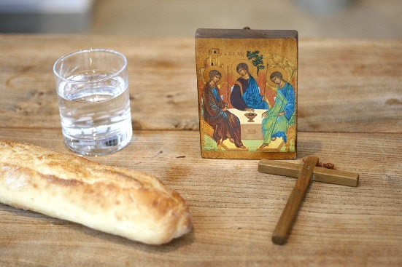
During each liturgical season, there are special prayer intentions and these are the ones for Lent each year:

PRAYER INTENTIONS during Lent  (Based on the liturgical year) | Liturgical Colour
Penitents and Wanderers | PURPLE/VIOLET
The Needy and Hungry of the World
Especially on Lent Fast day (Friday after 1st Sunday of Lent)
Candidates for the Sacraments
Especially on the Sundays in Lent
Women
Especially on Women’s World day of Prayer (1st Friday in March)
Survivors of Sexual Abuse
Friday 26 March (Friday 5th week of Lent)

The Liturgy Office has the official liturgical calendar for each year and more information about Lent liturgies HERE

How is Mass different during Lent?
During Lent, the word ‘Alleluia’ meaning ‘Praise the Lord’ is not said or sung at Mass. The Gloria is also omitted because these are joyful acclamations and are more appropriate at Easter and throughout the year. Flowers are also not seen in the church during Lent and during Holy Week the statues and artefacts are covered with purple cloth and the church is sparse and bare until Easter.

Lent: Ash Wednesday Q & A

What happens on Ash Wednesday?
On this first day of Lent, believers receive ashes on their foreheads as a sign of penance and to remind them of their mortality. The ashes used on this day are from the burnt palm leaves from Palm Sunday the previous year. When the priest distributes ashes, he says: “Remember that you are dust, and to dust you shall return.” He also may say, “Repent and believe in the Gospel” or “Turn away from your sin and be faithful to the Gospel.” The person who is receiving ashes need not do or say anything other than move their hair so that the priest can put the ashes on their forehead in the shape of a cross. For more information about the liturgy for this day see HERE.

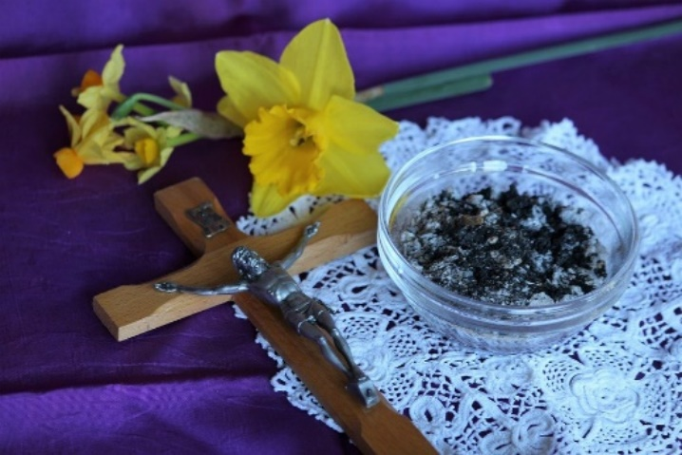
Who can distribute ashes?
While only a priest or deacon may bless the ashes, laypeople may do the placing of the ashes on a person's head. Even in the solemn rite, lay men or women may assist the priest in distributing the ashes.

Who can receive ashes?
On Ash Wednesday the procession to the altar is quite diverse because anyone, including children and non-Catholics, can receive ashes. Ash Wednesday is not a sacrament like Communion or Confession.

How do you get ashes?
Ashes are blessed and distributed on Ash Wednesday, often during Mass or a prayer service. People walk up to the altar using the same process as Communion.

Should you do anything special before receiving the ashes?
In receiving the ashes, we are entering into the time of Lent, preparing for Easter with prayer, fasting, and almsgiving. We are embracing Jesus’ journey: the cross of suffering and the promise of Resurrection. The ashes help us connect the spiritual aspect of Christ’s cross and Resurrection with our everyday lives. In addition to the liturgical significance of receiving ashes, we also are called to remember that this is a call to proper relationship between ourselves, God, and each other. Saying a prayer of repentance and remembering your sins is an appropriate way to prepare to receive the ashes. In summary, a person does not have to do any specific outward action; it is an inward journey to Christ.

How long should I leave on the ashes?
The ashes on our foreheads are a visible sign that we are followers of Jesus. The ashes are also a way to tell ourselves and those around us that we are beginning the holy season of Lent—the forty days leading up to Easter. Leaving them on helps you remember this throughout the day, but there are no rules requiring how long you leave them on or when you wash them off.

Is Ash Wednesday a Holy Day of Obligation?
Despite being one of the most-attended holy days of the year by Catholics around the world, it is not an official holy day of obligation.

Lent: Observance and Practice Q & A

What do Christians do during Lent?
Just as Christ undertook acts of penance and preparation for his ministry and Passion, so too do Christians take this time to reflect on their lives and make sacrifices, although these are personal to the individual. Many Catholics try to attend the Sacrament of Reconciliation during this time. As it says in the Church documents ‘Penance is a religious, personal act which has as its aim love and surrender to God.’ (‘Paenitemini’ chapter 1). Jesus himself said “I desire mercy, not sacrifice.' For I have not come to call the righteous, but sinners." (Mt 9:13)

There are three things that Christians try to do during Lent as a form of penance and preparation:
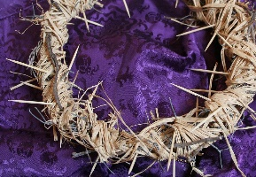
- Prayer
- Fasting
- Almsgiving
What are Lenten promises?
Lenten promises are based on the above and are personal intentions of the believer for the season of Lent. People often choose to fast or ‘give up’ something such as chocolate, alcohol or a bad habit. However, they may also choose to DO something such as praying daily, going to Mass, or being more charitable in some way. Lenten promises are not reserved for adults; in fact, children of all ages can find this very meaningful too. What is most pertinent is that the promise helps the Christian to become closer to God rather than becoming a barrier or the main focus of the season, which should always be Christ who leads us to the Father.

How can Christians be more charitable?
There are many ways Christians can be more charitable. The most obvious is to give to charity but there are many other things that they can do to support the charity without giving money such as getting involved in projects, growing in awareness of how they live out Catholic Social Teaching and praying for them. There are various ways in particular that schools can get involved with schools this Lent and these are included in the section on Catholic Social Teaching/Charitable Acts (to be amended).

Christians also can be more charitable in their thoughts and words during Lent. Charity does not have to include national and universal organisations but, instead, can begin at home, which is sometimes more difficult. A smile, a kind word, an offer of help or a forgiving hand would be equally meaningful.

What do Catholics not do during Lent?
It is traditional for Catholics to abstain from eating meat at certain times during Lent including Ash Wednesday and Good Friday as well as the other Fridays in Lent as this is intended to be a form of sacrifice. For those who are vegetarian or vegan or have special diets, however, this is unlikely to be a sacrifice so they may choose to ‘fast’ in another way to help the individual on their spiritual journey.

What prayers do Catholics say during Lent?
Prayer is personal to the individual and there is a great richness and breadth of prayer in the Church. Ultimately prayer is communication with God and simply be a conversation between the believer and God. Prayer can take many forms such as Christian Meditation, Lectio Divina (reflecting on the word of God) and the Examen and these (as well as others) are appropriate during Lent.
The Stations of the Cross and the Sorrowful Mysteries of the Rosary are prayers which focus on Christ’s Passion and death and can be said by people of various ages and abilities.

Lent: Holy Week and the Triduum Q & A

What is Holy Week?
Holy week is the last week of Jesus life and the events are simplified below and found in Scripture. The Triduum is the highlight of the Christian year as it marks the three days of Jesus’ Passion, death and Resurrection. It begins at sundown on Holy Thursday. The events of the Triduum are underlined below.
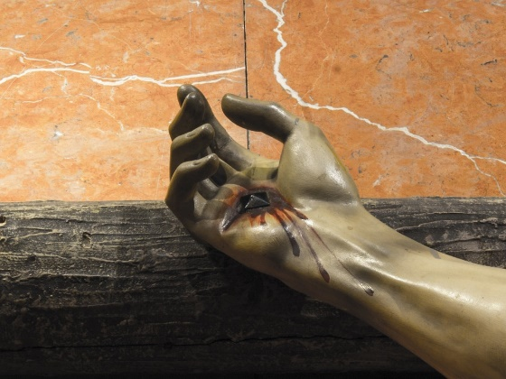

Day | What Jesus did | What Catholics do
Palm Sunday | - Rode on a donkey from Bethphage into Jerusalem with people singing ‘Hosanna’ and waving palms  - Was acclaimed as Son of David, and as the long-awaited king  - Spent night in Bethany with friends Mary, Martha and Lazarus | - Attend Mass which has readings of Passion and death of Christ, join in responses and wave palms (Holy day of obligation)
Monday | - Curses a fig tree because it did not bear fruit  - Overturns tables in the Temple as people using house of God as ‘den of thieves’  - Feet anointed by a woman
Tuesday | - Goes to Mt of Olives and speaks to friends about faith  - Leaves city and speaks in parables about end of time and his Second Coming  - Religious leaders plot against Jesus  - Judas negotiates with the Sanhedrin | - Chrism Mass celebrated in Westminster Diocese where oils are blessed by bishops and presented at Holy Thursday Mass (for clergy)
Spy Wednesday | - Bible doesn’t say what Jesus did on this day, possibly a day of rest in Bethany
Holy Thursday | - Sends Peter and John ahead to prepare Passover meal  - Washes the disciples’ feet and gives the command to love one another  - Has Last Supper with his friends and offers bread and wine as his body and blood  - Goes to Gethsemane to pray with Peter, James and John and sweats drops of blood (in agony)  - Kissed by Judas and arrested  - Denied by Peter three times  - Brought before Caiaphas the High Priest  - Brought before Pilate and tells him his kingdom is not of this world  - Sent to Herod who says he is a religious man  - Sent back to Pilate | - Chrism Mass celebrated in some dioceses where oils are blessed by bishops and presented at Holy Thursday Mass (for clergy)  - Attend Mass where 12 members of the parish have feet washed by priest (optional)  - Adoration before the Blessed Sacrament (optional)
Good Friday | - Whipped/scourged  - Crown of thorns placed on head  - Mocked and spat at, robe put on him as ‘king of Jews’  - Pilate asks crowds to decide his fate. They shout ‘crucify Jesus!’  - Pilate washes his hands of his death  - Jesus is given the cross to carry to Calvary  - Gives John Mary as his mother  - Crucified beside two thieves  - Soldier puts spear through his side – water pours out  - When Jesus dies there is an earthquake and eclipse; the curtain in the Temple splits in two  - Jesus is buried in a borrowed tomb | - Stations of the Cross (optional)  - Attend Good Friday liturgy (optional)
Holy Saturday | - Tomb guarded by Roman soldiers  - According to Catholic belief Jesus descended into Hell
Easter Sunday | - Tomb is empty; Jesus has risen

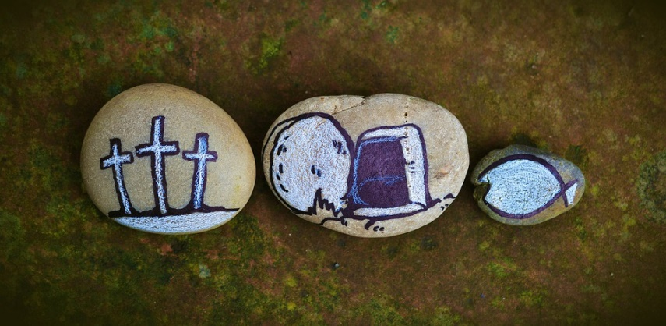

Lent: Charitable Acts

Mission Together
Lent begins on Wednesday 17 February 2021, and to help schools journey prayerfully through the season, Mission Together has revised their annual Lent calendar and produced new weekly pupil-led liturgies. Each liturgy contains an adapted version of the Sunday Gospel, questions for discussion and reflection. Download at missiontogether/Lent.

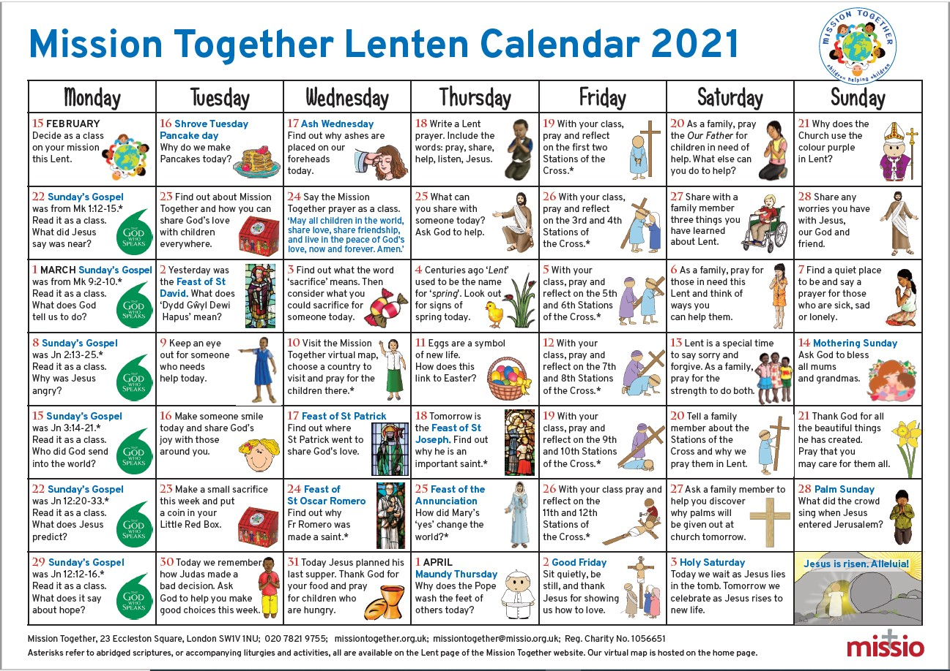

This Lent, to support the needs of remote learners, Mission Together has created a set of resources that can be uploaded to various teaching platforms. These faith-focused activity sheets include comprehension tasks and outdoor challenges, some of which can be used as Lenten fundraising drives. Download free at missiontogether/Lent.

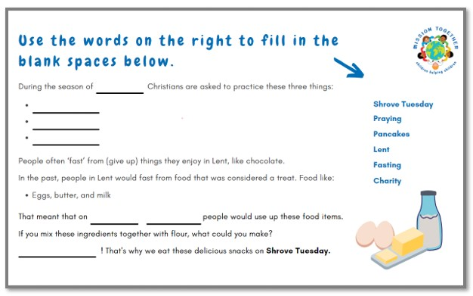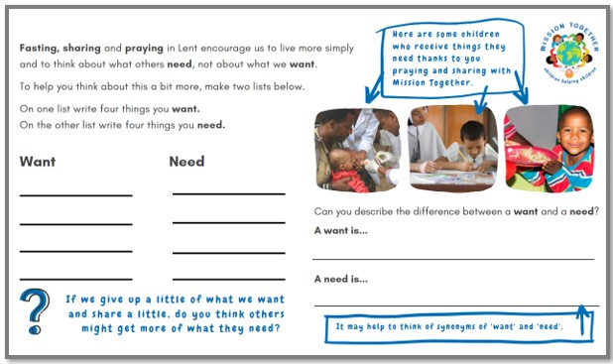

Mission Together
For more information about the ‘Lent Quest Fundraiser’ and Mission Together see missiontogether/Lent.

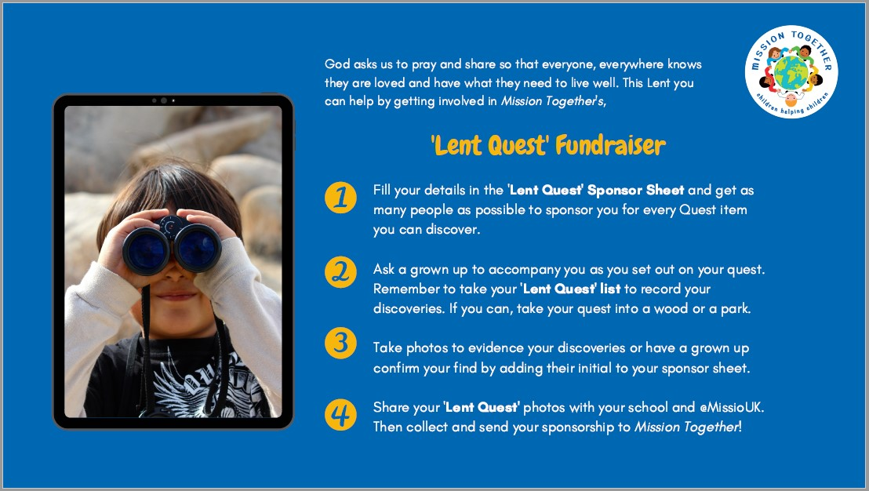

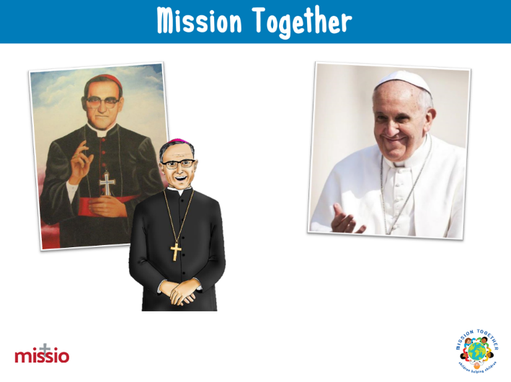
During Lent, there’s a couple of feast days that Mission Together can help you commemorate too. View the pupil-led Five Fact Assemblies for St Oscar Romero (3/24) and St Joseph (3/19).
See Mission Together Resources by Month

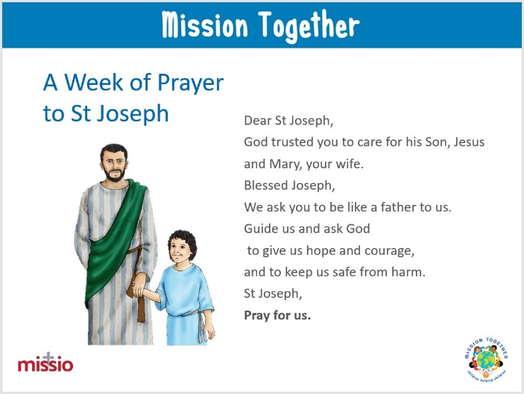
Finally, as Pope Francis has declared 2021, the year of St Joseph, schools are invited to join their Week of Prayer, leading up to Friday 19 March (St Joseph's feast day). Each daily prayer is modelled on a simplified version of the popular Mill Hill Missionaries' Novena (St Joseph's Missionary Society).

See Mission Together Feast of St Joseph

CAFOD
There are various materials which are relevant for pupils of various ages. Here are some below:

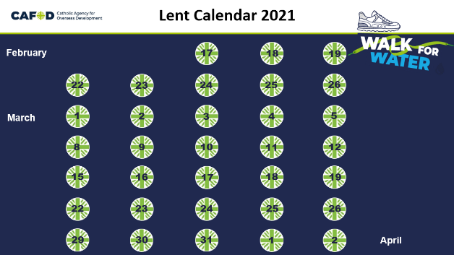
For assemblies, Stations of the Cross, liturgy, a PowerPoint calendar and a one page calendar click here: Lent 2021 resources for primary schools | CAFOD.

An interactive Lenten calendar can be found HERE and there is an online Lent calendar for families to share at home Family activities and ideas | CAFOD

The Water of Life assembly is already available here: Water of Life national assembly | CAFOD

There will be another reflective Lent live online assembly and details will appear here: https://cafod.org.uk/schoolstogether

Putting faith into action, their Lent fundraising campaign will be Walk for Water, (various options, including a cute Water Droplet trail, which can just be reflective/prayerful)
Lent 2021 resources for primary schools | CAFOD

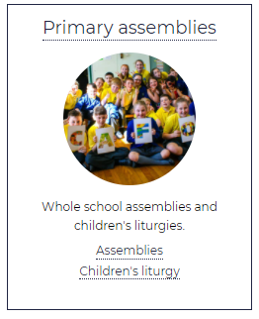
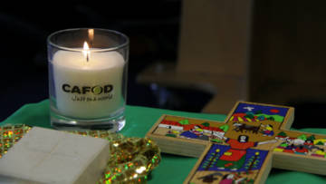
They have the Sunday Gospel collective worship Collective worship for primary schools | CAFOD

CAFOD
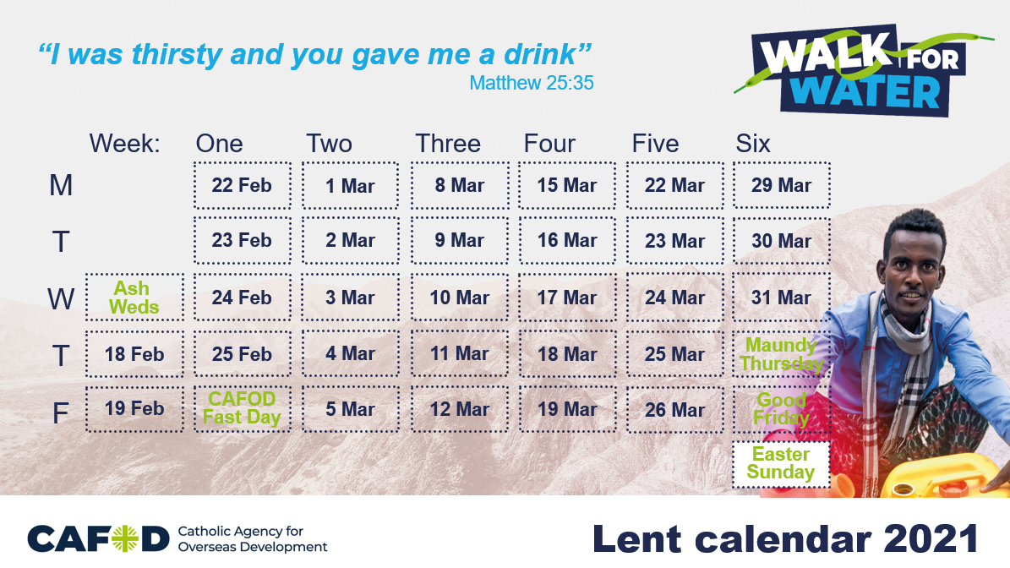
Their secondary team have a lovely new Lent Stations of the Cross for Young People based on the teachings of Pope Francis, quoting from Laudato Si’, Fratelli Tutti, and Christus Vivit: Lent 2021 resources for young people | CAFOD

There will be Lent themed home learning here: Home learning for primary schools | CAFOD and last year’s Lent home learning packs are still available on that same page at the moment.

Pupils Leading Pupils

Your Pupil Chaplaincy Team or other pupils taking a leading role in the school may be able to help to organise activities for the school and Local Church during Lent. For more information see here.

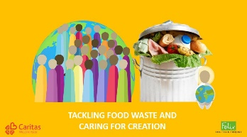
Caritas
Tackling Food Waste and Caring for Creation

Over the last year Caritas Westminster has been working with The Felix Project to ensure that perfectly good food is not going to waste but is going where it is needed the most. They have created a PowerPoint resource with The Felix Project to look at the issue of food waste and to think about how our faith calls us to care for creation and not waste the resources God has blessed us with. This is an interactive session you can use to get pupils thinking about their own consumption and how as individuals and as a school you can start to tackle food waste and make sure everyone is getting their fair share of God’s creation.

Caritas Ambassadors

Lent is a wonderful time to go deeper into our understanding of Catholic Social Teaching and think about how we can work to create the Kingdom of God on earth. Caritas Ambassadors is a programme for both primary and secondary schools created by Caritas Westminster. It aims to equip pupils with a strong understanding of Catholic Social Teaching and how we can put it into action in our daily lives.

The programme runs through six key themes of Catholic Social Teaching and helps the trainee Ambassadors to think about social justice issues in their local community, before taking them through responding by developing and running their own social action project. It also introduces them to the work of Caritas Westminster, offering practical examples of how they use Catholic Social Teaching to influence their work.
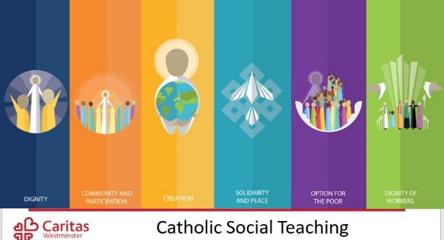
You are provided with 10 full sessions to run in school, complete with a PowerPoint and script for each session. These can be run either as an extracurricular session for a group of students, or can be done with a whole class. You will also get support from your local Caritas Development Worker to run the programme.

Lent is a great time to start but the programme can be used at any time of year. You can find out more here or by emailing caritasambassadors@rcdow.org.uk

Caritas Development Workers

Caritas Westminster has seven Development Workers covering different areas of the Diocese of Westminster. Your local Development Worker would be happy to meet with you to discuss how your school can be more involved with social outreach work or how to best engage your students with Catholic Social Teaching. Their team can also run assemblies or sessions for classes relating to Catholic Social Teaching, refugees, homelessness, food poverty, isolation, or a general overview of the work that Caritas does across the diocese. These can be run virtually during the COVID-19 pandemic. You can find out who your local Development Worker is here or email caritaswestminster@rcdow.org.uk to find out more.

Please do let Caritas know if you use any of these resources or get involved in any of their projects. They are keen to hear how you get on and thank the school and children for taking part and are always happy to help in any way they can. Email caritaswestminster@rcdow.org.uk to get in touch.

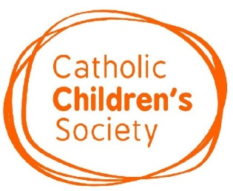
Catholic Children’s Society

Catholic Children’s Society (CCS) Lenten Challenge: “Will we bend down and help another to get up?”

This year’s CCS Lenten Appeal is inspired by Pope Francis’ latest encyclical Fratelli Tutti.
In Fratelli Tutti Pope Francis sets us a challenge:
“Each day we have to decide whether to be Good Samaritans or indifferent bystanders . . . Will we bend down and help another get up? This is today’s challenge, and we should not be afraid to face it.”
This Lent CCS is asking schools to take up Pope Francis’ challenge and help local disadvantaged children and families in their time of need.
CCS has produced online activities and resources for schools to encourage pupils to think about how they can help others and the difference they can make:

Lenten Challenge Overview: An introduction to this year’s appeal and activities.

Interactive Lenten Calendar: Pupils can reflect on how they are helping others during Lent.

Fundraising Challenges: Fundraising ideas for your school, including the Walk the Diocese Challenge.

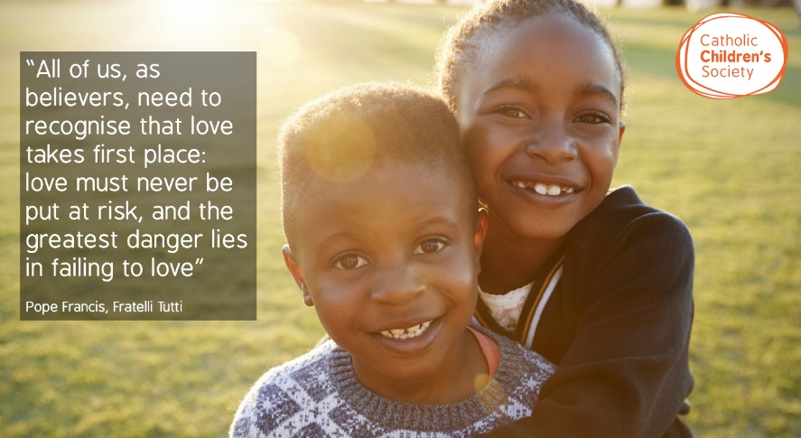
CCS Presentation and Quiz: Learn about CCS and how your fundraising makes a difference. Pupils can then test their knowledge with the CCS Quiz.

More from Fratelli Tutti: Find out more about Pope Francis’ latest encyclical.

To sign up to this year’s appeal visit www.cathchild.org.uk/lent
Please do get in touch with Katie katiew@cathchild.org.uk if you would like any further information.

Lent: Resources for teaching and learning

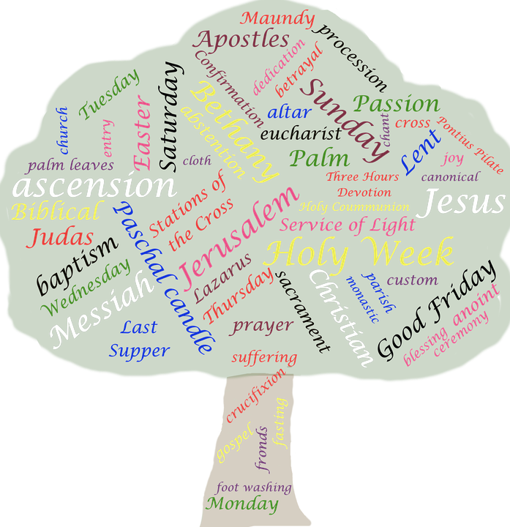
The resources on the following pages are to support development of teachers’ own understanding about Lent as well as including some ideas for teaching and learning which can be amended for pupils of different ages and abilities.
Lent videos

Image of Video | Information and link
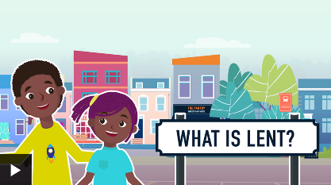 | BBC Bitesize - What is Lent?  This explains Pancake/Shrove Tuesday and the beginning of Lent in a very simple way. It is suitable for young primary school children. Other resources are available on this site.
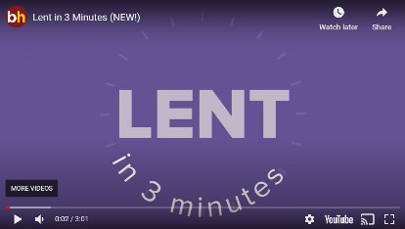 | Busted Halo: Lent in Three Minutes  What is Lent all about? Why do Christians receive ashes on Ash Wednesday? Why 40 days? Busted Halo explains the significance of this season of prayer, fasting, and giving, and how you can make the most of this time of repentance and renewal. It is suitable for adults and pupils from KS2.
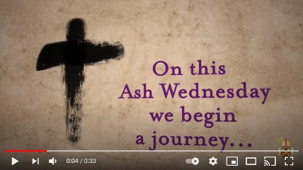 | Lent begins...  A simple visual reflection showing that Ash Wednesday marks the beginning of Lent, a time of fasting and prayer over the next 40 days till Easter. Can be used for pupils and adults as an introduction…
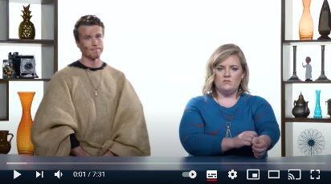 | Lent - Catholic Central  What is Lent all about? Do you have to give up everything good and/or fun? Why do Catholics do Lent? Kai and Libby take you through the history of Lent and how to get the most out of it this year. Suitable for pupils from KS2 and above.
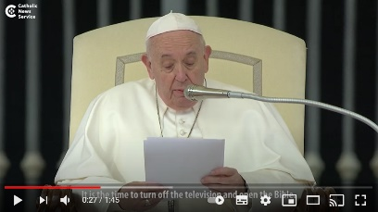  # | Pope Francis' advice for Lent  Pope Francis gives advice for Lent
Busted Halo: What's with the ash?
Every year on Ash Wednesday, Catholic churches are filled with people receiving ashes. More people attend church on this day than on any other throughout the year. Why?

Image of Video | Information and link
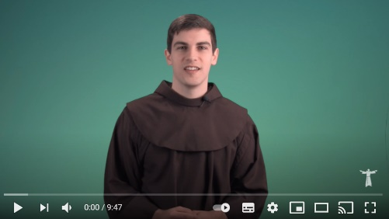 | Don't give up anything for Lent  Every year, Catholics give up something they love for Lent. But why? This year, the Brother from ‘Breaking the habit’ tells people why giving something up might actually distract them from the true purpose of Lent.
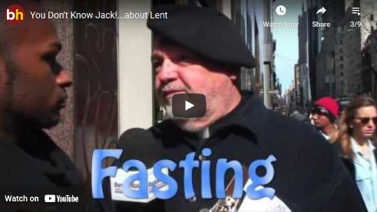 | You Don’t Know Jack… about Lent  What is Lent? What are the three practices the Church suggests we do during Lent based on the teachings of Jesus? Why do Catholics eat fish on Fridays and why is it called “Good” Friday, anyway? Fr. Jack Collins, CSP, is once again hitting the streets, this time on Ash Wednesday near St. Patrick’s Cathedral in New York, asking these questions and more.
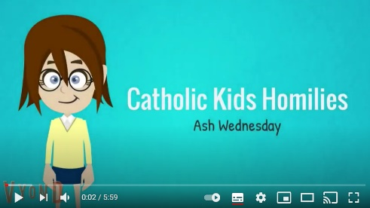 | Catholic Kids Media - Ash Wednesday and Lent Year A  A cartoon video about Ash Wednesday and Lent using Scripture from Year A. A homily given by a pupil. Similar videos are available on YouTube for each of the Sundays during Lent in Year A, B and C. See also Ash Wednesday Year B
The Lent Song For Catholic Kids
Here is a song for Catholic children during Lent! Hope you enjoy the song and hand motions. You can find the printable version on the link.

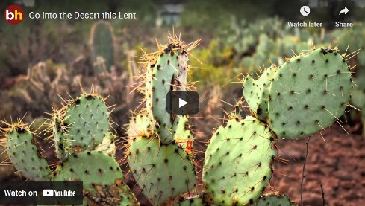 | Go into the desert this Lent  Looking for a way to ‘do’ Lent a little differently this year? We’re inviting you into the desert: a quiet place with less of us and more of God. The desert offers solitude as well as temptation. And it means something a little different to everyone. Watch this short, meditative video that will help you wander into your own desert this Lent.
The Paschal Triduum
Join Brother Andrew Bautista, O.P. and reflect about the Paschal Triduum, which begins on Maundy Thursday. Reflect on the momentous events of the Lord's life that culminated in the most selfless act we know--His dying for the salvation of mankind.
Image of Video | Information and link
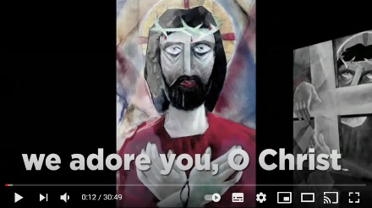 | Busted Halo - Virtual Stations of the Cross  Busted Halo has created a series of virtual stations designed for personal devotion. These stations relate to Jesus’ teachings about the Kingdom of God and the reason his vision of this Kingdom led to his death. Find a quiet place to watch these stations, and as you do the devotions be open to how God is speaking to you through the Stations of the Cross. Suitable for pupils from KS2.
Lent (EWTN)
A cartoon about Lent for young children.

What's the Purpose of Lent?
What’s the real connection between the Israelites’ forty years in the desert and the forty days of Lent? Sure, they both involve the number forty—which often represents a time of test and trial in the Bible—but what’s the more important connection? Fr Mike explains…
Lent and Ash Wednesday with Lego
Ash Wednesday and Lent explained in 60 seconds. With LEGO!

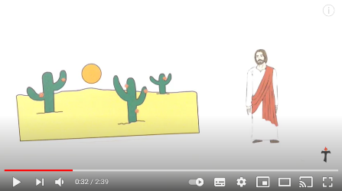 | Theo Matters: Lent Explained  Ash Wednesday is the beginning of the season of Lent, a time of preparation for the Passion, Death and Resurrection of Jesus Christ. This video explains in a simple way: prayer, fasting and almsgiving.
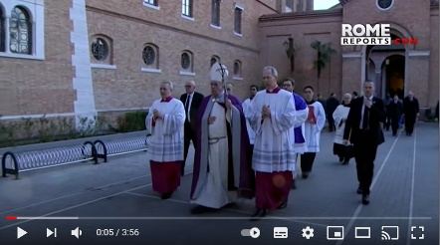 | Pope Francis’ message for Lent  Pope Francis’ message for Lent

Image of Video | Information and link
Busted Halo - Holy week in 3 mins
Why do Catholics wave palms on Palm Sunday, wash each other’s feet on Holy Thursday, or kiss the cross on Good Friday? In a new version of their classic video (with a bonus extra minute -- because there’s a lot going on this week!), Busted Halo explains the significance of the final week we spend preparing for Easter.

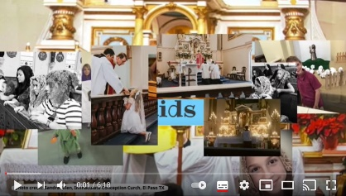 | Ash Wednesday & Lent for Kids, Traditional Catholic Faith Learning Fun Videos  A video about Ash Wednesday and Lent by kids for kids.
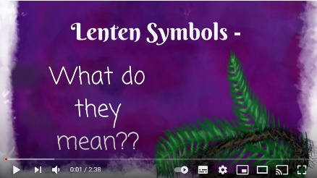 | Symbols of Lent and what they mean  Ever wonder what a moneybag has to do with Lent? Where do ashes come from? And why do so many Catholics make pretzels?? This quick video led by pupils will explain it all...in only two and a half minutes!! Test your knowledge of these intriguing symbols of Lent…
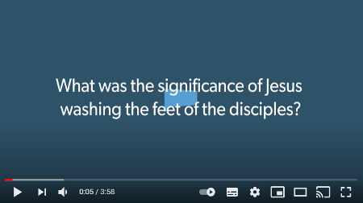 | Jesus washes his disciples’ feet  This video explores Jesus’ concept of servanthood and explains what he meant by the washing of the feet and the commandment to love one another. It refers to Scripture.
Psalm 22 & The Passion of Jesus - Superbook
An animation of the Passion, death and Resurrection of Jesus with a child reading Psalm 22 in the background.

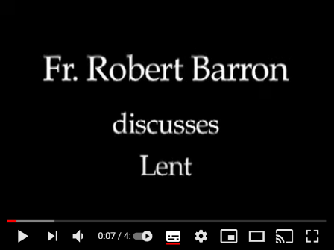 | Bishop Barron on Lent  This video is for adults who are looking to reflect more deeply during Lent.
Lent: General resources and artwork

General resources
Loyola Press resources | This is a very useful website and has lots of information as well as activities for pupils at home and at school. It also has prayers and 3-minute retreats for personal or professional use.
Scottish Catholic Education Service teaching resources | Lots of resources for teaching and learning about Lent for primary and secondary pupils, as well as resources for prayer and liturgy.
Home Learning | Lent Home learning Support materials.
Carfleo | 40 activities to do with pupils and adults of different ages and abilities.
Seasonal activities | Scroll down for lots of resources for teaching and prayer/liturgy.
Coventry resources | Top twenty ideas for teaching Lent and Easter
Resources for Catholic Educators | Resources for teaching about Holy Week such as a Christian Seder plate, making a palm cross and nailing sins to a cross.
The Religion Teacher | This Catholic website has lots of links to information, worksheets, activities, quizzes and videos on Lent.
Blank Lenten Calendar | A Lenten calendar that pupils can complete during Lent to mark their acts of kindness etc There are symbols for each day during Holy Week.
Art resources
Stuchie Art | Inspirational and simple artwork using symbols and colours of Lent.
Catholic Icing | Lots of craft activities for Lent for pupils of different ages.
Liturgy Tools | This has variety of beautiful and diverse copyright-free artwork for every Sunday during Lent in Year A, B and C. There are also songs available.
Mafa Jesus art | This website has artwork with black images of Jesus during Holy Week.
Holy Week paintings | Holy Week told through 100 paintings. Pause at any time for discussion, reflection or take a screenshot to use in resources or lessons.
Lectio Divina Lent | Reflections on Scripture using art.
Ash Wednesday 1  Ash Wednesday 2 | Bishops Conference Flicker page for copyright-free Ash Wednesday images
Palm Sunday 1  Palm Sunday 2 | Bishops Conference Flicker page for copyright-free Palm Sunday images
Holy Thursday | Bishops Conference Flicker page for copyright-free Holy Thursday images
Good Friday | Bishops Conference Flicker page for copyright-free Good Friday images

Lent: Prayer resources

The Sorrowful Mysteries of the Rosary
Westminster Education Service Rosary | Amendable PowerPoints on each decade of the Rosary YouTube videos on each decade which focuses on Covid-19.
My Catholic Life | Scripture and artwork for each decade of the Rosary.
Rosary Center | Reflections on each prayer in each decade.
Stations of the Cross
Loyola Press | Stations of the Cross for different ages, unlocking the Stations - Examen-Style, embracing the Way of the Cross… and more
Stations of the Cross | A Stations of the Cross art and prayer book
Simple Stations of the Cross | A simple Stations of the Cross liturgy for young children
My Catholic Life | Scripture and artwork for each decade of the Rosary.
CAFOD | Christ’s journey to the cross, following themes of justice, poverty, mercy, friendship and hope.
Children's Stations of the Cross | Children's Stations of the Cross video
Stations of the Cross - For Kids | Stations of the Cross - For Kids video
Way of the Cross for Kids | Way of the Cross for Kids video
Useful resources
Jesuit Institute | Prayers, texts and liturgies for Ash Wednesday and a reflection on fasting and feasting which can be used throughout Lent.
Prayer, liturgy and worship document | Support document with Collective Worship during Covid with free links to various types of prayer such as Examen, Lectio Divina and Christian Meditation. (Westminster Education Service)
Liturgical Year. | A support document on the Liturgical year has ideas for celebrating seasons and feast days throughout Lent and the liturgical year. It comes with ideas for focal points and displays too.
Pupil Chaplaincy Documents | Westminster Education Service’s Pupil Chaplaincy documents have various support materials for enhancing pupils’ engagement with social actions including templates for ‘See Act Do’ and the local, national and universal Church as well as prayer and liturgy.
Beatitudes | PowerPoints on each of the Beatitudes for primary and secondary pupils which can be used for prayer and liturgy of home-school learning.
Good books for Catholic Kids | A website which includes good picture books for young Catholic children for Lent and Easter.
Lent: Song Prayers

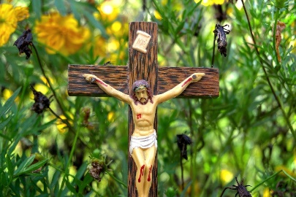
There are many Lent and Easter hymns available for use during this special time. Here are some contemporary songs for Lent which can be used with pupils and staff as a form of prayer. Each song has an appropriate video with lyrics.

Artist | Song
Andrew Peterson | Is he worthy?
Andrew Peterson | Behold the Lamb of God
Andrew Peterson | Last Words
Andrew Peterson | Remember Me
Hillsong Worship | King of Kings
Matt Maher | The Least of These
Matt Maher | Remembrance
Scartermusic | Passion Song
Sidewalk Prophets | Come to the Table
Sidewalk Prophets | Live Like That

Top 5 tips for using songs during Lent

- Listen to one of the song prayers. Reflect on what the Lord is saying to you through this song.

- Write another verse or chorus using a known Lent hymn or song using an idea that has not been mentioned in the hymn/song already.
- Compose your own song about Christ’s death and Resurrection or a Lenten theme.
- Create a simple song about Lent for a younger pupil to help them to understand it better.

- Write a short Lenten prayer and then add a simple tune. Sing as you pray.

Lent: Virtual Retreats

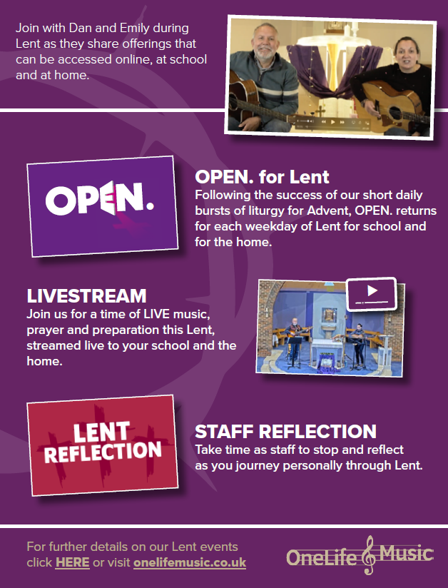
For a direct link to the website see.
https://www.onelifemusic.co.uk/

Sources and thanks

Images

All images from Pixabay

Videos

All videos from YouTube

Websites

https://www.liturgyoffice.org.uk/
https://www.liturgytools.net/
https://www.learnreligions.com/holy-week-timeline-700618
https://teachingcatholickids.com/7-questions-and-answers-about-ash-wednesday/http://jesuitinstitute.org/Pages/Liturgy/AshWednesday.htm
https://www.aboutcatholics.com/beliefs/lent-in-the-catholic-church/

With thanks to:

Fr Terry Tastard (Diocesan Censor)
Agency of Evangelisation (Westminster)
CAFOD
Caritas Westminster
Catholic Children Society
Mission Together

