Witness to the Word - School Bulletin 10.02.21

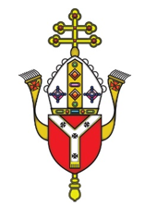
Dear Colleague in Catholic Education,
The Education Service every Wednesday provides schools with a wide variety of materials, resources, advice and updates on all matters relating to our schools and colleges. The content of these Bulletins are for Headteachers, Senior Leaders, Teaching Staff, Governors, Clergy and anyone who you feel would benefit from them. Please feel free to share widely

Objectives of the Education Service during Coronavirus (Covid-19) pandemic
- To provide support and training for Headteachers, Heads of RE, RE Coordinators, Chaplains, Teachers, Governors and the wider school community to cope at this time of unprecedented challenge;
- To provide resources and advice relating to the Teaching and Learning of Religious Education;
- To provide resources and advice relating to Spiritual support and renewal.
- To provide resources and advice relating to Mental Health issues;
- To provide the updates from the UK Government, DfE, CES and the Diocese of Westminster on all aspects of the Coronavirus Covid-19 relating to schools and colleges;

Subject Content Today
- Religious Education and Catholic Life resources are here
- Inspection Update is here
- RSE Updates are here
- Racial Justice, Equality and Diversity updates are here
- Caritas Updates are here
- Agency for Evangelisation updates are here
- Information about upcoming CPD and Training is here
- Mental Health and Wellbeing Resources are here
- Governance and Admissions Updates are here
- Capital and Pupil Placement Planning updates are here

Thank you for all you are doing for your school community and for Catholic education.

Religious Education and Catholic Life Resources

Pope Francis Prayer Intentions: February
Intention for evangelisation - Violence Against Women
We pray for women who are victims of violence, that they may be protected by society and have their sufferings considered and heeded.

Year of St Joseph
For assembly slides and notes on St Joseph created by Mission Together see HERE.

Our Education department is creating some materials for you on St Joseph and these will be shared with you in March and throughout the rest of the year.

Prayer Intentions during the season of Ordinary Time:
PRAYER INTENTIONS from the Baptism of Our Lord until Shrove Tuesday
(Based on the Liturgical Year)

During this season we listen to readings about the teachings and parables of Jesus and reflect on what it means to be a follower of Christ. In this ordinary time, we concentrate on the saints and try to imitate their holiness as Christ’s followers. We also pray for the intentions below in green at any time but especially on their special days.

Christian Unity
(Octave or prayer for Christian unity 18-25 January 2021)
Peace on Earth
(Peace Day – 2nd Sunday in Ordinary Time – 17 January 2021)
Victims of Human Trafficking
(Feast of St Josephine Bakhita – 8 February 2021)
Sick and Those Who Care For Them
(World day of the Sick – Feast of Our Lady of Lourdes – 11th February 2021)
Europe
(Feast of Ss Cyril and Methodius -14th February 2021)
Racial Justice
(Racial Justice day - 3 Sundays before Lent - 31st January 2021)
Unemployed
(Day for the unemployed – Sunday before Lent – 14th February 2021
LITURGICAL YEAR | NATIONAL AND INTERNATIONAL DAYS
February  - St Brigid (1st)  - St Jerome Emiliani; St Josephine Bakhita (8th)  - Our Lady of Lourdes (11th)  - Ss Cyril and Methodius (14th)  - Chair of St Peter (22nd) | February  - World Pulses Day (10th)  - International Day of Women and Girls in Science; Safer Internet Day (11th)  - World Day of the Sick (11th)  - World Radio Day (13th)  - World Day of Social Justice (20th)  - International Mother Language Day (21st)  - International Polar Bear Day (27th)  - Interfaith Harmony Week - 1st week in Feb

St Josephine Bakhita (8th February)
On 8 February we celebrate Bakhita Day, the Feast Day of St Josephine Bakhita, the patron saint of victims of modern slavery. It is an opportunity for schools to raise awareness of modern slavery and human trafficking, and to gain support for Caritas Bakhita House, a safe house for women escaping human trafficking and modern slavery, opened in the Diocese of Westminster in 2015 at an undisclosed location (for protection and safety) and providing accommodation for 12 women at a time. If you would like more information about how your school might help Caritas Bakhita House, more information can be found here HERE. For Caritas Westminster’s PowerPoint on Bakhita Day see HERE.
Our Lady of Lourdes (11th Feb) - For Mission Together’s liturgy for the World Day of the Sick see HERE.

Ash Wednesday - Lent begins on Ash Wednesday which is celebrated on 17th February this year.
PRAYER INTENTIONS during Lent - Ash Wednesday – Holy Thursday  Easter Triduum – Holy Thursday – Easter Sunday  (Based on the Liturgical Year) | Liturgical Colour
Penitents and Wanderers | PURPLE
The Needy and Hungry of the World
Especially on Lent Fast day (Friday after 1st Sunday of Lent)
Candidates for the Sacraments
Especially on the Sundays in Lent
Women
Especially on Women’s World day of Prayer (1st Friday in March)

Lent Information Sheets
Home learning Support materials for Lent which include information, Scripture, possible video questions and role play opportunities on topics including What is Lent and why do we celebrate it; Reconciliation and Lent; Prayer and Lent; Fasting and Lent and Almsgiving and Lent can be found here

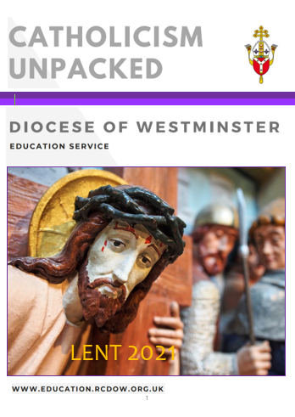
Catholicism Unpacked
This series of resources was written to develop subject knowledge and theology in RE and all documents are free to access on our website HERE.
The Lent one will be available this week and will include:
- An A-Z of Lent
- Q & A to support staff members of different levels with theological knowledge
- Links and resources from various charities to use during Lent
- Use of Scripture and liturgy during Lent
- Resources for teaching
- Videos for further research and teaching
This will be uploaded onto our website later this week and will be found HERE

Fratelli Tutti
We are providing a summary of a section of Pope Francis’ Social Encyclical each week taken from www.vaticannews.va. Click here to download the full document.

Week 10: The death penalty inadmissible, to be abolished
Francis expresses just as clear a position with regard to the death penalty: it is inadmissible and must be abolished worldwide, because “not even a murderer loses his personal dignity” – the Pope writes – “and God himself pledges to guarantee this”. From here, two exhortations: do not view punishment as vindictive, but rather as part of a process of healing and of social reintegration, and to improve prison conditions, with respect for the human dignity of the inmates, also considering that “a life sentence is a secret death penalty” (263-269). There is emphasis on the necessity to respect “the sacredness of life” (283) where today “some parts of our human family, it appears, can be readily sacrificed”, such as the unborn, the poor, the disabled and the elderly (18).

The Year of the Word
As you may recall, during the first lockdown, the Education Team produced a weekly Rosary resource to support our schools; we hope that you found this useful. As part of the remote on-going support that we are offering during the current lockdown, we have decided to produce a weekly resource to support 'The Year of the Word: The God Who Speaks'.
As such, you will receive weekly PowerPoints that can be used however you see fit, as either a class/home reflection or as part of an 'assembly' focusing on the Old Testament reading or Psalm from the coming Sunday.
The decision to focus on the Old Testament readings/Psalm was made based on two factors. Firstly, we recognise that our pupils are often less familiar with these readings; in addition to this, we recognise that the resources currently being produced by The Mark 10 Mission organisation are wonderful in bringing to life the Gospel reading from each Sunday...we simply could not compete! (https://www.themark10mission.co.uk/)
Initially, the opening slides will remain consistent each week as a way to reinforce/embed your pupils understanding of the Old Testament, with the 'focus' for each week being adapted as appropriate based on the OT passage for the following Sunday.
As part of the on-going support provided, the PowerPoints will also be placed on the Education Service website here each week from where they can be readily downloaded. Finally, if you have any feedback concerning these resources, or any of the other resources that we produce, we would love to hear from you.

Virtual Classrooms at the Jewish Museum London
Award-winning workshops can now be experienced through Virtual Classrooms offered for Primary and Secondary students. Each session is based on a guided exploration experience of a unique collection of authentic objects.
- Explore Jewish religion and culture through objects
- Use critical thinking to ask questions and spark discussion
- Authentic and interactive experience for your students
Sessions use high res images from the collection and critical thinking techniques to help students look closely at objects and understand what it means to be Jewish in Britain today.
Topics include Torah, Jewish festivals, Keeping Kosher, Tzedakah, and more.
All sessions are 60 minutes long. Explore the Virtual Classroom offer here.

Inspection Update

National framework update
The grade descriptors for the new national framework for the inspection of Catholic schools, colleges and academies are now available. You can access them here. These grade descriptors will form one part of the framework handbook that is currently being finalised that will bring consistency to the whole process of inspection under a national inspectorate. They have been approved and will form the basis for the pilot inspections that will (in theory) happen from September 2021. Further amendments may be made following this pilot, but the expectation is that these grade descriptors will remain substantially as they are now. The existing framework will run concurrently with the national framework from September 2021 - July 2022.
When the Handbook and supporting documents are published, these will be shared with you, along with details of Information Sessions. Before Easter, we hope to open the application process for inspectors with a view to virtual training being delivered in the Summer Term. More information will follow on this when it is available.

RSE Updates

Statutory RSE Implementation
RSE becomes statutory in the Summer term. You must conduct reasonable consultation on your policy with the parents of your students beforehand. Our recommendation is the consultation on your policy lasts for six weeks. With the deadline for implementation fast approaching, please contact your adviser if you would like support with this, or any other aspect of RSE. In addition, there are documents to support your planning and implementation on our website here. RSE – Guidance Education Service – Diocese of Westminster Education Service (rcdow.org.uk) There are cross mapping documents mapping compliance with DfE expectations and an FAQ’s document addressing tricky questions that students might ask.

Racial Justice, Equality and Diversity

Support materials for Racial Justice
All schools are invited to create a prayer card with a prayer and/or image on Racial Justice by 20th February. Information has been sent to all RECs. Please send all primary entries to elainearundell@rcdow.org.uk and all secondary entries to claireoneill@rcdow.org.uk. Pupils can use their art or ICT skills to design their image either independently or together and we hope to use the winning one as our logo for the website and for resources.
We have created support materials for you that can be used for prayer/liturgy in KS1, KS2 and Secondary and support with the Racial Justice Prayer cards. Click on the link HERE for the PowerPoints which can be used at any time. A video by Fr Albert on this theme can be found HERE

Caritas Update

Caritas Westminster Tech Appeal
The Caritas Westminster Tech Appeal is a new project aimed at combatting the Digital Divide felt in schools across the Diocese of Westminster. We will be appealing for people to donate their old and unused laptops and tablets which can be put to better use by schools. Schools will work with Caritas Westminster to receive and process devices before giving them to their students. Together we can help students continue learning throughout the pandemic!
If you would like to register your school's interest in the Caritas Westminster Tech Appeal, please go to: https://tinyurl.com/CaritasTechAppeal

Agency for Evangelisation Updates

Year of St Joseph
On the 150th anniversary of the proclamation of St Joseph as ‘Patron of the Catholic Church’ by Blessed Pius IX, Pope Francis has proclaimed ‘A Year of St Joseph’ from 8th December 2021 to 8th December 2021. https://rcdow.org.uk/faith/news/st-joseph/

Christian Leadership Formation Programme
In partnership with St Mary’s University, Twickenham and The Catholic Union of Great Britain, for 6th Formers open to applications: https://christianheritagecentre.com/clf/

Journeying with the Bible
A series of lectures given by Fr Javier Ruiz-Ortiz PhD & Sr Monica Cardona STL: 23rd Feb - Catholic Letters, 9th Mar – Apocalypse. Register at catadmin@rcdow.org.uk

Holy Week Voices of the Holy Land
Poems and Reflections for Lent and Easter, for individuals and groups. The resource is available in booklet or downloadable format. Included is a suggested selection of six chapters as this year’s Lenten Resource for Small Communities Faith-Sharing. https://rcdow.org.uk/faith/news/holy-week-voices/

Upcoming CPD – Online Courses - February – March 2021

Date/Time | Course | Booking Links
12th Feb - 9am - 10.30am | NQT Day 2 (The Taught RE) | Book Ticket
23rd Feb 3.30pm - 5pm | Developing a Pupil Chaplaincy Team | Book Ticket
26th Feb 9.30am - 12.30pm | Chaplaincy Day | Book Ticket
1st Mar 4pm - 6pm | Foundation Stones 12 Session Course | Book Ticket
4th Mar 3.30pm - 5pm | Standards Framework – Address Analysis and Evaluation | Book Ticket
5th Mar 9am - 12pm | Primary REC Virtual Conference | Book Ticket

Foundation Stones
This is a 12-hour online course which is appropriate for staff and governors. It explores the foundations of the Catholic faith using Scripture, Prayer and the Teaching of the Church (Magisterium). All delegates will receive a certificate on completion of the course. Detailed support materials and PowerPoints will be provided for each of the 12 sessions and these can be used for future teaching and research as they will include ideas and resources for practical application in the classroom.
We are aware that this is a big time-commitment for staff but we are dedicated to supporting schools as efficiently as possible. There are various ways in which to complete this course:
A – complete each of the 12 sessions which will run from January to July 2021. All sessions will take place from 3:45-5pm.
B – complete some of the sessions which are being run in January to July and then complete the rest in the next academic year.
C – complete a personalised course (with delegates from other schools) at times at times which are convenient to you and the course leader. Contact Claire O Neill if you are interested.
However, each of the individual sessions can also stand alone and are appropriate for staff training. To find out more about the Foundation Stones course, see our video In Conversation With...
The course begins in January and the dates are as follows. Should you have any questions about this course, please contact Elaine Arundell elainearundell@rcdow.org.uk
January | February | March | April | May | June | July
20th | 3rd | 10th | 21st | 5th | 9th | 7th
 | 24th | 24th |  | 19th | 23rd

Mental Health and Wellbeing Resources

Supporting children and young people through these anxious times

Young Minds
- Click here Information and advice on support children and young people with anxiety
- Click here Supporting your child during the pandemic (guidance for parents)
- Click here Helping your child with anxiety (guidance for parents)
- Click here Supporting your pupils during the pandemic (guidance for teachers)
- Click here Understanding Stress (KS1 &2 Lesson plans)

Mentally Healthy Schools
- Click here Supporting your child with anxiety (guidance for toolkits for parents)
- Click here Anxiety Thermometer (Tool for using with children in school)
- Click here Emotions Wheel (Tool for using with children in school)
- Click here Emotional Check-in resource (Tool for using with children in school)
- Click here Managing anxiety and improving wellbeing toolkit

Childline
- Click here Resources to support children and young people with Anxiety, Stress and Panic

Parentingni.org
- Click here Tips for helping children to cope with stress

Governance and Admissions Updates

Governor Hub

Please ensure all members of your governing body are registered on governor hub or they will not be receiving diocesan communication including notifications of training or events. Clerks are responsible for ensuring the platform stays up to date with current contact details.

Governor Hub is an incredibly useful platform enabling diocesan officers to identify if your governing body has any vacancies and direct willing volunteers accordingly. There are many benefits to ensuring your governing board information is up to date on this platform. If there are any queries relating to Governor Hub please contact Amanda Crowley amandacrowley@rcdow.org.uk

New process for appointing foundation governors / directors
For a long time now, we have known of the considerable frustration experienced in getting foundation governors appointed by the diocese. We have studied why these delays occur and looked at ways in which the system can be improved.
Time after time we have found that delayed applications are caused by difficulties in getting references and DBS clearances to support the applications, despite reminders being sent. In brief, instead of the diocese seeking to collect the supporting documentation from referees we are asking that the school does this instead. We believe that there is more likelihood that this will be effective when it is done locally than when done centrally. In addition, we have redesigned the process so that it occurs completely electronically. This new system will operate for all applications after the 1st January 2021.
What does your school need to do?
- We ask that your school appoints a Nominated Person (either the Clerk to Governors or perhaps, someone in the School Office) who will administer this process.
- The Nominated Person should download the suite of forms [available at Link to website ] and personalise them to the school, including the email address of the nominated person.
- The Nominated Person will send the application to and receive the application from the applicant.
- The Nominated Person will seek the references and the DBS certification. (Note: the parish priest may wish to return the reference directly to the diocese; if they wish to do this, they have been asked to let the nominated person know).
- When all references and Clearances are available, the Nominated Person will upload all documents to the Diocese using this secure link at : Link to website A receipt will be sent to the Nominated Person and the Applicant on submission.
- The Diocese will determine the complete application within 21 days, either with a letter and deed of appointment, or other communication.
If you have any questions about how the system will work or difficulty in downloading the materials, please contact Mike Pittendreigh (mikep@rcdow.org.uk) Other, more general, governors queries should continue to be addressed to Carol Campbell (governors@rcdow.org.uk)

Capital

Academies – Land and Buildings Collation Tool
All land and buildings collection tool (LBCT) repots were submitted by the deadline (28th January 2021).
7 CATs were Checked by the Diocese.
3 RO CATs were checked by the designated Asset Owners.

VASCA 2020/2021
There are currently 85 live projects on Statlog. The most recent addition relates to a heating system failure at one of our Primary Schools.

VASCA 2021/22
The survey data available within Statlog will be used to identify priority works. The deadline for uploading surveys is Friday 12th February 2021. A programme of work will be generated, and schools will be invited to engage at the appropriate time. As previously communicated, the aim is to fully resolve each identified need before moving on to the next project/school. We expect to launch 2 or 3 waves of projects during the course of the year.
The following is a summary of the required works identified to date:
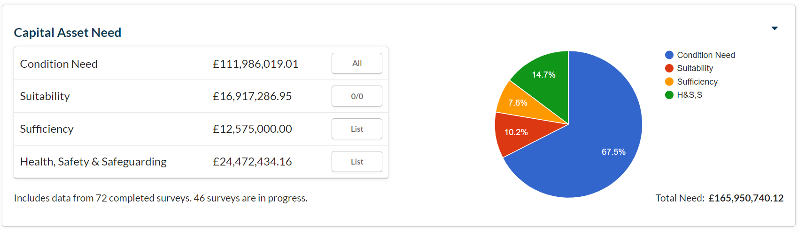
Since the report of January 26, an additional 13 surveys have been completed. The 46 “in-progress” surveys are all expect to complete this week.
The additional 13 completed surveys have increased the Total Need report by circa £32M. The annual School Capital Allocation is circa £10M; Therefore, unless we identify additional funding opportunities, it will take approximately 17 years to resolve all of the identified urgent needs.

Statlog
146 (+12) schools have purchased full licences for Statlog. Consultants are working to activate the Statutory Compliance Modules for licenced schools. Please see the setup tracker below:
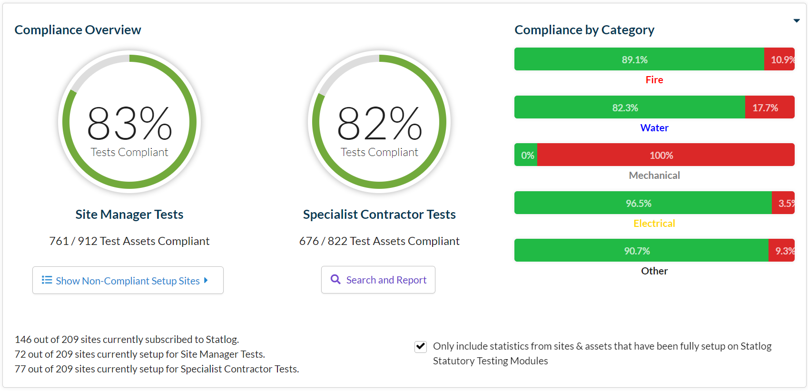
- 72 (+25) Schools are now set-up for Site Manger Tests
- 77 (+6) Schools are now set-up for Specialist Contractor Tests
- Total annual Site Manager Tests is now 912 (+347)
- Total annual Specialist Contractor Tests is now 822 (+55)
- The percentage of up-to-date Site Manager Tests has fallen slightly 83% (down from 85%). This will improve as newly added schools resolve historical tests
- The percentage of up-to-date Specialist Contractor Tests has improved 82% (up from 71%)

The Statlog Project Manager Tool is expected to be released by the end of this month. This will enable School Business Managers to procure and manage local Minor Capital Works Projects. The tool will be released to schools that satisfy the pre-requisites (upon application). Details of the release procedure will be circulated once the PM Tool has been released.

Priority School Building Programme
Project managers continue to monitor the progress of schools in this scheme.

Pupil Placement Planning

1st Planner Project
The Project Team is now focused on delivering the three strands of the programme.
- Major Project – The model of an 8FE Secondary School will be circulated to secondary school head teachers for comment. The challenge to the 1st planner team was to produce a Catholic Secondary School model that offered a minimum of 6FE but retained the capacity to expand to 8FE as required. The model for a 2FE Primary School is in development
- Minor Projects – The team is reviewing local need in preparation for detailed discussion with schools and Local Authorities. Aedificabo and 1st Planner are working with our Building Consultants to secure accurate “CAD”plans for each site.
- New Starts – The Team has begun the process of trawling for and cleansing data that will ensure that we can present WinWin options to Schools and Local Authorities as appropriate. The need for CAD Plans is affecting this programme too.
Aedificabo will:
- Manage the programme of work (Minor Works). The company will be the de facto project manager for all projects, commissioning services from other professional teams as appropriate.
- Engage as the Registered Social Housing Provider. The application to register for this function will begin this month.

