Witness to the Word - School Bulletin 03.03.21

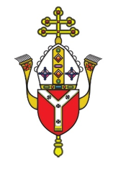
Dear Colleague in Catholic Education,
The Education Service every Wednesday provides schools with a wide variety of materials, resources, advice and updates on all matters relating to our schools and colleges. The content of these Bulletins are for Headteachers, Senior Leaders, Teaching Staff, Governors, Clergy and anyone who you feel would benefit from them. Please feel free to share widely

Objectives of the Education Service during Coronavirus (Covid-19) pandemic
- To provide support and training for Headteachers, Heads of RE, RE Coordinators, Chaplains, Teachers, Governors and the wider school community to cope at this time of unprecedented challenge;
- To provide resources and advice relating to the Teaching and Learning of Religious Education;
- To provide resources and advice relating to Spiritual support and renewal.
- To provide resources and advice relating to Mental Health issues;
- To provide the updates from the UK Government, DfE, CES and the Diocese of Westminster on all aspects of the Coronavirus Covid-19 relating to schools and colleges;

Subject Content Today
- Religious Education and Catholic Life resources are here
- Inspection Update is here
- RSE Updates are here
- Racial Justice, Equality and Diversity updates are here
- Caritas Updates are here
- SPEC updates are here
- Information about upcoming CPD and Training is here
- Mental Health and Wellbeing Resources are here
- Governance Updates are here
- Capital and Pupil Placement Planning updates are here

Thank you for all you are doing for your school community and for Catholic education.

Religious Education and Catholic Life Resources

Pope Francis Prayer Intentions: March
Intention for evangelisation - Sacrament of Reconciliation
We pray that we may experience the sacrament of reconciliation with renewed depth, to taste the infinite mercy of God.

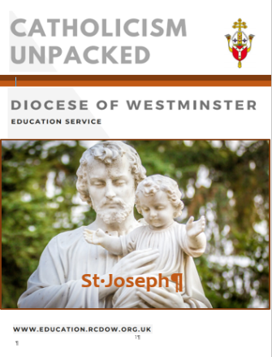
Catholicism Unpacked: The Year of St Joseph
The Education Department has created a support document for The Year of St Joseph in the same style as others in the Catholicism Unpacked series. It includes information about this saint and Pope Francis’ Apostolic Letter, Patris Corde, as well as ideas for teaching and praying with the community. The document can be found HERE.

Evangelisation and Caritas have worked together to create a Novena which can be used by staff and amended by pupils; it can be found HERE.

Missio have also created PowerPoints on St Joseph which are suitable for use with pupils as well as chaplaincy team members. They can be used for teacher or pupil-led worship at home or in school and can be found HERE.

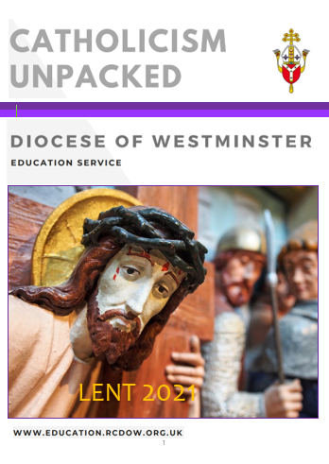
Catholicism Unpacked: Lent
This series of resources was written to develop subject knowledge and theology in RE and all documents are free to access on our website HERE.
The Lent one is available and includes:
- An A-Z of Lent
- Q & A to support staff members of different levels with
theological knowledge
- Links and resources from various charities to use during Lent
- Use of Scripture and liturgy during Lent
- Resources for teaching
- Videos for further research and teaching

Missio: Lent resources
Stations of the Cross meditations (suitable for staff reflections) can be found HERE.
New Lent reflections for KS3/4 can be found HERE. They look at themes of well-being in addition to exploring Lenten ideas.
Lent assemblies and Stations of the Cross for KS1-2 can be found HERE

Mark 10 Mission
The Sunday Gospel is shared each week by Mark 10 Mission and can be found using this link:
Series Four - Lent 2021 — The Mark 10 Mission.

Prayer Intentions during the season of Ordinary Time:
PRAYER INTENTIONS during Lent: Ash Wednesday – Holy Thursday  Easter Triduum: Holy Thursday – Easter Sunday (Based on the Liturgical Year) | Liturgical Colour
Penitents and Wanderers | PURPLE
The Needy and Hungry of the World
Especially on Lent Fast day (Friday after 1st Sunday of Lent)
Candidates for the Sacraments
Especially on the Sundays in Lent
Women
Especially on Women’s World day of Prayer (1st Friday in March)

March: Special dates
LITURGICAL YEAR | NATIONAL AND INTERNATIONAL DAYS | OTHER FAITHS  CULTURES
- St David (1st)  - St Casimir (4th)  - Ss Perpetua and Felicity (7th)  - St John of God (8th)  - St Frances of Rome (9th)  - St Patrick (17th)  - St Cyril of Jerusalem (18th)  - St Joseph (19th)  - Annunciation (25th) | - Zero Discrimination Day (1st)  - World Wildlife Day (2nd)  - Int Women’s Day (8th)  - International Day of Happiness; French Language Day (20th)  - International Day for the Elimination of Racial Discrimination (21st)  - World Poetry Day (21st)  - International Day of Forests (21st)  - World Water Day (22nd)  - World Meteorological Day (23rd)  - Remembrance of Victims of Slavery Day (23rd) | - Pesach (Jewish Passover Mar/Apr)  - Holla Mohalla (Sikh Olympics – 17th)  - Holi (Hindu Festival of Colours)  - Laylat al-Mi’raj (Islamic Mar/Apr)

Fratelli Tutti
We are providing a summary of a section of Pope Francis’ Social Encyclical each week taken from www.vaticannews.va. Click here to download the full document.
Week 11: Guarantee Religious Freedom
In the eighth and final chapter, the Pontiff focuses on “Religions at the service of fraternity in our world” and again emphasizes that violence has no basis in religious convictions, but rather in their deformities. Thus, “deplorable” acts, such as acts of terrorism, are not due to religion but to erroneous interpretations of religious texts, as well as “policies linked to hunger, poverty, injustice, oppression”. Terrorism must not be supported with either money or weapons, much less with media coverage, because it is an international crime against security and world peace, and as such must be condemned (282-283). At the same time the Pope underscores that a journey of peace among religions is possible and that it is therefore necessary to guarantee religious freedom, a fundamental human right for all believers (279). The Encyclical reflects, in particular, on the role of the Church: she does not “restrict her mission to the private sphere”, it states. She does not remain at the margins of society and, while not engaging in politics, however, she does not renounce the political dimension of life itself. Attention to the common good and concern for integral human development, in fact, concern humanity, and all that is human concerns the Church, according to evangelical principals (276-278). Lastly, reminding religious leaders of their role as “authentic mediators” who expend themselves in order to build peace, Francis quotes the “Document on Human Fraternity for World Peace and Living Together”, which he signed on 4 February 2019 in Abu Dhabi, along with the Grand Imam of Al-Azhar, Ahmad Al-Tayyib: from that milestone of interreligious dialogue, the Pontiff returns to the appeal that, in the name of human fraternity, dialogue be adopted as the way, common cooperation as conduct, and mutual knowledge as method and standard (285).

CAFOD Free CPD for Schools
We have been asked to alert you to CAFOD’s free CPD programme, an opportunity for schools to deepen their Catholic life and mission. This training is funded by the British Council and in order to complete the contract, CAFOD needs to train a further 500 teachers this year, either online or face to face. The contract forms a significant portion of income to enable CAFOD to deliver their education work in our Catholic schools so please do encourage your schools to make the most of this opportunity.

Everything is connected: Enrich school life through global learning
This course will support teachers to bring to life a commitment to the common good, through the inspiration of Laudato Si’ and an exploration of our human relationships, rooted in human dignity.
Enhance staff wellbeing through the life affirming and uplifting message of Catholic Social Teaching, including Laudato Si’ and Fratelli Tutti.
- Support school reflection on the new school inspection requirements for an ambitious curriculum.
- Enrich your broad curriculum with activities, strategies and resources that support global learning and the big issues that connect us all.
- Enhance the confidence of your staff and aspiring leaders in supporting the Catholic life of an outward facing school.
- Inspire your pupils to put their faith into action for the common good.
Available online, and face to face when possible, the training is suitable for whole school or wider partnership groups. There are also places available for individual teachers on CAFOD’s public courses, which take place over three sessions. To find out more and register for a course please visit cafod.org.uk/connectingclassrooms. To enquire about booking a course for your school or MAT, please email schools@cafod.org.uk or call 07740 543 046.
The Year of the Word
The Focus for March is on the Holy Family: godwhospeaks.uk/the-holy-family
To celebrate the Feast of St Joseph on 19th March:
Fr Michael Hall explores what we know about Joseph from the Bible and his unique role alongside Mary and Jesus: godwhospeaks.uk/what-do-we-know-about-st-joseph
Fleur Dorrell looks at some of the less well known texts and images that have influenced how St Joseph has been portrayed in art: godwhospeaks.uk/st-joseph-in-art-the-ultimate-multi-tasker
To celebrate the Feast of the Annunciation on 25th March:
There are 3 posters of Mary for you to use in your school and churches godwhospeaks.uk/our-lady-in-scripture
New in Our Top Ten's section:
Our Top Ten Angels:
Take a look at these different depictions of angels in art and explore the Bible passages that inspired them: godwhospeaks.uk/our-top-ten-angels-in-the-bible
Our Top Ten Home Quotes:
Having spent much more time at home over the last year, we've turned to the Bible to find our top ten quotes about the home: godwhospeaks.uk/our-top-ten-home-quotes
Home school RE Resources
Aimed at 5-11 year olds, these focus on the parables of Jesus and how he used them to teach people about God and about themselves.
There are a range of activities, games, puzzles and ideas for going deeper with the parables.
https://www.biblesociety.org.uk/explore-the-bible/homeschool-resources/
Lent at Home:
Our dedicated space with lots of great online resources for this Lent: godwhospeaks.uk/lent-at-home

Inspection
The Department for Education has confirmed that Section 48 inspections will resume in the summer term on a permission basis. However, we are yet to receive the detail on the adjusted timeline to work through the backlog of inspections.
The Inspection Committee has carefully considered the permission granted to inspect, our own (pre-Covid) inspection schedule, and the pressures which schools continue to face. The conclusion reached was that it would not be right to recommence diocesan inspections for the remainder of the academic year unless at its last inspection a school received a judgement of Requires Improvement or Causing Concern and are, therefore, now outside the cycle, or if a school invites us to inspect. However, there is no guarantee that in either case inspections will be conducted.
We intend to recommence a full schedule of inspections from September 2021 under the existing Westminster Diocese framework and the new National Inspection framework. Schools that are being inspected between September 2021 and July 2022 will be invited to take part in the National Inspection Framework pilot but can decline in favour of the existing Framework if they so choose.
I hope this brings some reassurance about the Diocese’s intentions around inspection in a time of ongoing uncertainty. In the meantime, if you have any questions or concerns about any of the above, please do not hesitate to contact Nancy Conoboy, Chief Inspector of Schools nancyconoboy@rcdow.org.uk.

RSE
As you know, the statutory requirement to teach RSE comes into place in the Summer term. In advance of teaching RSE you are required to have written and consulted on your school RSE policy. A model RSE policy and guidance on writing a model policy are available from the CES and are on our website here
Consultation
The advice we have received from the CES and shared with school via training has been to allow for 6 weeks to conduct your consultation following a sharing of information with parents.
Obviously, there is now limited time before the statutory implementation of RSE. There are only 4 or 5 weeks left of this half term and then the statutory obligation to teach RSE is in place after the Easter holidays. If your consultation has not begun, this is now an urgent matter, as you would be in breach of your statutory obligations.
It was our recommendation that schools adopt a three-stage consultation with parents. The original recommendations were as follows:
1) Host an information evening that gives an overview of statutory obligations and the interpretation of those in the CES model curriculum. This is also an opportunity to explain why RSE is a good opportunity for our schools and necessary for our pupils. Parental rights should be included here too. Allow time for answering questions. Decide who will answer questions and don’t be afraid to delay and answer and come back to that parent. A suggested outline for that evening was sent to schools last week. Please ask your adviser if you require a copy. It was created by the Education Service to be adapted for your school.
2) Allow 6 weeks to consult on the RSE policy for your school. Give parents several opportunities and ways in which to respond to the consultation, on paper, online, face to face. Ask the same questions but collect responses in several different ways.
3) Meet with parents of particular classes or phases to share the resources and content of RSE for their children.
In the current situation the following adaptations were suggested:
1. Create a video that delivers this information to parents (following the suggested parents information evening PowerPoint). Share this with parents via which ever platform your school uses. (considering parents who are difficult to reach). Provide an opportunity for parents to ask questions. You could also share the PowerPoint on your website or host a live consultation evening online.
2. Provide consultation questionnaires via school communications system. Extend the period of consultation to allow for those affected by Covid 19 to participate. Offer telephone consultation instead of face to face during school closures if possible.
3. These further evenings can take place in the late Summer or Autumn term when hopefully things are more normal or they can follow the format of step one.

RSE Resources
Through our training we have given lots of advice regarding the resources you use for RSE in your school. Most obviously the resources should not contain anything that that contradicts Catholic teaching on relationships. However, they should also promote a Catholic approach to relationships, so, any resources produced by a non-Catholic organisation will need adaptation. Please speak to your adviser for advice on the programmes available and tips for discerning resources.

Racial Justice, Equality and Diversity

All schools were invited to create a prayer card with a prayer and/or image and to share them with us. These have been shared with schools and can be found on our website HERE. See some below:
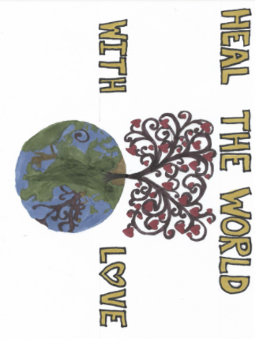
We love this prayer and image by Rachael, KS2, St John Fisher Primary, St Albans
Dear Lord,
Thank you for your beautiful creation of people from many different cultures and races. Please may you put love and acceptance into the heart of those people who do not treat others in the way you have taught us. Please help everyone to find love and understanding for each other, no matter what their background. We pray this in your heavenly name.
Amen.

We love the effort and care that has gone into this original prayer and image by Vincents, KS2, St Bernadette, Hillingdon

We love this poem and racial justice rainbow by Annaliese, KS2, Our Lady of Grace Primary, Brent
This is a special prayer to share
To help make sure the world is just right and fair
People need to unite and not fight
All together, we can make it right.
We pray to the Lord above
To give us all hope and love
Because everyone is equal
We are just different people
Let’s unite and pray
And hope this ends one day
And racial injustice just fades away…

We love this prayer and image created using ICT skills by Jack, KS2, St Mary’s Primary, Uxbridge
Dear God,
Thank you for the different colours of the world
Religions, cultures and beliefs
We pray for kindness, love and understanding
And for all to see us as one
Please help those who treat people
Different to the ways you have taught us
And help us to accept your ways.
Amen.
We love this prayer and image highlighting dignity and diversity by Daniel, KS1, English Martyrs Primary, Tower Hamlets
Thank you, God,
You are a true friend and a good father. Please help us to be kind to one another. Help us to understand that we are all special no matter our differences. Please protect every human in this world. We are all your children and we thank you for loving us all unconditionally. Please grant our prayers in Jesus name.
Amen.

We love the black and white handprints by Darcy, EYFS, Holy Rood Primary, Watford

We love this original painting and prayer by Bethany, KS3, St Edmund’s College, Ware
Dear Lord,
Help me and others around me not to participate in racial acts against others or our father in heaven. Clear our minds of all negative thoughts and embellishments that may cause emotional harm to you or our ourselves. Remind me that I am your child, and I am made in the image of yourself and always will be. Help me to remember the dignity you gave me when I was born and help me to entrust this into my life and reflect others around me. Amen

Caritas

Quarterly Diocese of Westminster Network Meeting
Caritas Westminster would like to invite you to their first Quarterly Diocese of Westminster Network Meeting on 11th March. This gathering is for all who welcome Refugees and Migrants, to meet together, share best practice and ideas, receive training and agree main advocacy issues. This event will be the opportunity to hear about the conditions refugees are currently experiencing, and the different options available to EEA nationals who haven’t yet sorted their settled status, and what support is available for people post Brexit. Register here if you would like to join.

Migrant & Refugee Network
As schools are on the frontline in ‘welcoming the stranger’, Caritas Westminster would like to invite you to the first Quarterly Diocese of Westminster Network Meeting for all who welcome Refugees and Migrants. Taking place on 11th March it’s a chance for everyone to meet together, share best practice and ideas, receive training and agree main advocacy issues. This event will be the opportunity to hear about the conditions refugees are currently experiencing, and explore the different options available to EEA nationals who haven’t yet sorted their settled status, and the support available post-Brexit. Register here if you would like to join.

Vaccination Confidence
Caritas Westminster is working with the local authorities across London and Hertfordshire to promote vaccine confidence. We are planning to hold a Diocesan event in the coming weeks. If you are worried about the up-take in your school and would like to be involved, please contact us on caritaswestminster@rcdow.org.uk

Asylum Seekers in Hotels
We have recently heard that the Home Office has housed asylum seekers in 35 hotels across London, but they may not have been linked up with the Local Authorities, Schools and GP and other support to which they are entitled. If you want more information or are aware of a hotel in the area and you wish to support, please contact caritaswestminster@rcdow.org.uk for a fact sheet.

Keep the Lifeline
Thanks so much to the headteachers and school governors who joined us in writing to your local MP to ask them to make the £20 universal credit uplift permanent and prevent half a million people from being pulled into poverty. Today is budget day, predictions are that the uplift will continue for a further six months. This is welcome news, but it means the campaign will go on for a permanent uplift.

Tech Appeal
Remote working may now be coming to an end, but the need for digital devices continues. If you would like to take part in our Tech Appeal, please fill in this form

Caritas Ambassadors
If you would like to promote Catholic Social Teaching in your school through our Caritas Ambassador programme, please email caritasambassadors@rcdow.org.uk

Westminster Justice and Peace

Fairtrade Fortnight
Westminster has recently become an accredited Fairtrade Diocese. That means that over half of our communities are registered as Fairtrade Parishes, along with a number of Catholic Schools in the Diocese. The Justice and Peace Department wants to thank everyone who was instrumental in achieving these awards and sustaining a commitment to fair trading for small farmers worldwide over many, many years.
Of course, we have reached a massive milestone as a Diocese, but the work doesn't end there. We know that we need to be constantly assessing our support for the world's farmers and other producers as we face new global threats from climate change and water shortages to pandemics and loss of biodiversity. We warmly encourage those parishes and schools who have not yet completed the award to consider whether they might now be in a position to do so.
For more about the Fairtrade Diocese Award and Fairtrade Fortnight - 22nd February to 7th March – please visit Westminster Justice & Peace Fairtrade
If you would like any more information about Fairtrade or can share any pictures or reports of anything you have done for Fairtrade or Fairtrade Fortnight please send directly to colettejoyce@rcdow.org.uk
For the Cardinal’s 3 minute message on Fairtrade see HERE

SPEC

Upcoming CPD – Online Courses - March 2021

Date/Time | Course | Booking Links
9th March  3.30pm to 5.00pm | ART in RE | Book Ticket
16th March  9.30am to 12.30pm | Poetry in RE | Book Ticket
18th, 22nd, 25th March  5.00pm to 7.00pm | Governors Induction Course | Book Ticket
23rd, 24th, 25th March | Online Leadership Conference | Book Ticket

Governors Induction Online Course
Do you have any new or recently appointed governors? If so, please do encourage attendance at our induction course which is relevant to all governors.
Dates: 18th, 22nd, 25th March 2021 (please note attendance at all three sessions is required)
Time: 5.00pm to 7.00pm
The AIM of this course is to gain a greater knowledge and understanding of the role of governors in relation to Classroom RE and the Catholic Life of the school.
Course Content:
- Governance in a Catholic context.
- Understanding the language of governance.
- Committees and school visits.
- Legal duties and responsibilities.
- Strategic v Operational issues.
To Book Please Click Here
Testimonials - Governors Induction held in November 2020
“Very good and thorough - thank you!”
“Thanks for running the course. It is helpful and feel like I have a great supporter on my side.”
“What an Inspiration! And a joy to follow from start to finish. Thank you so very much for this brilliant foundation - Your enthusiasm is infectious!”

Mental Health and Wellbeing Resources – Returning to school

Mental Health Foundation
- Click Here School guidance for coping with coronavirus and disruption to learning.
- Click Here Supporting pupils to return to school

Young Minds
- Click Here Coping with anxiety about going back to school
- Click Here Supporting you pupils through the covid-19 pandemic
- Click Here Supporting a child returning to school after lockdown

Mentally Healthy Schools/ Anna Freud Centre
- Click Here Rebuild and Recover resources for schools – Guidance for children, staff and parents
- Click Here Managing the transition back to school – Guidance for schools and teachers

NSPCC Learning - Click Here Coronavirus: transitioning back to school

Place2Be - Click Here Return to school resources

NHS - Click Here Guidance for parents

British Red Cross - Click Here Kindness Resources

CAMHS - Click Here Advice for teachers on children returning to school

TES/EduCare - Click Here Resources for teachers, children and parents

Governance

Governor Hub Training for Clerks – 16th March 1-3pm

Further to our requests for all members of your governing body to be registered on Governor Hub, we are providing training on the Governor Hub platform for all clerks. Please click here to reserve a place on this free training session. If your clerk is unavailable, you are welcome to send another representative.

Governors Induction Online Course
Do you have any new or recently appointed governors? If so, please do encourage attendance at our induction course which is relevant to all governors.
Dates: 18th, 22nd, 25th March 2021 (please note attendance at all three sessions is required)
Time: 5.00pm to 7.00pm
The AIM of this course is to gain a greater knowledge and understanding of the role of governors in relation to Classroom RE and the Catholic Life of the school.
Course Content:
- Governance in a Catholic context.
- Understanding the language of governance.
- Committees and school visits.
- Legal duties and responsibilities.
- Strategic v Operational issues.
To Book Please Click Here
Testimonials - Governors Induction held in November 2020
“Very good and thorough - thank you!”
“Thanks for running the course. It is helpful and feel like I have a great supporter on my side.”
“What an Inspiration! And a joy to follow from start to finish. Thank you so very much for this brilliant foundation - Your enthusiasm is infectious!”

New process for appointing foundation governors / directors
For a long time now, we have known of the considerable frustration experienced in getting foundation governors appointed by the diocese. We have studied why these delays occur and looked at ways in which the system can be improved.
Time after time we have found that delayed applications are caused by difficulties in getting references and DBS clearances to support the applications, despite reminders being sent. In brief, instead of the diocese seeking to collect the supporting documentation from referees we are asking that the school does this instead. We believe that there is more likelihood that this will be effective when it is done locally than when done centrally. In addition, we have redesigned the process so that it occurs completely electronically. This new system will operate for all applications after the 1st January 2021.
What does your school need to do?
- We ask that your school appoints a Nominated Person (either the Clerk to Governors or perhaps, someone in the School Office) who will administer this process.
- The Nominated Person should download the suite of forms [available at Link to website ] and personalise them to the school, including the email address of the nominated person.
- The Nominated Person will send the application to and receive the application from the applicant.
- The Nominated Person will seek the references and the DBS certification. (Note: the parish priest may wish to return the reference directly to the diocese; if they wish to do this, they have been asked to let the nominated person know).
- When all references and Clearances are available, the Nominated Person will upload all documents to the Diocese using this secure link at : Link to website A receipt will be sent to the Nominated Person and the Applicant on submission.
- The Diocese will determine the complete application within 21 days, either with a letter and deed of appointment, or other communication.
If you have any questions about how the system will work or difficulty in downloading the materials, please contact Mike Pittendreigh (mikep@rcdow.org.uk) Other, more general, governors queries should continue to be addressed to Carol Campbell (governors@rcdow.org.uk)

Capital

VASCA 2020/2021
There are currently 85 live projects on Statlog.
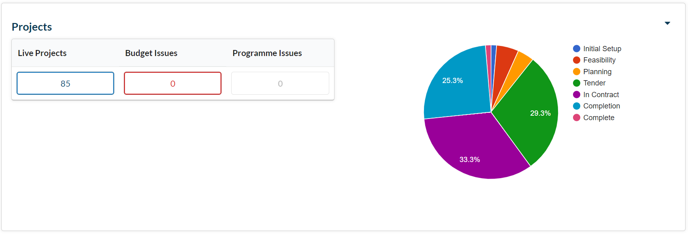

VASCA 2021/22
In preparation for the assignment of VASCA Funding, 128 surveys have been completed and uploaded to Statlog. A further 3 surveys are in progress. The Education Commission will begin the process of assigning Wave 1 Funding as soon as the Government announces the 2021/22 School Capital Allocations.
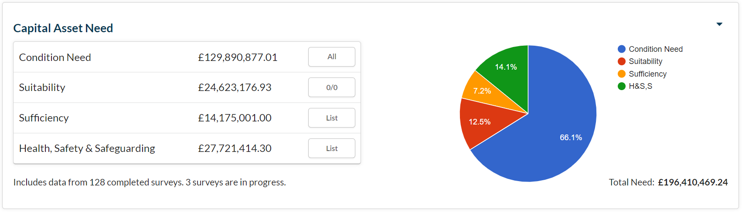
The total identified need now stands at £196,410,469.24

Statlog
The number of schools with Statlog Licences has remained unchanged.
However, the number of sites setup for Statutory Compliance Management continues to rise.
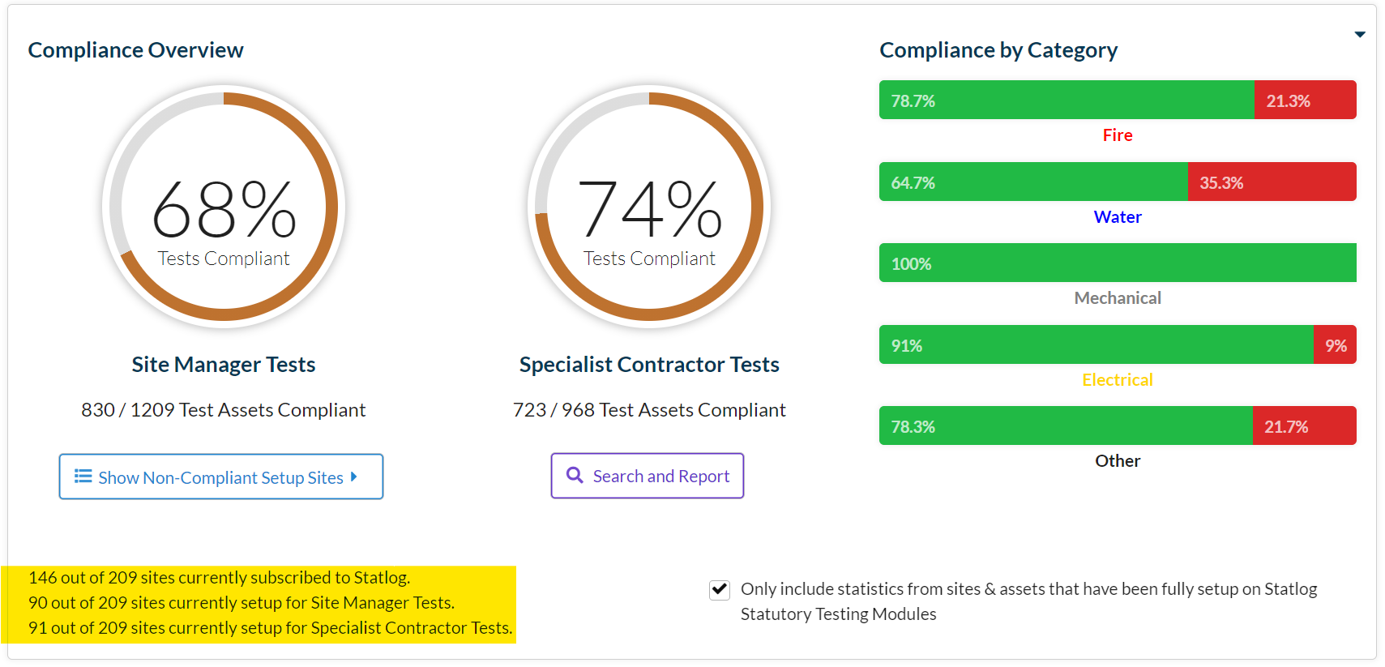
The Statlog Project Manager Tool was released on Monday 1st March.
To access Project Manager, Schools need:
- A current Statlog Licence,
- A recent Condition Survey, uploaded to Statlog, and
- An active Statlog Statutory Compliance regime
If your school can satisfy all of the above prerequisites, please email nigelspears@rcdow.org.uk with your assess request.

Priority School Building Programme
Project managers continue to monitor the progress of schools in this scheme.

Pupil Placement Planning

1st Planner Project
The Project Team continues to focus on the three strands in this programme.
- Major Project – The model of an 8FE Secondary School has been circulated to Secondary School Head teachers for comment. In addition, 1st Planner hosted a “fly-through” presentation for interested Heads. The development of a 2FE Primary School model is approaching completion and will be circulated to Primary School Head Teachers for review.
- Minor Projects – The team is reviewing local need in preparation for detailed discussion with schools and Local Authorities. Aedificabo and 1st Planner are working with our Building Consultants to secure accurate “CAD “plans for each site.
- New Starts – The Team is continuing the process of trawling for and cleansing data that will ensure that we can present WinWin options to Schools and Local Authorities as appropriate. The need for CAD Plans is affecting this programme too.
Aedificabo will:
- Manage the programme of work (Minor Works). The company will be the de facto project manager for all projects, commissioning services from other professional teams as appropriate.
- Engage as the Registered Social Housing Provider. The application to register for this function will begin this month.

Pupil Placement Planning
Local Authorities throughout the Diocese are preparing for significant changes in the number of pupils seeking school places. If schools are approached directly, please contact Nigel or Peter to ensure the Diocese is in the loop.

