Witness to the Word - School Bulletin 17.03.21

Dear Colleague in Catholic Education,

The Education Service *every* Wednesday provides schools with a wide variety of materials, resources, advice and updates on all matters relating to our schools and colleges. The content of these Bulletins are for Headteachers, Senior Leaders, Teaching Staff, Governors, Clergy and anyone who you feel would benefit from them. Please feel free to share widely

[](https://www.instagram.com/dow_ed_service/)[](https://twitter.com/DOW_Ed_Service)

FOLLOW US!

**Objectives of the Education Service during Coronavirus (Covid-19) pandemic**

* To provide support and training for Headteachers, Heads of RE, RE Coordinators, Chaplains, Teachers, Governors and the wider school community to cope at this time of unprecedented challenge;
* To provide resources and advice relating to the Teaching and Learning of Religious Education;
* To provide resources and advice relating to Spiritual support and renewal.
* To provide resources and advice relating to Mental Health issues;
* To provide the updates from the UK Government, DfE, CES and the Diocese of Westminster on all aspects of the Coronavirus Covid-19 relating to schools and colleges;

**Subject Content Today**

1. Religious Education and Catholic Life resources are here
2. RSE Updates are here
3. Racial Justice, Equality and Diversity updates are here
4. Caritas Updates are here
5. SPEC / Youth Ministry updates are here
6. Information about upcoming CPD and Training is here
7. Mental Health and Wellbeing Resources are here
8. Governance Updates are here
9. Capital and Pupil Placement Planning updates are here

**Thank you for all you are doing for your school community and for Catholic education.**

# Religious Education and Catholic Life Resources

Pope Francis Prayer Intentions: March   
Intention for evangelisation - **Sacrament of Reconciliation**

*We pray that we may experience the sacrament of reconciliation with renewed depth, to taste the infinite mercy of God.*

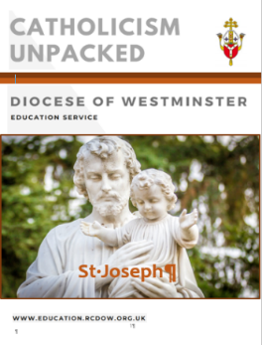

Catholicism Unpacked: The Year of St Joseph

The Education Department has created a support document for The Year of St Joseph in the same style as others in the Catholicism Unpacked series. It includes information about this saint and Pope Francis’ Apostolic Letter, *Patris Corde,* as well as ideas for teaching and praying with the community. The document can be found [HERE](https://education.rcdow.org.uk/catholicism-unpacked-new/).

Evangelisation and Caritas have worked together to create a Novena which can be used by staff, parents or pupils and can be found [HERE](https://rcdow.org.uk/faith/evangelisation/st-joseph-novena).

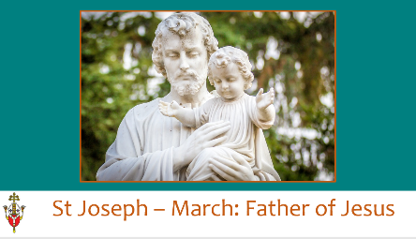Each month, a PowerPoint for prayer in schools based on this Novena will be shared each month for the reminder of The Year of St Joseph. The March one is based on St Joseph as the foster father of Jesus and it can be used for his feast day on 19th March or at any other time. For the resource see: [HERE](https://education.rcdow.org.uk/support-resources-catholic-life/).

If you have any artwork on St Joseph that we can include in our monthly resource, please send directly to

[elainearundell@rcdow.org.uk](mailto:elainearundell@rcdow.org.uk) or [trishahedley@rcdow.org.uk](mailto:trishahedley@rcdow.org.uk).

Prayer to St Joseph

At the conclusion of his Apostolic Letter, *Patris Corde*, Pope Francis adds another prayer to St Joseph, which he encourages all of us to pray together during this Year of St Joseph:

*Hail, Guardian of the Redeemer,*   
*Spouse of the Blessed Virgin Mary.*   
*To you God entrusted his only Son;*    
*in you Mary placed her trust;*   
*with you Christ became man.*

*Blessed Joseph, to us too,*    
*show yourself a father*   
*and guide us in the path of life.*   
*Obtain for us grace, mercy, and courage,*   
*and defend us from every evil.  Amen.*

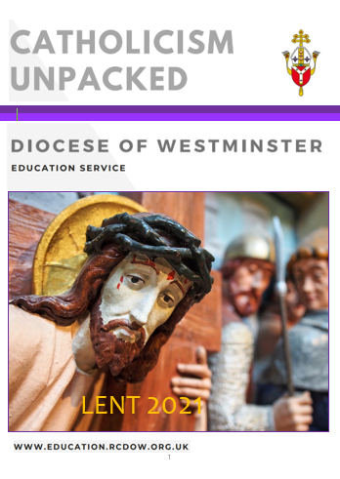Catholicism Unpacked: Lent

This series of resources was written to develop subject knowledge and theology in RE and all documents are free to access on our website [HERE](https://education.rcdow.org.uk/catholicism-unpacked-new/).

The Lent one is available and includes:

* An A-Z of Lent
* Q & A to support staff members of different levels with

theological knowledge

* Links and resources from various charities to use during

Lent

* Use of Scripture and liturgy during Lent
* Resources for teaching
* Videos for further research and teaching

Holy Week Voices from the Holy Land

Poems and Reflections for Lent and Easter with Fr Richard Nesbitt. This rich resource is available in booklet or downloadable format.  And includes a suggested selection of six chapters as this year’s Lenten Resource for Small Communities Faith-Sharing. For further information and to order your copy, visit: [HERE](https://rcdow.org.uk/faith/news/holy-week-voices).

Hexham & Newcastle Diocese   
 The Youth Ministry Team (YMT) have created a series of daily videos for Lent called '*Wait a minute - It's Lent*'. The videos are on their YouTube channel [HERE](https://atcre.us20.list-manage.com/track/click?u=8c3ccb22521d017db641bf551&id=c333d4747b&e=08259e5585).

Mission Together

They have created a set of resources that can be uploaded to various teaching platforms. These faith-focused activity sheets include comprehension tasks and outdoor challenges, some of which can be used as Lenten fundraising drives. Download free [HERE](https://missiontogether.org.uk/calendar/resources-for-lent-2021/).

During Lent, there are a couple of feast days that Mission Together can help you commemorate too. View the pupil-led Five Fact Assemblies for St Joseph (19th March) and St Oscar Romero (24th March).    
See [HERE](https://missiontogether.org.uk/resources-by-month/calendar-march/)

CAFOD

For assemblies, Stations of the Cross, liturgy, a PowerPoint calendar and a one page calendar click here: [HERE](https://cafod.org.uk/Education/Primary-teaching-resources/Lent-resources-for-children).  An interactive Lenten calendar can be found [HERE](https://cafod.org.uk/Education/Primary-teaching-resources/Lent-resources-for-children) and there is an online Lent calendar for families to share at home [HERE](https://cafod.org.uk/Education/For-families).

CCS

CCS has produced online activities and resources for schools to encourage pupils to think about how they can help others and the difference they can make this Lent: [Lenten Challenge Overview](https://www.cathchild.org.uk/wp-content/uploads/2021/02/Lenten-Challenge-PPT.pdf): An introduction to this year’s appeal and activities. [Interactive Lenten Calendar](https://www.cathchild.org.uk/wp-content/uploads/2021/02/CCS-Lenten-Challenge-Calendar.pdf): Pupils can reflect on how they are helping others during Lent. [Fundraising Challenges](https://www.cathchild.org.uk/wp-content/uploads/2021/02/CCS-Fundraising-Challenges.pdf): Fundraising ideas for your school, including the Walk the Diocese Challenge.

Prayer Intentions during the season of Lent:

|  |  |
| --- | --- |
| **PRAYER INTENTIONS during Lent:**  **Ash Wednesday – Holy Thursday**    **Easter Triduum: Holy Thursday – Easter Sunday**    **(Based on the Liturgical Year)** | **Liturgical Colour** |
| Penitents and Wanderers | **PURPLE** |
| The Needy and Hungry of the World  Especially on Lent Fast day (Friday after 1st Sunday of Lent) |
| Candidates for the Sacraments  Especially on the Sundays in Lent |
| Women  Especially on Women’s World day of Prayer (1st Friday in March) |

March - April: Special dates

|  |  |  |
| --- | --- | --- |
| **LITURGICAL YEAR** | **NATIONAL AND INTERNATIONAL DAYS** | **OTHER FAITHS**  **CULTURES** |
| * St Patrick (17th) * St Cyril of Jerusalem (18th) * St Joseph (19th) * Oscar Romero (24th) * Annunciation (25th) * Palm Sunday (28th) * **Maundy Thursday (1st April)** * **Good Friday (2nd)** * **Holy Saturday (3rd)** * **Easter Sunday (4th)** | * International Day of Happiness; French Language Day (20th) * International Day for the Elimination of Racial Discrimination (21st) * World Poetry Day (21st) * International Day of Forests (21st) * World Water Day (22nd) * World Meteorological Day (23rd) * Remembrance of Victims of Slavery Day (23rd) | * Pesach (Jewish Passover Mar/Apr) * Holla Mohalla (Sikh Olympics – 17th) * Holi (Hindu Festival of Colours) * Laylat al-Mi’raj (Islamic Mar/Apr) |

Made4Love

The Secondary Advisors, with the Convent of Jesus and Mary and the Agency for Evangelisation have developed a Core RE unit for Year 12 or Year 13 students called Made4Love. This is a dynamic and engaging scheme of work which looks at the Church's teaching on marriage and family life and its relevance in today's society. It is currently being trialled and if your school is interested in taking part please contact Claire O'Neill at [claireoneill@rcdow.org.uk](mailto:claireoneill@rcdow.org.uk)

Online Chaplaincy

Recently, the chaplains received some inspiring training from Tom Baptist, Director of Youth Services for the Diocese of Nottingham. Tom is doing incredible work by bringing Christ's message online in a way which meets young people where they are at. He has established a successful YouTube channel, Instagram account and is also a regular on TikTok. He explained why he thinks this work is so important and then gave useful links and advice about how to make it work. Mary Boland, the Lay Chaplain at Cardinal Wiseman commented that *'This morning has been really useful and I have come away with lots of ideas, from both Tom and my fellow chaplains. I have a list of over a dozen new resources that I have never heard of before, not only do they all sound great, but they have been tried and tested*.'

Carlise Jones, the Lay Chaplain at St Paul's said *'I found Tom a passionate inspiring speaker. I really found the first part of the training really engaging and helpful. I loved the advice on how to arrange liturgies and all the resources he offered. Really good.'*

**Tom will be speaking again at the Leadership Conference on the 24th March**

**so make sure you book your school ticket.**

Online Chaplaincy Retreat 14th May

Coming up for chaplains is an online retreat between 9.30 - 12.30pm on Friday 14th May. This will be an excellent opportunity for chaplains to have some time away from the busyness of school and be spiritually nourished and renewed. Do make sure your chaplain books on.

Teacher Assessed Grades

The Heads of RE across the Diocese gathered on Zoom last week to discuss how they were approaching 'Teacher Assessed Grades.' The discussions were informative and useful and participants were able to ask questions and work with other schools using the same exam board. If your Head of RE would like to be matched with another school who uses the same exam board for moderation or support please contact either Claire O'Neill at [claireoneill@rcdow.org.uk](mailto:claireoneill@rcdow.org.uk) or Trisha Hedley at [trishahedley@rcdow.org.uk](mailto:trishahedley@rcdow.org.uk)

Online Heads of RE Conference - 25th June

Please ensure your Head of RE books for the online Head of RE Conference on the 25th June. It is particularly important they attend as their will be updates about the new RECD and Inspection Process as well as time for sharing good practice and networking.

RE PGCE Students

Claire O'Neill recently spoke at an event for RE PGCE students across London and promoted the excellent opportunities available to those teaching RE in a Catholic school. As a result, a number of the students shared their interest in working in our Diocese. If you are looking for a RE teacher do contact Claire O'Neill at [claireoneill@rcdow.org.uk](mailto:claireoneill@rcdow.org.uk) and she can share their details.

Art resources for Holy Week, Lent and Pentecost:

Nigerian Stations of the Cross: [HERE](http://smafathers.org/museum/Nigeria-the-fourteen-%20stations-of-the-cross/)

Last Supper with the Street Children: [HERE](https://midfield.wordpress.com/2008/07/24/last-supper-with-the-street-children-update-joey-velasco-taken-ill/)

Crucifixion – Resurrection art: [HERE](https://www.heqiart.com/3-crucifixion--resurrection-ap.html)

Fratelli Tutti

We are providing a summary of a section of Pope Francis’ Social Encyclical each week taken from [www.vaticannews.va](http://www.vaticannews.va). Click [here](http://www.vatican.va/content/francesco/en/encyclicals/documents/papa-francesco_20201003_enciclica-fratelli-tutti.html) to download the full document.

Week 12: Blessed Charles de Foucauld, “the universal brother”

The Encyclical concludes by remembering Martin Luther King, Desmond Tutu, Mahatma Gandhi and above all Blessed Charles de Foucauld, a model for everyone of what it means to identify with the least in order to become “the universal brother” (286-287). The last lines of the Document are given to two prayers: one “to the Creator” and the other an “Ecumenical Christian Prayer”, so that the heart of mankind may harbour “a spirit of fraternity”.

# Relationships and Sex Education

As you know, the statutory requirement to teach RSE comes into place in the Summer term. In advance of teaching RSE you are required to have written and consulted on your school RSE policy. A model RSE policy and guidance on writing a model policy are available from the CES and are on our website [here](https://education.rcdow.org.uk/re-catholic-life/relationships-and-sex-education/)

Consultation

The advice we have received from the CES and shared with school via training has been to allow for **6 weeks to conduct your consultation following a sharing of information with parents.**

Obviously, there is now limited time before the statutory implementation of RSE. There are only 2/3 weeks left of this half term and then the statutory obligation to teach RSE is in place after the Easter holidays. **If your consultation has not begun, this is now an urgent matter, as you would be in breach of your statutory obligations.**

It was our recommendation that schools adopt a three-stage consultation with parents. The original recommendations were as follows:

1)    Host an information evening that gives an overview of statutory obligations and the interpretation of those in the CES model curriculum. This is also an opportunity to explain why RSE is a good opportunity for our schools and necessary for our pupils. Parental rights should be included here too.  Allow time for answering questions. Decide who will answer questions and don’t be afraid to delay and answer and come back to that parent. **A suggested outline for that evening was sent to schools last month**. Please ask your adviser if you require a copy. It was created by the Education Service to be adapted for your school.

2)    Allow 6 weeks to consult on the RSE policy for your school. Give parents several opportunities and ways in which to respond to the consultation, on paper, online, face to face. Ask the same questions but collect responses in several different ways.

3)    Meet with parents of particular classes or phases to share the resources and content of RSE for their children.

**In the current situation the following adaptations were suggested:**

1.  Create a video that delivers this information to parents (following the suggested parents information evening PowerPoint). Share this with parents via which ever platform your school uses. (considering parents who are difficult to reach).  Provide an opportunity for parents to ask questions. You could also share the PowerPoint on your website or host a live consultation evening online.

2. Provide consultation questionnaires via school communications system. Extend the period of consultation to allow for those affected by Covid 19 to participate. Offer telephone consultation instead of face to face during school closures if possible.

3. These further evenings can take place in the late Summer or Autumn term when hopefully things are more normal or they can follow the format of step one.

RSE Resources

Through our training we have given lots of advice regarding the resources you use for RSE in your school. Most obviously the resources should not contain anything that that contradicts Catholic teaching on relationships. However, they should also promote a Catholic approach to relationships, so, any resources produced by a non-Catholic organisation will need adaptation.  Please speak to your adviser for advice on the programmes available and tips for discerning resources.

# Racial Justice, Equality and Diversity

Anti-racist Religious Education

On the NATRE website you will find anti-racist resources for pupils of all ages. These project materials are designed to help teachers of Religious Education plan and provide excellent learning in the classroom that encourages pupils to learn about religion and beliefs, racism and prejudice in challenging ways that promote the well-being of all in our richly plural communities.

Project partners whom this work would not be possible without include black, asian and minority ethnic teachers, academics, religious and non-religious voices from many communities, other subject associations and educational partners and many pupils.

The project is generously supported initially by the Free Churches Group and Methodist Schools, and managed, written and edited by Lat Blaylock, RE Adviser and editor of *REtoday magazine*.

This project has launched in Autumn 2020, and will be added to, revised and updated as necessary over the coming months. This can be a sensitive topic, and this is just a starting point. Certainly, there is more to do, and more to get right. These resources can help and have been very positively received nationally.

Resources

For all information see[**HERE**](https://www.natre.org.uk/about-natre/projects/anti-racist-re/)Click here for key terms for anti-racist Religious Education:[**HERE**](https://www.natre.org.uk/uploads/Anti-racist%20RE/Professional%20Glossary/20%2B%20Key%20terms%20for%20anti-racist%20RE.pdf)

For primary resources click on the following links:

[**Unit of Work - KS2 8-11s Anti-Racist Primary RE**](https://www.natre.org.uk/uploads/Anti-racist%20RE/Primary%20classroom/Pri%20Unit%20of%20Work%20-%20KS2%208-11s%20AntiRacist%20Prim%20RE%20FINAL.pdf)[**Pri 1 Racism topic intro and what can we learn from 6 examples**](https://www.natre.org.uk/uploads/Anti-racist%20RE/Primary%20classroom/Pri%201%20Racism%20topic%20intro%20and%20what%20can%20we%20learn%20from%206%20examples.pptx)[**Pri 2 What can we learn from the stories of two statues in Bristol - Colston and Wesley**](https://www.natre.org.uk/uploads/Anti-racist%20RE/Primary%20classroom/Pri%202%20What%20can%20we%20learn%20from%20the%20stories%20of%20two%20statues%20in%20Bristol%20-%20Colston%20and%20Wesley.pptx)[**Pri 3 How did Saint Peter learn that God has no favourites**](https://www.natre.org.uk/uploads/Anti-racist%20RE/Primary%20classroom/Pri%203%20How%20did%20Saint%20Peter%20learn%20that%20God%20has%20no%20favourites.pptx)[**Pri 3 The story of Peter at Joppa - resource**](https://www.natre.org.uk/uploads/Anti-racist%20RE/Primary%20classroom/Pri%203%20The%20story%20of%20Peter%20at%20Joppa%20-%20resource.pdf)[**Pri 4 The Golden Rule and Silver Rule**](https://www.natre.org.uk/uploads/Anti-racist%20RE/Primary%20classroom/Pri%204%20The%20Golden%20Rule%20and%20Silver%20Rule.pptx)[**Pri 5 Anti-racist people from different religions**](https://www.natre.org.uk/uploads/Anti-racist%20RE/Primary%20classroom/Pri%205%20Anti-racist%20people%20from%20different%20religions.pptx)[**Pri 6 How can I express my own vision for justice and equality**](https://www.natre.org.uk/uploads/Anti-racist%20RE/Primary%20classroom/Pri%206%20How%20can%20I%20express%20my%20own%20vision%20for%20justice%20and%20equality.pptx)

For secondary resources click on the following links:

[**Unit of Work - KS3 11-14s Anti-Racist Secondary RE**](https://www.natre.org.uk/uploads/Anti-racist%20RE/Secondary%20classroom/Sec%20Unit%20of%20Work%20KS3%2011-14s%20AntiRacist%20Sec%20RE%20FINAL.pdf)

[**Sec 1 Racism what can be done to reduce its harmful impact**](https://www.natre.org.uk/uploads/Anti-racist%20RE/Secondary%20classroom/Sec%201%20Racism%20what%20can%20be%20done%20to%20reduce%20its%20harmful%20impact.pptx)

[**Sec 1a 12 Examples of respect - discussion and judgements**](https://www.natre.org.uk/uploads/Anti-racist%20RE/Secondary%20classroom/12%20Examples%20of%20respect%20-%20discussion%20and%20judgements.pdf)

[**Sec 2 What can we learn from the stories of two statues in Bristol**](https://www.natre.org.uk/uploads/Anti-racist%20RE/Secondary%20classroom/Sec%202%20What%20can%20we%20learn%20from%20the%20stories%20of%20two%20statues%20in%20Bristol.pptx)

[**Sec 3 Anti-racist people from Christianity two examples**](https://www.natre.org.uk/uploads/Anti-racist%20RE/Secondary%20classroom/Sec%203%20Anti-racist%20people%20from%20Christianity%20two%20examples.pptx)

[**Sec 3a Dr King What do we know - resource**](https://www.natre.org.uk/uploads/Anti-racist%20RE/Secondary%20classroom/Sec%203a%20%20Dr%20King%20What%20do%20we%20know%20-%20resource.pdf)

[**Sec 3b Nine Dreams Dr Kings Speech - resource**](https://www.natre.org.uk/uploads/Anti-racist%20RE/Secondary%20classroom/Sec%203b%20Nine%20Dreams%20Dr%20Kings%20Speech%20-%20resource.pdf)

[**Sec 3c Stormzy interview REtoday magazine - resource**](https://www.natre.org.uk/uploads/Anti-racist%20RE/Secondary%20classroom/Sec%203c%20Stormzy%20interview%20REtoday%20magazine%20-%20resource.pdf)

[**Sec 4 Anti-racist people from Islam two examples**](https://www.natre.org.uk/uploads/Anti-racist%20RE/Secondary%20classroom/Sec%204%20Anti-racist%20people%20from%20Islam%20two%20examples.pptx)

[**Sec 4a Dr Hany El Banna Learning ideas - resource**](https://www.natre.org.uk/uploads/Anti-racist%20RE/Secondary%20classroom/Sec%204a%20Dr%20Hany%20El%20Banna%20Learning%20ideas%20-%20resource.pdf)

[**Sec 5 Anti-racist people from different religions**](https://www.natre.org.uk/uploads/Anti-racist%20RE/Secondary%20classroom/Sec%205%20Anti-racist%20people%20from%20different%20religions.pptx)

[**Sec 6 How bad is racism in our school and community**](https://www.natre.org.uk/uploads/Anti-racist%20RE/Secondary%20classroom/Sec%206%20How%20bad%20is%20racism%20in%20our%20school%20and%20community.pptx)

[**Sec 6a Stairs to Respect**](https://www.natre.org.uk/uploads/Anti-racist%20RE/Secondary%20classroom/Sec%206a%20Stairs%20to%20Respect.pdf)

[**Sec 7 How can I express my own vision for justice and equality**](https://www.natre.org.uk/uploads/Anti-racist%20RE/Secondary%20classroom/Sec%207%20How%20can%20I%20express%20my%20own%20vision%20for%20justice%20and%20equality.pptx)

[**Sec 8 Can singing for freedom and justice help in the struggle against racism**](https://www.natre.org.uk/uploads/Anti-racist%20RE/Secondary%20classroom/Sec%208%20Can%20singing%20for%20freedom%20and%20justice%20help%20in%20the%20struggle%20against%20racism.pptx)

# Caritas

No Recourse to Public Funds

Last week Caritas Westminster launched a **fact sheet on how schools can help** those with NRPF see [here](https://mcusercontent.com/564d82514dd42ee97923d2a35/files/e04d4113-a85d-47d5-a9b5-315302fbf571/NRPF_Leaflet.pdf)**.**Thanks to those who attended the first Quarterly Diocese of Westminster Network Meeting for all who welcome Refugees and Migrants. We heard about the conditions refugees are currently experiencing, and explored the different options available to EEA nationals who haven’t yet sorted their settled status, and the support available post-Brexit. If you weren’t able to make it but have questions, please email [caritaswestminster@rcdow.org.uk](mailto:caritaswestminster@rcdow.org.uk)

Vaccination Confidence

Caritas is keen to support schools to tackle health inequalities.  As such we are planning a webinar (date to be confirmed) to encourage vaccine confidence among BAME communities. We encourage schools to invite a representative from each diaspora that you feel might be demonstrating vaccine hesitancy.  The school representative(s) will be known as a Vaccine or Community Champion.  The webinar is intended to inform and empower participants to promote vaccination and speak of its importance in their local communities.  A panel of Catholic medical professionals and Catholic clergy from BAME communities will be present at the webinar to speak about the importance of vaccination and to answer questions.  Research indicates that messages spread locally are successful in promoting vaccination of any kind.  When choosing a community champion please keep in mind that tackling the reasons for hesitancy requires understanding, trust and engagement at community level.  Please ask those chosen to complete and submit the form in this link:  [www.tiny.cc/RCDOW- CommunityChampion](http://www.tiny.cc/RCDOW-%20CommunityChampion)

Asylum Seekers in Hotels

We have recently heard that the Home Office has housed asylum seekers in 35 hotels across London, but they may not have been linked up with the Local Authorities, Schools and GP and other support to which they are entitled.  If you want more information or are aware of a hotel in the area and you wish to support, please contact [caritaswestminster@rcdow.org.uk](mailto:caritaswestminster@rcdow.org.uk?subject=Asylum%20Seekers%20in%20Hotels%20-%20forward%20to%20Meriel%20please) for a fact sheet.

Tech Appeal

Remote working may now be coming to an end, but the need for digital devices continues.  If you would like to take part in our Tech Appeal, please fill in [this form](https://forms.office.com/Pages/ResponsePage.aspx?id=ev868oUFaUGcVaeAS3KojS_do9ZlVs9Bt6ixmELVxkBUQUc1MTlVQThMMkVCNVdHTlhYS0xHSFhEUS4u)

Caritas Ambassadors

If you would like to promote Catholic Social Teaching in your school through our Caritas Ambassador programme, please email [caritasambassadors@rcdow.org.uk](mailto:caritasambassadors@rcdow.org.uk)

# SPEC / Youth Ministry

Retreat Leaders Wanted

SPEC are looking to make two appointments for the role of **‘Retreat Leader’** for their Retreat Centre in Pinner. As a Retreat Leader you will be expected to lead and deliver one-day and residential retreat programmes for young people from schools and parish groups and will be responsible for the recruitment and management of retreat volunteers. This is a non-residential post that will require high level of organisation, creativity and commitment to the mission of SPEC Retreat Centre that is part of the Diocese of Westminster Youth Ministry.

New Retreat Leaders will be an integral part of helping to bring together and deliver SPEC’s new volunteer programme, which will include opportunities for regular mentorship, termly retreats and a comprehensive formation element.

Applicants should be practising Catholics, ideally with a professional qualification or its equivalent and possess relevant experience of working with young people; and the right to work in the UK. For a full job description of the role and application form, please click [here](https://jobs.rcdow.org.uk/retreat-leader-x2-spec-retreat-centre/)

Free Virtual Assemblies

Westminster Youth Ministry are now offering to deliver free virtual assemblies for all ages. These can cover many different aspects of faith, formation and personal testimony. If you are interested, please contact [youth@rcdow.org.uk](mailto:youth@rcdow.org.uk)

Rise Up

Rise Up is a brand-new youth project for 16-21 years that is created to train, equip, and inspire young people in their leadership skills and faith formatio​n.

We are offering free taster sessions for anyone interested in learning more about leadership and what it means for you. Topics include leadership, public speaking, teamwork and many more. Register [now.](https://dowym.com/events/rise-up-taster-1-introduction-to-leadership-motivation/)

Upcoming CPD – Online Courses – March/April 2021

|  |  |  |
| --- | --- | --- |
| Date/Time | Course | Booking Links |
| 22nd March  3.45pm to 5.00pm | Foundation Stones: The Church Single Session | [**Book Ticket**](https://courses.rcdow.org.uk/event/foundation-stones-session-5-the-church-online-course/) |
| 23rd, 24th, 25th March  9.30am to 3.00pm | Online Leadership Conference | [**Book Ticket**](https://courses.rcdow.org.uk/event/onlineleadershipconference/) |
| 30th March  3.30pm to 5.00pm | Music in RE | [**Book Ticket**](https://courses.rcdow.org.uk/event/music-in-re-30th-march-online-course/) |
| 31st March  3.45pm to 5.00pm | Foundation Stones: The Liturgy, Liturgical Year and the Seven Sacraments Single Session | [**Book Ticket**](https://courses.rcdow.org.uk/event/foundation-stones-session-6-the-liturgy-liturgical-year-and-the-seven-sacraments-online-course/) |
| 21st April  3.30pm to 5.00pm | Foundation Stones: The Sacraments of Baptism and Confirmation Single Session | [**Book Ticket**](https://courses.rcdow.org.uk/event/foundation-stones-session-7-the-sacraments-of-baptism-and-confirmation-online-course/) |
| 28th April  3.30pm to 5.00pm | Reinvigorating Classroom RE | [**Book Ticket**](https://courses.rcdow.org.uk/event/reinvigorating-classroom-re-online-course-28th-april/) |

Summer Term CPD Programme

We are excited to announce that our Summer Term CPD programme is now live and open for bookings. You can find a link to the booklet attached and here

**Governors Induction Online Course  (attendance at all three sessions is required)**

**Do you have any new or recently appointed governors? If so, please do encourage attendance at our induction course which is relevant to all governors.** [**To Book Please Click Here**](https://courses.rcdow.org.uk/event/governors-induction-22nd-23rd-24th-march-online-course/)

**Dates: 18th, 22nd, 25th March 2021 Time: 5.00pm to 7.00pm**

Course Content:

* Governance in a Catholic context.
* Understanding the language of governance.
* Committees and school visits.
* Legal duties and responsibilities.
* Strategic v Operational issues.

**Testimonials - Governors Induction held in November 2020**

“Very good and thorough - thank you!”

“Thanks for running the course. It is helpful and feel like I have a great supporter on my side.”

“What an Inspiration!  And a joy to follow from start to finish.  Thank you so very much for this brilliant foundation - Your enthusiasm is infectious!”

Online Leadership Conference – final chance to book your school ticket!

Please find attached the programme for our upcoming Online Leadership Conference taking place next week 23rd, 24th and 25th March.

Sessions are suitable for all levels of leadership including chaplains, classroom teachers and governors.

Don’t worry if you cannot commit to each session, once you have purchased a ticket you will be sent a recording of each session to share with your staff and perhaps use as part of staff training later on.

There is still an opportunity to purchase your School Ticket. To do so, please click [here](https://courses.rcdow.org.uk/event/onlineleadershipconference/).

# Mental Health and Wellbeing – Support for School Governors

Hub4Leaders (The School Bus)

[Click here](https://hub4leaders.co.uk/learning-hub/resources/staff-wellbeing-the-role-of-the-governing-body/staff-wellbeing-the-role-of-the-governing-body/) Staff Well-being the role of the Governing Body

NGA (National Governance Association)

[Click here](https://www.nga.org.uk/Knowledge-Centre/Pupil-success-and-wellbeing/Pupil-wellbeing/Mental-health/Promoting-positive-mental-health.aspx) Promoting Positive Mental Health (Pupils and Staff)

Governors For Schools

* [Click here](https://governorsforschools.org.uk/wellbeing-governors/the-role-of-the-wellbeing-link-governor/) The role of the Link Well-being Governor
* [Click here](https://governorsforschools.org.uk/wellbeing-governors/) Resources for school governors on mental health and well-being for staff and pupils

Mentally Health Schools

[Click here](https://www.mentallyhealthyschools.org.uk/resources/10-steps-towards-school-staff-wellbeing/) 10 steps towards school staff well-being

SAS (Schools Advisory Service)

* [Click here](https://schooladvice.co.uk/accredited-wellbeing-governor-e-module-wellbeing-award-now-available-with-sas/) Accredited Wellbeing Governor E-Module & Wellbeing Award
* [Click here](https://schooladvice.co.uk/leadership-governance-of-wellbeing/) Support and information for school governors on mental health and well-being

Anna Freud Centre

* [Click here](https://www.annafreud.org/schools-and-colleges/5-steps-to-mental-health-and-wellbeing/) 5 steps to mental health and well-being – A tool for monitoring.
* [Click here](https://www.annafreud.org/schools-and-colleges/resources/mental-health-toolkit-for-schools/) Mental health toolkit for schools

Young Minds

* [Click here](https://youngminds.org.uk/youngminds-professionals/360-schools/we-support-your-whole-school-improvement/) Support for whole school improvement
* [Click here](https://youngminds.org.uk/resources/school-resources/10-wellbeing-tips-for-school-staff/) 10 well-being tips for staff well-being
* [Click here](https://youngminds.org.uk/resources/school-resources/caring-for-the-wellbeing-of-teachers-and-school-staff/) Caring For The Wellbeing Of Teachers And School Staff

Catholic Education Service

[Click here](https://www.catholiceducation.org.uk/schools/mental-health-resources) Mental Health resources and links

Catholic Mental Health Project

[Click here](http://www.catholicmentalhealthproject.org.uk/) General information/support on mental health and well-being

# Governance

Governor Hub Training – Recorded Session Link

It was wonderful to see so many clerks at the Governor Hub training this week. Please find a link [here](https://youtu.be/YoLcjdQ2y1I) to the recorded training session for those who couldn’t make it.

Mental health Support for School Governors

Please find links for Governors on Mental Health here

**Governors Induction Online Course**

**Do you have any new or recently appointed governors? If so, please do encourage attendance at our induction course which is relevant to all governors.**

**Dates: 18th, 22nd, 25th March 2021 (please note attendance at all three sessions is required)**

**Time: 5.00pm to 7.00pm**

The AIM of this course is to gain a greater knowledge and understanding of the role of governors in relation to Classroom RE and the Catholic Life of the school.

Course Content:

* Governance in a Catholic context.
* Understanding the language of governance.
* Committees and school visits.
* Legal duties and responsibilities.
* Strategic v Operational issues.

[**To Book Please Click Here**](https://courses.rcdow.org.uk/event/governors-induction-22nd-23rd-24th-march-online-course/)

**Testimonials - Governors Induction held in November 2020**

“Very good and thorough - thank you!”

“Thanks for running the course. It is helpful and feel like I have a great supporter on my side.”

“What an Inspiration!  And a joy to follow from start to finish.  Thank you so very much for this brilliant foundation - Your enthusiasm is infectious!”

New process for appointing foundation governors / directors

For a long time now, we have known of the considerable frustration experienced in getting foundation governors appointed by the diocese. We have studied why these delays occur and looked at ways in which the system can be improved.

Time after time we have found that delayed applications are caused by difficulties in getting references and DBS clearances to support the applications, despite reminders being sent. In brief, instead of the diocese seeking to collect the supporting documentation from referees we are asking that the school does this instead. We believe that there is more likelihood that this will be effective when it is done locally than when done centrally. In addition, we have redesigned the process so that it occurs completely electronically. **This new system will operate for all applications after the 1st January 2021.**

*What does your school need to do?*

1. We ask that your school appoints a Nominated Person (either the Clerk to Governors or perhaps, someone in the School Office) who will administer this process.
2. The Nominated Person should download the suite of forms [available at [Link to website](https://education.rcdow.org.uk/governance-admissions/governance/) ] and personalise them to the school, including the email address of the nominated person.
3. The Nominated Person will send the application to and receive the application from the applicant.
4. The Nominated Person will seek the references and the DBS certification. (Note: the parish priest may wish to return the reference directly to the diocese; if they wish to do this, they have been asked to let the nominated person know).
5. When all references and Clearances are available, the Nominated Person will upload all documents to the Diocese using this secure link at : [Link to website](https://education.rcdow.org.uk/governance-admissions/governance/) A receipt will be sent to the Nominated Person and the Applicant on submission.
6. The Diocese will determine the complete application within 21 days, either with a letter and deed of appointment, or other communication.

If you have any questions about how the system will work or difficulty in downloading the materials, please contact Mike Pittendreigh ([mikep@rcdow.org.uk](mailto:mikep@rcdow.org.uk)) Other, more general, governors queries should continue to be addressed to Carol Campbell ([governors@rcdow.org.uk](mailto:governors@rcdow.org.uk))

# Capital

**VASCA 2020/2021**

There are currently 87 live projects on Statlog.

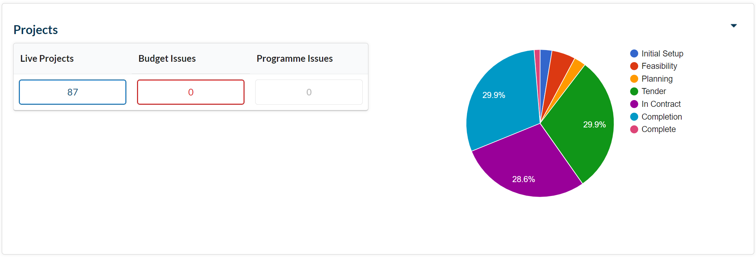

**VASCA 2021/22**

In preparation for the assignment of VASCA Funding, 129 surveys have been completed and uploaded to Statlog. A further 3 surveys are in progress. The Education Commission will begin the process of assigning Wave 1 Funding as soon as the Government announces the 2021/22 School Capital Allocations (announcement still awaited).

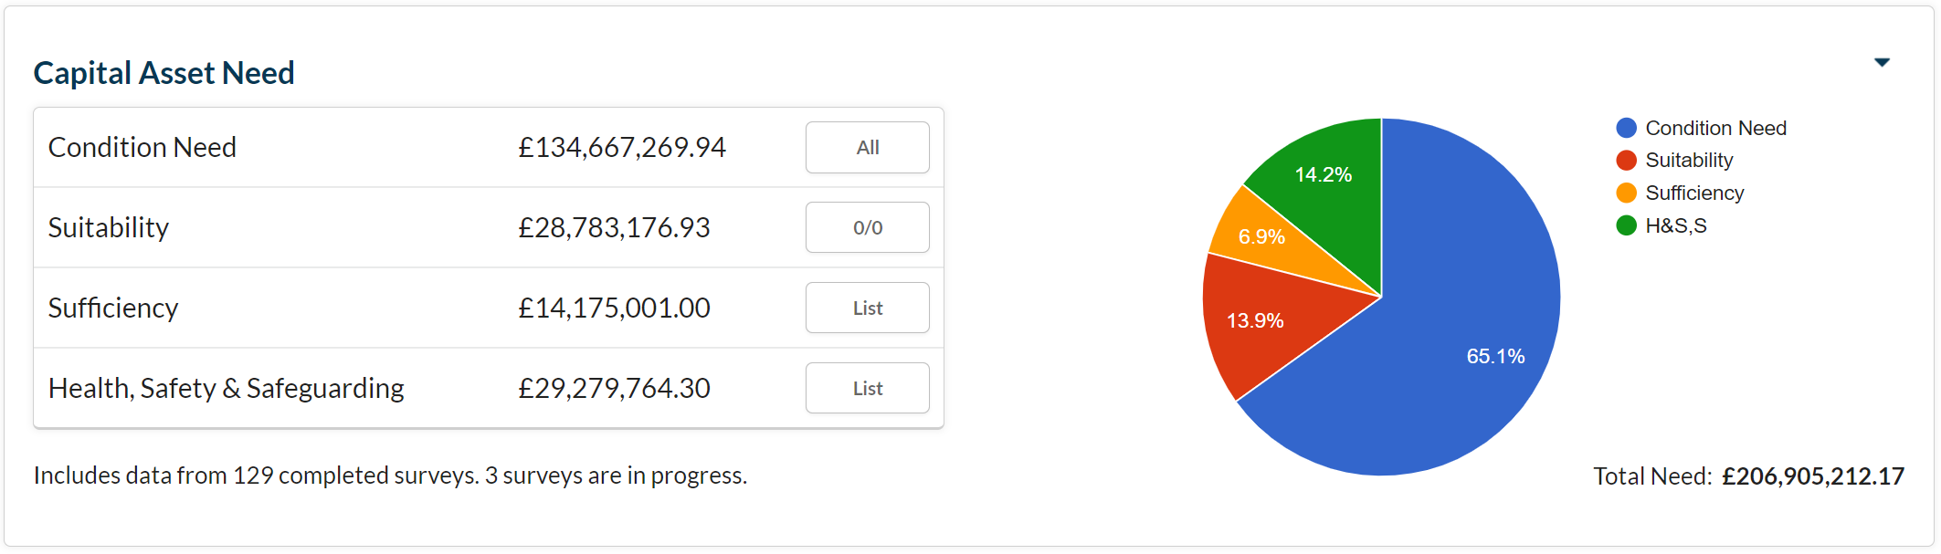

The total identified need now stands at **£206,905,212.17**

The Diocese receives a School Capital Allocation (VASCA) in the amount of circa £10M per annum. Existing survey to date (approx. 60% of all schools) suggests a programme in excess of 20 years, just to address current presenting need. Further deterioration in the condition of the school estate is anticipated in spite of the planned investment.

**Statlog**

The number of schools with Statlog Licences has remained unchanged.

However, the number of sites setup for Statutory Compliance Management continues to rise.

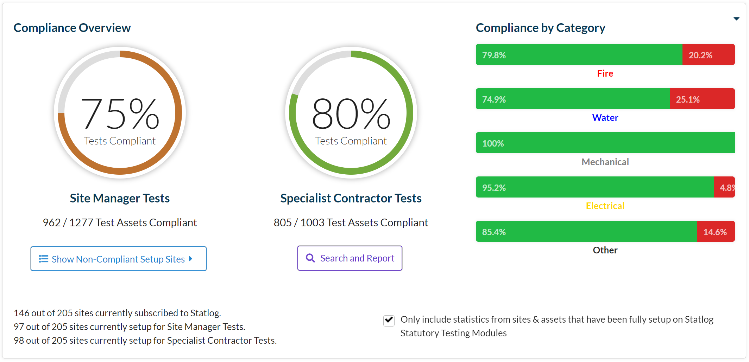

**Project Manager**

The Statlog Project Manager Tool was released on Monday 1st March. A number of schools have requested access to the module, and this has been granted. To secure approval, each school needed to demonstrate the following:

* A current Statlog Licence,
* A recent Condition Survey, uploaded to Statlog, and
* An active Statlog Statutory Compliance regime

If your school can satisfy all of the above prerequisites, please email [nigelspears@rcdow.org.uk](mailto:nigelspears@rcdow.org.uk) with your access request.

The following is an example of the steps involved in managing a project using the module:

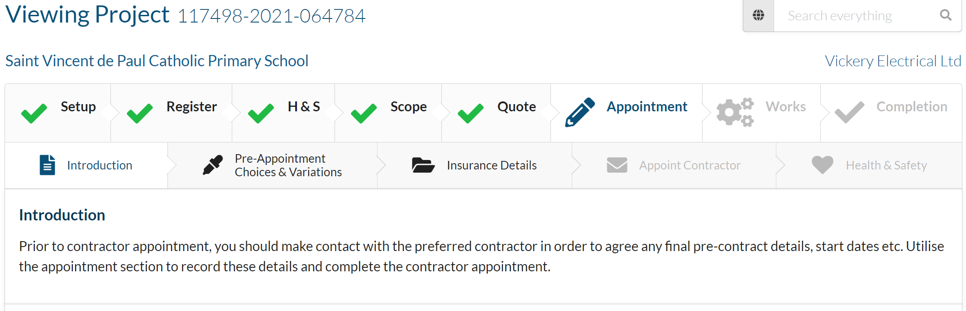

Support from Statlog and/or DOW is available for schools using this module.

**‘De minimis’ level**

There is a threshold below which any expenditure is not considered to be capital and should not be met from capital budgets. For all RCDOW Catholic Schools this is £2,000. The de minimis level also applies to the purchase of ICT equipment. This level has not changed for more then 20 years.

**Priority School Building Programme**

Project managers continue to monitor the progress of schools in this scheme.

# Pupil Placement Planning

**1st Planner Project**

The Project Team continues to focus on the three strands in this programme.

* Major Project – The model of an 8FE Secondary School has been circulated to Secondary School Head teachers for comment. In addition, 1st Planner hosted a “fly-through” presentation for interested Heads. The development of a 2FE Primary School model is approaching completion and will be circulated to Primary School Head Teachers for review.
* Minor Projects – The team is reviewing local need in preparation for detailed discussion with schools and Local Authorities. Aedificabo and 1st Planner are working with our Building Consultants to secure accurate “CAD “plans for each site.
* New Starts – The Team is continuing the process of trawling for and cleansing data that will ensure that we can present WinWin options to Schools and Local Authorities as appropriate. The need for CAD Plans is affecting this programme too.

Aedificabo will:

* Manage the programme of work (Minor Works). The company will be the de facto project manager for all projects, commissioning services from other professional teams as appropriate.
* Engage as the Registered Social Housing Provider. The application to register for this function will begin this month.

**Pupil Placement Planning**

Local Authorities throughout the Diocese are preparing for significant changes in the number of pupils seeking school places. If schools are approached directly, please contact Nigel or Peter to ensure the Diocese is in the loop.