

**Amoris Laetitia**

**Family Year**

**2021-2022**

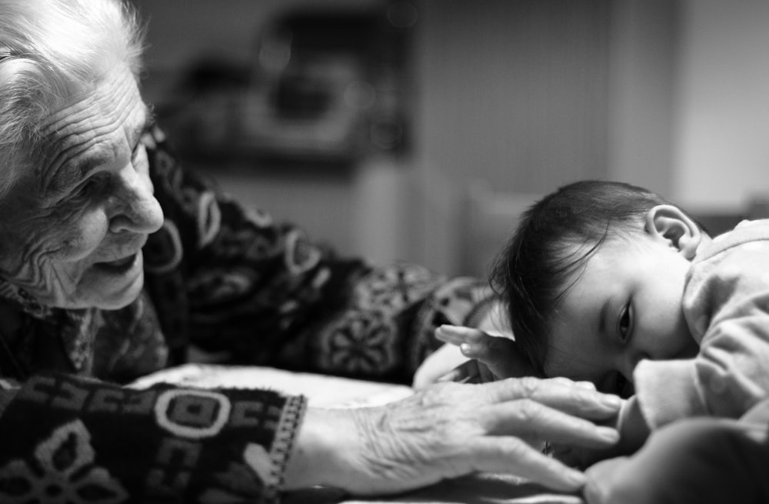

In March 2021 Pope Francis declared a year of the Family, five years after he wrote **Amoris Letitia** which is about the of beauty and joy of love in the family. As it is the feast day of Jesus’ grandparents (Anne and Joachim) in July, the Pope has announced the very first World Day of Grandparents and the Elderly to take place on 25th July 2021. The theme is   
‘I am with you always’ (Mt28:20).   
The feast can be celebrated by schools and families at a convenient time and this booklet offers some ideas on how pupils can grow in love with grandparents and the elderly at home.

**Growing in faith and love with grandparents and the elderly at home and in school**

**Playtime**

**“Recall the former days.**

**(Heb 10:32)**

**Light up**

In Amoris Letitia, Pope Francis writes: Listening to the elderly tell their stories is good for children and young people; it makes them feel connected to the living history of their families, their neighbourhoods and their country (Amoris Laetitia 193)

Spend some time playing a game, virtually or in person, with a grandparent or elderly person. Choose a game that they like to play. Perhaps they could teach you more about the game so you can learn from them.

While you play, talk to them and listen too.

**Reflect**

What can you learn from each other?

How can you show kindness to each other?

**Do not cast me off in the time of old age; forsake me not when my strength is spent. (Ps 71:9)**



The opening line of Amoris Letitia is:   
“Do not cast me off in the time of old age; forsake me not when my strength is spent”   
(Amoris Laetitia 191)

Light a candle for a grandparent or elderly person.

Think about them and their needs. Say a special prayer for them.

Let them know you are praying for them.

**Reflect:**

How might you help them to be happy and full of praise?

**Art to Heart**

**My flesh and my heart may fail,  
    but God is the strength of my heart and my portion for ever. (Ps 73:26)**



Pope Francis writes about grandparents and the elderly:

‘Their words, their affection or simply their presence help children to realise that history did not begin with them, that they are now part of an age-old pilgrimage and that they need to respect all that came before them’. (Amoris Laetitia 192)

Make a card, picture or scrapbook for a grandparent or elderly person.  Think about something that they like or that you want to talk to them about. Write a thoughtful message on it.

**Reflect:**

How can you help to make them feel strong and special?

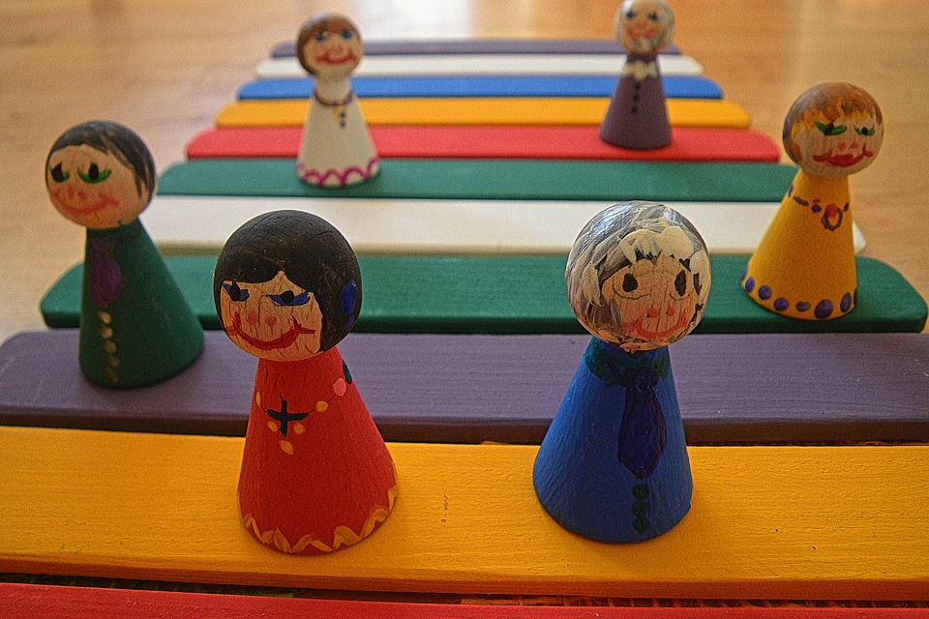**Generation Game**

**One generation shall laud your works to another,  
    and shall declare your mighty acts. (Ps 145:4)**



Pope Francis writes:

‘Many people can testify that they owe their initiation into the Christian life to their grandparents’  
(Amoris Laetitia 192)

Ask a grandparent or an elderly person about their parents and upbringing.

Find out about their culture and how they  practised their faith.

Spend time listening to them and finding out more about their experiences.

**Reflect:**

How can we pass on our faith to others?

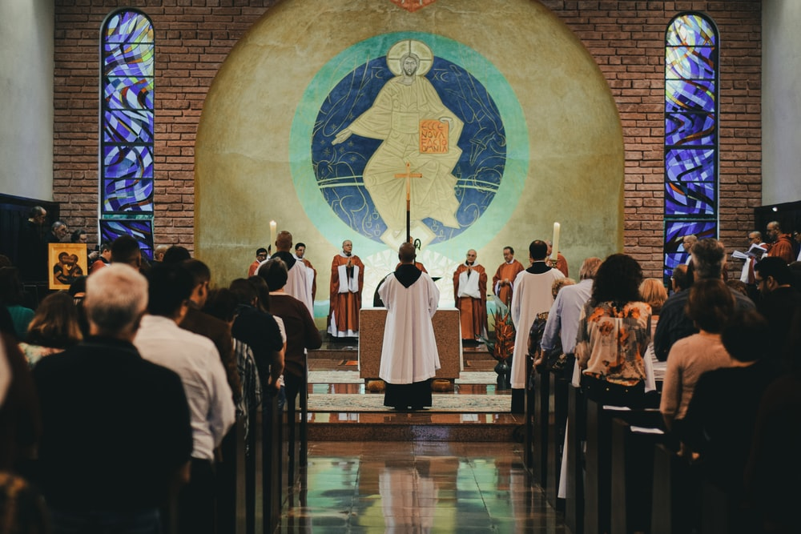 **Celebration time**

**In all this I have given you an example that by such work we must support the weak, remembering the words of the Lord Jesus, for he himself said, “It is more blessed to give than to receive”.  
Acts 20:35**

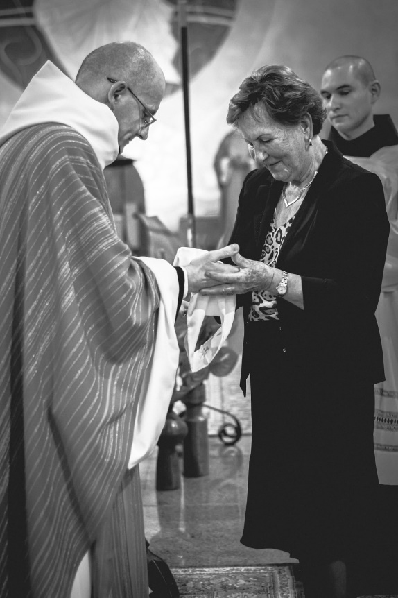

Pope Francis writes:

‘Love needs time and space; everything else is secondary’ (Amoris Letitia 224)

Go to Mass, the celebration of the Eucharist, with a grandparent or an elderly person.

Help them where you can with seating and any materials they might need.

If they cannot go, perhaps you could and pray for them during the Mass or help them to access an online Mass.

Reflect:  
In what ways can you give more than you receive?

**Running errands**

“Let each of you look not only to his own interests, but also to the interests of others”. **Phil 2:4** 



Pope Francis writes:

The Bible makes it clear that generously serving others is far more noble than loving ourselves

(Amoris Letitia 102)

Ask a grandparent or an elderly person if you can be of any practical help. Can you help shop for them or go with them to make it easier? Do they need anything collecting from the library or the post office?

**Reflect:**

How can you give your time to make things easier for others?

**Other ideas…**

**Do not cast me off in the time of old age;  
    do not forsake me when my strength is spent.**

**(Ps 71:9)**

There are lots of ways in which you can grow in love and faith with a grandparent or elderly member of the family or community. Here are some thoughts, although you may have better ideas:

- Watch a virtual tour of a museum or a show together

- Look at a photo album together. Perhaps you could start one of your own

- Research your family history online and talk about it with each other

- Share a skill together such as knitting, painting, woodwork….

- Create a party line phone chat and have fun. Be creative!

**For more ideas and information on the above see**[**Connecting-with-your-elderly-loved-ones-from-a-distance**](https://www.franciscanhealth.org/community/blog/connecting-with-your-elderly-loved-ones-from-a-distance)

**For more about this special feast see**[**Popes-theme-for-the-first-world-day-for-grandparents-and-the-elderly-announced**](http://www.catholicgrandparentsassociation.org/popes-theme-for-the-first-world-day-for-grandparents-and-the-elderly-announced/)

**For more about Amoris Laetitia for families see**[**Amoris-laetitia-family-a-special-year-to-bear-witness-to-family-love**](http://www.catholicgrandparentsassociation.org/amoris-laetitia-family-a-special-year-to-bear-witness-to-family-love/)