Mental Health and Well-being – Resources to support returning to school

Well-being Resources for teachers
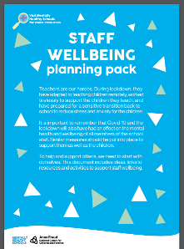 | Mentally Healthy Schools – Staff Wellbeing Planning Pack - Click Here
 | Mentally Healthy Schools – Reframing Thoughts for staff - Click Here
 | Mentally Healthy Schools – Reducing Separation Anxiety Teacher Resource - Click Here
 | Mentally Healthy Schools – Well-being INSET Day Toolkit - Click Here
Mental Health and Well-being – Resources to support returning to school
Well-being Resources for pupils
Mentally Healthy Schools – Reflecting on Lockdown Activity - Click Here

Mentally Healthy Schools – Brain Breaks helping children settle back into the classroom - Click Here

Mentally Healthy Schools – Piece of the Puzzle Assembly - Click Here

Mentally Healthy Schools – Piece of the Puzzle Activity Pack - Click Here

Mentally Healthy Schools – Reframing Thoughts Activity - Click Here

