Care of Creation

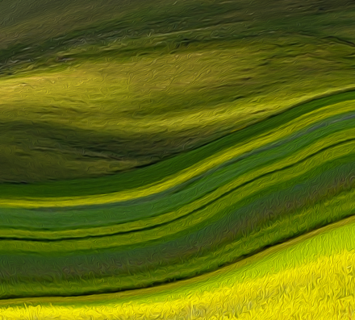

Saints of the Environment

Saint Francis of Assisi (1181-1226)

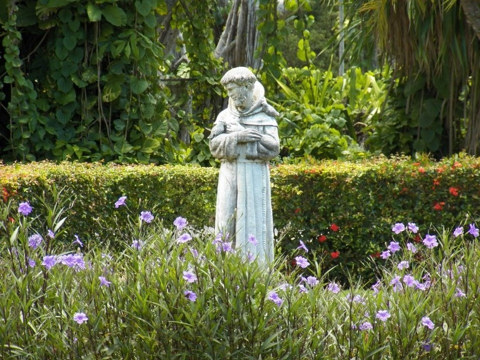

St. Francis famously loved animals, even to the extent of preaching to them, but his love extends well beyond being a dog-lover and embraces all of creation. He saw a strong bond between himself and the environment, inviting all of nature to give glory to God. In his Canticle of the Sun, Francis refers to “Brother Sun,” “Sister Moon,” and “Mother Earth.” About the sun, he writes: “Be praised, my Lord, through all your creatures, especially through my lord Brother Sun, who brings the day; and you give light through him. And he is beautiful and radiant in all his splendour!”
His follower St. Bonaventure says that Francis extended brotherhood to even the smallest of creatures. In each, he sees a reflection of God, meaning that the more we find fraternity with the environment, the more we are connected with the Creator.
St Francis is the patron saint of animals and the environment.
From https://aleteia.org/2017/06/18/5-saints-to-inspire-us-to-take-care-of-our-planet/

For more information and fun facts about St Francis as well as videos of saints see: https://www.catholic.org/saints/saint.php?saint_id=50

For St Francis’ Canticle of the Sun see: https://en.wikipedia.org/wiki/Canticle_of_the_Sun

Saint Francis of Assisi: Prayer
You are holy, Lord, the only God,
and Your deeds are wonderful.
You are strong.
You are great.
You are the Most High.
You are Almighty.
You, Holy Father are King of heaven and earth.
You are Three and One, Lord God, all Good.
You are Good, all Good, supreme Good,
Lord God, living and true.
You are love. You are wisdom.
You are humility. You are endurance.
You are rest. You are peace.
You are joy and gladness.
You are justice and moderation.
You are all our riches, and You suffice for us.
You are beauty.
You are gentleness.
You are our protector.
You are our guardian and defender.
You are our courage. You are our haven and our hope.
You are our faith, our great consolation.
You are our eternal life, Great and Wonderful Lord,
God Almighty, Merciful Saviour.

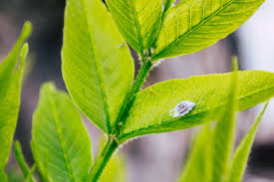

For more see: https://www.faithandworship.com/prayers_ St_Francis.htm

St. Kateri Tekakwitha (1656-1680)

Kateri was raised in the Iroquois nation, who environmental scientist Bill Jacobs says, “carefully managed the fields, forests, and wildlife of their homeland. They understood the rhythms of nature…Kateri herself would have intimately known the plants and animals around her, in a way that any botanist or biologist today would envy.” For this reason, she is referred to as a, “child of nature,” who often went into the woods to make crosses out of sticks and to talk to God.
It was in the silence of creation, far from the noise of the village, that she was able to commune with her Creator. Her experience is probably familiar to a lot of us and goes to show how precious the environment around us is and how important it is to protect it. If we lose these quiet places where we can get lost in nature, we will lose a vital avenue of spirituality.
St. Kateri is the patron saint of ecology.
From https://aleteia.org/2017/06/18/5-saints-to-inspire-us-to-take-care-of-our-planet/
For more information and fun facts about St Kateri as well as videos of saints see: https://www.catholic.org/saints/saint.php?saint_id=154

St. Kateri Tekakwitha: Prayer

God, thank you for the beauty of creation!
St. Kateri, you are the patron saint of ecology and the environment.
You must have especially found God’s presence among His creation.
You even found a spot in the woods where you would go to pray.
In today’s hectic world, I sometimes lose sight of the marvel of the earth.
Everything in it was put here for a purpose.
That purpose is to provide us protection, health, and beauty.
God is a master builder!
It is our responsibility to take care of God’s creation.
St. Kateri, please help me to see God in nature.
Inspire me to do all I can to help protect and care for the earth.
Pray for me to remove distractions in my life
that keep me from appreciating the world!
Please also bring my intentions before God:
(State your intentions here)
St. Kateri, pray for us!
Amen.

Read more at: https://www.praymorenovenas.com/st-kateri-tekakwitha-novena

St. Benedict of Nursia (480-543)

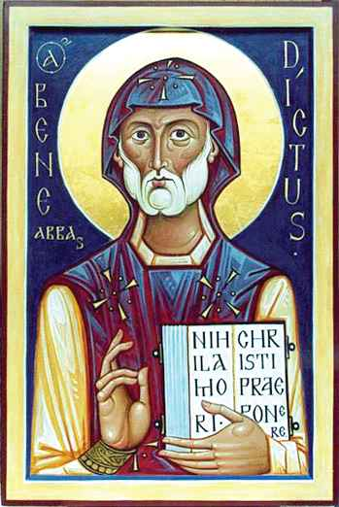

Benedict wasn’t an environmentalist in the modern sense, mostly because our damaged relationship with the earth is a modern problem, but his outlook on life reflects a concern with ecology. Benedict believed that a spiritual person will, along with prayer, work to make the world a better, more harmonious place. This is why most of his followers commit to staying on one piece of land for long periods of time and improving it. It’s also why many are involved with brewing beer, raising bees, or some form of organic farming or handcraft.
The principles by which he lived his life are summarized in a book called the Rule of St Benedict, and in it he recommends humility, commitment to improving your local neighbourhood, and frugality. “Frugality should be the rule on all occasions,” he writes, because taking more than your fair share and then wasting it throws off the ecological balance of both the soul and the environment. Benedict appreciated the beauty of the earth and its ability to reflect the beauty of heaven and he took every care to preserve and improve it.
From https://aleteia.org/2017/06/18/5-saints-to-inspire-us-to-take-care-of-our-planet/
For more information and fun facts about St Benedict as well as videos of saints see: https://www.catholic.org/saints/saint.php?saint_id=26
For details about Benedictine life and sustainable stewardship see: https://christdesert.org/about/sustainable-stewardship/

St. Benedict of Nursia: Prayer
Blest are You, God of the Universe,
You designed all created things to work
in harmony.
Send your Holy Spirit to inspire us with
a sense of right living.
We know how we appreciate being
treated fairly.
Give us the insight to recognize the
truth of justice in our relationships.
May our actions reflect care and
concern for all.
We ask this through Christ our Lord.
AMEN

Read more at: http://saintbenedictprotection.com/saint-benedict-prayers/

Blessed Paul VI (1897-1978)

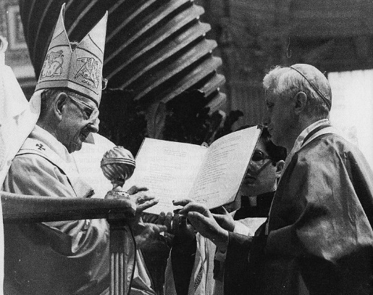

In 1971, Pope Paul VI labelled environmental degradation to be one of the most pressing problems facing humanity, at least partly linking our care for the environment to our own spiritual health. His words are a clear warning that are, unfortunately, proving to be prophetic: “Man is suddenly becoming aware that by an ill-considered exploitation of nature he risks destroying it and becoming in his turn the victim of this degradation.”
Not only do we eventually become the victims of a destroyed earth that can no longer sustain us, but there is also an effect on the human soul in the sense that an environment that no longer tolerates our presence creates a spiritual difficulty – we are no longer in harmony with the earth, and the way we treat our environment is a reflection on how we treat other people.
This is why Paul VI identifies damage to the environment as a major human crisis that affects all of us. The solution? The courage to make a radical change.
From https://aleteia.org/2017/06/18/5-saints-to-inspire-us-to-take-care-of-our-planet/

For more information about Blessed Paul VI see:
https://www.britannica.com/biography/Blessed-Paul-VI

Blessed Paul VI: Prayer
Gentle mother, Mary,
Implore for the world
the grace to esteem everything as the gift of God
and hence the virtue to work with generosity
and to make use of such gifts wisely and providently.
Implore peace for the world.
Fashion brothers and sisters
out of persons who are so divided.
Guide us to a more ordered and peaceful society.
For those who are suffering,
today there are so many and ever new ones,
afflicted by current misfortunes,
obtain solace;
and for the dead, obtain eternal rest.
Show yourself a mother to us;
this is our prayer,
O clement, O loving,
O sweet Virgin Mary!
Amen.

Read more at: https://www.catholic.org/prayers/prayer.php?p=1170

Dorothy Day (Servant of God) (1897-1980)

Dorothy Day is remembered for living in solidarity with the urban poor, but her Catholic Worker movement was also interested in rural farming. At first, her focus was only on the urban poor and she didn’t quite see the point of ecology or how nature was her particular concern, but her friend Peter Maurin eventually convinced her that it was important. Although she started out skeptical, she agreed to attend a women’s retreat on a working farm and excitedly reported, “We have learned to meditate and bake bread, pray and extract honey, sing and make butter, cheese, cider, wine, and sauerkraut.”
After that, she came to see that environmental stewardship was intimately connected with her mission to help the poor, at least in part because, “it would be wonderful to live entirely off the land and not depend on wages for a livelihood.” The Catholic Workers founded a farm called Maryfarm, which she described as “the heart of the work.”
What Dorothy Day came to appreciate about close contact with nature is the way it reconnects us to our roots and helps develop a profound gratitude for the sustenance we receive from the earth. This, in turn, provides a healthy basis to find dignity in the human beings we encounter in the course of our lives. A love for the environment can support love for our fellow man.
From https://aleteia.org/2017/06/18/5-saints-to-inspire-us-to-take-care-of-our-planet/

For more information about Dorothy Day see:
https://www.biography.com/writer/dorothy-day
Dorothy Day (Servant of God): Prayer
God our Creator,
Your servant Dorothy Day exemplified the
Catholic faith by her conversion,
life of prayer and voluntary poverty,
works of mercy, and
witness to the justice and peace
of the Gospel.
May her life
inspire people
to turn to Christ as their saviour and guide,
to see his face in the world’s poor and
to raise their voices for the justice
of God’s kingdom.
We pray that you grant the favours we ask
through her intercession so that her goodness
and holiness may be more widely recognized
and one day the Church may
proclaim her Saint.
We ask this through Christ our Lord.
Amen.
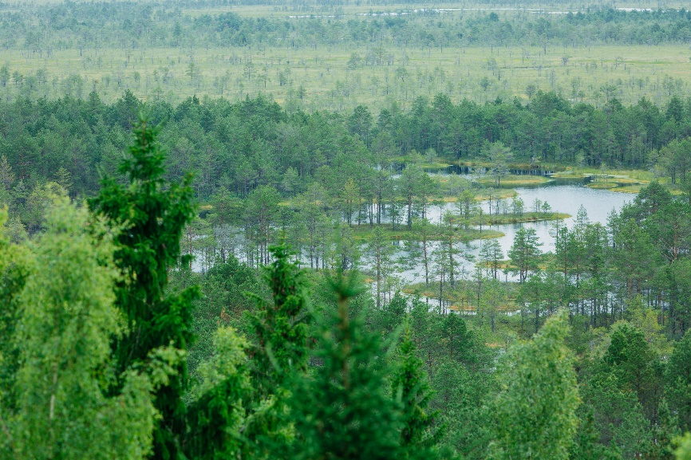

Read more at: http://dorothydayguild.org/support/petition-in-prayer/

