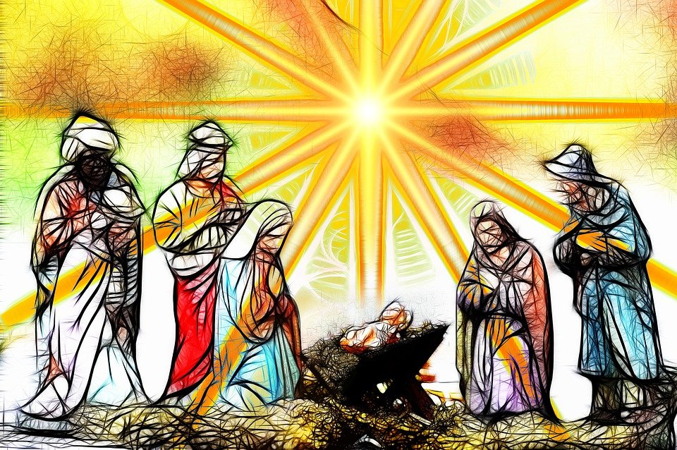
Advent and Christmas 2021
Diocese of Westminster Education Service
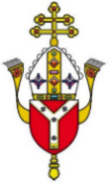
Support Materials for Advent and Christmas
December 2021

Saint Mother Teresa’s Advent Challenge

Are we ready to receive him? Before the birth of Jesus, his parents asked for a simple dwelling place, but there was none. If Mary and Joseph were looking for a home for Jesus, would they choose … your heart, and all it holds?
Let us pray that we shall be able to welcome Jesus at Christmas not in the cold manger of a selfish heart, but in a heart full of love, compassion, joy and peace, a heart warm with love for one another.
About this Resource

Aims
The main purpose of this resource is to help you as teachers and leaders to appreciate more fully the Advent season and save you time and energy so that you, in turn, can develop the theology, religious literacy and spirituality of pupils as well as their understanding of Catholic Social Teaching.

Structure
There are four main sections in the document, although they may overlap:
- Developing one’s own theology and religious literacy
- Becoming more confident with sharing the Advent tradition through prayer and scripture with the school community
- Enhancing home-school and blended learning in a creative and meaningful way for pupils
- Deepening pupils’ understanding of the common good and strengthening the links with the domestic, local and universal Church

How to use this resource
Each section includes information and interactive resources with each hyperlink being unique – everything blue and underlined is a link to either a video, an article, a reflection or information to help you to appreciate more fully the joys and depth of this wonderful season. We hope that there will be something valuable here for teachers of all faiths, backgrounds and experiences and we wish you a very peaceful and healthy Advent.

Advent – Theology and Religious Literacy

Advent Q&A
What is the definition of Advent?
Advent is the period leading up to Christmas. It starts on the Sunday nearest to 30 November and ends on Christmas Eve. The word 'advent' comes from the Latin word ‘adventus’ meaning 'coming' which is a translation of the Greek word ‘parousia’. It is a time of waiting and preparation rather than a joyful celebration like Christmas.

What is Advent?
Advent is a season of the liturgical year observed in many Christian churches. It reminds Christians of the sacred meaning of Christmas. Despite the secular preparations taking place, eg buying presents and going to parties, Advent reminds Christians to remember and prepare for the birth of Jesus. One important aspect of Advent in the Catholic Church, especially before 16 December, is to prepare for the Second Coming of Christ in judgement at the end of time.

What does the Catholic Church teach about Advent?
‘When the Church celebrates the liturgy of Advent each year, she makes present the ancient expectancy of the Messiah, for by sharing in the long preparation for the Saviour's first coming, the faithful renew their ardent desire for his second coming. By celebrating the precursor's birth and martyrdom, the Church unites herself to his desire: "He must increase, but I must decrease."’(CCC 524)
In other words, the faithful are encouraged to reflect back and celebrate the anniversary of the Lord’s first coming into the world. We ponder at the great mystery of the Incarnation when Our Lord, taking on our humanity, entered our time and space to free us from sin. We also recall in the Creed that our Lord will ‘come again to judge the living and the dead’ and that we must be ready to meet him.

How does Advent link to the Old Testament?
The Church is in a similar situation to Israel at the end of the Old Testament: in exile, waiting and hoping in prayerful expectation for the coming of the Messiah. Israel looked back to God’s past gracious actions on their behalf in leading them out of Egypt in the Exodus, and on this basis, they called for God once again to act for them. Before Jesus came, Israel was under Roman rule and suffering persecution. They were waiting for a saviour, the ‘promised one’ (foretold to them in the ancient Scriptures) to deliver them from their suffering. They expected a mighty warrior; instead Jesus came as a humble baby, a servant king.

In the same way as the Israelites looked back on God’s kind actions, the Church, during Advent, looks back upon Christ’s coming in celebration while at the same time looking forward in eager anticipation to the coming of Christ’s kingdom when he returns for his people at the end of time. In this light, the Advent hymn “O Come, O Come, Emmanuel” perfectly represents the church’s cry during the Advent season.

What is the origin of the Advent season?
The celebration of Advent has evolved in the spiritual life of the Church. Although it is difficult to determine the exact date of origin, it is believed that it started around the 5th century when it was seen as similar to Lent in terms of prayer and fasting and has evolved since then. In 1963, the Second Vatican Council introduced minor changes to Advent, emphasizing it as a season of promise of Christ’s return:
“We Christians are called to safeguard and spread the joy of waiting,” Pope Francis said on Saturday in an address at the Vatican. “We await God who loves us infinitely and at the same time we are awaited by Him. In this way, life becomes a great betrothal.”
How do Christians observe Advent?
There are various ways Christians can prepare for Christ’s coming during Advent which include: attending church services, carol services and Nativity plays, completing an Advent calendar and lighting an Advent wreath, praying (eg through a daily devotional), erecting a Christmas tree, hanging greens, putting up a Jesse tree, lighting a Christingle, giving gifts and cards, sharing with the needy, and attending family/social gatherings. Catholics around the world have different traditions for Advent, some of which are similar similar and some which are quite unique!

It is not only Catholics who observe Advent, but Christians in general, although it is observed in different ways. Some people fast during Advent to help them to concentrate on Jesus’ coming. In many Orthodox and Eastern Catholic Churches, Advent lasts for 40 days and starts on November 15th and is also called the Nativity Fast. Orthodox Christians often don’t eat meat and dairy during Advent, and depending on the day, also olive oil, wine and fish.

What is the liturgical colour during Advent and why?
The liturgical colour for this season is purple/violet which is the colour of preparation and humility. For this reason, the priests’ vestments are purple as are three of the Advent candles. On the third Sunday of Advent, known as Gaudete (joy) Sunday, the priests wear pink/rose instead and this matches the third Advent candle. The Catholic Church has some more official teaching about liturgies, decoration and music during Advent. Click here to find out more.

How long does the Advent season last?
Advent begins on the Sunday that falls on or closest to the 30th November and lasts until the Christmas Vigil which takes place on the evening of Christmas Eve. Advent calendars help children to count down the days to Christmas, although many modern calendars indicate that Advent begins on 1st December, which is not accurate. Wreaths also help to mark off the weeks. The four coloured candles represent the four Sundays in Advent whilst the white Candle represents Christmas day.

What are the main points I need to teach my children?
Each programme or resource used in the primary school will do things differently in terms of teaching Advent. According to the RECD, EYFS pupils should be able to hear the Christmas story and that Mary is the mother of God. This will then develop in KS1 so that pupils should be aware of the main events, characters and places in the Nativity, as well as the key figures in the history of the People of God (such as John the Baptist and Elizabeth), knowing the role of Mary and her ‘yes’ to God’s word. They should be able to experience the ways the Church celebrates major seasons during the Liturgical Year (ie Advent) and be familiar with the signs and symbols. Pupils should be familiar with passages which express joy and trust in God’s love and be able to talk about the love shown to them and how they can show love to others.

In KS2 pupils should progress to know about God’s call to his people in the Old Testament and be familiar with Gospel accounts of the Nativity. They should know about the life of the Church in other parts of the world, and the signs and symbols used in prayer and liturgy during Advent. Pupils should be aware of the joy and challenges of giving and receiving and know how the ways of love for neighbour can be shown at home, church, locally and globally.

As pupils develop further, they will learn about the concept of the Messiah in the Old and New Testament and the role of the prophets. They should develop in their understanding of the Church’s faith that Jesus is the Son of God and his mission as revealed in the New Testament with particular reference to his priestly, prophetic and kingly roles. Pupils will grow in their understanding of the Church’s vocation to have special care for the poor and oppressed and Jesus’ response to issues of justice and relationship. With regards prayer and liturgy, pupils will be familiar with the rich variety of forms of worship in the Church and the developments of the celebration of liturgy. Ultimately, pupils will be able to understand Catholic Social Teaching and apply this to their lives.

Further research and information
For more materials on the traditions and preparations for Advent as well as resources see the CARFLEO website here
For Q and A about Christmas created by the Stations of the Cross Catholic Radio Network see here
For more information about Advent and Christmas from RE:quest, enter a key word in the search box here
I wonder… what questions might you have about Advent or Christmas? What big questions might your pupils have?

Perhaps… you could collate the questions and research the answers. Perhaps pupils could bring Advent to their home in some way?

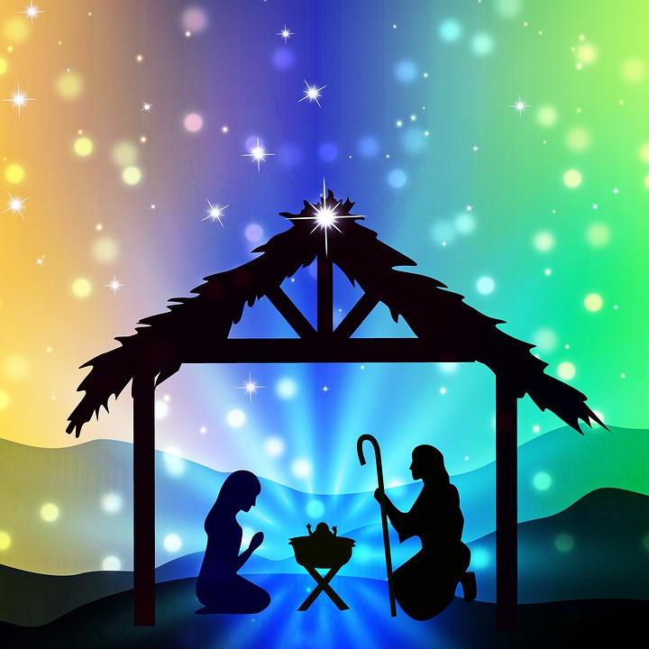
An A-Z of Advent

Advent
The first season of the Liturgical Year, leading up to Christmas and including the four preceding Sundays. The Church runs on a three-year cycle: Year A (Matthew), Year B (Mark) and Year C (Luke), with passages from John’s Gospel used throughout the year.
Advent Wreath
The Advent wreath is a Christian tradition that symbolises the passage of the four weeks of Advent in the liturgical calendar of the Western church. Each week is represented by a candle: three purple and one pink. Many Advent wreaths include a fifth, white candle, representing Christ, which is lit during the Christmas Eve vigil.
Annunciation
The Annunciation refers to the visit of the angel Gabriel to the Blessed Virgin Mary to inform her that she was to be the Mother of the Saviour. (Luke 1:26–38) After giving her consent to God’s word, Mary became the Mother of Jesus by the power of the Holy Spirit. The feast of the Annunciation is celebrated on 25 March, nine months before Christmas day.
Angels
The accounts of Jesus’ birth in the Gospels includes a number of references to angels, heavenly beings sent by God to deliver the news of Jesus’ conception and birth. The meaning of the word angel in Greek is ‘messenger’. Angels were created by God (Psalm 148:5) and they are spirits sent to serve believers (Hebrews 1:14).
Antiphons
In traditional Western Christian liturgy, an antiphon is a short sentence sung or recited before or after a psalm or canticle. The O Antiphons refer to the seven antiphons that are recited (or chanted) preceding the Magnificat during Vespers of the Liturgy of the Hours. They cover the special period of Advent preparation known as the Octave before Christmas, Dec. 17-23, with Dec. 24 being Christmas Eve and Vespers for that evening being for the Christmas Vigil.
Bethlehem
Bethlehem in the Holy Land is the site of the Church of the Nativity. It contains a cave which is now one of Christianity’s holiest shrines, because this is traditionally the place where Mary gave birth to Jesus in a stable. Mary and Joseph had to travel roughly 80 miles to Bethlehem to sign the register at the time of Jesus’ birth. From there, the family had to flee into Egypt to escape the tyranny of Herod. Only when it was safe could they return to Nazareth.
Candlemas
This is a Christian festival held on 2 February to commemorate the purification of the Virgin Mary (after childbirth, according to Jewish law) and the presentation of Christ in the Temple. Candles are traditionally blessed at this festival. It signifies the end of the 40 days of Christmas and is the day on which some Christians take down their crib, although the Christmas season ends on the feast of the Baptism of Jesus (the first Sunday after the Epiphany).
Census
The census that was ordered by Caesar Augustus was the first of its kind. It was carried out because the Roman government wanted to make sure that everyone in the Empire was paying their taxes correctly. This meant that families had to register in their historical tribal town rather than where they lived.
Christmas Day
Christmas is the Feast of the Nativity, an annual festival commemorating the birth of Jesus Christ, observed on December 25 as a religious and cultural celebration among billions of people around the world. It is one of the most important Christian festivals as it celebrates the Incarnation – God made man through Jesus Christ. There is a Vigil Mass on Christmas Eve. On Christmas Day there are 3 separate Masses that are held by the Catholic Church:
1. The Midnight Mass – sometimes called THE ANGELS’ MASS
2. The Dawn Mass – likewise, THE SHEPHERD’S MASS
3. The Christmas Day Mass – THE KINGS’ MASS. All Masses have their own different readings.
Christmas Season
The beginning of the Christmas season begins at the Vigil Mass on Christmas Eve and lasts until the Feast of the Baptism of the Lord (usually the second Sunday of January). The liturgical colour of this season is white or gold.
David
David was an ancestor of Jesus which is why Mary and Joseph had to go to Bethlehem for the census (Joseph belonged to the ‘House of David’). When he was young, David was a shepherd boy who defeated the giant, Goliath. He was a fighter and a musician and many of the psalms are attributed to him. David became a great king and a central character in Judaism, Christianity and Islam. St Matthew begins his Gospel by calling Jesus the son of David, indicating his royal origin, and also son of Abraham, indicating that he was an Israelite; both are phrases, in which ‘son’ means ‘descendant’, calling to mind the promises God made to David and to Abraham.
Emmanuel
The word ‘Emmanuel’ comes from the Greek rendering of two Hebrew words, ‘immanu’ = ‘with us,’ and 'el’ = ‘God’ (thus in English it is found as either ‘Emmanuel’ or ‘Immanuel’). The word is found three times in the Bible: Isaiah 7:14, 8:8, and Matthew 1:23. It is found only once in the New Testament, toward the end of the birth narrative of Jesus in the Gospel of Matthew where he says that the birth of Jesus by the Virgin Mary is to fulfil what the Lord had spoken by the prophet: 'Behold, the virgin shall conceive and bear a son, and they shall call his name Immanuel' (1:22-23). Thus, Matthew tells his readers that Jesus' birth fulfils the prophecy of Isaiah and goes on to explain what the word ‘Emmanuel’ means - ‘God with us’.
Frankincense
The gift of frankincense is said to have been an acknowledgement of Jesus' priesthood and divinity. Frankincense was used in the Temple routines, burned ceremonially by the priests. The other gifts Jesus was given by the magi were: gold (a precious metal signifying that he was a king above all kings) and myrrh (a sweet-smelling anointment used for embalmment signifying his humanity and death). These gifts were precious in both meaning and value.
Gaudete
The third Sunday of Advent is Gaudete (meaning ‘rejoice’) Sunday and is meant to remind us of the joy that the world experienced at the birth of Jesus, as well as the joy that the faithful have reached the midpoint of Advent. Gaudete Sunday is when the pink candle of the Advent wreath is lit. It is a counterpart to Laetare Sunday in Lent, and provides a similar break about midway through a season which is otherwise of a penitential character, and signifies the nearness of the Lord's coming.
Gloria (in Excelsis Deo)
Gloria in Excelsis Deo means ‘Glory to God in the highest’ and was sung by the angels to the shepherds on the hills on the night that Jesus was born. They also proclaimed ‘And on earth peace to people of good will’ (Lk 2:4) This song is known as the Greater Doxology and the Angelic Hymn/the Hymn of the Angels. During Advent, the Gloria is omitted as its return at Christmas gives the Gloria a new freshness appropriate to celebrating the Holy Birth.
Herod
Israel at the time of Jesus was under Roman rule. By the time of Jesus' birth, the Romans had established in Israel a system of government consisting of Roman overseers and local leaders who held and exercised power in the name of Rome. By the time of the birth of Jesus, the family of Herod the Great had grown to prominence and the Romans made Herod king over Israel. Herod the Great is the king the magi visited on the way to Bethlehem and he is responsible for the massacre of all male infants below the age of two (as he was jealous that a ‘new king’ had been born). This is the reason that the Holy Family had to escape into Egypt after Jesus’ birth.
Immaculate Conception
The Immaculate Conception is a dogma (teaching) of the Catholic Church which states that the Virgin Mary was free of original sin from the moment of her conception. When Mary appeared to St Bernadette, she said ‘I am the Immaculate Conception’. The feast is celebrated on 8th December and should not be confused with the Virgin Birth, which is Christ’s birth on Christmas day
Incarnation
By the word ‘Incarnation’ we mean that God the Son took to himself a human nature for the sake of our salvation. The word ‘Incarnation’ expresses the fact that Jesus Christ is not merely a man, a perfect man or even a saint, but God himself in human flesh to save us and bring us back to God.
Jesse tree
The Jesse Tree is named from Isaiah 11: ‘A shoot shall come out of the stock of Jesse and a branch shall grow out of his roots.’ Jesse was the father of King David, an ancestor of Jesus. He is often looked at as the first person in the genealogy of Jesus. The Jesse tree tells of the ancestry of Jesus through symbols and relates to Scripture in salvation history.
Jesus
Christians believe that Jesus is the only Son of God who was conceived by the power of the Holy Spirit and became incarnate through Mary. He is the second person of the Trinity and his nature is both truly human and divine. His coming was foretold in the Old Testament and he fulfilled the Scriptures and the law. He is the Christ, the Messiah, the Chosen One, the Saviour. He is God-with-us. Jesus came to save all mankind from sin and he accomplished this through his death and resurrection.
Joseph
Joseph was a descendant of David, husband of Mary and the foster father of Jesus. We know about St Joseph from what it tells us in the gospels of Matthew and Luke, mainly that he was a carpenter as well as the provider and protector of Mary and Jesus. At the time of the Annunciation, Mary was betrothed to Joseph . When he discovered that Mary was pregnant but that the baby was not his, the Angel of the Lord appeared to him in a dream, so he chose to trust in God.
King
We hear from Matthew’s Gospel about the three kings or wise men (magi) who visited Jesus. They brought gold to signify that he was a king – he is the supreme king, King of Kings and Prince of Peace. Another title given to Jesus is Christ the King and this solemnity is celebrated on the Sunday before Advent- It has an eschatological dimension pointing to the end of time when the kingdom of Jesus will be established in all its fullness to the ends of the earth. It leads into Advent, when the Church anticipates Christ’s second coming.
Luke
Luke is writing to Greek Christians who were non-Jews. His purpose is to show how God is inviting non-Jews, as well as Jews, into the Church. Many of the events and stories in Luke’s Gospel, feature non-Jews ie Gentiles and how Jesus interacted with them. His opening chapters include: the announcement and birth of John the Baptist, Annunciation, Visitation, Magnificat, Benedictus, the birth of Jesus, the visit of the shepherds and the Presentation. Luke depicts Jesus in his short-lived ministry as deeply compassionate — caring for the poor, the oppressed, and the marginalized of that culture, such as Samaritans, Gentiles, lepers and others. Women play a more prominent role in this gospel.
Magi
The Magi (the kings or wise men) from the East visited Jesus and brought him gifts and the account of this can be found in Matthew 2:1-12. They brought gifts of gold, frankincense and myrrh and are traditionally known as Balthasar, Caspar and Melchior. The Church celebrates the visit of the Magi on 6th January (or the nearest Sunday) and this feast is called the Epiphany which means manifestation or ‘showing’. This is because Jesus was made manifest to those outside the Jewish world signifying that Jesus came for the salvation of all mankind. The feast of the Epiphany
marks the end of the 12 days of Christmas.
Mary
Mary is the mother of Jesus and our mother too. Her faith-filled yes is an example for all of us, she is a perfect disciple; her response to the angel Gabriel was ‘I am the Lord’s faithful servant. Let it be it done unto me according to thy word’ (Lk 1:38). She is known as the Immaculate Heart, Mother of the Church, Mediatrix (intercessor) and Theotokos (Mother of God) and has many other titles also. Marian prayers include: Hail Mary, Hail Holy Queen, Memorare and Regina Caeli. The Rosary is a Catholic devotion based on the events of Jesus’ life, beginning with the Annunciation.
Matthew
The Gospel of Matthew differs from the other gospels due to its heavily Jewish perspective. He quotes the Old Testament (such as the prophecies of Jesus’ birth) far more than any of the other gospel writers. The Gospel of Matthew is concerned with the position of the early Christian church within Israel, and in its relationship to Judaism. Matthew’s account fully and systematically explains much of this, from Jesus’s genealogy and the circumstances of his birth to his teaching, healing, and other miracles.
Messiah
The term Messiah is Hebrew and means 'anointed one'. This is a title given to the person believed to be the Saviour, who has been chosen to bring salvation to humankind. The term 'anointed one' is used in both Christianity and Judaism. Christians believe that the Messiah was sent by God to save humanity.
Nativity
A Christmas nativity is probably one of the most recognizable symbols of the Christmas season. The word nativity is taken from the Latin ‘nativus’, which means ‘arisen by birth’. Nativities are art, models, carvings, or live demonstrations depicting the night of Jesus' birth. These scenes generally contain the same elements: the Christ-child in a manger; his mother, Mary; his earthly guardian, Joseph; shepherds; angels; various barn animals; and sometimes the Magi. St Francis of Assisi created the very first nativity scene in 1223 in an effort to promote the true meaning of Christmas and worship of Jesus Christ.
Old Testament
The first part of the Bible is called the Old Testament and is considered to be the story of the People of God. It begins with God’s creation of the universe and humanity. The Old Testament was written before the incarnation of Jesus. It begins with five books known as the Books of God’s Law - the rules on how to live a good religious life that God sent to the Jewish people via Moses. In Judaism, these five books form the holy scriptures known as the Torah. As a whole, the Old Testament describes the history, beliefs and culture of the Jewish people before Christianity. It foretells the coming of the Messiah, the Saviour: Jesus who is born at Christmas. While there were many writers of the Old Testament, God is considered to be its author. The writers were inspired by the Holy Spirit and God’s words still speak to us today.
Preparation
Advent is a time of preparation. There are many ways that we can prepare for Christmas when we remember Jesus’ birth. This season is also about preparing our hearts and getting our lives in order so that we will be ready to meet Jesus face to face.
Quirinius
The Gospel of Luke chapter 2 correlates the date of the nativity of Jesus to the census of Quirinius: In those days a decree went out from Emperor Augustus that all the world should be registered. This was the first registration and was taken while Quirinius was governor of Syria.
Redemption
Redemption is at the heart of the Christmas story: Jesus, the Son of God, has been born into the world so that he can save sinners. He is the Redeemer, the Saviour. Because of this, Advent is a season of great hope and Christmas a time of great joy and peace.
Saviour
The name Jesus is derived from the same as Joshua and means ‘God saves’. Jesus Christ is our Saviour because he gives us the perfect revelation of God’s love for us. He does this through his life of teaching, and in his death on the cross which cancels out human sins. On the night of his birth, the angels told the shepherds the good news: ‘Today in the city of David a Saviour has been born to you. He is Christ the Lord!’ (Lk 2:11)
Twelve days of Christmas
The celebration of the twelve days of Christmas (12 being a significant number) begins at the Christmas vigil Mass and ends on the Epiphany of Our Lord. The carol is a famous one which was written when Catholics could not practise their faith, although less famous are the hidden religious meanings behind each item. The ‘True Love’ one hears in the song is not a smitten boy or girlfriend but Jesus Christ, because true love was born on Christmas Day. The partridge in the pear tree also represents Jesus because that bird is willing to sacrifice its life if necessary to protect its young by feigning injury to draw away predators.
Unity
During Advent we are invited to prepare our hearts for the coming of Jesus, the one who taught us to live in love of God and our neighbour, looking after those on the fringes of society. As Christians we are meant to be the light and the hope of the world, because we claim to live our lives in union with Christ, Emmanuel, which means, 'God with us'. We are called into unity with him and others: “I ask that they may all be one, just as you, Father, are in me, and I in you, that they also may be in us, so that the world may believe that you have sent me”. (Jn 17:21)
Visitation
The Visitation is the visit of Mary, who was pregnant with Jesus, to St. Elizabeth, who was pregnant with John the Baptist, as recorded in the Gospel of Luke. While the opening words of the Hail Mary were spoken by the angel Gabriel, the next words were spoken by Elizabeth upon seeing Mary when the child in her womb leapt for joy: ‘Blessed art thou among women and blessed is the fruit of thy womb’. Mary responds in praise of God in her famous song known as the Magnificat.
Wenceslaus
A famous Christmas Carol tells us about ‘Good King Wenceslaus’ whose feast day is celebrated on 28th September. When he died, it was said of this Wenceslaus: “No one doubts that, rising every night from his noble bed, with bare feet and only one chamberlain, he went around to God’s churches and gave alms generously to widows, orphans, those in prison and afflicted by every difficulty.” The carol was written for the Feast of St Stephen, better known as Boxing Day, and it celebrates the long tradition of charitable giving on the Second Day of Christmas.
Xmas
The word Christmas is often abbreviated to Xmas. The reason for this is because, in Greek, the language of the New Testament, the word Christos (Christ) begins with the letter "X," or chi. Here's what it looks like: Χριστός.
Yearn
Luke says that Simeon was yearning for God to fulfil his promise; he was "waiting for the consolation of Israel" (2:25). The consolation of Israel is the promise of comfort God would show His people in sending the Messiah to free them from their sins, as prophesied in Isaiah 40:1-2. Simeon's yearning was rewarded in seeing the Christ child in the temple. The Spirit of God revealed to Simeon that Jesus was the promised Messiah. Simeon takes the baby in his arms and praises God (See Luke 2:29-32). Simeon's story is an encouragement to those of us who follow Christ today to look and hope and yearn for the promise of Christ's second coming. This feast is known as the Presentation and is celebrated on Candlemas (2nd February) which marks the end of the 40 days of Christmas.
Zechariah
Zechariah was a devout Jewish priest, the husband of Mary’s elderly cousin, Elizabeth, and the father of John the Baptist. At the beginning of Matthew’s Gospel, we hear about the Annunciation of the birth of John but Zechariah does not believe the angel so he is struck dumb. When John is born, he can finally speak and he praises God in a song which is known as Zechariah’s song or the Benedictus.
I wonder… if you can think of another Advent or Christmas word that could belong in the A-Z of Advent and how you would define it….

Perhaps… your pupils could create their own Advent A-Z at home or at school.

Perhaps… your pupils could create an Advent alphabet poem.

Perhaps… you could work together to create a class Advent/Christmas mini-dictionary.

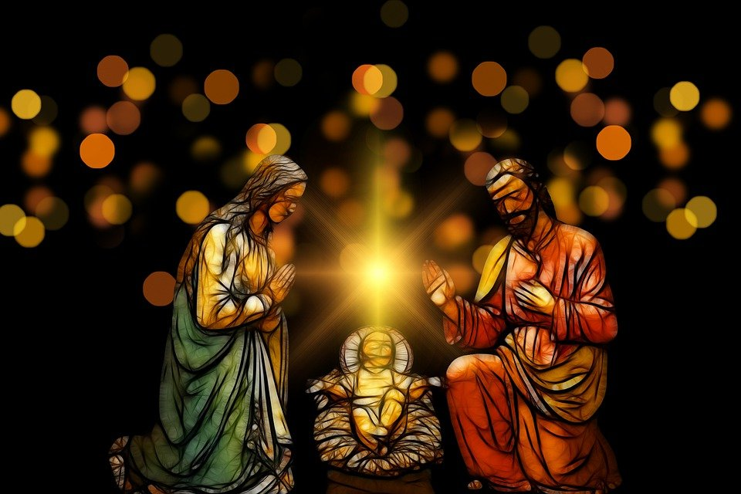
Prayer, Liturgy and Scripture

Advent and the Liturgical Year
The liturgical year, or the Church year, superimposes the mysteries of the life of Christ – from his Incarnation to his second coming in glory – on the normal course of the year. The liturgical year begins with Advent, the time of the waiting for the Lord, and has its first high point in the Christmas season and its second, even greater climax in the celebration of the redemptive suffering, death and Resurrection of Christ at Easter…The liturgical year is repeatedly interrupted by feasts of Mary and the saints, in which the Church praises God’s grace, which has led mankind to salvation.
(Catechism of the Catholic Church 1168-1173, 1194-1195)

The feast of Christ the King is celebrated on the Sunday before Advent and the World Day of the Poor is the week before Christ the King. The Liturgy Office has a liturgical calendar for each year and more information about Advent liturgies here. During each liturgical season, there are special prayer intentions and these are the ones for Advent each year:

PRAYER INTENTIONS during Advent and Christmastide  (Based on the liturgical year) | Liturgical Colour
Migrants and Refugees  (Migrants’ day - 3rd December) | PURPLE
Openness to the Word of God
(Bible Sunday – 2nd Sunday in Advent)
Expectant Mothers
(especially on 4th Sunday)

Special feast days during Advent include:
- St Andrew (30th), martyr
- St Francis Xavier (3rd), martyr
- St Nicholas (6th)
- St Ambrose (7th)
- Immaculate Conception (8th), solemnity
- Our Lady of Guadalupe (12th)
- St Lucy (13th), martyr
- St John of the Cross (14th)
For other resources see:
Westminster Education Service has resources to enhance the school year highlighting special saints’ days and celebrations during Advent and the rest of the year.

For CAFOD’s free liturgical year calendar as well as assemblies for every season including Advent, see here. For collective worship, see here. For prayer resources see here.

For Catholic Top Ten Saints for Advent by Catholic Exchange see here.

For creative ways to celebrate saints’ feast days during Advent by Catholic Icing see here.

Mission Together has resources for St Francis Xavier and St Nicholas here.
Advent and Scripture

The Gospel Accounts
The account of the coming of Jesus over 2000 years ago is recorded in the Gospel accounts of St Matthew and St Luke , although both differ in their details. While Matthew’s account concentrates on the geneology of Jesus, Joseph’s dreams and the visit of the Magi, Luke’s includes the Annunciation, Visitation, the visit of the shepherds and the presentation. For common and different elements in both narratives as well as different theological emphases in both narratives see here.

Weekly Scripture and Themes in Advent

The first Sunday of Advent begins between 27th and 3rd November each year. There are 4 Sundays in Advent followed by Christmas day (which is always 25th December although the day of the week always changes). The beginning of the Liturgical Year begins on the first Sunday of Advent. All of this information can be found on the liturgy office website here.

WEEK 1

Liturgical colour: Purple
Theme: The Prophets' Candle, symbolising hope

Reading 1 | Jer 33:14-16 | I will make a virtuous branch grow for David.
Psalm | Ps 24:4-5, 8-9, 10, 14 | To you, O Lord, I lift up my soul
Reading 2 | 1 Thess 3:12—4:2 | May the Lord confirm your hearts in holiness when Christ comes
Gospel acclamation | Ps 84:8 | Let us see, O Lord, your mercy and show us your saving help
Gospel | Luke 21:25-28, 34-36 | Your liberation is near at hand.

WEEK 2

Liturgical colour: Purple
Theme: The Bethlehem Candle, symbolising faith

Reading 1 | Bar 5:1-9 | God means to show your splendour to every nation.
Psalm | Ps 125:1-2a, 2b-3, 4-5, 6 | What marvels the Lord worked for us! Indeed we were glad.
Reading 2 | Phil 1:4-6, 8-11 | Be pure and blameless for the day of Christ.
Gospel acclamation | Luke 3: 4, 6 | Prepare a way for the Lord, make his paths straight, and all mankind shall see the salvation of God.
Gospel | Luke 3:1-6 | All mankind shall see the salvation of God.

WEEK 3

Liturgical colour: Rose pink (Gaudete Sunday)
Theme: The Shepherds' Candle, symbolising joy

Reading 1 | Zeph 3:14-18a | The Lord will dance with shouts of joy for you as on a day of festival.
Psalm | Isa 12:2-3, 4, 5-6 | Sing and shout for joy for great in your midst is the Holy One of Israel.
Reading 2 | Phil 4:4-7 | The Lord is very near.
Gospel acclamation | Is 61:1 (Lk 4: 18) | The spirit of the Lord has been given to me. He has sent me to bring good news to the poor.
Gospel | Luke 3:10-18 | What must we do?

WEEK 4

Liturgical colour: Purple
Theme: The Angel's Candle, symbolising peace

Reading 1 | Mic 5:1-4a | Out of you will be born the one who is to rule over Israel.
Psalm | Ps 79:2-3, 15-16, 18-19 | God of hosts, bring us back; let your face shine on us and we shall be saved.
Reading 2 | Heb 10:5-10 | Here I am! I am coming to obey your will.
Gospel acclamation | Luke 1: 38 | I am the handmaid of the Lord: let what you have said be done to me.
Gospel | Luke 1:39-45 | Why should I be honoured with a visit from the mother of my Lord!

Other Resources:

For CAFOD’s Children’s Liturgy Gospel Collective Worship resource see here. It is available for teachers to use with pupils in the primary school and includes the Gospel, reflection and a prayer in a PowerPoint form. For Word versions and illustrations for pupils see here.

For Mission Together’s Advent liturgies which include Scripture, prayer and craft ideas see here.
I wonder… What any of these readings mean and how they might make a difference to your life.
Perhaps… you could work with your pupils to organise an Advent liturgy of the Word based on the appropriate readings for the week. Perhaps your pupils could write a reflection on one of the readings (and check it with you or your priest/chaplain).

.

Prayer During Advent

Prayer is a helpful way of getting our hearts ready to meet Jesus. Although there are many ways to pray, it can depend very much on the individual. Here are some ideas:

Hail Mary
Say, sing or sign this slowly and with understanding. Notice the words in the prayer which were said by the angel Gabriel and Elizabeth.

Magnifat
Say or sing Mary’s song of praise and reflect on what you can give thanks for this Advent.

Benedictus/ Song of Zechariah
Reflect on the words in the song of Zechariah and the meaning of this for Zechariah and/or for you.
Rosary
Say a decade of the (Joyful) Mysteries together in solidarity with other children around the world.

Angelus
Recite the Angelus together, thinking about Mary’s yes and how you can follow her example.

Lectio Divina
Meditate on the Sunday/daily readings during Advent. Which words or phrases were meaningful to you? What conversion of mind, heart, and life is the Lord asking of you today?

Visio Divina
Reflect on religious artwork linked to Advent and the Christmas story. Discuss and pray. Find another piece of religious art linked to Scripture that could help you to dig deeper.

Prayer Service
Hold a prayer service in your home/school or class. Look at some examples and then create your own.

O Antiphons
Learn, chant or recite the O Antiphons on the last seven days of Advent. Listen to the song ‘O Come O Come Emmanuel’ and reflect on Jesus’ coming.

St Andrew Novena
Learn and recite this prayer and say it each day from 30 November until Christmas.

Say Sorry
If you cannot go to Confession or have a penitential service during Advent, examine your conscience and say sorry to God for the times when you have not shown love.

The Posada
At home bring out the nativity characters and tell the story together and then say a family prayer. Write or draw your own Posada prayer using this example.

Song Prayers
Reflect on the Advent or Christmas story through song and listen to what Jesus is telling you. Respond to Jesus in your heart.

Advent Song Prayers
There are many Advent and Christmas hymns available for use during this special time. Here are some contemporary songs for Advent which can be used with pupils and staff.

Artist | Song
Clay Aiken | Mary, did you know?
Carola | Heaven in my arms
Faith Hill | A Baby Changes Everything
Steven Cutis Chapman | This Baby
Mercy Me | Joseph’s Lullaby
Sidewalk Prophets | Hope was Born this Night
Hayley Westenra | Veni, Veni, Emmanuel
Andrew Peterson | Matthew’s Begats
Mark Schultz | When Love Was Born
Matt Maher | Born on that Day
Kari Jobe | When Hope Came Down
Mumford and Sons | Waiting for Jesus
Stephen McWhirter | Come Jesus Come
Lincoln Brewster | While I Wait
Matt Redman | His Name Shall Be
Matt Redman ft Chris Tomlin | Angels, Angels
Matt Redman | Hearts Waiting
Andrew Peterson | Labour of Love
CJM Boyce and Stanley | Love Shone Down
CYC | O Mary, Mother of God
CYC | Hail Mary, Gentle Woman
CYC | Magnificat
Catholic Icing | Advent Song for Kids

Other prayer and liturgy resources for staff and pupils:
For support with prayer and liturgy see our Westminster Education Service support document here
For a booklet by the Scottish Education Service with liturgies for every week and day in Advent for children see here
For a variety of reflections and prayers by the Catholic Apostolate Centre including a Christmas tree and Nativity scene blessing as well as lots of other resources about the liturgy and traditions during Advent see here
For a variety of prayers for children by Loyola Press for use at home and at school see here and here
For weekly Advent reflections and liturgies with videos, podcasts and inspirational quotes by Articles of Faith see here
For Advent prayers and liturgies by Faith and Worship see here
For an example of an Advent liturgy with parents see here
For Missio’s Advent reflections and assemblies see here
For online reflection, retreats or reading Ignatian Spirituality see here

Advent Wreath
The Candles

Week 1 (purple) | Prophet candle | Hope
Week 2 (purple) | Bethlehem candle | Faith or peace
Week 3 (rose) | Shepherd candle | Joy
Week 4 (purple) | Angel candle | Peace or love
Week 5 (white) | Christ candle

Symbols

Candles | Evergreen | Circle | Holly
Light – birth of Jesus – Jesus is light of the world | Enduring life during Winter | God’s everlasting love, eternity and unity of God’s creation | Crown that Jesus wore on the cross (the red berries – his blood)

Further resources for support:

This video on the Advent Wreath by The Religion Teacher explains the symbolism of the in a visual way.
This video explains the meaning of each of the Advent candles.
This tutorial by Catholic Icing demonstrates how to draw an Advent wreath.
This simple video explains the meaning of Advent and the Advent wreath for children.

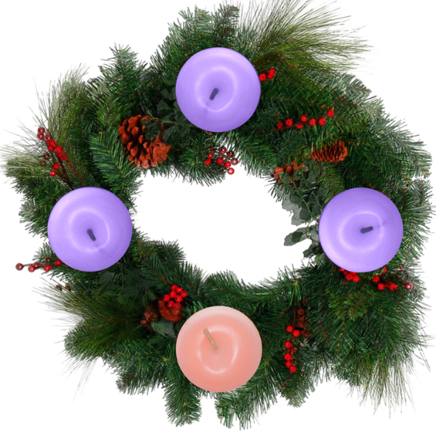

I wonder… If you could make an Advent video, podcast or PowerPoint to share with pupils.

Perhaps… the pupils could create their own to share with families at home.

Perhaps… they could create their own Advent hymn/song to share.

Creativity in Home – School Learning
Cross-curricular Links

Here are just some ideas for bringing Advent to life this year especially during times of social distancing. It is important that the tasks are age-appropriate as well as challenging for the pupils and that they are linked to Scripture, Prayer and Church Teaching where you can.

Gospel Art
- Research a Gospel writer and the symbol associated with him. Create a piece of art using hand/foot/finger prints
- Make a sculpture of the symbol of a Gospel writer. Add your favourite line from their Gospel on some card beside it and explain what it means to you
- Make a 2D sculpture of the symbol of the Gospel writer using natural materials and then take a photo of it. What is his message?
- Create a Haiku to describe this writer or one to summarise a scripture passage they have written
- Write an acrostic poem using the name of the writer
- Create a symbol of the writer or one of their stories/messages using food eg Epiphany. Take a photo and summarise it with a line of Scripture
Light of the World
- Design a Christmas card with the theme of ‘light of the world’ using Stuchie art. Write a short prayer/blessing inside
- Design an Advent wreath and create a Wordle for each candle based on the theme for each candle
- Create an Advent prayer card or poster with a theme of your choice (love, joy, peace or hope). Choose an appropriate piece of Scripture to link to it
- Create a piece of artwork using photography of Advent symbols. You may include Scripture, a prayer or quote in the photograph
- Reflect on the image of the Light of the World by William Hunt and how this links to you this Advent.
- Write an Advent prayer service/liturgy on the theme of light. Design and create an Advent focal point to link to this
- Use children’s stories to look at themes of hope, joy, peace and love such as ‘Amazing Peace’, a Christmas poem by Maya Angelou or ‘The Last Angel’ by Dyan Shelton. Create symbols/artwork inspired by these
Advent Mosaic
Design an Advent mosaic using appropriate symbols and colours as a group/class or school
- Reflect on the mosaic and look at the different signs/symbols used and how they link to the birth, life, death and resurrection of Christ
- Create a song, poem or prayer linked to the image
- Design your own mosaic for Advent with your preferred theme/focus such as the wreath, Holy Family, hope or Emmanuel

Advent Triptych
Use Scriptures to create an Advent Triptych like this one from John Henry Swanson. You can decide whether they all come from the same Gospel writer (eg Matthew) or not
- Use this image to help you to retell the story in verse, one stanza for each picture
- Label the picture and add references to Scripture where you can
- Retell the story shown to the right using sticks. Add a different piece of coloured ribbon/thread for each part of the story
O Antiphons
- Design/create your own banner/stained-glass window based on your favourite one of the O Antiphons
- Listen to the song ‘O Come O Come Emmanuel’ and then compose your own short verse (using your preferred style) about the O Antiphons or about the theme/concept of one of them
- Create some O Antiphon ornaments or crafts
Mafa Jesus
- Reflect on an Advent/Christmas scene in the Mafa Jesus style and how it links to a Gospel passage. What do you notice?
- Design a Christmas card in this style and choose an appropriate line/verse for inside the card
- Research Advent/Christmas images of Mary and Jesus from other cultures. Choose a favourite one and explain why
- Find out about how someone from another culture prepares for Advent or celebrates Christmas. What is similar? What is different? What can you learn?
- Design a poster based on hope and justice this Advent
- Research a saint, martyr or prophet from another culture and create a PowerPoint to share this with others. How do they link to Advent?
Other creative resources

Catholic Icing offers free arts and crafts which include: Advent wreaths, Advent saints, O Antiphons, Jesse Tree ornaments and Nativity sets to make.

CARFLEO offers ideas for using Sacred Art for deeper reflection and engagement with Scripture
Free daily reflections on the Gospel through Art can be found at Christian Art. Subscribe here

The Adventus Project has various resources/ideas for creativity including: art, poetry, music and activities (such as Lego Nativity) as well as videos, prayers and sermons.

Traditional and Contemporary Sacred Art

Annunciation (Luke 1:26–38)
The angel’s visit to Mary has inspired many artists throughout the years. Here is a small selection of artwork from different ages, styles and cultures, some of which have video or written reflections to aid your understanding of the piece or event. As you or your pupils engage with the colours and imagery in the artwork as well as the appropriate Scripture, think about what message God might have for you today and how you might respond.

Paul Woelfel: Annunciation
Jen Norton: Magnificat
Henry Ossawa Tanner: The Annunciation
John Collier: The Visitation of the Angel
Dante Gabriel Rosetti: The Annunciation
Fra Angelico: Annunciation
Janet McKenzie: Annunciation
Caravaggio: Annunciation
Arthur Hacker: Annunciation
The Adventus Project: Annunciation

Visitation (Luke 1:39–56)
Mary’s visit to her cousin Elizabeth provides believers with a perfect example of trust, charity and grace which encapsulate the Advent season and which we aspire to: she puts others before herself even at great personal cost; she is patiently accepting of God’s will although she knows it brings many challenges; she remains faithful to God through prayer and meditation on his word; she is a source of joy and inspiration for others, and her heart is filled with praise and thanks to God as she awaits the coming of Jesus. As you and your pupils reflect on the pieces of art and/or text, think about how you can be more like Mary this Advent.

The Adventus Project: Visitation
Fra Angelico: Visitation
James B. Janknegt, The Visitation
Windsock Visitation by Brother Mickey McGrath
Good Shepherd Campus
Learn Religions: Visitation
Passionist Nuns: Visitation
Catholic Exchange Visitation
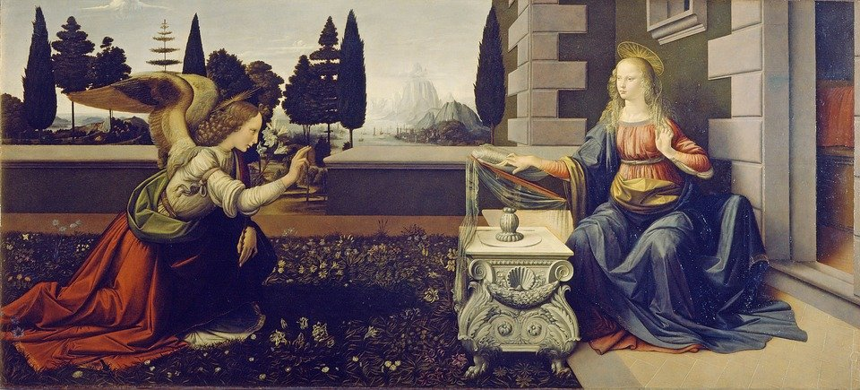

Mary and Joseph’s Journey
Jesus’ parents were no strangers to travelling and hardships: they had to travel on foot from Nazareth to Bethlehem, from Bethlehem to Egypt then from Egypt back to Nazareth – a very long way with little money, belongings, comfort or security. They experienced ridicule, persecution, homelessness and to fear for their lives and the life of their only beloved child. As you and your pupils reflect on these images, imagine what Mary and Joseph may have felt. Journey inwards towards Christ and ask for his guidance and light as you travel through your own challenges and darkness this Advent.

Journey to Bethlehem
Mary and Joseph's journey
Walking to Bethlehem
“Holy Family Icon” by Kelly Latimore
Jesus as a refugee

Nativity (Mt 2; Lk 2)
Behold, I bring you good tidings of great joy, which shall be to all people. For unto you is born this day in the city of David a Saviour, which is Christ the Lord. (Luke 2:10-11)

Jesus Christ was born for all people of all times. To illustrate this truth, Christians around the world often depict him as coming into their own culture, in the present time. Being able to see Jesus as the Saviour of your own people, as incarnated very close to you, and relevant to life today, is valuable for believers. As you and your pupils reflect on pieces of art, think about how Jesus is present in your life here today, especially in places where you might not expect him to be. Will others see Jesus in you?
Nativity of the Lord Slide Show with Scripture and Artwork
Nativity Paintings from Around the World
More Nativity Paintings from Around the World
Modern Nativity from Around the World
CARFLEO - Nativity Paintings from Around the World
Traditional paintings of the Nativity with Magi and Shepherds

I wonder… which image was most meaningful to you and why?

Perhaps… you could encourage your pupils to create something based on art and then celebrate the diversity of thought and creation.

Thank God for our uniqueness and originality, and for being God-with-us in our time, place and culture.

Other Advent Learning Resources

CARFLEO has various resources to support Classroom RE and Catholic Life at different levels
Scottish Catholic Education Service has resources to support primary teachers and pupils including ideas for lessons and prayer/liturgy.
NCEA has a variety of fun ideas for home and school preparation for Advent.
Today’s Catholic Teacher
Catholic Teacher has a plethora of fun seasonal printable resources for home/school learning
The Religion Teacher has a variety of printable resources and activities for home/school use for different ages and abilities
Ideas for resources that families will love including: The Giving Manger and Names of Jesus Advent Calendar.
Advent resources that the whole family will love has some ideas such as the Giving Manger and a Names of Jesus Advent Calendar which you can use and then make your own.
The National Catholic Reporter has 10 tips for busy Catholics to observe the Advent season.

Storybooks for Children

- Love – Matt De La Pena, Loren Long
- Amazing Peace – Maya Angelou
- Joy – Corrinne Averiss, Isabelle Follath
- A Child’s Garden, a story of hope – Michael Foreman
- Maybe God is Like That Too – Jennifer Grant
- When God Made You – Matthew Paul Turner
- Dan’s Angel – Lauren Child, Alexander Sturgis
- The Three Trees retold by Angela Elwell Hunt
- An Angel’s Story by Max Lucado
- The Last Angel by Dyan Sheldon

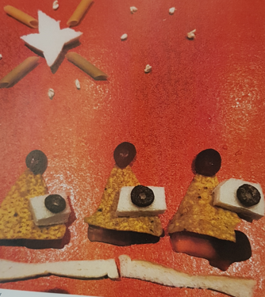
Image below by OLSJ Primary, Hackney
Catholic Social Teaching
Common Good during Advent

Advent is a time of preparation, not just for Christmas, but for meeting Our Lord at the end of time. In Matthew’s Gospel, Jesus told us that he is already present with us - in the least of our brethren (Mt 25:31-46). We meet him regularly in the poor, the hungry, the needy, the vulnerable – people of various ages, backgrounds and cultures. Our challenge during Advent is to respond to Jesus in our fellow man with compassionate, generous and forgiving hearts and, as teachers, to guide our pupils in building up the Kingdom of God.
Christ the King
(A reflection by Raymond Friel from Prayers for Schools)

Judge of the nations –
This is what you said would be our final judgement:
What we did for the weak and vulnerable, the victims of our society.

For the hungry –
Whose crops have failed and go without food
Who go to Food Banks to feed their families

For the thirsty –
Whose water is unclean
Whose water sources are drying up due to human activity

For the strangers –
Who are new to our country and feel unwelcome
Who are lonely in our community

For the naked –
Who have been stripped of dignity by an uncaring world
Who have been humiliated online

For the sick –
Who suffer ill health with not enough medicine or help
Who suffer from anxiety or depression

For the imprisoned –
Who are trapped in debt or addiction
Who are in prison with little education or company

Because whatever we do to them, we do it to you.

Catholic Charities
There are many ways that we can get involved with charity work and areas of social action and justice this Advent. Although there are numerous charities to choose from throughout the year, we have selected a few that you can get involved with this Advent to support your Domestic, Local and Universal Church.

Caritas Westminster

World Day of the Poor – Sunday 14th November 2021

In 2017 Pope Francis started the World Day of the Poor, one Sunday every year when we are asked to particularly focus on those living in poverty. This year Pope Francis has made the theme of the day ‘The poor you will always have with you’. In his message for this World Day of the Poor Pope Francis tells us ‘Last year we experienced yet another scourge that multiplied the numbers of the poor: the pandemic, which continues to affect millions of people and, even when it does not bring suffering and death, is nonetheless a portent of poverty. The poor have increased disproportionately and, tragically, they will continue to do so in the coming months. Some countries are suffering extremely severe consequences from the pandemic, so that the most vulnerable of their people lack basic necessities. The long lines in front of soup kitchens are a tangible sign of this deterioration. There is a clear need to find the most suitable means of combating the virus at the global level without promoting partisan interests. It is especially urgent to offer concrete responses to those who are unemployed, whose numbers include many fathers, mothers, and young people. Social solidarity and the generosity which many, thanks be to God, have shown are, together with far-sighted projects of human promotion, making a most important contribution at this juncture.’

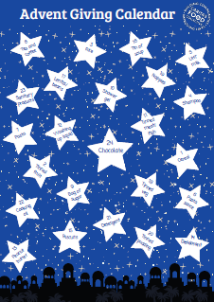
This Advent, Caritas Westminster will be sharing a ‘reverse’ Advent calendar which will give suggestions for items to collect each day to donate to a local foodbank or food poverty project in time for Christmas. Over the past two years many schools have got involved with the calendar, collecting hundreds of boxes of food for local foodbanks and helping to ensure families did not have to go hungry at Christmas. This year the calendar will run in the same way, and it will also include information on how to find and access help, for the benefit of any families that are struggling and unsure where to turn.

You will be able to find the calendar here – it will be uploaded before Advent. Caritas would also love to hear from any schools using the calendar, whether with pictures, questions or feedback.
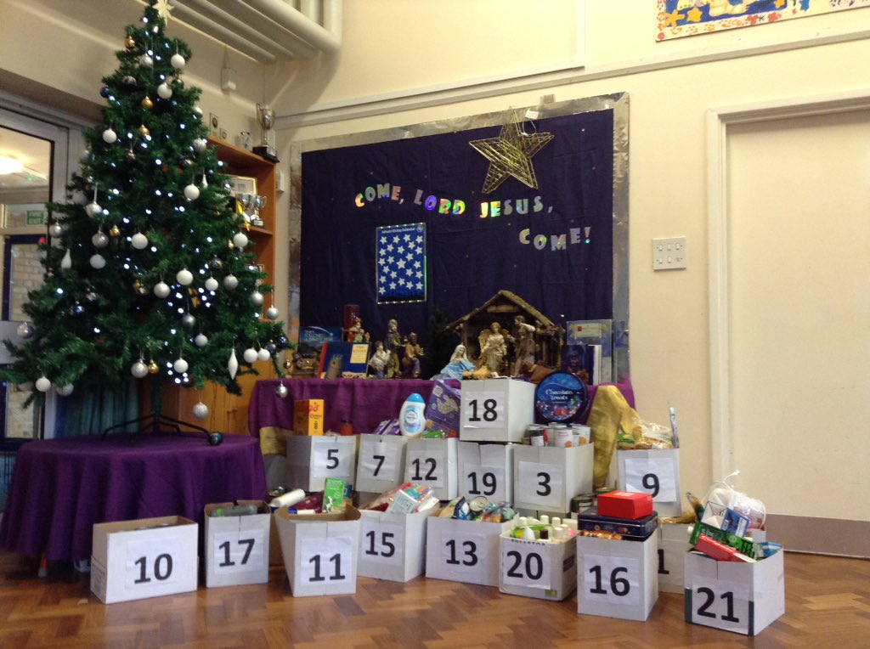

Operation Christmas Elf - Gifts for prisoners’ children

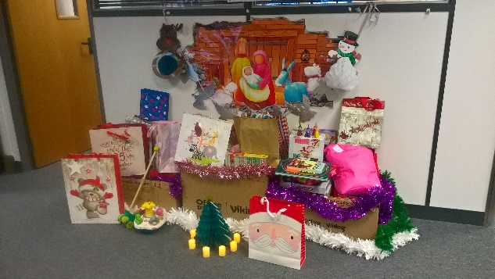
Since 2016 Caritas Westminster has partnered with PACT to help collect presents for the children of prisoners, who often face stigma and loneliness whilst their parent is in prison. The project allows the imprisoned parent to give the donated gift to their child for Christmas. Usually they ask people to donate presents directly, but unfortunately because of the pandemic this is not possible. This year they are asking that people buy book tokens or gift cards and send them to the PACT office so these can be sent to the children instead. You can find all the information about how to get involved in this important project here. Please note the deadline to take part this year is 30th November to allow time for the book tokens to reach PACT and for them to distribute them before Christmas, so this activity would need to be done before Advent. Please let Caritas Westminster know if you are taking part and if they can help in anyway.

Tackling Food Waste and Caring for Creation

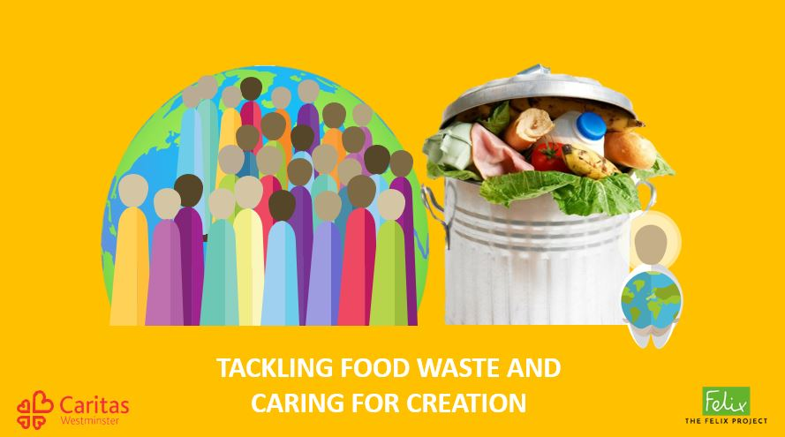
Over the last two years Caritas Westminster has been working with The Felix Project to ensure that perfectly good food is not going to waste but is going where it is needed the most. They have created a PowerPoint resource with The Felix Project to look at the issue of food waste and to think about how our faith calls us to care for creation and not waste the resources God has blessed us with.

This is an interactive session you can use to get pupils thinking about their own consumption, and how as individuals and as a school you can start to tackle food waste and make sure everyone is getting their fair share of God’s creation.

This is a great resource to use hand in hand with the Advent Giving Calendar as they both help us to understand how we can play a part in creating a world where no one goes hungry, as Jesus told us to do. You can find the PowerPoint here.

Caritas Ambassadors

Advent is a wonderful time to go deeper into our understanding of Catholic Social Teaching and think about how we can work to create the Kingdom of God on earth. Caritas Ambassadors is a programme for both primary and secondary schools created by Caritas Westminster. It aims to equip pupils with a strong understanding of Catholic Social Teaching and how we can put it into action in our daily lives.

The programme runs through six key themes of Catholic Social Teaching and helps the trainee Ambassadors to think about social justice issues in their local community, before taking them through responding by developing and running their own social action project. It also introduces them to the work of Caritas Westminster, offering practical examples of how they use Catholic Social Teaching to influence their work.

You are provided with 11 full sessions suitable for Key Stage 2 or 3 to run in school, complete with a PowerPoint and script for each session. These can be run either as an extracurricular session for a group of students, or can be done with a whole class. You will also get support from your local Caritas Development Worker to run the programme.

Advent is a great time to start but the programme can be used at any time of year. You can find out more here or by emailing caritasambassadors@rcdow.org.uk
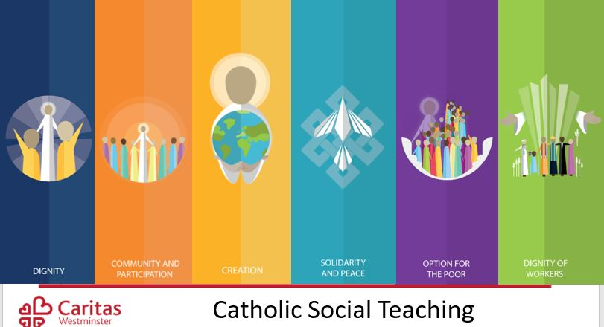

Caritas Development Workers

Caritas Westminster has seven geographic hubs covering different areas of the Diocese of Westminster with dedicated Development Workers. Your local Development Worker would be happy to meet with you to discuss how your school can be more involved with social outreach work or how to best engage your students with Catholic Social Teaching. Their team can also run assemblies or sessions for classes relating to Catholic Social Teaching, refugees, homelessness, food poverty, isolation, or a general overview of the work that Caritas does across the diocese. These can be run virtually during the COVID-19 pandemic. You can find out who your local Development Worker is here or email caritaswestminster@rcdow.org.uk to find out more.

Please do let Caritas know if you use any of these resources or get involved in any of their projects. They are keen to hear how you get on and thank the school and children for taking part and are always happy to help in any way they can. Email caritaswestminster@rcdow.org.uk to get in touch.

Aid to the Church in Need

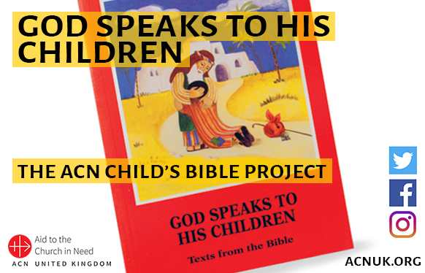
Check out Week 10, of the ACN Child’s Bible Project > HERE

There are video recordings and reflections on the scripture of the Christmas Story, and activities relating to each chapter. There are lots of ways to reflect in Advent, leading to the Christmas Story.

CAFOD
Advent Calendar and national assembly
Join CAFOD’s Advent national assembly live on 2 December to find out how we can all prepare for the coming of Jesus, the light of the world, by loving others and showing love for our world. See here.
Counting down to Christmas using an Advent calendar is a popular tradition for Christians. CAFOD’s interactive online Advent calendar helps pupils to join in joyful expectation for Christmas while also thinking of their neighbours in the Universal Church. It links prayer and liturgy with the common good and is a great way of building up the Domestic Church during Advent too. See here.

Pupils Leading Pupils
Your Pupil Chaplaincy Team or other pupils taking a leading role in the school may be able to help to organise activities for the school and Local Church during Advent. For more information see here.

Catholic Children’s Society
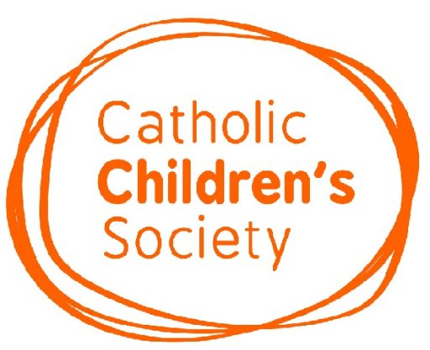
Christmas Gift Appeal – Gifts for local children in need
Every year the Catholic Children’s Society (CCS) distribute gifts to local disadvantaged children and young people. CCS would be so grateful if your school could donate new toys, books, clothes or gift cards for this year’s appeal. Please drop off any donations to our main
office: 73 St Charles Square, London W10 6EJ by Monday 6th December. For more information please see here.

Advent Calendar
The CCS Advent Calendar can help your pupils reflect and prepare during the season of Advent. The interactive calendar can be completed online or in hard copy at school or at home. See here for further details.

Mission Together
‘Children helping Children’
Each year Mission Together, Pope Francis’ official children’s charity for overseas mission, produce engaging and fun resources to help children keep Jesus at the heart of the Advent season. Their resources are free to download and include Scripture, prayer, craft activities and a call to action which focuses on how children all over the world live out the motto: ‘Children helping children’.

Liturgies for Advent
This year’s Mission Together Advent Liturgies follow the season’s Sunday’s Gospel readings and help pupils to understand how, during Advent, we recall the Israelites’ long wait for the Messiah’s birth and remember that Jesus was born into the world as a humble baby and will come again in glory. The prayers and readings can be delivered by pupil leaders and/or staff and are supported by the Advent calendar and optional craft Activities. These activities are available here for use at home or at school.

Advent Calendar
Mission Together’s popular Advent Calendar is available to download for free. It has suggestions for each day for the season and, in addition to encouraging children to reflect on the Gospel readings, there are ideas for prayers, activities and acts of kindness. By following the calendar pupils can discover that, through prayers and generosity, no one is too young or too small to be a missionary of God’s love. All Advent resources are available to download here.

Mission Together Virtual Map
As a fun way to bring the school year to an end, use the new virtual map to show pupils that they belong to God’s family - the Universal Church - and discover how children everywhere pray and share their time, gifts and talents to be ‘Children helping children’. Follow the link here then just click and drag to navigate the globe. Pupils can select any of the countries coloured in orange to access film clips, audio, prayers and resources of children around the world who are being missionaries of God’s love.

Other Resources

One Life Music: Advent Retreats

Twilight Reflections for Staff and Governors.
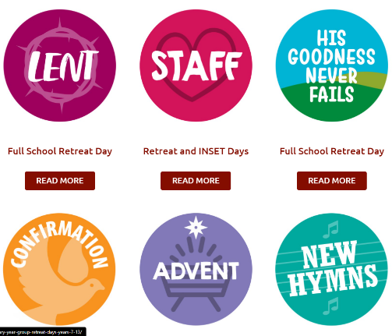
Exploring the themes of Autumn, Advent, Lent and Summer, these reflections require very little preparation from school. OneLife Music has prepared everything for you. The course platform guides you through each section allowing participants to simply stop for an hour of community reflection, prayer and wellbeing. Dan and Emily are already very well known for their visits to schools across the Midlands since 2010 and are now excited to be using their wealth of experience to create wonderfully tailored virtual retreats for the school setting. For an Advent Staff Twilight see here.

Virtual Retreats for Pupils.
Experience the gift of retreating as a community of faith, through sharing, prayer, song, sign language,
and more, all written, recorded and provided for you by OneLife Music. A retreat for the whole primary
school: Celebrating that in God’s eyes we are all unique and valuable. For Virtual Retreats see here.

Pupil Chaplaincy Documents

Our Westminster Education Service’s Pupil Chaplaincy documents have various support materials for enhancing pupils’ engagement with social actions including templates for ‘See Act Do’ and the local, national and universal Church. For more information see here.

Songs for Reflection

The Least of These by Matt Maher
Live Like That by The Sidewalk Prophets

The Ten Commandments for a Future Without Hunger

Caritas Austria

I wonder… what you could do with your pupils to build up the Kingdom of God this Advent?

Perhaps… you could think about your own 10 Commandments and then act on them?

Perhaps… you could get involved together to support the Local, National and Universal Church?

Perhaps… you could work together in your Domestic Church (family) through both prayer and action?

- You shall co-operate so that everyone on earth has enough to eat.
- You shall not gamble away your neighbour’s bread by speculation.
- You shall not hoard what the hungry need to eat.
- You shall honour the earth, so that you, your children, and everyone on earth might prosper.
- You shall live in such a way that your life-style is not at the expense of others.
- You shall not covet your neighbour’s land and property
- You shall reduce hunger with your agrarian policies and not increase it.
- You shall challenge corrupt regimes and their underlings.
- You shall help prevent armed conflicts and wars.
- You shall combat hunger effectively with developmental aid.
- Caritas

