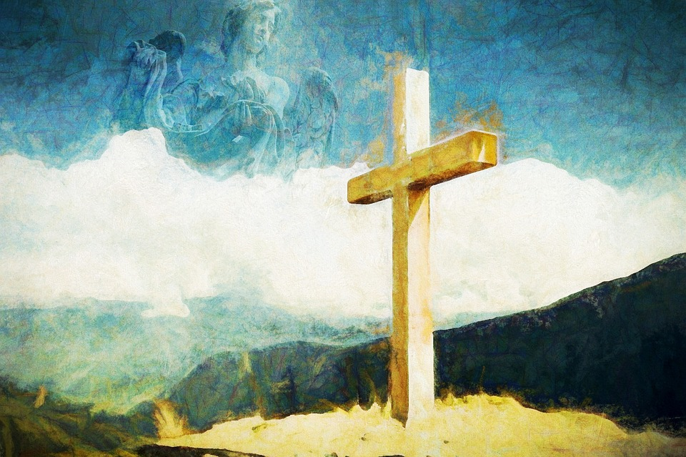
SACRAMENTS:
Reconciliation
and Service

CONTENTS

Introduction 3
SECTION 1: Sacraments: An Overview 4
Video Links for Sacraments (General) 5
Visual Aids 6

SECTION 2: The Sacrament of Reconciliation: Q & A 7

Reconciliation A-Z 10

A Step by Step Guide to Reconciliation 14

Reconciliation in Scripture 15

Video Links for the Sacrament of Reconciliation 16

Hymns and Songs 18

Useful Websites and Resources 19

Reconciliation Art 20

Reconciliation Poetry 21

Storybooks for Children 23

Prayers and Saints 24

Topic Grids 25

Resources from Charities 27
- ACN
- CAFOD
Sources and thanks 35
Introduction

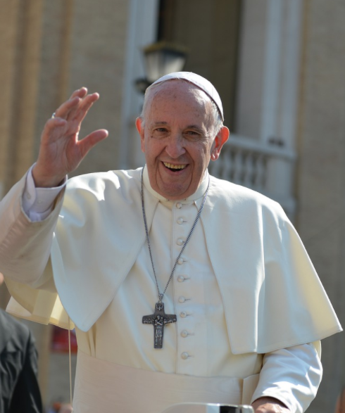
Pope Francis reassures us that ‘To celebrate the Sacrament of Reconciliation means to be wrapped in a warm embrace’.

He urges us ‘Don’t be afraid to go to the Sacrament of Confession where you will meet Jesus who loves you’.

Pope Francis also reminds us that ‘The Lord never tires of forgiveness. It is we who tire of asking for forgiveness. Let us ask for the grace not to tire of asking for forgiveness because he never tires of forgiving’.

Aims
The main purpose of this resource is to help you as an educator to appreciate more fully what the Catholic Church teaches about the Sacrament of Reconciliation, one of the seven sacraments in the Catholic Church (and one of the Sacraments of Healing, the second of which is the Sacrament of the Sick). It is hoped that the information and resources can help you to teach pupils about the benefits of this wonderful sacrament where they can meet Jesus and feel wrapped in his warm embrace while also developing the theology, religious literacy and spirituality of pupils.

Structure
There are two main sections in this document:

1. The Seven Sacraments (an overview)
2. Sacrament of Reconciliation

This document is primarily intended to enhance the subject knowledge of teachers in both primary and secondary Catholic schools. While there is a lot of information in the Q & A as well as the A-Z, the videos are also extremely informative and engaging. Other resources are highlighted in this document but it is not meant to be an exhaustive list of resources but support for teaching and learning.
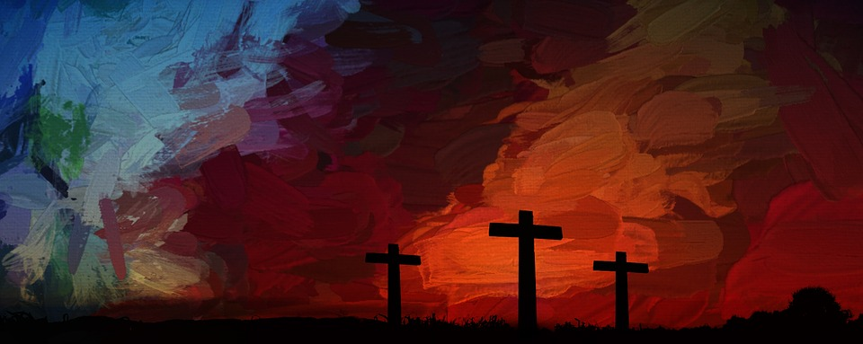

SECTION 1: Sacraments - an overview
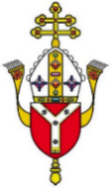
Sacraments
The seven sacraments are meeting points where God himself is present, waits for you, blesses you and leads you into deeper communion with the Church.

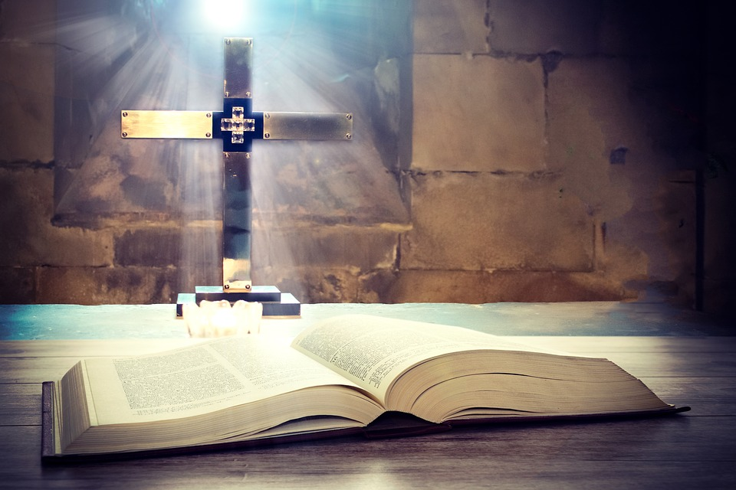

A sacrament is an effective sign of something hidden which comes from God. Catholics believe that that they are outward signs of an inward grace through which we share in God’s love (St Augustine). In other words, they are visible ways in which the invisible gifts of God’s love and mercy are given to us through the Holy Spirit. More information about sacraments and signs can be found HERE.

The sacraments were entrusted to the Church by Jesus so they are all deeply rooted in Scripture and Tradition. They are administered through prayer services known as liturgical rites which usually take place inside a church but which may be celebrated elsewhere.

The seven sacraments can be divided into three groups: Sacraments of Initiation, Sacraments of Healing and Sacraments of Service.

Sacraments of Initiation Baptism, Confirmation and Eucharist
Sacraments of Healing Reconciliation and the Sacrament of the Sick
Sacraments of Service Marriage and Ordination

In this document, information about Reconciliation is provided in the form of videos and artwork as well as the written word which is based on the teaching from the Catechism of the Catholic Church. We hope that you find them useful for your own personal and professional development. To find out more about Baptism and other sacraments as well as the Catholic faith, it is recommended that you use other documents in the Catholicism Unpacked series which can be found on the Diocese of Westminster Education website: https://education.rcdow.org.uk/catholicism-unpacked-new/
Video links for Sacraments (General)

For the videos included below, simply click on the links underlined below.

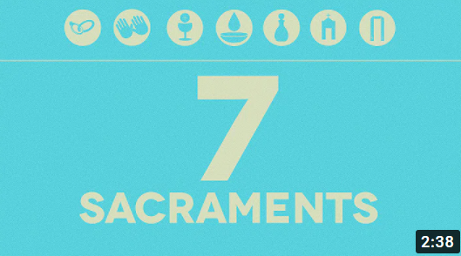
The Seven Sacraments (OBD Films)

This short film offers a brief overview of the seven Sacraments of the Catholic Church and the purpose each serves. It uses images of sacred art and references to Scripture. Suitable for teachers and pupils in KS2.

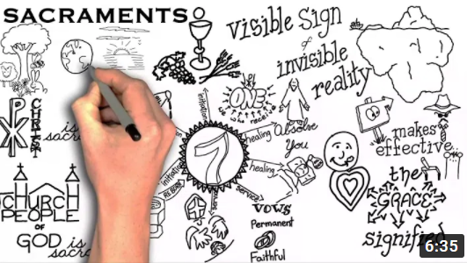
The Sacraments (Sketchy Catholicism)
Using sketches, this video explains what a sacrament is and then explains each of the sacraments of initiation, healing and service and how they link together. Suitable for teachers and some pupils in KS2.

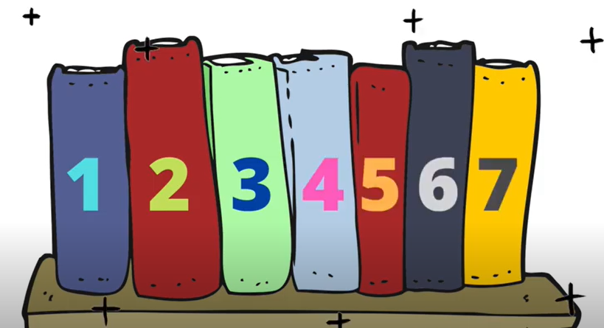
7 Sacraments - Catechism Songs
Jesus instituted the 7 Sacraments and these are explained in the Catechism which can be found here. This song will help to memorise them in a fun way! Suitable for teachers and pupils in KS2.

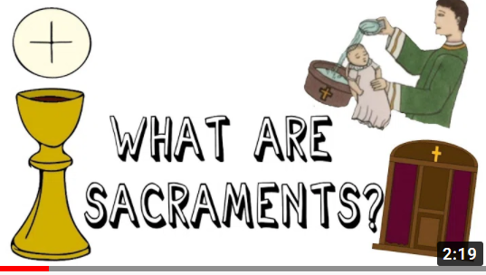
The Sacraments (Theo Matters)
This video explains the sacraments as a whole. It uses simple images to explain each of the sacraments using the words from the Catechism. It is suitable for teachers and may be used for some pupils in KS2.

Visual Aids

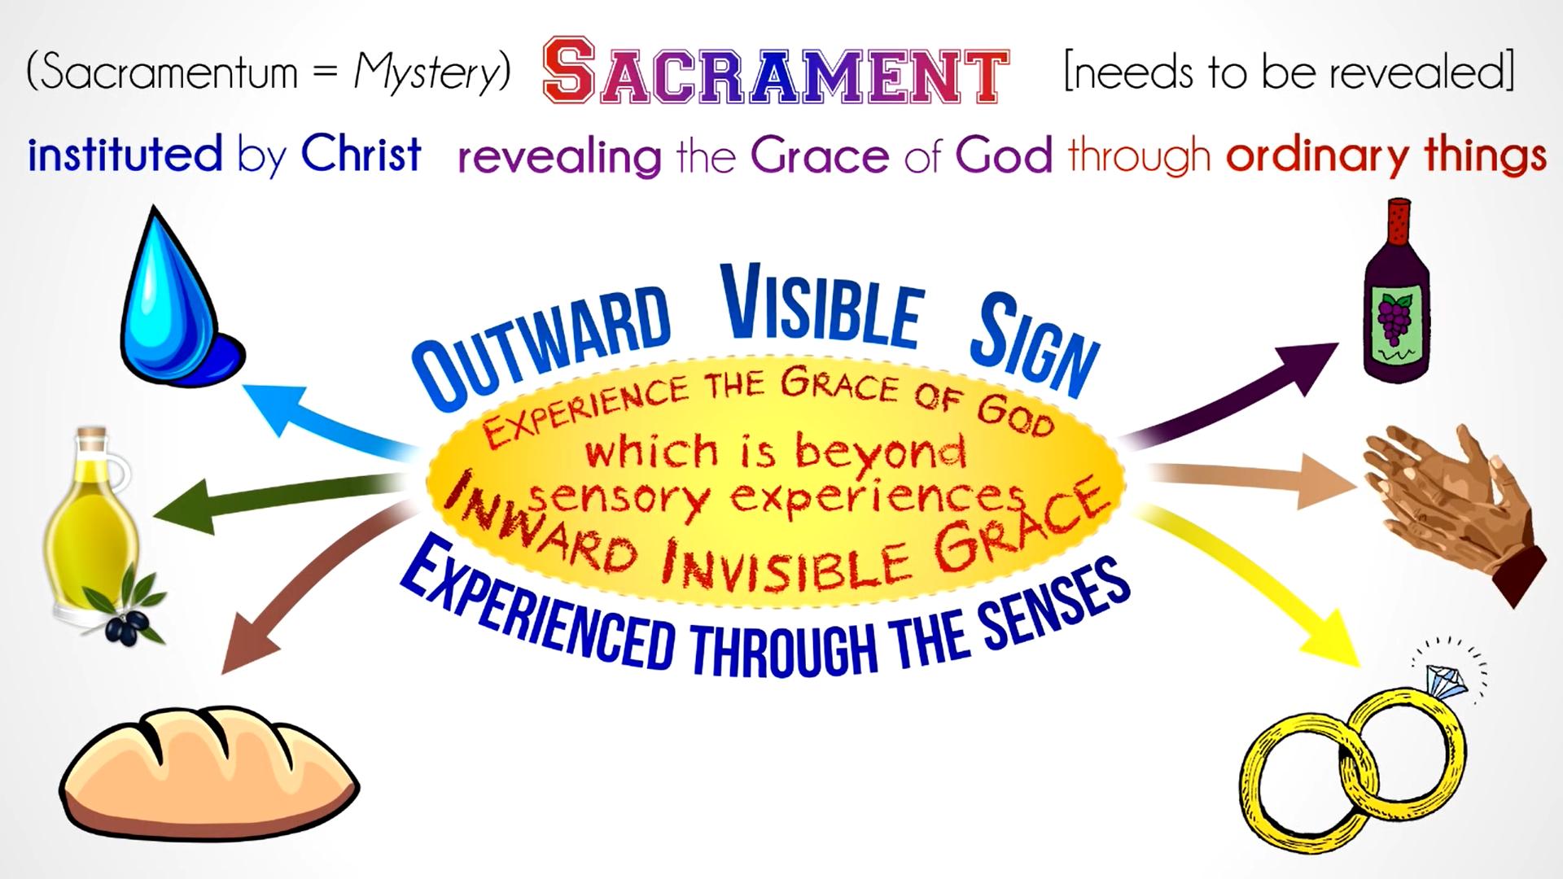

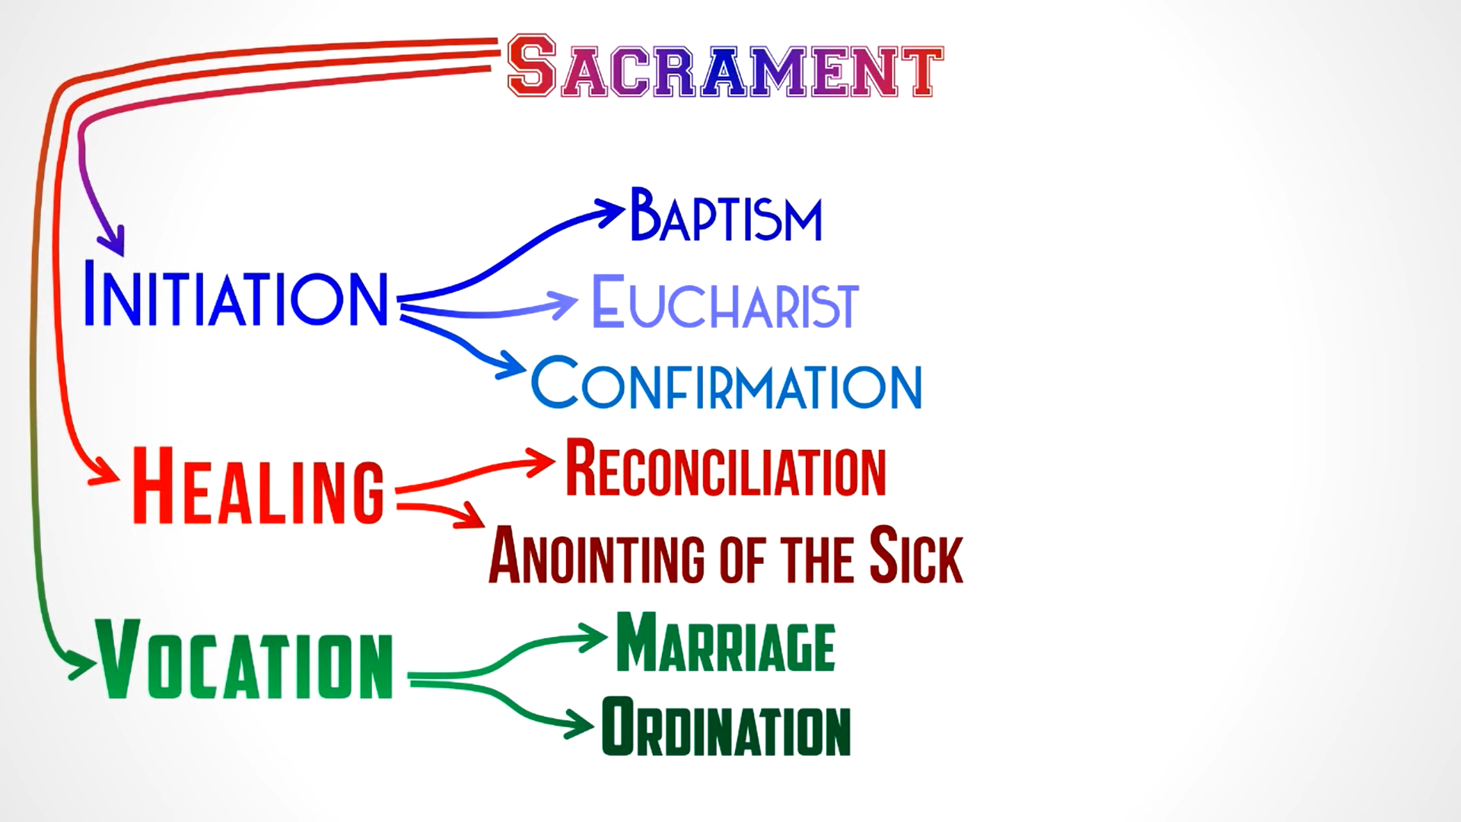

These images were screenshots from Mr McMillan REvises Baptism and Confirmation. Click HERE to see the YouTube video.
SECTION 2: The Sacrament of Reconciliation - Q & A

The Sacrament of Reconciliation is also known as the Sacrament of Penance, of forgiveness, and of conversion. Some also refer to is as the Sacrament of Confession, although this may cause a little confusion as the Church teaches that confession is only one of the four elements of the sacrament. [CCC 1422-1424, 1486].

In the Catechism of the Catholic Church this sacrament is properly known as the Sacrament of Penance and Reconciliation, although for efficiency and consistency in this document it will be referred to as the Sacrament of Reconciliation. The concepts of penance, reconciliation and forgiveness will be explored in this section so as to offer a clear picture about this wonderful sacrament. The A-Z which follows will then shed further light on the concepts and terminology used here. The videos and resources which are also included in this document will help to explain these difficult concepts further in an engaging and simple way.

What is penance?
Penance is making restitution or satisfaction for a wrong that has been committed. Penance must not take place exclusively in my head; it must be expressed in acts of charity and in solidarity with others. A penitent (the person acknowledging their sins and expressing sorrow for them) does penance also by praying, fasting and supporting the poor spiritually and materially. [CCC 1424-1439] People often misunderstand penance. It is not about being sad and having a low self-esteem or brooding over poor choices. Penance encourages us to make amends and a fresh start, therefore making us free.

What is reconciliation?
The word ‘reconciliation’ comes from a Latin verb meaning ‘to bring back together, to restore’. It brings spiritual healing which has a positive impact on our lives and relationships. The act of confession is important because it allows the penitent to put things right with God and others to know that they have been forgiven. It helps to build up and heal the individual as well as the community and the body of Christ. The sacrament is important because it brings us peace and unity – with God, with others and with ourselves.

The Sacrament of Reconciliation reconciles the sinner with God and the Church. [CCC 1468-1470, 1496]

Who instituted this sacrament?
Jesus himself instituted this sacrament when he showed himself to his apostles on Easter day and commanded them, “Receive the Holy Spirit. If you forgive the sins of any, they are forgiven; if you retain the sins of any, they are retained” (Jn 20:22-23). [CCC 1439-1485]

Jesus expressed what happens in this sacrament in his parable of the Prodigal Son: when we are led astray, we get lost and cannot cope. God our loving and merciful Father waits for us with infinite longing; he desires to forgive us and draw him closer to himself. His love and mercy are unconditional and given freely. Jesus himself showed us the love of the Father through the forgiveness of sins. He forgave sins in the power of the Holy Spirit and handed that power to his Apostles which was then passed down to our priests. When we go to the Sacrament of Reconciliation and tell our sins to the priest, we fall into the heavenly arms of our Father who forgives us through the words of the priest. (YouCat 227)

Why did Christ give us the Sacrament of Reconciliation and the Anointing of the Sick?
Christ’s love is shown in the fact that he seeks the lost and heals the sick. That is why he gave us the Sacraments of Reconciliation and the Sacrament of the Sick as they bring healing and restoration. In them we are freed from sin and helped in our physical and spiritual weakness. [CCC 1420-1421]

Why should a person go to the Sacrament of Reconciliation?
Baptism brings us into the new life of the children of God, but it does not free us from human weakness and the inclination to sin. That is why we need a place where we can be reconciled with God again and again. That place is the Sacrament of Reconciliation. [CCC 1425-1426]

It can be difficult to admit our failings and confess our sins in the Sacrament of Reconciliation. It requires some sacrifice but it has many benefits in that it renews the soul, leaving the penitent unburdened and accepted in love. It is a wonderful gift that we can receive again and again as God is merciful and always ready to forgive us. Going to Reconciliation offers a person the opportunity to turn a clean, new page in the book of their life. (YouCat 226) The Sacrament of Reconciliation can be celebrated by those who have been baptised in the Catholic Church. For more information about grace and penitence see the A-Z.

What are the steps of Reconciliation?
The Catholic Church teaches that there are four steps in this sacrament which are explained as follows. This comes from the YouCat for Kids (p134-135).

- Reflection and Repentance
The confession starts with a reflection, an examination of conscience. You think about the bad you have done and the good you have not done. You feel sorry. We call this feeling repentance. You resolve to never do these things again. In order not do forget anything, you can also write everything down and take the piece of paper with you (and dispose of the paper afterwards).

- Confession
You go to the priest. You greet each other. With the sign of the cross you greet God. You can start now: tell him when your last confession was! List your sins; you can also read them from the piece of paper. Tell him when you are finished. Tell him that you are sorry.

- Absolution
After you have acknowledged your sins, ask for the absolution: ‘I ask God for forgiveness’. Now it’s the priest’s turn. He talks to you. He gives you a penance to do afterwards and, in the power of Jesus, says ‘I absolve you from your sins in the name of the Father, and of the Son and of the Holy Spirit’. You are free! God has now forgiven you everything. Now between you and God it is as if you have never done anything wrong. You can start your new life now.

- Penance and Amendment
Sometimes the penance is a prayer. Other times it can be an instruction to make good the damage, or to do something else good. Go home with the resolution to better yourself.

Who can forgive sins?
God alone can forgive sins. Jesus could say “Your sins are forgiven” (Mk 2:5) only because he is the Son of God. Priests can forgive in Jesus’ place only because Jesus has given them that authority. [CCC 1441-1442] Some people are confused about this sacrament as they feel they can go directly to God to say sorry for their sins rather than going through a priest. Of course, going to God directly in prayer is to be encouraged, but the Sacrament of Reconciliation is a gift that Christ himself has given to complement and strengthen this direct relationship. Confession to a priest gives the absolute assurance of God’s forgiveness and helps us make our penitence deeper and truer.

God wants us to have a personal encounter with him by acknowledging our sins and telling them to another. We will then also hear his words of love and forgiveness. The priest represents the community as well as God. Sin not only impacts on a person’s relationship with God but also on their relationship with others which was why it is important to not just confess to God through prayer but to partake in the sacrament. The following words from the Gospel of John are therefore true of priests as they were for the Apostles: “If you forgive the sins of any, they are forgiven; if you retain the sins of any, they are retained” (Jn 20:23) (YouCat 228). For further information on this see Fr Mike Schmitt’s video Why Confess My Sins to a Priest?

Who can celebrate the Sacrament of Reconciliation?
Anyone who has been baptised into the Catholic Church can celebrate this sacrament. A person can celebrate their first Reconciliation around the age of 7-8 when they understand the difference between right and wrong. Before a person receives their First Communion, they must first go to Reconciliation.

What are the two basic elements required for the forgiveness of a Christian’s sins to occur in the Sacrament of Reconciliation?
What is required for the forgiveness of sins is the person who undergoes conversion and the priest who in God’s name gives him absolution from his sins. (YouCat 231). For more information on absolution and conversion see the A-Z.

What must I bring to the sacrament?
Essential elements of every Sacrament of Reconciliation are: an examination of conscience, contrition, a purpose of amendment, confession and penance. [CCC 1450-1460; 1490-1492; 1494]. For further information about these elements see the terms in the A-Z and Busted Halo’s video: Confession-101 (Busted Halo part 2)

How often can you receive this sacrament?
Unlike the sacraments of Baptism, Confirmation and Marriage, this sacrament can be celebrated over and over again, like the Eucharist.
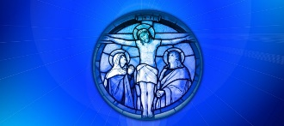

The above information has been simplified and adapted from the Catechism of the Catholic Church and the YouCat as well as the YouCat for Kids. To find out more about the sacraments and about this resource as well as YouCat for Kids and free bonus materials see https://www.youcat.org/

Reconciliation A-Z

Absolution
The term used for forgiveness in the Catholic Church. It is given by the priest during the Sacrament of Reconciliation. The priest absolves the penitent from their sins after they have confessed. When the priest raises his hand over the contrite sinner he says, “I absolve you from your sins in the name of the Father, and of the Son, and of the Holy Spirit. Amen.” These are the words of absolution. Only a priest/bishop may absolve sins.
Act of Contrition (or Sorrow)
Prayer of penance/sorrow said during the Sacrament of Reconciliation after the penitent has confessed sins.
Blessing
At the end of the sacrament the priest will bless the penitent. See the Step by Step Guide to Confession on p14.
Confession
Confession lies at the heart of the Sacrament of Reconciliation and is one of the four steps (see p8).

To confess something is to admit to it, to acknowledge when I have done something wrong. In order to confess to someone else, I first have to confess (admit) it to myself, so the first step is to reflect, to think about where I have failed. So, confession requires self-reflection first, then confession to someone else – to God, through the priest.
Confessional
A small room used for the Sacrament of Reconciliation. In some parishes this might be called a Reconciliation room.
Contrition
This is the feeling or expression of remorse (feeling contrite) at the recognition that one has done wrong. It is being truly sorry and ready to change.
Conversion
Conversion comes from the Latin conversio, which means ‘to turn around.’ In the New Testament, the Greek writers used the word metanoia which means having a change of heart.

Conversion involves both turning away from a past life and turning toward God. This results in an interior transformation of the person. Conversion can mean turning from sin to repentance, from indifference to fervour, from lack of faith to belief, from error to truth.
Examination of Conscience
A review of one’s past thoughts, words, actions and omissions. Some useful Scripture passages for examining one’s conscience could be: the Ten Commandments, the Beatitudes, Gospel Values and the teaching of the Church.

Before the sacrament, the penitent person is required to examine their conscience and be truly sorry for their sins.
Forgiveness
Forgiveness is a conscious, deliberate decision to release feelings of resentment or vengeance toward a person or group who has harmed you. In the Lord’s Prayer we pray, ‘Forgive us our trespasses as we forgive those who trespass against us.’ Ephesians 4:32 tells us, ‘be kind to one another, tender-hearted, forgiving one another, as God in Christ has forgiven you.’

‘Forgiveness is above all a personal choice, a decision of the heart to go against the natural instinct to pay back evil with evil.’ St Pope John Paul II.
Grace
Grace is a spontaneous, free and undeserved gift from God. Salvation is the process of being saved from sin and returning to God through his grace. Jesus is our saviour who brought about salvation. For more information see HERE.
Healing
The Sacraments of Reconciliation and Anointing of the Sick are both sacraments of healing as they offer peace and healing of spirit. Jesus taught parables such as the Prodigal Son, the Lost Sheep and the Lost Coin to help people understand God’s infinite love and mercy. His miracles also demonstrate this love and bring healing and peace.
Holy Trinity
Like in other sacraments, the Holy Spirit is present in the Sacrament of Reconciliation. The Holy Spirit is the third person of the Trinity (the Father, the Son and the Holy Spirit).
Jesus
The name Jesus comes from the Hebrew name Yeshua (Joshua in English) meaning ‘to deliver; to rescue’. Jesus was the name given to the Son of God. Jesus came into the world to rescue all people and reconcile all people to God. He came to save sinners and he did this through his death and resurrection. Jesus taught the Good News – that God loves us and nothing can separate us from God’s love and mercy.
Mercy
The disposition to be kind and forgiving. Founded on compassion, mercy differs from the feeling of sympathy in putting this feeling into practice with a readiness to assist. It is therefore the ready willingness to help anyone in need, especially those in need of pardon or reconciliation. God himself is full of compassion and mercy.
New life
Jesus conquered sin and death on the cross and rose to new life on the third day. Later that evening he appeared to the Apostles in the upper room where he breathed on them and gave them the Holy Spirit and the power to forgive sins in his name. Jesus offers his followers new life through his mercy and forgiveness.

The Sacrament of Reconciliation is a time to make a new start and begin again. It is a reminder of our Baptism. The Apostle Paul teaches that a believer can be a “new creation” in Christ through reconciliation (2 Cor 5:17 -21). God sent Christ into the world to provide reconciliation through His death.

Original sin
The term ‘original sin’ does not refer to our own sin or our own fault, but the broken condition we all inherit into which we are born before we sin by our own free decision.

Penance
An act by which you show that you are sorry for what you did wrong. During the Sacrament of Reconciliation, the priest will give you a ‘penance’ such as saying a prayer or doing an action to make amends. After this sacrament, the penitent person does their penance and tries to live a life more like Christ.
Penitent
The person acknowledging their sins and expressing sorrow for them. Penitent (adj) also means contrite or repentant.

When the penitent person goes to Reconciliation, they will confess/tell the priest their sins. The priest usually offers them a word of advice and gives them a ‘penance’ after which the penitent person says a prayer called an Act of Contrition. Then the priest gives them absolution which means that all their sins are forgiven. The penitent person can then go in peace.
Prodigal Son
The parable (also called the Good/Forgiving Father) told by Jesus about a son who leaves his father to lead a prodigal (reckless/wasteful) life but later makes a penitent return.
Reconciliation
One of the seven sacraments (also known as Penance) in which the penitent person asks for forgiveness for their sins and is given absolution by the priest in the name of Jesus. The Sacrament of Reconciliation (like the Eucharist) can be received many times whereas some sacraments can only be received once (such as Baptism and Confirmation). It is the sacrament of forgiveness because God grants the penitent “pardon and peace” by the priest’s sacramental absolution. It is the Sacrament of Reconciliation, because it imparts to the sinner the love of God who reconciles. (CCC 1424)
Jesus gave the ministry of reconciliation and forgiveness to the Church when he breathed the Holy Spirit on the apostles after his resurrection and told them that those whose sins they forgave would be forgiven (see John 20:22-23).
Repentance
It is turning back to God and having a conversion of heart.
Sacrament
There are seven sacraments in the Catholic Church: Baptism, Reconciliation, Eucharist, Confirmation, Marriage, Anointing of the Sick, Holy Orders. A sacrament is an outward sign of an inward grace. We need sacraments to help us to ‘outgrow our petty human life and become more like Jesus through Jesus: children of God in freedom and glory’ [CCC1129].

Seal (of Confession)
Everything that is said during this sacrament is confidential and this is known as the Seal of Confession. The priest cannot share this information with anyone else and this secrecy is absolute, and cannot be disclosed to anyone.
Sin
A sin is anything that separates me from God and from people. Sin separates us from love and from good. Every sin causes damage. It destroys something in me. It damages relationships between person to person, between person and God. In the Sacrament of Reconciliation, sins are forgiven and the relationship between God and the person is restored.

Ten commandments
The ten commandments written on stone tablets given to Moses by God on Mount Sinai (Ex 20:2-17; Deut 5:6-21). These can be the basis of the Examination of Conscience before Reconciliation.
A Step by Step Guide to the Sacrament of Reconciliation

The Sacrament of Reconciliation is one which was instituted by Jesus Christ in his infinite love and mercy to offer all sinners forgiveness for their offences against God and against their sisters and brothers. The sacrament brings reconciliation between the penitent and God, between the penitent and others as well as healing and forgiveness to the individual penitent.

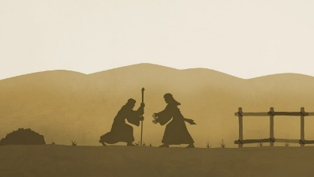

A person can celebrate this sacrament in a confessional or Reconciliation room, privately behind a screen or face-to-face with the priest. The penitent can prepare for the Sacrament of Reconciliation by examining their conscience. This examination, which is often guided by the Ten Commandments, helps the person to prepare for confessing their sins to the priest. To make a good confession, the penitent should be truly sorry for their sins and resolved not to sin again.

Here are the simple steps:

(1) Make the Sign of the Cross and the penitent greeting the priest with the words,
(2) “Bless me, Father, for I have sinned. It has been (…weeks, months, years) since my last confession. I am sorry for…”
(3) The penitent confesses their sins to the priest, who stands in the name of Christ and the Church. The priest helps them make a good confession. If the penitent is unsure or uneasy, they can ask the priest to help. It is important to trust in God, a merciful Father who wants to forgive.
(4) The priest will assign a penance which takes into account the penitent’s personal situation and supports their spiritual good. It may be a prayer, an offering, works of mercy, service, or sacrifice; whatever the penance, the individual is joined in some way to Christ and the cross.
(5) The penitent will then pray an Act of Contrition/Sorrow. This prayer expresses true sorrow for the sins confessed. This prayer may be expressed in one’s own words or one may use one of the formal prayers of sorrow.
(6) The priest, acting in the person of Christ, absolves the person from their sins by saying the prayer of Absolution.
(7) As the prayer is ending, the penitent makes the Sign of the Cross and responds, “Amen.”
(8) The priest expresses some words of praise and blessing.
(9) The penitent thanks the priest and leaves, thanks God for his forgiveness and completes the assigned penance.
The above is adapted from: Confession-step-by-step/
For a child-friendly guide see: Guide-to-Confession-Handout-color.pdf

Reconciliation in Scripture

Scripture | Reference
Jesus teaches forgiveness | Mt 6:14
Paralysed man | Mt 9:1-8
Jesus gives Peter the keys to the Kingdom of God | Mt 16:19
Lost sheep | Mt 18:10-12 or Lk 15:1-7
How many times to forgive | Mt 18:21-35
Unforgiving servant | Mt 18:23-35
Jesus forgives Peter | Mt 26:26-69 or Jn 21: 15-1
Paralysed man | Mk 2:1-12
Forgiven woman | Lk 7:36-50
Barren fig tree | Lk 13:6-9
Bent over woman | Lk 13:10-13
Lost coin | Lk15:8-10
Forgiving (or Good) Father or Prodigal son | Lk 15:11-32
Zacchaeus | Lk 19:1-9
Jesus forgives on the cross | Lk 23: 32-35
The penitent thief | Lk 23: 40-43
Jesus forgives woman who committed adultery | Jn 8: 1-11
Cast the first stone | Jn 8:7
John gives his Apostles authority to forgive sins | Jn 20:22,23)

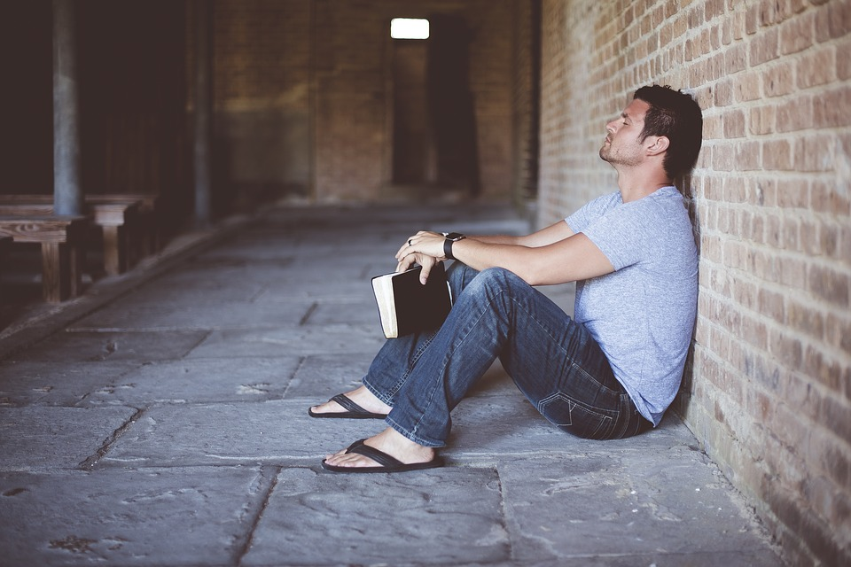

Video links for the Sacrament of Reconciliation

For the following videos, click on the underlined titled in blue:

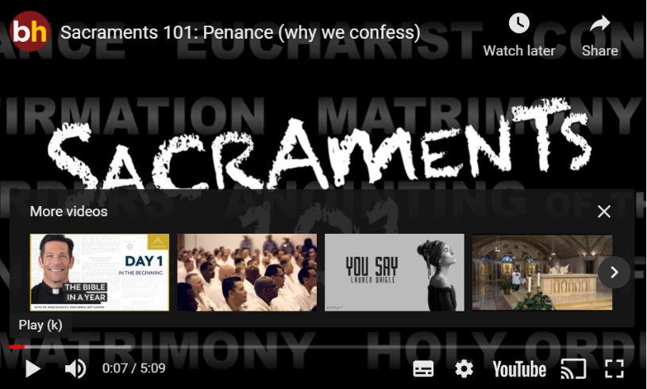
Penance: why we confess (Busted Halo part 1)

In this video, Fr Dave Dwyer explains the Sacrament of Reconciliation and the teaching of the Church using Scripture linked to communion, unity and the body of Christ. It can be used with pupils from KS2 upwards.

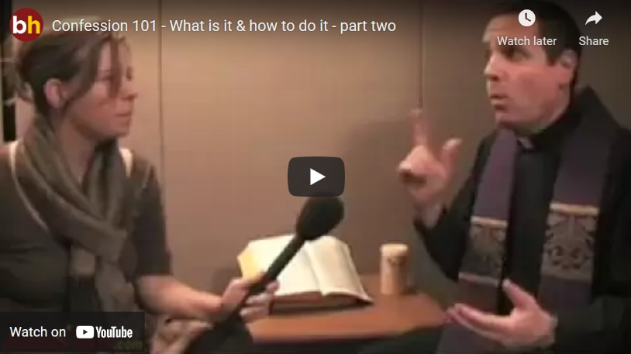
Confession-101 (Busted Halo part 2)

This is a conversation between the interviewer and the priest as they go through the steps of reconciliation in a simple and straight-forward way. It goes through the four main steps:
Confession, Penance, Contrition and Absolution. It is suitable for KS2+

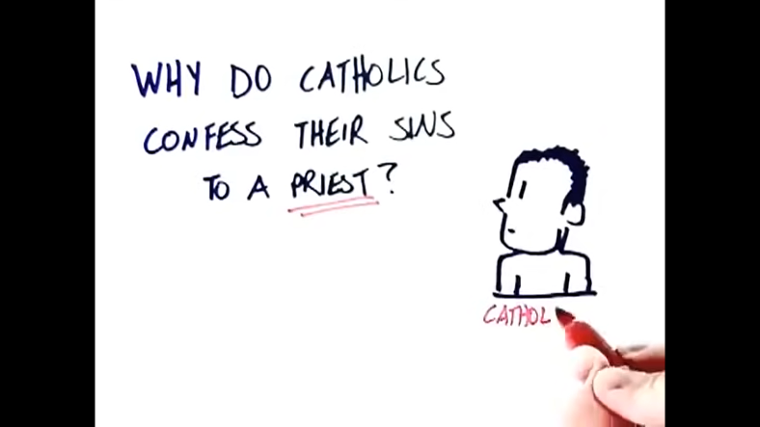
Sacrament of Reconciliation Explained

This video explains this Sacrament through drawings and Scripture in a straight-forward and detailed way which can be used with pupils from KS2. It also explains how this sacrament was passed down from Christ to his Apostles and then to priests.

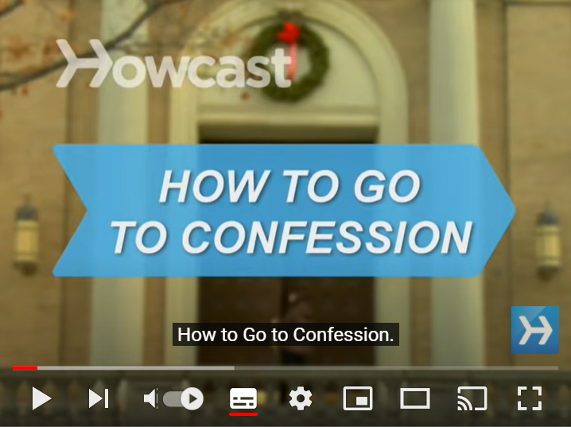
How to go to Confession

This explains what happens at the Sacrament of Reconciliation and goes through the steps in a simple way. It is suitable for pupils in KS2+.

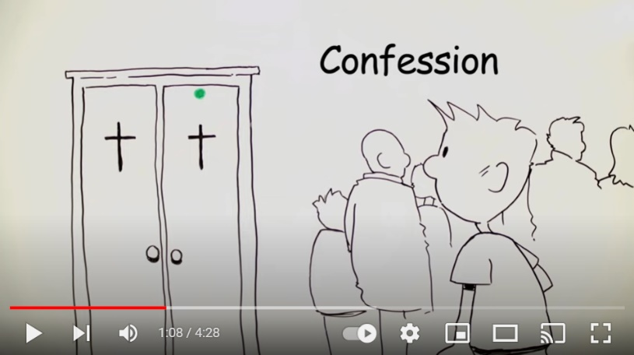
How to go to Confession (ODB Films)

This explains the sacrament using music, drawings and some words. It is useful for KS2+ pupils. It explains the terminology associated with reconciliation in a simple way and talk about the benefits of the sacrament.

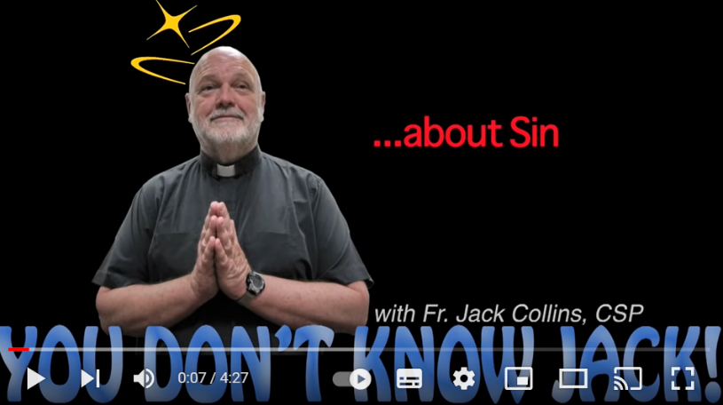
You don’t know Jack about Sin

While vacationing in Las Vegas, Busted Halo's own Fr. Jack Collins, CSP, decides to hit the strip and ask people what they know and think about that topic that everyone associates with Sin City...sin. This is for adults only.

For excellent videos to enhance subject knowledge of teachers see:

Why Confess My Sins to a Priest? By Fr Mike Schmitz | Why Confess My Sins to a Priest?
Making a Good Confession by Fr Mike Schmitz | Making a Good Confession
Going to Confession for the First Time in a Long Time by Fr Mike Schmitz | Going to Confession for the First Time in a Long Time
Forgiveness by Fr Mike Schmitz | Forgiveness
How Does God Restore Us? by Fr Mike Schmitz | How Does God Restore Us?
What you can do when another can’t forgive by Fr Mike Schmitz | What you can do when another can’t forgive
Hymns and songs

Song | Link
A variety of songs on this theme and others | https://www.cjmmusic.com/songs/
Father I have sinned (Words and music by Eugene Reilly, video CJM Music) | https://www.cjmmusic.com/songs/father-i-have-sinned-the-prodigal-son-song/
Face of your Mercy (Words and music by Joanne Boyce, video CJM Music) | https://www.cjmmusic.com/songs/face-of-your-mercy-song/
A variety of songs on this theme and others including:  Refiner’s Fire  Open the Eyes of my Heart  Healing Waters  Jesus Remember Me  Prayers of St Francis | https://carfleo.com/2020/03/28/song-prayers/
You’re a good, good Father by Chris Tomlin | https://www.youtube.com/watch?v=-ak0OoFBw3c
Lay it Down by Matt Maher | Lay it down
10 Christian Songs about forgiveness | https://www.godtube.com/news/top-10-christian-songs-about-forgiveness.html
Sample of other suggested hymns:
Freely, Freely
Amazing Grace
Come Back to Me
Oh Lord all the World Belongs to You
Amazing Love (Kendrick)
Turn to Me
Eagles’ Wings
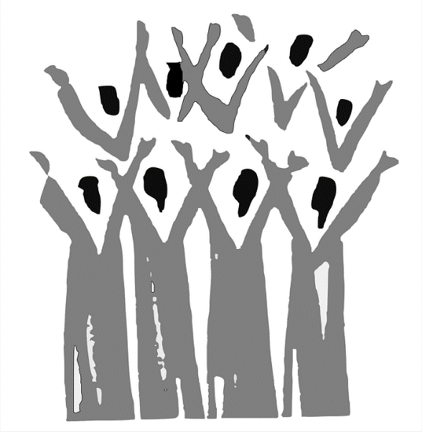
Useful websites and resources

Website/Resource | Description | Audience
Catholics Come Home | Website with various useful resources including videos, Q & As, various examinations of consciences for people of different ages as well as articles and links. | Adults
Pray as you go | Examen for children from Pray as you go | KS2+
Pray as you go (adults) | Examen for adults from Pray as you go | Adults
Busted Halo | Guide to confession for pupils in one coloured sheet. | KS2+
Pauline uk | Reconciliation poster (to purchase). | KS1+
Aleteia.org | A slideshow of 5 saints who spent extremely long hours hearing confession | KS2+
Catholic Icing | Reconciliation craft. It also has links to other resources such as printable: 5 steps to a good confession. | KS1-2
Flame of faith.org | Reconciliation FAQs, videos and resources for teaching and catechising children. Makes references to Diocesan specifics (e.g. age of first Reconciliation.) | KS2+
Sacrament of Reconciliation Guide | This leaflet from SVP has an examination of conscience, some prayers and a step-by-step guide to the sacrament | Age 7+
Reconciliation Guide for Children | This resource from The Light is on For You has materials adapted from Loyola Press explains choices and sin in a child-friendly way and includes an examination of conscience. | Age 7+
The Religion Teacher | A few resources for teaching this topic | KS2

Reconciliation Art

The following links show a variety of artwork on the parables of the Prodigal Son and the Lost Sheep. There is a mixture of traditional and contemporary work, fine and abstract art and art from various cultures and styles. Some are accompanied by reflections while others stand alone. They can be used with pupils of any age.

The Prodigal Son
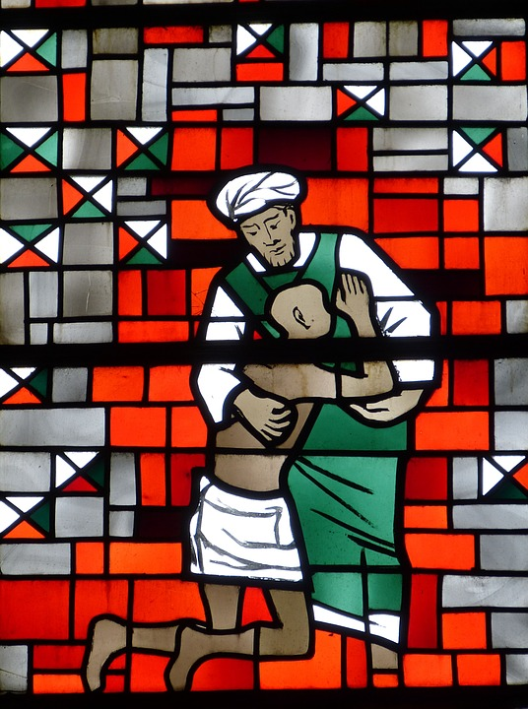
Prodigal-son-parable-painting-by-bertram-poole-thomas
Eyekons Prodigal Son portfolio of art
Prodigal Son - modern version George Lightfoot
Return of prodigal son Rembrandt
Reflections on the parable of the prodigal son
Leaving and returning- Sieger Koeder
The Prodigal Son by He Qi
Natre spirited arts gallery
Return of the prodigal son by Brent Kastler
Prodigal Son christian art
Revjoelle Prodigal Son

Lost Sheep
Lost Sheep parable Thomas Bertram Poole
The Lost Sheep - Jorge Cocco
Lost Sheep by Daniel Bonnell
The shepherd and the lost sheep by Peter Clarke

Christian Art
The following pieces of art are based on the themes of forgiveness and mercy. They are accompanied by scripture and a reflection about the piece of art and are more suitable for older pupils and adults, although the artwork can be used for discussion with younger pupils.

How often must I forgive my brother?
Love your enemies
The tax-collector said “God, be merciful to me”
There is rejoicing among the angels of God over one repentant sinner
To be forgiven you must forgive
You must forgive seventy-seven times
I have found my sheep that was lost
Jesus summoned the twelve disciples
The lost sheep, the lost coin
Go rather to the lost sheep
The one lost sheep gives him more joy than the ninety-nine that did not stray
The parable of the lost coin
What I want is mercy not sacrifice
Divine Mercy Sunday (Those whose sins you forgive, they are forgiven…)

Reconciliation Poetry

XIV– Shalom
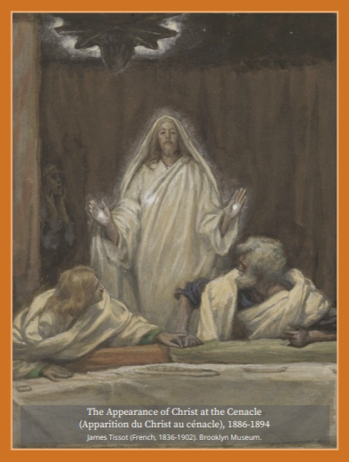

Doors bolted shut
Last Supper dishes still not washed up
wine-drunk flies buzzing to get out
ten men frightened and numb
humbled by fear, failure and doubt
bewildered by the women’s empty tomb reports
vigilant to the threat prowling outside
of their own arrest, torture and death
waiting for the coast to clear
waiting to be somewhere, anywhere but here…

Then it happens.
From nowhere, without a bolt loosened
a handle turned or roofing removed
Jesus appears
standing before them
radiant, risen, real?
Ecstasy and agony. Shock and awe.
Fresh fragrant air
flooding the fetid fractious lair
before any can speak
he raises his hand in blessing and prayer
and softly says the word they need to hear
‘Shalom’.

And again ‘Shalom’
the gift they most urgently desire
peace from guilt and shame
peace from never knowing hope again
once more his ‘Shalom’ drenches
and softens their broken, beaten hearts.
Moving closer, mercy-eyed
he shows them his hands and his side
healing miracle-making hands
now punctured and torn by hammered iron nails
and his side gashed and gouged
but now somehow glorious, victorious…

In the wounds of death they see new life
the defeated Jesus becomes the Risen Christ
who now holds them with his eyes and says
“As the Father sent me so am I sending you.
No more locked doors, no more hiding in fear
your mission is to the world spreading out from here
and not in your own power
but in my Spirit’s way
to bring to all the mercy
I have shown to you this Resurrection day.
Break through the doors of sin and shame
and forgive others in my name.”

With this he breathes on them
igniting the Spirit’s fire
sparking to life in each an apostle’s desire.
Filled now with their Lord’s peace, purpose and power
the ten men run towards the bolted door
and with one pull burst out into the street
no longer afraid, no longer in retreat
but bold and hungry for souls
themselves risen from the dead, a radical rebirth
sent out, empowered
to renew the face of the earth.

Reflection
John 20: 19-23
How often does it happen in life that a physical place where we can experience pure spiritual grace can on another day be a place of defeat and failure. This was so true of the Upper Room. We need to remember that between its celebration of the Last Supper and the appearance of the Risen Christ to the shattered disciples, that special Jerusalem upper floor room, so carefully chosen and prepared by Jesus, also saw the days of the disciples’ deepest depression. Everything they had believed in and worked for lay in ruins around them. They were holed up in this one room totally lost and vulnerable in the heart of this seething city which had just brutally put their Lord to death. Into this paralysis and trauma the risen Christ brings, in a matter of moments, new life, restored hope and renewed mission for life. Can you think of any “Upper Room experiences” which you have had in your own life?

Poem by Fr Richard Nesbitt, parish priest of White City in Hammersmith.
From Holy Week Voices of the Holy Land
For other Lenten poetry linked to Reconciliation see: HERE
I wonder…

Which piece of art helped you to engage most with learning about this sacrament?

Can you find inspiring pieces of artwork for Reconciliation or other sacraments?
Storybooks for Children

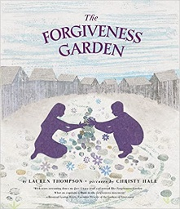
The Forgiveness Garden Lauren Thompson
A long time ago and far away--although it could be here, and it could be now--a boy threw a stone and injured a girl. For as long as anyone could remember, their families had been enemies, and their towns as well, so it was no surprise that something bad had happened. Hate had happened. Revenge had happened. And that inspired more hate and more calls for revenge. But this time, a young girl decided to try something different...

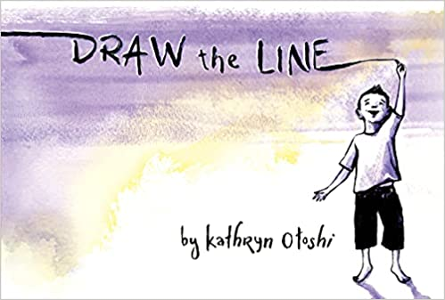

Draw the Line by Kathryn Otoshi
When two boys draw their own lines and realize they can connect them—magic happens! A misstep causes their lines to get crossed, and soon their line unravels into an angry tug-of-war. With a growing rift between them, will the boys find a way to come together again? Kathryn Otoshi’s book is a multi-layered statement about friendship, boundaries, and healing after conflict.

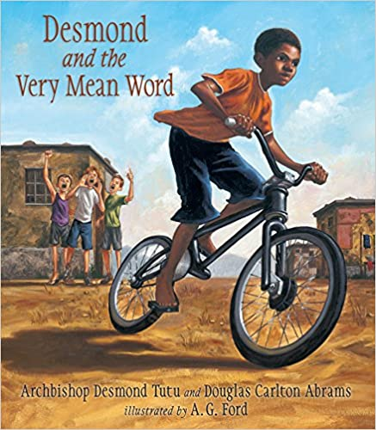
Desmond and the very mean word
by Desmond Tutu and Douglas Carlton Abrams
Based on a true story from Archbishop Desmond Tutu’s childhood in South Africa, Desmond and the Very Mean Word reveals the power of words and the secret of forgiveness.

Top 10 books about forgiveness for children
https://bookroo.com/explore/books/topics/forgiveness

Prayers for Reconciliation

Acts of Contrition (Sorrow)
There are many versions of this, a few of which are included below. However, the most important thing is that you say a prayer of sorrow that is genuine; it can be a known one or a spontaneous one.
O my God
Because you are so good
I am very sorry that I have sinned against you
And with the help of your grace I will not sin again.
Amen.

O my God
I thank you for loving me
I am sorry for all my sins
For not loving others and not loving you
Help me to live like Jesus
And not sin again.
Amen.
For some other Acts of Contrition see Vatican news
Other prayers about forgiveness include:
- The Our Father
- Make me a channel of your peace (Prayer of St Francis)

Saints
Saints
- St Oliver Plunkett – Patron saint of peace and reconciliation
- St Maria Goretti – Patron saint of forgiveness
- St Francis of Assisi – A man of peace and forgiveness
- St Josephine Bakhita – An excellent example of forgiveness
Saints who spent a long time hearing confession:

Saint John Vianney, le Curé d'Ars
- St Padre Pio
- St Leopald Mandic
- St Philip Neri
- St Joseph Cafasso
For a slideshow of 5 saints who spent extremely long hours hearing confession see Aleteia.org
Topic Grids

The following Come and See topic grids are used for Summer Term Reconciliation Year 3, Year 4, Year 5 and Year 6 and all resources can be taken from the Nottingham Diocese website which can be found HERE. However, they may be of use to anyone teaching and learning about this topic.

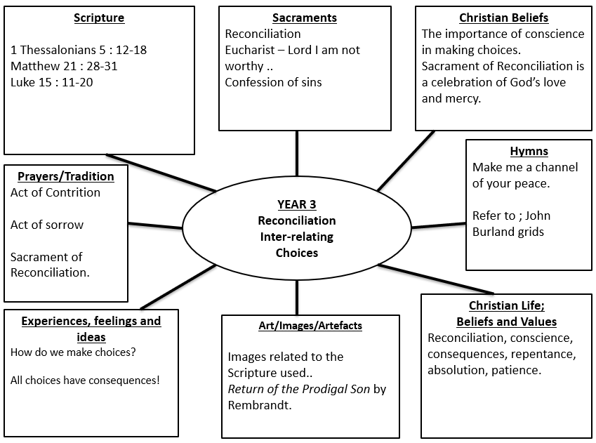

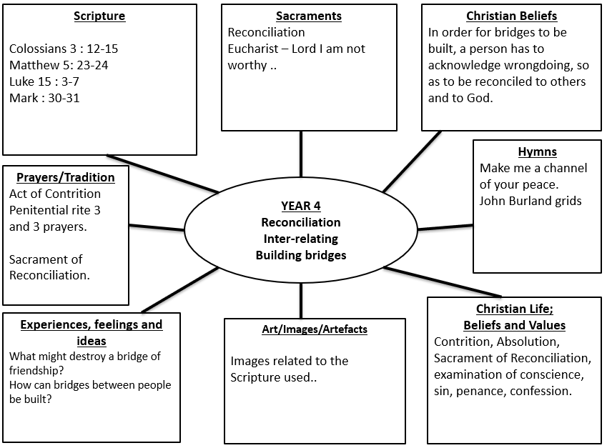
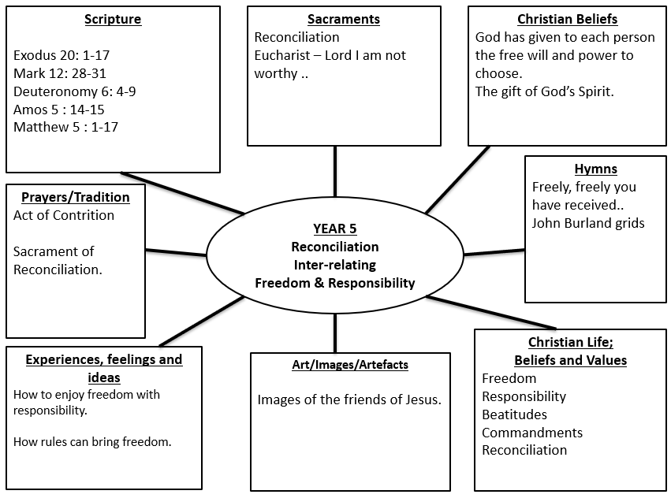

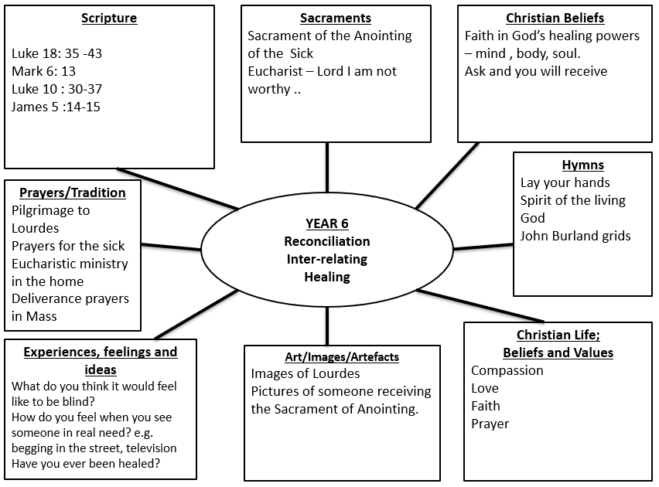
Charities
Saints
AID TO THE CHURCH IN NEED

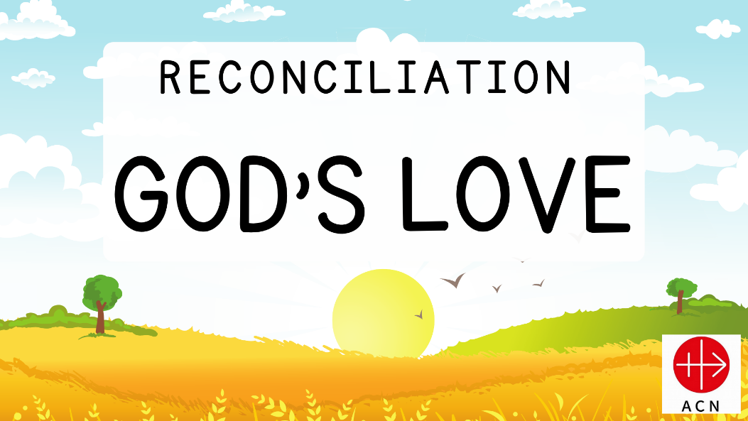
Click on presentations below. If you would like a PowerPoint version, please contact marie.fahy@acnuk.org
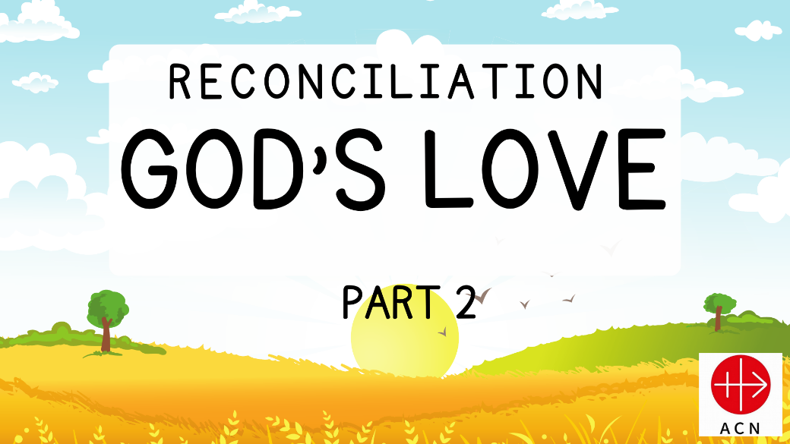

Activities

Please click on the images below get the full-size versions for print. If you would rather black and white versions for any of these resources for pupils to colour, please contact marie.fahy@acnuk.org

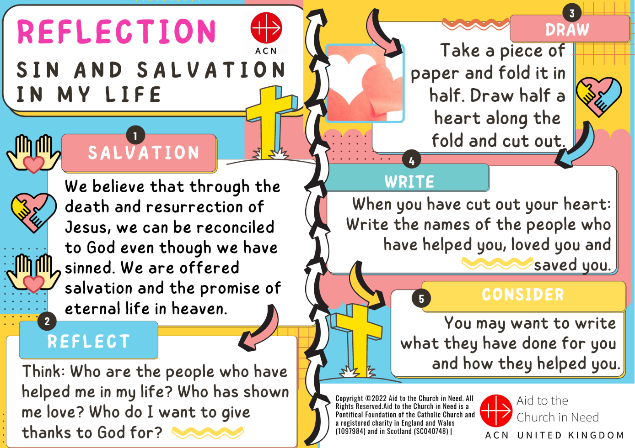

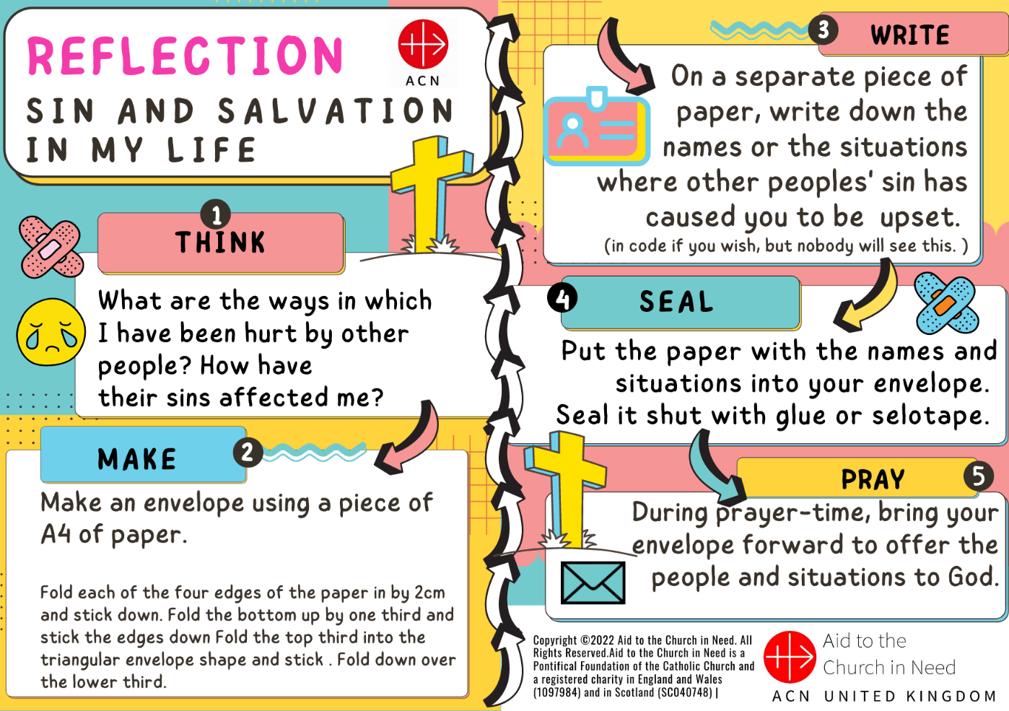
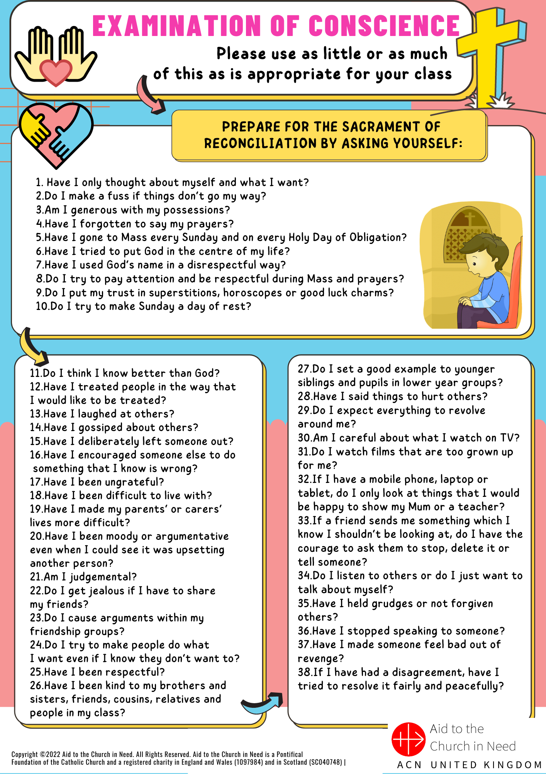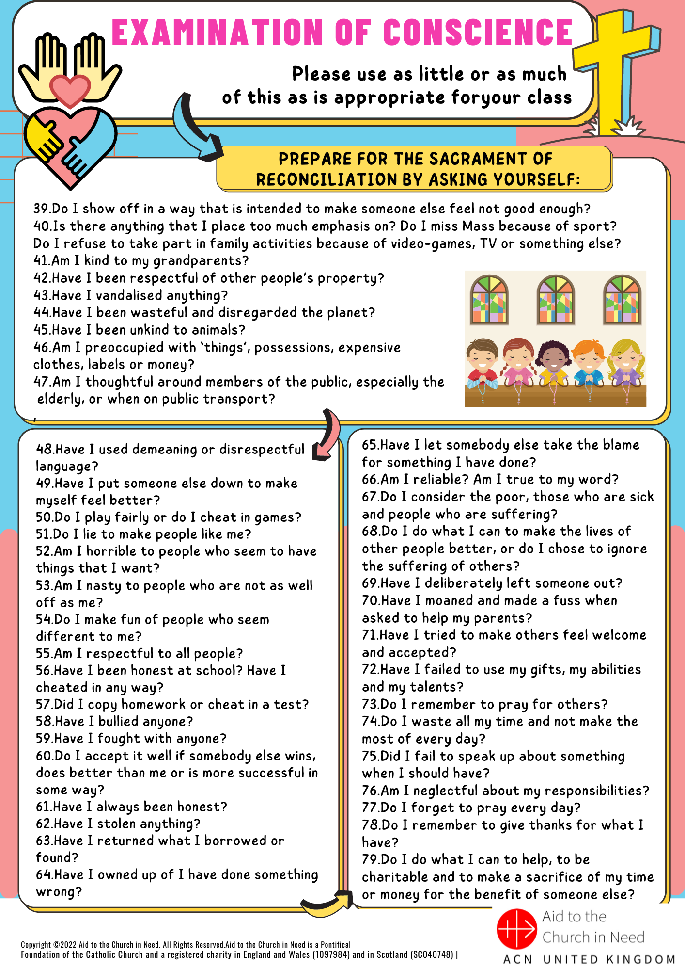
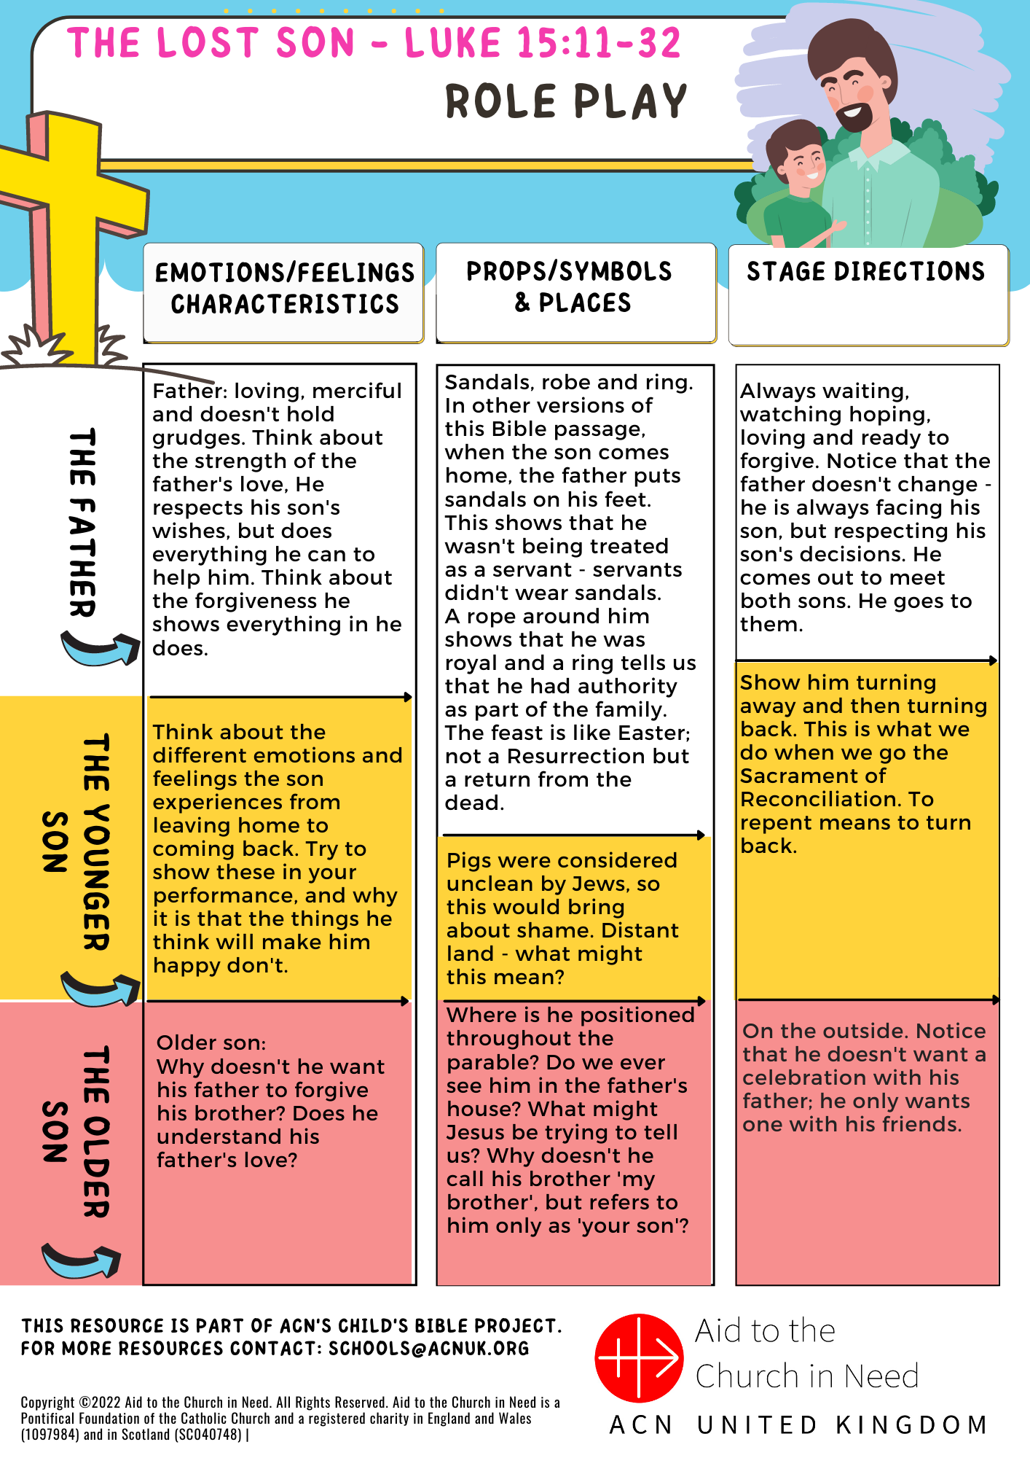
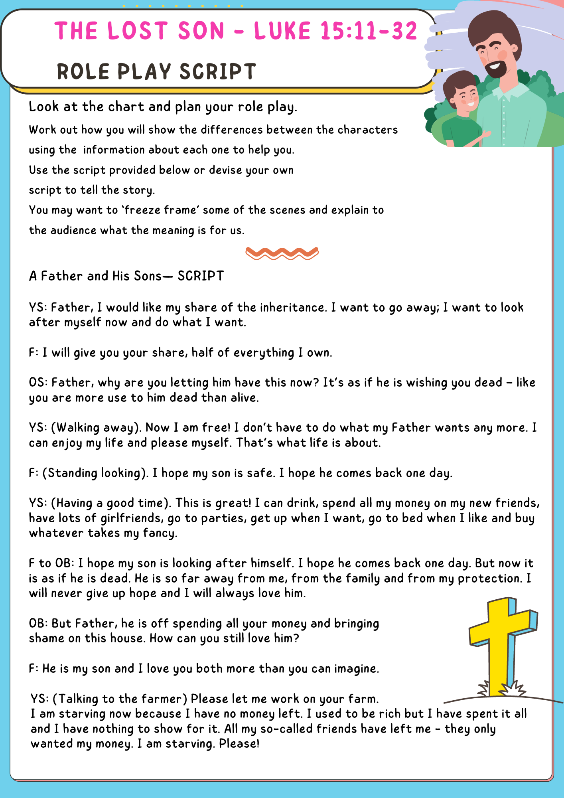
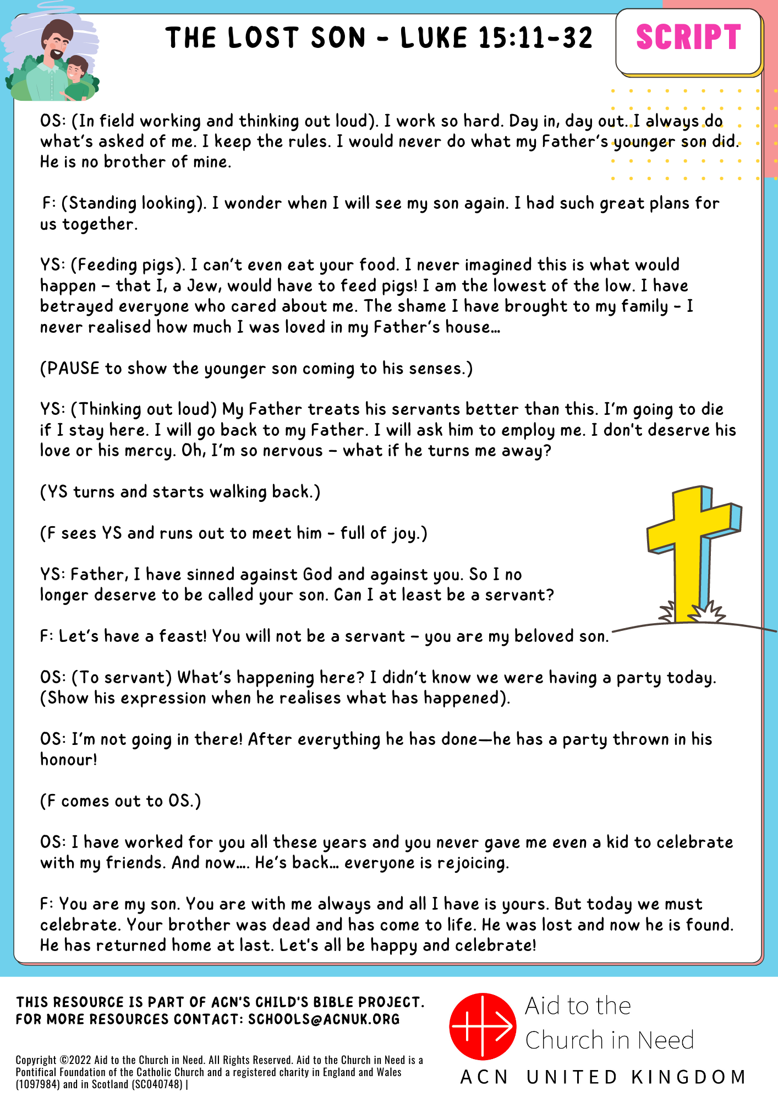

CAFOD

CAFOD has a variety of resources on this theme, some of which are included below:

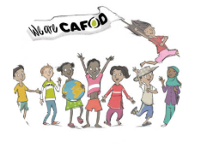
Reconciliation Service for Young People: This service has a global justice theme, so works well after a session or retreat on justice
A reflection on Reconciliation and healing: a gift from God
Secondary and youth resources - Peace and conflict

Sources

Images
All images from Pixabay

Books
All Bible references are from the New Revised Standard Version
Catechism of the Catholic Church
YouCat: Youth Catechism of the Catholic Church
YouCat for Kids
Catholic Foundation Stones by Archbishop John Wilson and Fr Andrew Allman

Websites

https://catholiccourier.com/articles/a-glossary-of-penance-terms/https://www.bbc.co.uk/bitesize/guides/zh4f3k7/revision/5
http://www.beginningcatholic.com/sacrament-of-reconciliationhttps://www.biblestudytools.com/topical-verses/bible-verses-about-reconciliation/https://www.scripturecatholic.com/sacrament-confession-forgiveness-sins/
https://holyspiritchurch.org/sacrament-reconciliation-living-lit/
https://www.archspm.org/faith-and-discipleship/catholic-faith/what-did-jesus-teach-about-forgiveness/
https://www.dioceseofnottingham.uk/education/primary-re/come-and-see/topic-webs-key-stage-2
Other websites and videos used are included in the text.

With thanks to:
Fr Terry Tastard (Diocesan Censor)
Fr Richard Nesbitt
Agency of Evangelisation (Westminster)
CAFOD
Aid to the Church in Need (CAN)

