Racial Justice, Equality and Diversity in Sacred Scripture

Contents

- Introduction 2
- The purpose of this document 4
- What does the Bible say about race? 5
- What does the Bible say about Justice? 9
- What does the Bible say about equality? 11
- What does the Bible say about diversity? 13
- References 15

Introduction

From the beginning to the end of Sacred Scripture, God is present for all of humanity. In Genesis we hear how he made each one in his own image (Genesis 1:27) and in Revelation we are reminded that each one will be judged according to their deeds when they meet him face to face (Revelation 10:13). God does not discriminate: each person is equally called and valued and no-one can escape his infinite love and mercy. He is also fair and unbiased, protecting his people, especially those who are disadvantaged or suffering.

God’s call to justice and mercy have been unequivocally clear. It has been written in the Law and spoken by the Prophets. Micah summarises it in this phrase:

Act justly, love kindly and walk humbly with your God. (Micah 6:8)

Mary praises God for his acts of justice and kindness in her song, the Magnificat (Luke 1:46-55):

The Almighty works marvels for me, holy is his name
His mercy is from age to age on those who fear him
He puts forth his arm in strength and scatters the proud-hearted
He casts the mighty from their thrones and raises the lowly
He fills the starving with good things and sends the rich away empty
He protects Israel his servant, remembering his mercy
The mercy promised to our fathers, to Abraham and his sons forever.

Ultimately, God’s message of justice, mercy and love are personified in his only Son, Jesus Christ. Through all of his words and actions, Christ shows how the Father loves each person in abundance and unconditionally, calling each one him to himself. Jesus demonstrates this through his many miracles, he speaks about it in his parables and he teaches us the values and attitudes (the Beatitudes in Matthew 5:3-12) to live a good and holy life like him. Jesus also gives us a new commandment: to love one another (John 15:12). In all that he does, Christ promotes love, justice and equality; he never discriminates, excludes or devalues others.
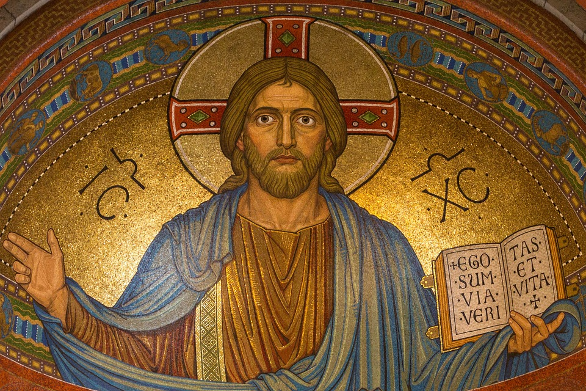

Jesus’ birth itself demonstrates that people from all nations, races, ages and social standings are valued: Mary, a young peasant girl is chosen to be the mother of the Most High (Luke 1:39-56); the humble carpenter, Joseph receives messages from God in a dream to take Mary as his wife and look after her child (Matthew 1:18-25); the poor shepherds are invited by the angels to attend the birth of the Messiah (Luke 2:8-20); while rich and wise men from the East are called in their own way to follow a star (Matthew 2:1-12). God has no boundaries, no prejudices and no limitations (Luke 1:37).

In Luke, we hear about Jesus’ mission:

“The Spirit of the Lord is on me, because he has anointed me to proclaim good news to the poor. He has sent me to proclaim freedom for the prisoners and recovery of sight for the blind, to set the oppressed free. (Luke 4:18)

From the very beginning of his ministry, therefore, Jesus highlights the importance of valuing the dignity of each individual and he has a particular love for those who are downtrodden or abandoned. He teaches us to take a stand against any injustice, intolerance or inequality and to do what is right:

“Blessed are those who hunger and thirst for righteousness, for they will be filled”. (Matthew 5:6)

Jesus’s disciples were diverse in many ways: politically, educationally and financially as well as in temperament. Yet, Jesus gives them all the one commandment to follow:

“By this everyone will know that you are my disciples, if you have love for one another.” (John 13:35)

It is this commandment that he gives to Christians everywhere. By observing this rule, it means that there will be no place for racial injustice, inequality or lack of diversity. Instead, there will be a world of tolerance, respect, compassion and mercy.
However, throughout human history, people have not always obeyed God’s law of love but have used race and ethnicity to differentiate themselves from others. Instead of recognising the image of God in one another, people have elevated their racial and ethnic group over others and this has led to violence, suffering and great injustice.

The purpose of this document

The purpose of this document is to make it clear that in Sacred Scripture God does not represent or justify racism or ethnocentrism of any kind. He created each human being in his own image and sent Jesus to redeem all people. Christ calls his Church (the people of God) to act impartially and reflect the diversity of heaven in both its membership as well as its mission to the nations.
This document is split into several sections:
- What does the Bible say about race?
- What does the Bible say about justice?
- What does the Bible say about equality?
- What does the Bible say about diversity?
Each of these areas include direct quotations from Sacred Scripture, although none of the lists are exhaustive, as it is hoped that these will act as a springboard for research or stimulus for conversations with pupils so that they can then take actions for racial justice, equality and diversity. There are also some links to Bible stories which can be followed up in more detail. At the back of the document, the reference list is included and these links might offer further support for research.
Further areas to explore which are not included in detail this document include:
- Gospel values (for example Gospel Values for Catholic Schools Friel)
- Virtues (for example Formation in Virtues CES)
- Parables (such as The Good Samaritan)
- Beatitudes

What does the Bible say about race?

We are made in the image of God

Genesis 1:27 So God created humankind in his image, in the image of God he created them; male and female he created them.

The creation of all human beings in the image of God is the fundamental principle of human dignity and equality. It is also the basis of the sanctity of life. This piece of Scripture tells us that all humanity without exception, has inherent worth that comes from God alone.

We are equally created and equally blemished

Romans 5:12 Therefore, just as sin came into the world through one man, and death came through sin, and so death spread to all because all have sinned.

Original sin, brought into the world by Adam and Eve, affected all of humanity. In this letter, St Paul reminds us that no race or ethnicity is more valued or more sinful than the others. Instead, all are equally worthy, and all are equally blemished and in need of a Saviour.
God has impartial judgement

Romans 2:11 For God shows no partiality.

St Paul reminds us that all humanity, without exception, stands guilty before God deserving his judgment. Scripture teaches us that God is an impartial judge who is not swayed or biased like humans are.
God plans for a great nation
Genesis 12:1-7 I will make of you a great nation, and I will bless you, and make your name great, so that you will be a blessing. I will bless those who bless you, and the one who curses you I will curse; and in you all the families of the earth shall be blessed” …Then the Lord appeared to Abram, and said, “To your offspring I will give this land.” So he built there an altar to the Lord, who had appeared to him.
In this piece of Scripture, the narrative turns from the nations to one nation - descendants of Abraham (Israel). God chose Abraham and his descendants to bless the nations. His election is missional meaning that Abraham has been given a special role by God for the good of all people. This mission is not one of partiality or showing favouritism of one people over another. Instead, it shows that God’s people are many and diverse.

God tells us to love foreigners and treat them with impartiality

Leviticus 19:33-34 “Do not mistreat foreigners who are living in your land. Treat them as you would an Israelite, and love them as you love yourselves. Remember that you were once foreigners in the land of Egypt. I am the Lord your God.”

This piece reinforces the message that God is impartial and desires to bless the nations, He commands Israel, his chosen people, to love foreigners and treat them impartially. The term foreigners refers to anyone who is different or ‘alien’ in any way.

God’s kingdom is for all nations

Acts 17:26 From one ancestor he made all nations to inhabit the whole earth…

Although Scripture focuses mainly on Israel, God’s chosen people, this does not mean that God was not aware or involved other groups of people and their history. In saying this (above), Paul was echoing the teaching of the Old Testament prophets. They viewed the kingdom of God as extending to all nations as opposed to merely Israel.
Jesus is a Saviour for all

Isaiah 42:1-7 Here is my servant, whom I uphold, my chosen, in whom my soul delights; I have put my spirit upon him; he will bring forth justice to the nations… He will not grow faint or be crushed until he has established justice in the earth; and the coastlands wait for his teaching… I am the Lord, I have called you in righteousness, I have taken you by the hand and kept you; I have given you as a covenant to the people.
Prophets from the Old Testament foretold the coming of a king from the line of David who would fulfil God’s promises to all nations as well as Israel. This highlights the importance of justice and righteousness in the Lord’s eyes. Matthew’s Gospel quoted this prophecy (above) and stated that Jesus fulfilled it.

Christ does not discriminate

Romans 3:22-24 The righteousness of God through faith in Jesus Christ for all who believe. For there is no distinction, since all have sinned and fall short of the glory of God; they are now justified by his grace as a gift, through the redemption that is in Christ Jesus.

This letter from St Paul reminds us that Christ does not discriminate in his offer of salvation to humanity. It highlights that Christ made atonement for all and that this gift of salvation is open to all without exception.

The Spirit is for all

Acts 2:4 All of them were filled with the Holy Spirit and began to speak in other languages, as the Spirit gave them ability.

Not only does Christ offer justification to all races and ethnicities, but he also freely and impartially pours out his Holy Spirit. The words above remind us what happened at Pentecost when Luke told the story about the spread of the Gospel to the end of the earth. This meant that God was including new members into the community, the body of Christ. When St Peter reflected on this event he said:

“God, who knows the heart, showed that he accepted them by giving the Holy Spirit to them, just as he did to us. He did not discriminate between us and them, for he purified their hearts by faith”
(Acts 15:8–9)
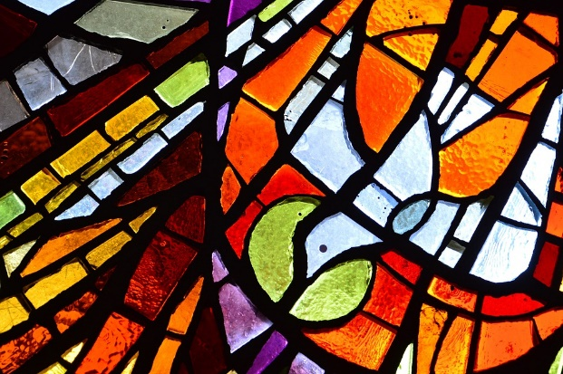

We are one in Christ

Galatians 3:28 There is no longer Jew or Greek, there is no longer slave or free, there is no longer male and female; for all of you are one in Christ Jesus.

Baptism unites us to Christ’s death and resurrection, and we are justified by faith. This means that race and ethnicity cannot be used to distinguish membership in the body of Christ. This is made clear in the Bible reference above which also shows that neither biological nor socioeconomic status can be used to win (or lose) favour of the Lord. Being united in the body of Christ renders these identity markers useless.
Jesus told his followers to make disciples of all nations

Matthew 28:18-20 And Jesus came and said to them, ‘All authority in heaven and on earth has been given to me. Go therefore and make disciples of all nations, baptising them in the name of the Father and of the Son and of the Holy Spirit, and teaching them to obey everything that I have commanded you. And remember, I am with you always, to the end of the age.

Jesus is the Messiah of all nations and he will judge all people impartially. Because we are all sinners and because he died for all of humanity and poured out his Spirit on all flesh, the Church has been given the mandate to take the Gospel to every nation. This is the point of the Great Commission given by Jesus to his disciples just before his Ascension into heaven and shown above. This emphasises the need for all of his people to both hear the word and follow his teaching. Not only is Jesus with his disciples; he is with all those who believe in him and follow his commandments regardless of their nationality, colour or background.

A multitude from every nation is foretold

Revelation 7:9-10 After this I looked, and there was a great multitude that no one could count, from every nation, from all tribes and peoples and languages, standing before the throne and before the Lamb, robed in white, with palm branches in their hands. They cried out in a loud voice, saying, ‘Salvation belongs to our God who is seated on the throne, and to the Lamb!’

The book of Revelation predicts the final days of our human history in which a multitude of people stand before the Lord. This teaches us that all are welcome in the worship of the Lord, in being redeemed by him and in his judgement at the end of time. Each race, each tribe, each nation, each people is included in this final assembly; no-one is excluded and everyone is relevant.

For other Bible stories and teachings to follow up with pupils at an age-appropriate level see:
- Amos 8:4-7 – The prophet Amos was furious with God’s people of his day because they worshipped God but cheated the poor
- 1 Kings 21 – The story of Naboth’s vineyard describes God’s concern for ‘the little man’, who is exploited by those with power and money
- Luke 16:19-31 – The parable of the rich man and Lazarus condemns those who deny justice to the poor around them
- Matthew 21:12-13 – Jesus himself was angry at the way the courtyard in the temple of Jerusalem had been turned into a marketplace where traders made money by taking advantage of others
- Matthew 25:31-45 – In the parable of the sheep and the goats, Jesus teaches that by acting justly for the poor, the weak and vulnerable we are loving and serving God
- Throughout his whole life, Jesus upheld the rights of the marginalised both in his stories and his miracles: such as the outsider (the Good Samaritan); the outcast (the leper); the unfairly treated (women, children and non-Jews).
- Luke 18:1-8 – The parable of the unjust judge is a parable told by Jesus about a judge who did not fear God, nor care for his fellow man. Jesus’ message is that God will always grant them justice. It also teaches us to never give up.

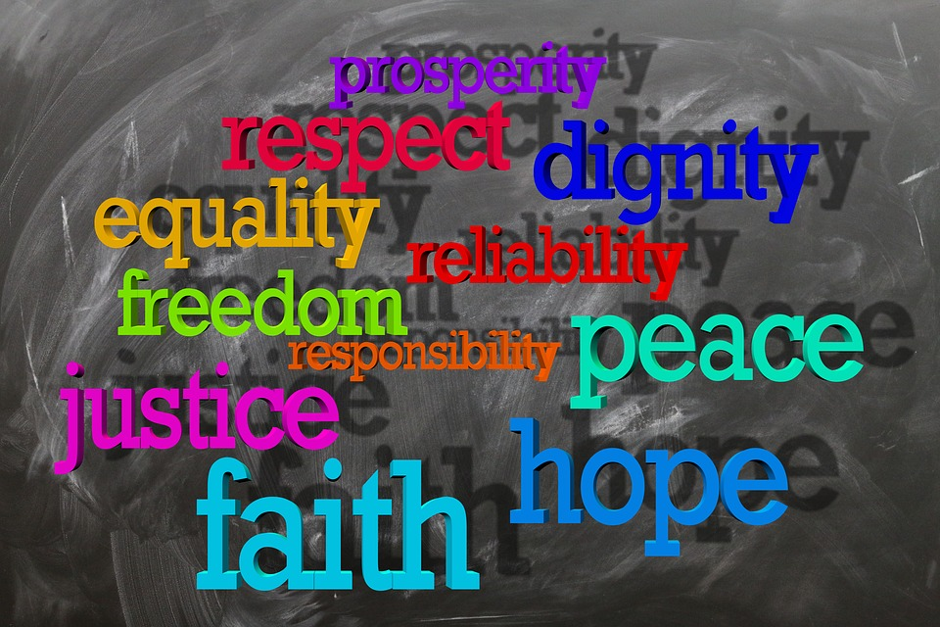

What does the Bible say about Justice?

Micah 6:8 He has told you, O mortal, what is good; and what does the Lord require of you but to do justice, and to love kindness, and to walk humbly with your God?

Hosea 12:6 So now, descendants of Jacob, trust in your God and return to him. Be loyal and just, and wait patiently for your God to act.

Proverbs 21:15 When justice is done, good people are happy, but evil people are brought to despair.

Amos 5:24 But let justice roll on like a river, righteousness like a never-failing stream!

Isaiah 1:17 Learn to do right; seek justice. Defend the oppressed. Take up the cause of the fatherless; plead the case of the widow.

Isaiah 30:18-19 And yet the Lord is waiting to be merciful to you. He is ready to take pity on you because he always does what is right. Happy are those who put their trust in the Lord.
You people who live in Jerusalem will not weep any more. The Lord is compassionate, and when you cry to him for help, he will answer you.

Isaiah 61:8-9 The Lord says, "I love justice and I hate oppression and crime. I will faithfully reward my people and make an eternal covenant with them. They will be famous among the nations; Everyone who sees them will know That they are a people whom I have blessed."

Psalm 34:17-18 When the righteous cry for help, the Lord hears, and rescues them from all their troubles. The Lord is near to the broken-hearted, and saves the crushed in spirit.

Psalm 106:3 Happy are those who obey his commands, who always do what is right.

Zechariah 7:9 "Long ago I gave these commands to my people: "You must see that justice is done, and must show kindness and mercy to one another.

Deuteronomy 16:20 Always be fair and just, so that you will occupy the land that the Lord your God is giving you and so that you will continue to live there.

Leviticus 19:15 “Do not pervert justice; do not show partiality to the poor or favouritism to the great, but judge your neighbour fairly.

Ecclesiastes 3:17 I said in my heart, God will judge the righteous and the wicked, for he has appointed a time for every matter, and for every work.

Jeremiah 22:3 Thus says the Lord: Act with justice and righteousness, and deliver from the hand of the oppressor anyone who has been robbed.

Deuteronomy 32:4 The Rock, his work is perfect, and all his ways are just. A faithful God, without deceit, just and upright is he;

Jeremiah 23:5 The days are surely coming, says the Lord, when I will raise up for David a righteous Branch, and he shall reign as king and deal wisely, and shall execute justice and righteousness in the land.

Luke 4:18-19 ‘The Spirit of the Lord is upon me, because he has anointed me to bring good news to the poor. He has sent me to proclaim release to the captives and recovery of sight to the blind, to let the oppressed go free, to proclaim the year of the Lord’s favour.’

1 John 3:17-18 How does God’s love abide in anyone who has the world’s goods and sees a brother or sister in need and yet refuses help? Little children, let us love, not in word or speech, but in truth and action.

What does the Bible say about equality?

Genesis 1:27 So God created humankind in his image, in the image of God he created them; male and female he created them.

Deuteronomy 10:17 For the Lord your God is God of gods and Lord of lords, the great God, mighty and awesome, who is not partial and takes no bribe…

Psalms 67:4 “Let the nations be glad and sing for joy, for you judge the peoples with equity and guide the nations upon earth.”

Psalm 139:13-14 For it was you who formed my inward parts; you knit me together in my mother’s womb. I praise you, for I am fearfully and wonderfully made. Wonderful are your works; that I know very well.

Proverbs 2:9-10 “Then you will understand righteousness and justice and equity, every good path; for wisdom will come into your heart, and knowledge will be pleasant to your soul.”

Leviticus 19:33-34 “Do not mistreat foreigners who are living in your land. Treat them as you would an Israelite, and love them as you love yourselves. Remember that you were once foreigners in the land of Egypt. I am the Lord your God.”
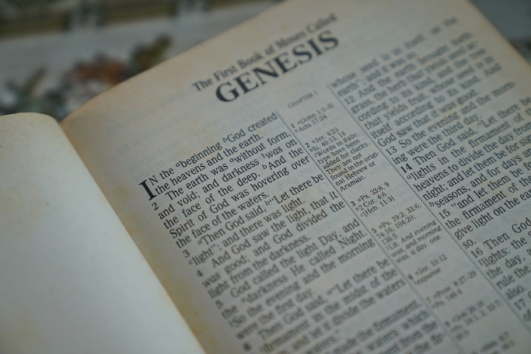

Matthew 7:12 ‘In everything do to others as you would have them do to you; for this is the law and the prophets.

Mark 12:31 The second is this, “You shall love your neighbour as yourself.” There is no other commandment greater than these.’

Acts 17:26 From one ancestor he made all nations to inhabit the whole earth…

Galatians 3:28 There is no longer Jew or Greek, there is no longer slave or free, there is no longer male and female; for all of you are one in Christ Jesus.

Romans 2:11 For God shows no partiality.

Romans 10:12 The same Lord is Lord of all and is generous to all who call on him.

Colossians 3:11 Christ is all and in all!

Philippians 2:1-3 If then there is any encouragement in Christ, any consolation from love, any sharing in the Spirit, any compassion and sympathy, make my joy complete: be of the same mind, having the same love, being in full accord and of one mind. Do nothing from selfish ambition or conceit, but in humility regard others as better than yourselves.

James 2:8-9 You do well if you really fulfil the royal law according to the scripture, ‘You shall love your neighbour as yourself.’ But if you show partiality, you commit sin and are convicted by the law as transgressors.

Ephesians 2:10 For we are what he has made us, created in Christ Jesus for good works, which God prepared beforehand to be our way of life.

1 Timothy 5:21 In the presence of God and of Christ Jesus and of the elect angels, I warn you to keep these instructions without prejudice, doing nothing on the basis of partiality.

1 Peter 2:9 But you are a chosen race, a royal priesthood, a holy nation, God’s own people,[a] in order that you may proclaim the mighty acts of him who called you out of darkness into his marvellous light.

1 Peter 4:10-11 Like good stewards of the manifold grace of God, serve one another with whatever gift each of you has received. Whoever speaks must do so as one speaking the very words of God; whoever serves must do so with the strength that God supplies, so that God may be glorified in all things through Jesus Christ. To him belong the glory and the power for ever and ever. Amen.

What does the Bible say about diversity?

Romans 12:5 So in Christ we, though many, form one body, and each member belongs to all the others.
1 Corinthians 12:12-14 For just as the body is one and has many members, and all the members of the body, though many, are one body, so it is with Christ. For in the one Spirit we were all baptised into one body—Jews or Greeks, slaves or free—and we were all made to drink of one Spirit. Indeed, the body does not consist of one member but of many.
Colossians 1:16-17 For in him all things in heaven and on earth were created, things visible and invisible, whether thrones or dominions or rulers or powers—all things have been created through him and for him. He himself is before all things, and in him all things hold together.
James 2:1-4 My brothers and sisters, do you with your acts of favouritism really believe in our glorious Lord Jesus Christ? For if a person with gold rings and in fine clothes comes into your assembly, and if a poor person in dirty clothes also comes in and if you take notice of the one wearing the fine clothes and say, ‘Have a seat here, please’, while to the one who is poor you say, ‘Stand there’, or, ‘Sit at my feet’, have you not made distinctions among yourselves, and become judges with evil thoughts?
2 Corinthians 5:19 That is, in Christ God was reconciling the world to himself, not counting their trespasses against them, and entrusting the message of reconciliation to us.
Colossians 1:19-20 For in him all the fullness of God was pleased to dwell, and through him God was pleased to reconcile to himself all things, whether on earth or in heaven, by making peace through the blood of his cross.
John 15:26 When the Advocate comes, whom I will send to you from the Father, the Spirit of truth who comes from the Father, he will testify on my behalf.
Mark 10:6 But from the beginning of creation, “God made them male and female.”
Psalm 139:13–16 For it was you who formed my inward parts; you knit me together in my mother’s womb. I praise you, for I am fearfully and wonderfully made. Wonderful are your works; that I know very well. My frame was not hidden from you, when I was being made in secret, intricately woven in the depths of the earth. Your eyes beheld my unformed substance. In your book were written all the days that were formed for me, when none of them as yet existed.

Genesis 11:9 Therefore it was called Babel, because there the Lord confused the language of all the earth; and from there the Lord scattered them abroad over the face of all the earth.

Genesis 9:1 God blessed Noah and his sons, and said to them, ‘Be fruitful and multiply, and fill the earth.
Revelation 7:9 After this I looked, and there was a great multitude that no one could count, from every nation, from all tribes and peoples and languages, standing before the throne and before the Lamb, robed in white, with palm branches in their hands.
Revelation 5:9 They sing a new song: ‘You are worthy to take the scroll and to open its seals,
for you were slaughtered and by your blood you ransomed for God saints from every tribe and language and people and nation;
Revelation 4:11 ‘You are worthy, our Lord and God, to receive glory and honour and power, for you created all things, and by your will they existed and were created.’

Colossians 1:16 For in him all things in heaven and on earth were created, things visible and invisible, whether thrones or dominions or rulers or powers—all things have been created through him and for him.

Ephesians 4:3 Making every effort to maintain the unity of the Spirit in the bond of peace.

Galatians 3:28 There is no longer Jew or Greek, there is no longer slave or free, there is no longer male and female; for all of you are one in Christ Jesus.

John 17:10 All mine are yours, and yours are mine; and I have been glorified in them. And now I am no longer in the world, but they are in the world, and I am coming to you. Holy Father, protect them in your name that you have given me, so that they may be one, as we are one.
John 17:20 ‘I ask not only on behalf of these, but also on behalf of those who will believe in me through their word, that they may all be one. As you, Father, are in me and I am in you, may they also be in us, so that the world may believe that you have sent me. The glory that you have given me I have given them, so that they may be one, as we are one, I in them and you in me, that they may become completely one, so that the world may know that you have sent me and have loved them even as you have loved me.
John 17:25‘Righteous Father, the world does not know you, but I know you; and these know that you have sent me. I made your name known to them, and I will make it known, so that the love with which you have loved me may be in them, and I in them.’
Ephesians 4:5 One Lord, one faith, one baptism…

Ephesians 4:32 And be kind to one another, tender-hearted, forgiving one another, as God in Christ has forgiven you.

Philippians 2:4 Let each of you look not to your own interests, but to the interests of others.

References

Bible Gateway: New Revised Standard Version, Anglicised Catholic Edition
https://www.openbible.info/topics/racism

https://influencemagazine.com/Theory/Twelve-Bible-Verses-About-Race-and-Ethnicity

https://sharedhope.org/2018/06/04/biblical-justice-and-social-justice/

https://www.google.com/amp/s/www.biblestudytools.com/topical-verses/bible-verses-about-justice/%3famp

https://www.brf.org.uk/product/exploring-values-with-the-bible-justice/

https://www.christiantoday.com/article/5-bible-verses-which-teach-us-to-celebrate-diversity/90602.htm

https://converge.org/article/new-testament-bible-verses-about-diversity

For more resources see https://racialjustice.rcaos.org.uk/

