The basic structure of the Mass
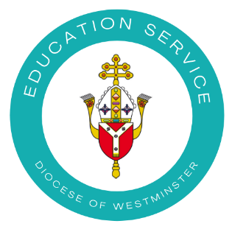

The celebration of the Eucharist has four parts: a beginning and an end and 2 central pillars (those marked * are included according to the nature of the feast or solemnity)
1. Introductory Rites
- Sign of the cross (In the name of the Father and of the Son and of the Holy Spirit)
- Penitential Rite (When we say sorry to God)
- [Gloria] (A song of praise used on feast days)*
2. Liturgy of the Word
- 1st reading (From the Old or New Testament)
- Responsorial Psalm (A Psalm from the Old Testament)
- [Second reading] (From the New Testament)
- Gospel Acclamation (To prepare for the Gospel)
- Gospel Reading (From St Matthew, St Mark, St Luke or St John)
- Homily (A short address by the bishop, priest or deacon)
- [Creed] (A statement of what we believe)
- Prayer of the Faithful (Bringing our prayers for different needs before God)

3. Liturgy of the Eucharist
- Preparation of the Altar and the Gifts (The bread and wine)
    - Eucharistic Prayer (Including the words of Jesus and prayer of Consecration)
- Lord's Prayer (The Our Father)
- Sign of Peace (Offering a gesture of peace to others)
- Breaking of the Bread
- Communion (Distribution of the Body and Blood of Christ)

4. Concluding Rite
- Blessing
- Dismissal (sending out)
Deacon or Priest: Go forth, the Mass is ended; Or, Go and announce the Gospel of the Lord; Or, Go in peace, glorifying the Lord by your life; Or simply, Go in peace.

All: Thanks be to God!
For a very simple version of this with explanation and images for children, see YouCat for Kids p122-125

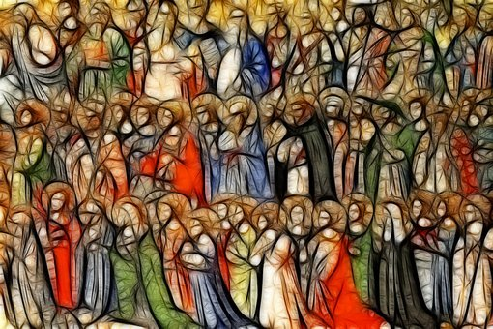

For more information about the structure of the Mass see
Q & A GUIDELINES FOR CELEBRATING SCHOOL MASSES https://education.rcdow.org.uk/wp-content/uploads/2020/04/Mass-Guidelines.pdf

