The Eucharist: A very brief overview
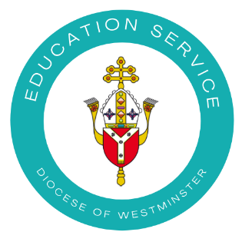

The Eucharist is hugely important to Catholics because we believe that Jesus Christ, the Son of the ever-living God, is truly present in the form of bread and wine; this is not merely symbolic but a present reality. The Mass is rich in meaning and tradition and is central to the Catholic faith. The Eucharist (or Mass) is the sacrament with which Catholics are most familiar. In their experience it is a beautiful and wonderful sacrament, often the centre of their spirituality. The Catechism of the Catholic Church says it is ‘a source of inexhaustible richness’.
Sometimes this sacrament can be misunderstood or underappreciated as there is so much to know about it, but this cannot be imparted in one or even many documents. Instead it is something to be lived and experienced. It is through the Eucharist that we strengthen our relationship with Christ himself, with others and with the Church because we join in ‘communion’ with him and the Church.
Here are some very basic concepts about the Eucharist which are explored further in Catholicism Unpacked: Eucharist which can be found HERE
- The Eucharist is also known as the Mass or Holy Communion.

- Jesus instituted the Eucharist at the Last Supper when he said, ‘Take and eat, this is my body. Take and drink, this is my blood. Do this in memory of me.’
- During the Mass we celebrate the life, death and resurrection of Jesus.
- Weekly Mass for Catholics occurs on a Sunday as it is the day of the resurrection. It is also a day of rest to keep holy.
- The Mass is divided into four parts: Introductory Rite, Liturgy of the Word, Liturgy of the Eucharist and Concluding Rite.

- During the first half, we have the first two parts: the Introductory Rite and the Liturgy of the Word. This is when we say sorry, give glory to God, listen to readings from the Bible, say prayers and recite what we believe in the Creed.
- During the second half, we have the other two rites: the Liturgy of the Eucharist and Concluding Rite. This is when we bring gifts to the altar over which many prayers are said, we offer peace and share Communion (the body and blood of Christ). At the end we are dismissed to go out to love and serve others.
- Catholics believe that during the most special part of the Mass (Consecration) the bread and wine truly become the Body and Blood of Christ (transubstantiation).
- After Mass, some of the consecrated bread (host) is reserved in a special box in the church called the tabernacle.
- When the Sanctuary Lamp is lit, it tells us that Jesus is present in the tabernacle in the form of bread which has been consecrated at Mass so that we can pray to/adore him.
- The Mass is similar in all Catholic churches over the world, just in different languages. The same readings and prayers are said, many of which are ancient, as they have their roots in Jewish scriptures and the New Testament.
- Only a priest/bishop can say Mass whereas a deacon can read the Gospel, preach and distribute Holy Communion. This is because it is the main and most important role of a priest.
- Other sacraments such as Baptism, Confirmation, Ordination and Marriage usually take part in a Mass whereas Reconciliation and the Sacrament of the Sick do not, although they do not need to be. This is because the Mass is so meaningful to Catholics. More information about each of the sacraments can be found in other Catholicism Unpacked documents HERE.

