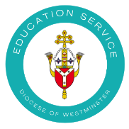
Mass Kit
This resource is to support schools with ensuring that the Mass kit contains everything necessary for the celebration of Mass in the school. It must be highlighted that it must be kept safely and in a special place to show due reference for this sacrament and also for health and safety reasons.
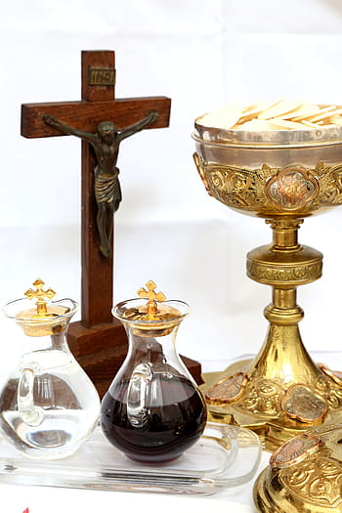
This contains:
- A crucifix
- Two candles (or battery-operated ones instead)
- A lavabo dish (for water for celebrant’s hands)
- Altar breads
- Altar wine
- Table cloth (for altar)
- Altar linens (see below)
- Cruets (two glass bottles for water and wine)
- Lectionary (check readings beforehand to see which lectionary you need. If it is ordinary time use the blue one (Vol II); if it is a feast day or season such as Lent/Advent use the red one (Vol I).

You will also need:
- Chalice and Ciborium (essential); Missal (essential); Lighter (if required) and fresh flowers
Altar Linens - white in colour
- Altar cloth – a simple table cloth kept particularly for Mass and not used otherwise
- Corporal (essential) –It is a large square cloth folded into nine sections upon which the chalice and paten are placed and where the consecration takes place
- Purificator (essential) – It is a rectangular cloth (folded into three) embroidered with a simple cross. One is used by priest and others made available for extra Ordinary Ministers of Holy Communion in giving out the Precious Blood to wipe the chalice
- Lavabo towel – used by priest to wash his hands. It is a small unmarked cloth.
- Pall (optional) – made of starched linen or fabric over card or wood. It is placed on top of the chalice to avoid dust or insets falling into it.

Washing altar linen
- The altar cloth and lavabo towel can be washed as normal.
- The altar linens that touch the Body and Blood of Christ, the corporal and purificatory, should be steeped in a bowl of water, rinsed and the water drained in the ground (not put down the sink). Afterwards they can be washed as normal.
- When we want to dispose of any old cloths, they must be burned and the ash put back into the ground. They cannot simply be thrown away/recycled.
Please ensure that all of the items are returned, bread and wine are replenished where necessary and that Mass cloths are washed after use.
NOTE: In the current context due to covid, extra Ordinary Ministers of Communion would only be distributing the host and therefore would not use the purificator.

For more information about what is needed at Mass see
Q & A GUIDELINES FOR CELEBRATING SCHOOL MASSES https://education.rcdow.org.uk/wp-content/uploads/2020/04/Mass-Guidelines.pdf

