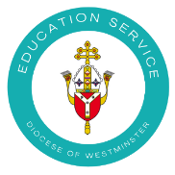
Mass Planning Sheet
Mass intention
Title/theme
Gathering hymn:
Gloria (said/sung):
Liturgy of the Word:
Alleluia (said/sung):
Offertory:

Prayers of the Faithful:

Acclamation (said/sung):
Our Father (said/sung):
Communion hymn(s):

Recessional hymn(s):

