Welcome Handbook
Diocese of Westminster Education Service
2022-2023

Contents

Welcome to our Catholic schools Page 2

A Catholic School Page 3

Our Diocesan Family Page 4

Your role as a teacher in a Catholic school Page 6

The Liturgical Year Page 7

The Mass as Source and Summit of Catholic Life Page 9

Prayer and Spirituality Page 11

Prayer Focus Page 13

Catholic Social Teaching Page 15

Requirements Page 16

Contact Details Page 17

Welcome to our Catholic schools

This is a short guide for all staff and governors in Catholic schools, especially those who are new to our schools and Catholic Education.

It is not a comprehensive document but rather it sets out to describe some fundamental principles of Catholic education, what might be expected of staff new to Catholic schools, and to offer tips on areas such as Catholic life, Catholic Social Teaching, and being part of a community of prayer.
We respect and value the past experiences and belief system that you bring to the school, and we hope you will find the opportunity to grow in your own spiritual way during your time here.

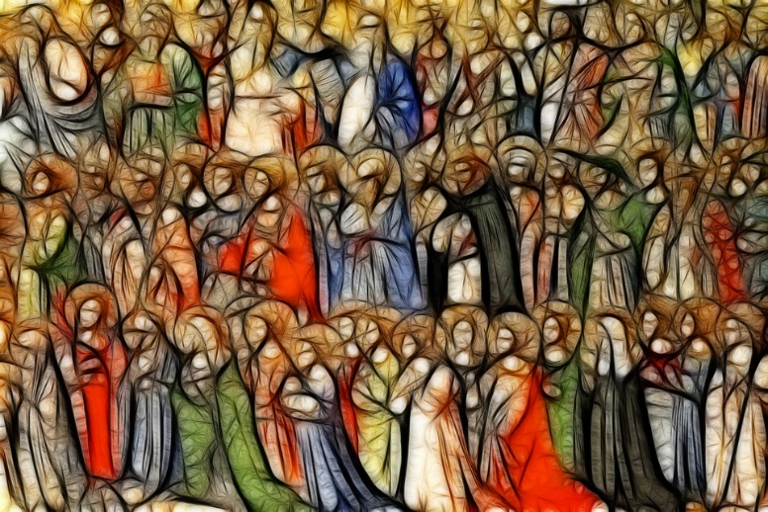

Very importantly, whoever you are, whatever your beliefs, values, certainties and uncertainties… We value you and thank you for being in our schools…
We need you and we appreciate your commitment and service to our schools. You are an important part of the jigsaw, as is everyone!

Help is always at hand from other members of staff, particularly clergy, chaplains, RE leaders and SLT as well as from the young people themselves.
We welcome and value all who teach in our schools and we pray that it is a positive experience for all in their mission to spread the love and joy of Christ.
For support see:
Raymond Friel: ‘How to Survive Teaching in a Catholic School’
ISBN 9780852314043
YouCat (Youth Catechism of the Catholic Church)
A Catholic School

- Offers a ‘Christian Curriculum’ reflecting a Catholic worldview
- Ensures quality provision for Religious Education and Faith Formation
- Ensures Catholic social and moral teaching
- Ensures space for prayer, liturgy and spirituality
- Has a sense of being a vibrant Christian community (Common Good and Human Flourishing)
- Facilitates Partnership and Community in our school (Ecclesiology)

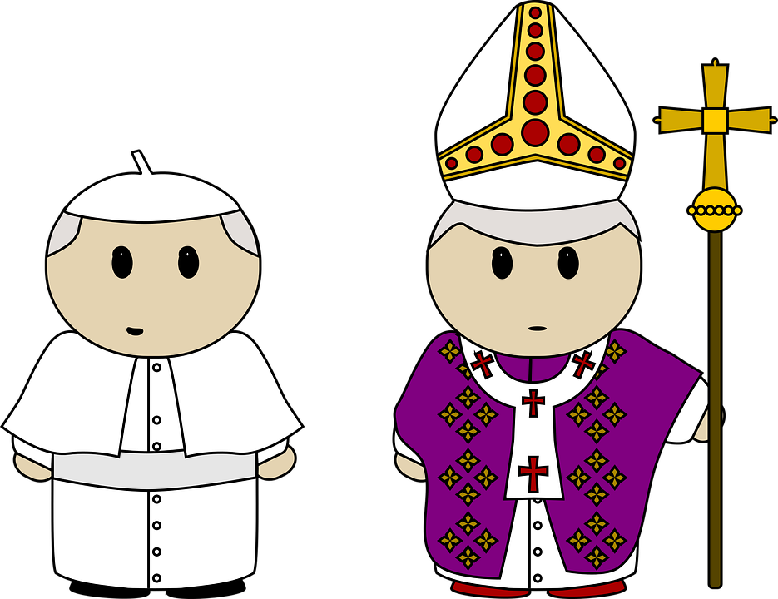

‘In your Catholic schools there is always a bigger picture, over and above the individual subjects you study, the different skills you learn. All the work you do is placed in the context of growing in friendship with God, and all that flows from that friendship. So you learn not just to be good students, but good citizens, good people…. Always remember that every subject you study is part of a bigger picture ... a good school provides a rounded education for the whole person. And a good Catholic school over and above all this should help all its students to become saints.’
Pope Benedict XVI 2010
Our Diocesan Family: The Education Service

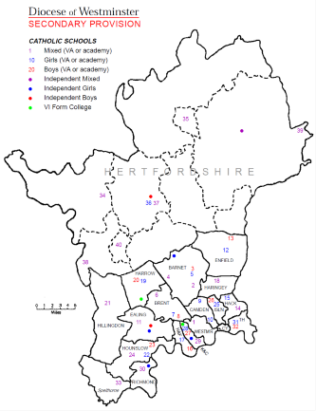
Our Diocesan Catholic Schools
You are part of the family!
•204 schools across the Diocese
•5000+ staff
•91,000+ pupils

Promoting ‘Gospel’ values and often ‘counter – cultural values’ to contemporary society

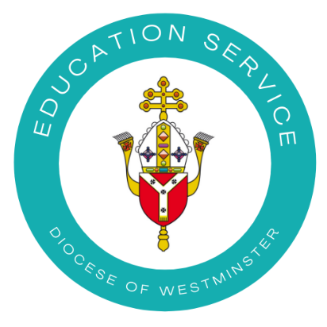
The Diocese of Westminster is divided into 20 deaneries and these are supported by the Education Service. These deaneries have been divided into regional hubs, each of which has a primary and secondary advisor.

Hub | Deaneries | Advisers
East | Camden, Enfield, Haringey, Islington, Tower Hamlets, Hackney | Elaine Arundell (primary)  Claire O’ Neill (secondary)
West | Upper Thames, Hounslow, Ealing, Hillingdon, Harrow | Claire O’Neill (primary and secondary)
Central | Barnet, Brent, Hammersmith and Fulham, Westminster, Kensington and Chelsea | Tony Gorton (primary)  Trisha Hedley (secondary)
Hertfordshire | Lea Valley, St Albans, Watford, Stevenage | Patrick Murphy (primary)  Trisha Hedley (secondary)

Our Diocesan Family: The Clergy

Bishops have the right to confirm and ordain members of the clergy, and their main duty is to supervise the clergy within their diocese. In the Catholic Church, the bishop is selected by the pope and receives confirmation in his office at the hands of an archbishop and two other bishops. In each diocese, the bishops are overseen by an archbishop. In Westminster this is Vincent Nichols who also serves as a cardinal.

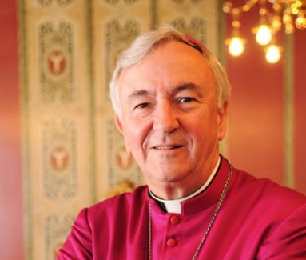 | Cardinal Vincent Nichols — First teacher  •providing sufficient Catholic Education in the Diocese  •supervision and inspection of all Catholic schools
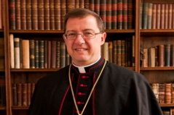  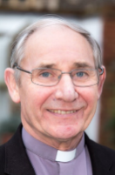 | Bishop John Sherrington – North London
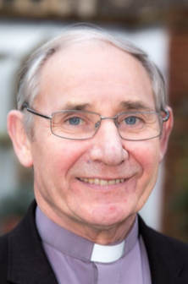 | Bishop Paul McAleenan – Hertfordshire
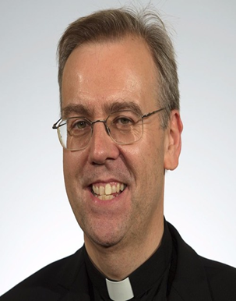  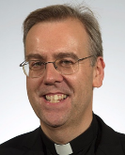 | Bishop Nicholas Hudson – East London
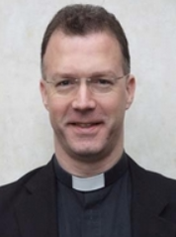  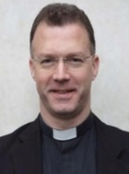 | Fr Michael Dunne, Chairperson of the Education Commission
Your Role as a Teacher in a Catholic School

‘The young people in our schools and colleges come not as empty
vessels to be filled with knowledge, but, through their relationship with you, and each other, to discover what it is to be human and the place God has in their lives… This doesn’t mean that you have to personally assent to every statement of belief, but you must recognise and appreciate the ethos of the school/college, and value it as a place which is underpinned and imbued with a sense of Christian
spirituality.’
(‘How to Survive Working in a Catholic School’ by Sr Judith Russi, Raymond Friel 2013)

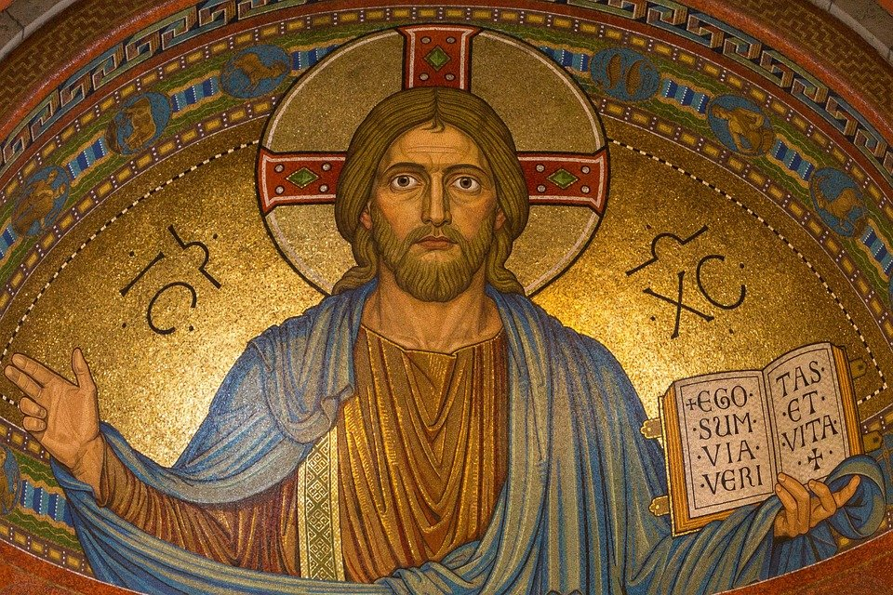

For in our schools we believe:

God is there,
Christ must be followed
The Holy Spirit is a source of help

Expectations of you:

- Our schools are outstanding places of learning
- We expect you to grow and excel as teachers
- Our schools are vibrant communities of Christ
- We expect you to be strong and active members of the ‘family’
- Our schools are dynamic centres of spirituality and values
- We expect you to respect, share and promote our values

The Liturgical Year: An Overview

The richness of the Catholic faith is evident in the celebrations throughout the liturgical year. On the next page, the main events and feast days are highlighted but there are many other celebrations throughout the year.
Each of these times of year has its own particular celebrations, liturgies and styles of prayer. A ‘liturgy’ is any form of public worship within the Catholic community, and it takes many different forms, from group prayer to celebration of the Mass, the most important liturgy of the Catholic Church.

Liturgical Colours
Green: Ordinary time (Symbolising hope, eternal life, Holy Spirit)
Purple: Lent and Advent; Reconciliation; Funerals (Penance)
White: Christmas and Easter; Feasts of Our Lord, Mary and the Saints who were not Martyrs; weddings and funerals ; Confirmation (Purity, joy, triumph)
Red: Feast of Our Lord’s Passion; Palm Sunday; Feasts of Martyrs and Pentecost (Passion, blood, fire, God’s love, martyrdom)
Gold: This can replace white, gold or green but not purple (Joy)

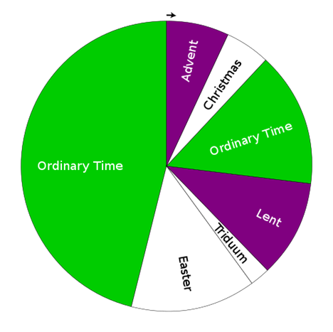

For further support see:
Liturgy Office: http://www.liturgyoffice.org.uk/
Catholic org: https://www.catholic.org/
Loyola Press: https://www.loyolapress.com/our-catholic-faith/liturgical-year
Busted Halo: https://bustedhalo.com

The Liturgical Year: Special Seasons and Feast Days

ADVENT 4 week preparation for coming of Jesus at Christmas
(Colour: purple, pink on 3rd-Sunday - Gaudete)
CHRISTMAS From Christmas to The Epiphany (6 Jan), celebrating the visit of the Wise Men/Magi (Colour: white/gold)
LENT 40 day preparation for Easter, begins on Ash Wednesday with
distribution of the ashes. The focus is on prayer, fasting and
almsgiving/charity. Holy Week is the final week before Easter and it is a very solemn time. It begins with Palm Sunday; Holy Thursday commemorates the Last Supper and the first Mass; Good Friday commemorates the Crucifixion of Jesus. (Colour: purple, pink on 4th Sunday - Laetare)

EASTER The high point of the Christian year celebrating Jesus’
Resurrection (Colour: white/gold)

ASCENSION 40 days after Easter, when Jesus returns to heaven (Colour: white)

PENTECOST The birthday of the Church, the descent of the Holy Spirit
(Colour: red)

TRINITY One week after Pentecost, celebrates the central Christian
SUNDAY belief in the three persons in one God: Father, Son & Holy Spirit
(Colour: white)

CORPUS Feast of the Body of Christ, in the Eucharist, is celebrated
CHRISTI (Colour: white)

SAINTS PETER 29 June: Feast of St Peter (disciple, martyr and first pope) and St
AND PAUL Paul (convert, martyr and writer of many letters in the New
Testament). They are two giants of the Church (Colour: red)

ALL SAINTS 1 Nov: a celebration in honour of all the saints (Colour: white)

ALL SOULS 2 Nov: a commemoration of all who have died (Colour: black)

In addition, we celebrate the feast day of our community’s patron saint/s

The Mass as Source and Summit of Catholic Life

The Mass is one of the seven sacraments, the others being: Baptism, Reconciliation, Confirmation, Marriage, Holy Orders and Anointing of the Sick. The Mass is also known as the ‘Eucharist’, a great act of thanksgiving.

One of the special features of all Catholic schools and colleges is the regular
celebration of Mass. Staff new to Catholic education can be concerned about not knowing what is happening, and why. Just to reassure you: the vast majority of both students and staff gain from their participation in the Mass. We talk about ‘celebrating Mass’ and it is indeed a celebration.

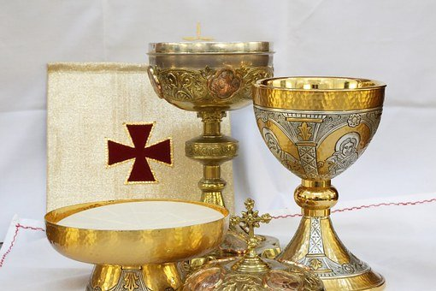

At Mass everyone is welcomed to join in the prayers and the singing, as well as
offering the Sign of Peace. During the distribution of Communion, although only Catholics can receive the Host, everyone is invited/encouraged to receive a blessing.
Service sheets are usually provided, with the prayers /responses. No one is
compelled to say or do something that they don’t believe in. However, there is an expectation that everyone is respectful and that teachers lead by example.
To sum up the Mass: in the Liturgy of the Word Jesus feeds us with his Word, and we respond in faith and action. And in the Liturgy of the Eucharist Jesus feeds us with himself, and we then go out into the world, nourished with Christ and his Word, to live out the Gospel in our communities (Mission)
The Mass: Four Parts

1.INTRODUCTORY RITES
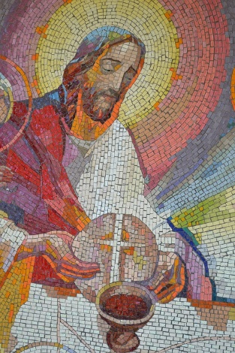
GREETING – we start (and finish) Mass with the sign of the cross, and the priest
usually greets us and introduces the theme of the Mass.
PENITENTIAL RITE – this is the section of the Mass when we seek reconciliation with God for the times we have failed to love God/neighbour, saying sorry for what we have and have not done.
(GLORIA – because we know we can be forgiven, we praise our God with joy. The Gloria is usually only used on Feast Days and on Sundays.)

2. LITURGY OF THE WORD
THE WORD – we listen to God’s Word given to us through the Old and New Testament books of the Bible, all inspired by God.
CREED – having heard the Word of God, we can confidently proclaim the basis of our faith. The Creed is one of the oldest statements of the Church – we are maintaining the central components of the faith that has sustained the Church for 2000 years. The Creed is followed by the Bidding Prayers for our community and for the wider world, usually written and led by students.

3. LITURGY OF THE EUCHARIST
OFFERTORY – gifts of bread and wine are brought to the altar, and we symbolically offer ourselves.
HOLY, HOLY – composed of verses from both Old and New Testaments, in the most solemn part of the Mass this response reminds us that we are participating in the eternal sacrifice of the Lord, a quiet and reflective moment.
EUCHARISTIC PRAYER - the most solemn part of the Mass as the priest echoes Jesus’ words over the bread and wine at the Consecration, where the bread and wine become the body and blood of Christ.
OUR FATHER – we have been made a community within Christ’s sacrifice, and we now pray using the words that He taught us.
SIGN OF PEACE AND COMMUNION – we are about to receive the Lord and we seek to be transformed into the body of Christ, but first we need to recognise that we must be at peace with the world, beginning in our own community. This peace is a special grace from the Lord. It will permeate the world through our actions.
At Communion we become united in the most special way with the Lord.

4. CONCLUDING RITE
DISMISSAL – we have heard the Word of God and received the Lord in Holy
Communion. We are now tasked to go out to be disciples in our community and in the world, renewed to live joyfully in the peace of Christ.
Prayer and Spirituality
Prayer is traditionally described as raising the mind and heart to God, or listening to and speaking to God.

Prayer is not about a performance and lengthy words to impress God and others. In
Matthew’s Gospel, Jesus tells us not to bring offerings to the altar until we have been reconciled with anyone who has something against us (Matthew 5:23-25) – and in Luke’s gospel we hear about the humble taxpayer, praying simply: ‘God, be merciful to me, a sinner.’ (Luke 18:24).

When we pray, we shouldn’t feel any pressure to be ‘holy’ or false. It is best to be
simple and honest for God already knows what is in our hearts. Quite simply, God’s
spirit is within each of us, praying for us. Jesus told us to call God ‘abba’, our loving parent to whom- we can talk to at anytime, anywhere and about anything. Praying with children can be quite rewarding as they are so open-hearted and sincere.

Prayer in the Catholic tradition is rich and varied and can take numerous forms and some of these are included below:

- Using a formula (eg Sign of the Cross)
- Traditional prayer (eg The Lord’s Prayer, Hail Mary, Glory Be)
- Spontaneous prayers (Expressing thoughts and needs)
- Petition, thanksgiving, praise, intercession, penance
- Mediation, contemplation (eg Lectio Divina, Examen, Rosary)
- Liturgical celebrations (eg Mass, Adoration/Benediction)

Prayer and Spirituality

In our schools we aim to give our pupils a rich and wide experience of Catholic prayer and liturgy which is age appropriate and actively engaging for pupils.

Please don’t feel that you have to buy in to every or any aspect of Catholic
belief, but the practice of Catholic rituals, traditions and celebrations is built into the everyday life of our schools and colleges.

There will be times when you are called on to assist your students in the
practice of the faith: don’t be daunted, because the clergy, pupils / students and staff members will always help you.

As part of their life as a faith community, Catholic schools are committed to
communal prayer and there is an expectation that all teachers will play an
active part in this. Most teachers will be required to organise or support daily acts of worship (liturgical prayer) in the class/school.

This will often include the following structure: GATHER, MISSION, RESPOND, WORD so you may want to reflect on the following questions:

- Preparation: When, where, who, what? What resources will I need? Create a focus.
- Gather: How will we begin? How will I create an atmosphere of prayer?
- Word: What will be the scripture focus and how will this be presented?
- Response: What will we do in response to listening to God’s Word e.g. prayer and symbolic action?
- Mission: What will I do to help the pupils take the message away with them?
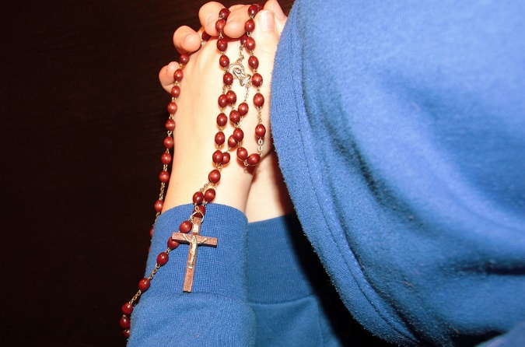
For further support see:
https://education.rcdow.org.uk/support-resources-catholic-life/
https://education.rcdow.org.uk/chaplaincy-resources-support-materials/

Raymond Friel: ‘Prayers for Schools’ ISBN 9780852314920
Prayer Focus
SETTING UP A FOCAL AREA
As a teacher in a Catholic school, you will need to be responsible for the prayer focus in your classroom. This should help the pupils focus for prayer and so should be respected and not left untidy or cluttered. It can be set up in several ways:
- To reflect the liturgical day/feast/season
- To link with a special topic or theme
- To emphasise a Gospel value/scripture
Remember that your focal area needs to be changed regularly if it is to remain relevant. You may want to involve the children in the design and content and encourage them to take ownership of this. You may also wish to develop the area gradually as the topic develops.
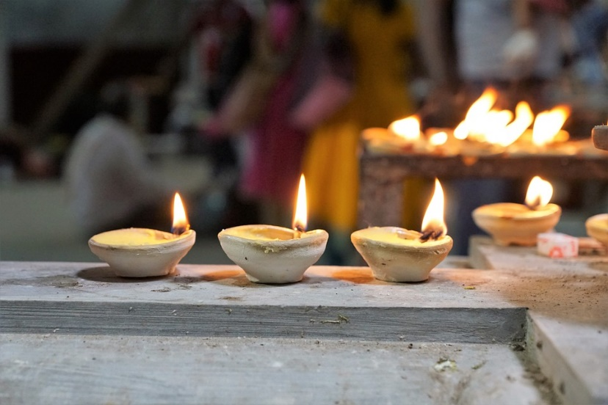
WHAT YOU MAY NEED
- Material / coloured backing paper (this could signify the liturgical year)
- A Bible which is appropriate for the age of the children in your class
- Artefacts / pictures / statues / photographs /crucifix
- Candles (different sizes / shapes /scented) . Battery powered ones can be used
- Relevant books/ book stands/prayer books
- Some examples of children’s work as the topic progresses
- Plants / flowers
- A class prayer book / a book for intentions /Home-School prayer book
- Card for captions/ questions /children’s own prayers
- Words or quotes from scripture/pupils

For more support see: Diocesan Sharing Platform—SLACK for photos and support with liturgical year. Ask your RE Subject Leader re access to SLACK
Collective Worship: Prayer and Liturgy

Daily acts of worship are a legal requirement in the school so they need to be planned for and evaluated. These may be led in the classroom, with other classes or as a school. They can be led by teachers or pupils but it is important that teachers model this correctly and support pupils in doing this. It should also be recorded. Here is an example of an act of worship (liturgical prayer) recorded by pupils:

PUPILS/DATE: (Add here)
GATHER Ring the bell until everyone is seated
LISTEN The Promise of the Holy Spirit (John 13:33)
RESPOND Make a promise
MISSION Find a few moments in the day to say ‘thank you’ to God
EVALUATION ‘I will make a promise because that is what Jesus did. The bells made me feel excited and special’.

Prayer and liturgy can link to:
- The liturgical year (eg October, the month of the Rosary)
- A topic/theme (eg Memories/Eucharist)
- A special feast day (eg St David’s Day)
- The wider world (eg Harvest Fast Day, World Peace Day)
It can be enhanced through the use of music, song, action, movement, silence, liturgical dance, images and a focal point, although this list is not exclusive.

Getting pupils involved in the process is ideal. In this way it is more meaningful for them. Make sure that it is age appropriate and that you cater for different learners where possible (visual, auditory and kinesthetic).

Catholic Social Teaching

“The principle of Catholic Social Teaching is that from a ‘living faith’ comes loving action ‘which brings about a transformation into a ‘civilisation of love’”
(‘Our best kept secret – the rich heritage of Catholic social teaching’ - M. Schultheis 1988)
You must be the change you want to see in the world.
The task of all teachers in our school is to encourage those we teach to work for positive change in our world - and Catholic schools are very actively involved in social justice issues, which appeal so much to young people’s idealism, enthusiasm and innate sense of justice. Catholic Social Teaching (CST), sometimes called ‘the Church’s best kept secret’, includes:

- Life and Dignity of the Human Person
- Call to Family, Community, and Participation
- Rights and Responsibilities
- Preferential Option for the Poor
- The Dignity of Work and the Rights of Workers
- Solidarity
- Care for God's Creation
- Peace and Reconciliation
To say it is radical is an understatement, but it must permeate all our work in all parts of the curriculum in our schools and colleges. It is the Common Good: working in a world in which everyone can live their lives to the full. Catholic Social Teaching should inform all our actions – and the issues that the teaching covers affect everyone in our school, as we engage with and affect each other. CST should be very visible in our Catholic schools and colleges — a guide to our relationships with one another, and to our interactions with the
wider world.
The future of humanity lies in the hands of those who are strong enough
to provide coming generations with reasons for living and hoping.
(‘Pastoral Constitution on the Church in the modern world -1965’)
For further support see:
Caritas Love in Action: https://www.caritaswestminster.org.uk/love-in-action.php
CAFOD: https://cafod.org.uk
Missio: https://missio.org.uk/
ACN: https://acnuk.org/
Mission Together: https://missiontogether.org.uk/
CCS: https://www.cathchild.org.uk/
Requirements

As well as ensure that you are taking part in the Catholic life of the school, it is
generally expected that you teach RE which is the ‘core of the core’ in Catholic schools. In other words, it is to be taught with rigour to the highest possible
standard.

It is required that you teach RE for 10% of the curriculum time. You may also teach it during the other 90% through cross curricular work. This 10% teaching time does not include any form of prayer or liturgy; it is for Classroom RE/teaching time only. You are expected to plan for, record /evidence and mark RE so that it is in line with or better than other core subjects. Homework may be set depending on the school policy.
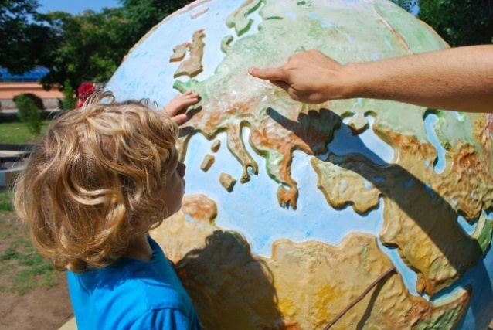

A daily Act of Worship should also take place every day in the school and this will need to be timetabled and planned for also.

Planning should link to the RECD (Curriculum Directory) and should refer to the four sources of Revelation: Scripture, Tradition, Experience and Revelation. Where
possible, pure scripture should be used, preferably with Bibles.

It is required that teachers will assess and track pupils’ progress in RE so that it is in line with Diocesan Requirements and other core subjects.

Every Catholic school is subject to Diocesan Inspection generally every five years (although this may vary e.g. due to Covid 19 special arrangements). This is to be a celebration of the good work taking place in the school.

You should get lots of support from your SLT, RE leader, clergy and other staff members. Your diocesan adviser is also there to support through visits and training.

For further information please see
https://education.rcdow.org.uk/diocesan-inspection/

Contacts

For information about support in your school, please contact your Diocesan Advisor.

Primary Advisers

Elaine Arundell elainearundell@rcdow.org.uk
Felicity Henson felicityhenson@rcdow.org.uk
Jo Browne jobrowne@rcdow.org.uk
Tony Hall tonyhall@rcdow.org.uk

Secondary Advisers

Trisha Hedley trishahedley@rcdow.org.uk
Claire O Neill claireoneill@rcdow.org.uk

Deputy Directors

Amanda Crowley amandacrowley@rcdow.org.uk
Catherine McMahon catherinemcmahon@rcdow.org.uk

Director of Education

Peter Sweeney petersweeney@rcdow.org.uk

Chief Inspector of Schools

Nancy Conoboy nconoboy@rcdow.org.uk

