Racial Justice, Equality and Diversity:
Practice in Schools
School Context:
Christ the King and Sacred Heart, both Catholic primary schools in Islington, are in a soft federation. We often work on shared initiatives where there is commonality across both schools. One curriculum initiative that has been part of our work these past two years is developing a more inclusive curriculum. Following a key note presentation from Professor Paul Miller at the Diocesan Leadership Conference in 2021 we were inspired to undertake more meaningful and purposeful work in this area.

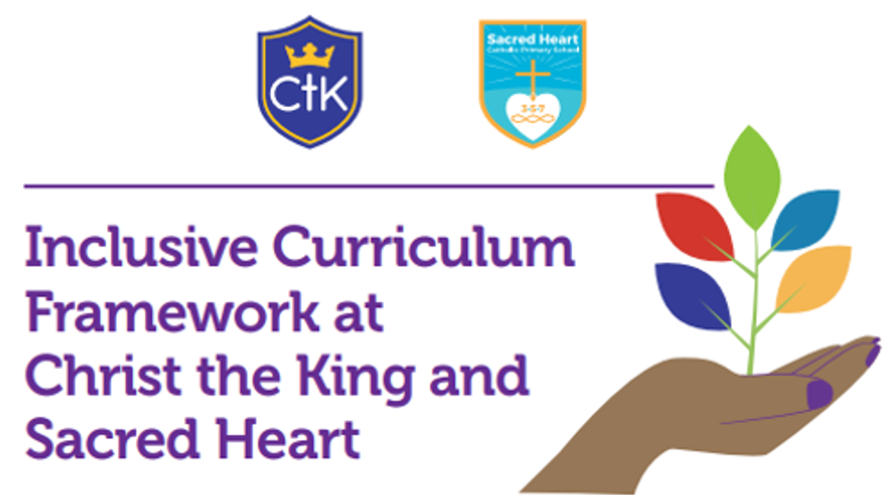
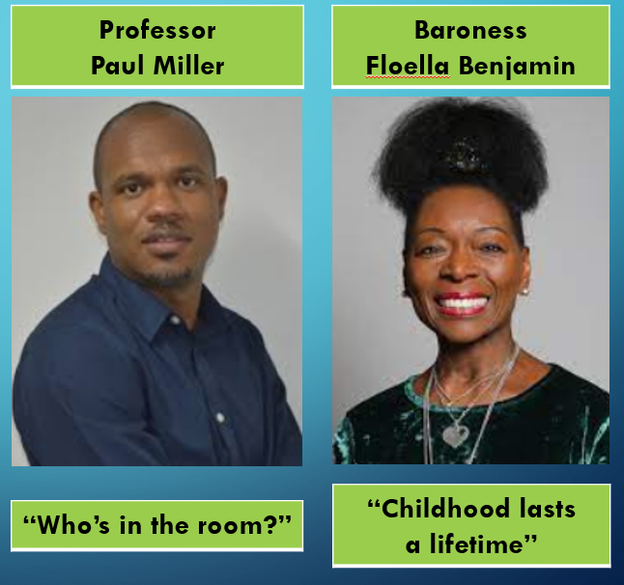
Add photo/image here if required. (Do not add images of pupils, ensure it is copyright free).

What have we done:  In the 2021/22 academic year key members of staff at each school have completed Inclusive Curriculum Framework Training with Professor Paul Miller which has been accredited by the Institute of Leadership & Management.  We have reviewed one area of our curriculum (Science) undertaken by Professor Paul Miller on behalf of Institute for Educational & Social Equity.  Members of staff involved in this process have developed their skills at reviewing and adapting a more inclusive framework, a curriculum where we feel our pupils and their backgrounds are reflected more.  We have informed all staff of our work at an INSET Day recently – the key note speakers were Professor Paul Miller and Baroness Floella Benjamin.  Presented to Governing Body joint committee on our work to date.  (Provide a brief overview of the work done. If more is needed, put a link to another document) | Valuable learning from this process:  Having a better understanding of the theory and research enabled us to have a better understanding of (a) what we were trying to achieve and (b) why we were trying to achieve it.  Work initially with leaders/staff who are keen to embrace this change and/or are passionate about the curriculum.  Crucially important to understand the demographics of your school community.  Inform your staff and governors of the work you are doing as you go along.  Talk and learn from others who are further on with this work that you are as a school.  Remember that developing cultural competence in your curriculum is a journey and not a destination.
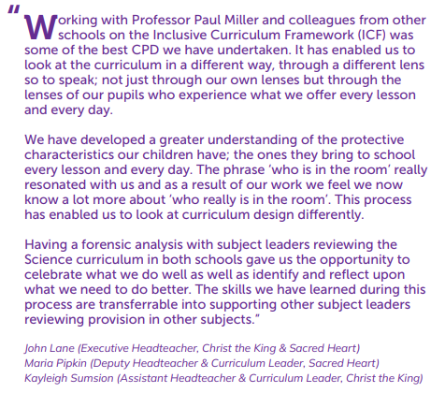

Our next steps:  Using the skills, we have learnt during our work with Professor Miller, support other leaders to ensure our Curriculum Intent is more inclusive.  Ensure that our work is closely aligned with the Equalities Framework and addresses pupils personal and key skills, knowledge, understanding, their backgrounds and cultural capital which will prepare them for their future lives.  Review another area of the curriculum this year.  (eg How will you continue on the RJED journey to develop this in your school? | Useful links/resources:  Weekly phase news in our weekly newsletters in each school reflects aspects of greater diversity and inclusiveness in our curriculum.  Sacred Heart  https://www.sacredheart.islington.sch.uk/topic/newsletters  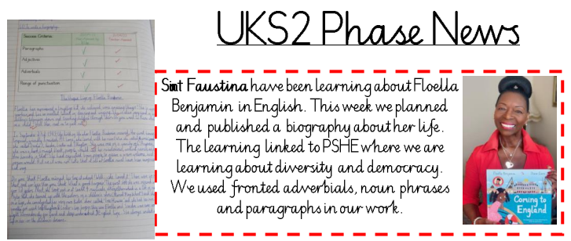  Christ the King  https://www.ctks.co.uk/stream/newsletters/headline/1/-//  