Racial Justice, Equality and Diversity:
Practice in Schools
School Context:
During the school year 2019/2020, due to our collective desire to create a broader Catholic curriculum, we began diversifying and broadening our curriculum to include aspects of Catholic Social Teaching across all subject areas. We realised that we needed to do more in terms of RJED and so, in 2021/2022, we embarked on a whole school programme within the whole curriculum to complement and build on the work we were doing . All staff completed a term’s training on Unconscious Bias and Black History and did a lot of research and discussion which continues to support us. We are also involved in the Voice 21 Oracy programme which supports RJED in many ways

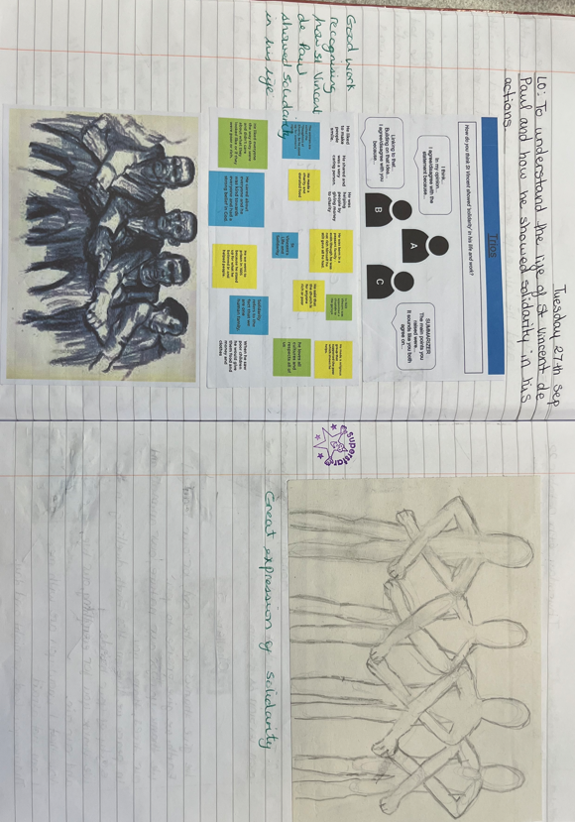

What have we done:  - This term we have all been learning about WW II. The children have researched the role of black men and women during this period of time.  - Year 1 were learning about significant people in History and included Winston Churchill within their learning of WW II. They discovered that, although he had many great leadership qualities, he was racist. Knowing this, they pondered a 'big question:' "Do you think Winston Churchill should have been Prime Minister?"  - As part of our work on CST, our theme this term has been 'Solidarity.' We linked this to work on St Vincent and paintings by Henry Moore. Between September 1940 and the summer of 1941, at the height of the German bombing raids on London, Moore made more than 300 drawings, mainly of women and children sheltering on the platforms of the London Underground and in its tunnels, as the city was subjected to nightly air raids that killed some 10,000 civilians. | Valuable learning from this process:  Pupils have gained a broader understanding of the impact of all contributions made to the war effort and not just limited to a narrow group.  They have also learned to speak up against racism by learning about key figures who have had/have expressed racist views.  Our work on the CST of ‘Solidarity,’ has further supported our development around a discussion of racism and why, as a human race, we need to support one another.  Pupils in Year 6 studied the work of artist Henry Moore and his paintings during the Blitz on the London Underground. This was linked to discussions of working together for the common good.
Our next steps:  Each term, we develop plans within our connected curriculum to reflect on and learn about the extensive contributions of black and other ethnic groups to the history of the time period we are studying. Next term, our theme ‘All that Giltters is Gold’ (Benin and Ancient Egypt) will be supported by the CST, ‘Options for the Poor and Vulnerable’ | Useful links/resources:  School website: https://www.st-vincents.ealing.sch.uk/  A range of books associated with Black History  Caritas – Catholic Social Teaching  Educarem – Building the Kingdom

