St Anne’s and Guardian Angels Primary School, Tower Hamlets
Racial Justice, Equality and Diversity: Practice in Schools
School Context:
At St Anne’s and Guardian Angels, RJED is not a standalone concept but built into the culture and ethos of the school. We are working with staff, pupils and their families to enhance the good practise that we already have in place to ensure that our school is an inclusive and equitable place to learn and work. As such, the RJED work that we are undertaking is one element in our broader work around the nine protected characteristics of the Equality Act. We would like to share some of the things that we’re doing in school in relation to RJED and this work more broadly.
RJED is included in the school development plan and shapes the curriculum. We have appointed a member of our middle leadership team to lead on this area of school development - throughout the year they will contribute to SLT meetings and present to the Governing Body on the work that the school is doing and more importantly, its impact. Curriculum topics are diverse and we include topics such as the Windrush, The Brixton Uprisings, Immigration to East London throughout history (including the Huguenots, Jewish settlers, the Bangladeshi community) Fairtrade, the Commonwealth, Benin Civilisation as well as the geographical study of countries such as Ghana and Bangladesh. In our knowledge organisers, we also include RJED links, which guides teachers on how to teach about other racial groups living in eras such as the Stone Age, Tudor period and in WW1/2. Whilst we have designed a curriculum that celebrates diversity, reflects our school community and addresses themes around equality all year round, we acknowledge the importance of celebrating Black History Month and Refugee week in their own right. This year we are adding these to our curriculum overview to ensure that the knowledge the pupils gain is robust and that we show progression across year groups in the content and themes covered.
Each of our classes are named after saints and we have changed some of our class saints to reflect more racial and gender diversity. This gives pupils the opportunity to learn about a greater range of Catholic Christians which we hope will enrich their religious knowledge and literacy. We have also reviewed the iconography and religious images that we use around the school and made changes to ensure that they reflect the diversity of our school community. This in particular has been well-received by our parents/carers.
At SAGA, we have held many whole school RJED related celebration events which have involved parents. Celebrations include World religion day, Black History Month, Cultural Day, Human Rights Day and National Afro Day. Our parental turnout in these events are good and we receive positive feedback from them. Last term we also held a parents’ workshop where we met with parents explaining our plans regarding RJED and asking for their opinions and suggestions. We also have a good relationship with nearby schools (which have a high number of Muslim pupils) who often join us in our events. We encourage year groups across the school to visit other places of worship as part of our study of other faiths.
The RJED lead and our resident librarian also work together to organise regular whole school library events based on RJED/inclusion/equality related topics (e.g. Deaf Awareness Week, Mental Health Week, Disability Awareness Day, Refugee Week, BHM, World Religion Day). Here, classes have enjoyed Windrush picture exhibitions, learning BSL, writing messages on our ‘be good to yourself’ mental health wall and creating music videos celebrating black artists.
This year, our staff had a CPD explaining what RJED is and what it will look like in our school. This helped staff understand the importance of our RJED practice. Staff members have also had unconscious bias training.
We are also part of the Equally Safe Programme by EqualiTeach who work with schools to help them become more inclusive.
Pupils at St Anne’s have a good understanding of RJED and have led many RJED specific liturgies and assemblies. Our Monday morning worship assemblies, led by our head, also include reference to RJED related topics.
To compliment this, we have also focused on CST and implemented this throughout the curriculum using resources from Caritas and CAFOD. The Year 5s are currently following the Caritas programme and we are training the Year 4s to be Mini Vinnies. We are applying for the Oscar Romero award next term which we hope will acknowledge our good work in this area.
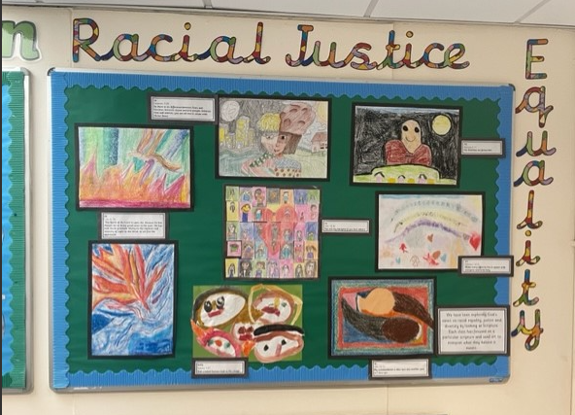
Whole school RJED display with contributions from all year groups.

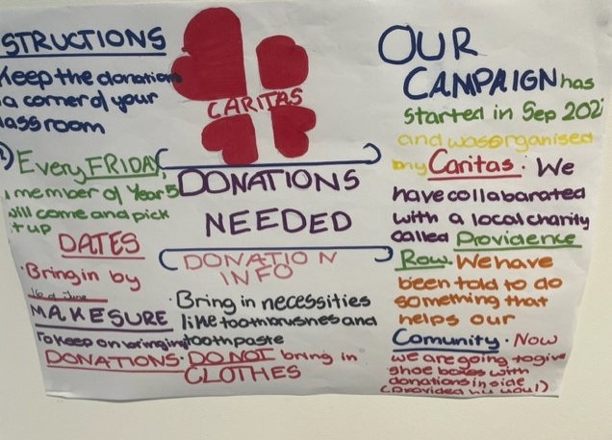
Year 5’s Caritas campaign

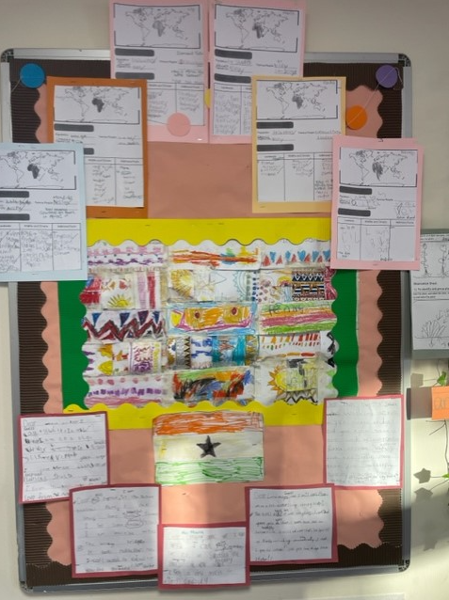
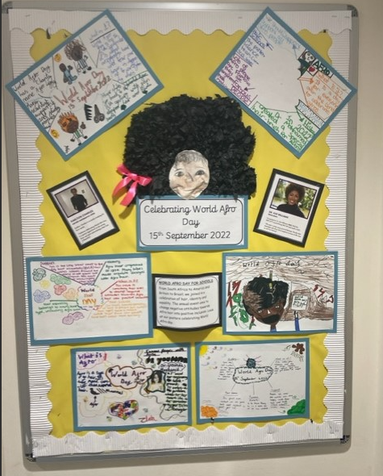
World Afro Day display

Year 1’s Ghana topic display

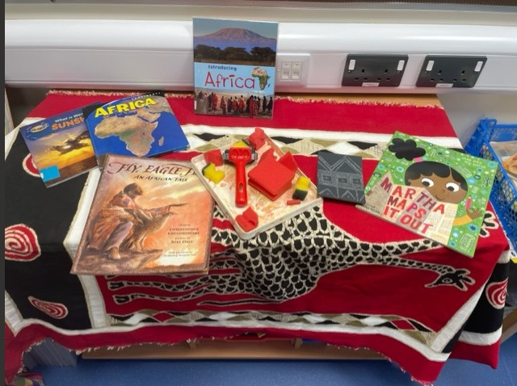

Extracts from Y6 Knowledge Organiser:
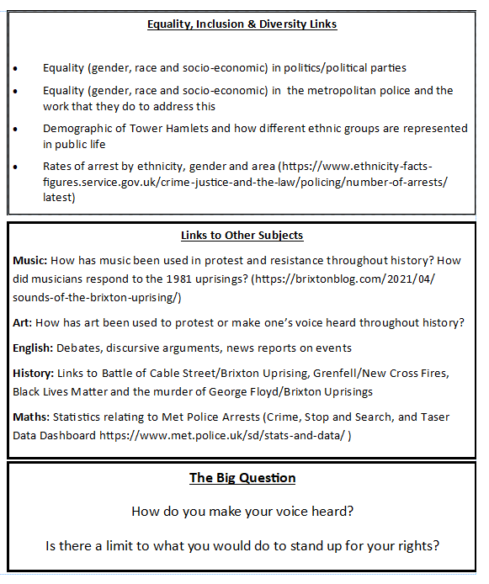

What have we done:  -Included RJED in SDP  -RJED staff meeting  -Parents’ forum meeting about RJED  - RJED related topics throughout the curriculum  -BHM whole month celebration and event which parents attended  -Fairtrade fortnight fairs and events  -Windrush picture library exhibition  -RJED library events  -Working with Equaliteach  -RJED liturgies  -More racially diverse books in the library  -More racially diverse visitors and speakers  -Unconscious bias training  -School dinners more ethnically diverse  - Y5’s caritas campaign. | Valuable learning from this process:  Involve the parents when generating ideas. They have good ideas.  Promoting RJED can be hugely successful if SLT are supportive and involved.  RJED is not a standalone concept. Having one RJED related observation during BLM or Afro day is not enough. It is something that should inform the school’s practise.  Teachers are mostly supportive of the concept but need support in obtaining RJED related curriculum links. If it is provided it is more likely to be used.
Our next steps:  -Continue with what we’re doing so it something that is embedded and fully evident in pupils’ learning and in the life of the school.  - Use the Caritas Ambassadors and Mini Vinnies to be advocates and a driving force for improvement  - Encourage children to be more independent in raising issues that they would like to discuss around inclusion and diversity  - Encourage children to be more independent in leading acts of worship relating to RJED  - Empower staff and pupils to challenge any inequalities that they see by giving them a common language/framework to use | Useful links/resources:  Our school’ twitter pages  St Anne’s and Guardian Angels CPS

