St Joseph’s Primary School, Hertfordshire
Racial Justice, Equality and Diversity: Practice in Schools
School Context:
St Joseph’s is a one form entry Primary school with 203 pupils from Nursery to Year six. Our demographic is changing quickly as we border Enfield. We currently have 33% of Black British children, this being our largest group of children. Our children speak over 12 different languages. Our journey of curriculum review began three years ago. We began looking at introducing a variety of different texts and started to expose our year six pupils to current topics. This process was slower than anticipated due to staff perceptions. Some embraced, some felt secure in their topics.
More specific to outcomes and the need to embrace all of our communities. For many years we held celebrations, event days and assemblies on various themes; black history month, international week, other faith weeks, world book week with two black authors sharing their books and stories. It was then after Covid when many of our younger year group parents hadn’t even entered our school and questioned our ethos and celebration of diversity that we agreed that we needed to review fully and give greater context to all we do.

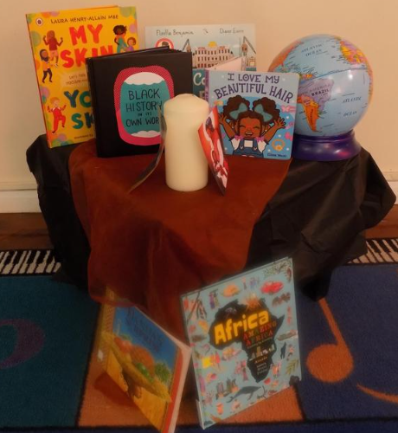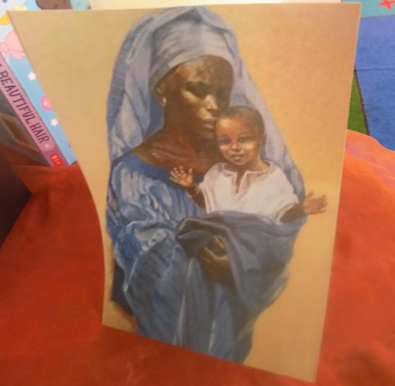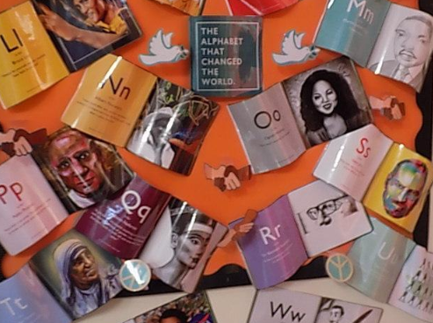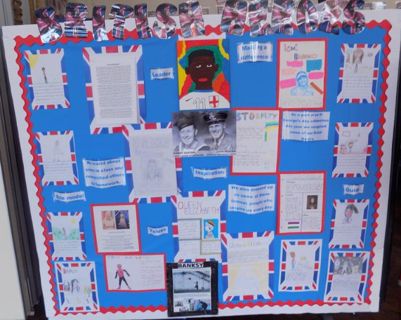
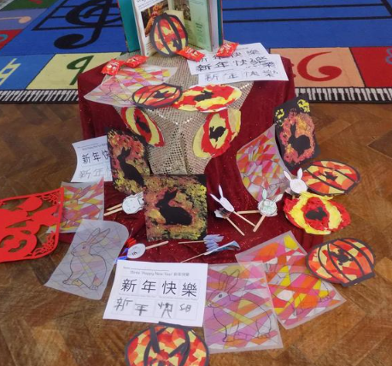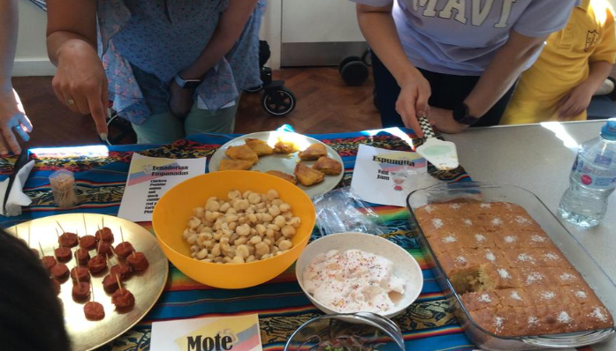
What have we done:  The main change was looking at everything from our children’s point of view and allowing them to hold us to account.  Can I see myself represented in my school?’  This was us as leaders and as a staff team exposing ourselves, being brave, open and honest and saying, it’s a time for change. We were doing ,but was it enough?  And so our journey since then;  · Curriculum review in every aspect – not tokenistic  · Curriculum mapping with explicit diversity sections  · Reviewing all aspects of our SMSC events  · Ensuring we deliver Diwali assemblies  · Windrush day to involve all  · Visits to other places of worship  · Reviewing black history activities  · International week being more specific  · Class saints being diverse of colour /age/sex  · Month of May –Mary focus on the image of Mary our children see  · Considering ‘why’ we do everything  · Pupil voice on curriculum  · Parent survey with diversity questions  · Parent working party  · Review of school displays  The review and the journey will continue as our vision is – ‘Children seeing themselves represented in everything’ within our school, or their school experiences, this begins in Nursery to their final days in Year 6. | Valuable learning from this process:  - Do not be afraid of difficult conversations  - Ensure all children come first in this process  - Get parents on board and be honest where your starting point it  - Audit books and reflect current modern Britain and our children’s home lives  - Get authors/speakers who have valuable experience to offer children  - CPD!!!! This is an absolute essential for moving forward  - All stake holders need to know step by step what the long term plan is  - Start with curriculum and build around  - Link with other local school who have begun on this journey
Our next steps:  - To continue developing our Lighthouse Keepers  - To continue to develop and listen to our parents  - Ask our pupils if they feel they belong and can be seen in what we do  - Staff training  - Invite Suffian in to speak to staff and Governors as well as a pupil group  - secondary link students to visit for workshops and an assembly  - To re audit all the books we have; to share, as class books, in our library and reading areas  - Continue to develop and evaluate our curriculum  - Continue reviewing our action plan | Useful links/resources:  - Black history curriculum  - Islington educational resources  - Hackney curriculum  - Topic books reflecting the needs of your children  - Displays  - Pupil voice  - Parent surveys – including diversity related question  - Websites displaying every insight into your school  - Great Representation course run by HfL

