Name: ________________________ Form: _______
RE Teacher: __________________________________

Lesson 1 - The Call
Lesson 2 - Forever-Ever
Lesson 3 - The Wedding
Lesson 4 - Fruitful Families
Lesson 5 - Fruitful Families Continued
Lesson 6 - Love Remains
Assessment

Lesson 1: The Call

Why do humans
love?

Stretch and Challenge

Out of the reasons you have picked, which one would be the most ‘popular’ and which would be the most ‘controversial’?
__________________________________________________________________________________________________________________________________________________________________________________________________________________________________________________________________________________________________________________________________________________________________________________________________________________________________________________________________________________________________________________________________________________________________________________________________________________________________________________________________________________________________________________________________________________________________________________________________________________________________________________________________________________________________________________________

Genesis 1 - What does ’making them to be like himself’ mean?
__________________________________________________________________________________________________________________________________________________________________________________________________________________________________________________________________________________________________________________________________________________________________________________________________________________________________________________________________________________________________________________________________________________________________________________________________________________________________________________________________________________________________________________________________________________________________________________________________________________________________________________________________________________________________________________________

- With your partner, name as many accounts as you can from the Bible that show love.
- What different sacrifices can be seen in these acts of love?
Bible Accounts | What sacrifices are present?

How does the clip describe love? How can that be translated into our own lives?
Write your notes around the image.

So what is love?
____________________________________________________________________________________________________________________________________________________________________________________________________________________________________________________________________________________________________________________________________________________________________Where do we find love like this in the world? ____________________________________________________________________________________________________________________________________________________________________________________________________________________________________________________________________________________________________________________________________________________________________________________________________________________________________________________________

1 Corinthians 13:4-7
⁴ _______ is patient and kind; it is not jealous or conceited or proud; ⁵ _________
is not ill-mannered or selfish or irritable; ________ does not keep a record of wrongs; ⁶ _______ is not happy with evil, but is happy with the truth. ⁷ ________
never gives up; and its faith, hope, and patience never fail.

1. What could the word ‘love’ be changed to in this passage?
2. Give examples of people who are like St Paul’s description of love.
3. Give examples of ways in which the opposites of love are open to young people today.
4. What challenges might young people have when it comes to patience, kindness, truth and hope?
______________________________________________________________________________________________________________________________________________________________________________________________________________________________________________________________________________________________________________________________________________________________________________________________________________________________________________________________________________________________________________________________________________________________________________________________________________________________________________________________________________________________________________________________________________________________________________________________________________________________________________________________________________________________________________________________________________________________________________________________________________________________________________________________________________________________________________________________________________________________________________________________________________________________________________________________________________________________________________________________________________________________________________________________________________

Discuss how the different descriptions of love in 1 Corinthians 13 fit in with modern day society. Give examples of how every day actions can show the different descriptions of love below. Explain why the action is an example of love. What can you learn from your answers about love?

Patient
Why is this love?

Services others
Why is this love?

Not jealous
Why is this love?

Not boastful
Why is this love?

Generous
Why is this love?

Forgives
Why is this love?

2. What stops humans being able to sacrifice for others?
Challenges
1. How can you make a sacrifice for others in today’s world?
Opportunities

3. Do you think it is reasonable to truly sacrifice oneself for another in the busy, modern world? Give reasons and examples for your answer.
_____________________________________________________________________________________________________________________________________________________________________________________________________________________________________________________________________________________________________________________________________________________________________________________________________________________________________________________________________________________________________________________________________________________________________________________________________________________________________________________________________________________________________________________________________________________________________________________________________________________________________________________________________________________________________________________________________________________________________________________________________________________________________________________________________________________________________________________________________________________________________________________________________________

Lesson 2: Forever-ever?
1. Using these different traits, people look for in a partner, rank where you would put each trait -

similar morals/values money earnt health
gets on with your family social status sense of humour
sense of style do what you want looks

Most important

Least important
2. Discuss with your partner/group what they consider the most important traits in a partner.

Give reasons why you chose your most important and least important trait. ________________________________________________________________________________________________________________________________________________________________________________________________________________________________________________________________________________________________________________________________________________________________________________________________________________________________________________________________________________________________________________________________________________________

Activity 2:
Stretch and Challenge

Think of different key traits – which of the original traits would you change? Why would they be more important to you?
________________________________________________________________________________________________________________________________________________________________________________________________________________________________________________________________________________________________________________________________________________________________________________________________________________________________________________________________________________________________________________________________________________________

“Love is not breathlessness, it is not excitement, it is not the promulgation of promises of eternal passion. That is just being "in love" which any of us can convince ourselves we are. Love itself is what is left over when being in love has burned away, and this is both an art and a fortunate accident. Your mother and I had it, we had roots that grew towards each other underground, and when all the pretty blossom had fallen from our branches we found that we were one tree and not two.”
Corelli's Mandolin, by Louis de Bernières,

Using the description of what love is, add different ideas below of what may be seen as ‘being in love’ and what true ‘love’ is in the table.
‘Being in love’ | ‘Love’

Stretch and Challenge
Out of the ideas you have included, what was the hardest to distinguish between? Provide a modern day example of a relationship where the two affects; ‘being in love’ and true ‘love’ can be confused.
_________________________________________________________________________________________________________________________________________________________________________________________________________________________________________________________________________________________________________________________________________________________________________________________________________________________________________________________________________________________________________________________________________________________________________________________________________________________________________________________________________________________________________________________________________________________________________________________________________________________________

Explain what Catholics believe about marriage __________________________________________________________________________________________________________________________________________________________________________________________________________________________________________________________________________________________________________________________________________________________________________________________________________________________________________________________________________________________________________________________________________________________________________________________________________________________________________________________________________________________________________________________________________________________________________________________________________________________________________________________________________________________________________________________

If you were to be with someone forever, what would you want to know about them before you got married?
Write a list of questions that you would want to ask:

- ___________________________________________________________________________________
- ___________________________________________________________________________________
- ___________________________________________________________________________________
- ___________________________________________________________________________________
- ___________________________________________________________________________________
- ___________________________________________________________________________________
- ___________________________________________________________________________________
- ___________________________________________________________________________________
- ___________________________________________________________________________________
- _______________________________________________________________________________________________________________________________________________________________________________________________________________________________

Compare your questions to the questions usually asked when preparing for Catholic marriage. What are the similarities and differences?

_________________________________________________________________________________________________________________________________________________________________________________________________________________________________________________________________________________________________________________________________________________________________________________________________________________________________________________________________________________________________________________________________________________________________________________________________________________________________________________________________________________________________________________________________________________________________________________________________________________________________________________________________________________________________________

Stretch and Challenge

“When you know, you know.” How far would you agree with this statement in regards to getting married?
__________________________________________________________________________________________________________________________________________________________________________________________________________________________________________________________________________________________________________________________________________________________________________________________________________________________________________________________________________________________________________________________________________________________________________________________________________________________________________________________________________________________________________________________________________________________________________________________________________________________________________________________________________________________________________________________________________________________________________________________________________

Complete this mind-map

Challenges in Marriages?

adultery

anger
mistrust

Stretch and Challenge

In your opinion, what is the biggest challenge for married couples trying to ensure their marriage is life-long? What could be the remedy to this challenge?

__________________________________________________________________________________________________________________________________________________________________________________________________________________________________________________________________________________________________________________________________________________________________________________________________________________________________________________________________________________________________________________________________________________________________________________________________________________________________________________________________________________________________________________________________________________________________________________________________________________________________________________________________________________________________________________________________________________________________________________________________________

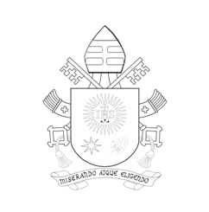
Read chapter 8 in Amoris Laetitia - what does the Church teach on how to persevere through these challenges?
________________________________________________________________________________________________________________________________________________________________________________________________________________________________________________________________________________________________________________________________________________________________________________________________________________________________________________________________________________________________________________________
The Discernment of “Irregular Situations”
296. The Synod addressed various situations of weakness or imperfection. Here I would like to reiterate something I sought to make clear to the whole Church, lest we take the wrong path: “There are two ways of thinking which recur throughout the Church’s history: casting off and reinstating. The Church’s way, from the time of the Council of Jerusalem, has always been the way of Jesus, the way of mercy and reinstatement... The way of the Church is not to condemn anyone for ever; it is to pour out the balm of God’s mercy on all those who ask for it with a sincere heart... For true charity is always un- merited, unconditional and gratuitous”.326 Consequently, there is a need “to avoid judgements which do not take into account the complexity of various situations” and “to be attentive, by necessity, to how people experience distress be- cause of their condition”.
(Amoris Laetitia 296)
1. How can ‘casting off and reinstating’ be linked to marriage?
________________________________________________________________________________________________________________________________________________________________________

2. How can ‘mercy and reinstatement’ be linked to marriage?
________________________________________________________________________________________________________________________________________________________________________
Stretch and Challenge
Is there anything that you feel could not be forgiven in a marriage? Give your reasons with examples and explain why below:
___________________________________________________________________________________________________________________________________________________________________________________________________________________________________________________________________________________________________________________________________________________________________________________________________________________________________________________________________________________________________________________________________________________________________________________________________________________________________________________________________________

- Go back to your starter diamond 9 – now that you have examined the Catholic aims of marriage, would you choose to change any of your previous choices, would you not?
__________________________________________________________________________________________________________________________________________________________________________________________________________________________________________________________________________________________________________________________________________________________________________________________________________________________________________________________________
__________________________________________________________________________________________
- Out of the different ideas – what do you think is the most important for ensuring a marriage is life-long?
__________________________________________________________________________________________________________________________________________________________________________________________________________________________________________________________________________________________________________________________________________________________________________________________________________________________________________________________________

Lesson 3: The Wedding
“Marriage rates remain at historical lows despite a small increase in the number of people who got married in 2016. Most couples are preferring to do so with a civil ceremony and for the first time ever, less than a quarter of everyone who married had a religious ceremony. Meanwhile, the age at which people are marrying continues to hit new highs as more and more over 50s get married.”
(Kanak Ghosh, Vital Statistics Outputs Branch, Office for National Statistics)

1.What are the key points from the statistics?
________________________________________________________________________________________________________________________________________________________________________________________________________________________________________________________________________________________________________________________________________________________________________________________________________________________________________________________________
2.Think-pair-share some of the reasons behind the findings.
________________________________________________________________________________________________________________________________________________________________________________________________________________________________________________________________________________________________________________________________________________________________________________________________________________________________________________________________________________________________________________________________________________________________________________________________

Use a Bible to read the following passages:
- Genesis 1:27-28 - Genesis 2:24 - Proverbs: 18:22

- Deuteronomy 24:5 - Matthew 19:6 - Ephesians 4:2-3

- Ephesians 5:25 - 1 John 4:7 - 1 Corinthians 13:13

What does the Bible teach are the different purposes of marriage?
____________________________________________________________________________________________________________________________________________________________________________________________________________________________________________________________________________________________________________________________________________________________________________________________________________________________________________________________________________________________________________________________________________________________________________________________________________________________________________________________________________________________________________________________________________________________________________________________________________________________________________________________________________________________________________________________________________________________________________________________________________________________________________________________________________________________________________________________________________________________________________________________________________________________________________________________________________________________________________________________________________________________________________________________________________________________________

1. What does each of these words mean?

- Sacramental - ______________________________________________ ____________________________________________________________________________________________________________________

- Permanent - _______________________________________________
____________________________________________________________________________________________________________________

- Exclusive - _________________________________________________
____________________________________________________________________________________________________________________

- Life-giving - ________________________________________________ ____________________________________________________________________________________________________________________

2. How reasonable are the four different purposes of marriage today?
Is there any one more or less reasonable than another? Give reasons with examples for your answer.

What happens at a Catholic wedding?

There are two types of Catholic marriage ceremony: one includes the celebrates of the Eucharist (Communion). The other is without the Eucharist:
- Discuss and then explain the reason and symbolism for each part of the Catholic wedding ceremony.
Entrance Rite
Reason | Symbolism
Liturgy of the Word
Reason | Symbolism
The rite of marriage
Reason | Symbolism
Communion rite
Reason | Symbolism
Concluding rite
Reason | Symbolism

2. Where do you see the different purposes of marriage (previously discussed) in the symbolic acts that happen?
________________________________________________________________________________________________________________________________________________________________________________________________________________________________________________________________________________________________________________________________________________________________________________________________________________________________________________________________
3. Which part of the ceremony do you think is the most important for a married couple? Give reasons for your answer.
________________________________________________________________________________________________________________________________________________________________________________________________________________________________________________________________________________________________________________________________________________________________________________________________________________________________________________________________

Stretch and Challenge

Research what happens during a civil marriage ceremony. Why might civil ceremonies be increasing whereas religious ceremonies are decreasing?

__________________________________________________________________________________________________________________________________________________________________________________________________________________________________________________________________________________________________________________________________________________________________________________________________________________________________________________________________________________________________________________________________________________________________________________________________________________________________________________________________________________________________________________________________________________________________________________________________________________________________________________________________________________________________________________________________________________________________________________________________________

1.What could be the reasons for this?
__________________________________________________________________________________________________________________________________________________________________________________________________________________________________________________________________________________________________________________________________________________________________________________________

2. To what extent do you agree with the view that many who get married are focused on the wedding day and not the lifelong commitment?
________________________________________________________________________________________________________________________________________________________________________________________________________________________________________________________________________________________________________________________________________________________________________________________________

3. How could we as a community highlight the commitment of marriage more?
________________________________________________________________________________________________________________________________________________________________________________________________________________________________________________________________________________________________________________________________________________________________________________________________________________________________________________________________
215. The Kenyan Bishops have observed that “many [young people] concentrate on their wedding day and forget the life-long commitment they are about to enter into”.244 They need to be encouraged to see the sacrament not as a single moment that then becomes a part of the past and its memories, but rather as a reality that permanently influences the whole of married life. 245 The procreative meaning of sexuality, the language of the body, and the signs of love shown throughout married life, all become an “uninterrupted continuity of liturgical language” and “conjugal life becomes in a certain sense liturgical”.246
Amoris Laetitia, Chapter 8

Is it important for Catholics to have a Catholic wedding?
Yes, very important | No, not important at all

1.With the knowledge you have learnt about what love is, what marriage is and the significance of the marriage ceremony, in your groups/pairs complete the table with different views on each side of the argument.

2. Write a conclusive summary explaining your own view on the question, include clear reasoning and examples to support your points.
_________________________________________________________________________________________________________________________________________________________________________________________________________________________________________________________________________________________________________________________________________________________________________________________________________________________________________________________________________________________________________________________________________________________________________________________________________
___________________________________________________________________________________________________________________________________________________________________________________________________________________________________________________________________________________________________________________________________________________________________________________________________________________________________________________________________________________________________________________________________________________________________________________________________________________________________________________________________________________________________________________________________________

Lesson 4 – Fruitful Families
How far do you agree with the phrase:

“…you can’t have a family without dreams.”

10 – Agree fully
10 – Agree fully
1 – Disagree entirely
Explain your view on the above statement.
______________________________________________________________________________________________________________________________________________________________________________________________________________________________________________________________________________________________________________________________________________________________________________________________________________________________________________________________________________
__________________________________________________________________

In Amoris Laetitia, Pope Francis quotes a comment made at the Meeting with Families in Manila in 2015 where he stated: “…you can’t have a family without dreams.” Dreams are an integral part of a Catholic couple’s life.
1. Think-pair-share the different dreams a couple may have when they first meet each other, decide to get married and then are married for a number of years.
2. Add the dreams onto the table -
First Date | Engagement | Married for 5+ years

3. What are some of the common dreams throughout the different times in a relationship?
__________________________________________________________________________________________________________________________________________________________________________________________________________________________________________________________________________________________________________________________________________
4. What do you think is the most important dream a couple can have together?
__________________________________________________________________________________________________________________________________________________________________________________________________________________________________________________________________________________________________________________________________________

“You shall eat the fruit of the labour of your hands; you shall be happy, and it shall be well with you.” (Psalm 128:2)
God blessed them, and God said to them, “Be fruitful and multiply, and fill the earth and subdue it…” (Genesis 1:28)

Use this Scripture and the explanations given on the powerpoint to explain what it means to be fruitful within a marriage.
______________________________________________________________________________________________________________________________________________________________________________________________________________________________________________________________________________________________________________________________________________________________________________________________________________________________________________________________________________________________________________________________________________________________________________________________________________________________________________________________________________________________________________________________________________________

=================-

‘The example of Jesus is a paradigm for the Church.’
Read the following Bible accounts and complete the questions.
The Wedding at Cana (John2:1-11)
2 Two days later there was a wedding in the town of Cana in Galilee. Jesus' mother was there, ² and Jesus and his disciples had also been invited to the wedding. ³ When the wine had given out, Jesus' mother said to him, “They are out of wine.” ⁴ “You must not tell me what to do,” Jesus replied. “My time has not yet come.” ⁵ Jesus' mother then told the servants, “Do whatever he tells you.” ⁶ The Jews have rules about ritual washing, and for this purpose six stone water jars were there, each one large enough to hold between twenty and thirty gallons. ⁷ Jesus said to the servants, “Fill these jars with water.” They filled them to the brim, ⁸ and then he told them, “Now draw some water out and take it to the man in charge of the feast.” They took him the water, ⁹ which now had turned into wine, and he tasted it. He did not know where this wine had come from (but, of course, the servants who had drawn out the water knew); so he called the bridegroom ¹⁰ and said to him, “Everyone else serves the best wine first, and after the guests have drunk a lot, he serves the ordinary wine. But you have kept the best wine until now!” ¹¹ Jesus performed this first miracle in Cana in Galilee; there he revealed his glory, and his disciples believed in him.
Jesus with Lazarus and his sisters (Luke 10:38)
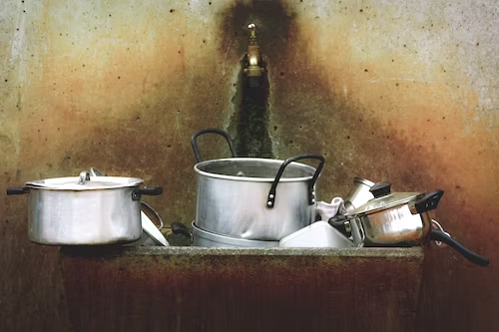
³⁸ As Jesus and his disciples went on their way, he came to a village where a woman named Martha welcomed him in her home. ³⁹ She had a sister named Mary, who sat down at the feet of the Lord and listened to his teaching. ⁴⁰ Martha was upset over all the work she had to do, so she came and said, “Lord, don't you care that my sister has left me to do all the work by myself? Tell her to come and help me!” ⁴¹ The Lord answered her, “Martha, Martha! You are worried and troubled over so many things, ⁴² but just one is needed. Mary has chosen the right thing, and it will not be taken away from her.”

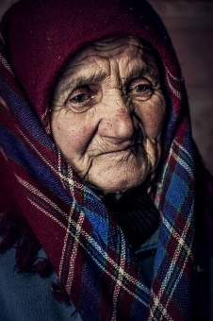
Jesus and Peter’s family
¹⁴ Now when Jesus had come into Peter’s house, He saw his wife’s mother lying sick with a fever. ¹⁵ So He touched her hand, and the fever left her. And she arose and served them.

Jesus and Jairus’ daughter (Mark 5:41)
36 As soon as Jesus heard the word that was spoken, He said to the ruler of the synagogue, “Do not be afraid; only believe.” ³⁷ And He permitted no one to follow Him except Peter, James, and John the brother of James. ³⁸ Then He came to the house of the ruler of the synagogue, and saw ^{[g]}a tumult and those who wept and wailed loudly. ³⁹ When He came in, He said to them, “Why make this commotion and weep? The child is not dead, but sleeping.” ⁴⁰ And they ridiculed Him. But when He had put them all outside, He took the father and the mother of the child, and those who were with Him, and entered where the child was lying. ⁴¹ Then He took the child by the hand, and said to her, “Talitha, cumi,” which is translated, “Little girl, I say to you, arise.” ⁴² Immediately the girl arose and walked, for she was twelve years of age. And they were overcome with great amazement. ⁴³ But He commanded them strictly that no one should know it, and said that something should be given her to eat.
Jesus and the Samaritan Woman (John 1:4-30)
⁵ In Samaria he came to a town named Sychar, which was not far from the field that Jacob had given to his son Joseph. ⁶ Jacob's well was there, and Jesus, tired out by the trip, sat down by the well. It was about noon. ⁷ A Samaritan woman came to draw some water, and Jesus said to her, “Give me a drink of water.” (⁸ His disciples had gone into town to buy food.) ⁹ The woman answered, “You are a

Jew, and I am a Samaritan—so how can you ask me for a drink?” (Jews will not use the same cups and bowls that Samaritans use.) ¹⁰ Jesus answered, “If you only knew what God gives and who it is that is asking you for a drink, you would ask him, and he would give you life-giving water.” ¹¹ “Sir,” the woman said, “you don't have a bucket, and the well is deep. Where would you get that life-giving water? ¹² It was our ancestor Jacob who gave us this well; he and his children and his flocks all drank from it. You don't claim to be greater than Jacob, do you?” ¹³ Jesus answered, “Those who drink this water will get thirsty again, ¹⁴ but those who drink the water that I will give them will never be thirsty again. The water that I will give them will become in them a spring which will provide them with life-giving water and give them eternal life.” ¹⁵ “Sir,” the woman said, “give me that water! Then I will never be thirsty again, nor will I have to come here to draw water.” ¹⁶ “Go and call your husband,” Jesus told her, “and come back.” ¹⁷ “I don't have a husband,” she answered. Jesus replied, “You are right when you say you don't have a husband. ¹⁸ You have been married to five men, and the man you live with now is not really your husband. You have told me the truth.” ¹⁹ “I see you are a prophet, sir,” the woman said. ²⁰ “My Samaritan ancestors worshiped God on this mountain, but you Jews say that Jerusalem is the place where we should worship God.” ²¹ Jesus said to her, “Believe me, woman, the time will come when people will not worship the Father either on this mountain or in Jerusalem. ²² You Samaritans do not really know whom you worship; but we Jews know whom we worship, because it is from the Jews that salvation comes. ²³ But the time is coming and is already here, when by the power of God's Spirit people will worship the Father as he really is, offering him the true worship that he wants. ²⁴ God is Spirit, and only by the power of his Spirit can people worship him as he really is.” ²⁵ The woman said to him, “I know that the Messiah will come, and when he comes, he will tell us everything.” ²⁶ Jesus answered, “I am he, I who am talking with you.” ²⁷ At that moment Jesus' disciples returned, and they were greatly surprised to find him talking with a woman. But none of them said to her, “What do you want?” or asked him, “Why are you talking with her?” ²⁸ Then, leaving her water jar, the woman went back to the town and said to the people, ²⁹ “Come, see a man who told me everything I ever did. Could this be the Messiah?” ³⁰ They came out of the town and made their way toward him.

Jesus and the Adulterous Woman (John 8:1-11)
8 Jesus returned to the Mount of Olives, ² but early the next morning he was back again at the Temple. A crowd soon gathered, and he sat down and taught them. ³ As he was speaking, the teachers of religious law and the Pharisees brought a woman who had been caught in the act of adultery. They put her in front of the crowd. ⁴ “Teacher,” they said to Jesus, “this woman was caught in the act of adultery. ⁵ The law of Moses says to stone her. What do you say?” ⁶ They were trying to trap him into saying something they could use against him, but Jesus stooped down and wrote in the dust with his finger. ⁷ They kept demanding an answer, so he stood up again and said, “All right, but let the one who has never sinned throw the first stone!” ⁸ Then he stooped down again and wrote in the dust. ⁹ When the accusers heard this, they slipped away one by one, beginning with the oldest, until only Jesus was left in the middle of the crowd with the woman. ¹⁰ Then Jesus stood up again and said to the woman, “Where are your accusers? Didn’t even one of them condemn you?” ¹¹ “No, Lord,” she said. And Jesus said, “Neither do I. Go and sin no more.”
1. What are the themes found in these six different accounts from the Gospels?
____________________________________________________________________________________________________________________________________________________________________________________________________________________________________________________________________________________________________________________________________________________________________________________________________________________________________________________________________________________________________________________________________________________________________________________________________________________________________________________________________________________________________________________________________________________________________________________________________________________________________________________________________________________________________________________________________________________________

2. How can families embed these themes throughout their lives?
____________________________________________________________________________________________________________________________________________________________________________________________________________________________________________________________________________________________________________________________________________________________________________________________________________________________________________________________________________________________________________________________________________________________________________________________________________________________________________________________________________________
______________________________________________________________________________________________________________________________________________________________________________________________________________________________________________________________________________________________________________________________________________________________________________________________________________________________________________________________________________

3. How might you have seen these themes in your home lives? Are there any parts of your life that seem lacking? How can they be adapted?
______________________________________________________________________________________________________________________________________________________________________________________________________________________________________________________________________________________________________________________________________________________________________________________________________________________________________________________________________________________________________________________________________________________________________________________________________________________________________________________________________________________________________________________________________________________________________________________________________________________________________________________________________________________________________________________________________________________________________________________________________________________________________________________________________________________________________________________________________________________________________________________________________________________________________________________________________________________________________

If you had to describe your family life in three words, what would they be? ___________________________________________________________________
Stretch and Challenge
How can the themes shown in the Gospels fit into family life for you? Where do you see the opportunities to forgive, share faith and understand others?
________________________________________________________________________________________________________________________________________________________________________________________________________________________________________________________________________________________________________________________________________________________________________________________________________________________________________________________________________________________________________________________________________________________

Describe what you believe would be the most desirable family life. ___________________________________________________________________________________________________________________________________________________________________________________________________________________________________________________________________________________________________________________________________________________________________________________________________________________________________________________________________________________________________

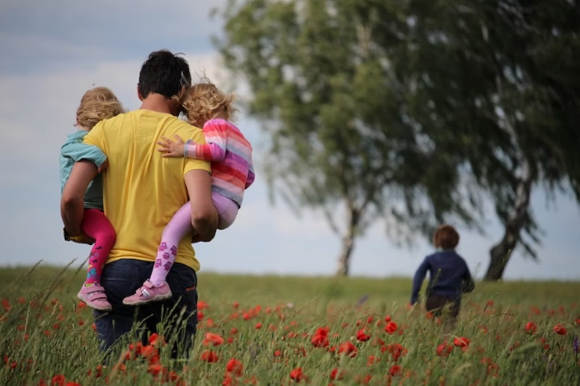

“The experience of love in families is a perennial source of strength for the life of the Church.” (Amoris Laetitia 3:88)
“The Church is a family of families.” (Amoris Laetitia 3:87)
1.What is the experience of love in families? Give examples.
__________________________________________________________________________________________________________________________________________________________________________________________________________________________________________________________________________________________________________________________________________________________________________________________________________________
2.Why are families so important for the Church?
_______________________________________________________________________________________________________________________________________________________________________________________________________________________________________________________________________________________________________________________________________________
3.‘Healthy marriages = a healthy Church’ How far do you agree with this statement?
_________________________________________________________________________________________________________________________________________________________________________________________________________
Think-Pair-Share:
How reasonable is it to expect families to ensure they are being fruitful in the modern world?
Write your own response, giving a range of reasons.
_______________________________________________________________________________________________________________________________________________________________________________________________________________________________________________________________________________________________________________________________________________

Lesson 5 – Fruitful Families 2

How fairly does this image depict an image of the modern family?
_______________________________________________________________________________________________________________________________________________________________________________________________________________________________________________________________________________________________________________________________________________________________________________________________________________________________________________________________________

Stretch and Challenge:

How can this image of an orangutan link to the image above?
________________________________________________________________________________________________________________________________________________________________________________________________________________________________________________________________________________________________________________________________________________________________________________________________________________________________________________________________________________________________________________________________________________________________________

Couple B
Grace and Paul have been married for just under ten years. They have two young daughters. Paul has been diagnosed with a terminal tumour that the prognosis is 6-12 months left.
What are their options?

What are the different options for the couples below? How can love and mercy by incorporated into the situations?

Couple A
Ben and Louise have been married for 18 months. They met at university and knew very soon after meeting that they had both found the ‘one’. They got married just before their 22nd birthdays. 18 months on, they have been trying to conceive and they have not been able to as of yet.

Couple B
Grace and Paul have been married for just under ten years. They have two young daughters. Paul has been diagnosed with a terminal tumour that the prognosis is 6-12 months left.

Couple C
Justin and Carla have been married for five years. They have two sons and one daughter. Carla has noticed that there have been small amounts of money being taken out of their joint bank account. Carla has wanted to raise with Justin for a few months now but knows Justin had a gambling problem before they met.

Stretch and Challenge
Strains on families cause challenges.
What do you think are the key challenges for families in the modern world?
__________________________________________________________________________________________________________________________________________________________________________________________________________________________________________________________________________________________________________________________________________________________________________________________________________________________________________________

Which out of the below options has been the biggest influence in developing your faith?
Tick the box and explain why you feel that particular place had such an influence.
- Church | - Home
- School | - Other [discuss and share]
________________________________________________________________________________________________________________________________________________________________________________________________________________________________________________________________________________________________________________________________________________________________________
What do you think are the key things families should do to embed a strong foundation of Gospel values within the household?
___________________________________________________________________________________________________________________________________________________________________________________________________________________________________________________________________________________________________________________________________________________________________________________________________________________________________________

S&C: What do you think the key routines of the family should be to be able to be valid and purposeful teachers of faith?
_________________________________________________________________________________________________________________________________________________________________________________________________________________________________________________________________________________________________________________

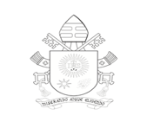

Read
Son, do what your father tells you and never forget what your mother taught you. Keep their words with you always, locked in your heart. Their teaching will lead you when you travel, protect you at night, and advise you during the day. (Proverb 6:20-22)
The Lord corrects those he loves, as parents correct a child of whom they are proud.
(Proverb 3:12)

1.Should a parent correct their children?
________________________________________________________________________________________________________________________________________________________________________________________________________________________________________________________
2. What have your parents/carers taught you that will help guide you in life? What would you teach your children?
______________________________________________________________________________________________________________________________________________________________________________________________________________________________________________________________________________________________________________________________________________________________________________________________________________________________________________________________________________________________________________________________________________________________________________________________________________________________________________________
_______________________________________________________________

The family is called to join in daily prayer, to read the word of God and to share in Eucharistic communion, and thus grow in love and become ever more fully a temple in which the spirit dwells. (Amoris Laetitia 1:29)

Key responsibilities for parents to share with children:
- Daily Prayer
- Reading the Sacred Scripture
- Sharing the Eucharist
Write down the challenges there are for families today to fulfil these duties:
______________________________________________________________________________________________________________________________________________________________________________________________________________________________________________________________________________________________________________________________________________________________________________
What is the most prominent challenge, and why?
____________________________________________________________________________________________________________________________________________________________________________________________________________________________________________________
How might families prepare for these challenges?
_______________________________________________________________________________________________________________________________________________________________________________________________________________________________________________________________________________________________________________________________________________________________________________________________________________________________________________________________________________________________________________________________________________________________________________________________________________________________________________________________________

The Lord corrects those he loves, as parents correct a child of whom they are proud. Prov 3:12

- Describe in your own words what you believe the ‘culture of comfort’ to be.
_________________________________________________________________________________________________________________________________________________________________________________________________________________________________________________________________________________________________________________
- How does the ‘culture of comfort’ undermine the duty to be fruitful?
_________________________________________________________________________________________________________________________________________________________________________________________________________________________________________________________________________________________________________________
- Why might technology be problematic within families?

_________________________________________________________________________________________________________________________________________________________________________________________________________________________________________________________________________________________________________________

- What do you think is the biggest challenge to families today?
___________________________________________________________________________________________________________________________________________________________________________________________________________________________________________________________________________________________________________________________________________________________________________________________________________________________________________

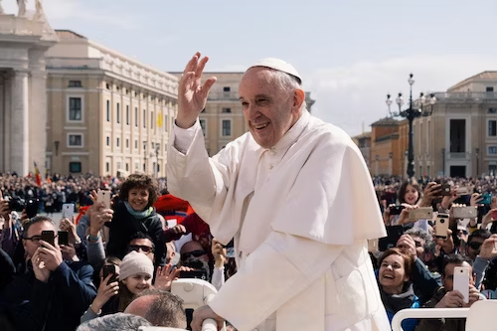

Stretch and Challenge
Striving, forgiveness, prayer and dedication are the foundations of fruitful families. How far do you agree with this statement?
________________________________________________________________________________________________________________________________________________________________________________________________________________________________________________________________________________________________________________________________________________________________________________________________________________________________________________________________________________________________________________________

What is the best way to find the right balance between being in the world and being separated from its negative influences?
____________________________________________________________________________________________________________________________________________________________________________________________________________________________________________________________________________________________________________________________________________________________________________________________________________________________________________________________________________________________________________________________________________________________________________________________________________________________________________________________________________________________________________________________________________________________________________________

Lesson 6 – Love Remains
- Before watching the clip, what do you think the secret to a long and happy marriage is?
_________________________________________________________________________________________________________________________________________________________________________________________________________________________________________________________________________________________________________________
- Discuss as a class and share views – what is the most popular view, why is that?
_________________________________________________________________________________________________________________________________________________________________________________________________________________________________________________________________________________________________________________
- Watch the clip – how far do you agree with Annie and Dodie’s view on the secret to longevity?
_________________________________________________________________________________________________________________________________________________________________________________________________________________________________________________________________________________________________________________
- If you could ask Annie and Dodie two questions about their married life, what would they be?
__________________________________________________________________________________________________________________________________________________________________________________________________________________________________________________________________________________________________________________________________________________________________________________________

The Catholic marriage vows reflect the purposes of marriage; life-long, being unbreakable in the eyes of God.
When looking at the vow: “For better or worse”; what do you think could be the ‘better’ and the ‘worse’ parts of life as a married couple.
Better | Worse
Stretch and Challenge:
Are there any times when the ‘better’ can make a marriage harder?
____________________________________________________________________________________________________________________________________________________________________________________________________________________________________________________________________________
___________________________________________________________________
____________________________________________________________

- What thoughts does this image evoke?
______________________________________________________________________________________________________________________________________________________________________________________________________________________________________________________________________________________________________________________

- What might be seen as the ‘light in the darkness’ in a marriage?
____________________________________________________________________________________________________________________________________________________________________________________________________________________________________________________________________________________________________________________________________________________________________________________

In pairs/groups, read through the couple case studies. There is space to create your own examples for couples E and F.
For each couple, discuss how the couple can overcome their issues in light of Church teaching. What do you think the couple should do? Complete the table in your booklet.

Couple A:
Wife and husband are both very successful in their music careers. They have three children together and have been married a number of years. Rumours swell within their friendship groups and on social media that the husband has had multiple affairs with different women. The wife is unsure at what to do.

Couple B:
Wife and husband are newlyweds. They are both Catholic and have been married for just under six months, moved in together after they were married and have been trying to have a baby. They have been unsuccessful so far. The couple are unsure about what they should do next.

Couple C:
Wife and husband have been married for many years. The couple have four children who are all in their twenties.
The husband is diagnosed with cancer and is told he will have to have long and gruelling treatment that cannot definitely cure him.
The treatment he has been taking has made him irritable and both husband and wife have been arguing a lot.

Couple D:
Couple have been together a few years and have decided to get married. Prior to the wedding both families seemed to get on. However, just after the wedding there seems to be a lot of pressure from the families of the couple. Some hurtful comments have been made and the couple have shared that they would like to move away from the family location. The family are not happy with their decision.

Couple E:

Couple F:

Couple | How can the couple overcome their problem? | What do you think should happen?
A
B
C
D
E
F

“families are not a problem; they are first and foremost an opportunity…”
Address at the Meeting of Families in Santiago de Cuba

Think-Pair-Share:
1.Why might some think families are a ‘problem’?
________________________________________________________________________________________________________________________________________________________________________________________________________________________________________________________
2. What would be the best way to end the sentence from Pope Francis’ address?
________________________________________________________________________________________________________________________________________________________________________________________________________________________________________________________
3. What is your opinion on families and marriage as we come to the end of this topic?
______________________________________________________________________________________________________________________________________________________________________________________________________________________________________________________________________________________________________________________
________________________________________________________________________________________________________________________________________________________________________________________________________________________________________________________
__________________________________________________________________________________________
What do you think the rate of divorce is per 1000 men and women in the UK currently?
On the continuum, place where you think it might be.
0
1000
1000
500
1. What could be the reasons for this?
____________________________________________________________________________________________________________________________________________________________________________________________________________________________________________________________________

2.Why might some be happy with these figures?
_____________________________________________________________________________________________________________________________________________________________________________________________________________________________________________________________________________________________________________________________________

3.Why might the figures be of concern to some?
_____________________________________________________________________________________________________________________________________________________________________________________________________________________________________________________________________________________________________________________________________

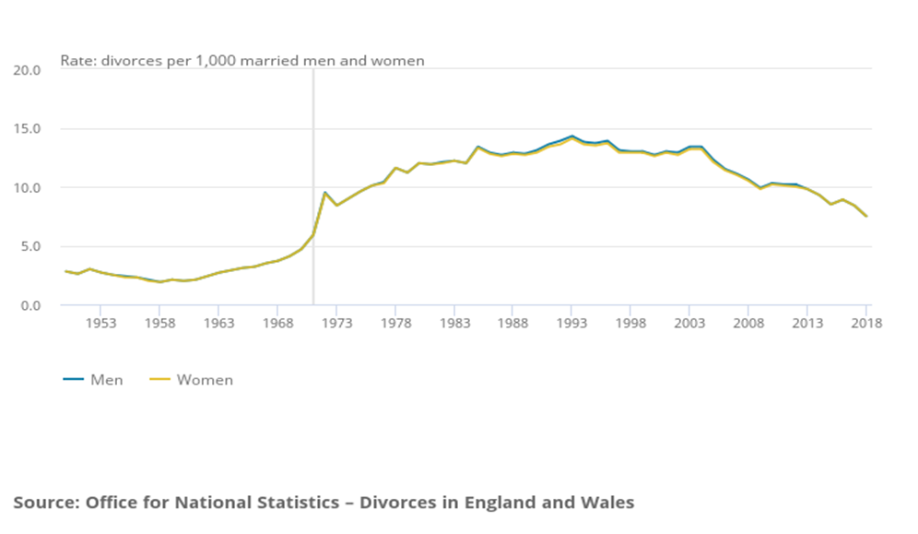

Can love conquer all?
_________________________________________________________________________________________________________________________________________________________________________________________________________________________________________________________________________________________________________________________________________________________________________________________________________________________________________________________________________________________________________________________________________________________________________________________________________________________________________________________________________________________________________________________________________________________________________________________________________________________________________________________________________________________________________________________________________________________________________________

Assessment
Using Scripture and Church Teachings, explain why marriage is still important for Catholics today.
_____________________________________________________________________________________________________________________________________________________________________________________________________________________________________________________________________________________________________________________________________________________________________________________________________________________________________________________________________________________________________________________________________________________________________________________________________________________________________________________________________________________________________________________________________________________________________________________________________________________________________________________________________________________________________________________________________________________________________________________________________________________________________________________________________________________________________________________________________________________________________________________________________________________________________________________________________________________________________________________________________________________________________________________________________________________________________________________________________________________________________________________________________________________________________________________________________________________________________________________________________________________________________________________________________________________________________________________________________________________________________________________________________________________________________________________________________________________________All images used from Unsplash - https://unsplash.com/

