**Racial Justice, Equality and Diversity**



Practice in Schools:  
A Portfolio *Jan 2023*

**St Francis de Sales Primary School, Tottenham**

**School Context:**

St Francis de Sales Junior School in Tottenham is a three-form entry Catholic Voluntary Aided school for pupils aged 3 to 11 years old. Executive Headteacher, James Lane, is also the head of school in another borough which works closely with St Francis de Sales. The proportion of pupils who come from minority ethnic backgrounds is very high, with the largest groups being those from Black African, Black Caribbean or ‘Any Other White’ backgrounds. Around 75% of the pupils use English as an additional language. The proportion of pupils who are disadvantaged is above the national average at 38%. The proportion who have special educational needs or disability is broadly average at 25%. Pupils who join the school tend to stay on roll throughout their primary education. Only a few join the school later than would usually be expected.

Racial Justice, Equality and Diversity: *Practice in Schools*

|  |  |
| --- | --- |
| **What have we done:**  In 2019, leaders started a cycle of reviewing the curriculum with the aim of ensuring it is relevant to the needs and context of the school population. The murder of George Floyd led the school to reflect that the curriculum could better reflect the diversity of the pupils and their families. Work began in September 2020 to improve, contextualise, and ensure relevance of the curriculum through co-construction of an approach to curriculum development.  In order to carry out this important work, headteacher James Lane decided to collaborate with ten other local primary schools to pool knowledge and resources in the development of good practice. For James, it was pivotal to model the notion that knowledge comes from far and wide, and this is what motivated the idea to collaborate in this way. The group engaged Professor Paul Miller from the Institute of Equity in Education and Society (IEES) to support them through the process, with a focus on evidence-informed practice.  Professor Miller led four capacity-development workshops for school leaders, two of which were open to staff with curriculum leadership roles in participating schools. Included in the four workshops was training in how to ‘identify and tackle bias in the curriculum’ and how to use a tool designed by IEES, called the Inclusive Curriculum Framework Inventory to assess and index the perceived degree of inclusivity in a subject curriculum. Deputy Headteacher, Claudia reflects:  *These sessions were so informative. They used some really engaging slides and clips of interviews with people. And that gave us thinking time to really consider how we could implement it in our schools.*  A key understanding for the schools, says James, was that their starting point actually needed to be different from what had been originally anticipated. The schools were hoping to start with an audit of the curriculum, but through this work, they realised they needed to start with an audit of the school communities they serve, hand-in-hand with an in-depth understanding of their own learned biases with regards these communities. | **Valuable learning from this process:**  The main reasons behind changing the curriculum was to reflect the community the school serves and to give children a wide range of cultural opportunities that they may not otherwise experience. A yearly review of the curriculum now takes place – informed by the school’s diversity review – and the content covered, especially in Geography and History, is designed to be less Eurocentric, and better represent the diverse nature of the school and multicultural Britain. Resources were also reviewed with a renewed focus on suitability for the more diverse curriculum, and this work is ongoing as opportunities arise to explore issues with critical thinking at the heart. James names mentions for example:  *Leading up to Black History Month, there’s an opportunity to make sure we address issues in ways that aren’t tokenistic and that are part of the daily diet of education.*  The governors and leaders are energised and committed to using the review process to give a voice to the full range of stakeholders, to respond to any identified needs, and to showcase where they are in their journey with openness and willingness to explore other possibilities. Subject leaders and staff are going into regular curriculum design meetings far better equipped and more knowledgeable, having an awareness of ‘the other’ and being mindful about representing different groups positively and responsibly.  Subject leaders and the Deputy Headteacher, with dedicated regular time to meet to review, revisit and revise the History and Geography curriculum, know that as well as meeting the needs of the National Curriculum, it is now more relevant to the school context. Greater emphasis is now placed on the diversity of the texts used throughout the curriculum to enable children to see themselves reflected in different elements. Pupils have the opportunity to develop their knowledge of each other’s heritages and also have many opportunities for celebration - the school is starting to see the results of this focus in children’s engagement and outcomes.  Parents speak positively about the school and the way the curriculum is delivered. The school feels it is very strong in how it responds to parents and carers and that conversations and questions can be addressed with confidence from both parties. This is as a result of realising that staff needed to create scaffolded experiences for families as well as for the pupils, when introducing material and subject matter that can be new, emotive or challenging. |
| **Our next steps:**  Subject leaders will continue to develop their own knowledge of the Early Years and Foundation Stage (EYFS) curriculum and disseminate this to all staff. They will work with the EYFS lead to regularly review the curriculum, ensuring that the new cohort of children coming into the school are well represented and supported. Across the school, a number of areas are priority, including extending the range of music to include music which originates from or is performed by Black artists. Similarly, leaders and subject specialists will continue to research more diverse scientists and other role models for pupils so that they are reflected in the curriculum. Post-Covid, there are opportunities to repair lost connections with parents and build engagement through events and celebrations of diversity across the school.  The headteacher, James, has identified that a clear next step would be to re-group with the other schools in the collective to evaluate what happened next for each school, what the impact has been, and to potentially write this up. There is much to be learned from the many ways to approach curriculum design with a focus on context.  **Useful links/resources:**  [School leaders leading curriculum inclusion: Re-culturing pedagogy, re-imagining the student experience - Paul Miller, James Lane, Karen Jaeggi, 2022 (sagepub.com)](https://journals.sagepub.com/doi/full/10.1177/27526461211069133) | |

**Christ the King and Sacred Heart Primary Schools, Islington**

**School Context:**

Christ the King and Sacred Heart, both Catholic primary schools in Islington, are in a soft federation. We often work on shared initiatives where there is commonality across both schools. One curriculum initiative that has been part of our work these past two years is developing a more inclusive curriculum. Following a key note presentation from Professor Paul Miller at the Diocesan Leadership Conference in 2021 we were inspired to undertake more meaningful and purposeful work in this area.

**School Context:**

St Francis de Sales Junior School in Tottenham is a three-form entry Catholic Voluntary Aided school for pupils aged 3 to 11 years old. Executive Headteacher, James Lane, is also the head of school in another borough which works closely with St Francis de Sales. The proportion of pupils who come from minority ethnic backgrounds is very high, with the largest groups being those from Black African, Black Caribbean or ‘Any Other White’ backgrounds. Around 75% of the pupils use English as an additional language. The proportion of pupils who are disadvantaged is above the national average at 38%. The proportion who have special educational needs or disability is broadly average at 25%. Pupils who join the school tend to stay on roll throughout their primary education. Only a few join the school later than would usually be expected.

Racial Justice, Equality and Diversity: *Practice in Schools*

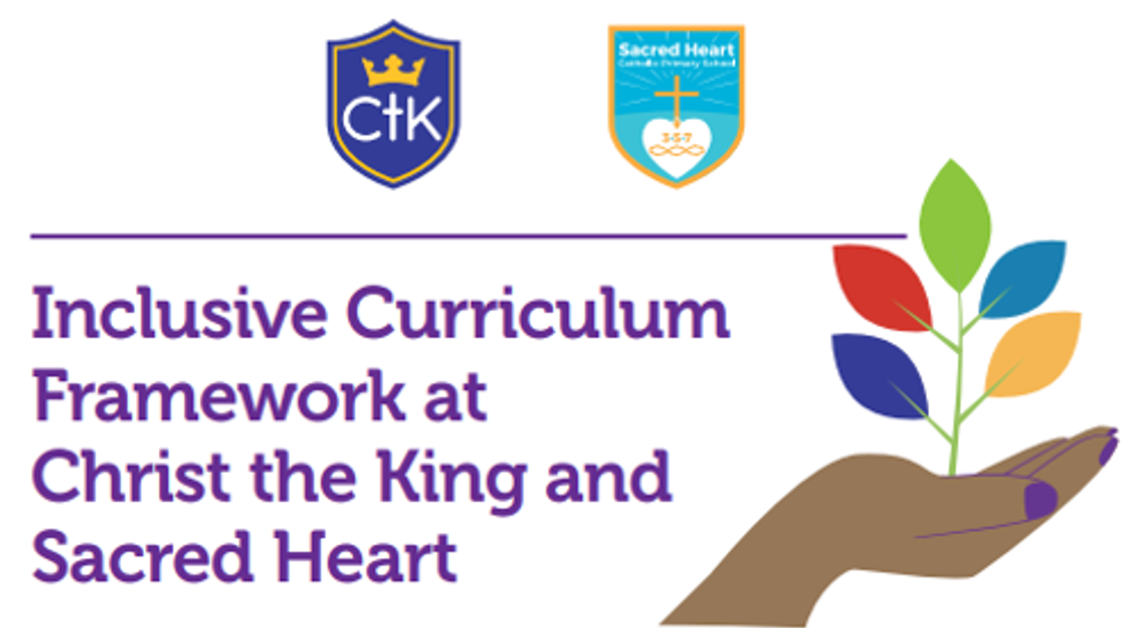

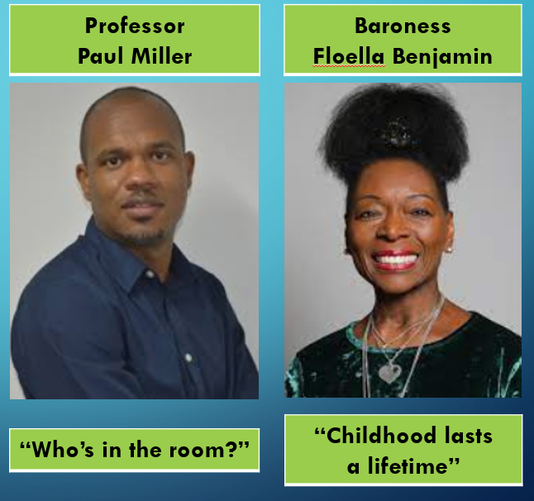

*Add photo/image here if required. (Do not add images of pupils, ensure it is copyright free).*

|  |  |
| --- | --- |
| What have we done:  In the 2021/22 academic year key members of staff at each school have completed Inclusive Curriculum Framework Training with Professor Paul Miller which has been accredited by the Institute of Leadership & Management.  We have reviewed one area of our curriculum (Science) undertaken by Professor Paul Miller on behalf of Institute for Educational & Social Equity.  Members of staff involved in this process have developed their skills at reviewing and adapting a more inclusive framework, a curriculum where we feel our pupils and their backgrounds are reflected more.  We have informed all staff of our work at an INSET Day recently – the key note speakers were Professor Paul Miller and Baroness Floella Benjamin.  Presented to Governing Body joint committee on our work to date.  *(Provide a brief overview of the work done. If more is needed, put a link to another document)* | Valuable learning from this process:  Having a better understanding of the theory and research enabled us to have a better understanding of (a) what we were trying to achieve and (b) why we were trying to achieve it.  Work initially with leaders/staff who are keen to embrace this change and/or are passionate about the curriculum.  Crucially important to understand the demographics of your school community.  Inform your staff and governors of the work you are doing as you go along.  Talk and learn from others who are further on with this work that you are as a school.  Remember that developing cultural competence in your curriculum is a journey and not a destination. |
|  | |
| Our next steps:  Using the skills, we have learnt during our work with Professor Miller, support other leaders to ensure our Curriculum Intent is more inclusive.  Ensure that our work is closely aligned with the Equalities Framework and addresses pupils personal and key skills, knowledge, understanding, their backgrounds and cultural capital which will prepare them for their future lives.  Review another area of the curriculum this year.  *(eg How will you continue on the RJED journey to develop this in your school?* | Useful links/resources:  Weekly phase news in our weekly newsletters in each school reflects aspects of greater diversity and inclusiveness in our curriculum.  Sacred Heart  https://www.sacredheart.islington.sch.uk/topic/newsletters    Christ the King  https://www.ctks.co.uk/stream/newsletters/headline/1/-// |

**St Monica’s Primary School, Enfield**

**School Context:**

*Following the death of George Floyd in 2020 I began sharing some of my husband’s experiences as a black Caribbean man in London with the school staff and parents. It prompted a very positive response and a desire to ensure equality. My school is majority White British/European with a small (but increasing) minority of black children/families. We felt it important to educate everyone about how to be anti-racist.*

Racial Justice, Equality and Diversity: *Practice in Schools*

|  |  |
| --- | --- |
| **What have we done:**   * Invited Marva Rollins in to school to do what was called a “BAME review” (this was organised with Haringey Education Partnership). This involved initially completing an audit (I have permission to share the blank if you’re interested). She met with staff, governors, parents and children * Drew up an action plan (after Marva’s visit) * Reviewed all our library books and found them woefully lacking in terms of reflecting our children – our PTA have given us several £1000 to improve this (but there’s more to be done) * Chose books for every year group for English lessons which reflect black/ethnic minority authors/heroes * Reviewed our curriculum (all subjects) in terms of significant people and ensured black British people are referenced (avoiding just Rosa Parks and Martin Luther King which can frequently be the “go-to”!) * Took part in “show racism the red card” day in October (3 years running now) * Celebrated “World Afro Day” in Sept (helped by my 3 daughters) * Looked at images around the school, images on assembly PowerPoints eg black saints on 1st Nov, black images of Mary during May, the nativity etc * Elected a link governor who is leading work with parent groups * Joined the Diocesan RJED group (Headteacher) * Attended Paul Miller training, anti-racism training and had an Inset day with Karen Brooke from Oshun (school staff) | **Valuable learning from this process:**   * Be open about what you don’t know * Ask what is appropriate language to use if you’re not sure * Use personal experiences as much as possible (if not you, another staff member, parent, visitor) – I’m lucky I had my husband’s family and daughters to reference in order to try to educate white people what life can be like (many didn’t believe the true life stories I told, “surely not in this day and age??”) * Don’t touch afro hair of people you don’t know or without asking and make sure you educate others to do the same * Recognise there is bigotry everywhere and continue educating and talking and reviewing what we do/teach/show. * Try not to get cross when people say, “but white lives matter too/don’t ALL lives matter?” as these people need educating * Don’t do “Black History Month” and think your work is done! |
| **Our next steps:**   * Purchase more art work/statues for around the school to reflect a more ethnically diverse range * Agree an RJED policy for school * Continue to improve the curriculum for EVERY subject and buy more, more, more books! * Hope to encourage greater diversity on the staff and governing board | **Useful links/resources:**  [*https://www.st-monicas.enfield.sch.uk/show-racism-the-red-card/*](https://www.st-monicas.enfield.sch.uk/show-racism-the-red-card/)  [*https://www.theredcard.org/*](https://www.theredcard.org/)  [*https://www.worldafroday.com/the-big-hair-assembly-2022/*](https://www.worldafroday.com/the-big-hair-assembly-2022/) |

**St Scholastica’s** **Primary School, Hackney**

Racial Justice, Equality and Diversity: *Practice in Schools*

**School Context:**Over the past two years school leaders and teachers and governors have worked together to ensure our children are provided with a rich, relevant and representative curriculum. As a school community with a large Black and Global majority community, all stakeholders felt it important that what our children are taught reflects and inspires them. We were keen to ensure children see themselves represented in their lessons and in resources and that what is taught provides them with a sense of belonging and identity.

*Practice in Schools*

|  |  |
| --- | --- |
| **What have we done:**   * Audited the current provision and created an action plan based on our findings * Included this in part of our School Development Plan * Organised staff training and CPD * The curriculum has been diversified to include more Black history throughout the year.​ (This includes studying key figures from Black British history when studying key events in history and some key event in Black British history) * Appointing TLR post holder and Link Governor for Diversity in Curriculum * Consult and collaborate with parents and families * Ensure classrooms represent cultural diversity and provide a range of books.​ * Providing more exposure to positive, current and British Black role models.​ * Numerous days throughout the year celebrating significant people and cultures. * Increasing opportunities for pupil voice and leadership through ‘Leaders for Change’ | **Valuable learning from this process:**   * Start by auditing current provision * Start small, focus on a few key areas but do them thoroughly * An action plan is essential * Accountability and shared responsibility: ensure every stakeholder group has a role/target so that this a job for everyone not just curriculum leads or SLT * Use resources already available, no need to reinvent the wheel! * Educate yourself, read books, listen to podcasts etc – knowledge is power!   ​ |
| **Our next steps:**   * Finalise our policy and send to FGB for ratification - share with all stakeholders * Ensure policy is embedded so that this is not a ‘standalone’ piece of work. RJED runs through all aspects of school life * Promote RJED principles through visits, visitors to the school etc * Monitor and evaluate action plan, consider actions for next academic year | **Useful links/resources:**  **RESOURCES**  <https://education.rcdow.org.uk/re-catholic-life/racial-justice-equality-and-diversity/resources/>  **TRAINING**  <https://education.rcdow.org.uk/re-catholic-life/racial-justice-equality-and-diversity/cpd-and-events/> |

**St Vincent’s** **Primary School, Ealing**

**School Context:**

*During the school year 2019/2020, due to our collective desire to create a broader Catholic curriculum, we began diversifying and broadening our curriculum to include aspects of Catholic Social Teaching across all subject areas. We realised that we needed to do more in terms of RJED and so, in 2021/2022, we embarked on a whole school programme within the whole curriculum to complement and build on the work we were doing . All staff completed a term’s training on Unconscious Bias and Black History and did a lot of research and discussion which continues to support us. We are also involved in the Voice 21 Oracy programme which supports RJED in many ways*

Racial Justice, Equality and Diversity: *Practice in Schools*

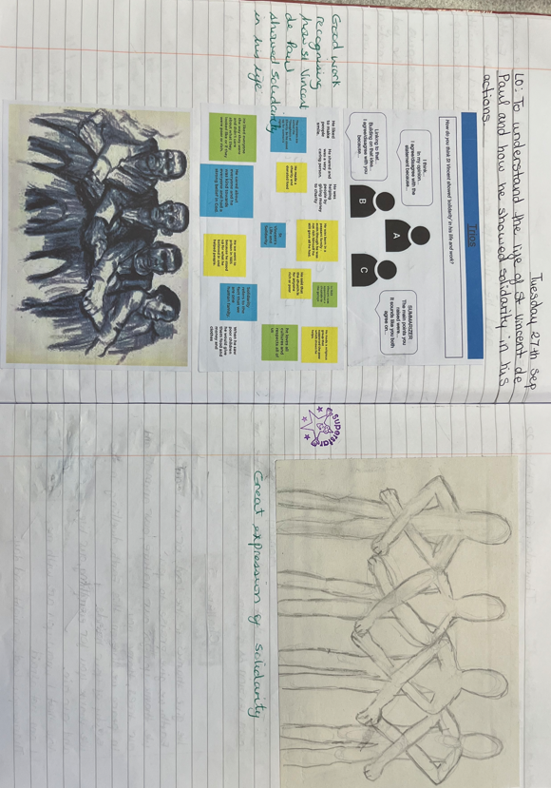

|  |  |
| --- | --- |
| **What have we done:**   * This term we have all been learning about WW II. The children have researched the role of black men and women during this period of time. * Year 1 were learning about significant people in History and included Winston Churchill within their learning of WW II. They discovered that, although he had many great leadership qualities, he was racist.  Knowing this, they pondered a 'big question:' "Do you think Winston Churchill should have been Prime Minister?" * As part of our work on CST, our theme this term has been 'Solidarity.' We linked this to work on St Vincent and paintings by Henry Moore.  Between September 1940 and the summer of 1941, at the height of the German bombing raids on London, Moore made more than 300 drawings, mainly of women and children sheltering on the platforms of the London Underground and in its tunnels, as the city was subjected to nightly air raids that killed some 10,000 civilians. | **Valuable learning from this process:**  Pupils have gained a broader understanding of the impact of all contributions made to the war effort and not just limited to a narrow group.  They have also learned to speak up against racism by learning about key figures who have had/have expressed racist views.  Our work on the CST of ‘Solidarity,’ has further supported our development around a discussion of racism and why, as a human race, we need to support one another.  Pupils in Year 6 studied the work of artist Henry Moore and his paintings during the Blitz on the London Underground. This was linked to discussions of working together for the common good. |
| **Our next steps:**  Each term, we develop plans within our connected curriculum to reflect on and learn about the extensive contributions of black and other ethnic groups to the history of the time period we are studying. Next term, our theme ‘All that Giltters is Gold’ (Benin and Ancient Egypt) will be supported by the CST, ‘Options for the Poor and Vulnerable’ | **Useful links/resources:**  School website: <https://www.st-vincents.ealing.sch.uk/>  A range of books associated with Black History  Caritas – Catholic Social Teaching  Educarem – Building the Kingdom |

**St Joseph’s** **Primary School, Camden**

Racial Justice, Equality and Diversity: *Practice in Schools*

**School Context:**

*We have written an Equality Policy and attended various training. We have revised our curriculum so that it is more diverse in terms of both race and gender. Our unit plans for this include different authors and biographies. Throughout the Partnership, we do Equalities Studies and part of this is doing an Equalities Week. Our governors have also completed questionnaires about the diversity of governors within the school.*



|  |  |
| --- | --- |
| **What have we done:**  The children focused on Equality Studies at St. Joseph’s. The children had a fantastic time learning about many of the important issues surrounding Racial and Gender Equality, Social Justice (including votes for women and the Suffragette movement) and British Values. Equality Studies is about getting the children to think and talk about these issues and about inspirational people who ‘Shine in the World, including Rosa Parks, Malala Yousafzal, Martin Luther King, Mother Teresa of Calcutta and Nelson Mandela.  **Year 6** have been learning about Nelson Mandela and Mahatma Gandhi. They learnt about the main events of Mandela’s life and why he was inspirational in working for equality and unity, whilst reflecting on his key qualities. They identified the teachings in the Bible about equality and were able to explain tolerance, determination, peace and forgiveness in relation to Nelson Mandela and Jesus Christ.  **Year 5** have been learning about Emmeline Pankhurst. They developed an understanding of how voting works and that sometimes you might not get your way. They also learnt about protests and that you may have to fight to get what is right. Year 5 found out that Emmeline Pankhurst demanded equality for women, by persuading the government to allow women to vote. They also produced some outstanding biographies about Emmeline’s life.  **Year 4** have been learning about the social activist Martin Luther King, who tirelessly fought and campaigned for equal rights. They used his example as one where they too can, ‘Shine in the World’, linking his determination, bravery and courage to Jesus' Sermon on the Mount and the Beatitudes. The children looked at themselves, and society, reflecting on how God created us all in His image and loves everyone equally. The children wrote their own, ‘I have a dream’ speech, based on the inspirational example presented in 1963 by Martin Luther King.  **Year 3** have been learning about gender equality. They focused on the life and contributions of Malala Yousafzay. They discussed gender inequality in her life and how she was treated unfairly because she was a girl. Children discussed how they are all different, but all equally valuable in the world, no matter if they are a boy or girl. They discovered the similarities and differences between our school and a school in Islamabad. They also made links between Malala’s values for forgiveness and those of Jesus.  **Year 2** have been learning about the life of Rosa Parks. Rosa fought for the rights of black people in America, refusing to give up her seat on the bus to a white man and arguing for equality. Her actions, as well as the actions of many others, led to changed laws and more equal treatment of black people in America.  **Year 1** were given mirrors to study their facial features. They discussed with their partner their different eye colours, hair colours and skin colours in class. They spoke about how unique they are and that everyone looks different. Using this information, they created self-portraits of themselves. Afterwards they celebrated their differences by talking about the unique features each child has.  **Reception** started to understand ‘fair’ and ‘unfair’. The teacher created a barrier across the classroom and would only allow certain children through to the other side, where there were new toys to choose from. The girls soon realised that the teacher was only letting the boys go through. The girls thought this was very unfair! The children were then given a box of toys to sort, using two labels - ‘toys for boys’ and ‘toys for girls’. As the children were sorting, they found they played with the same toys. The children decided that toys can be for everyone because they have the choice to play with whatever they want to. The children decided to tear up the labels and use a different one, ‘toys for everyone’.  In **Nursery** we made our own self-portraits and talked about our similarities and differences. We also enjoyed listening to the story of Elmer and making our own different patterned elephants. | |
| **Valuable learning from this process:**  We noticed that when we adapted the curriculum and made it more diverse, our pupils can relate to it more. They have greater relevance and enjoyment and can identify with the authors. | |
| **Our next steps:**  Continue to make the curriculum diverse and reflect our school community. Celebrate this learning with the wider community. | **Useful links/resources:**  [**https://www.stjosephs.camden.sch.uk/stream/newsletters/headline/1/-//**](https://www.stjosephs.camden.sch.uk/stream/newsletters/headline/1/-//)  [**https://education.rcdow.org.uk/re-catholic-life/racial-justice-equality-and-diversity/**](https://education.rcdow.org.uk/re-catholic-life/racial-justice-equality-and-diversity/) |

**St Joseph’s Primary School, Hertfordshire**

Racial Justice, Equality and Diversity: *Practice in Schools*

**School Context:**

*St Joseph’s is a one form entry Primary school with 203 pupils from Nursery to Year six. Our demographic is changing quickly as we border Enfield. We currently have 33% of Black British children, this being our largest group of children. Our children speak over 12 different languages. Our journey of curriculum review began three years ago. We began looking at introducing a variety of different texts and started to expose our year six pupils to current topics. This process was slower than anticipated due to staff perceptions. Some embraced, some felt secure in their topics.*

*More specific to outcomes and the need to embrace all of our communities. For many years we held celebrations, event days and assemblies on various themes; black history month, international week, other faith weeks, world book week with two black authors sharing their books and stories. It was then after Covid when many of our younger year group parents hadn’t even entered our school and questioned our ethos and celebration of diversity that we agreed that we needed to review fully and give greater context to all we do.*

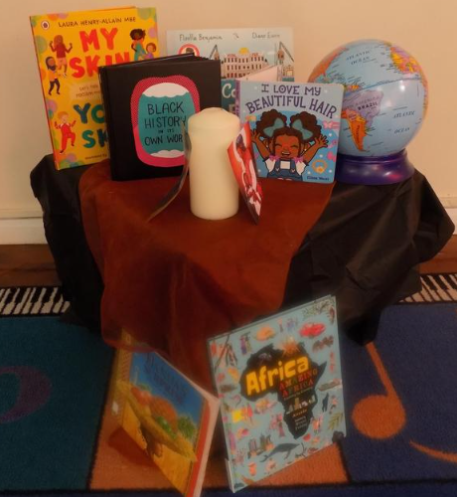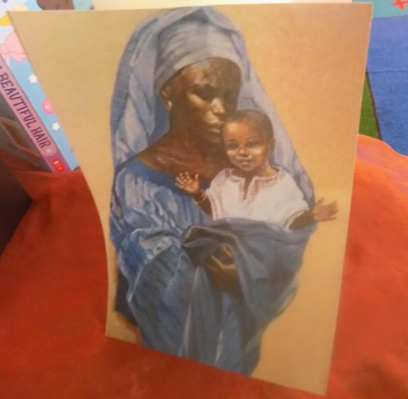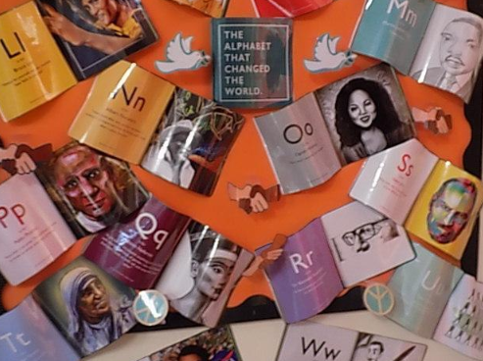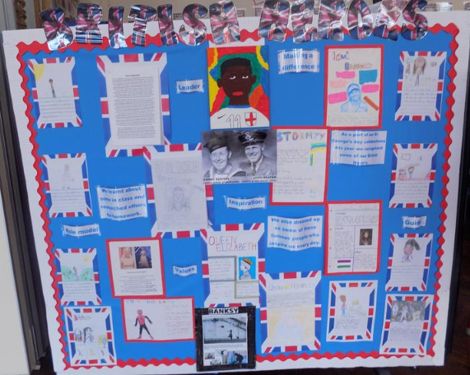

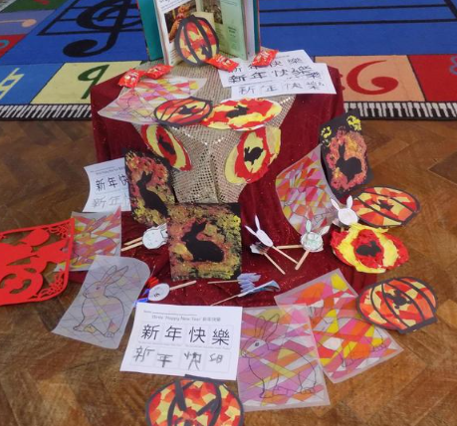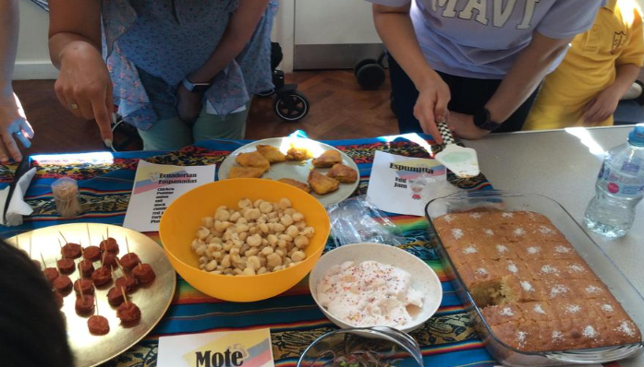

|  |  |
| --- | --- |
| **What have we done:**  The main change was looking at everything from our children’s point of view and allowing them to hold us to account.  Can I see myself represented in my school?’  This was us as leaders and as a staff team exposing ourselves, being brave, open and honest and saying, it’s a time for change. We were doing ,but was it enough?  And so our journey since then;  · Curriculum review in every aspect – not tokenistic  · Curriculum mapping with explicit diversity sections  · Reviewing all aspects of our SMSC events  · Ensuring we deliver Diwali assemblies  · Windrush day to involve all  · Visits to other places of worship  · Reviewing black history activities  · International week being more specific  · Class saints being diverse of colour /age/sex  · Month of May –Mary focus on the image of Mary our children see  · Considering ‘why’ we do everything  · Pupil voice on curriculum  · Parent survey with diversity questions  · Parent working party  · Review of school displays  The review and the journey will continue as our vision is – ‘Children seeing themselves represented in everything’ within our school, or their school experiences, this begins in Nursery to their final days in Year 6. | **Valuable learning from this process:**   * Do not be afraid of difficult conversations * Ensure all children come first in this process * Get parents on board and be honest where your starting point it * Audit books and reflect current modern Britain and our children’s home lives * Get authors/speakers who have valuable experience to offer children * CPD!!!! This is an absolute essential for moving forward * All stake holders need to know step by step what the long term plan is * Start with curriculum and build around * Link with other local school who have begun on this journey |
| **Our next steps:**   * + To continue developing our Lighthouse Keepers   + To continue to develop and listen to our parents   + Ask our pupils if they feel they belong and can be seen in what we do   + Staff training   + Invite Suffian in to speak to staff and Governors as well as a pupil group   + secondary link students to visit for workshops and an assembly   + To re audit all the books we have; to share, as class books, in our library and reading areas   + Continue to develop and evaluate our curriculum   + Continue reviewing our action plan | **Useful links/resources:**   * *Black history curriculum* * *Islington educational resources* * *Hackney curriculum* * *Topic books reflecting the needs of your children* * *Displays* * *Pupil voice* * *Parent surveys – including diversity related question* * *Websites displaying every insight into your school* * *Great Representation course run by HfL* |

St Anne’s and Guardian Angels Primary School, Tower Hamlets

Racial Justice, Equality and Diversity: *Practice in Schools*

**School Context:**

*At St Anne’s and Guardian Angels, RJED is not a standalone concept but built into the culture and ethos of the school. We are working with staff, pupils and their families to enhance the good practise that we already have in place to ensure that our school is an inclusive and equitable place to learn and work. As such, the RJED work that we are undertaking is one element in our broader work around the nine protected characteristics of the Equality Act. We would like to share some of the things that we’re doing in school in relation to RJED and this work more broadly.*

*RJED is included in the school development plan and shapes the curriculum. We have appointed a member of our middle leadership team to lead on this area of school development - throughout the year they will contribute to SLT meetings and present to the Governing Body on the work that the school is doing and more importantly, its impact. Curriculum topics are diverse and we include topics such as the Windrush, The Brixton Uprisings, Immigration to East London throughout history (including the Huguenots, Jewish settlers, the Bangladeshi community) Fairtrade, the Commonwealth, Benin Civilisation as well as the geographical study of countries such as Ghana and Bangladesh. In our knowledge organisers, we also include RJED links, which guides teachers on how to teach about other racial groups living in eras such as the Stone Age, Tudor period and in WW1/2. Whilst we have designed a curriculum that celebrates diversity, reflects our school community and addresses themes around equality all year round, we acknowledge the importance of celebrating Black History Month and Refugee week in their own right. This year we are adding these to our curriculum overview to ensure that the knowledge the pupils gain is robust and that we show progression across year groups in the content and themes covered.*

*Each of our classes are named after saints and we have changed some of our class saints to reflect more racial and gender diversity. This gives pupils the opportunity to learn about a greater range of Catholic Christians which we hope will enrich their religious knowledge and literacy. We have also reviewed the iconography and religious images that we use around the school and made changes to ensure that they reflect the diversity of our school community. This in particular has been well-received by our parents/carers.*

*At SAGA, we have held many whole school RJED related celebration events which have involved parents. Celebrations include World religion day, Black History Month, Cultural Day, Human Rights Day and National Afro Day. Our parental turnout in these events are good and we receive positive feedback from them. Last term we also held a parents’ workshop where we met with parents explaining our plans regarding RJED and asking for their opinions and suggestions. We also have a good relationship with nearby schools (which have a high number of Muslim pupils) who often join us in our events. We encourage year groups across the school to visit other places of worship as part of our study of other faiths.*

*The RJED lead and our resident librarian also work together to organise regular whole school library events based on RJED/inclusion/equality related topics (e.g. Deaf Awareness Week, Mental Health Week, Disability Awareness Day, Refugee Week, BHM, World Religion Day). Here, classes have enjoyed Windrush picture exhibitions, learning BSL, writing messages on our ‘be good to yourself’ mental health wall and creating music videos celebrating black artists.*

*This year, our staff had a CPD explaining what RJED is and what it will look like in our school. This helped staff understand the importance of our RJED practice. Staff members have also had unconscious bias training.*

*We are also part of the Equally Safe Programme by EqualiTeach who work with schools to help them become more inclusive.*

*Pupils at St Anne’s have a good understanding of RJED and have led many RJED specific liturgies and assemblies. Our Monday morning worship assemblies, led by our head, also include reference to RJED related topics.*

*To compliment this, we have also focused on CST and implemented this throughout the curriculum using resources from Caritas and CAFOD. The Year 5s are currently following the Caritas programme and we are training the Year 4s to be Mini Vinnies. We are applying for the Oscar Romero award next term which we hope will acknowledge our good work in this area.*

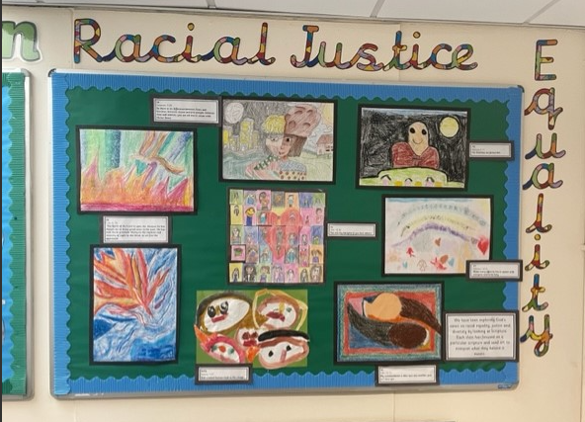Whole school RJED display with contributions from all year groups.

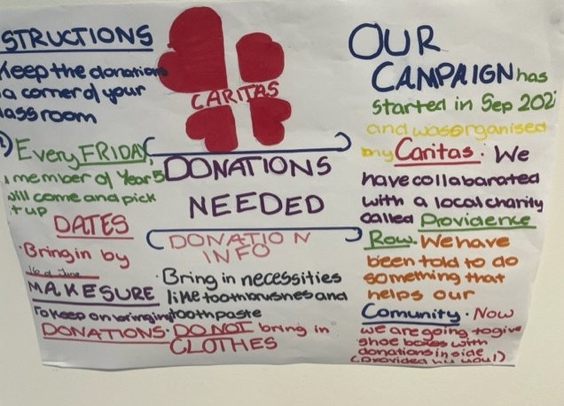

Year 5’s Caritas campaign

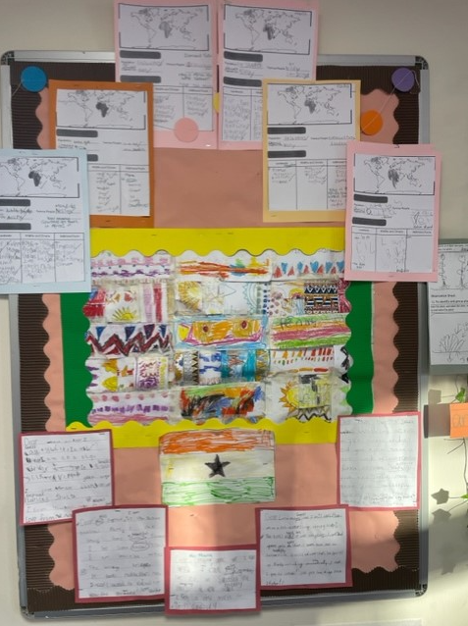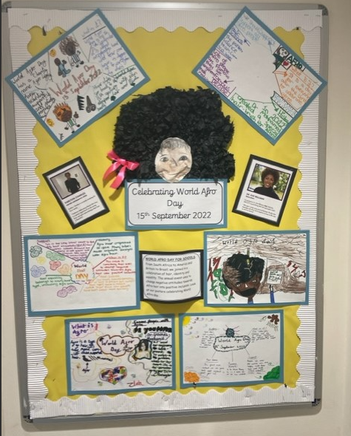World Afro Day display

Year 1’s Ghana topic display

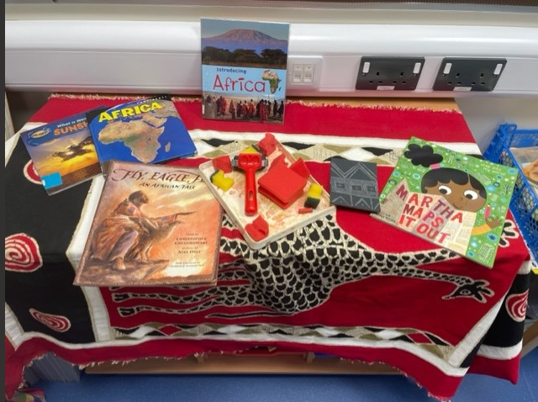

**Extracts from Y6 Knowledge Organiser:**

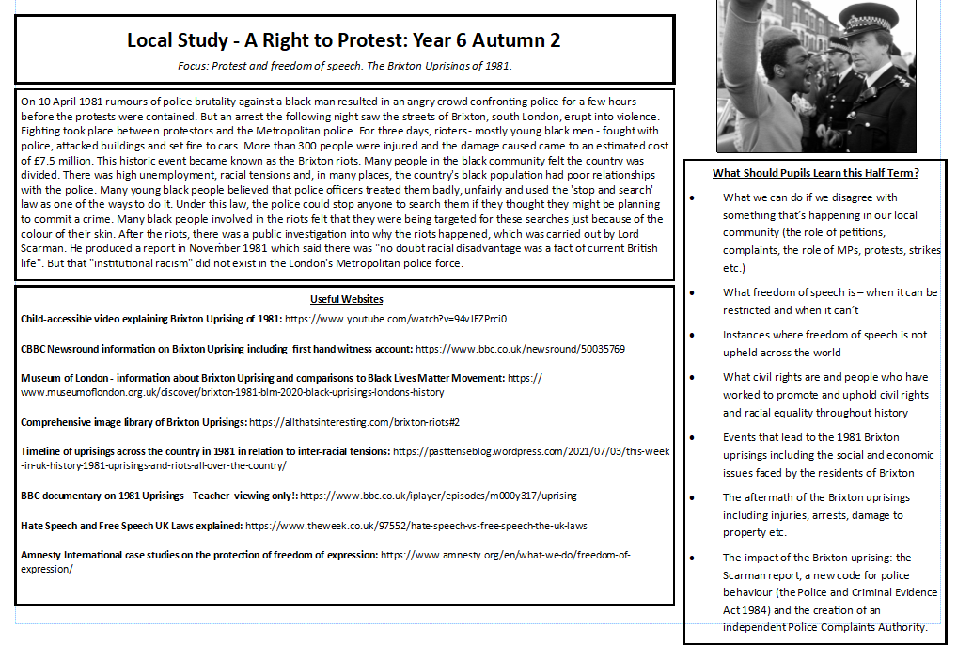

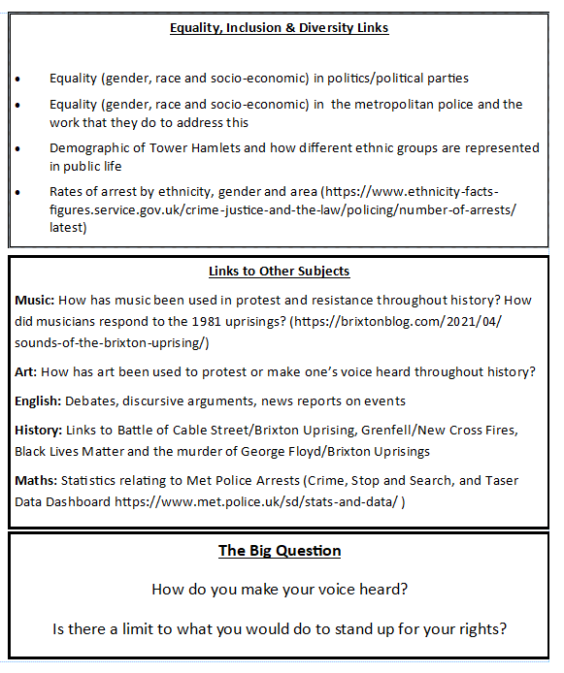

|  |  |
| --- | --- |
| **What have we done:**  -Included RJED in SDP  -RJED staff meeting  -Parents’ forum meeting about RJED  - RJED related topics throughout the curriculum  -BHM whole month celebration and event which parents attended  -Fairtrade fortnight fairs and events  -Windrush picture library exhibition  -RJED library events  -Working with Equaliteach  -RJED liturgies  -More racially diverse books in the library  -More racially diverse visitors and speakers  -Unconscious bias training  -School dinners more ethnically diverse  - Y5’s caritas campaign. | **Valuable learning from this process:**  Involve the parents when generating ideas. They have good ideas.  Promoting RJED can be hugely successful if SLT are supportive and involved.  RJED is not a standalone concept. Having one RJED related observation during BLM or Afro day is not enough. It is something that should inform the school’s practise.  Teachers are mostly supportive of the concept but need support in obtaining RJED related curriculum links. If it is provided it is more likely to be used. |
| **Our next steps:**  -Continue with what we’re doing so it something that is embedded and fully evident in pupils’ learning and in the life of the school.  - Use the Caritas Ambassadors and Mini Vinnies to be advocates and a driving force for improvement  - Encourage children to be more independent in raising issues that they would like to discuss around inclusion and diversity  - Encourage children to be more independent in leading acts of worship relating to RJED  - Empower staff and pupils to challenge any inequalities that they see by giving them a common language/framework to use | **Useful links/resources:**  Our school’ twitter pages  St Anne’s and Guardian Angels CPS |

St Peter and St Paul’s Primary school, Islington

Racial Justice, Equality and Diversity: *Practice in Schools*

**School Context:**

We at St Peter & St Paul dream of the day when we can achieve true representation in our school. We felt that for many pupils, the arrival into primary school will be their first major opportunity to experience diversity, bringing with it the potential to meet peers and school staff who represent different backgrounds from their own. There was a strong desire to embrace and reflect our whole school community through introducing changes. This has been further heightened by the ‘Black Lives Matter’ movement. For the last two years all stakeholdershave worked together to ensure our children are provided with an enriched curriculum and a school environment which reflects our diverse school community.



|  |  |
| --- | --- |
| **What have we done:**   * All staff given the book ‘Why I’m no longer talking about race by Reni Eddo – Lodge as a starting point for them to read, digest and reflect on the powerful content within the book and then to discuss their thoughts on identity and race and what this means for the school community. INSET September 2020 * Training provided by the LA on unconscious bias November 2020 * Further staff training and CPD (Diocesan Training) * Audit of current provision i.e. curriculum, books, pictorial representation, resources etc. * Pupil and Parent/Carer Questionnaire on what they would like to see reflected in the curriculum and school environment * Created action plan and included in the School Development Plan * New diversified curriculum across most subjects launched September 2021 * Donation from local business to   ensure classrooms represent cultural diversity. We were able to purchase a range of books for all classes.​   * Providing more exposure to positive, current British Black role models.​ Images and contributions are around the school * Bespoke History timeline reflecting diverse History themes painted by artist * Recruitment of diverse staff * Recruitment of diverse governors | **Valuable learning from this process:**   * Opportunities for all stakeholders in school to tell their story. Everyone has a shared responsibility and role to achieve true representation not just leadership or curriculum leads * audit current provision * Important to find out views of children and school community * Create an action plan in order to have a record of points for development and when achieved * Make work manageable - teach yourself about diversity with extracts and books etc. Retrain your mindset to always leave space for different experiences, abilities and faces etc. * Don’t be nervous about getting things wrong or causing offence. Ask for advice from colleagues or someone in your wider circle. By working on our own understanding, we can quickly make a difference to those around us. * Take a few key areas to begin with but do them thoroughly e.g. diversify the curriculum in a meaningful way - not merely as a bolt on * Take your existing curriculum and work with it. * Ensure the school environment reflects your school community i.e. representation in literature, display etc.   ​ |
| **Our next steps: 2023 -2024**   * Sharing our pledge with the Governing body and asking for their input * Appointing Link Governor for RJED * Ensuring policy and work around RJED is on the new website * Ensure RJED runs through all aspects of school life * Evaluate curriculum make necessary changes if needed * Monitor and evaluate action plan, consider actions for next academic year | **Useful links/resources:**  **RESOURCES**  <https://education.rcdow.org.uk/re-catholic-life/racial-justice-equality-and-diversity/resources/>  **TRAINING**  <https://education.rcdow.org.uk/re-catholic-life/racial-justice-equality-and-diversity/cpd-and-events/> |

St Monica’s Primary School, Hackney

**School Context:**

*Across Britain schools, libraries and community organisations have been celebrating Black History Month during October. Whilst we have diversified our curriculum to ensure that it is inclusive and representative of the communities in which we serve, each year, we at St Monica’s, Hoxton focus our learning for one week on recognising and appreciating the contribution of the Black community throughout history.*

*Black History Week is an opportunity to share in a celebration of the vast contribution of the black community to the world: a time to demonstrate pride in its creativity, respect for its intellectual prowess and a celebration of its cultural identity.*

Racial Justice, Equality and Diversity: *Practice in Schools*

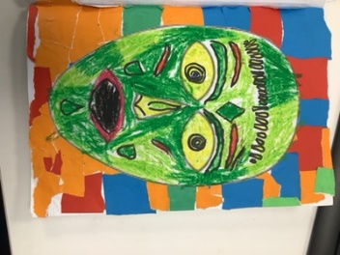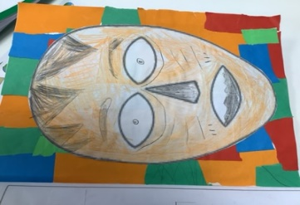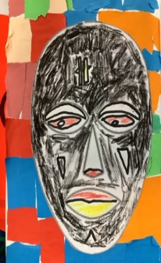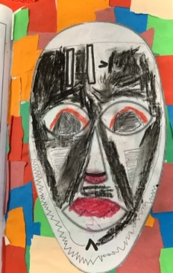

|  |  |
| --- | --- |
| **What have we done:**  Black History Month in the UK celebrates the history, arts and culture of Black British people. Awareness of, and education about, the history of British history is well-established, but there is a lack of representation within the multi ethnic community. Dedicating a month to it every year helps redress that balance, and helps us all learn more about our shared History as Britons. | **Valuable learning from this process:**  Black History Week is an opportunity to share in a celebration of the vast contribution of the Black community to the world: a time to demonstrate pride in its creativity, respect for its intellectual prowess and a celebration of its cultural identity. |
| **Our next steps:**  To continue to diversify the curriculum with memorable learning experiences. | **Useful links/resources:**  <https://www.stmonicasprimaryhackney.co.uk/web/one_voice_magazine/649065> |