Racial Justice, Equality and Diversity:
Practice in Schools
School Context:
Across Britain schools, libraries and community organisations have been celebrating Black History Month during October. Whilst we have diversified our curriculum to ensure that it is inclusive and representative of the communities in which we serve, each year, we at St Monica’s, Hoxton focus our learning for one week on recognising and appreciating the contribution of the Black community throughout history.
Black History Week is an opportunity to share in a celebration of the vast contribution of the black community to the world: a time to demonstrate pride in its creativity, respect for its intellectual prowess and a celebration of its cultural identity.

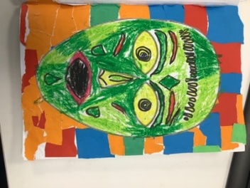
What have we done:  Black History Month in the UK celebrates the history, arts and culture of Black British people. Awareness of, and education about, the history of British history is well-established, but there is a lack of representation within the multi ethnic community. Dedicating a month to it every year helps redress that balance, and helps us all learn more about our shared History as Britons. | Valuable learning from this process:  Black History Week is an opportunity to share in a celebration of the vast contribution of the black community to the world: a time to demonstrate pride in its creativity, respect for its intellectual prowess and a celebration of its cultural identity.
Our next steps:  To continue to diversify the curriculum with memorable learning experiences. | Useful links/resources:  https://www.stmonicasprimaryhackney.co.uk/web/one_voice_magazine/649065

