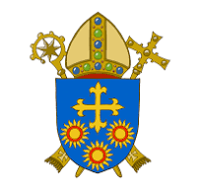
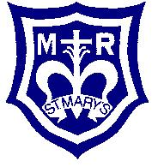

St Mary’s Catholic Primary School Diocese of Brentwood
Hornchurch Road
Hornchurch RM12 4TL
01708 448430
admin@stmcps.co.uk
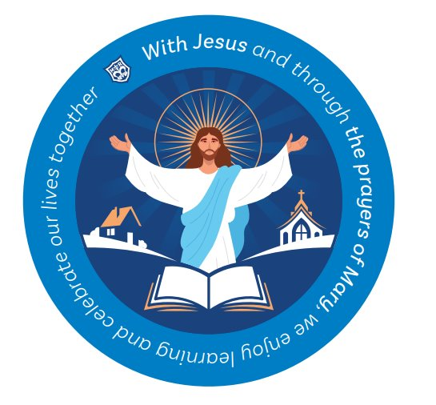
Head Teacher
Required from 1st September 2026 or sooner
L19 – L25 (starting salary negotiable based on experience).
NOR: 420 (2 form entry).

The Governors of St Mary’s Catholic Primary School are seeking to appoint an inspirational and dedicated Head Teacher. St Mary’s is a caring, friendly school and parish community where our Catholic Ethos is central to all that we do. Our new Head Teacher will work with Governors to shape the strategic direction of the school and will be responsible for the day-to-day leadership and management of St Mary’s.
Our new Head Teacher will lead a team that strives together in the best interest of all of our children, following the school’s values and mission statement:
‘With Jesus and through the prayers of Mary, we enjoy learning and celebrate our lives together.’
Applications are invited from Head Teachers, Deputy Head Teachers or Assistant Head Teachers with outstanding leadership experience.
The successful candidate will:
· Be a practising Catholic who can nurture faith and spirituality and take the lead role in providing inspirational Catholic education based on our shared Gospel values.
· Be passionate in promoting a clear child-centred vision.
· Be inclusive, aspirational and ambitious for all our children and our staff.
· Be a committed and engaging leader as we continue to strive for excellence

Governors are seeking someone who:
· Will encourage a curriculum that our teachers will be excited to teach and will inspire our children to learn.
· Can demonstrate a proven track record of providing inspirational, strategic and professional leadership.
· Has a secure understanding of all matters relating to safeguarding.
· Will be an enthusiastic team leader, with a strong commitment to working in partnership parents and Parish
· Will bring together a team in the school to achieve an outstanding level of education for our children
· Will work hard to ensure that every child is supported and challenged to maximise their potential.
· Can demonstrate to communicate clearly and pro-actively their vision and mission
We can offer the successful candidate:
· Children who are committed, enthusiastic and fully engaged in their learning.
· Professional and dedicated staff, supportive parents, and active Governors.
· An enthusiastic and aspirational Senior Leadership Team and support from a PA.
· Excellent opportunities for further professional development.
· A vibrant community with an active PTA and parent body
· Ofsted (2023) ‘Good’ rated school.
· Catholic Inspection (2025) ‘Good’ rated school.
St Mary’s is committed to safeguarding and promoting the welfare of children and young people, and expect all staff and volunteers to share this commitment. We will ensure that all our recruitment and selection practices reflect this commitment. The successful candidate will be subject to an enhanced Disclosure and Barring Service check, along with other relevant employment checks. Please note that this will also include a check of life online.

Applications should be on a CES application form and sent to the school (applications not submitted on the CES application form will not be considered). Any electronic applications will have to be signed by the applicant attending an interview.

Please note that we do not accept CVs or applications from agencies. Only shortlisted candidates will be contacted. This is a reserved post and is open to practising Catholics only, please review the document produced by the Diocese of Brentwood ‘’Definition of a Practising Catholic for Reserved Posts” for further information

We welcome and encourage applicants to visit our school. If required please liaise with the School Office Manager, Joanne Brooks. Information and application packs are available at admin@stmcps.co.uk and completed applications should be sent to this address also.

Closing date: Friday 6th March 2026 at 5 pm
Shortlisting: Thursday 12th March 2026
Interview: Friday 20th March 2026

